**Database Project – Final Report**

# First Name: Abhinav Last Name: Verma

Database Management Systems - Professor Fernandez

George Washington University

Month 04, 2016

# **Part 1**

## Overview

This project focuses on the creation of a database from the conceptual model design to a fully functional database including primary and foreign key constraints, indices to improve query performance, and triggers for history tracking and auditing. The database will be developed using the Oracle SQL Modeler and SQL Developer Applications. This database will store and manage projects and tasks for a catering company. I will refer to this organization as the Classic Catering People (CCP) although this is not the organization’s real name. A database will be created to store and manage CCP’s events, contractors and clients. Information describing events must be stored along with the contractors for the particular event. Details of different contractors like florist, musicians, entertainers and photographers are added to database. Client details are also added and the location details that the client chose for a particular event along with the order details. The proposed database will assist management on future event handling.

## Purpose and Objectives

Classic Catering People (CCP) is a catering company and requires a database for its operation. There are clients who can be individuals or business organizations. They can book events with CCP on their hall or any other location. In the CCP hall one event can be booked at a time. Any number of events can take place at offsite locations. Minimum 150 guests need to be there for hall to be booked which can handle 200 maximum guests. Offsite locations can host any number of guests. The hall can be booked two years in advance and offsite events can be booked months in advance. The client can choose menu for the event from menus provided by CCP. Client can also choose florist, musicians, entertainers and photographers for the event. CCP charges 10% extra of the cost to the client, that the contractors charge the CCP. Total price depends on the time of year, location, number of guests, contractors hired etc. Client can choose the color of linen, number of waiters bartenders etc too.

The solution provided in appendix is quite effective. But I feel the addition of client Id would be better as the name could be same for two people. Also the addition of event ID would help in creating an effective database.

**Data Modeling Tools**

Oracle SQL Developer Data Modeler will be used to design the Data Flow Diagram, Entity Relationship Diagram, and Relational Model.

**Database Software**

The database will be based on Oracle 11g software.

Oracle SQL Developer will be used to access the database although other Developer and Query Tools will also be compatible including SQL Plus, SQL Navigator and other SQL and PL/SQL developer tools.

**Additional Hardware and Software Details**

The CCP project database will be hosted on a server running the Linux operating system located at the George Washington University. Oracle SQL Developer will be used to access the database with support for other Developer and Query Tools including Oracle SQL Plus and third-party tools including SQL Navigator.

# **Part 2**

**Brief Project Goal**

A database will be created for the Atlantic Classing Catering People (CCP) to store and manage CCP’s short-term and long-term projects, tasks, and staff assignments.

**Business Direction Information**

Assumption: CCP would like the new event management database to be developed using Oracle Database version 11g.

Problem: CCP does not have a database to record all its events and contractors data. As the business is growing it is difficult maintain all the data manually. The company also wants to create a website for the business for which database is required.

Business Objective: To improve the maintenance of records.

## Data Flow Diagram (DFD)

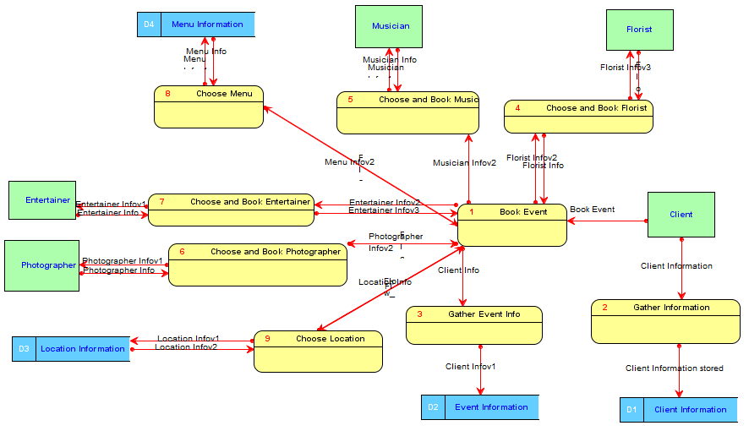

## Entity-Relation Diagram (ERD)

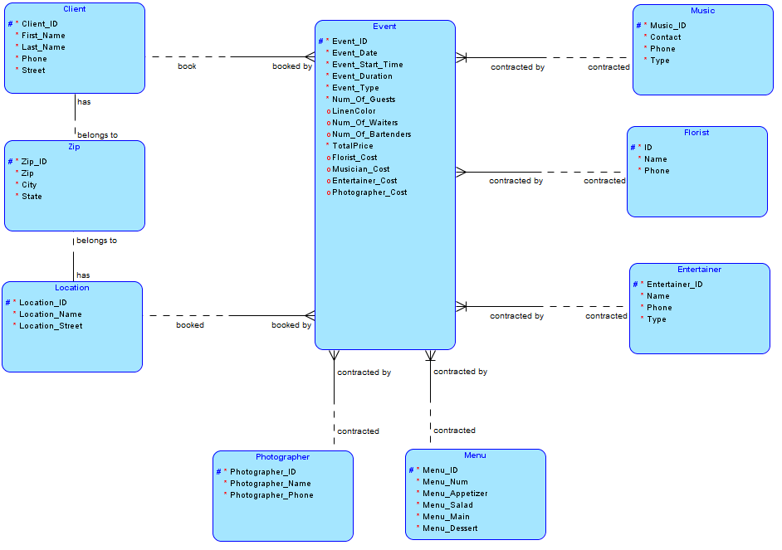

# **Part 3**

## Relational Database Design

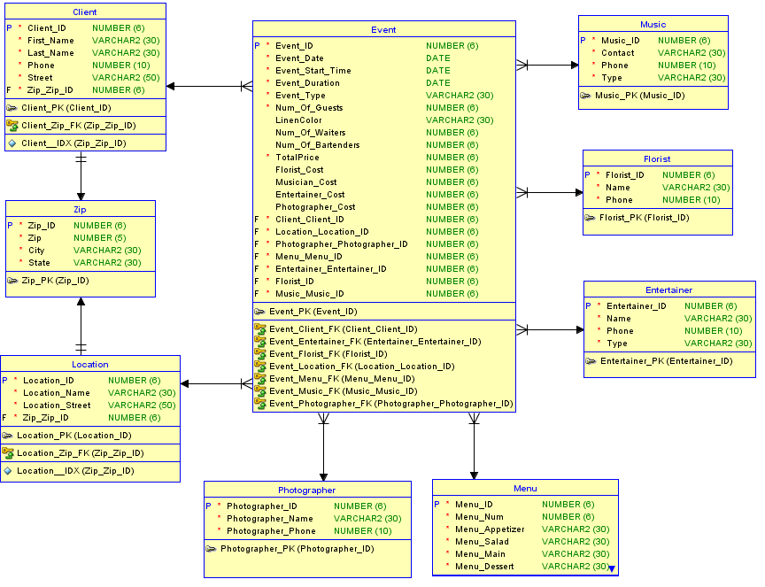

## Dependency Diagram

To show high level of relationships among the attributes of the table dependency diagram is created. In the below dependency diagram, primary key is shown with highlighted box. Arrows which are drawn above the attributes shows that there is desirable dependency between attributes.

**Event Table:**

Event_Date

 Event_Duration

Client_client_id

Event_start_time

Entertainer_Cost

Musician_Cost

Florist_Cost

TotalPrice

Num_Of_Bartenders

LinenColor

 Num_Of_Guests

 Event_Type

Num_Of_Waiters

Photographer_Cost

Music_Music_ID

Florist_ID

Entertainer_Entertainer_ID

Menu_Menu_ID

Photographer_Photographer_ID

Location_Location_ID

**Client Table:**

First_Name

Last_Name

Zip_Zip_ID

Street

Phone

**Entertainer Table:**

Name

Phone

Type

**Florist Table:**

Name

phone

**Location Table:**

Location_Name

Location_street

Zip_Zip_ID

**Menu Table:**

Meny_Num

    Menu_Dessert

Menu_Main

Menu_Salad

Menu_Appetizer

**Music Table:**

Contact

Type

Phone

**Photographer Table:**

Photographer_name

Photographer_Phone

**Zip Table:**

Zip

State

City

## Comparison of Relational Diagrams



## Physical Database Design

|  |
| --- |
| CREATE TABLE Client  (  Client_ID NUMBER (6) NOT NULL ,  First_Name VARCHAR2 (30) NOT NULL ,  Last_Name VARCHAR2 (30) NOT NULL ,  Phone NUMBER (10) NOT NULL ,  Street VARCHAR2 (50) NOT NULL ,  Zip_Zip_ID NUMBER (6) NOT NULL  ) ;  CREATE UNIQUE INDEX Client__IDX ON Client  (  Zip_Zip_ID ASC  )  ;  ALTER TABLE Client ADD CONSTRAINT Client_PK PRIMARY KEY ( Client_ID ) ;  CREATE TABLE Entertainer  (  Entertainer_ID NUMBER (6) NOT NULL ,  Name VARCHAR2 (30) NOT NULL ,  Phone NUMBER (10) NOT NULL ,  Type VARCHAR2 (30) NOT NULL  ) ;  ALTER TABLE Entertainer ADD CONSTRAINT Entertainer_PK PRIMARY KEY ( Entertainer_ID ) ;  CREATE TABLE Event  (  Event_ID NUMBER (6) NOT NULL ,  Event_Date DATE NOT NULL ,  Event_Start_Time DATE NOT NULL ,  Event_Duration DATE NOT NULL ,  Event_Type VARCHAR2 (30) NOT NULL ,  Num_Of_Guests NUMBER (6) NOT NULL ,  LinenColor VARCHAR2 (30) ,  Num_Of_Waiters NUMBER (6) ,  Num_Of_Bartenders NUMBER (6) ,  TotalPrice NUMBER (6) NOT NULL ,  Florist_Cost NUMBER (6) ,  Musician_Cost NUMBER (6) ,  Entertainer_Cost NUMBER (6) ,  Photographer_Cost NUMBER (6) ,  Client_Client_ID NUMBER (6) NOT NULL ,  Location_Location_ID NUMBER (6) NOT NULL ,  Photographer_Photographer_ID NUMBER (6) NOT NULL ,  Menu_Menu_ID NUMBER (6) NOT NULL ,  Entertainer_Entertainer_ID NUMBER (6) NOT NULL ,  Florist_ID NUMBER (6) NOT NULL ,  Music_Music_ID NUMBER (6) NOT NULL  ) ;  ALTER TABLE Event ADD CONSTRAINT Event_PK PRIMARY KEY ( Event_ID ) ;  CREATE TABLE Florist  (  Florist_ID NUMBER (6) NOT NULL ,  Name VARCHAR2 (30) NOT NULL ,  Phone NUMBER (10) NOT NULL  ) ;  ALTER TABLE Florist ADD CONSTRAINT Florist_PK PRIMARY KEY ( Florist_ID ) ;  CREATE TABLE Location  (  Location_ID NUMBER (6) NOT NULL ,  Location_Name VARCHAR2 (30) NOT NULL ,  Location_Street VARCHAR2 (50) NOT NULL ,  Zip_Zip_ID NUMBER (6) NOT NULL  ) ;  CREATE UNIQUE INDEX Location__IDX ON Location  (  Zip_Zip_ID ASC  )  ;  ALTER TABLE Location ADD CONSTRAINT Location_PK PRIMARY KEY ( Location_ID ) ;  CREATE TABLE Menu  (  Menu_ID NUMBER (6) NOT NULL ,  Menu_Num NUMBER (6) NOT NULL ,  Menu_Appetizer VARCHAR2 (30) NOT NULL ,  Menu_Salad VARCHAR2 (30) NOT NULL ,  Menu_Main VARCHAR2 (30) NOT NULL ,  Menu_Dessert VARCHAR2 (30) NOT NULL  ) ;  ALTER TABLE Menu ADD CONSTRAINT Menu_PK PRIMARY KEY ( Menu_ID ) ;  CREATE TABLE Music  (  Music_ID NUMBER (6) NOT NULL ,  Contact VARCHAR2 (30) NOT NULL ,  Phone NUMBER (10) NOT NULL ,  Type VARCHAR2 (30) NOT NULL  ) ;  ALTER TABLE Music ADD CONSTRAINT Music_PK PRIMARY KEY ( Music_ID ) ;  CREATE TABLE Photographer  (  Photographer_ID NUMBER (6) NOT NULL ,  Photographer_Name VARCHAR2 (30) NOT NULL ,  Photographer_Phone NUMBER (10) NOT NULL  ) ;  ALTER TABLE Photographer ADD CONSTRAINT Photographer_PK PRIMARY KEY ( Photographer_ID ) ;  CREATE TABLE Zip  (  Zip_ID NUMBER (6) NOT NULL ,  Zip NUMBER (5) NOT NULL ,  City VARCHAR2 (30) NOT NULL ,  State VARCHAR2 (30) NOT NULL  ) ;  ALTER TABLE Zip ADD CONSTRAINT Zip_PK PRIMARY KEY ( Zip_ID ) ;  ALTER TABLE Client ADD CONSTRAINT Client_Zip_FK FOREIGN KEY ( Zip_Zip_ID ) REFERENCES Zip ( Zip_ID ) ;  ALTER TABLE Event ADD CONSTRAINT Event_Client_FK FOREIGN KEY ( Client_Client_ID ) REFERENCES Client ( Client_ID ) ;  ALTER TABLE Event ADD CONSTRAINT Event_Entertainer_FK FOREIGN KEY ( Entertainer_Entertainer_ID ) REFERENCES Entertainer ( Entertainer_ID ) ;  ALTER TABLE Event ADD CONSTRAINT Event_Florist_FK FOREIGN KEY ( Florist_ID ) REFERENCES Florist ( Florist_ID ) ;  ALTER TABLE Event ADD CONSTRAINT Event_Location_FK FOREIGN KEY ( Location_Location_ID ) REFERENCES Location ( Location_ID ) ;  ALTER TABLE Event ADD CONSTRAINT Event_Menu_FK FOREIGN KEY ( Menu_Menu_ID ) REFERENCES Menu ( Menu_ID ) ;  ALTER TABLE Event ADD CONSTRAINT Event_Music_FK FOREIGN KEY ( Music_Music_ID ) REFERENCES Music ( Music_ID ) ;  ALTER TABLE Event ADD CONSTRAINT Event_Photographer_FK FOREIGN KEY ( Photographer_Photographer_ID ) REFERENCES Photographer ( Photographer_ID ) ;  ALTER TABLE Location ADD CONSTRAINT Location_Zip_FK FOREIGN KEY ( Zip_Zip_ID ) REFERENCES Zip ( Zip_ID ) ; |

## Non – Unique Indexes for foreign Keys

|  |
| --- |
| CREATE INDEX ZipID_Loc_IND ON Location (Zip_Zip_ID);  CREATE INDEX ZipID_Cli_IND ON Client (Zip_Zip_ID);  CREATE INDEX ZipID_IND ON Client (Client_Client_ID);  CREATE INDEX LocID_IND ON Client (Location_Location_ID);  CREATE INDEX PhotoID_IND ON Client (Photographer_photographer_ID);  CREATE INDEX Men_IND ON Client (Menu_Menu_ID);  CREATE INDEX Entr_IND ON Client (Entertainer_Entertainer_ID);  CREATE INDEX Flor_IND ON Client (Florist_ID);  CREATE INDEX Musi_IND ON Client (Music_Music_ID); |

## Functional Dependencies of the tables created

**Client Table**

{Last_Name, First_Name} 🡪 {Phone, Street, Zip}

We created a surrogate key: Client_ID

**Event Table**

{client_ID, event_Date, event_Start_Time} 🡪 {event_Duration, event_Type, num_Of_Guests, location_ID, linenColor, num_Of_Waiters, num_Of_Bartenders, totalPrice, florist_ID, florist_Cost, music_ID, musician_Cost, entertainer_ID, entertainer_Cost, photographer_ID, photographer_Cost, menu_ID}

We created a surrogate key: Event_ID

**Menu Table**

{menuNumber} 🡪 {menuAppetizer, menuSalad, menuMain, menuDessert}

We created a surrogate key: Menu_ID

**Location Table**

{locationName} 🡪 {locationStreet, locationZip}

We created a surrogate key: Location_ID

**Zip Table**

{Zip} 🡪 {City, State}

We created a surrogate key: Zip_ID

**Florist Table**

{floristName} 🡪 {floristPhone}

We created a surrogate key: Florist_ID

**Music Table**

{musicContact} 🡪 {musicContactPhone, musicType}

We created a surrogate key: Music_ID

**Entertainer Table**

{entertainerName} 🡪 {entertainerPhone, entertainerType}

We created a surrogate key: Entertainer_ID

**Photographer Table**

{photographerName} 🡪 {photographerPhone}

We created a surrogate key: Photographer_ID

## Lessons Learnt

# **Part 4**

## Unique constraints for Natural and alternate keys

|  |
| --- |
| ALTER TABLE Event ADD CONSTRAINT event_key UNIQUE (Client_Client_ID, Event_Date, Event_Start_Time);  ALTER TABLE Client ADD CONSTRAINT client_name UNIQUE (First_Name, Last_Name);  ALTER TABLE Zip ADD CONSTRAINT unique_zip UNIQUE (Zip);  ALTER TABLE Location ADD CONSTRAINT unique_location UNIQUE (Location_Name);  ALTER TABLE Photographer ADD CONSTRAINT unique_photographer_name UNIQUE (Photographer_Name);  ALTER TABLE Menu ADD CONSTRAINT unique_menu_num UNIQUE (Menu_Num);  ALTER TABLE Entertainer ADD CONSTRAINT unique_entertainer_name UNIQUE (Name);  ALTER TABLE Florist ADD CONSTRAINT unique_florist_name UNIQUE (Name);  ALTER TABLE Music ADD CONSTRAINT unique_music_contact UNIQUE (Contact); |

## Sequences

|  |
| --- |
| CREATE SEQUENCE ClientSeq  START WITH 1  INCREMENT BY 1 ;    CREATE SEQUENCE ZIPSequence  START WITH 1  INCREMENT BY 1 ;  CREATE SEQUENCE LocationSeq  START WITH 1  INCREMENT BY 1 ;      CREATE SEQUENCE FloristSeq  START WITH 1  INCREMENT BY 1 ;    CREATE SEQUENCE PhotoGrapherSeq  START WITH 1  INCREMENT BY 1 ;  CREATE SEQUENCE EntSeq  START WITH 1  INCREMENT BY 1 ;    CREATE SEQUENCE MusicSeq  START WITH 1  INCREMENT BY 1 ;  CREATE SEQUENCE MenuSeq  START WITH 1  INCREMENT BY 1 ;  Commit;  CREATE SEQUENCE EventSeq  START WITH 1  INCREMENT BY 1 ;  Commit; |

## Insert Database Queries

|  |
| --- |
| Insert into ZIP values (ZIPSequence.NextVal,'20004', 'Washington','District of Columbia');  Insert into ZIP values (ZIPSequence.NextVal,'20005', 'Washington','District of Columbia');  Insert into ZIP values (ZIPSequence.NextVal,'10018', 'New York','New York');  Insert into CLIENT values (ClientSeq.NextVaL,'Client1','CF1', [2027423499](tel:2027423499),'1331 Pennsylvania Ave NW', 1);  Insert into CLIENT values (ClientSeq.NextVaL,'Bank of America','CF2',[2027423499](tel:2027423499),'700 13th St NW',2);  Insert into CLIENT values (ClientSeq.NextVaL,'The New York Times','CF3',[9176984637](tel:9176984637),'620 8th Ave',3);  Insert into LOCATION values (LocationSeq.NextVaL,'BOFA','700 13 NW', 2);  Insert into LOCATION values (LocationSeq.NextVaL,'New York Times Building','620 8th Ave', 3);  Insert into LOCATION values (LocationSeq.NextVaL,'JW Marriott Washington, DC','1331 Pennsylvania Ave NW', 1);  Insert into FLORIST VALUES (FloristSeq.NextVal,'Caruso Florist',[2022233816](tel:2022233816));  Insert into FLORIST VALUES (FloristSeq.NextVal,'Nosegay Flowers',[2023381146](tel:2023381146));  Insert into FLORIST VALUES (FloristSeq.NextVal,'Flowers On Fourteenth',[2026677888](tel:2026677888));  Insert into PHOTOGRAPHER VALUES (PhotoGrapherSeq.NextVal,'DuHon Photography',[2026414889](tel:2026414889));  Insert into PHOTOGRAPHER VALUES (PhotoGrapherSeq.NextVal,'Sam Hurd Photography',[4344265018](tel:4344265018));  Insert into PHOTOGRAPHER VALUES (PhotoGrapherSeq.NextVal,'Moshe Zusman Photography',[2025067218](tel:2025067218));  Insert into ENTERTAINER VALUES (EntSeq.NextVal,'Capitol Steps',[2023121555](tel:2023121555),'Agency');  Insert into ENTERTAINER VALUES (EntSeq.NextVal, 'The Walt Disney Company',[2022224810](tel:2022224810),'Agency');  Insert into ENTERTAINER VALUES (EntSeq.NextVal, 'Aloha Luau Entertainment',[2022438484](tel:2022438484),'Agency');  Insert into MUSIC VALUES (MusicSeq.NextVal, 'Blue House Productions',[3015891001](tel:3015891001),'Company');  Insert into MUSIC VALUES (MusicSeq.NextVal, 'Alexandria Music Company',[7036606025](tel:7036606025),'Company');  Insert into MENU VALUES (MenuSeq.NextVal,1,'Parmesian Garlic Cheese Bread','Chicken Salad','Lasagna','Lemon Meringue Cheesecake');  Insert into MENU VALUES (MenuSeq.NextVal,2,'Southern Fried Chicken Sliders','Chicken Salad','Lasagna','Lemon Meringue Cheesecake');  Insert into MENU VALUES (MenuSeq.NextVal,3,'Factory Nachos','Chicken Salad','Lasagna','Lemon Meringue Cheesecake');  Insert into MENU VALUES (MenuSeq.NextVal,4,'Factory Nachos','Chicken Salad','Lasagna','Salted Caramel Cheesecake');  Insert into MENU VALUES (MenuSeq.NextVal,5,'Southern Fried Chicken Sliders','Chicken Salad','Lasagna','Lemon Meringue Cheesecake');  Commit;  Insert into EVENT VALUES (EventSeq.NextVal,  TO_DATE('2016/05/03 21:02:44', 'yyyy/mm/dd hh24:mi:ss'),  TO_DATE('2016/05/03 21:02:44', 'yyyy/mm/dd hh24:mi:ss'),  TO_DATE('2016/05/03 21:02:44', 'yyyy/mm/dd hh24:mi:ss'),  'Conference',  50,  'Off White',  20,  5,  30000,  500,  2000,  5000,  500,  11,1,1,2,1,1,1);  Commit; |

## Select Queries

|  |
| --- |
| /* to get the photographer name for known event id 2*/  select p.Photographer_name from photographer p, event e where e.event_id = 1 and p.photographer_id = e.photographer_photographer_id;  /* to find out the menu main dish for an event given event id */  select m.menu_main from event e, menu m where e.menu_menu_id = m.menu_id and e.event_id = 1;  /* to find out client phone number for the event id 1 */  select c.phone from event e, client c where e.client_client_id = c.client_id and e.event_id = 1;  /* to check the total sum of different type of events */  select e.event_type, sum (totalprice) from event e group by e.event_type;  /* to calculate the count of number of events by event type */  select e.EVENT_TYPE ,count(e.EVENT_ID) from event e group by e.event_type having count(e.EVENT_TYPE) > 1;  /* to check total number of guests attended by event type */  select event_type, sum(NUM_OF_GUESTS) from event group by event_type;  /* to check the location (city) of the client */  select c.FIRST_NAME, c.LAST_NAME, z.CITY from client c, zip z where c.zip_zip_id = z.zip_id;  /* to find all the clients in the state of New York */  select c.FIRST_NAME, c.LAST_NAME from client c where c.zip_zip_id in (select zip_id from zip z where state = 'New York');  /* to find out the most favorite dessert */  select e.event_type from event e where e.menu_menu_id in (select menu_id from menu where menu_dessert = 'Salted Caramel Cheesecake');  /* searching all the events in state of DC */  select e.EVENT_TYPE from event e where e.LOCATION_LOCATION_ID in (select l.LOCATION_ID from location l join zip z on l.ZIP_ZIP_ID = z.ZIP_ID where z.STATE = 'New York'); |

1. **Normalization:**

Functional Dependencies are as follows:

|  |
| --- |
| **Client Table**  {Last_Name, First_Name} 🡪 {Phone, Street, Zip}  We created a surrogate key: Client_ID  **Event Table**  {client_ID, event_Date, event_Start_Time} 🡪 {event_Duration, event_Type, num_Of_Guests, location_ID, linenColor, num_Of_Waiters, num_Of_Bartenders, totalPrice, florist_ID, florist_Cost, music_ID, musician_Cost, entertainer_ID, entertainer_Cost, photographer_ID, photographer_Cost, menu_ID}  We created a surrogate key: Event_ID  **Menu Table**  {menu_Num} 🡪 {menu_Appetizer, menu_Salad, menu_Main, menu_Dessert}  We created a surrogate key: Menu_ID  **Location Table**  {location_Name} 🡪 {location_Street, Zip}  We created a surrogate key: Location_ID  **Zip Table**  {Zip} 🡪 {City, State}  We created a surrogate key: Zip_ID  **Florist Table**  {Name} 🡪 {Phone}  We created a surrogate key: Florist_ID  **Music Table**  {Contact} 🡪 {Phone, Type}  We created a surrogate key: Music_ID  **Entertainer Table**  {Name} 🡪 {Phone, Type}  We created a surrogate key: Entertainer_ID  **Photographer Table**  {Name} 🡪 {Phone}  We created a surrogate key: Photographer_ID |

|  |
| --- |
| Tables Created:  **Event** (EventID, client_ID, event_Date, event_Start_Time, event_Duration, event_Type, num_Of_Guests, location_ID, linenColor, num_Of_Waiters, num_Of_Bartenders, totalPrice, florist_ID, florist_Cost, music_ID, musician_Cost, entertainer_ID, entertainer_Cost, photographer_ID, photographer_Cost, menu_ID)  **Client** (Client _ID, Last_Name, First_Name ,Phone, Street, Zip)  **Menu** (Menu_ID, menu_Num, menu_Appetizer, menu_Salad, menu_Main, menu_Dessert)  **Location** (Location_ID, location_Name, location_Street, Zip)  **Zip** (Zip_ID, Zip, City, State)  **Florist** (Florist_ID, Phone, Name)  **Music** (Music_ID, Phone, Name, Contact)  **Entertainer** (Entertainer_ID, Phone, Type, Name)  **Photographer** (Photographer_ID, Phone, Name) |

1. 1NF:

As there are no multi valued columns present the above

1. 2NF:

In all the tables, every attribute is dependent on the primary key, and so they are in 2NF form.

1. 3NF:

In all tables, no attribute is dependent on any non-key attribute, and so there are no transitive dependencies. Hence all tables are in 3NF form.

1. BCNF:

All table dependencies include superkeys, hence all tables are in BCNF form.

## Lessons Learnt

# **Part 5**

## 

create or replace

TRIGGER t_before_update_event before update on EVENT

for each row

begin

insert into Event_hist1

(Event_ID ,

Event_Date ,

Event_Start_Time ,

Event_Duration ,

Event_Type ,

Num_Of_Guests ,

LinenColor ,

Num_Of_Waiters ,

Num_Of_Bartenders ,

TotalPrice ,

Florist_Cost ,

Musician_Cost ,

Entertainer_Cost ,

Photographer_Cost ,

Client_Client_ID ,

Location_Location_ID ,

Photographer_Photographer_ID ,

Menu_Menu_ID ,

Entertainer_Entertainer_ID ,

Florist_ID ,

Music_Music_ID )

values

(:old.Event_ID ,

:old.Event_Date ,

:old.Event_Start_Time ,

:old.Event_Duration ,

:old.Event_Type ,

:old.Num_Of_Guests ,

:old.LinenColor ,

:old.Num_Of_Waiters ,

:old.Num_Of_Bartenders ,

:old.TotalPrice ,

:old.Florist_Cost ,

:old.Musician_Cost ,

:old.Entertainer_Cost ,

:old.Photographer_Cost ,

:old.Client_Client_ID ,

:old.Location_Location_ID ,

:old.Photographer_Photographer_ID ,

:old.Menu_Menu_ID ,

:old.Entertainer_Entertainer_ID ,

:old.Florist_ID ,

:old.Music_Music_ID);

end t_before_update_event;

1. ALTER TABLE Music

ADD LastInsert_By varchar(30)

ADD LastInsert_Date date;

commit;

create or replace TRIGGER MUSIC_AUDIT

BEFORE INSERT ON Music

FOR EACH ROW

BEGIN

If INSERTING then

:new.LastInsert_By := user;

:new.LastInsert_Date := sysdate;

end if;

END;

ALTER TABLE Zip

ADD LastInsert_By varchar(30)

ADD LastInsert_Date date;

commit;

create or replace TRIGGER ZIP_AUDIT

BEFORE INSERT ON Zip

FOR EACH ROW

BEGIN

If INSERTING then

:new.LastInsert_By := user;

:new.LastInsert_Date := sysdate;

end if;

END;

ALTER TABLE Client

ADD LastInsert_By varchar(30)

ADD LastInsert_Date date;

commit;

create or replace TRIGGER CLIENT_AUDIT

BEFORE UPDATE ON Client

FOR EACH ROW

BEGIN

If UPDATING then

:new.LastInsert_By := user;

:new.LastInsert_Date := sysdate;

end if;

END;

(c) -- Update Queries  
UPDATE client SET FIRST_NAME = 'Ola' WHERE CLIENT_ID =1;  
UPDATE entertainer SET NAME = 'OlaHola' WHERE ENTERTAINER_ID =1;  
UPDATE florist SET NAME = 'Lily' WHERE FLORIST_ID =1;  
UPDATE photographer SET PHOTOGRAPHER_NAME = 'Click' WHERE PHOTOGRAPHER_ID =1;  
UPDATE location SET LOCATION_NAME = 'Kashmir' WHERE LOCATION_ID =1; 

**‘What we learned in the project’ and Summary**

The project was very helpful in learning triggers, index; both unique and non-unique, foreign keys, primary keys, triggers, sequences, natural keys, alternate keys, joins, subqueries etc.

We also learned the concepts of normalization. We converted a database from a raw data to a fully functional and efficient system with BCNF normalization. All the stages of normalization was reached in a proper step by step manner.

We learned about sequences in which the primary key of the table is automatically entered in the insert statements to a table using sequences. Sequences help the key to remain unique.

We learned the concept of foreign keys in an in- dept. fashion. We also realized that foreign keys play a very important role in maintaining the normalization of the database.

Primary keys are equally important because they help in uniquely identifying each and every row in a table.

Joins are of many types and they provide a lot of flexibility in extracting data from a database. In a normalized database the significant data is spread across many tables. So joins are required to bring meaningful data out of the database in front of the user from various tables at once.

Subqueries are also very helpful. Their name is apt. Subqueries are queries inside a query. They are usually used with ‘IN’ operators and present a range of values which satisfy a condition. These range of values can be compared with the main set of values in the outer query.

Triggers also form a very important part of the database. It comes under PL/SQL concept of the database. They are similar to stored procedures in a way that they can be invoked repeatedly but on certain conditions only. They cannot be explicitly called. They have many functions like to log events, prevent invalid transactions etc.

We also wrote select queries which included grouping queries. We also wrote DDL and DML statements.

We performed almost all the steps in successfully creating a data base in a step by step professional manner. In addition to this we also learned how to work in a team and maintain a healthy constructive environment.

This project also helped us to gain hands on experience on the aforementioned concepts.

**References**

1. <http://docs.oracle.com/cd/E11882_01/appdev.112/e25519/triggers.htm#LNPLS723>
2. <http://docs.oracle.com/cd/B19306_01/server.102/b14200/clauses002.htm>
3. <https://docs.oracle.com/cd/B28359_01/server.111/b28286/statements_6015.htm>
4. <https://docs.oracle.com/cd/E11882_01/server.112/e40540/indexiot.htm>
5. <https://social.msdn.microsoft.com/Forums/sqlserver/en-US/27bd9c77-ec31-44f1-ab7f-bd2cb13129be/surrogate-keys-natural-keys-candidate-keys-composite-keys-and-super-keys?forum=sqlgetstarted>
6. <https://msdn.microsoft.com/en-us/library/aa291817(v=vs.71).aspx>
7. <http://docs.oracle.com/cd/B28359_01/gateways.111/b31053/c_array_handling.htm>