Student Loyalty and Reward management System

*A Project Report Submitted in the Partial Fulfillment of the Requirements for the Award of the Degree of*

### BACHELOR OF TECHNOLOGY IN

**COMPUTER SCIENCE AND ENGINEERING**

**Submitted by**

**DEEPAK SINGH THAKUR 17881A05D5 AKKEM ABHINAV YADAV 17881A05C1 CHERIPALLI NAMRATH 17881A05E7**

**SUPERVISOR**

**Sowmya Dudyala Assistant Professor**



**Department of Computer Science and Engineering**

**May, 2021**





**Department of Computer Science and Engineering**

**CERTIFICATE**

This is to certify that the project titled **Student Loyalty And Reward Management** is carried out by

### Akkem Abhinav Yadav 17881A05C1 Deepak Singh Thakur 17881A05D5 Cheripalli Namrath 17881A05E7

in partial fulfillment of the requirements for the award of the degree of **Bachelor of Technology** in **Computer Science and Engineering** during the year 2020-21.

### Signature of the Supervisor Signature of the HOD Sowmya Dudyala Dr. Rajanikanth Aluvalu

**Assistant Professor Professor and Head, CSE**

Kacharam (V), Shamshabad (M), Ranga Reddy (Dist.)–501218, Hyderabad, T.S. Ph: 08413-253335, 253201, Fax: 08413-253482, [www.vardhaman.org](http://www.vardhaman.org/)

# Acknowledgement

The satisfaction that accompanies the successful completion of the task would be put incomplete without the mention of the people who made it possible, whose constant guidance and encouragement crown all the efforts with success.

We wish to express our deep sense of gratitude to , and Project Supervi- sor, Department of Computer Science and Engineering, Vardhaman College of Engineering, for his able guidance and useful suggestions, which helped us in completing the project in time.

We are particularly thankful to **Dr. Rajanikanth Aluvalu**, the Head of the Department, Department of Computer Science and Engineering, his guidance, intense support and encouragement, which helped us to mould our project into a successful one.

We show gratitude to our honorable Principal **Dr. J.V.R. Ravindra**, for providing all facilities and support.

We avail this opportunity to express our deep sense of gratitude and heart- ful thanks to **Dr. Teegala Vijender Reddy**, Chairman and **Sri Teegala Upender Reddy**, Secretary of VCE, for providing a congenial atmosphere to complete this project successfully.

We also thank all the staff members of Computer Science and Engineering department for their valuable support and generous advice. Finally thanks to all our friends and family members for their continuous support and enthusiastic help.

### Akkem Abhinav Yadav Deepak Singh Thakur Cheripalli Namrath

# Abstract

Over the beyond few years, as we recognize that Blockchain generation has enabled a brand new software program paradigm for coping with of the virtual possession in partial agree with environments. In this packages we use Blockchain concepts that may generate tokens .The System generated tokens may be used as loyalty factors that are generated with the aid of using those idea of Token era in cryptocurrency and that are controlled with the aid of using this blockchain. It is utilized in an firms or institutes in which those college students can use the loyalty factors to behavior the transactions like tokens or loyalty factors may be redeemed within the campus for transactions or make use of to sign up withinside the virtual guides and to attain the coordination throughout organizations. If a pupil completes a task then the pupil can be rewarded with a few tokens like , Tokens are awarded to the scholars as they development thru the described milestones with the aid of using the faculty. And as a praise, When a pupil Won any opposition or contest. This streamlines the praise device of college students and enables us to create cost for the generated tokens. All those transcation of tokens are controlled withinside the wallet. Wallet holds all of the device generated tokens and rewarded tokens . Fundamental to this illustration is that customers can independently control token custody in virtual wallets and engage with each other in a peer-topeer manner. And we are able to say that it’s miles a disbursed ledger that records and secures transactions in a peer-to- peer network. This networks provide steady transaction linkage, and garage in integrity covered disbursed ledgers forming jointly operated record- maintaining execution environments.

***Keywords***: Token Generation System ; Security Management System ;

User Management System ; Wallet

# Table of Contents

### Title Page No.

Acknowledgement i

Abstract ii

List of Figures v

Abbreviations v

CHAPTER 1 INTRODUCTION 1

* 1. Introduction 1
  2. Motivation 2
  3. Limitation 4
     1. User Management System 4
     2. Addressing of Wallet 5

CHAPTER 2 LITERATURE SURVEY 6

* 1. Motivation 6
     1. Cryptocurrency has revolutionized the payment system: 6
     2. The Bitcoin is One of the best innovations of the century: 7
  2. Existing system vs proposed 8
  3. Proposed objectives 8
     1. Token generation system: 8
     2. Security Management System: 9
     3. User management system: 9
     4. Wallet: 9
  4. Proposed Outcomes 9

CHAPTER 3 ANALYSIS 10

* 1. Software Requirement Specification 10
     1. Software Requirements 10
     2. Hardware Requirements 10
     3. User Requirements 10
  2. Architectural Diagram 10

CHAPTER 4 DESIGN 12

* 1. UML Diagrams 12
     1. Data Flow Diagram 12

|  |  |  |  |
| --- | --- | --- | --- |
| 4.1.2 |  | Data Flow Diagram . . . . . . . . . . . . . . . . . . . . . . | 12 |
| 4.1.3 |  | Process Flow Diagram . . . . . . . . . . . . . . . . . . . . . | 13 |
| 4.1.4 |  | Process Flow diagram . . . . . . . . . . . . . . . . . . . . . | 13 |
| **CHAPTER** | **5** | **TESTING AND RESULTS** . . . . . . . . . . . . . . . | 16 |

* 1. Testing Strategy 16
  2. Output Screens 16

### CHAPTER 6 CONCLUSION AND FUTURE SCOPE 24

* 1. Conclusion 24
  2. Future Scope 24

### REFERENCES 25

# List of Figures

|  |  |  |
| --- | --- | --- |
| 3.1 Architecture | diagram . . . . . . . . . . . . . . . . . . . . . . . . . . | 11 |
| 3.2 Architecture | Diagram . . . . . . . . . . . . . . . . . . . . . . . . . | 11 |
| 4.1 ProcessFlow | . . . . . . . . . . . . . . . . . . . . . . . . . . . . . . . | 12 |
| 4.2 ProcessFlow | Diagram . . . . . . . . . . . . . . . . . . . . . . . . . | 13 |

* 1. Sequence Diagram 14
  2. Sequence Diagram 15
  3. Testing Stategy Diagram 16
  4. Stufflogin page 17
  5. student login page 17
  6. output screen 18
  7. output screen 18
  8. Output screen 19
  9. output screen 19
  10. output screen 20
  11. output screen 20
  12. output screen 21
  13. output screen 22
  14. output screen 22
  15. output screen 23

## Abbreviations

**AbbreviationDescription** ERCEthereum Request for Comment EVMEthereum Virtual Machine RCPRich Client Program

# CHAPTER 1

**INTRODUCTION**

# Introduction

This application focuses on the reward system. The System generated tokens can be used as reward points which are generated by the concept of Token generation in Cryptocurrency and which are managed by the Blockchain. Tokens are awarded to the students as they progress through the defined milestones , by the faculty members . And as a reward, When a student Wons any competition or contest These reward points can be used to conduct transactions. i.e.; to enroll the digital courses or use for paying the library dues. In this Application , facult defines a mildstones like create an article

, quiz , assignment etc to the students . by completing the mildstones the students will get reward tokens. and this tokens can be manage by an external Wallet which is an CryptoCurrency Wallet . A cryptocurrency pockets is a tool and a physical medium program or a provider which shops a public, non-public keys for those cryptocurrency transactions. In addition to this , the primary characteristic of storing the keys and an cryptocurrency pockets extra regularly additionally gives the capability of encrypting and/or signing information. Signing for an example result in executing an clever contract, a cryptocurrency transaction (see ”bitcoin transaction” image), identity or legally signing a ’document’ [1] . A crypto currency pockets works via way of means of an theoretical or random variety being generated and used with an duration relying at the set of rules length of the cryptocurrency’s generation necessities. The variety is then transformed to an non-public key the usage of the particular necessities of the cryptocurrency cryptography set of rules requirement. A public secret’s generated from the non-public key the usage of which cryptographic’s set of rules necessities are required. The non-public secret’s utilised via way of means of the proprietor to get admission to the

proprietor and ship cryptocurrency and is non-public to the proprietor, while the

public secret’s to be shared to of the any 1/3 birthday birthday celebration

to get hold of cryptocurrency. Up to the degree no pc until now or digital tool is needed and the all (key pair) may be mathematically derived and written down via way of means of the hand. The non-public key and public key pair are the addresses (recognized as deal with) are did not recognized via way of means of the blockchain or all and sundry else. The blockchain will document the transaction of the general public deal with whilst the cryptocurrency is despatched to the opposite pockets , hence recording withinside the blockchain ledger of an transaction for an publicly deal with.

# Motivation

As we know that in colleges , reward system for a competition or a contest or a quiz consist of trophies , cash price , certificates , gifts etc. we thought that to give freedom to choose they price by creating this application . In this application , when a student complete a milestone then he will be rewarded with some tokens . That tokens consisting of some economic value . That tokens can be redeem with in the organization like paying a college fee , paying library dues ,enrolling the digital courses , paying in canteen , paying to your friends etc . This tokens can be redeem anywhere as it consist of economic value. The main role plays here is Wallet , which maintain the tokens and which runs on the blockchain so we can say that the tokens are Cryptocurrencies. A cryptocurrency is a intermediate process of alternate of token example like everyday currencies which includes INR,USDT,USD,trx,xrp however it’s far designed for the motive of changing virtual information. Cryptocurrency is described with the aid of using the Investopedia.com as a decentralized “virtual or digital foreign money that uses cryptography for the security” making it hard for counterfeit. Since it’s far now no longer issued with the aid of using the valuable authority the governments can’t take it away from you and its secure. Here are a few correct motives motivation for this application : Over the final couple of years, virtual foreign money has

been gaining the general public eye very speedy and reached soon.

### Fraud-proof:

When crypto foreign money is created , all showed transactions are saved in public ledgers. All identities of coin proprietors are encrypted to make certain that the legitimacy of report preserving is safe. Because the foreign money is decentralized system , you very own it. Neither authorities nor financial institution has any manage over the crypto currencies.

### Identity Theft:

The ledger guarantees that each one transactions between “ crypto wallets” can calculate a accurate stability in wallet. All transactions are checked to make cite conform that cash used are owned through the only modern spender. This public ledger is likewise referred to a “transaction blockchain”. Blockchain generation guarantees steady virtual transactions thru encryption and “clever contracts” that make an entity genuinely un hackable and void of fraud. With protection like this, blockchain generation is poised to effect almost every and each phase of our lives.

### Instant Settlement:

Blockchain is the simplest cause why cryptocurrency has extra value. Ease of use is the best cause why cryptocurrency is in excessive demand in the market . All you want is a clever device, a web connection and right away you grow to be your very own financial institution making bills and cash transfers in sucessfulway.

### Accessible:

There are over billion humans with get entry to to the Internet who do not have rights to apply to standard change systems. These people are clued-in for the cryptocurrency market.

### You are the owner:

There isn’t anyt any different digital coins machine wherein your account is owned with the aid of using you

# Limitation

## User Management System

### More Costly

Creating and handling a database is pretty high priced. High fee software program and hardware is needed for the database. Also enormously educated body of workers is needed to deal with the database and it additionally wishes non-stop maintenance. All of those finally ends up creating a database pretty a high priced venture.[1]

### High Complexity

Storing, purchasing, or replacing cryp- tocurrencies on a web pockets, to save you the prevalence of a breach withinside the pockets systems. Creating and dealing with a database is pretty expensive . High fee software program and hardwares is needed for the database only . Also notably educated group of workers is needed to address the database and it additionally desires non- stop protection of servers . All of end up creating a database as a expensive venture.

### High Hardware Cost

A database carries massive quantity of data. So massive disk garage devices are required to keep all this data. Sometimes more garage may also also be needed.So all this will increase hardware prices with the aid of using lots and makes a database pretty expensive.

### Huge Size

A database incorporates a big quantity of statistics, specifically for larger organisa- tions. This statistics may also even growth as extra statistics is up to date into the database. All of this process results in a big length of the database.

## Addressing of Wallet

* + - * Ensure pockets protection with now no longer best number one protec- tion means (passwords) however additionally with two-manner authentication techniques are needed. • Check and examine your software program/hardware often with out fail.[2] • Maintain backup on your pockets software program, with a purpose to assist you deal with conditions like software program malfunction and different crashes.
      * Secure the personal key on your pockets, due to the fact dropping it

will result in dropping your tokens all the time and can not be recovered. Use a distinct browser while

# CHAPTER 2

**LITERATURE SURVEY**

# Motivation

## Cryptocurrency has revolutionized the payment sys- tem:

[3] In current times, the cryptocurrency introduced a main extrade approx- imately transfor- mational extrade in on-line price structures and in keeping with the Koeppl in coming years a one-of-a-kind sorts of cryptocurrencies will extend at a quicker rate. the Various kinds of cryptocurrencies has came into our life together with the Dogecoin, Litcoin, Matic , Dash, Ripple, Bitcoin and lots of extra. But the maximum a hit cryptocurrency that has been captured the eye of the tech freaks is the Bitcoin. This growing fashion suggests up a revolutionary foreign money has received excessive recognition and it’ll addi- tionally similarly advantage extra recognition because of its very usefuls and has particular value. the Most of a sorts of an cryptocurrencies are essentially made through the expert pc specialists and scientists who emphasize on the general feasibility, an effectiveness and protection components of the digital price version. Koeppl of their studies paper have described the time period cryptocurrency as an virtual “record-preserving device” that makes use of the balances for the motive of preserving the song of various duties and responsi- bilities from buying and selling and this is brazenly acknowledged to all of the trader.Without this new virtual price structures , human beings use the cash that they have got of their financial institution bills through taking the assist of an middleman so as to switch it to the financial institution account of some other parties. But while human beings use this cryptocurrency machine, they simply want to go into into the Bitcoin networking machine with the intention to make out a hassle-unfastened price transactions . The Bitcoin community

6

is essentially peer-to-peer community that works on a “decentralized allotted self-clearing ledge” machine. The Bitcoins are the digital foreign money

gadgets which can be problems on the idea of a set set of policies and

rules in order that a valid cash version can come into the life that can not be managed through any of the principal authoritative frame or a malicious controller.

## The Bitcoin is One of the best innovations of the century:

[4] the crypto currency i.e. , Bitcoin is that the first decentralized cryp- tocurrency that has received tremen dous following from the many sections of the society consisting of the media, the financial enterprise and its consultants and the tutorial professionals. per the announce article states“A applied math analysis of cryptocurrencies” through Chan and Nadarajah, the worldwide interest in Bitcoin has been a redoubled withinside the on the far side few years. within the United Kingdom, the govt. is thinking of making bills various studies presents through the utilization of world wide web cryptocur- rency – Bitcoin. Similarly, numerous data Technology-primarily based mostly completely teams are ac- cumulating withinside the Bitcoins so as that those will effectively defend towards dangerous ransomware . Even the U.S. Federal Reserve” has expressed its interest on this virtual fee version. it’s encouraging the imperative banks withinside the dominion to get new regions withinside the financial enterprise [4]. A variety of studies analysis had been carried at the Bitcoin cryptocurrency on the thanks to spotlight the principle blessings of the digital fee gadget. Schar ANd Berentsen of their article believed that the gold normal capability of the Bitcoin version is also nicely understood in returning years solely . within the trendy scenarios, the great and viable utility of this digital forex version is as an asset. within the on the point of destiny, there’ a excessive chance for the Bitcoin forex can support as “cryptoassets” and grow to be a useful instruments. Similarly, the sturdy data integrity version of the Bitcoin technology will encourage the folks withinside the destiny to learn higher experience on cryptocurrency gismo. within the

modern instances, the sturdy data integrity gadget makes positive that it doesn’t have any variety of a manipulation strive is created obvious to the users. All those key capabilities of the Bitcoin cryptocurrency indicate that the digital Bitcoin unit incorporates a heap of scope withinside the fashionable instances additionally to withinside the on the point of destiny.

# Existing system vs proposed

* Existing rewarding system allows users to redeem the reward with in the specific organization only[4] .
* Ex: Myntra points can be redeemed only in Myntra application only ,

we cannot redeem the points in other application

* Proposed system generates the tokens that holds economical value. So, these tokens can be redeemed in exchange of services or products.
* The current student reward system comprises of cash prize, trophies,

certificates(handheld), coupons, loyalty points. But these tokens enables free- dom to students to choose and utilize on something that truly holds value to oneself.

* This even encourages students to participate in activities in pursuit of

these tokens.

# Proposed objectives

Here are the main four objectives in this application ie.

1. Token generation system 2.Security Management System

1. User Management System
2. Wallet

## Token generation system:

It is implemented upon the Ethereum network (ERC-20).

These generated tokens could be used as the currency as they hold eco- nomical value.

## Security Management System:

It ensures all the transactions to be consistent And provides security to all the user data.

It enables the user to get connected to the secured transaction tunnel

during, making any kind of transaction .

## User management system:

It manages all the user data and profiles. And user authentication system. Account recovery system.

## Wallet:

It holds all the received rewards and generated tokens.(External Accounts)

# Proposed Outcomes

* Tokens are generated with the aid of using ERC-20 because of validating the transaction
* Simple signups as compared to obtaining a financial institution account

which has felony and complex approaches and verification needs.

* Better protection and privateness of transactions due to block-chain.
* Faster transactions as compared to legacy banking methods(takes ap- proximately 5-10sec).
* Easy to control and create

# CHAPTER 3

**ANALYSIS**

# Software Requirement Specification

## Software Requirements

Ethereum network

ERC-20 (token generator)

Web3.js package to communicate with the remote Ethereum node Django framework

Solidity(creating smart contract ) Sql-lite database

Rest framework (to handle the api requests) Ganache for local test network implementation

Infura (bridge server between the web wallet and the metamask wallet) Metamask (is the external wallet to handle the transactions )

## Hardware Requirements

Pc with RAM¿4GB and windows 7/8/9/10 or mac os or ubuntu. Desktop

## User Requirements

Mobile Phone or Desktop Good internet

# Architectural Diagram

10

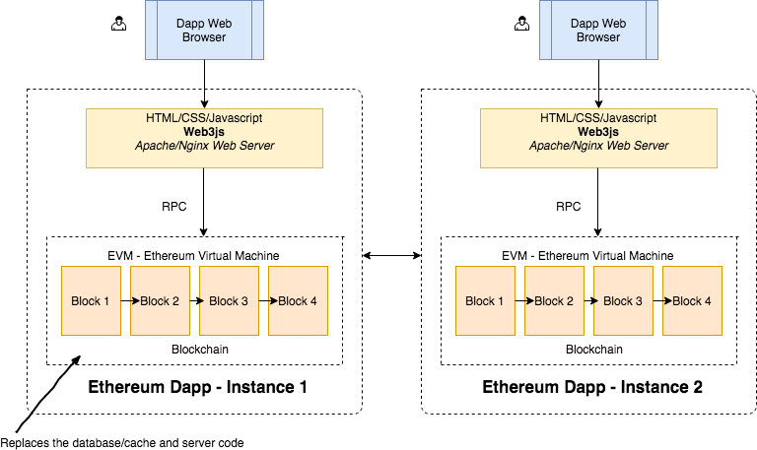

**Figure 3.1:** Architecture diagram

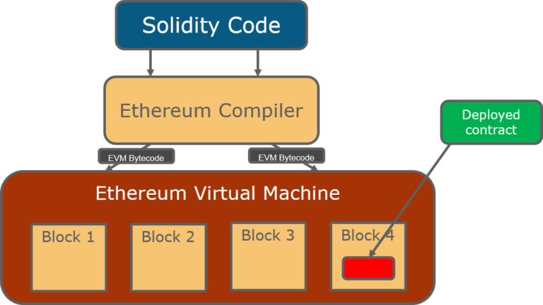

**Figure 3.2:** Architecture Diagram

Department of computer science and Engineering 11

# CHAPTER 4 DESIGN

# UML Diagrams

## Data Flow Diagram

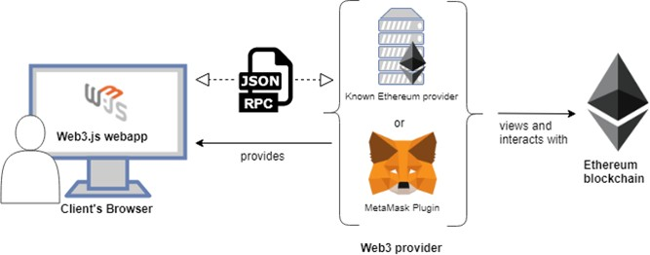

**Figure 4.1:** ProcessFlow

## Data Flow Diagram

In the above diagram we can have client , who is sending request to server by using web browser. the client is sending request in JSON format.JSON is called JavaScript object notation . in web browser the request format will be mostly JSON .and RCP which is remote procedure call make a call to the Ethereum provider or MetaMask plugin . this two plays a major roll in the data Flow process .then the request is send to ethereum blockchain

. Ethereum is the second most used crypto after btc , which handles the request. then the data is updated in the metaMask which is an external wallet use to store and manage tokens.Ethereum has smart contracts and DAPPS ( distributed applications).Ethereum network is a distributed public network which has all the account transactions are verified and stored for the future records

12

## Process Flow Diagram

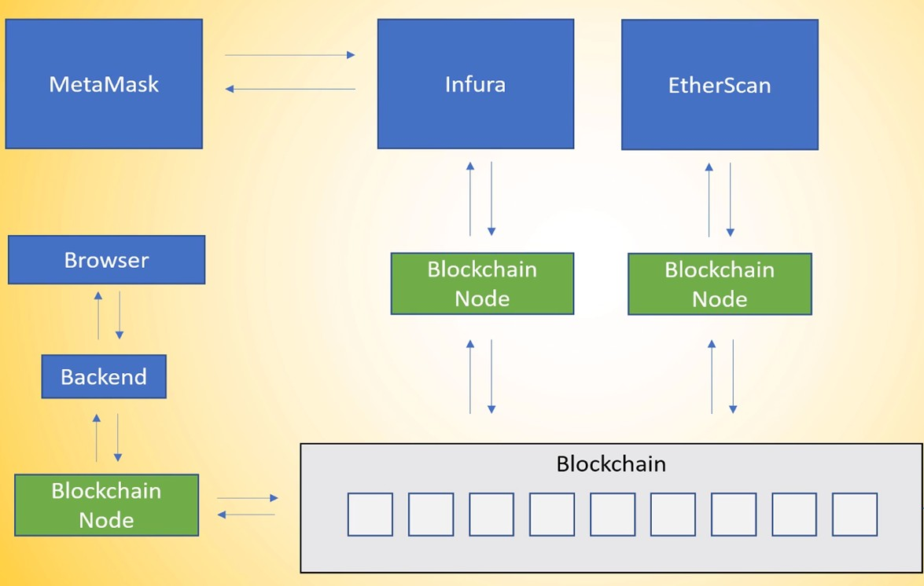

**Figure 4.2:** ProcessFlow Diagram

## Process Flow diagram

In this fig. the end Node or a user sends the request by useing web browser to the server by using infura . infura is a bridge between user and wallet. In the backend , blockchain comes into the pitcure . the user Node request is manage by the blockchain. the request is converted into the blocks as shown in the figure. now the request is sended to connected users or Nodes which are in network of an existing user . request is handled by infura and EtherScan where Infura is a bridge between the user and wallet and EtherScan is a Block Explorer and Analytics Platform for Ethereum. and then data is send back to the end Node. here the MetaMask is a external wallet use to manage the tokens which are generated by the system and which are rewarded by facult when completeing the milestones.

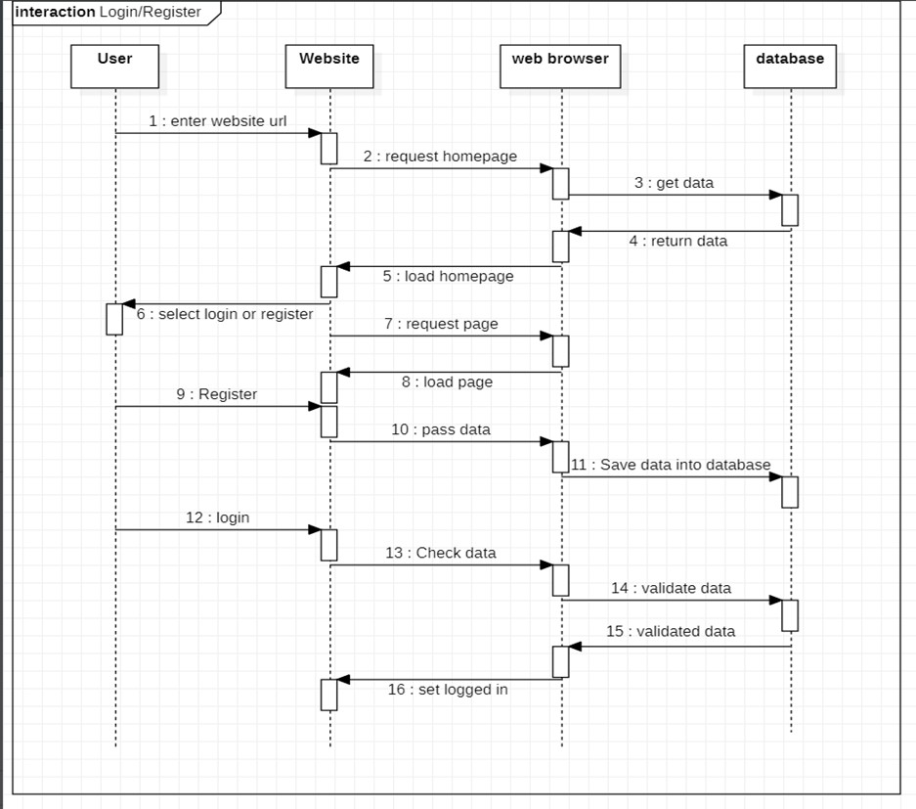

**Figure 4.3:** Sequence Diagram

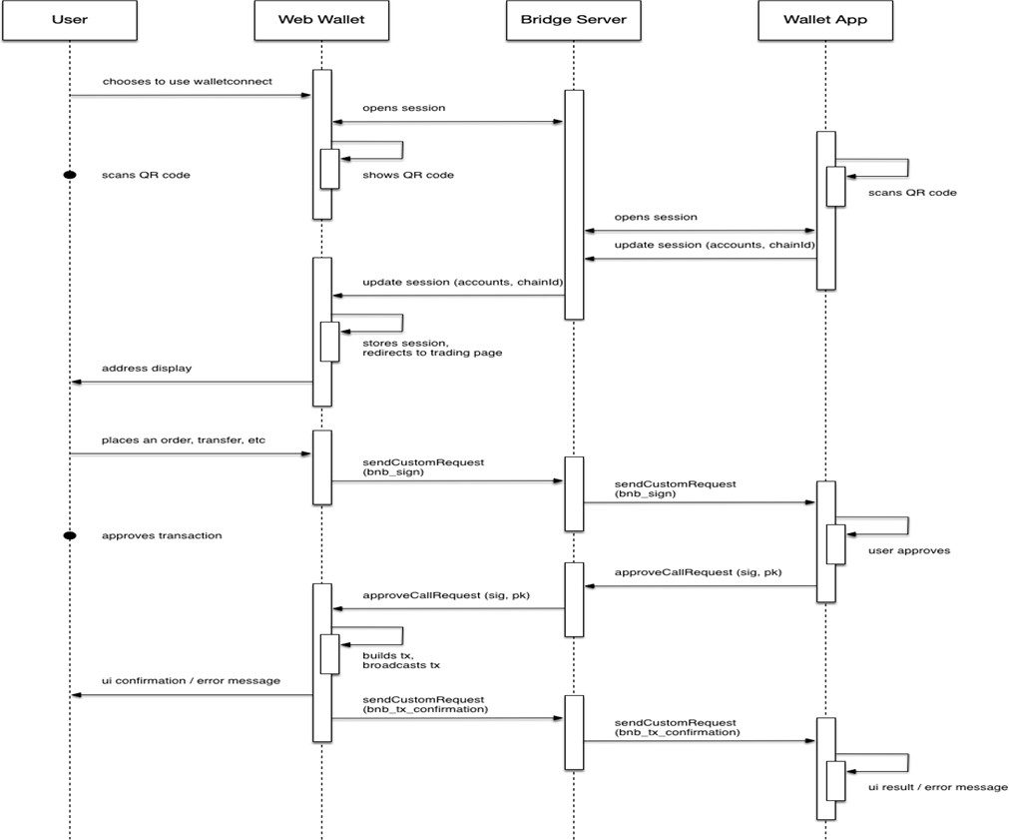

**Figure 4.4:** Sequence Diagram

# CHAPTER 5

**TESTING AND RESULTS**

* 1. **Testing Strategy**

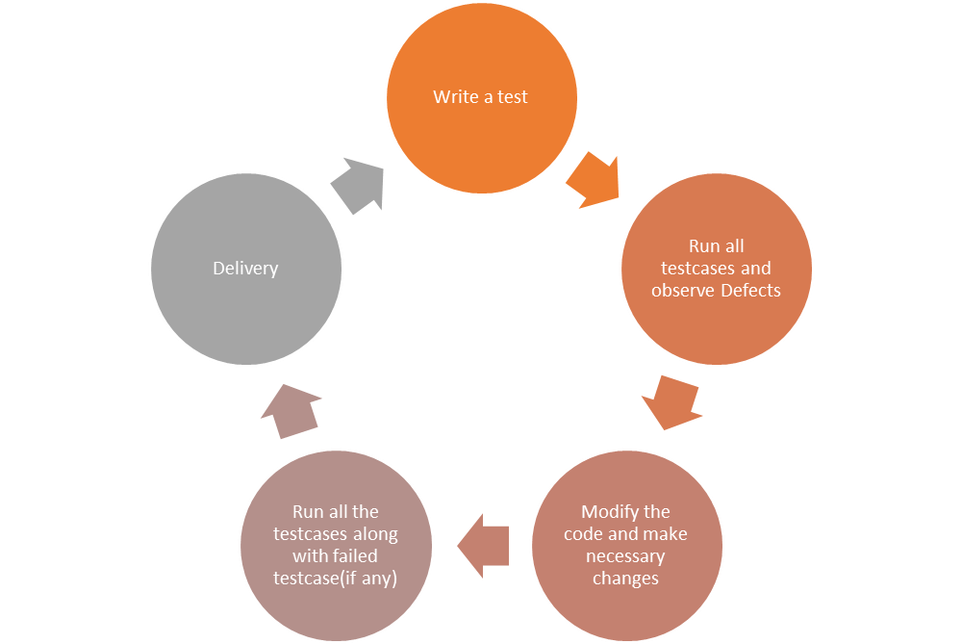

**Figure 5.1:** Testing Stategy Diagram

# Output Screens

16

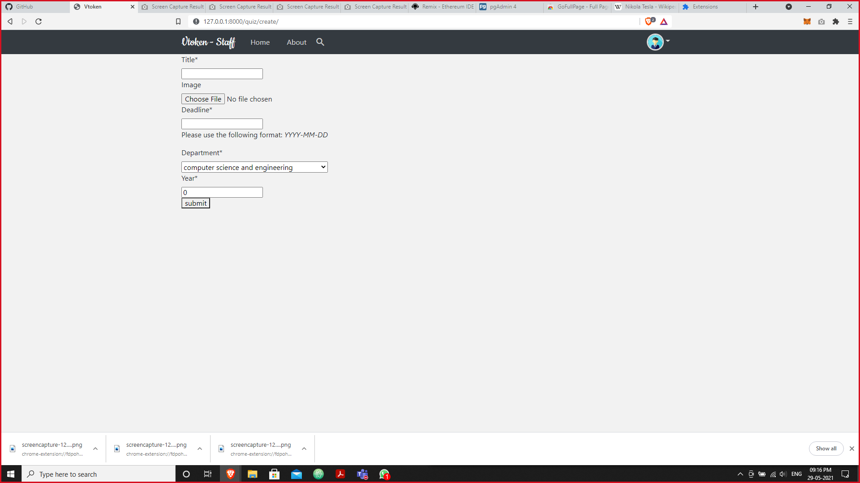

**Figure 5.2:** Stufflogin page

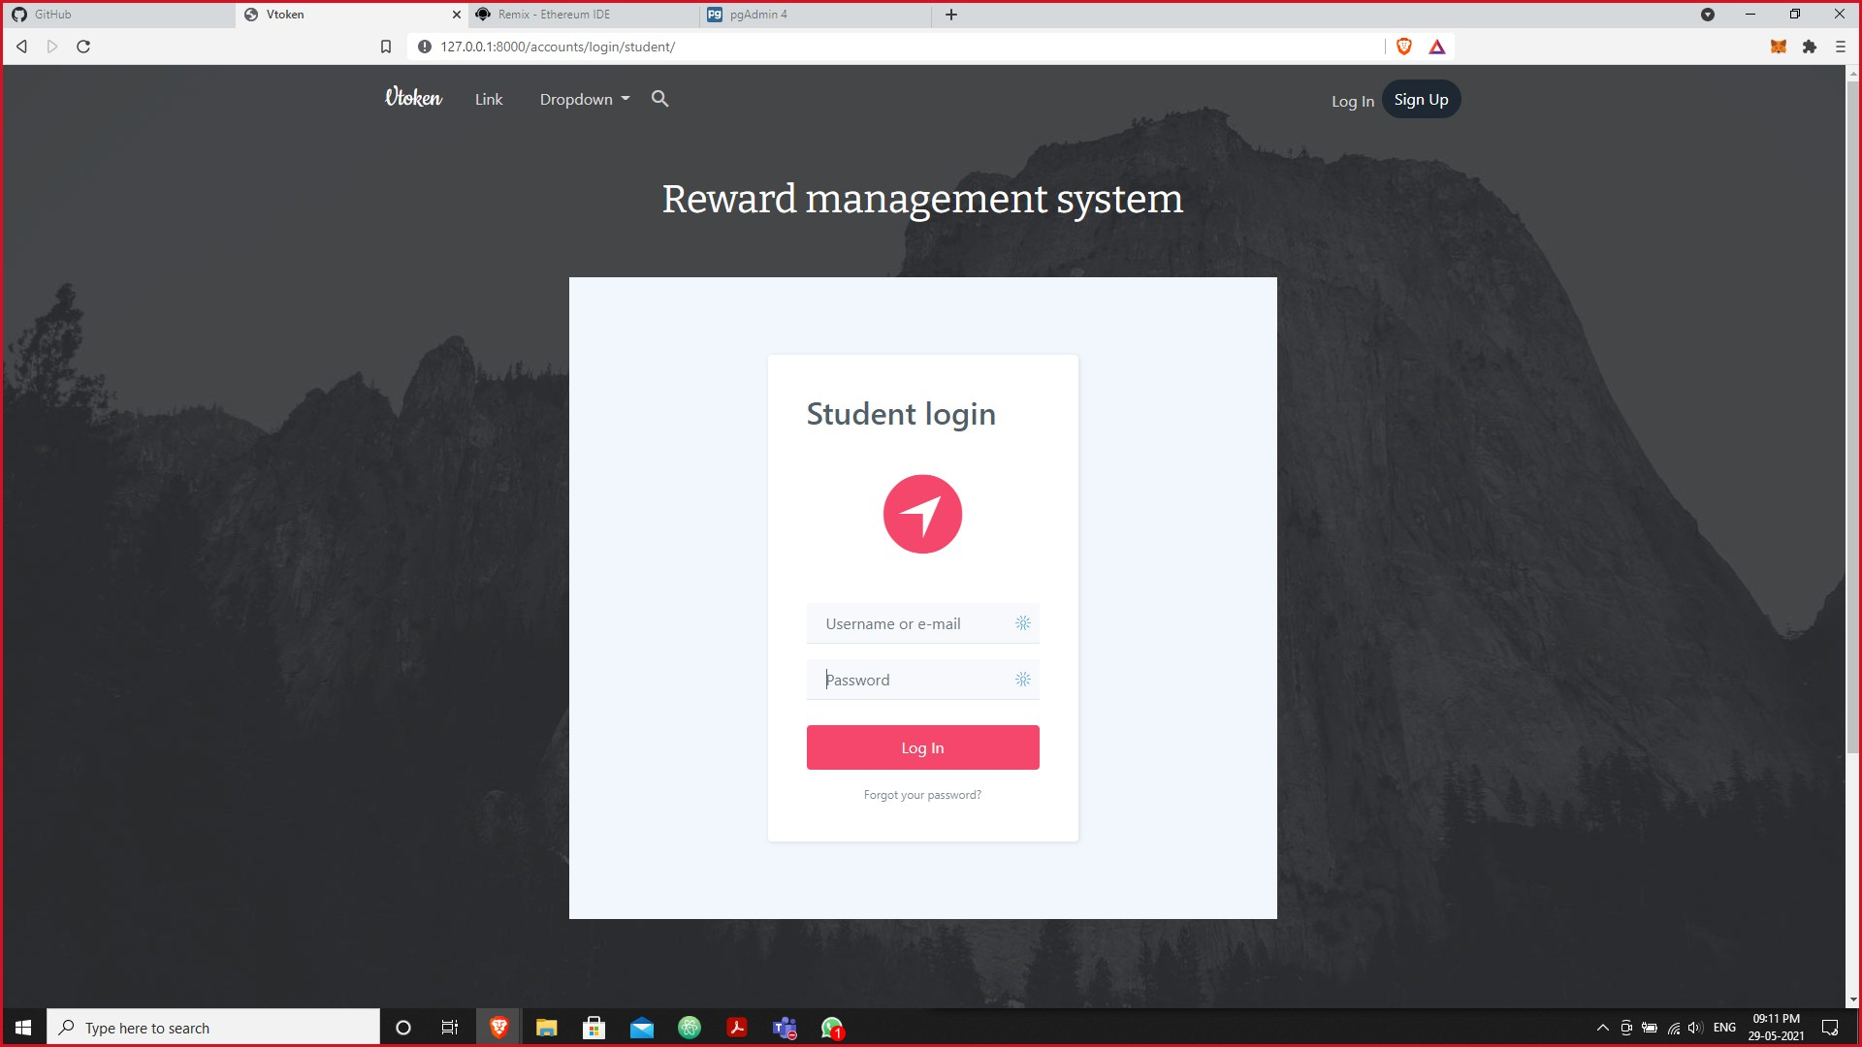

**Figure 5.3:** student login page

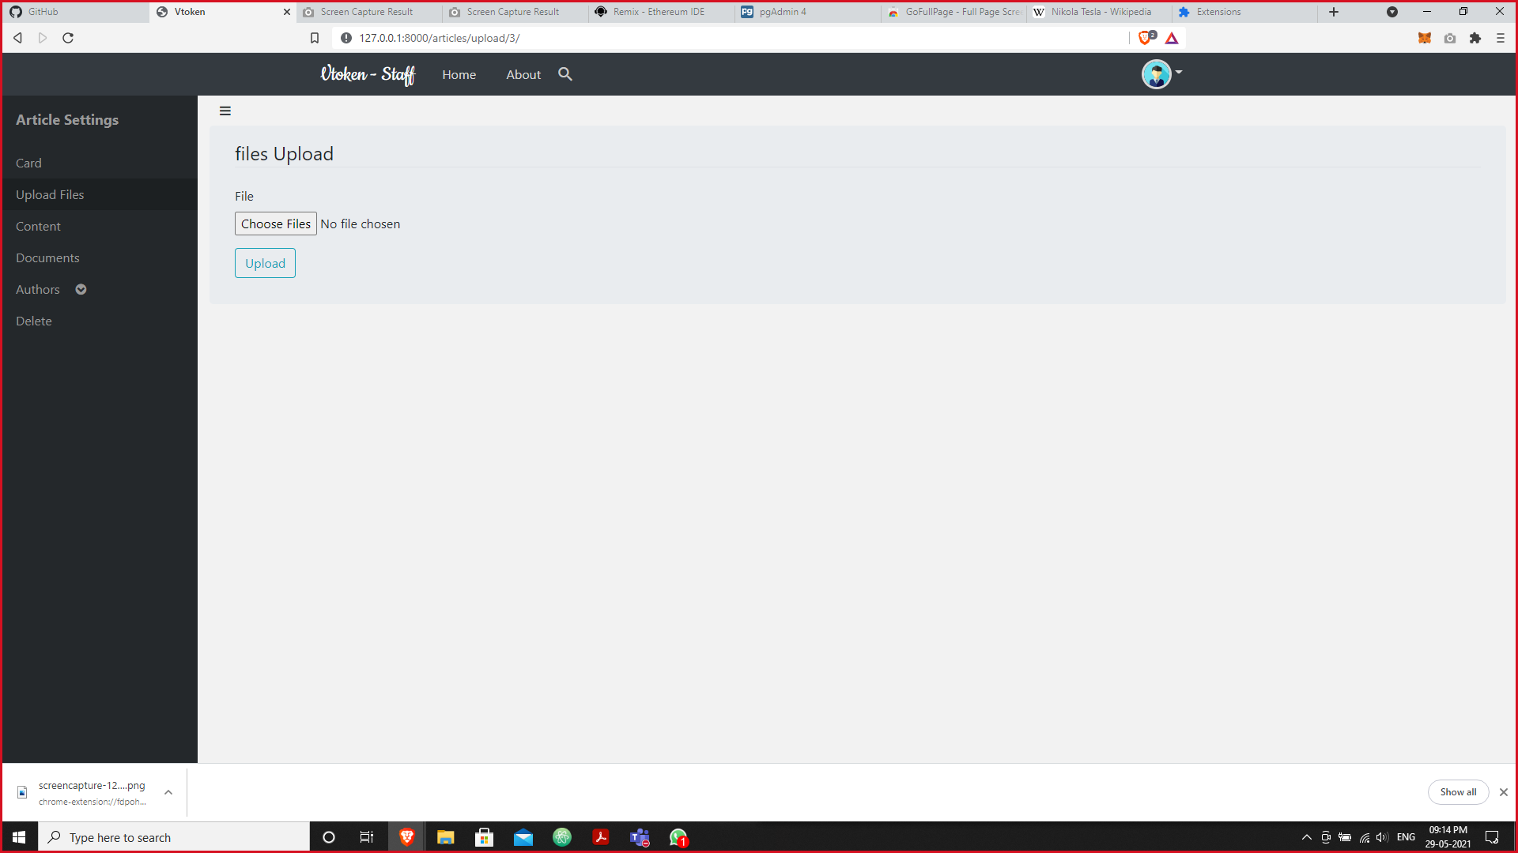

**Figure 5.4:** output screen

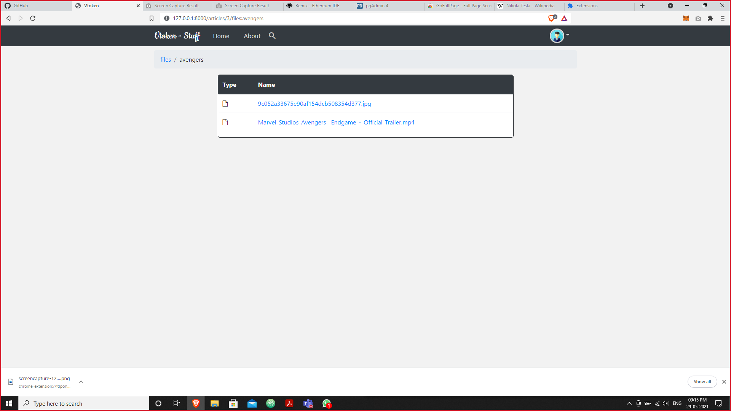

**Figure 5.5:** output screen

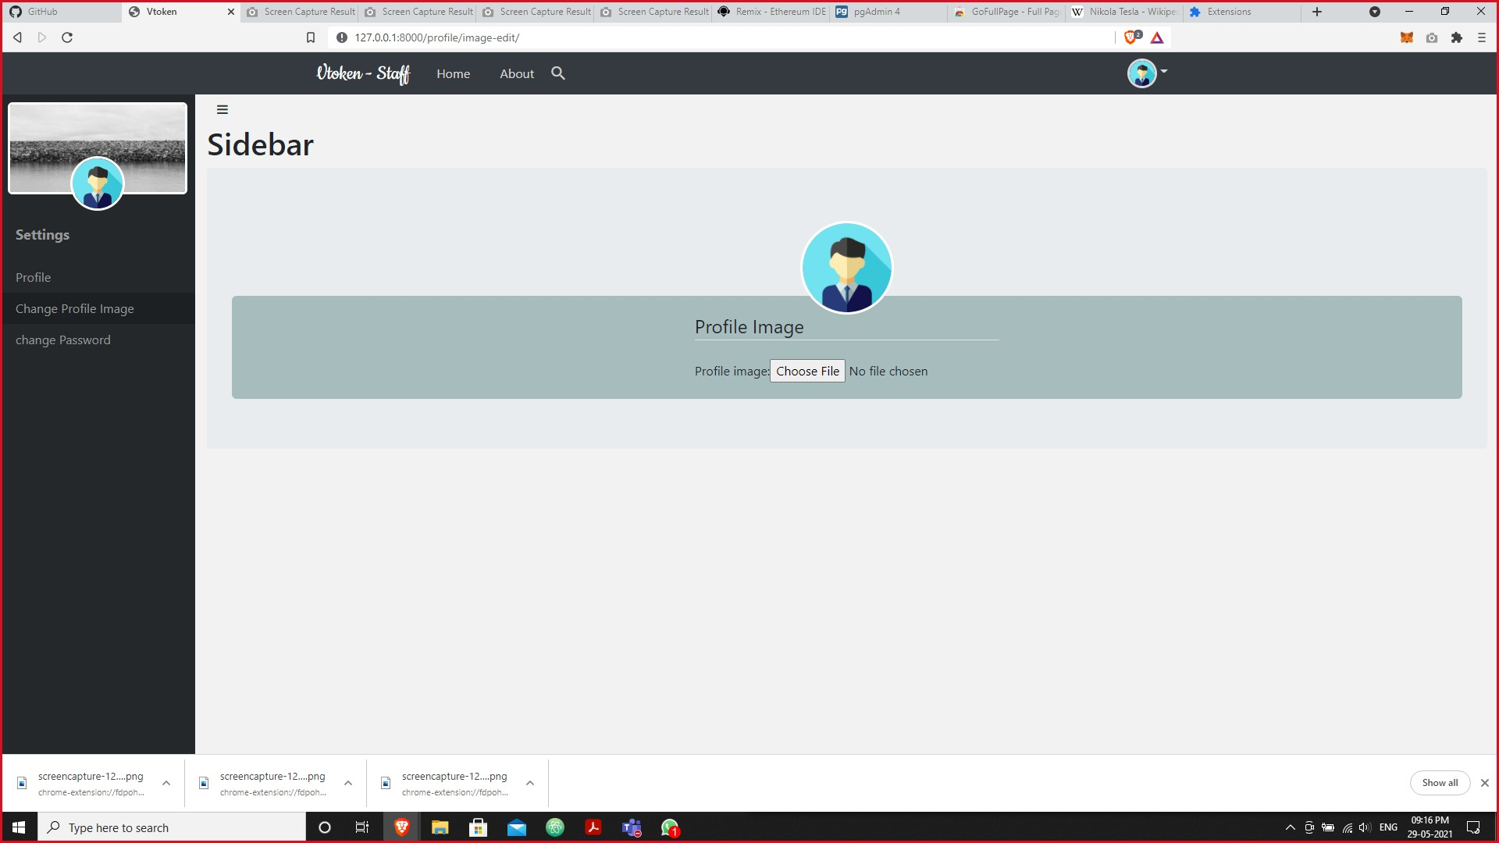

**Figure 5.6:** Output screen

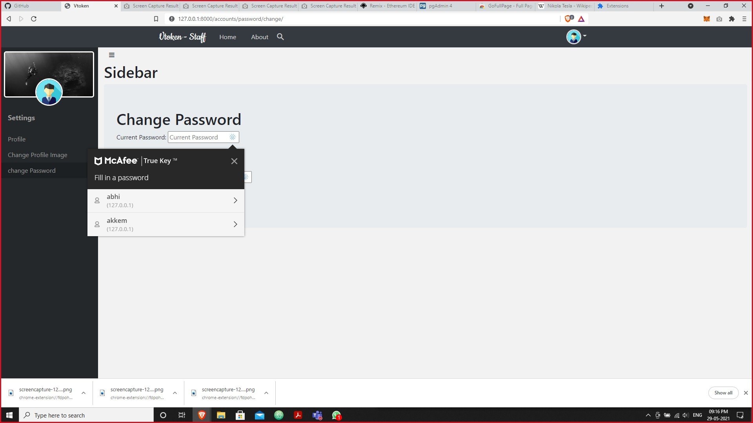

**Figure 5.7:** output screen

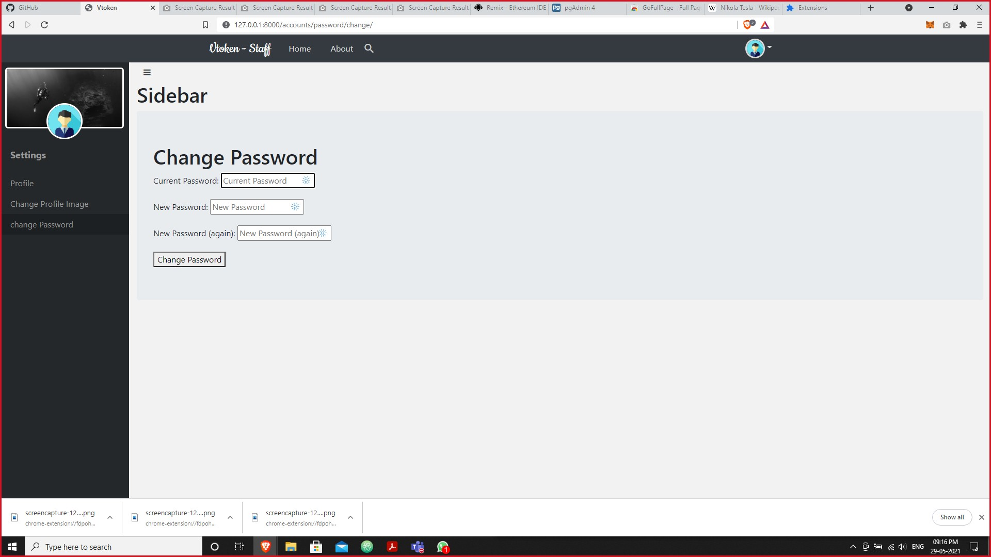

**Figure 5.8:** output screen

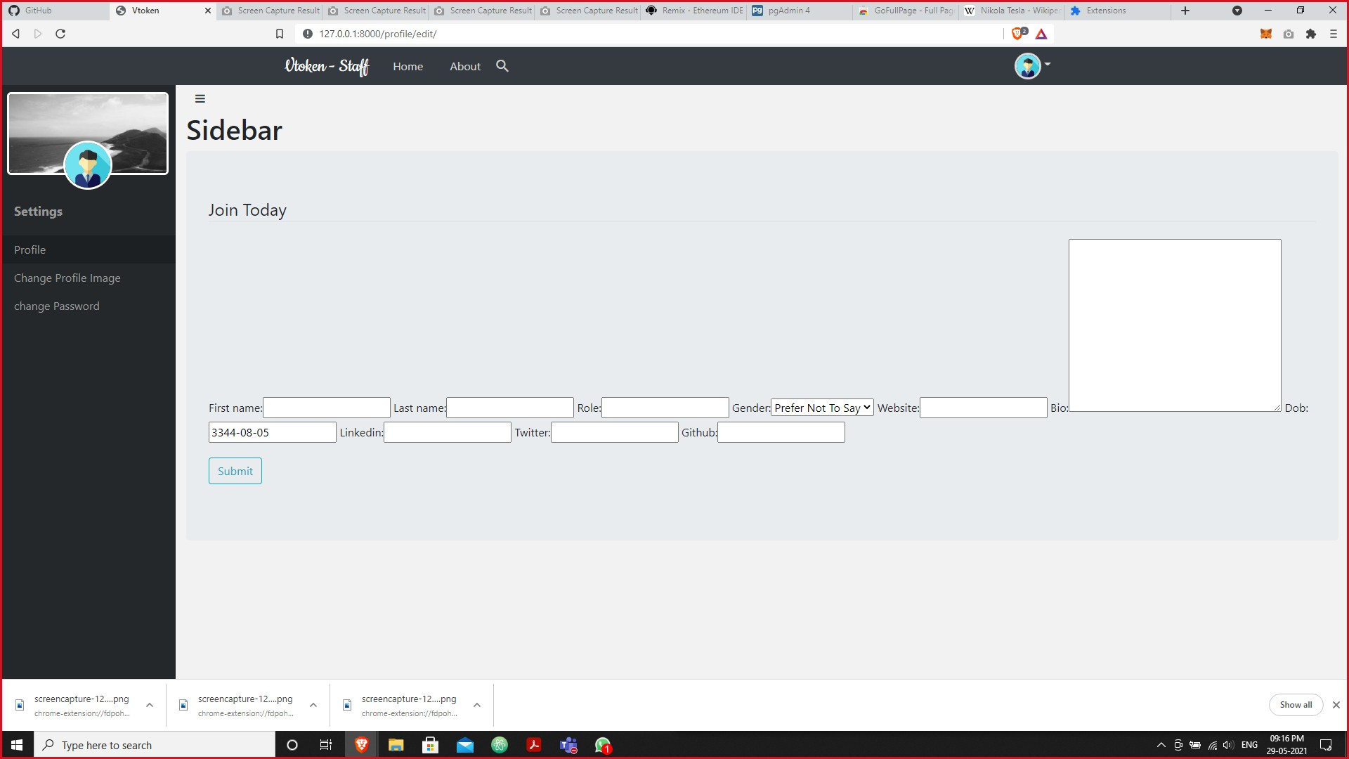

**Figure 5.9:** output screen

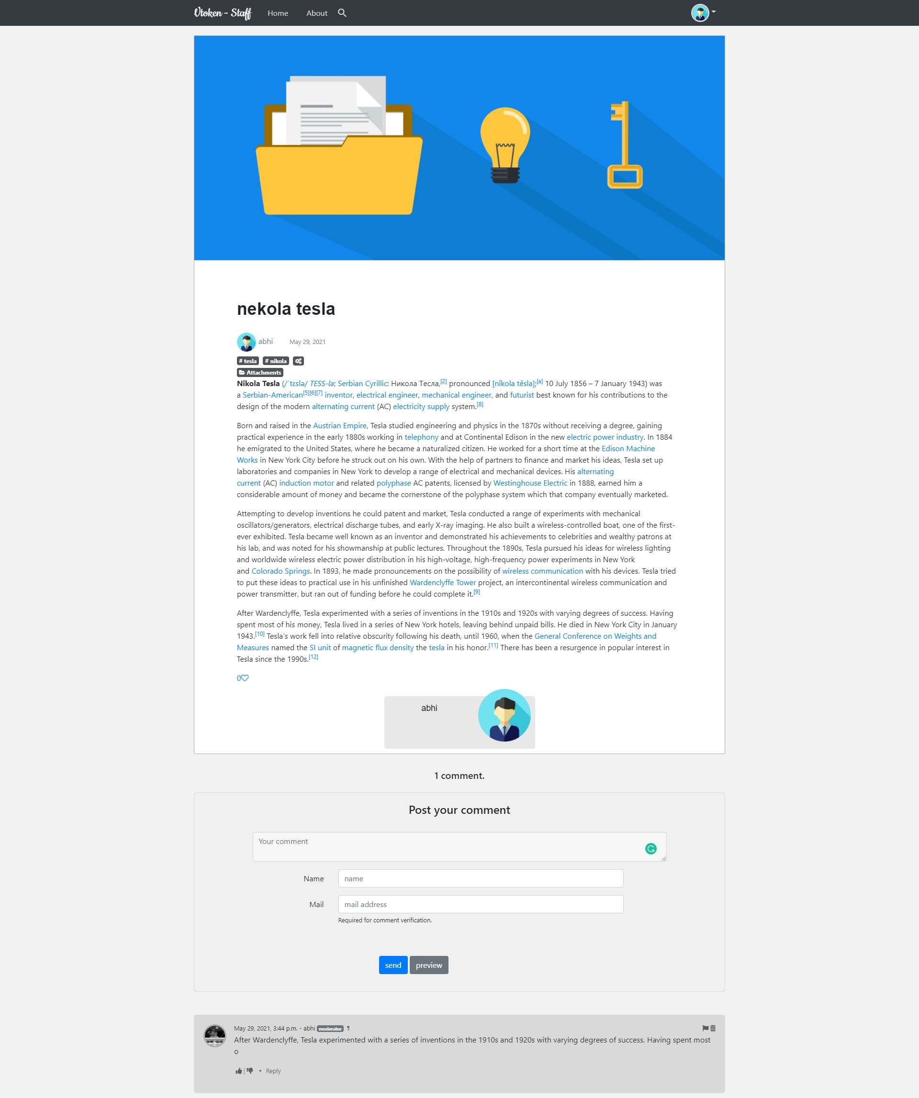

**Figure 5.10:** output screen

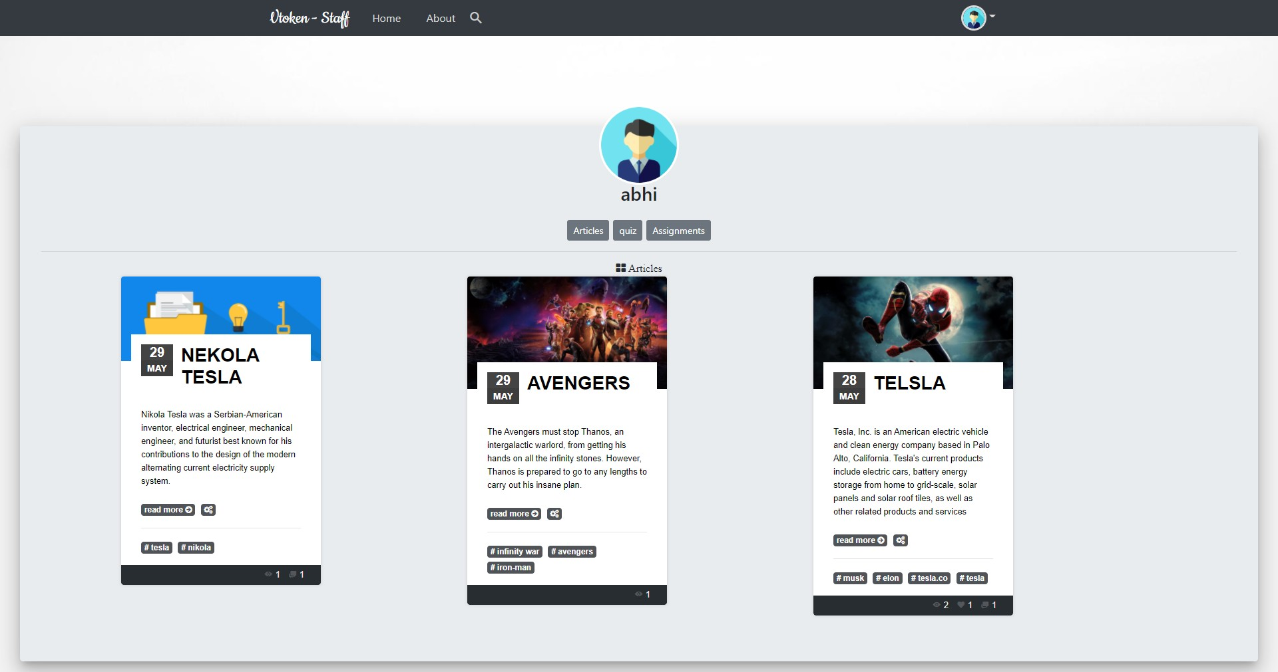

**Figure 5.11:** output screen

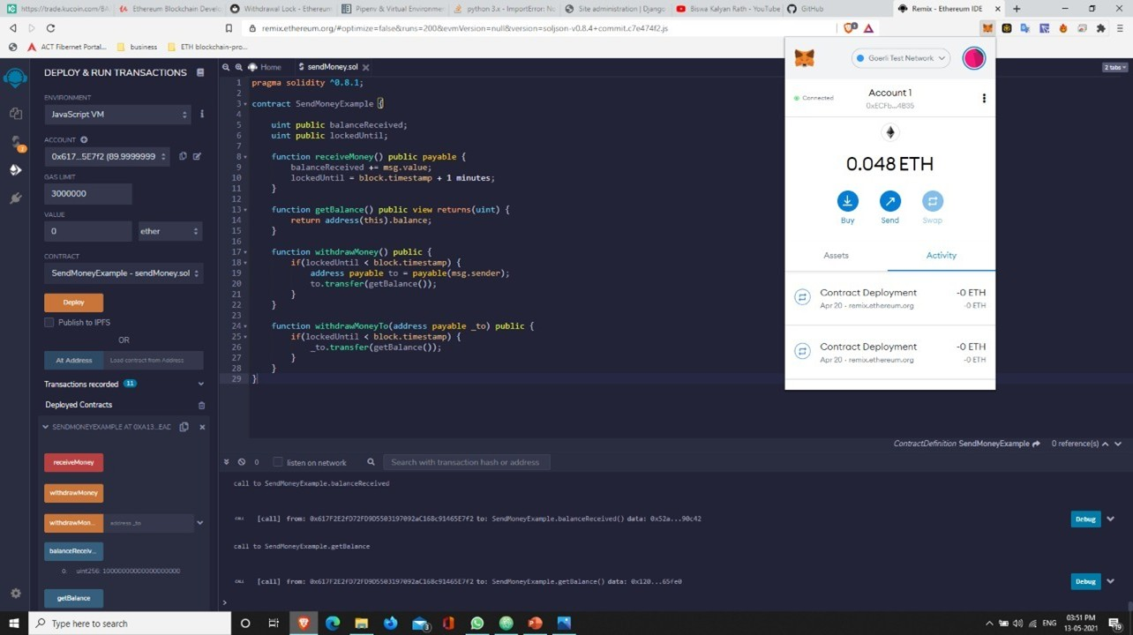

**Figure 5.12:** output screen

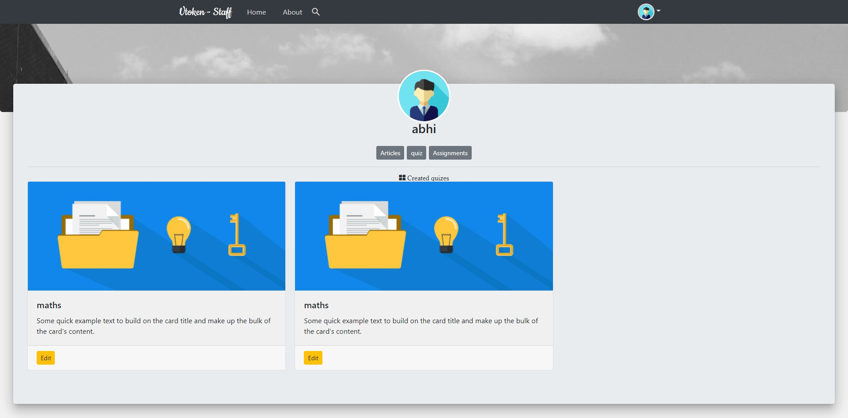

**Figure 5.13:** output screen

# CHAPTER 6

**CONCLUSION AND FUTURE SCOPE**

* 1. **Conclusion**

This application is used within the Organisation by faculty and students. Faculty defines a milestones by which tokens or rewards are awarded to the students. And that tokens can be redeemed with in the organisation like enrolling the digital course or paying dues in the library

# Future Scope

1. Can be integrated with the existing e-learning portal of the college.
2. It can be used in day to day commercial transactions.

# REFERENCES

1. Kim Sundtoft Hald and Aseem Kinra. “How the blockchain enables and constrains supply chain performance”. In: *International Journal of Physical Distribution & Logistics Management* (2019).
2. Cheman Shaik. “Securing Cryptocurrency Wallet Seed Phrase Digitally with Blind Key Encryption”. In: *International Journal on Cryptography and Information Security (IJCIS)* 10.4 (2020).
3. Andreas M Antonopoulos. *Mastering Bitcoin: unlocking digital cryptocur- rencies*. ” O’Reilly Media, Inc.”, 2014.
4. Stevo Joki´c, Aleksandar Sandro Cvetkovi´c, Saˇsa Adamovi´c, Nenad Risti´c, and Petar Spalevi´c. “Comparative analysis of cryptocurrency wallets vs traditional wallets”. In: *Ekonomika* 65.3 (2019), pp. 65–75.