DBMS | CASE STUDY REPORT
Automating Book Circulation at a University Central Library
A relational database for catalogue, copies, members, loans and fines

STUDENT | Abhinav Yadav
REGISTER NUMBER | 24BCE2968
COURSE | Database Management Systems
FACULTY | ______________________
SLOT | ________
SUBMITTED ON | October 2026

EXECUTIVE SUMMARY
The central library of a mid-sized university lends around 300 books a week to students, faculty and members of the public. The library in this case study is a composite example. Circulation is recorded in a handwritten ledger, so staff cannot tell which copies are on the shelf, which members are over their limit, or who owes fines. Late fines are worked out by hand and are often missed.
This report presents a database that replaces the ledger. Ten relations, designed from an ER model and normalised to BCNF, hold the catalogue, physical copies, members, staff, loans and fines. Five triggers enforce the lending policy: a copy must be available, members must stay within their borrowing limit, members with unpaid fines are blocked, and late fines are created automatically at Rs 10 per day. A console program and a web portal (Athenaeum, a JSON API with a single-page front end) let staff use the system, and 17 SQL queries answer the librarian's questions.
Table 1. Project at a glance
Metric | Value
Relations | 11 (incl. materialised view)
Triggers | 8
Views | 3
Indexes | 6 (incl. partial + expression)
Report queries | 22
Policy tests passed | 11 / 11see Chapter 10

TABLE OF CONTENTS
Chapter 1 Organisation and current process
Chapter 2 Pain points
Chapter 3 Proposed solution and requirements
Chapter 4 Data modelling
Chapter 5 From ER diagram to tables
Chapter 6 Normalisation
Chapter 7 Enforcing the lending policy
Chapter 8 The application
Chapter 9 SQL workload
Chapter 10 Advanced database features
Chapter 11 Validation
Chapter 12 Findings, limitations and next steps
Bibliography

CHAPTER 1 | ORGANISATION AND CURRENT PROCESS
The library holds titles in Computer Science, Databases, Mathematics, History and Fiction, with several physical copies of popular textbooks. Three kinds of member borrow books, each with a different limit:
Table 2. Member categories
Member type | Borrowing limit | Typical use
Student | 3 books | Textbooks for the semester
Faculty | 8 books | Reference and research
Public | 2 books | General reading

1.1 How a loan works today
- The member brings a book to the counter.
- A staff member writes the member name, book title and date in the ledger.
- The due date is written on a slip inside the book (14 days later).
- On return, staff search the ledger for the entry and strike it out.
- If the book is late, staff should work out a fine, but this is often forgotten.

CHAPTER 2 | PAIN POINTS
Table 3. Problems with the ledger system
# | Problem observed | Consequence
P1 | No live view of which copies are on the shelf | Members queue for books that are already out
P2 | Limits are not checked at the counter | Some students hold 5 or 6 textbooks
P3 | Fines are calculated by hand | Lost revenue, and disputes with members
P4 | A book's title and authors are rewritten on every ledger line | Spelling variations; impossible to count loans per title
P5 | No record of which staff member issued a book | No accountability for lost books

CHAPTER 3 | PROPOSED SOLUTION AND REQUIREMENTS
The proposal is a relational database at the centre of circulation, with a simple console program at the counter. The policy rules move from staff memory into the database, so they apply to every transaction.

3.1 What the system must do
Table 4. Requirements traced to pain points
Code | Requirement | Solves
R1 | Search the catalogue by title or author and show copies available | P1
R2 | Issue a copy to a member, recording the staff member and the due date | P5
R3 | Refuse a loan if the copy is out, the member is at their limit, or has unpaid fines | P2, P3
R4 | On return, free the copy and add a fine automatically if it is late | P3
R5 | Store title, publisher and authors once, and link copies to them | P4
R6 | Report overdue loans, popular titles, fines collected and outstanding | P1, P3

3.2 Assumptions
- A book is identified by its 13-digit ISBN; each physical copy has its own copy number.
- The standard loan period is 14 days and the fine is Rs 10 per day late.
- A loan generates at most one fine.

CHAPTER 4 | DATA MODELLING
The ER diagram below uses Chen notation: rectangles are entities, diamonds are relationships, ellipses are attributes (key attributes are underlined), and a double rectangle marks a weak entity.
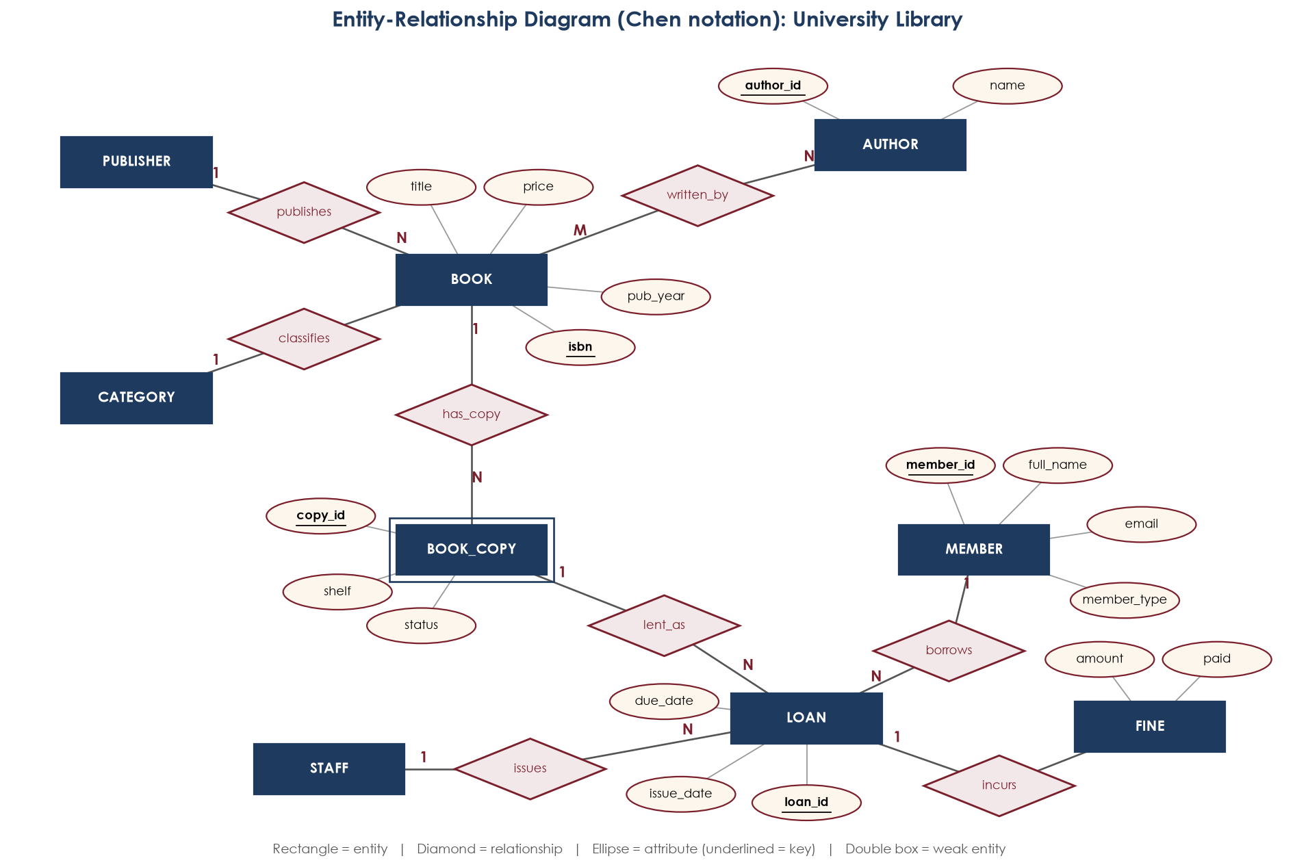
Figure 1. ER diagram of the library (Chen notation)

4.1 Entities
Table 5. Entity catalogue
Entity | Meaning | Key
BOOK | A title in the catalogue | isbn
BOOK_COPY | One physical copy on a shelf (weak, depends on BOOK) | copy_id
AUTHOR | A person who wrote one or more books | author_id
PUBLISHER | Publishing house | publisher_id
CATEGORY | Subject area | category_id
MEMBER | Someone allowed to borrow | member_id
STAFF | Library employee who issues books | staff_id
LOAN | One borrowing of one copy | loan_id
FINE | Penalty for a late loan | fine_id

4.2 Why BOOK and BOOK_COPY are separate
This was the key modelling decision. A title (ISBN 9780078022159, Database System Concepts) is one thing; the three copies on shelves DB-01 and DB-02 are three separate things. Loans are made against copies, not titles. If they were merged, the title and authors would be repeated for each copy, and it would be impossible to know which copy a member has.

CHAPTER 5 | FROM ER DIAGRAM TO TABLES
Mapping steps:
- Strong entities (BOOK, AUTHOR, PUBLISHER, CATEGORY, MEMBER, STAFF) → one table each.
- Weak entity BOOK_COPY → its own table with isbn as a foreign key to its owner.
- 1:N relationships (publishes, classifies, has_copy, borrows, issues, lent_as) → a foreign key on the N side.
- M:N relationship written_by → new table BOOK_AUTHOR(isbn, author_id) with a composite key.
- 1:0..1 relationship incurs → FINE.loan_id with a UNIQUE constraint.
The resulting tables, read from the implemented database:
Table 6. BOOK
Attribute | Type | Constraint
isbn | CHAR(13) | PK
title | VARCHAR(200) | NOT NULL
publisher_id | INTEGER | FK -> publisher(publisher_id), NOT NULL
category_id | INTEGER | FK -> category(category_id), NOT NULL
pub_year | INTEGER
price | DECIMAL(8,2) | NOT NULL

Table 7. BOOK_COPY
Attribute | Type | Constraint
copy_id | INTEGER | PK
isbn | CHAR(13) | FK -> book(isbn), NOT NULL
shelf | VARCHAR(10) | NOT NULL
status | VARCHAR(12) | NOT NULL, DEFAULT 'AVAILABLE'

Table 8. BOOK_AUTHOR
Attribute | Type | Constraint
isbn | CHAR(13) | PK, FK -> book(isbn)
author_id | INTEGER | PK, FK -> author(author_id)
author_order | INTEGER | NOT NULL, DEFAULT 1

Table 9. AUTHOR
Attribute | Type | Constraint
author_id | INTEGER | PK
first_name | VARCHAR(50) | NOT NULL
last_name | VARCHAR(50) | NOT NULL
nationality | VARCHAR(50)

Table 10. PUBLISHER
Attribute | Type | Constraint
publisher_id | INTEGER | PK
name | VARCHAR(100) | NOT NULL
city | VARCHAR(60)
phone | VARCHAR(20)

Table 11. CATEGORY
Attribute | Type | Constraint
category_id | INTEGER | PK
name | VARCHAR(60) | NOT NULL

Table 12. MEMBER
Attribute | Type | Constraint
member_id | INTEGER | PK
full_name | VARCHAR(100) | NOT NULL
email | VARCHAR(100) | NOT NULL
phone | VARCHAR(20)
member_type | VARCHAR(10) | NOT NULL
join_date | DATE | NOT NULL, DEFAULT DATE('now')
max_books | INTEGER | NOT NULL, DEFAULT 3

Table 13. STAFF
Attribute | Type | Constraint
staff_id | INTEGER | PK
full_name | VARCHAR(100) | NOT NULL
role | VARCHAR(30) | NOT NULL

Table 14. LOAN
Attribute | Type | Constraint
loan_id | INTEGER | PK
copy_id | INTEGER | FK -> book_copy(copy_id), NOT NULL
member_id | INTEGER | FK -> member(member_id), NOT NULL
staff_id | INTEGER | FK -> staff(staff_id), NOT NULL
issue_date | DATE | NOT NULL, DEFAULT DATE('now')
due_date | DATE | NOT NULL
return_date | DATE

Table 15. FINE
Attribute | Type | Constraint
fine_id | INTEGER | PK
loan_id | INTEGER | FK -> loan(loan_id), NOT NULL
amount | DECIMAL(8,2) | NOT NULL
paid | INTEGER | NOT NULL, DEFAULT 0

CHAPTER 6 | NORMALISATION
A single ledger line is effectively this relation:
LEDGER(member_id, member_name, email, isbn, title, authors, publisher, publisher_city,
category, copy_id, shelf, issue_date, due_date, return_date, fine)

Table 16. Normalisation walk-through
Step | Problem found | Action taken
1NF | 'authors' holds a list (e.g. Silberschatz, Korth, Sudarshan) | One row per author, giving BOOK_AUTHOR
2NF | In BOOK_AUTHOR(isbn, author_id, title...), title depends on isbn only (partial dependency) | Move title, price and year to BOOK
3NF | isbn → publisher → publisher_city (transitive dependency) | PUBLISHER table; same for CATEGORY
3NF | copy_id → isbn → title (transitive) | BOOK_COPY keeps only isbn, shelf, status
3NF | loan → member_id → member_name, email | MEMBER table; LOAN keeps only member_id
BCNF | member: email → all attributes | email is a candidate key (UNIQUE), so BCNF still holds

Final functional dependencies, each with a key on the left:
isbn -> title, publisher_id, category_id, pub_year, price
copy_id -> isbn, shelf, status
member_id -> full_name, email, phone, member_type, join_date, max_books
email -> member_id (candidate key)
loan_id -> copy_id, member_id, staff_id, issue_date, due_date, return_date
loan_id -> fine_id, amount, paid (via UNIQUE fine.loan_id)

CHAPTER 7 | ENFORCING THE LENDING POLICY
CHECK constraints cover rules that involve a single row: price ≥ 0, due_date > issue_date, member_type IN ('STUDENT','FACULTY','PUBLIC'), and the four allowed copy statuses. Rules that need other tables are written as triggers:
Table 17. Lending-policy triggers
Trigger | When | Rule
trg_loan_check_copy | BEFORE INSERT on loan | Copy status must be AVAILABLE
trg_loan_check_limit | BEFORE INSERT on loan | Open loans must be below member.max_books
trg_loan_check_fines | BEFORE INSERT on loan | Member must have no unpaid fine
trg_loan_issue | AFTER INSERT on loan | Set copy status to ON_LOAN
trg_loan_return | AFTER UPDATE of return_date | Set copy AVAILABLE; insert fine if late

The return trigger is the most interesting one. It works out the fine with date arithmetic and inserts it only when the book is late:
CREATE TRIGGER trg_loan_return
AFTER UPDATE OF return_date ON loan
WHEN OLD.return_date IS NULL AND NEW.return_date IS NOT NULL
BEGIN
UPDATE book_copy SET status = 'AVAILABLE' WHERE copy_id = NEW.copy_id;
INSERT INTO fine (loan_id, amount)
SELECT NEW.loan_id, (JULIANDAY(NEW.return_date) - JULIANDAY(NEW.due_date)) * 10
WHERE JULIANDAY(NEW.return_date) > JULIANDAY(NEW.due_date);
END;

7.1 Views
- v_book_availability: total and available copies per title.
- v_overdue_loans: open loans past their due date, with days overdue.
- v_member_summary: loans, active loans and unpaid fines per member.

CHAPTER 8 | THE APPLICATION
Staff use a menu-driven console program (library.py) written in Python with the built-in sqlite3 module. Each menu option maps to one or more SQL statements. Issuing a book is wrapped in a transaction: if any trigger raises an error, nothing is saved, and the message is shown to the operator.
Table 18. Menu options
Option | What it does | SQL feature used
1 Search books | Keyword search on title/author | LEFT JOIN, LIKE, GROUP_CONCAT
2 Book availability | Copies on shelf per title | View v_book_availability
3 Add member | Register a member | INSERT, UNIQUE email
4 Issue a book | Lend first free copy | INSERT + 3 BEFORE triggers
5 Return a book | Close a loan | UPDATE + AFTER trigger
6 Show open loans | All unreturned loans | CASE for OVERDUE/OK
7 Pay fines | Mark fines paid | UPDATE in a transaction
8 Member summary | Per-member statistics | View v_member_summary
9 Run all report queries | Prints the 17 queries | Runs sql/03_queries.sql

8.1 Web portal: Athenaeum
For the front office and for members, a second interface was built as a web portal (portal.py + portal.html). Unlike the console program, it is split into two tiers: the Python server exposes a small JSON API (/api/books, /api/loans, /api/members, /api/issue, /api/return, /api/pay), and the page itself is a single-page application that calls the API with fetch(). Both interfaces share the same library.db, so the triggers in Chapter 7 protect the portal exactly as they protect the console.
Table 19. Portal screens
Screen | What it shows | Endpoint / SQL
Overview | Counts, fines due, most-borrowed titles, books out | /api/stats: aggregates + view v_overdue_loans
Catalogue | Book cards coloured by subject, live search, copies on shelf | /api/books: 5-table join + HAVING ... LIKE
Circulation Desk | Issue a title, return open loans | POST /api/issue, /api/return (one transaction each)
Members | Register; click a member for full loan and fine history | /api/member: loan LEFT JOIN fine

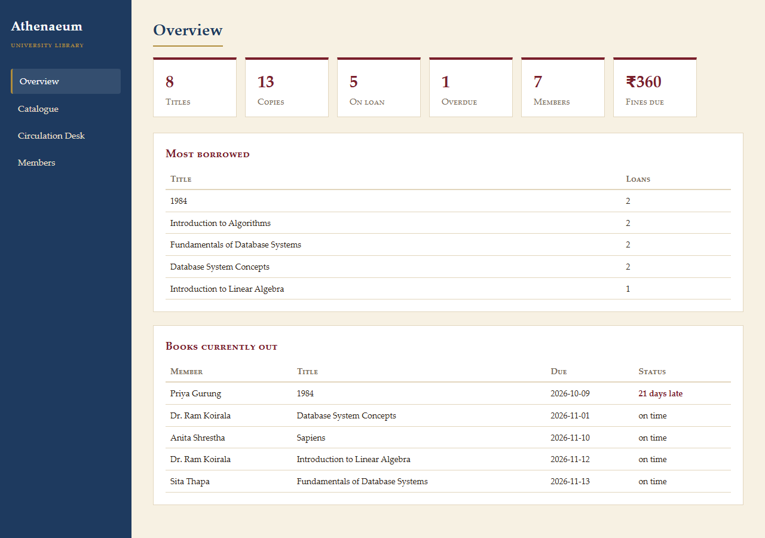
Figure 2. Portal overview
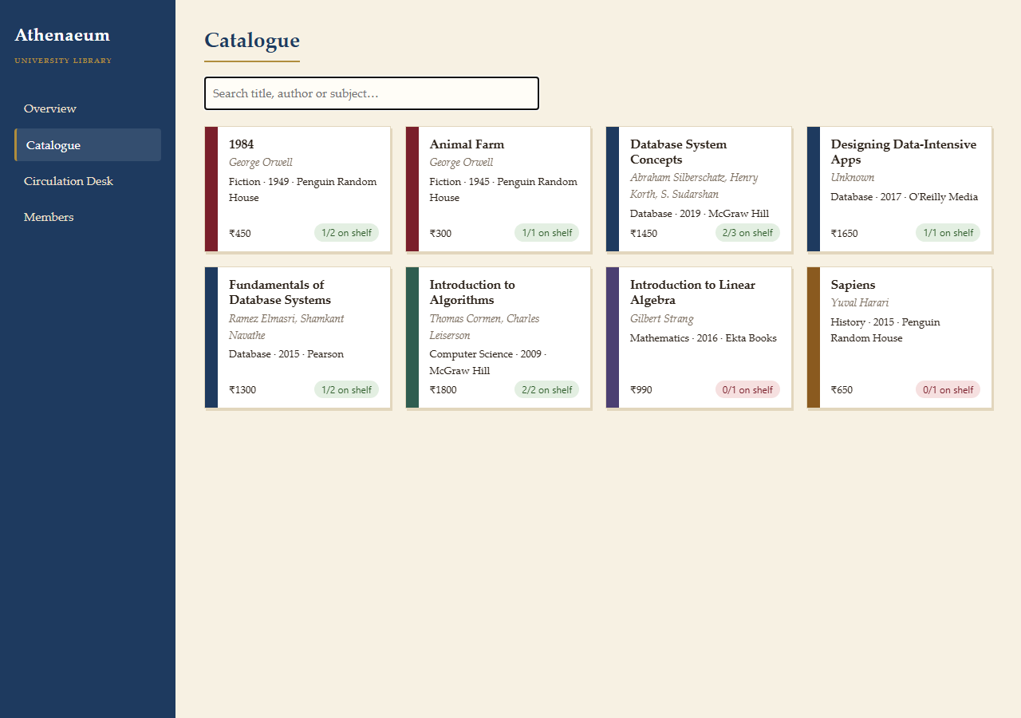
Figure 3. Catalogue: each card's spine colour is the book's category
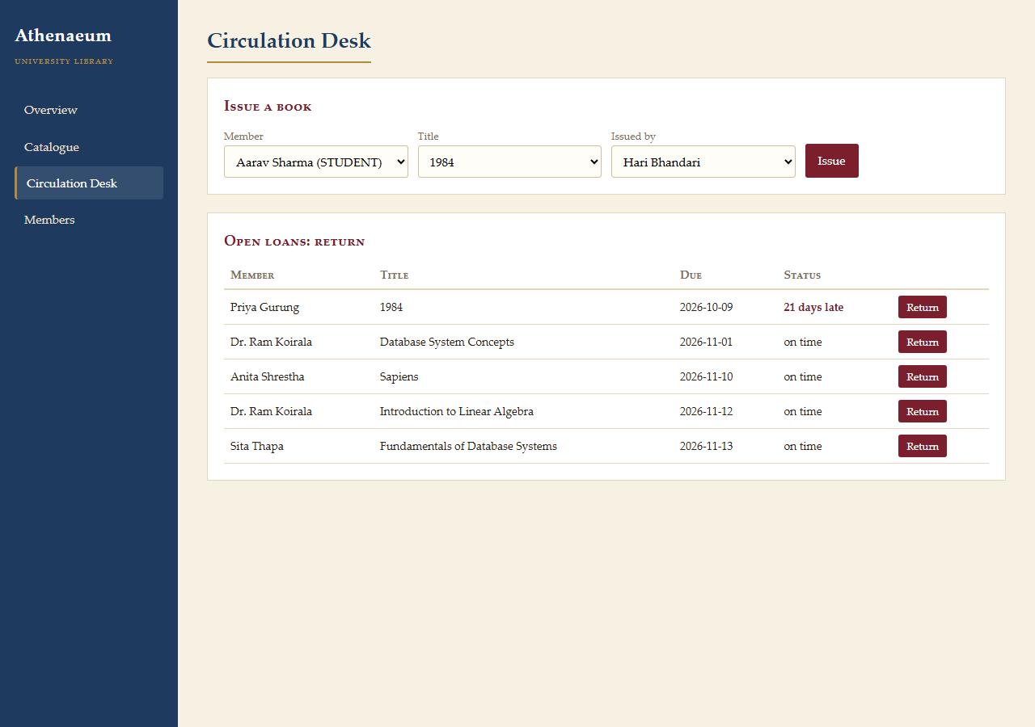
Figure 4. Circulation desk: refusals from triggers appear as messages

8.2 Console program screens
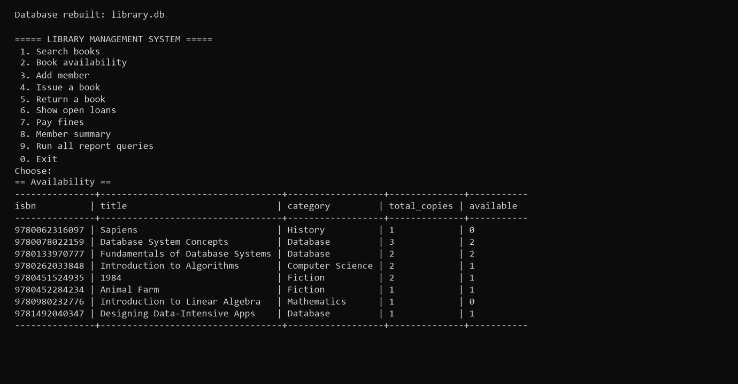
Figure 5. Main menu and the book availability report
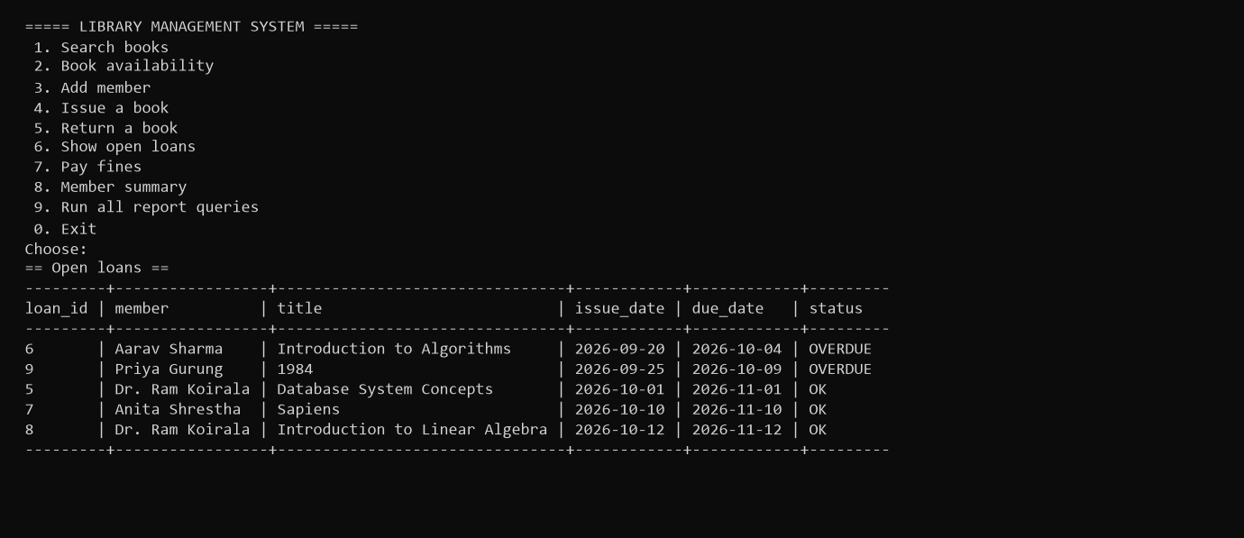
Figure 6. Open loans with overdue status

CHAPTER 9 | SQL WORKLOAD
The librarian's questions were translated into queries. Each is shown with its result on the sample data (8 titles, 13 copies, 7 members, 9 loans).

9.1 Which books, with all their authors?
Inner join across four tables, with GROUP_CONCAT to list co-authors.
SELECT b.title, GROUP_CONCAT(a.first_name || ' ' || a.last_name, ', ') AS authors,
p.name AS publisher
FROM book b
JOIN book_author ba ON ba.isbn = b.isbn
JOIN author a ON a.author_id = ba.author_id
JOIN publisher p ON p.publisher_id = b.publisher_id
GROUP BY b.isbn ORDER BY b.title;

Table 20. Result 1
title | authors | publisher
1984 | George Orwell | Penguin Random House
Animal Farm | George Orwell | Penguin Random House
Database System Concepts | Abraham Silberschatz, Henry Korth, S. Sudarshan | McGraw Hill
Fundamentals of Database Systems | Ramez Elmasri, Shamkant Navathe | Pearson
Introduction to Algorithms | Thomas Cormen, Charles Leiserson | McGraw Hill
Introduction to Linear Algebra | Gilbert Strang | Ekta Books
Sapiens | Yuval Harari | Penguin Random House

9.2 Which titles have no author on record?
LEFT OUTER JOIN keeps unmatched books; IS NULL picks them out.
SELECT b.isbn, b.title FROM book b
LEFT JOIN book_author ba ON ba.isbn = b.isbn
WHERE ba.author_id IS NULL;

Table 21. Result 2
isbn | title
9781492040347 | Designing Data-Intensive Apps

9.3 Which categories own more than two copies?
GROUP BY with a HAVING filter on the aggregate.
SELECT c.name AS category, COUNT(bc.copy_id) AS copies
FROM category c JOIN book b ON b.category_id = c.category_id
JOIN book_copy bc ON bc.isbn = b.isbn
GROUP BY c.name HAVING COUNT(bc.copy_id) > 2;

Table 22. Result 3
category | copies
Database | 6
Fiction | 3

9.4 Most expensive book in each category
Correlated sub-query: the inner query is re-evaluated for each outer row.
SELECT c.name AS category, b.title, b.price
FROM book b JOIN category c ON c.category_id = b.category_id
WHERE b.price = (SELECT MAX(b2.price) FROM book b2 WHERE b2.category_id = b.category_id);

Table 23. Result 4
category | title | price
Computer Science | Introduction to Algorithms | 1800
Fiction | 1984 | 450
History | Sapiens | 650
Mathematics | Introduction to Linear Algebra | 990
Database | Designing Data-Intensive Apps | 1650

9.5 Members who have never borrowed
NOT EXISTS anti-join.
SELECT m.member_id, m.full_name FROM member m
WHERE NOT EXISTS (SELECT 1 FROM loan l WHERE l.member_id = m.member_id);

Table 24. Result 5
member_id | full_name
7 | Kiran Magar

9.6 Titles that have never been borrowed
Set difference with EXCEPT.
SELECT b.isbn, b.title FROM book b
EXCEPT
SELECT b.isbn, b.title FROM book b
JOIN book_copy bc ON bc.isbn = b.isbn JOIN loan l ON l.copy_id = bc.copy_id;

Table 25. Result 6
isbn | title
9780452284234 | Animal Farm
9781492040347 | Designing Data-Intensive Apps

9.7 Which loans are overdue right now?
Query on a view.
SELECT member, title, due_date, days_overdue FROM v_overdue_loans ORDER BY days_overdue DESC;

Table 26. Result 7
member | title | due_date | days_overdue
Aarav Sharma | Introduction to Algorithms | 2026-10-04 | 26
Priya Gurung | 1984 | 2026-10-09 | 21

9.8 Member status
View plus CASE to label each member.
SELECT full_name, active_loans, unpaid_fines,
CASE WHEN unpaid_fines > 0 THEN 'BLOCKED'
WHEN active_loans = 0 THEN 'IDLE' ELSE 'ACTIVE' END AS status
FROM v_member_summary;

Table 27. Result 8
full_name | active_loans | unpaid_fines | status
Aarav Sharma | 1 | 0 | ACTIVE
Sita Thapa | 0 | 0 | IDLE
Dr. Ram Koirala | 2 | 0 | ACTIVE
Priya Gurung | 1 | 0 | ACTIVE
Bikash Rai | 0 | 100 | BLOCKED
Anita Shrestha | 1 | 0 | ACTIVE
Kiran Magar | 1 | 0 | ACTIVE

9.9 How much has been collected in fines?
Conditional aggregation.
SELECT SUM(CASE WHEN paid = 1 THEN amount ELSE 0 END) AS collected,
SUM(CASE WHEN paid = 0 THEN amount ELSE 0 END) AS outstanding
FROM fine;

Table 28. Result 9
collected | outstanding
60 | 100

CHAPTER 10 | ADVANCED DATABASE FEATURES
Four more advanced techniques were added. Each one solves a specific library need rather than being there just for show.

10.1 Incrementally maintained materialised view
The librarian checks 'most borrowed' many times a day. A normal view re-runs COUNT(*) over every loan each time it is read. BOOK_STATS stores the result instead and is kept current by three triggers: one creates a stats row when a book is catalogued, one adds 1 to times_borrowed on every loan, and one adds late days on a late return. Reads become a primary-key lookup, at the cost of a little extra work on each write. This is the classic read/write trade-off behind materialised views in Oracle and PostgreSQL.
CREATE TRIGGER trg_stats_loan AFTER INSERT ON loan
BEGIN
UPDATE book_stats
SET times_borrowed = times_borrowed + 1,
last_borrowed = MAX(COALESCE(last_borrowed, ''), NEW.issue_date)
WHERE isbn = (SELECT isbn FROM book_copy WHERE copy_id = NEW.copy_id);
END;

Table 29. BOOK_STATS contents
title | times_borrowed | last_borrowed | total_late_days
1984 | 2 | 2026-09-25 | 6
Database System Concepts | 2 | 2026-10-01 | 0
Introduction to Algorithms | 2 | 2026-09-20 | 0
Fundamentals of Database Systems | 1 | 2026-09-01 | 10
Introduction to Linear Algebra | 1 | 2026-10-12 | 0
Sapiens | 1 | 2026-10-10 | 0
Animal Farm | 0 |  | 0
Designing Data-Intensive Apps | 0 |  | 0

To prove the stored figures are correct, the view is compared with a live aggregate using set difference. An empty result means they match exactly:
SELECT isbn, times_borrowed FROM book_stats
EXCEPT
SELECT b.isbn, COUNT(l.loan_id) FROM book b
LEFT JOIN book_copy bc ON bc.isbn = b.isbn LEFT JOIN loan l ON l.copy_id = bc.copy_id
GROUP BY b.isbn;

Result: Rows returned: 0 (consistent).

10.2 Recommendations by self-join ('readers also borrowed')
LOAN is joined to itself on member_id to find pairs of loans by the same reader. Grouping by the second book and counting distinct readers gives a simple co-occurrence recommender, the idea behind 'customers also bought', written in plain SQL.
SELECT b2.title AS also_borrowed, COUNT(DISTINCT l1.member_id) AS shared_readers
FROM loan l1
JOIN book_copy c1 ON c1.copy_id = l1.copy_id
JOIN loan l2 ON l2.member_id = l1.member_id AND l2.loan_id <> l1.loan_id
JOIN book_copy c2 ON c2.copy_id = l2.copy_id
JOIN book b2 ON b2.isbn = c2.isbn
WHERE c1.isbn = '9780078022159' AND c2.isbn <> c1.isbn
GROUP BY b2.isbn ORDER BY shared_readers DESC;

Table 30. Readers of 'Database System Concepts' also borrowed
also_borrowed | shared_readers
Introduction to Algorithms | 2
Introduction to Linear Algebra | 1

10.3 Temporal (point-in-time) query
Because each loan stores both issue_date and return_date, the LOAN table is a valid-time table: each row records the period during which a copy was out. That means the database can answer 'what did the shelf look like on any past day' with one predicate, a period-containment test:
SELECT b.title, m.full_name AS borrower, l.issue_date, COALESCE(l.return_date, 'not yet') AS returned
FROM loan l JOIN book_copy bc ON bc.copy_id = l.copy_id JOIN book b ON b.isbn = bc.isbn
JOIN member m ON m.member_id = l.member_id
WHERE l.issue_date <= '2026-08-20' AND (l.return_date IS NULL OR l.return_date > '2026-08-20');

Table 31. Books on loan on 20 Aug 2026
title | borrower | issue_date | returned
1984 | Sita Thapa | 2026-08-10 | 2026-08-30
Introduction to Algorithms | Dr. Ram Koirala | 2026-08-05 | 2026-09-01

10.4 Partial and expression indexes
Most loans are closed, but the borrowing-limit trigger only ever looks at open ones. A partial index stores only the rows WHERE return_date IS NULL, so it stays small however many years of history build up. An expression index on LOWER(title) lets case-insensitive title lookups seek instead of scanning. EXPLAIN QUERY PLAN confirms that both are used:
CREATE INDEX idx_loan_open_by_member ON loan(member_id) WHERE return_date IS NULL;
CREATE INDEX idx_book_title_lower ON book(LOWER(title));

Table 32. Execution plans
Query | Optimiser plan
SELECT COUNT(*) FROM loan WHERE member_id = 3 AND return_date IS NULL | SEARCH loan USING INDEX idx_loan_open_by_member (member_id=?)
SELECT isbn FROM book WHERE LOWER(title) = 'sapiens' | SEARCH book USING INDEX idx_book_title_lower (<expr>=?)

10.5 In the portal
The Athenaeum portal's Insights screen shows all three read-side features: the popularity bars come from BOOK_STATS, the recommender updates when a title is chosen, and the time machine re-runs the temporal query for any chosen date.
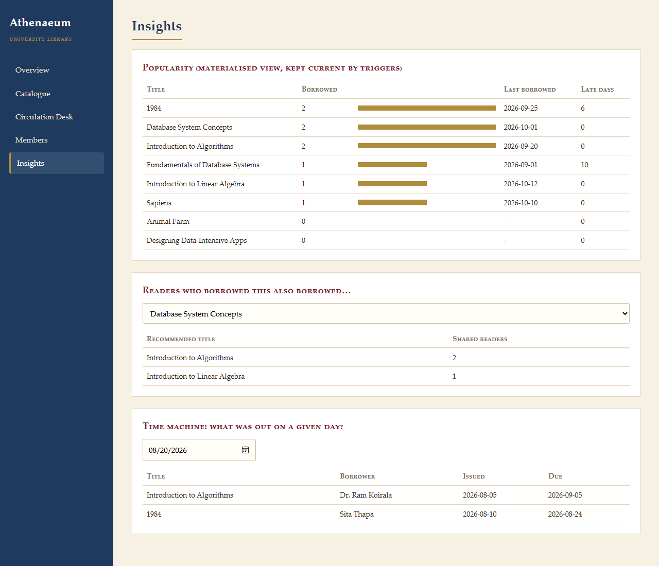
Figure 7. Insights: materialised view, recommender and time machine

CHAPTER 11 | VALIDATION
Each policy rule was tested by attempting a transaction that should be refused, or by checking the side effect of one that should succeed. Tests run on a fresh database and are rolled back afterwards. The 'Observed' column is the database's actual response.
Table 33. Policy validation
# | Scenario | Expected | Observed | OK
V1 | Issue copy 7 (already on loan) | Refused | Rejected: Copy is not available for loan | ✓
V2 | Public member Priya (limit 2) borrows 2 more | Refused on 2nd | Rejected: Member has reached the borrowing limit | ✓
V3 | Bikash (unpaid Rs 100 fine) borrows | Refused | Rejected: Member has unpaid fines | ✓
V4 | Issue copy 3 to Sita; check copy status | ON_LOAN | ON_LOAN | ✓
V5 | Return loan 6 on 2026-10-25 (due 10-04) | Fine Rs 210 | 210 | ✓
V6 | Return loan 5 on time; count its fines | 0 | 0 | ✓
V7 | Due date before issue date | Refused (CHECK) | Rejected: CHECK constraint failed: due_date > issue_date | ✓
V8 | Register a member with a duplicate email | Refused (UNIQUE) | Rejected: UNIQUE constraint failed: member.email | ✓
V10 | Issue copy 3 to Sita; BOOK_STATS count for its title | 2 -> 3 | 3 | ✓
V11 | Catalogue a new book; stats row auto-created | 1 | 1 | ✓
V9 | Delete a publisher that still has books | Refused (FK) | Rejected: FOREIGN KEY constraint failed | ✓

Result: 11/11 checks behaved as expected.

CHAPTER 12 | FINDINGS, LIMITATIONS AND NEXT STEPS

12.1 Findings
- Separating titles from physical copies (BOOK vs BOOK_COPY) gives accurate availability. This was the root cause of pain point P1.
- Putting the lending policy in triggers means it is applied the same way to every loan, whether made through the app or directly in SQL.
- Fines are now calculated automatically when a book is returned, which removes pain point P3.
- Normalisation removed the duplicated title and author text that made the ledger hard to count (P4).

12.2 Limitations
- Single-file SQLite suits one counter. Several counters would need a client-server DBMS such as MySQL.
- There are no reservations or holds when every copy is out.
- Staff log-in is not implemented; the staff ID is typed in by hand.

12.3 Next steps
- Add a RESERVATION table with a queue position, and notify the next member when a copy is returned.
- Add a web or mobile front end so members can search the catalogue themselves.
- Let fine rates vary by member type by moving the rate into a MEMBER_TYPE lookup table.

12.4 Closing remarks
Designed from the library's real pain points, a ten-table normalised schema with a small set of triggers replaces the ledger and enforces the lending policy without depending on staff memory. The design, implementation and validation in this report show that the requirements in Chapter 3 are met.

BIBLIOGRAPHY
[1] Elmasri, R. and Navathe, S. B., Fundamentals of Database Systems, 7th edition, Pearson, 2015.
[2] Silberschatz, A., Korth, H. F. and Sudarshan, S., Database System Concepts, 7th edition, McGraw-Hill, 2019.
[3] Date, C. J., An Introduction to Database Systems, 8th edition, Addison-Wesley, 2003.
[4] SQLite Consortium, "SQL As Understood By SQLite", sqlite.org/lang.html.

