**NAME:ABHINAV**

**ROLL NUMBER:101903587**

**QUES:1**

#include<iostream>

#include<stdlib.h>

using namespace std;

int main()

{

int n,s,i,j,pos,em,pos2;

int arr[50];

cout<<"enter how many elements you want ?"<<endl;

cin>>n;

for(i=1;i>0;i++)

{

cout<<"enter what you want to do"<<endl;

cout<<" 1.CREATE \n 2.DISPLAY \n 3.INSERT \n 4.DELETE \n 5.SEARCH \n 6.EXIT"<<endl;

cin>>s;

switch(s)

{

case 1:

for(j=0;j<n;j++)

{

cout<<"enter "<<j+1<<"st element"<<endl;

cin>>arr[j];}

break;

case 2:

for(j=0;j<n;j++)

{

cout<<arr[j]<<endl<<flush;

}

break;

case 3:

cout<<"\n enter the position at which you want to insert a new element"<<endl;

cin>>pos;

cout<<"enter the value of the element"<<endl;

cin>>em;

for(j=n;j>pos-1;j--)

{

arr[j]=arr[j-1];

}

arr[pos-1]=em;

n=n+1;

break;

case 4:

cout<<"\nEnter the position of the element you want to delete:\n";

cin>>pos;

for(j=pos-1;j<n-1;j++)

{

arr[j]=arr[j+1];

}

n=n-1;

cout<<"Item deleted successfully !\n";

break;

case 5:

int key;

cout<<"enter the element you want to search"<<endl;

cin>>key;

for(j=0;j<n;j++)

{

if(key==arr[j])

{

cout<<"element is at "<<j<<"th position of the array";

break;

}

}

break;

case 6:

exit(0);

default:

"please select statement";

break;

}

cout<<"task completed \n";

}

}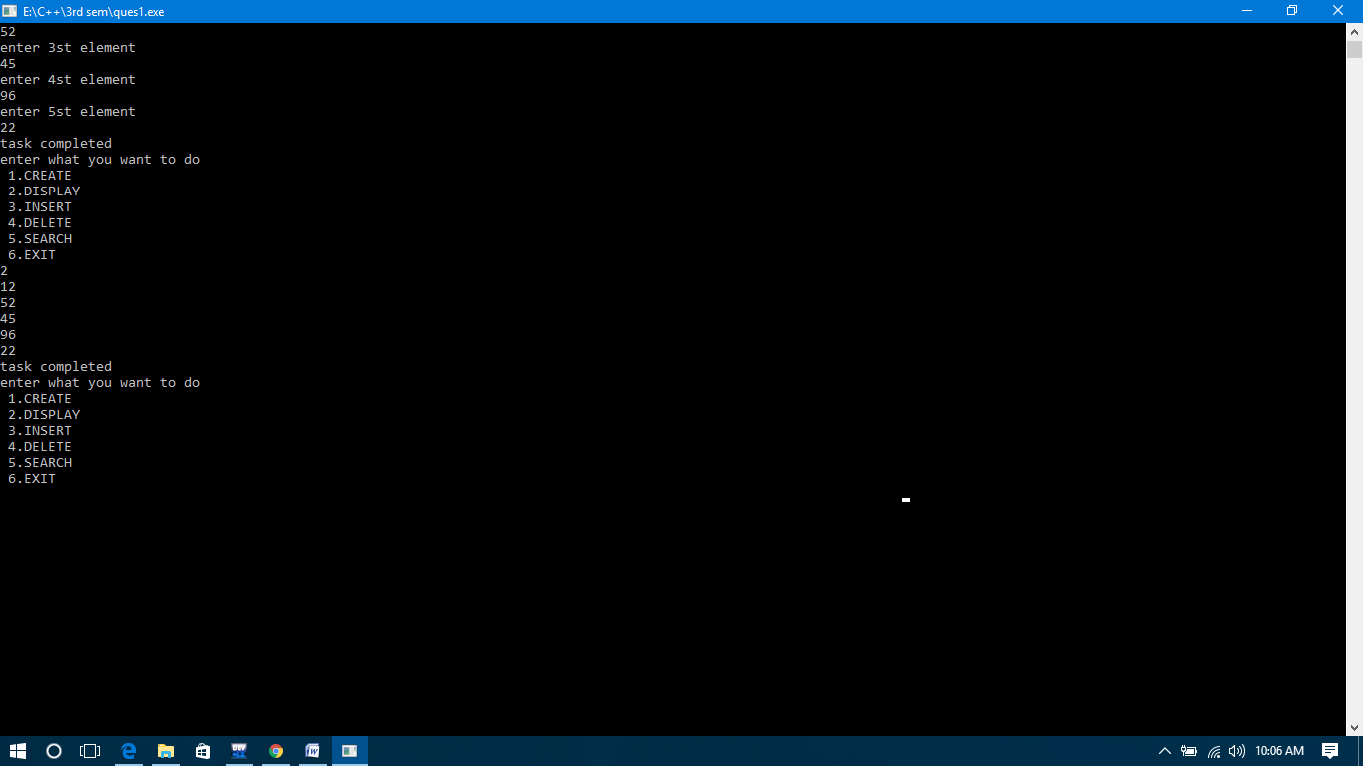

**QUES2:**

#include <iostream>

using namespace std;

int main()

{

int arr[100],b[100];

int size, i, j, temp;

cout<<"Enter size of array: ";

cin>>size;

cout<<"Enter elements in array: ";

for(i=0; i<size; i++)

{

cin>>arr[i];

}

for(i=0; i<size; i++)

{

for(j=i+1; j<size; j++)

{

if(arr[j] < arr[i])

{

temp = arr[i];

arr[i] = arr[j];

arr[j] = temp;

}

}

}

cout<<"Elements of array in sorted ascending order:"<<endl;

for(i=0; i<size; i++)

{

cout<<arr[i]<<endl;

}

for(i=0;i<size;++i)

for(j=i+1;j<size;)

{

if(arr[i]==arr[j])

{

for(int k=j;k<size-1;++k)

arr[k]=arr[k+1];

--size;

}

else

++j;

}

cout<<"Elements of array after removing identical elements:"<<endl;

for(i=0; i<size; i++)

{

cout<<arr[i]<<endl;

}

return 0;

}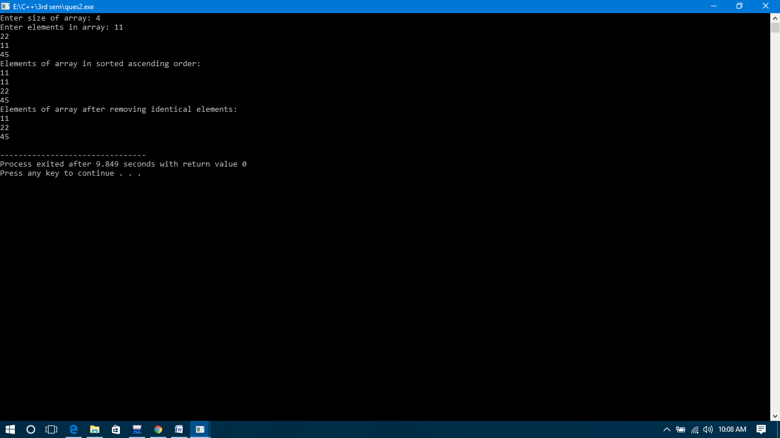

**QUES3:**

#include<iostream>

#include<stdlib.h>

using namespace std;

int main()

{

int i;

int arr[5]={1};

for(i=0;i<5;i++)

{cout<<arr[i];

}

}

Output=10000

**QUES4(1):**

#include<iostream>

using namespace std;

int main(){

int n;

cout<<"enter number of elements in array";

cin>>n;

int a[n];

cout<<"enter elements";

for(int i =0;i<n;i++){

cin>>a[i];

}

int i=0;

int j =n-1;

while(i<=j){

swap(a[i],a[j]);

i++;

j--;

}

for(int m =0;m<n;m++){

cout<<a[m]<<"\t";

}}

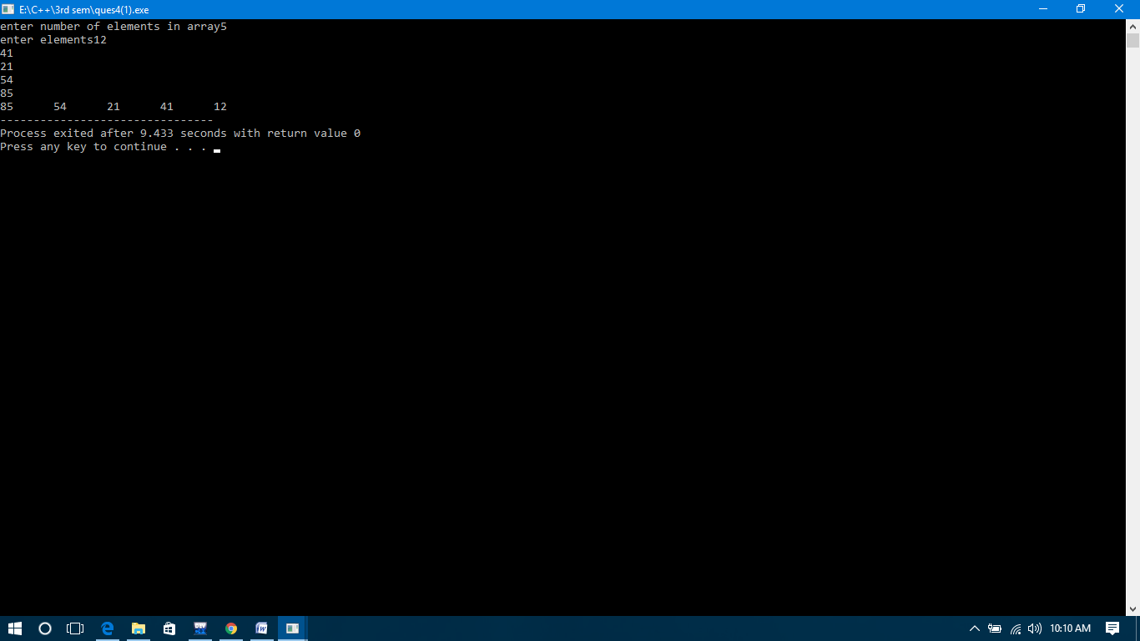

**QUES4(2):**

#include <iostream>

using namespace std;

int main()

{

int a[10][10], b[10][10], mult[10][10], r1, c1, r2, c2, i, j, k;

cout << "Enter number of rows and columns for first matrix: ";

cin >> r1 >> c1;

cout << "Enter number of rows and columns for second matrix: ";

cin >> r2 >> c2;

while (c1!=r2)

{

cout << "Error! column of first matrix not equal to row of second.";

cout << "Enter number of rows and columns for second matrix: ";

cin >> r1 >> c1;

cout << "Enter number of rows and columns for second matrix: ";

cin >> r2 >> c2;

}

cout << endl << "Enter elements of matrix 1:" << endl;

for(i = 0; i < r1; ++i)

for(j = 0; j < c1; ++j)

{

cout << "Enter element A" << i + 1 << j + 1 << " : ";

cin >> a[i][j];

}

cout << endl << "Enter elements of matrix 2:" << endl;

for(i = 0; i < r2; ++i)

for(j = 0; j < c2; ++j)

{

cout << "Enter element B" << i + 1 << j + 1 << " : ";

cin >> b[i][j];

}

for(i = 0; i < r1; ++i)

for(j = 0; j < c2; ++j)

{

mult[i][j]=0;

}

for(i = 0; i < r1; ++i)

for(j = 0; j < c2; ++j)

for(k = 0; k < c1; ++k)

{

mult[i][j] += a[i][k] * b[k][j];

}

cout << endl << "Output Matrix: " << endl;

for(i = 0; i < r1; ++i)

for(j = 0; j < c2; ++j)

{

cout << " " << mult[i][j];

if(j == c2-1)

cout << endl;

}

return 0;

}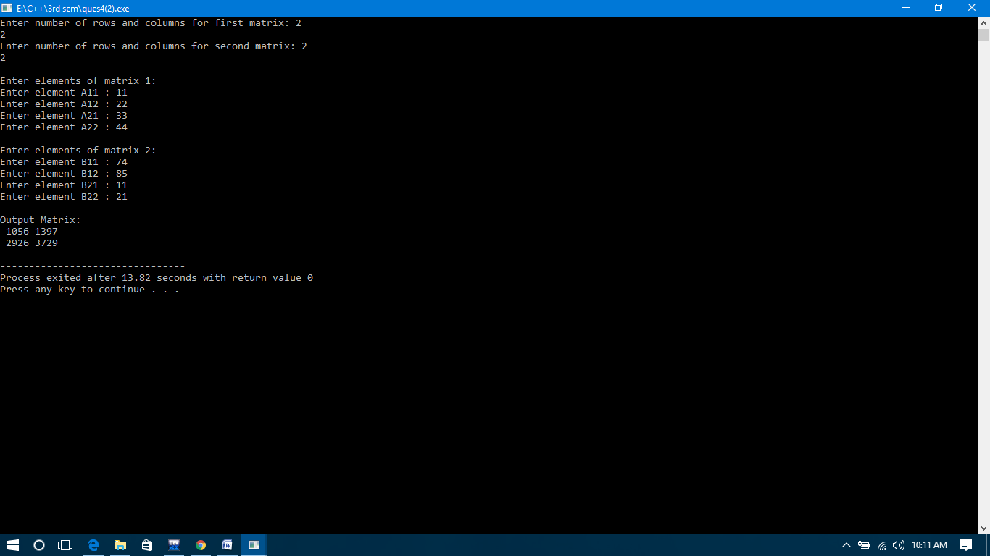

**QUES4(3):**

#include <iostream>

using namespace std;

int main() {

int a[10][10], transpose[10][10], row, column, i, j;

cout << "Enter number of rows and columns of matrix: ";

cin >> row >> column;

cout << "\nEnter elements of matrix: " << endl;

for (int i = 0; i < row; ++i) {

for (int j = 0; j < column; ++j) {

cout << "Enter element a" << i +1 << j+ 1 << ": ";

cin >> a[i][j];

}

}

cout << "\nMatrix Entered: " << endl;

for (int i = 0; i < row; ++i) {

for (int j = 0; j < column; ++j) {

cout << " " << a[i][j];

if (j == column - 1)

cout << endl << endl;

}

}for (int i = 0; i < row; ++i)

for (int j = 0; j < column; ++j) {

transpose[j][i] = a[i][j];

}

cout << "\nTranspose of Matrix: " << endl;

for (int i = 0; i < column; ++i)

for (int j = 0; j < row; ++j) {

cout << " " << transpose[i][j];

if (j == row - 1)

cout << endl << endl;

}

return 0;

}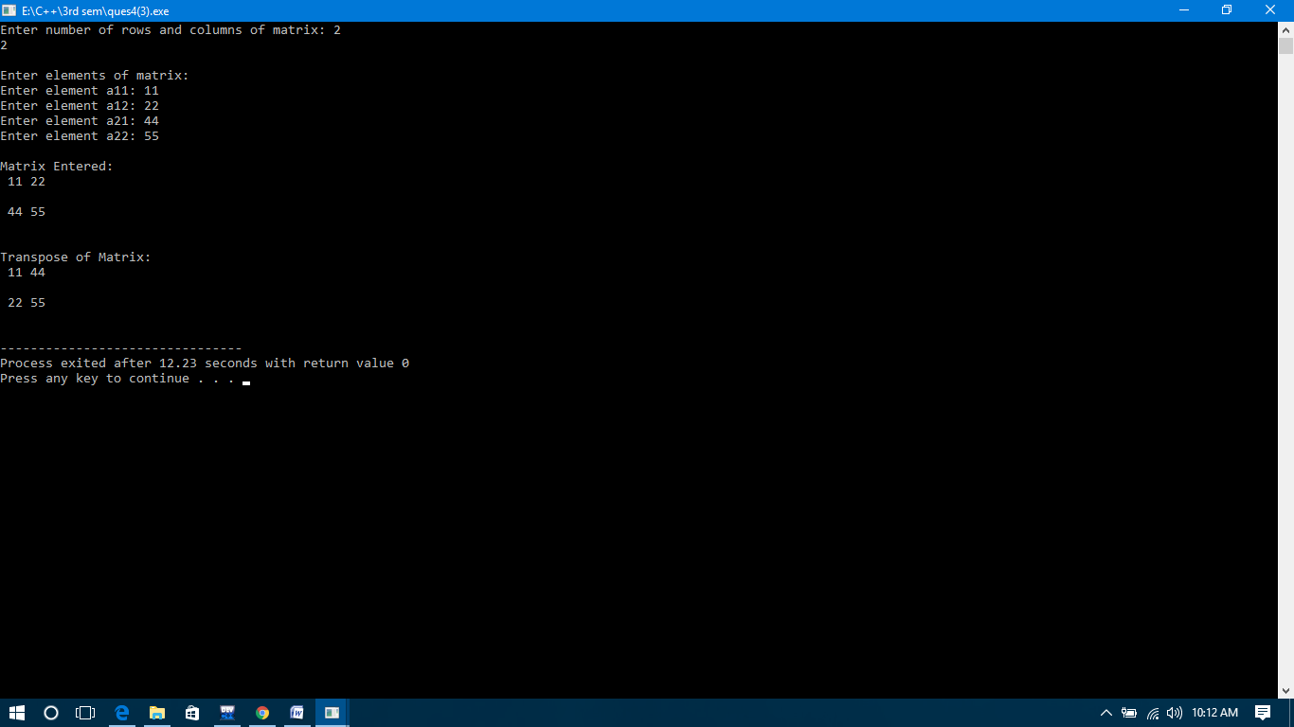

**QUES5:**

#include <iostream>

using namespace std;

int main()

{

int count, i, arr[30], num, first, last, middle;

cout<<"how many elements would you like to enter?:";

cin>>count;

for (i=0; i<count; i++)

{

cout<<"Enter number "<<(i+1)<<": ";

cin>>arr[i];

}

cout<<"Enter the number that you want to search:";

cin>>num;

first = 0;

last = count-1;

middle = (first+last)/2;

while (first <= last)

{

if(arr[middle] < num)

{

first = middle + 1;

}

else if(arr[middle] == num)

{

cout<<num<<" found in the array at the location "<<middle+1<<"\n";

break;

}

else {

last = middle - 1;

}

middle = (first + last)/2;

}

if(first > last)

{

cout<<num<<" not found in the array";

}

return 0;

}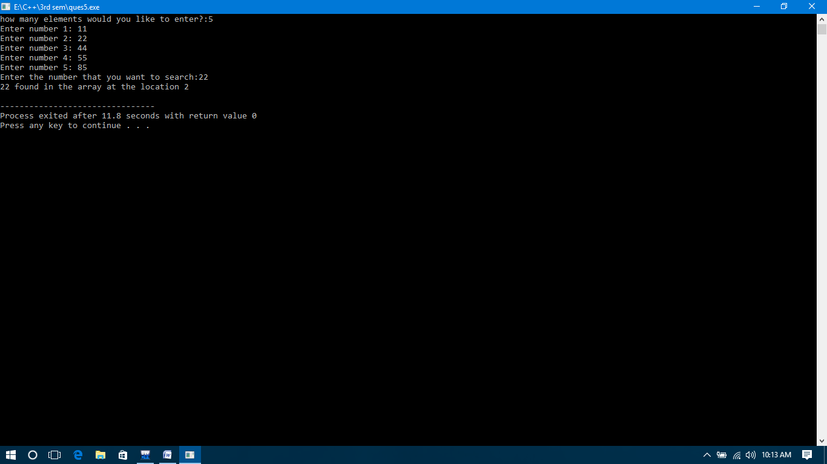

**QUES6:**

#include<iostream>

using namespace std;

int main ()

{

int i, j,temp,pass=0;

int a[7] = {64,34,25,12,22,11,90};

cout <<"Input list ...\n";

for(i = 0; i<7; i++) {

cout <<a[i]<<"\t";

}

cout<<endl;

for(i = 0; i<7; i++) {

for(j = i+1; j<7; j++)

{

if(a[j] < a[i]) {

temp = a[i];

a[i] = a[j];

a[j] = temp;

}

}

pass++;

}

cout <<"Sorted Element List ...\n";

for(i = 0; i<7; i++) {

cout <<a[i]<<"\t";

}

cout<<"\nNumber of passes taken to sort the list:"<<pass<<endl;

return 0;

}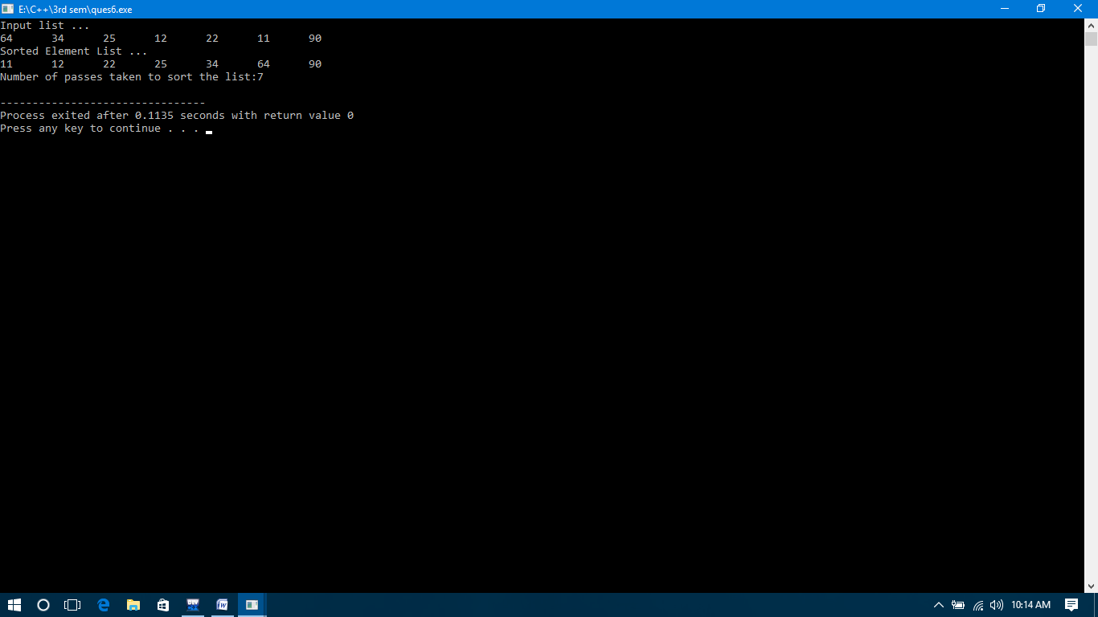

**QUES7:**

#include <iostream>

using namespace std;

int getMis(int a[], int n)

{

int total = (n + 1) * (n + 2) / 2;

for (int i = 0; i < n; i++)

total -= a[i];

return total;

}

int main()

{

int arr[] = { 1, 2, 4, 5, 6 };

int n = sizeof(arr) / sizeof(arr[0]);

int miss = getMis(arr, n);

cout << miss;

}