Prepaid Electricity Billing Meter

Most of the energy meters are designed to bill as per the units of energy consumed. These meters need to be manually read by people in order to provide monthly/quarterly bills. We here propose a prepaid energy billing meter. The system is designed to allow amount of energy to be used as long as the account has balance pending. It also allows the operator to recharge the user account using GSM.
The system first accepts account recharge and allows to use only limited units of energy as per recharge and then cuts off the supply. The prepaid electricity billing meter could be widely used to provide a new more customized electricity billing system, where users may recharge when they intend to use that facility. It also consists of a GSM modem that allows the operator to recharge the meter remotely using am SMS message. This puts forward an innovative electricity billing and “use as needed” electricity usage scheme. It also eliminates the need for manual electricity meter reading tasks.

Hardware Specifications
- 8051 Microcontroller
- LCD
- Crystal Oscillator
- Energy meter
- Relay
- Resistors
- Capacitors
- Transistors
- Cables and Connectors
- Diodes
- PCB and Breadboards
- LED
- Transformer/Adapter
- Push Buttons
- Switch
- IC
- IC Sockets

Software Specifications
- Keil µVision IDE
- MC Programming Language: Embedded C

GSM Modem
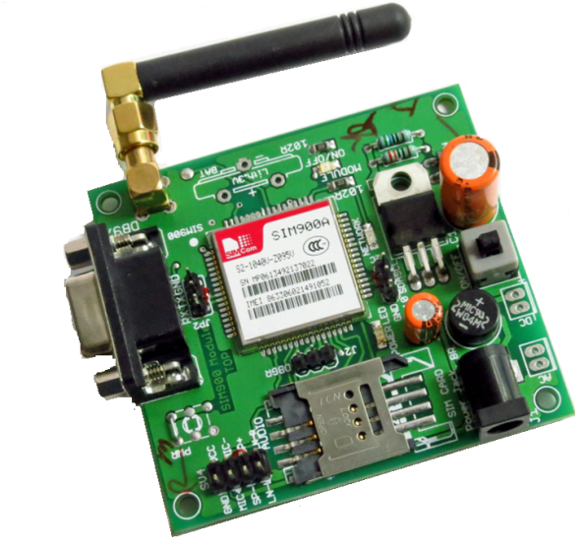
The SIM900 is a complete Quad-band GSM/GPRS solution in a SMT module which can be embedded in the customer applications. Featuring an industry-standard interface, the SIM900 delivers GSM/GPRS 850/900/1800/1900MHz performance for voice, SMS, Data, and Fax in a small form factor and with low power consumption. With a tiny configuration of 24mm x 24mm x 3 mm, SIM900 can fit almost all the space requirements in your M2M application, especially for slim and compact demand of design.

