**QAT – Question Assessment Tool**

**Framework used : Backend(Django-Python)**

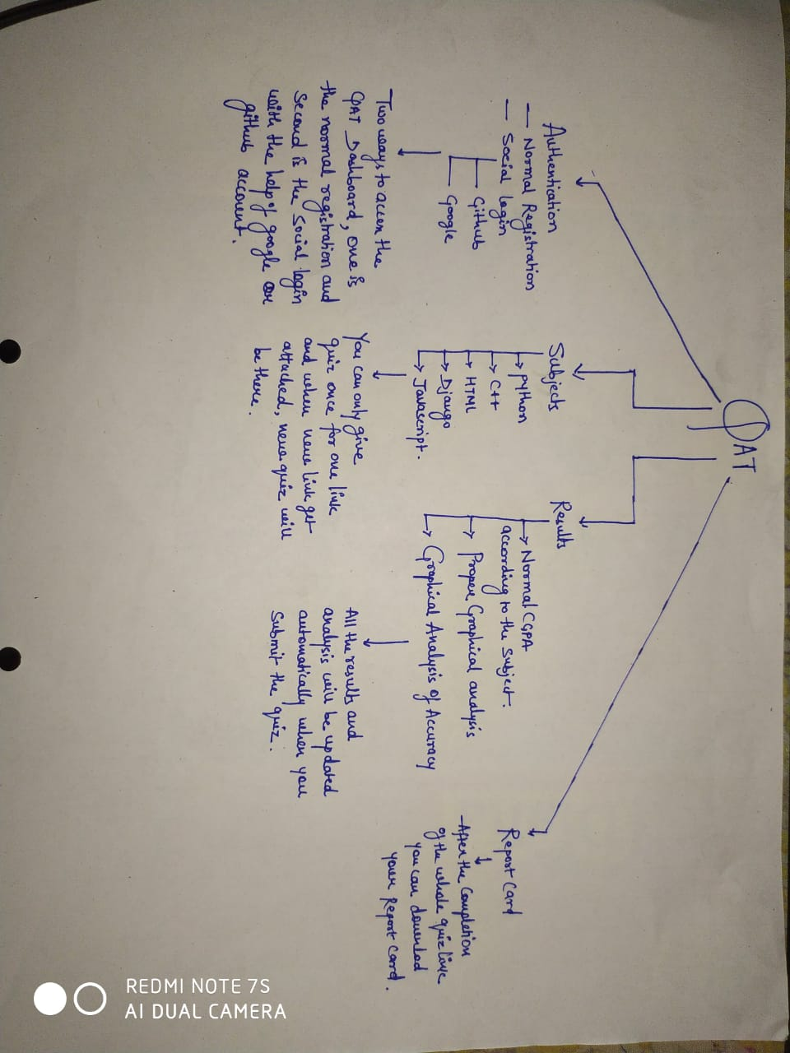**Frontend: HTML,CSS,JS,SCSS**

**Browser Compatibility: Morzilla-Firefox,Google-Chrome**

**Warning in the app:**

**1) When you click on the subject button to give test so you will get a warning as You cant go to another page untill you submit the quiz otherwise your quiz will be submitted automatically and also you cant the refresh the quiz page so you quiz will get automatically submitted.**

**So in Morzilla Firefox the saved data untill you go against the rule is saved and as you break the rule the quiz will get submitted and you will get only that much mark that you have clicked on**

**In Google Chrome according to the compatibility of the browser the data will not be saved and if you break the rule you will get 0.**

**So Read the warning carefully and dont break the rule**

**Images of the app:**

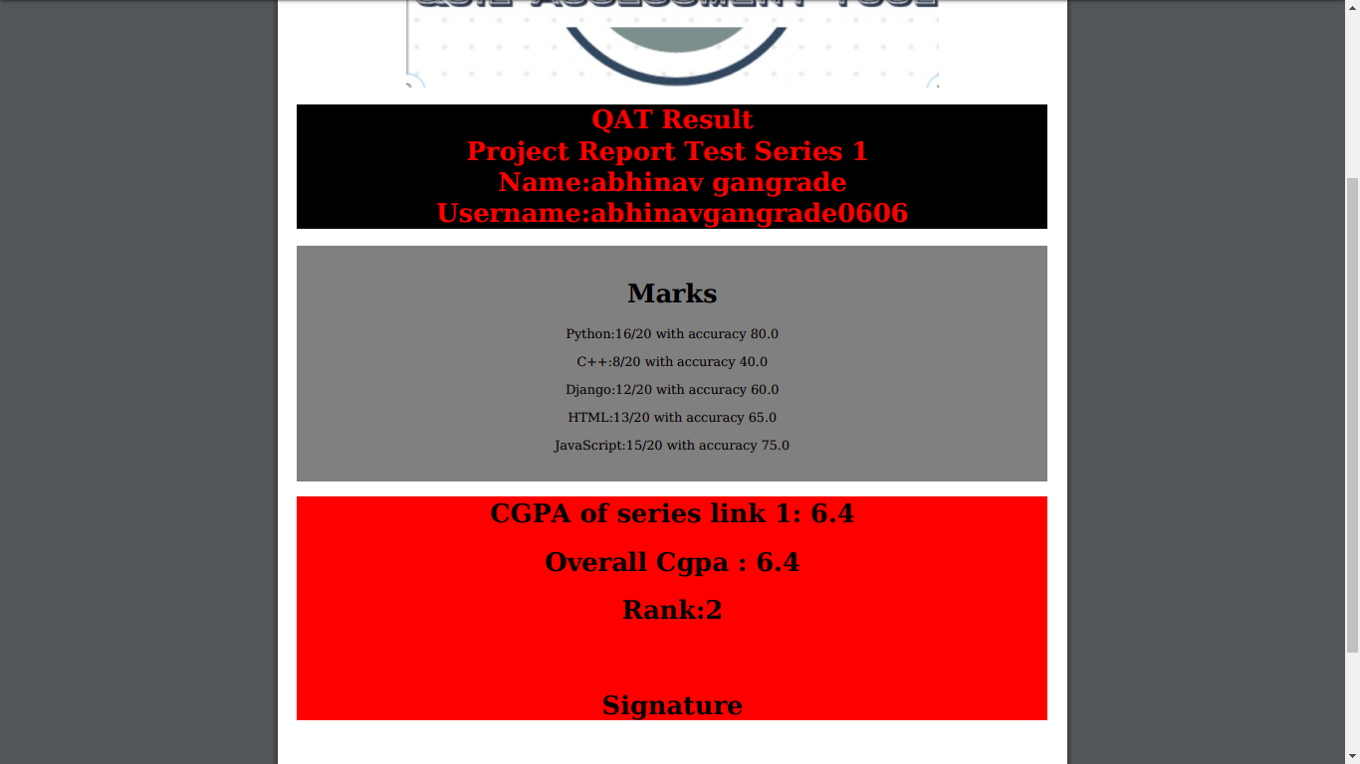

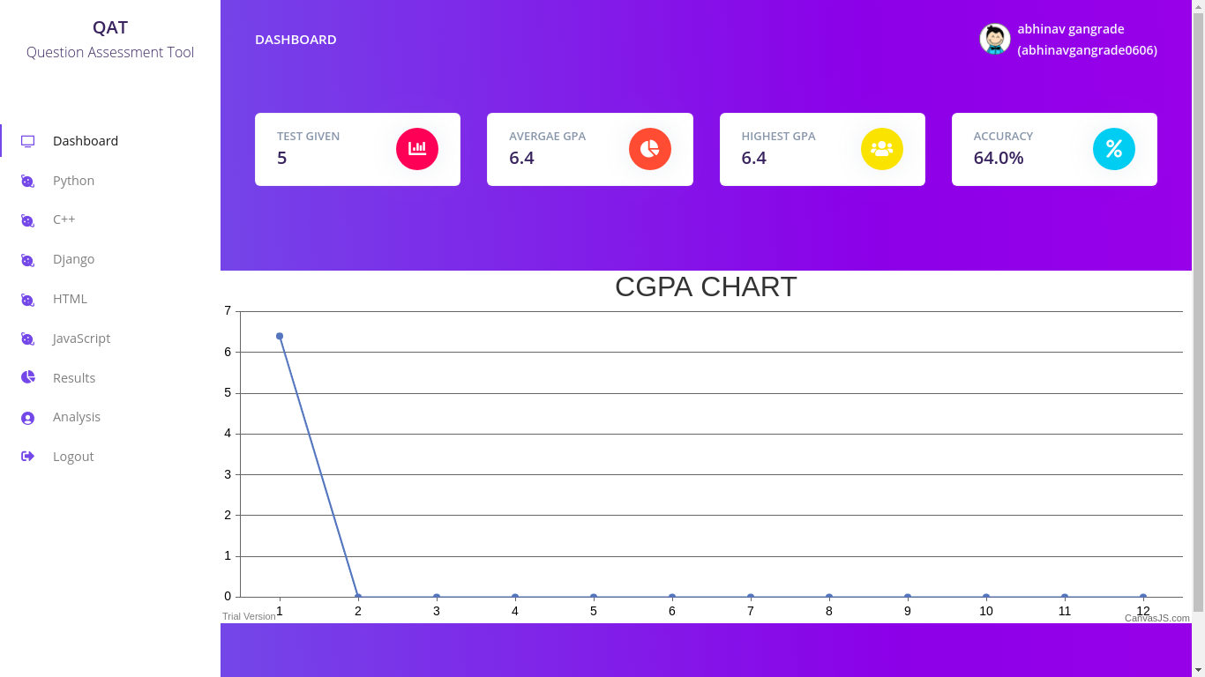

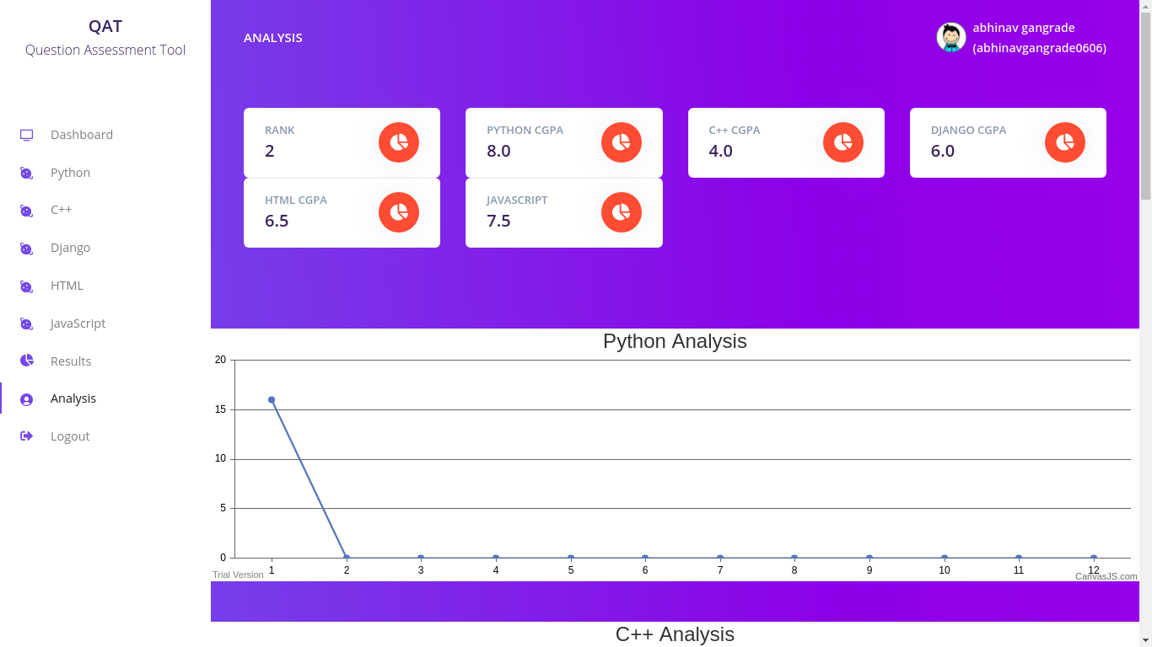

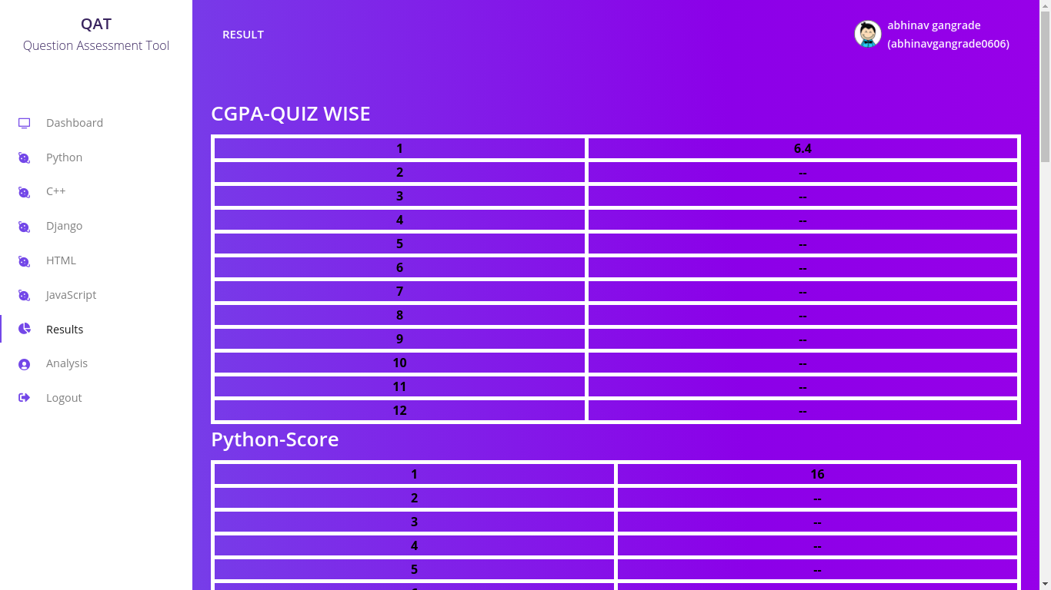

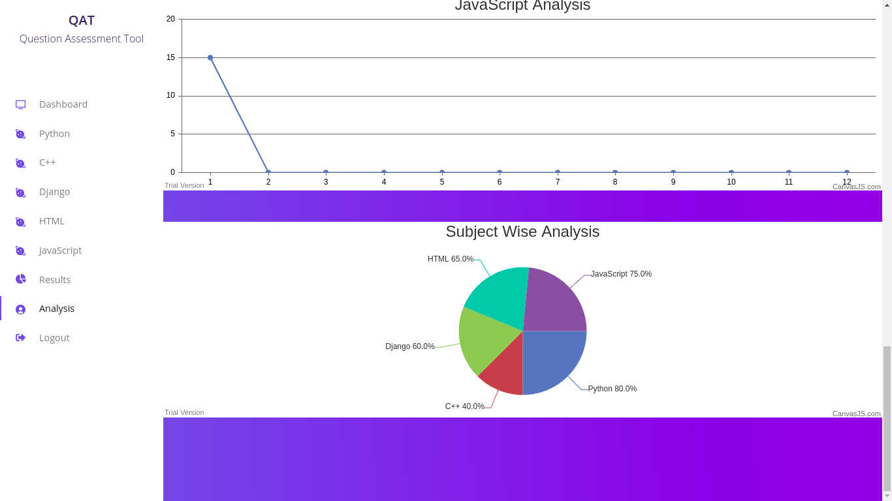

Full code at: <https://github.com/abhinav0606/Question-Assessment-Tool>