Solid Wooden Doors Documentation

1. User can Login with the credentials with the login URL.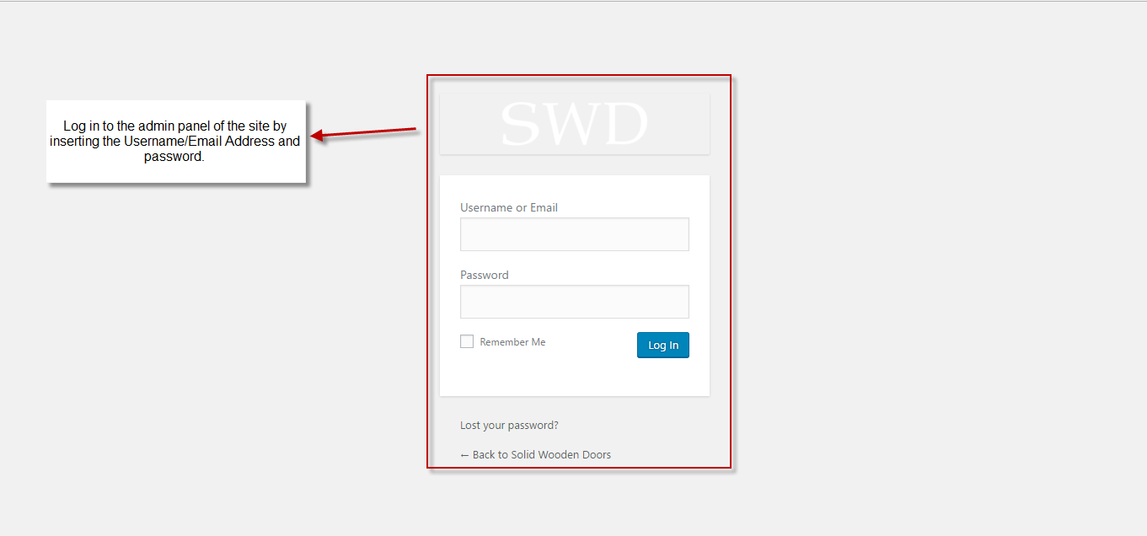
2. Dashboard Views.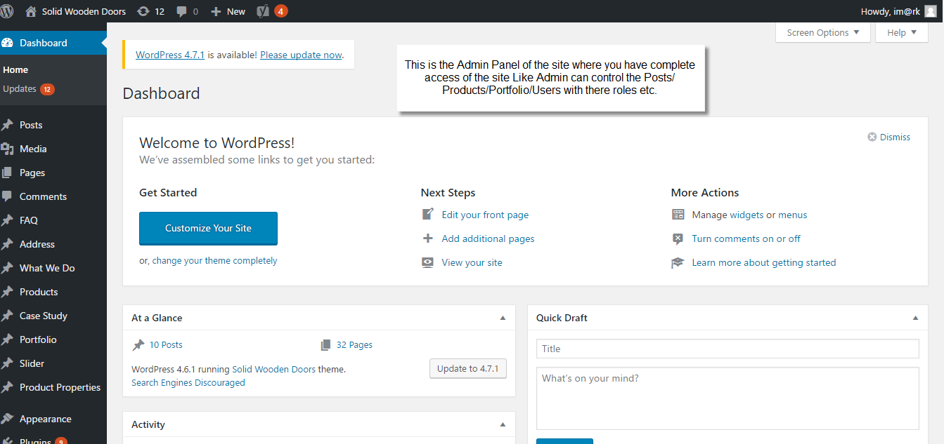
3. Admin Can view all the pages and edit existing pages and add new once.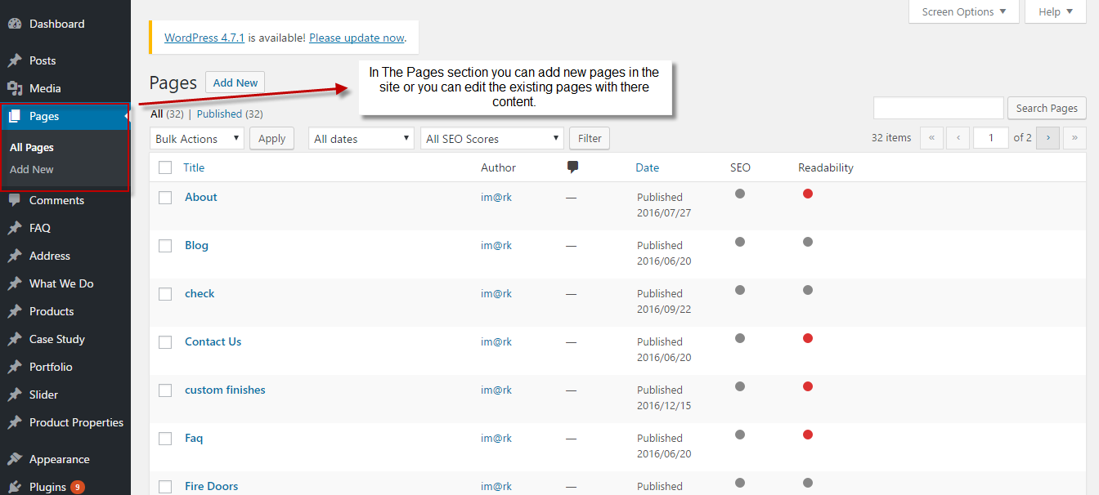
4. User can edit the existing pages and add the Title, Content, featured Images. 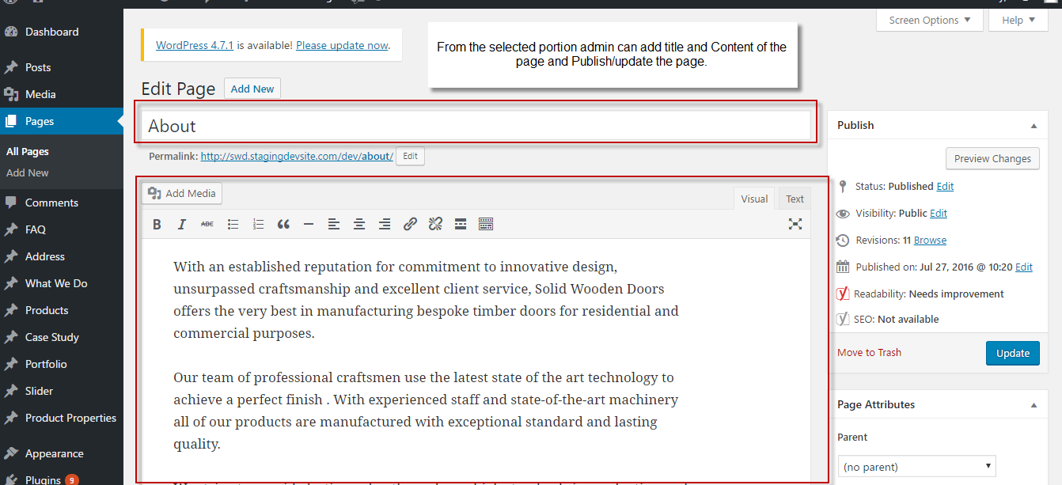
5. User can View all the faq`s from the attached screenshots.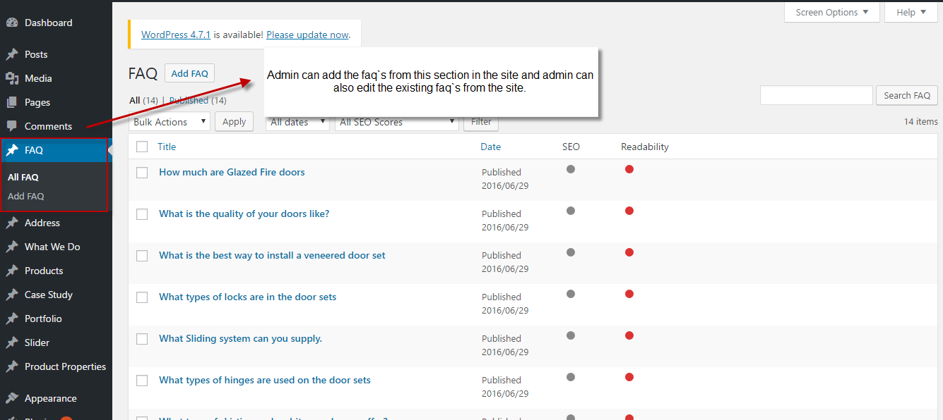
6. The address in the Contact us pages can be managed with the help of attached screenshots.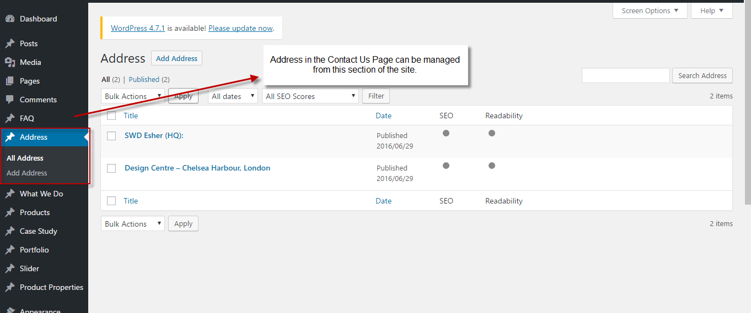
7. For the What We do please follow the next four screenshots in order.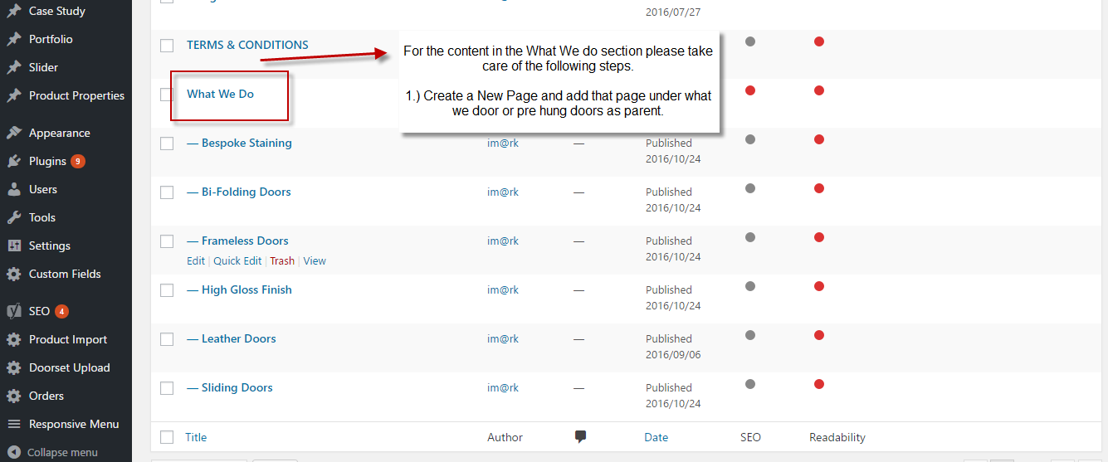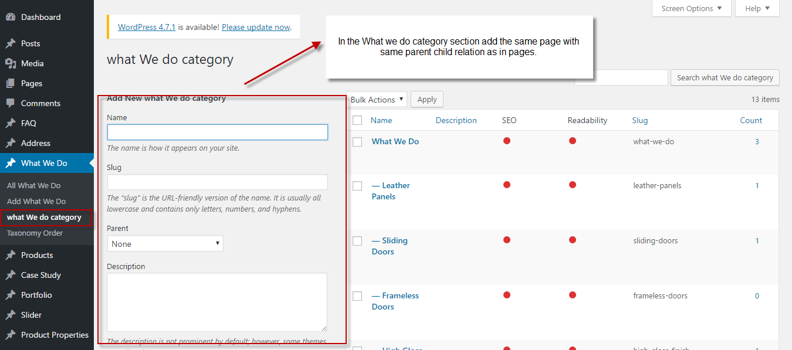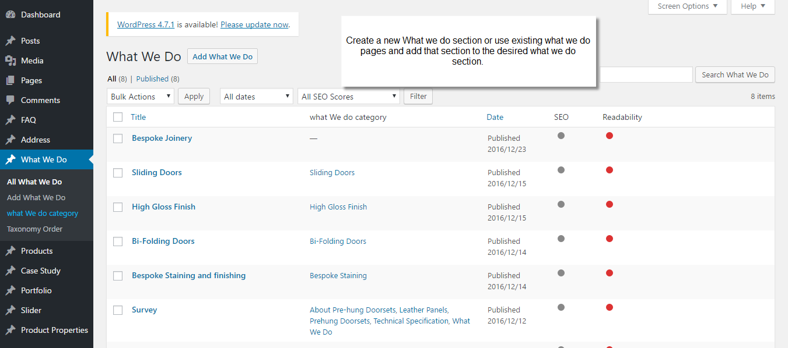
8. Edit the Request a Brochure Dropdowns.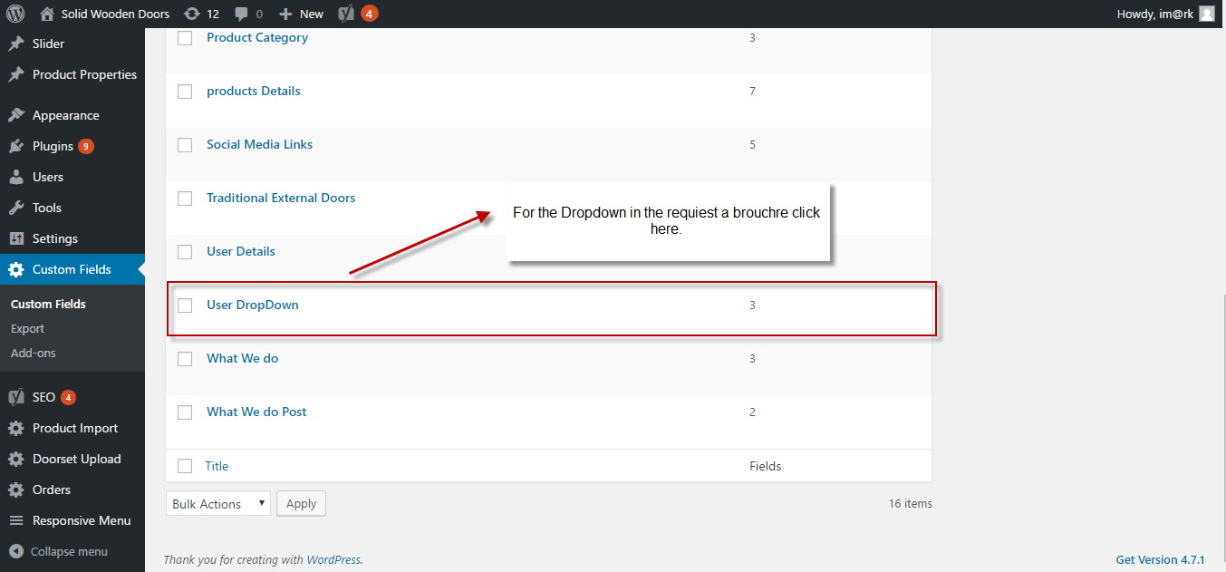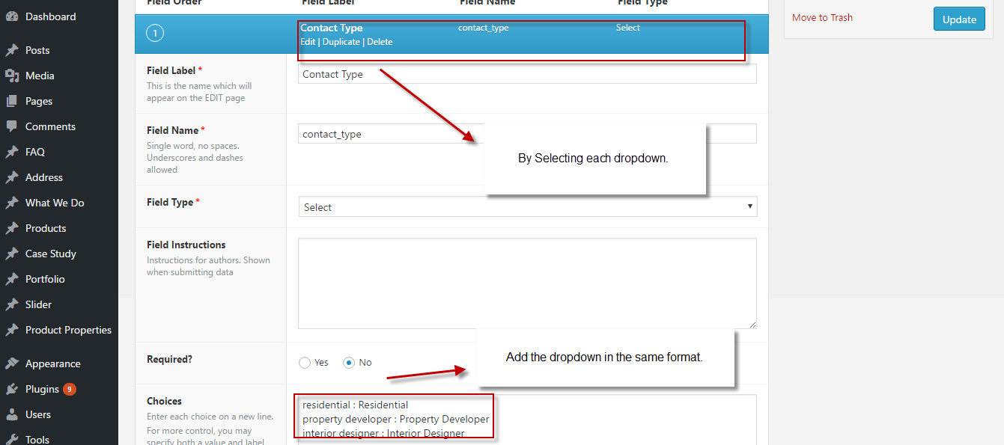
9. Products section (adding products with the .xls file) with Door Leaf and Doorset.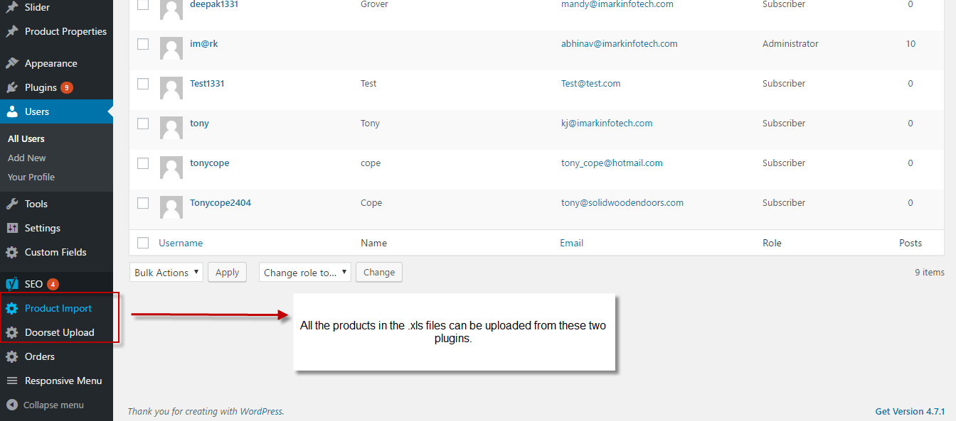
10. Admin can manage the portfolio from the attached screenshots.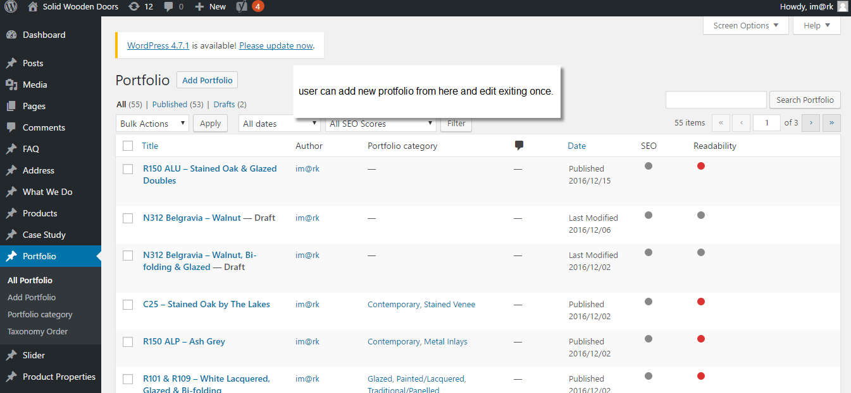
11. Admin can manage all the other users with the attached screenshot