**Zoovadoo Application - Which Colors Is Your Life Made Of?**

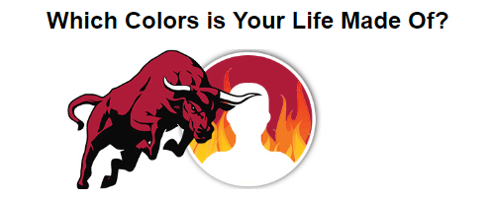

**RED**

Red is the color of extremes. It stands for love, passion and adventure. You are a brave, adventurous and an energetic person!

**PURPLE**

Purple is a rarity in nature and is associated with royalty, luxury and mystery. You are a mysterious and sensitive person!

**PINK**

Pink symbolizes tenderness, sweetness and unconditional love. You are a charming and compassionate person!

**YELLOW**

Yellow stands for sunshine, optimism and happiness. You are full of fun and positivity which attracts people to you!

**GREEN**

Green is associated with new beginnings, harmony and freshness. You are an intellectual person with high ambitions!

**ORANGE**

Orange is a vibrant color and stands for health, success and freedom. You are an extrovert and a party animal!

**BLUE**

Blue stands for trust, loyalty and confidence. You are a serene and trustworthy person with a tender heart!

**WHITE**

White is the color of light and reflects innocence and purity. You are a practical, spiritual and an illuminated person!

**GOLD**

Gold is associated with wealth, grandeur and prosperity. You are a treasured person, full of wisdom and intellect!

**BLACK**

Black stands for power, aggression and elegance. You are highly emotional, disciplined and an overachiever!