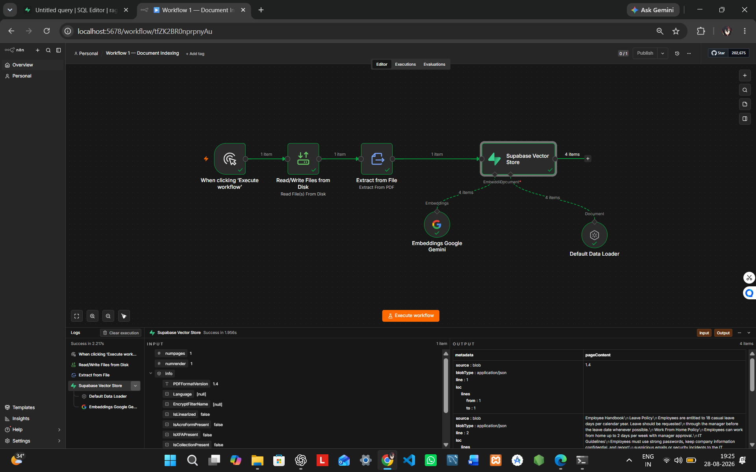
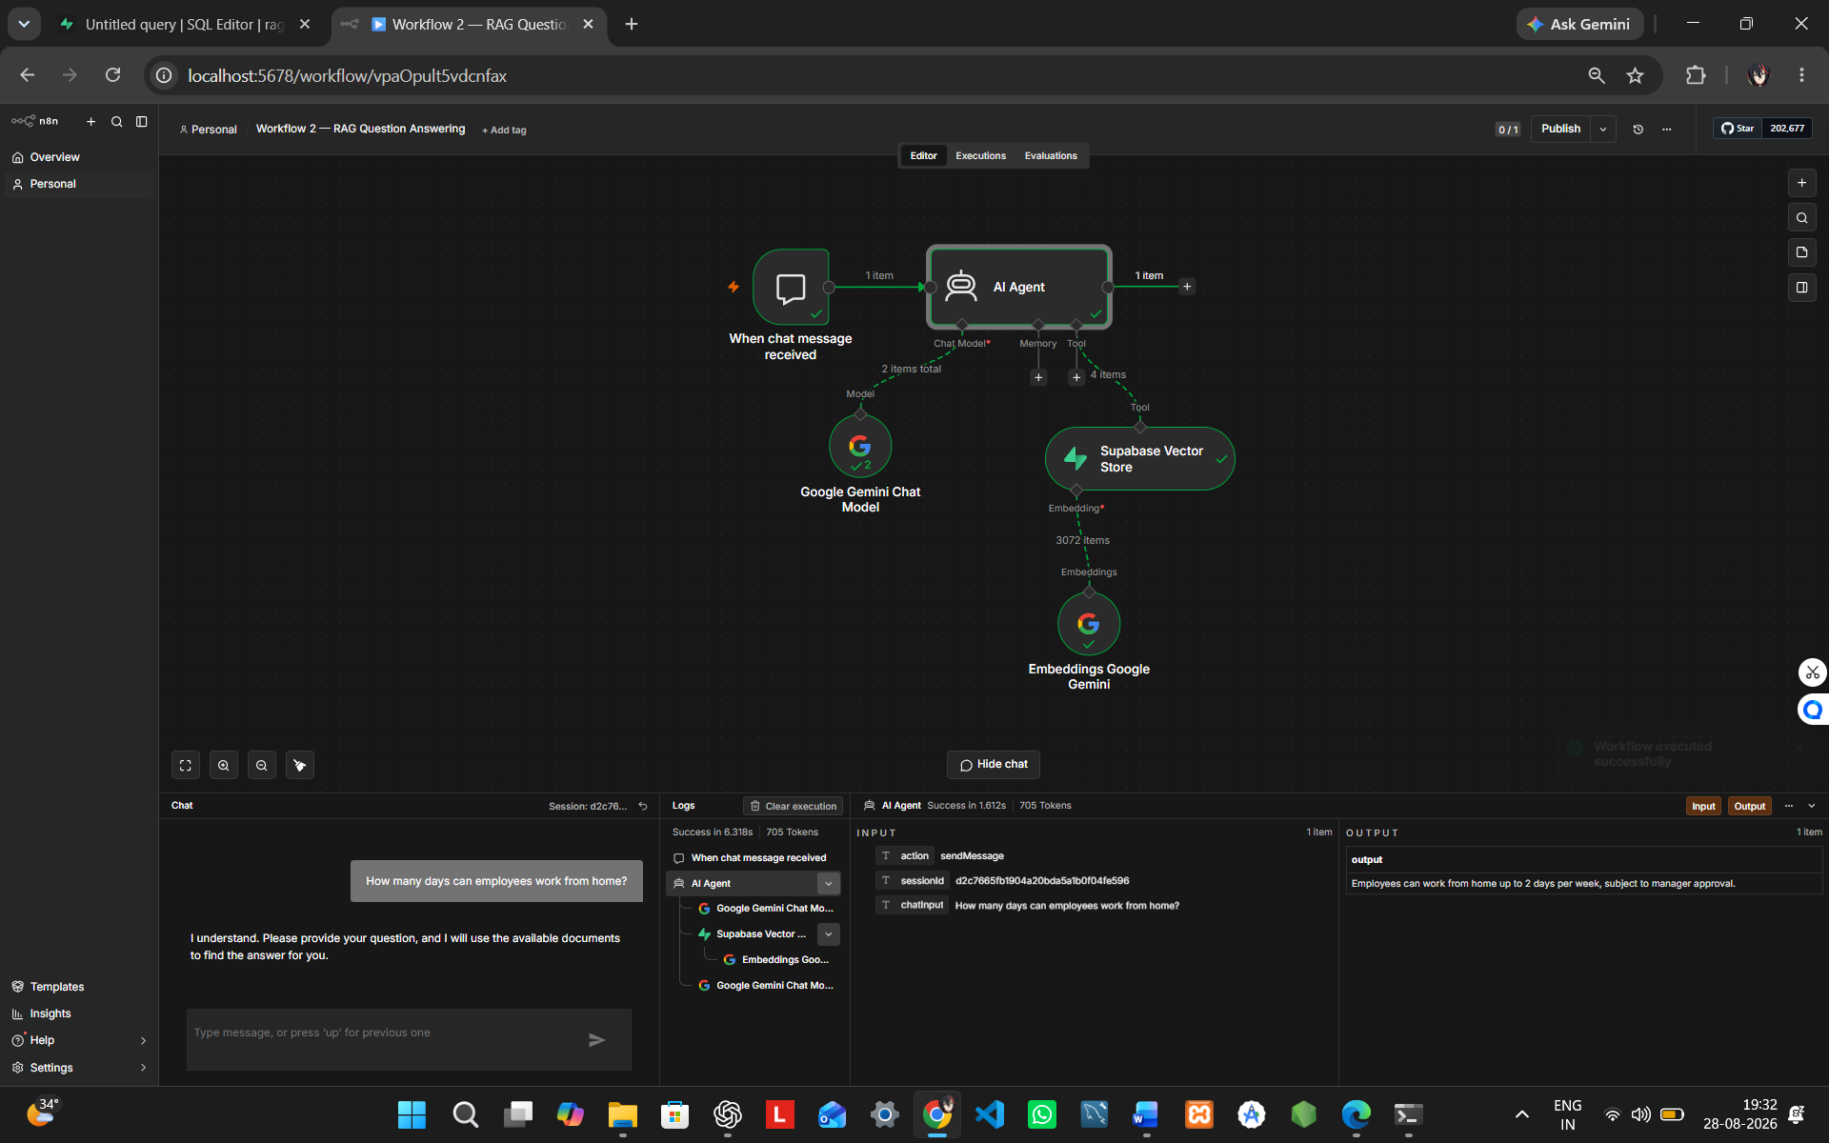
RAG Without Code — Project Report
Project Title: RAG Without Code using n8n
GitHub Repository: https://github.com/abhinav2006parihar-cloud/n8n-rag-without-code
1. Objective
To build a no-code Retrieval-Augmented Generation (RAG) Agent that processes a PDF, stores its information in a vector database, retrieves relevant context, and generates grounded answers.
2. Tools Used
- n8n
- Google Gemini
- Supabase Vector Store
- PDF Knowledge Document
3. Workflow
Workflow 1 — Document Indexing
PDF → Read File → Extract Text → Gemini Embeddings → Supabase Vector Store
Workflow 2 — Question Answering
User Question → AI Agent → Supabase Retrieval → Relevant Context → Gemini → Answer
This demonstrates the required RAG pipeline from document processing and indexing through retrieval and answer generation.
4. Sample Knowledge Document
An Employee Handbook PDF containing:
- Leave Policy
- Work From Home Policy
- IT Guidelines
- Company FAQ
5. Test Result
Question: How many days can employees work from home?
Answer: Employees can work from home up to 2 days per week, subject to manager approval.
The answer was successfully retrieved from the indexed document.
6. Missing Information Handling
Question: What is the company's international travel allowance?
Expected/Configured Response:
“I couldn't find this information in the available documents.”
This prevents the agent from inventing information that is not present in the knowledge base.
7. AI Prompt
Answer only using information from the retrieved documents. If the information is not found, say: “I couldn't find this information in the available documents.” Do not invent facts.
8. Result
The RAG Agent successfully demonstrates:
Document → Index → Search → Retrieve → Context → Generate → Answer
The implementation uses a simple no-code workflow and demonstrates document-based question answering.
9. Screenshots
Screenshot 1: Workflow 1 — Document Indexing
Screenshot 2: Workflow 2 — Working RAG Question Answering
10. GitHub
Repository:
https://github.com/abhinav2006parihar-cloud/n8n-rag-without-code

