An Internship Report

Of

GenAI Powered Data Analytics Job Simulation

Submitted
To

School of Computer Science and Engineering
IILM University, Greater Noida, U.P.

In partial fulfilment of the requirement of degree of
B-Tech (CSE)



By

Roll Number of Student: 25SCS1003002573
Name of Student: ABHINAV RAJ
Batch: 2025-2029

CANDIDATE'S DECLARATION
I, ABHINAV RAJ, do hereby declare that the internship report titled "GenAI Powered Data Analytics Job Simulation" has been completed by me to fulfil the requirement for the award of the degree of Bachelor of Technology in Computer Science and Engineering. All the references have been quoted and I have not taken as such any material from any other source. I affirm that this report is my own and has not been submitted to any other institute for any degree/diploma requirement, and further I shall be solely responsible for any kind of copyright violation in this regard.

Signature:-
Student Name: ABHINAV RAJ
Roll No.: 25SCS1003002573

ACKNOWLEDGEMENT
I am using this opportunity to express my gratitude to everyone who supported me throughout the internship. I am thankful for their aspiring guidance, invaluably constructive criticism and friendly advice during this work. I am sincerely grateful to them for sharing their truthful and illuminating views on a number of issues related to this work.
I would like to thank Tata and Forage for providing me the opportunity and the structured virtual platform to learn and gain hands-on exposure in the domain of Data Analytics and Generative AI. I am also thankful to my institute, IILM University, Greater Noida, and the faculty of the School of Computer Science and Engineering for their continuous support and encouragement.
I express my gratitude to my parents for their blessings.

Signature:
Student Name: ABHINAV RAJ
Roll No.: 25SCS1003002573

TABLE OF CONTENTS
1. Candidate's Declaration ... i
2. Acknowledgement ... ii
3. Internship Completion Certificate ... -
4. Project Description ... 1
4.1 Introduction ... 1
4.2 Organization Profile ... 2
4.3 Problem Statement ... 3
4.4 Project Objectives ... 3
4.5 Scope of the Project ... 4
4.6 Technologies and Tools Used ... 4
4.7 Tasks Undertaken ... 5
4.8 Methodology ... 6
4.9 Expected Outcomes ... 7
4.10 Certificate of Completion ... 8
5. Bibliography/References ... 9

3. INTERNSHIP COMPLETION CERTIFICATE
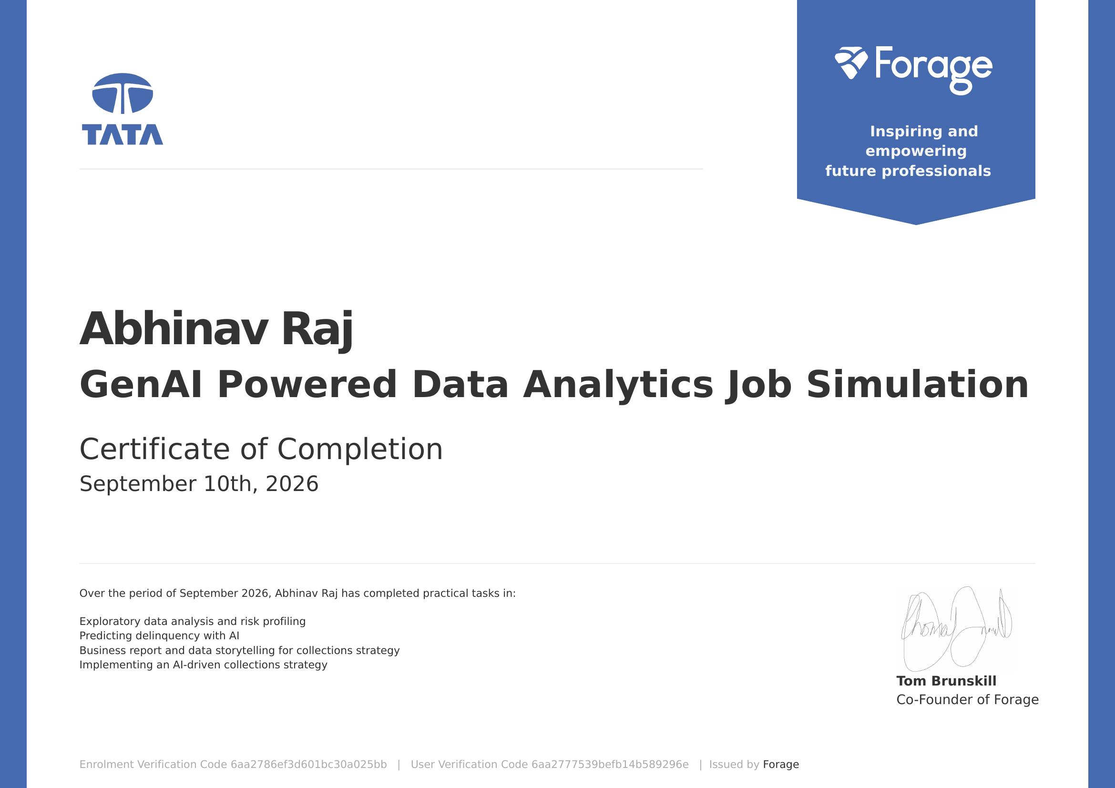

4. PROJECT DESCRIPTION

4.1 Introduction
This report presents a detailed account of the virtual job simulation undertaken on the Forage platform, sponsored by Tata, in the domain of "GenAI Powered Data Analytics Job Simulation". The simulation was completed in September 2026 as part of the requirement of the Bachelor of Technology (Computer Science and Engineering) programme at IILM University, Greater Noida. The primary aim of this simulation was to bridge the gap between classroom learning of data analytics and its practical application in the financial services sector, specifically in the area of credit risk and loan collections, using Generative AI tools.
The programme followed a task-based structure comprising exploratory data analysis, AI-assisted prediction modelling, business reporting, and strategy implementation. On successful completion of all tasks, a Certificate of Completion was issued by Forage, confirming the practical skills demonstrated.

4.2 Organization Profile
Tata is one of India's largest and most trusted business conglomerates, with a presence across industries including financial services, technology, and consulting. Forage is a global virtual work experience platform that partners with leading organizations such as Tata to design realistic, task-based simulations, allowing students to experience day-to-day responsibilities of a given role and build job-ready skills in areas such as data analytics, software engineering, and business strategy.

4.3 Problem Statement
Financial institutions extend credit to a large customer base, a portion of which is likely to default or fall delinquent on repayments. Identifying at-risk customers early and designing an effective, data-driven collections strategy is critical to minimizing financial losses while maintaining customer relationships. The problem addressed in this simulation was to analyse customer and loan data to profile risk, build an AI-based model to predict delinquency, and translate the analytical findings into an actionable, AI-driven collections strategy communicated through a business report.

4.4 Project Objectives
- To perform exploratory data analysis (EDA) on financial/loan datasets and profile customer risk segments.
- To understand how Generative AI tools can assist in predicting loan delinquency.
- To translate data analysis into a clear, structured business report using data storytelling techniques.
- To design and propose an AI-driven collections strategy based on the analytical insights.
- To gain hands-on, job-simulated experience in a data analytics role within the financial services domain.

4.5 Scope of the Project
The scope of this simulation covered the analytics workflow relevant to loan collections — from initial exploratory analysis and risk profiling of customer data, through AI-assisted delinquency prediction, to communicating findings via a business report and proposing an implementation strategy. The work was carried out in a virtual, simulation-based environment provided by Forage and did not involve access to any live organizational data or production systems.

4.6 Technologies and Tools Used
- Data Analysis: Exploratory Data Analysis (EDA) techniques, risk profiling methods
- Generative AI: AI-assisted prediction and analysis of delinquency patterns
- Reporting & Storytelling: Business report writing, data storytelling for stakeholder communication
- Strategy Design: AI-driven collections strategy formulation
- Platform: Forage Virtual Job Simulation environment

4.7 Tasks Undertaken
- Task 1 — Exploratory Data Analysis and Risk Profiling: Analysed customer and loan-level data to identify patterns and segment customers by risk level.
- Task 2 — Predicting Delinquency with AI: Used Generative AI-based approaches to predict the likelihood of customer delinquency.
- Task 3 — Business Report and Data Storytelling for Collections Strategy: Compiled findings into a business report, using data storytelling to communicate insights to non-technical stakeholders.
- Task 4 — Implementing an AI-Driven Collections Strategy: Proposed a practical, AI-supported strategy to improve collections efficiency based on the risk profiles and predictions.

4.8 Methodology
The simulation followed a task-wise methodology, with each task building on the previous one:
Task | Module | Description
1 | EDA & Risk Profiling | Explored the dataset, cleaned and analysed customer/loan attributes, and segmented customers by risk profile.
2 | Predicting Delinquency with AI | Applied Generative AI to build an approach for predicting which customers were likely to become delinquent.
3 | Business Report & Data Storytelling | Synthesized findings into a business report using data storytelling to make insights accessible to stakeholders.
4 | Implementing AI-Driven Collections Strategy | Proposed a collections strategy informed by the risk profiling and delinquency predictions to improve recovery outcomes.

Each task concluded with a review against Forage's model solution, allowing self-assessment of the approach and outcomes before proceeding to the next task.

4.9 Expected Outcomes
- Ability to perform exploratory data analysis and risk profiling on financial datasets.
- Practical understanding of how Generative AI can support delinquency prediction.
- Skill in translating data analysis into a clear business report using data storytelling.
- Capability to design a practical, AI-informed collections strategy.
- A completed, task-based project demonstrating an end-to-end data analytics workflow in the financial services domain.

4.10 Certificate of Completion
The Certificate of Completion issued by Forage, confirming successful completion of the GenAI Powered Data Analytics Job Simulation sponsored by Tata, is attached in Chapter 3 of this report.

5. BIBLIOGRAPHY/REFERENCES
1. Forage, "GenAI Powered Data Analytics Job Simulation," Certificate of Completion, User Verification Code 6aa2777539befb14b589296e, Issued September 2026.
2. Tata & Forage Virtual Job Simulation Programme, https://www.theforage.com/
3. Introduction to Exploratory Data Analysis, standard data analytics references.
4. Generative AI for Predictive Analytics, industry documentation.

