An Internship Report
Of
Cyber Security Analyst – E-Governance & Digital Services

Submitted
To
School of Computer Science and Engineering
IILM University, Greater Noida, U.P.

In partial fulfilment of the requirement of degree of
B.Tech (CSE)


By

Roll Number of Student:- 25SCS1003003612
Name of Student: ABHINAV KUMAR

CANDIDATE'S DECLARATION
I, ABHINAV KUMAR, do hereby declare that the internship report titled “Cyber Security Analyst – E-Governance & Digital Services” has been completed by me to fulfil the requirement for the award of the degree of Bachelor of Technology in Computer Science and Engineering. All the references have been quoted and I have not taken as such any material from any other source. I affirm that this report is my own and has not been submitted to any other institute for any degree/diploma requirement, and further I shall be solely responsible for any kind of copyright violation in this regard.

Signature:-
Student Name: ABHINAV KUMAR
Roll No.: 25SCS1003003612

ACKNOWLEDGEMENT
I am using this opportunity to express my gratitude to everyone who supported me throughout the Internship Program. I am thankful for their aspiring guidance, invaluably constructive criticism and friendly advice during this work. I am sincerely grateful to them for sharing their truthful and illuminating views on a number of issues related to this work.
I would like to thank the Yuvaltern (Yuva Intern) team, in association with NSDC, and its Founder, Mr. Kounal Gupta, for providing me the opportunity and the structured platform to learn and gain practical exposure in the domain of Cyber Security – E-Governance & Digital Services. I am also thankful to my institute, IILM University, Greater Noida, and the faculty of the School of Computer Science and Engineering for their continuous support and encouragement.
I express my gratitude to my parents for their blessings.

Signature:
Student Name: ABHINAV KUMAR
Roll No.: 25SCS1003003612

TABLE OF CONTENTS
1. Candidate's Declaration i
2. Acknowledgement ii
3. Internship Completion Certificate -
4. Project Description 1
4.1 Introduction 1
4.2 Organization Profile 2
4.3 Problem Statement 2
4.4 Project Objectives 3
4.5 Scope of the Project 3
4.6 Technologies and Concepts Studied 4
4.7 Cybersecurity & E-Governance Security Framework 5
4.8 Methodology 5
4.9 Expected Outcomes 7
4.10 Certificate of Completion 7
5. Bibliography/References 8

3. INTERNSHIP COMPLETION CERTIFICATE

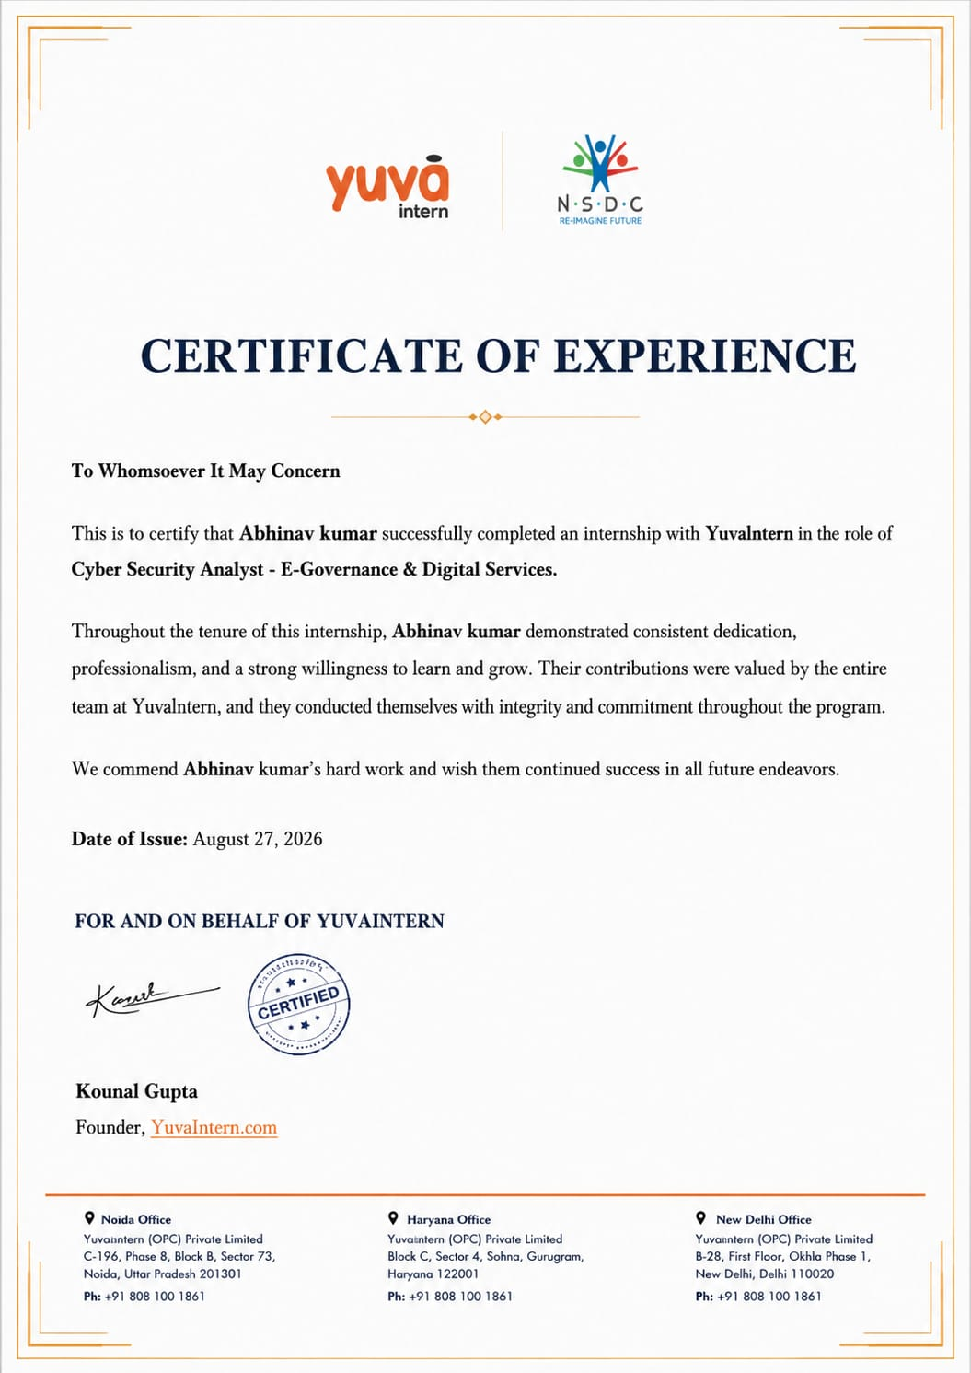
Certificate of Experience issued by Yuvaltern, dated August 27, 2026.

4. PROJECT DESCRIPTION

4.1 Introduction
This report presents a detailed account of the 8-week internship undertaken with Yuvaltern (branded as Yuva Intern, in association with NSDC), in the domain of “Cyber Security – E-Governance & Digital Services”. The internship was carried out over a period of 8 weeks as part of the requirement of the Bachelor of Technology (Computer Science and Engineering) programme at IILM University, Greater Noida, and culminated in the award of a Certificate of Experience dated August 27, 2026. The primary aim of this internship was to bridge the gap between theoretical understanding of cybersecurity concepts and their practical relevance to protecting government and public digital service platforms from cyber threats. Over the course of the programme, the intern was exposed to industry-relevant awareness of cybersecurity principles, threat and risk analysis, and the specific security considerations that apply to e-governance and digital service platforms.
The internship followed a structured, week-wise learning plan that combined conceptual study with applied analysis, reflection, and documentation. On successful completion of the programme, a Certificate of Experience was awarded by Yuvaltern, recognizing the intern's dedication, professionalism, and consistent contribution throughout the internship.
4.2 Organization Profile
Yuvaltern (branded as Yuva Intern) is a skill-development and internship platform operating in association with NSDC (National Skill Development Corporation). The organization is focused on giving students practical, industry-aligned learning experiences across digital and emerging technology domains, including cybersecurity, e-governance, and digital services. Yuvaltern is led by its Founder, Mr. Kounal Gupta, and maintains registered offices in Noida (Uttar Pradesh), Gurugram (Haryana), and New Delhi.
4.3 Problem Statement
A large number of engineering students study computing and networking concepts during their academic coursework, but very few get structured exposure to the practical cybersecurity considerations involved in protecting real-world digital services. As government and public services increasingly move online, e-governance and digital-service platforms present an expanding attack surface that requires professionals who can recognize common threats, assess risks, and apply sound security practices. The problem addressed by this internship was to build a working, analyst-level understanding of cybersecurity fundamentals, common threats and vulnerabilities, and the specific security considerations relevant to e-governance and digital-service platforms — through structured, guided learning rather than through live penetration testing or production security operations.
4.4 Project Objectives
- To understand practical cybersecurity concepts and the core principles of information security.
- To develop awareness of common cyber threats, security risks, and basic vulnerability concepts.
- To understand the security considerations specific to e-governance and digital service platforms.
- To build analytical and problem-solving abilities applicable to security-related scenarios.
- To understand professional cybersecurity practices, including documentation and reporting standards.
- To apply academic knowledge to practical, industry-oriented situations.
- To improve professional communication and technical documentation skills.
- To develop a professional and ethical approach toward cybersecurity practice.
4.5 Scope of the Project
The scope of this internship covered awareness-level study and analysis of cybersecurity fundamentals, common threat vectors, and their relevance to the security of e-governance and digital-service platforms. The work involved understanding risk and vulnerability concepts, studying recognized security frameworks, and applying analytical thinking to security-related scenarios and documentation exercises. The internship was conducted within Yuvaltern's structured virtual learning environment and did not involve penetration testing, ethical hacking, exploitation of live systems, or security operations on any production or organizational infrastructure.
4.6 Technologies and Concepts Studied
- Core Cybersecurity Concepts: the CIA triad (Confidentiality, Integrity, Availability), authentication and access control, and basic encryption principles.
- Threat & Risk Analysis: common attack vectors, vulnerability concepts, and foundational risk-assessment thinking.
- E-Governance & Digital Service Security: security considerations relevant to citizen-facing digital platforms and public-sector online services.
- Security Frameworks & Standards (awareness level): OWASP Top 10, the NIST Cybersecurity Framework, and ISO/IEC 27001 principles.
- Documentation & Reporting: professional security documentation and analytical reporting practices.
- Professional Practices: communication, teamwork, and ethical conduct within a cybersecurity work environment.
4.7 Cybersecurity & E-Governance Security Framework
The conceptual framework studied during the internship for understanding security in e-governance and digital services can be summarized in the following layers:
- Policy & Governance Layer: the rules, standards, and compliance requirements that guide secure digital service delivery.
- Application / Digital Service Layer: security considerations specific to citizen-facing digital services and government portals.
- Network & Access Layer: authentication, access control, and network-level protective measures.
- Threat & Risk Layer: identification and analysis of common vulnerabilities and threat vectors.
- Monitoring & Analysis Layer: awareness of the monitoring and logging practices used to detect anomalies and potential incidents.
- Compliance & Documentation Layer: reporting practices and adherence to recognized security standards and guidelines.
4.8 Methodology
The internship followed a structured, week-wise methodology combining conceptual learning, guided analysis, reflection, and documentation, as summarized in the table below.
Week | Module | Description
1 | Orientation & Introduction | Organizational onboarding, understanding internship expectations, introduction to the cybersecurity domain, and an overview of e-governance and digital services.
2 | Cybersecurity Fundamentals | Core cybersecurity concepts, security principles, threat awareness, and the importance of information security.
3 | Threats & Security Risks | Understanding common cyber threats, security risk awareness, vulnerability concepts, and risk identification.
4 | E-Governance Security | Cybersecurity considerations in e-governance, protection of digital services, and security aspects of online service delivery.
5 | Security Analysis | Analytical approach to security, understanding common security issues, applying cybersecurity concepts, and structured problem-solving.
6 | Practical & Professional Learning | Applying learned concepts, documentation practices, professional communication, and team collaboration.
7 | Consolidation & Development | Reviewing cybersecurity concepts, strengthening analytical skills, and reinforcing professional practices.
8 | Completion & Reflection | Consolidating internship learning, reviewing the overall experience, professional development, and internship completion.

Each week concluded with self-review and reflection on the concepts covered, and select modules involved short documentation exercises. Overall completion was assessed by Yuvaltern, culminating in the award of the Certificate of Experience.
4.9 Expected Outcomes
- Practical understanding of core cybersecurity concepts and terminology.
- Ability to recognize and analyze common cyber threats and vulnerabilities.
- Understanding of the security considerations specific to e-governance and digital-service platforms.
- Awareness of key security frameworks and standards, including OWASP Top 10, the NIST Cybersecurity Framework, and ISO/IEC 27001 concepts.
- Improved analytical thinking, documentation, and professional communication skills.
- A professional, ethics-driven approach to cybersecurity practice.
4.10 Certificate of Completion
The Certificate of Experience issued by Yuvaltern, confirming successful completion of the 8-week Cyber Security Analyst – E-Governance & Digital Services internship, dated August 27, 2026 and signed by Founder Mr. Kounal Gupta, is attached in Chapter 3 of this report.

5. BIBLIOGRAPHY/REFERENCES
1. Yuvaltern (Yuva Intern), “Certificate of Experience – Cyber Security Analyst – E-Governance & Digital Services,” issued August 27, 2026.
2. OWASP Foundation, “OWASP Top 10,” https://owasp.org/www-project-top-ten/
3. National Institute of Standards and Technology (NIST), “Cybersecurity Framework,” https://www.nist.gov/cyberframework
4. International Organization for Standardization, “ISO/IEC 27001 – Information Security Management,” https://www.iso.org/standard/27001.html
5. Ministry of Electronics and Information Technology (MeitY), Government of India, Digital India Programme, https://www.meity.gov.in/
6. Indian Computer Emergency Response Team (CERT-In), https://www.cert-in.org.in/

