

**LOVELY PROFESSIONAL UNIVERSTY**

**CSE326**

PROJECT

**GROCERY WEBSITE**

**Project Group Number: 5**

**Course Code: CSE326**

**Under the guidelines of**

**Ms. Nahita Pathania**

**School of Computer Science and Engineering**

**Lovely Professional University**

**Punjab, India**

Submitted By:

ABHINAV ARUN 12006206

MANISH RAGHAV 12006257

BHUVIK GUGNANI 12006761

**TABLE OF CONTENTS**

Table of Content……………………………………………….………….. (2)

Declaration…...……………………………………………….…………… (3)

Certificate……..…….……………………………………….……………. (4)

Introduction……..…………………...………………………..………........ (5)

Purpose of the Website……………………..……………………….……... (5)

Hardware and Software Requirements….………………………..….…….. (6)

Tags Used…………………………………………………………………... (7)

Module wise description ………………...………………..………………… (8) - (17)

Benefits of Grocery website………...………………………….…………… (18)

**DECLARATION**

We hereby declare that the project work entitled (“ABM GROCERY WEBSITE”) is an authentic record of our own work carried out as requirements of Capstone Project for the award of B.Tech degree in Computer Science and Engineering from Lovely Professional University, Phagwara, under the guidance of Ms. Nahita Patania, during January to May 2021. All the information furnished in this project report is based on our own intensive work and is genuine.

Project Group Number: 5

Name of Student 1: Abhinav Arun

Registration Number: 12006206

Name of Student 2: Manish Raghav

Registration Number: 12006257

Name of Student 3: Bhuvik Gugnani

Registration Number: 12006761

**CERTIFICATE**

This is to certify that the declaration statement made by this group of students is correct to the best of my knowledge and belief. They have completed this Project under my guidance and supervision. The present work is the result of their original investigation, effort and study. No part of the work has ever been submitted for any other degree at any University. The Capstone Project is fit for the submission and partial fulfillment of the conditions for the award of B.Tech degree in Computer Science and Engineering from Lovely Professional University, Phagwara.

**Signature and Name of the Mentor**

**Designation**

**School of Computer Science and Engineering,**

Lovely Professional University,

Phagwara, Punjab.

Date: 04th May 2021

**INTRODUCTION**

The ABM Grocery Website is developed to override the problems of people travelling to shops and markets to buy groceries. Moreover this site is designed for the particular need of the company to carry out operations online in a smooth and effective manner.

**Purpose of the Website**

The Corona virus pandemic changed consumer habits, forcing food retailers to adapt quickly. Millions of households started buying groceries online for pickup or home delivery and many will continue using ecommerce options after the crisis passes. In 2020, the relationship with grocery shoppers and food retailers changed dramatically, causing a surge in online orders nobody expected. Online ordering is also changing what customers buy and creating a more personalized experience. Instead of unrelated items placed far apart in a physical store, retailers and food brands can connect items in the ordering app. A push towards personalization and recommendations, paired with powerful Artificial intelligence algorithms, has not only increased how well grocery stores and delivery services know their customers, but also increased targeted marketing.

Instead of going to shops, people prefer to get things in one click at their houses ABM store is open 24/7.We have dedicated delivery workers which ensure fast and safe delivery. ABM also provide best deals customer reviews to get glimpse of product and have separate section for best deals with regular update of discount on products, Have various payment options. The old model is dying. To survive, grocers need to deliver fresher, healthier, more convenient, transparent food, and cater to local markets and demographics. It will be a complete revolution for ABM users and the grocery business has been stable for decades, but with modernization and digitalization, the industry is finding new ways to feed consumers needs.

**HARDWARE AND SOFTWARE REQUIREMENTS:**

* 1. **Servers:**
* Operating System Server: Windows 8 or later
* Notepad/VSCode/Notepad++
* Hyper Text Markup Language
* Web Browser (Chrome, Edge, Safari)
* Cascading Style Sheets
  1. **Hardware specification:**
* Processor: Intel Pentium or more
* Ram: 2.00GB Ram
* Hard Disk: PC with 20GB

**Tags used**

* <!DOCTYPE> - Defines the document type
* <html> - Defines an HTML document
* <title> - Defines a title for the document
* <body> - Defines the document’s body
* <h1> to <h6> - Defines HTML headings
* <p> - Defines a paragraph
* <br> - Inserts a single line break
* <hr> - Defines a thematic change in the content
* <!–…–> - Defines a comment
* <small> - Defines smaller text
* <input> - Defines an input control
* <button> - Defines a clickable button
* <img> - Defines an image
* <a> - Defines a hyperlink
* <link> - Defines the relationship between a

document and an external resource (most used to link to style sheets)

* <nav> - Defines navigation links
* <ul> - Defines an unordered list
* <li> - Defines a list item
* <table> - Defines a table
* <th> - Defines a header cell in a table
* <tr> - Defines a row in a table
* <td> - Defines a cell in a table
* <div> - Defines a section in a document
* <span> - Defines a section in a document
* <header> - Defines a header for a document or section
* <footer> - Defines a footer for a document or section
* <head> - Defines information about the document
* <meta> - Defines metadata about an HTML document

**MODULE WISE DESCRIPTION**

1. Homepage, Cart, Product Page, Vision & Purpose
2. Responsibility: **ABHINAV ARUN**

**HOMEPAGE**

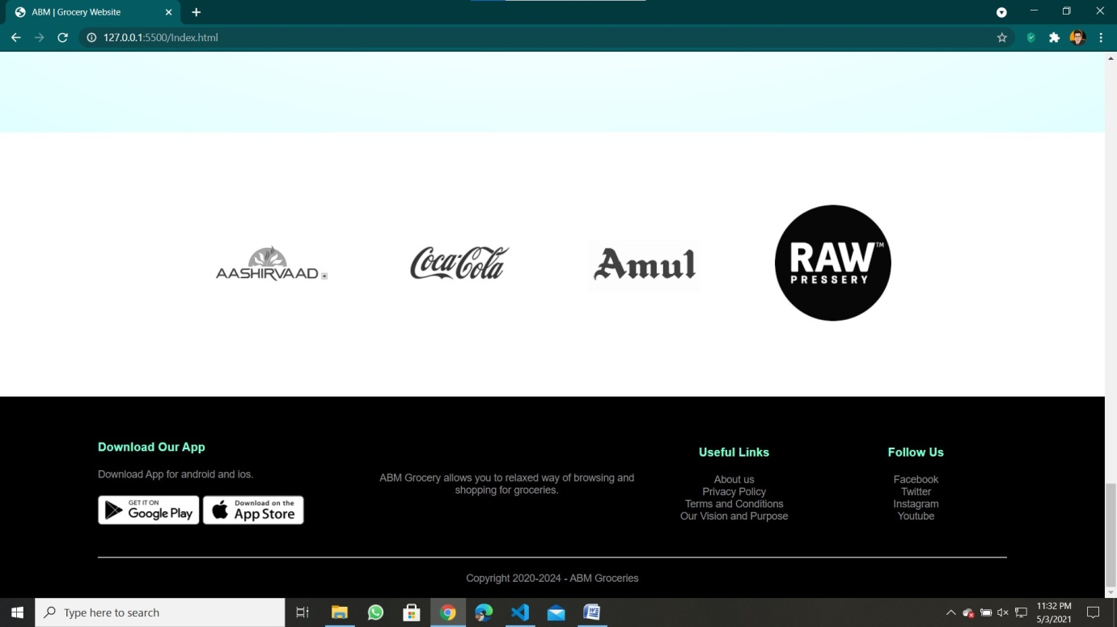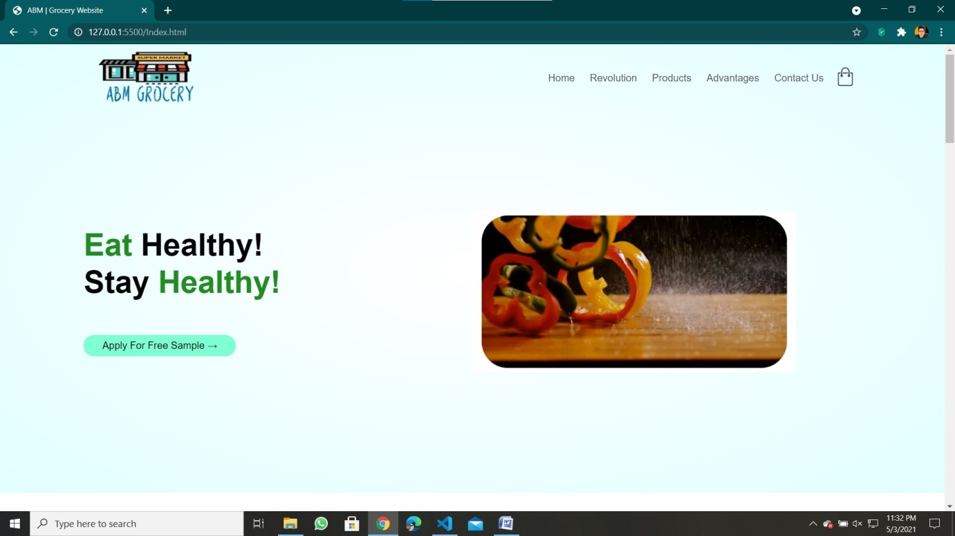

Homepage contains all the information and links to other pages of the website.

The navigation bar at the top has links to the pages: Revolution, Products, Advantages and Contact Us.

Header displays a video and Button to apply for free sample. Today’s Offers, features and latest products are displayed. An exclusive product and some of the company logos are also displayed.

Footer contains the Website’s motto and links to the other pages: About Us,

Privacy Policy, Terms and Conditions and Our Vision.

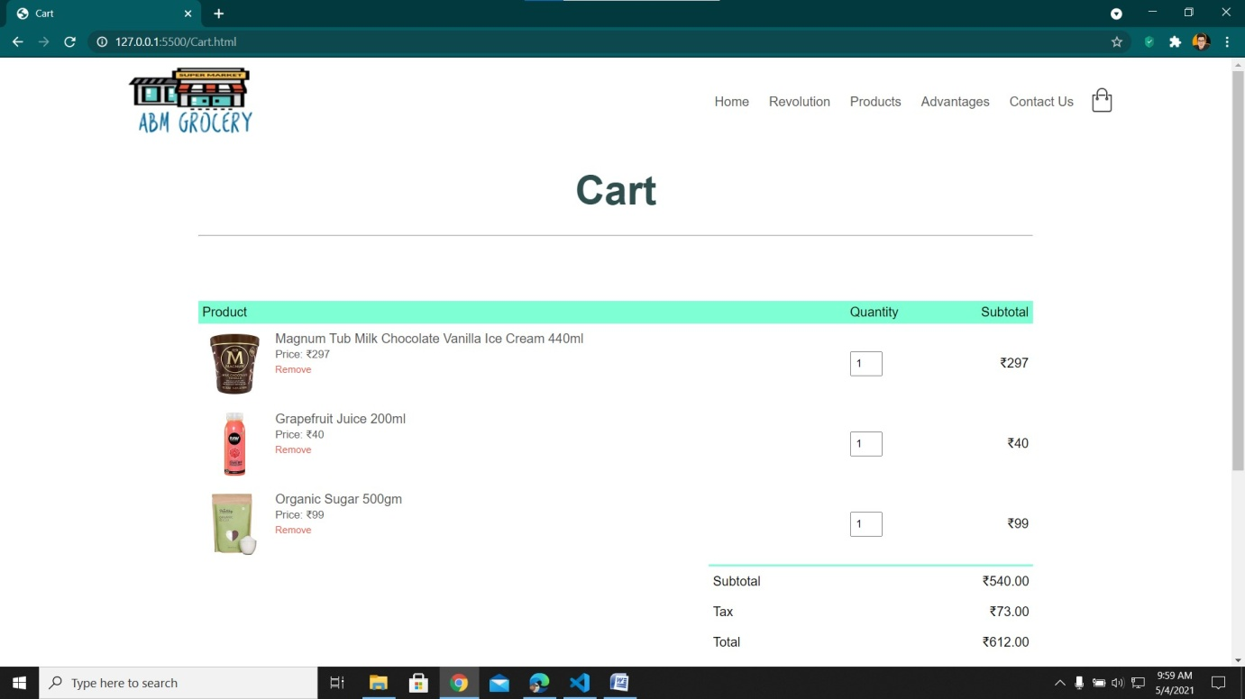**Cart**

Cart page displays the products which you have selected to purchase and also shows the individual product image, price and quantity selected. Total price along with Tax is displayed below that.

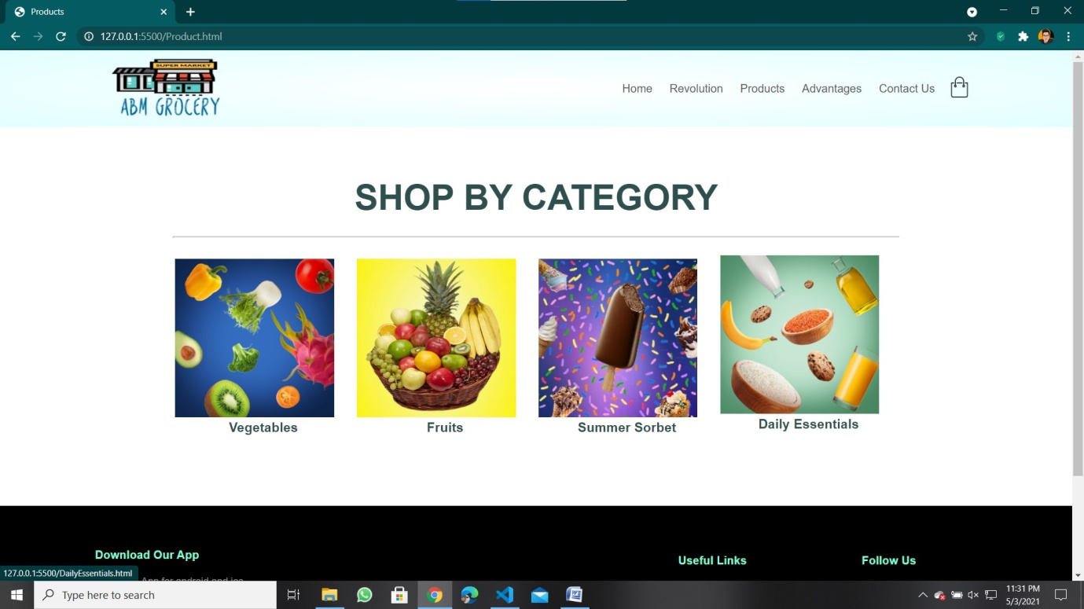**Product Page**

Product page displays four sub categories to select accordingly:

1. Vegetables: This page contains fresh vegetables.

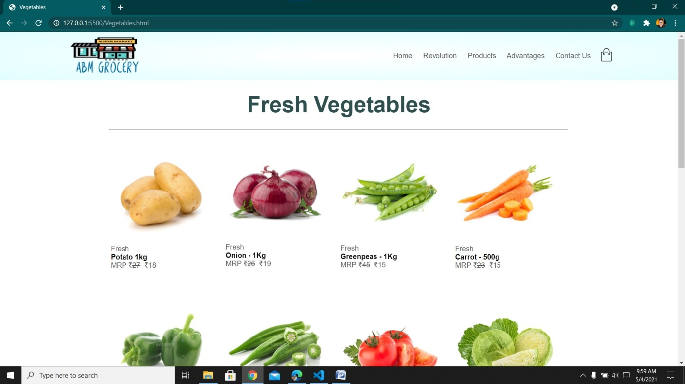

1. 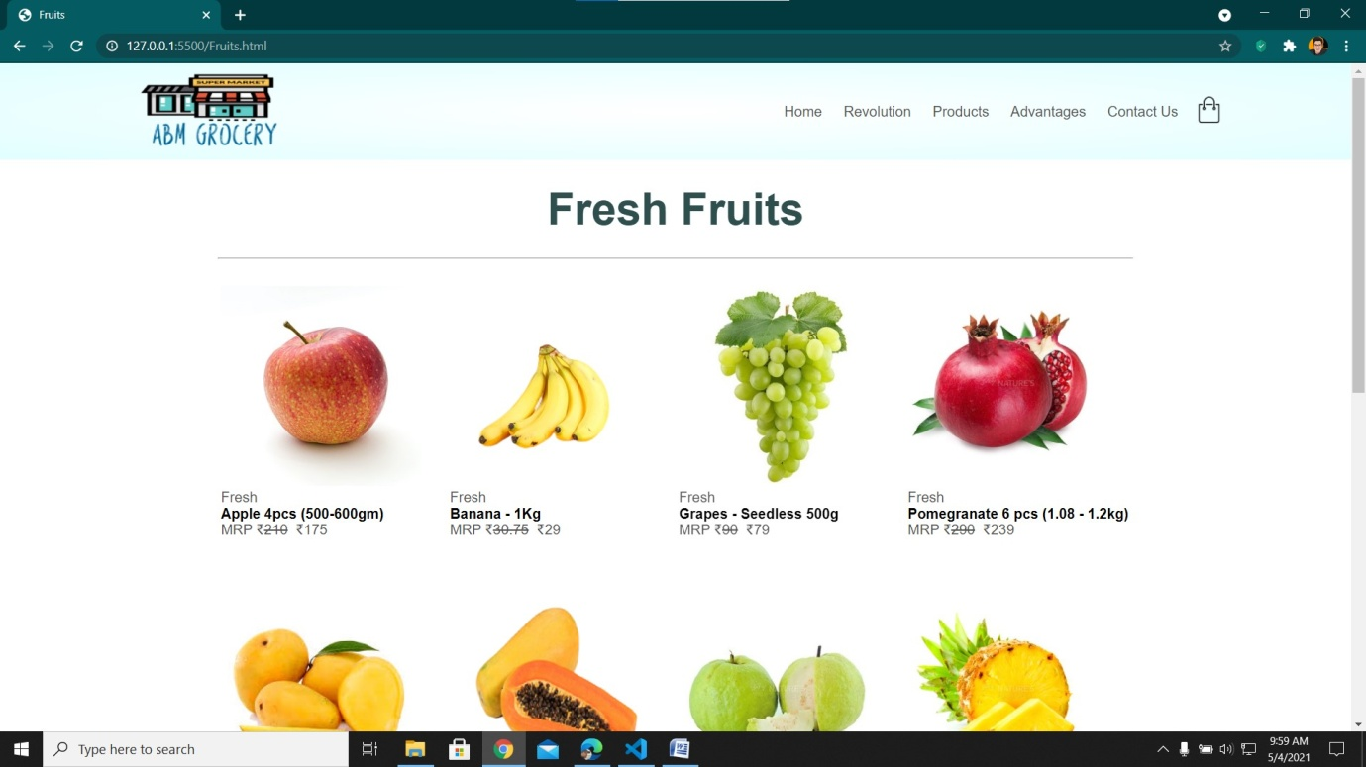Fruits: This page contains fresh fruits.
2. Summer Sorbet: This section displays Ice-creams and other summer drinks and juices.

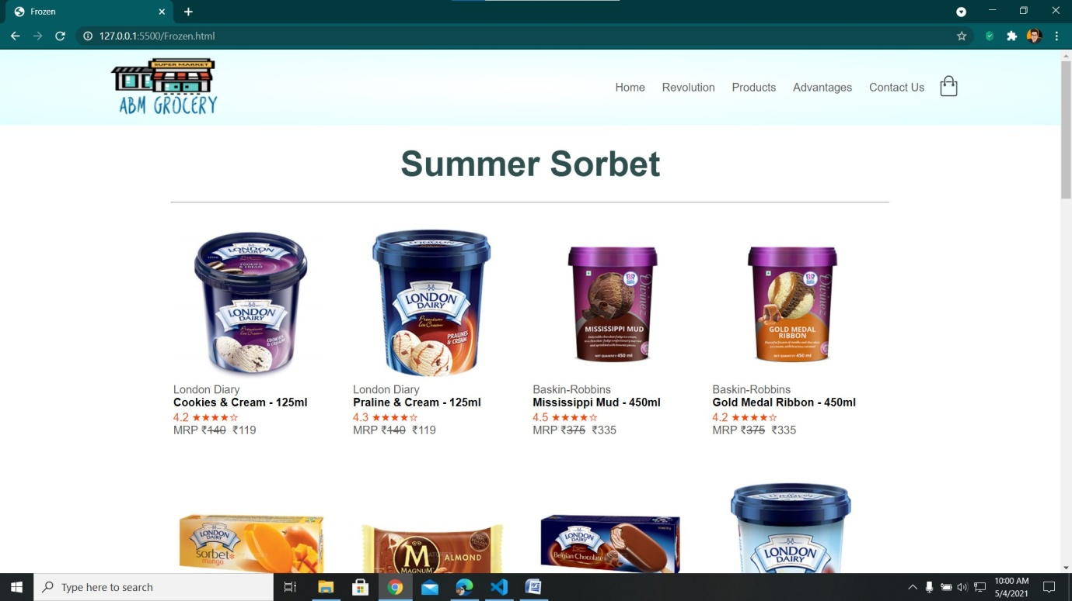

1. 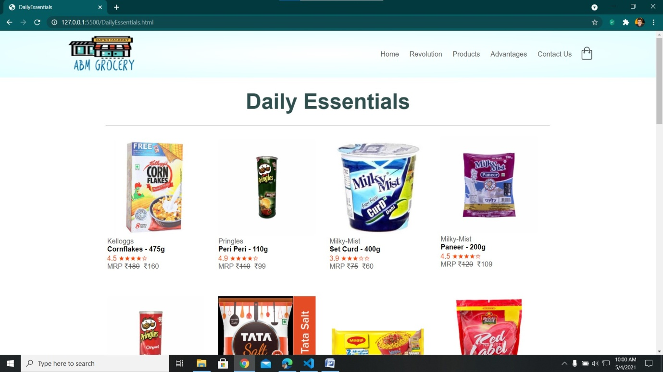Daily Essentials: This page contains all the day to day used products and grocery items.

**Our Vision and Purpose**

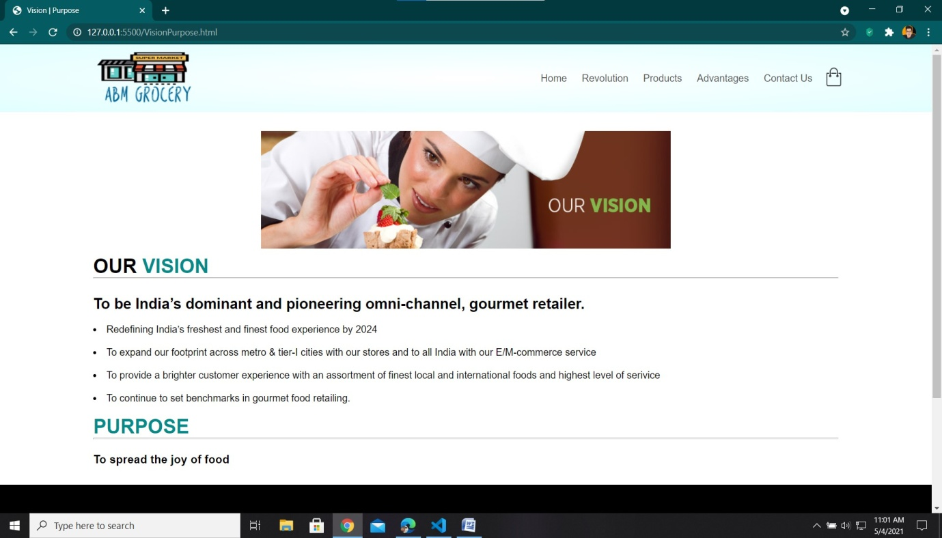Our vision and Purpose page displays our main vision of becoming one of the leading E/M service in India. To continue to set a benchmark in gourmet food retailing . This also helps the customer to understand the companies true motto and join them in their growth.

1. Revolution, Contact Us, Privacy and Policy
2. Responsibility: **MANISH RAGHAV**

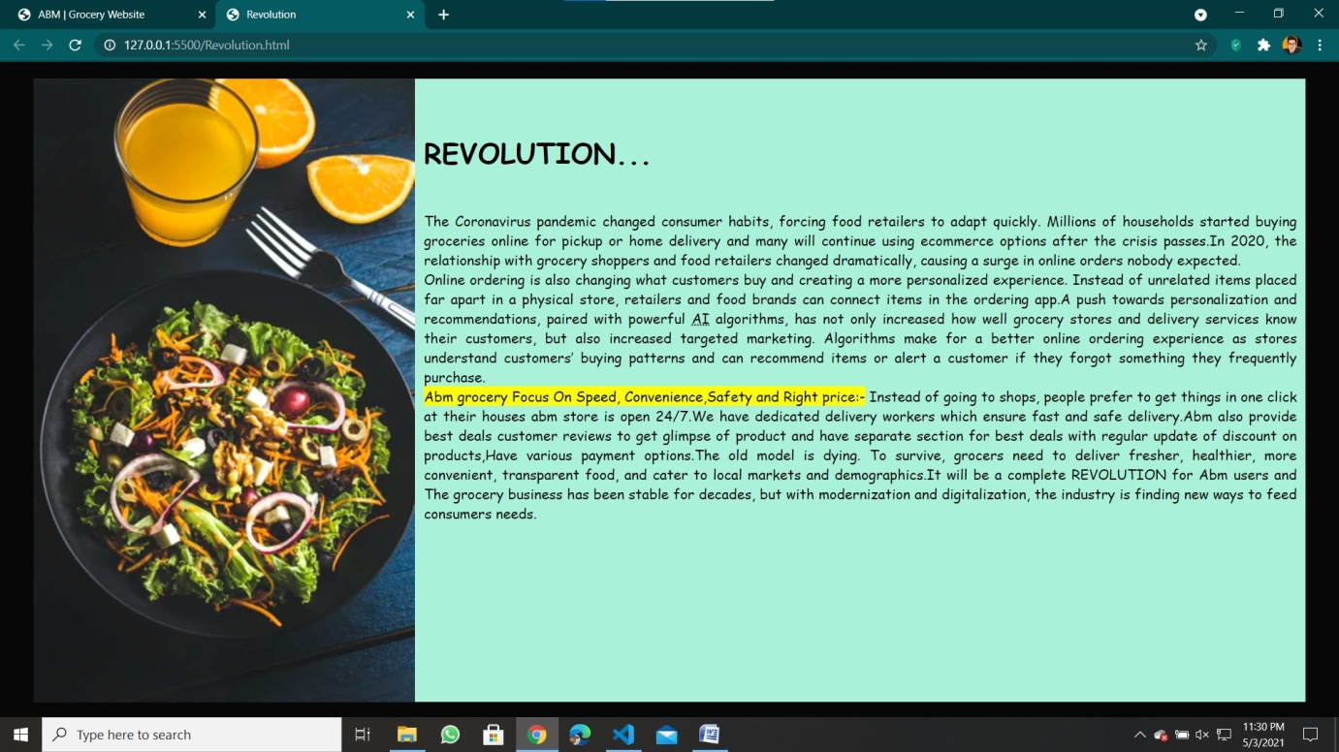**REVOLUTION**

Revolution pages tells about the recent Covid times and how the all the systems chose the online mode which created a boom in the online E/M commerce industry. This page displays the boon of using online services in these hard times.

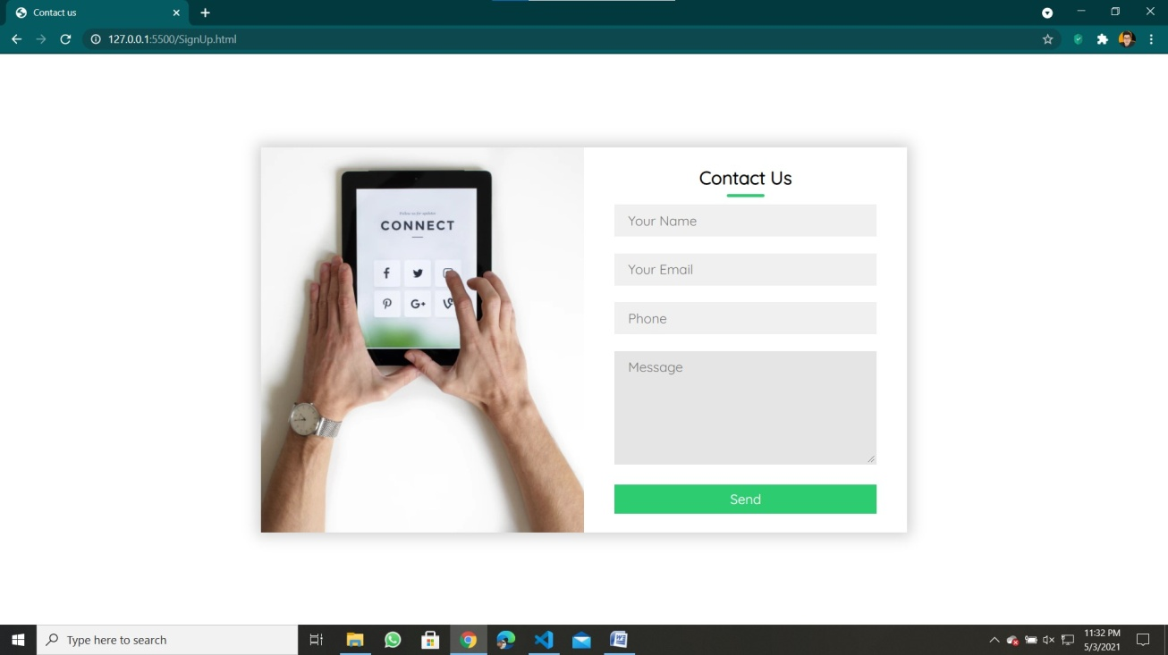**Contact Us**

Contact Us Page helps the customer to contact the website owners in case of any problem faced while using the website. The interface is very simple, it asks the customer’s name, email, phone number and message. E-mail and phone number helps the company to resolve the issue and comeback to the customer as soon as possible.

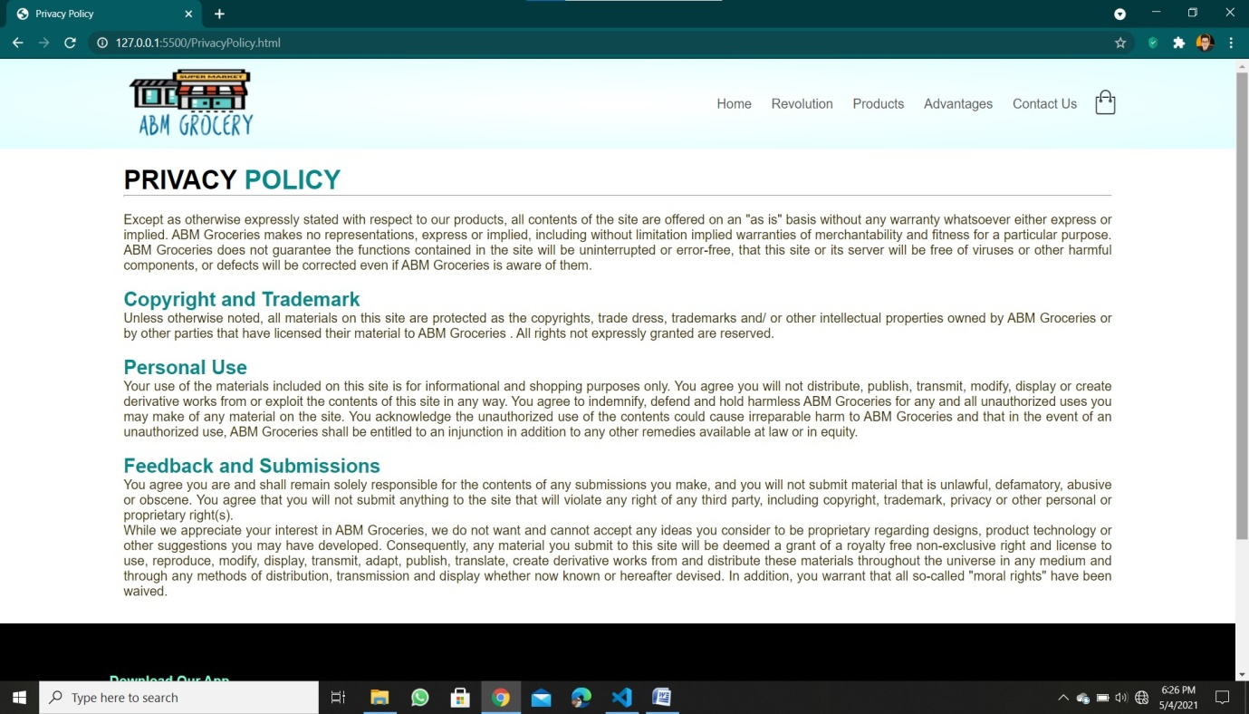**Privacy And Policy**

This page displays the privacy policy of the company. Copyright and Trademark, personal use of the website by an individual. It shows the feedback and submission the customer makes and anything against the rules and policy of the website is lawfully punishable.

1. Advantages, Terms and Conditions, About Us.
2. Responsibility: **BHUVIK GUGNANI**

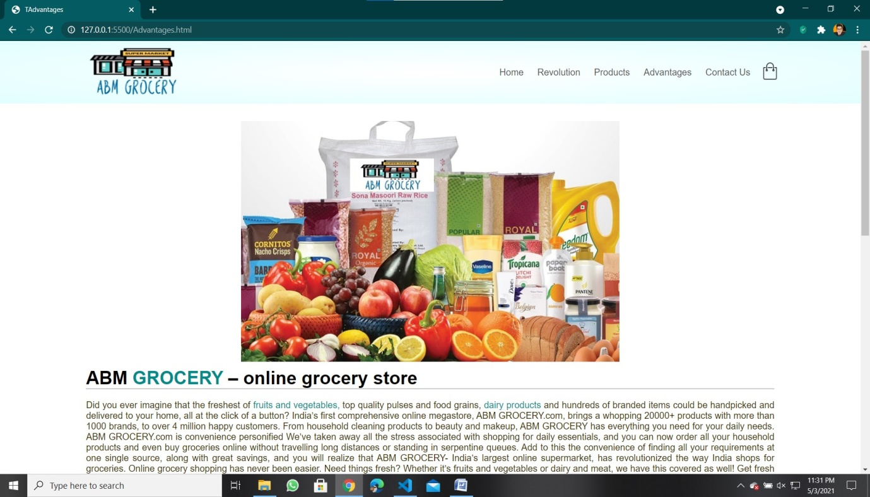**Advantages**

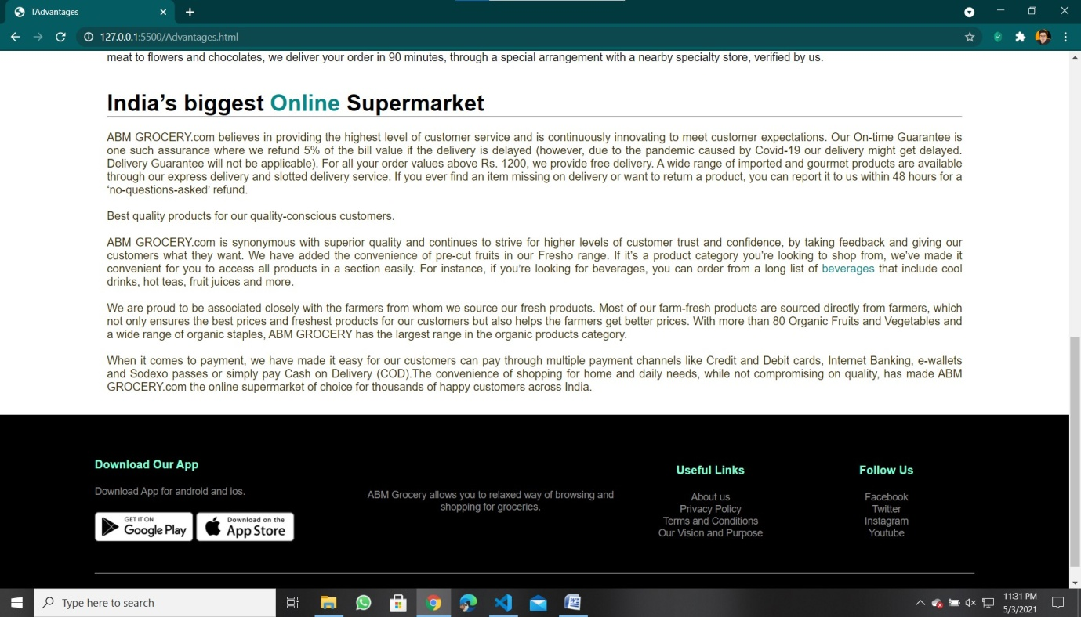This page displays the advantages of using online E/M commerce services using a readily available site for ordering daily groceries without going out. Customer gets to use 24/ 7 website with speedy deliveries to their doorstep and payments are made so easy with all the major payment methods included like paytm, net banking etc.

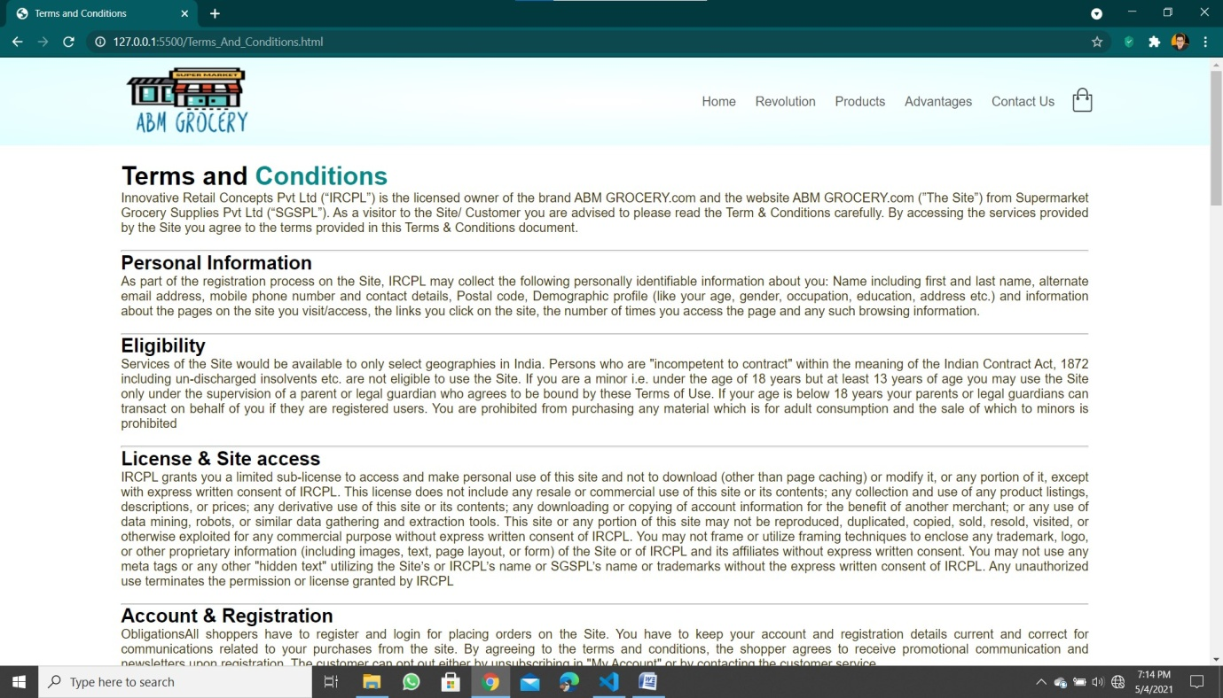**Terms and Conditions**

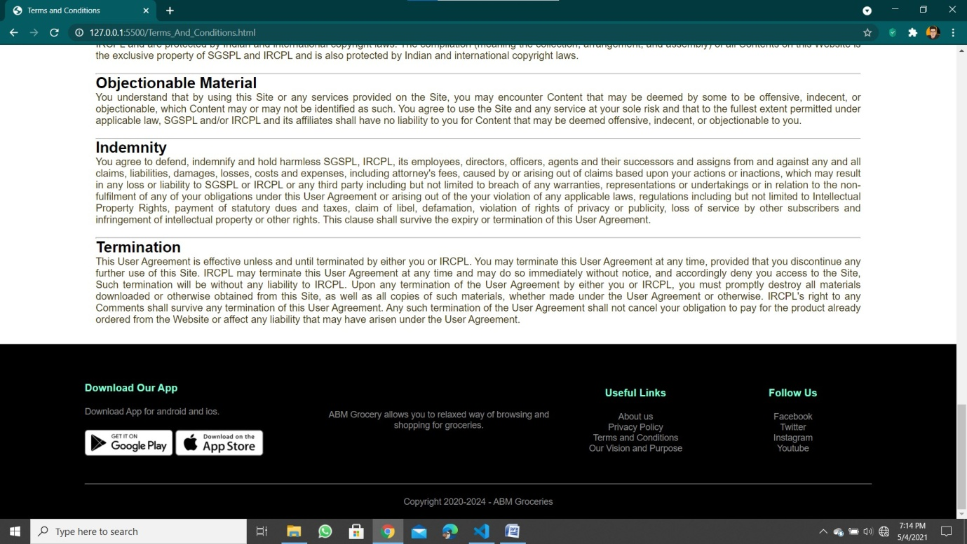

Terms and conditions page displays the security of customer’s personal information, eligibility (age criteria) and other account registration information related to the website. This is included so the customer understands and adheres to the usage criteria of the website.

**About Us**

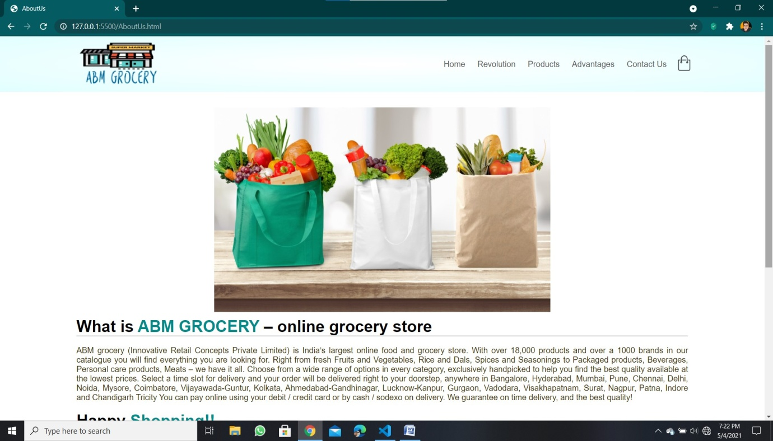

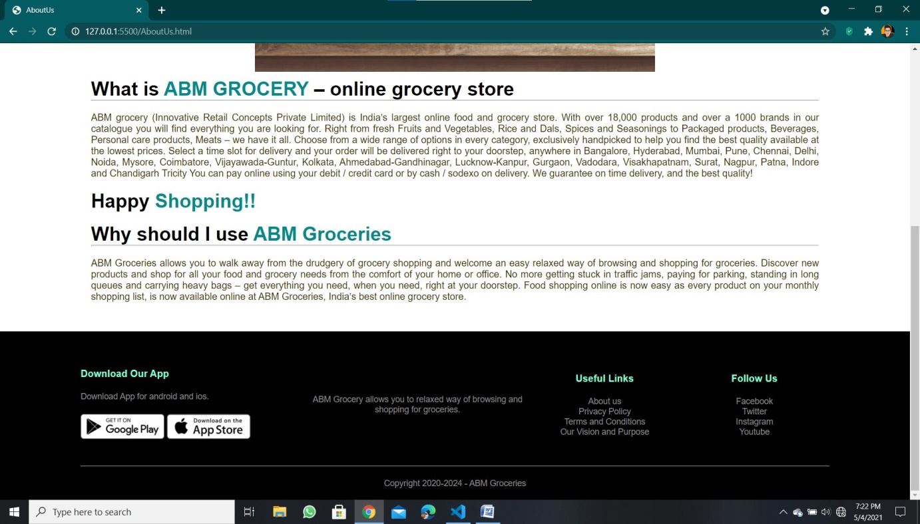

A good About Us page doesn't just tell the story behind a company-it shows it. The page also displays the services and products which are made easily available and it also includes the various states and cities covered. It shows the unique selling point of the website that is to provide day to day groceries at the customer’s doorstep without making them carry heavy bags at a reasonable price.

**Benefits of Grocery Website**

The Corona virus pandemic changed consumer habits, forcing food retailers to adapt quickly. Millions of households started buying groceries online for pickup or home delivery and many will continue using ecommerce options after the crisis passes. In 2020, the relationship with grocery shoppers and food retailers changed dramatically, causing a surge in online orders nobody expected. Online ordering is also changing what customers buy and creating a more personalized experience.

This Website helps the customer to shop according to their choice and time and also delivers the groceries to their doorstep with ease without having them to carry heavy bags. The old model of going to grocery shops is dying. To survive, grocers need to deliver fresher, healthier, more convenient, transparent food, and cater to local markets and demographics. It will be a complete revolution for ABM users and the grocery business has been stable for decades, but with modernization and digitalization, the industry is finding new ways to feed consumers needs and this site helps them to do in an effective manner.