**1. Select all attributes for all employees and order them alphabetically by last name:**

***Select* FfromEmployees Order By lname***

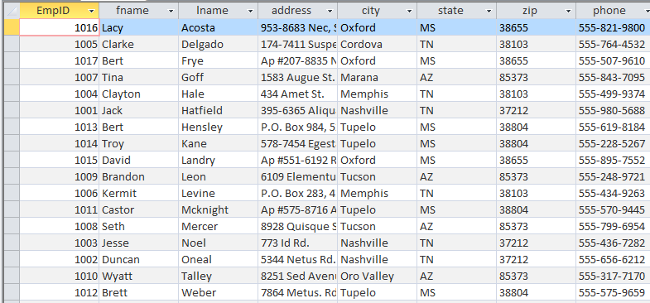

**2. Select the first name, last name, city, state and phone number for all employees living in Arizona (AZ)**

***Select fname,lname,city,state,phone from Employees where state='AZ'***

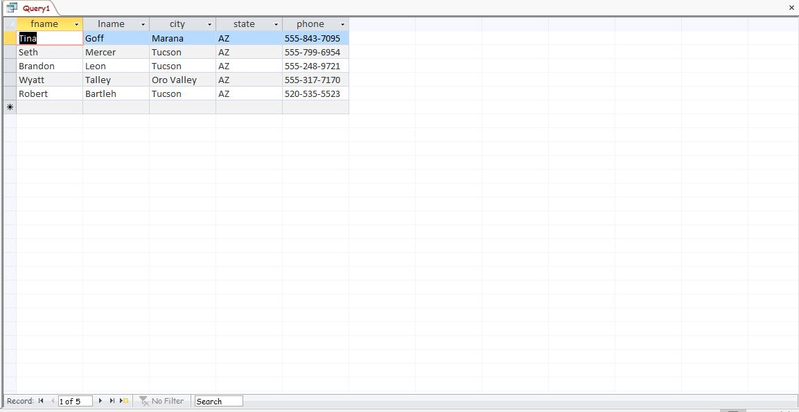

**3. For each store, display the store’s address, city, state, zip, the manager’s first and last name, and manger’s phone number**

***Select S.address,S.city,S.state,S.zip,E.fname,E.lname,E.phone from Stores S, employees E where S.manager = E.empID***

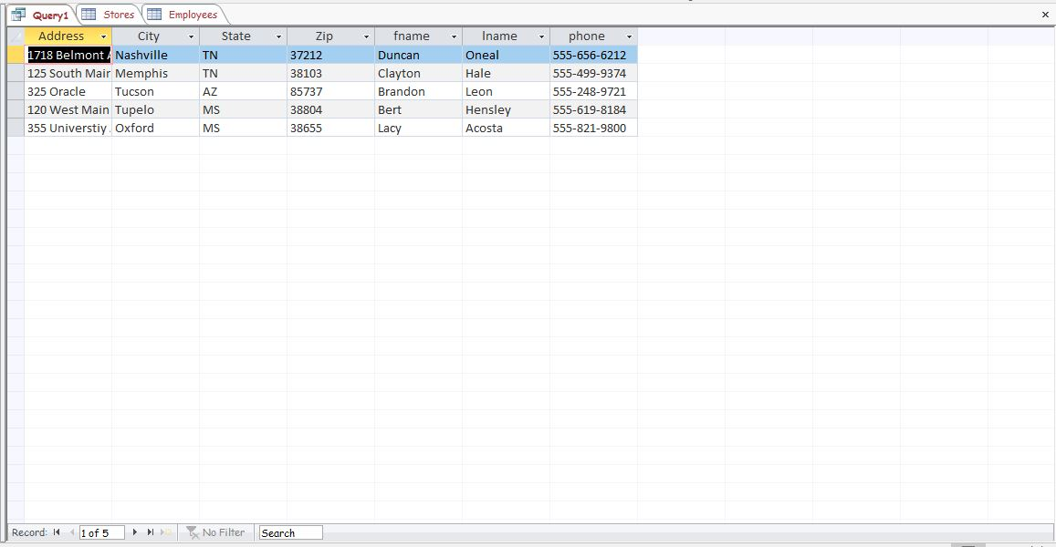

**4.Display the names and prices of products with a price under $10, ordered so that the most expensive item is at the top and the least expensive item is at the bottom**

***Select product,price from Inventory where price <10 order by price desc***

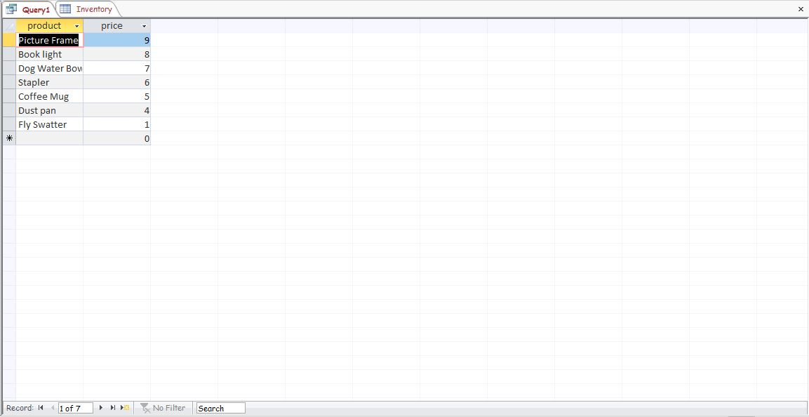

**5. Display the inventory for the Memphis store. Display the city, product, price and quantity. List each item alphabetically with the price and quantity in stock. If you cannot get the entire list in one screenshot that is OK – just take a screenshot that shows the first 10 items.**

***Select city,product,price,quantity from Inventory I , (Select invid,quantity,city from stock S , (Select StoreId,city from Stores where city='Memphis') t where s.storeid = t.storeId) f where f.invid = I.invid order by product***

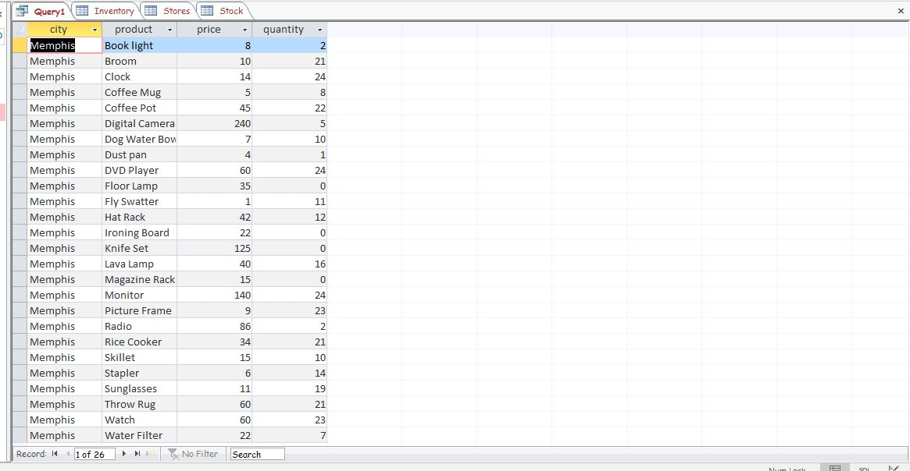

**6. Display the name and price of all product with the word “water” anywhere in the product name.**

***Select product,price from inventory where product like '*water*'***

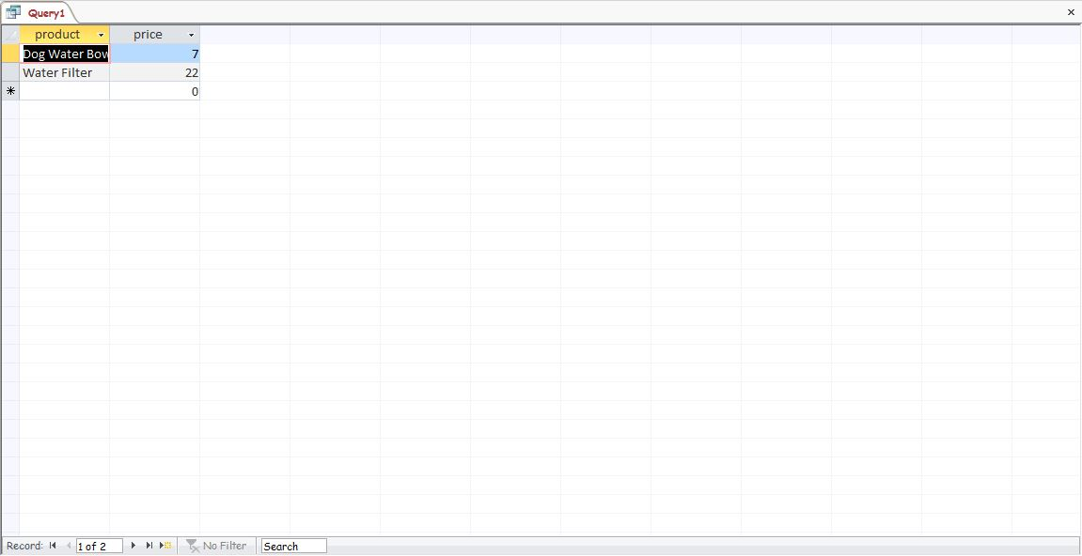

**7 . Add a new employee with the following information (No Screenshot needed)**

***Insert into Employees (empID,fname,lname,address,city,state,zip,phone) values('2001','Robert','Bartleh','125 Birdy Lane','Tucson','AZ','85705','520-535-5523')***

**8.** **Associate the employee created in #7 with the Tucson store. Start date is 7/24/2013. (No Screenshot needed)**

***Insert into Emp_store (empID,StoreID,startDate) values('2001','3','7/24/2013')***

**9.** **You are changing management styles! Make the employee you created in #7 the manager for all stores in Mississippi (MS) – do this using one SQL command (No Screenshot needed)**

***Insert into Emp_store (empID,StoreID,startDate) values('2001','3','7/24/2013')***

**10.** **For each store, display the address, city, state, zip, manager’s first and last name, and manger’s phone number (Do this AFTER steps 7-9)**

***Select S.address,S.city,S.state,S.zip,E.fname,E.lname,E.phone from Stores S, employees E where S.manager = E.empID***

