**MongoDB Installation**

We can Download and install from the Link

[**https://www.mongodb.com/try/download/community**](https://www.mongodb.com/download-center?jmp=tutorials#atlas)

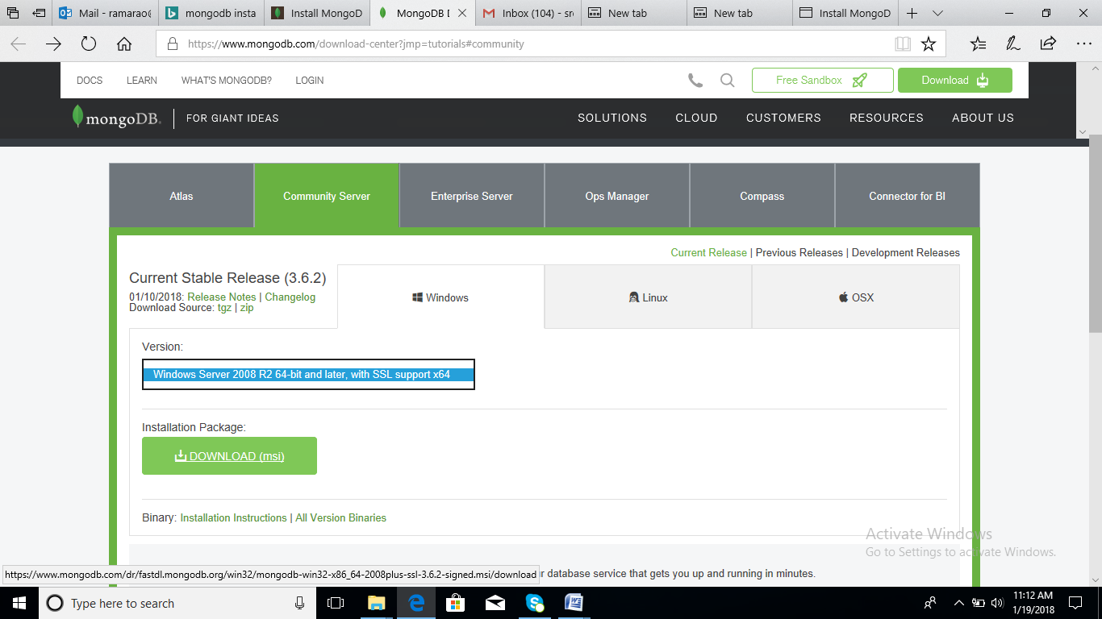

After Download Just run the Setup file >>

Next >> select Complete Option >> next >>

Once the installation Completed

We can check the installation at c:\ProgramFile\MongoDB Folder

We need to set the path variable

Right Click on MyComputer >> Properties >> Advanced System Settings Link >> Advanced Tab >> EnvironmentVariables >> at System Variables >> select Path option >> Edit >> New >> Specify the path as

C:\Program Files\MongoDB\Server\3.4\bin

Now to Check the Installation

Run Command Prompt as Administrator

Run the command : Mongo –version

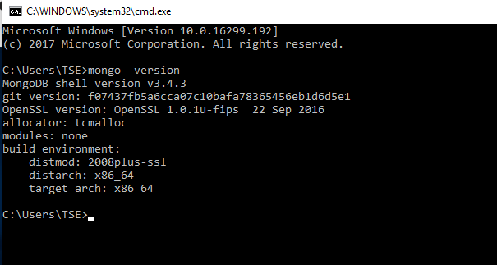

Indicates Mongo Installed Succesfully and ready to use

**To start Mongo Server**

First We need to Create a folder which is the Physical Location for the databases we are going to create using MongoDB

**Create A folder named MongoData at any Drive**

Let it be E:\MongoData

Now to start Mongo Server

Run Command Prompt as Administrator

Use the command

**Mongod --dbpath “E:\MongoData”**



Indicates our MongoDB server Launched Successfully

**Now To connect MongoDB Server using MongoShell**

Open New Command Prompt

Use Command

mongo >> press Enter

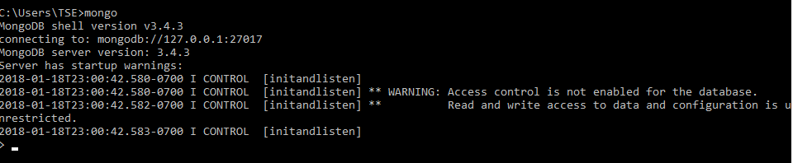

**Enjoy MongoDB Queries Now**

**For GUI IDE to Work with MongoDB**

**NoSqlBoosterForMongo :** (Previously MongoBooster)

https://nosqlbooster.com/downloads

**Studio3t :**

https://studio3t.com/download/