HOSPITAL PATIENT READMISSION ANALYSIS
Diabetes 130-US Hospitals Dataset

Prepared by: Data Analytics Portfolio Project
Dataset: 101,766 raw records | 69,560 after cleaning
Tools: Python, Pandas, SQLite, Scikit-learn, Matplotlib/Seaborn

1. Executive Summary
This report presents a full end-to-end data analysis of hospital patient readmission patterns using the Diabetes 130-US Hospitals dataset. The study covers 130 US hospitals across 1999-2008 and examines clinical and demographic factors contributing to early readmission (within 30 days).

Key business question: Which patients are most at risk of being readmitted within 30 days, and what clinical factors drive this risk?

Overall Readmission Rate: Only 8.84% of cleaned patient records were readmitted within 30 days — but with 69,560 total patients, that represents over 6,150 high-risk readmissions with significant cost and care quality implications.

2. Data Overview & Cleaning

2.1 Dataset Summary
Metric | Value
Raw Records | 101,766
Cleaned Records | 69,560
Features (after cleaning) | 48
High-Risk Readmissions (<30 days) | 6,150 (8.84%)
Readmitted >30 days | 21,804 (31.4%)
Not Readmitted | 41,606 (59.8%)

2.2 Cleaning Steps
- Replaced all "?" placeholder values with NaN for proper handling
- Dropped 3 columns exceeding 40% missing data: weight, medical_specialty, max_glu_serum, A1Cresult
- Removed 30,248 duplicate patient records — kept first encounter per patient
- Created binary target variable: readmitted_binary (1 = readmitted within 30 days, 0 = otherwise)
- Mapped age groups to numeric midpoints for machine learning compatibility

3. SQL Analysis — Key Findings

3.1 Readmission Rate by Age Group
Older patients are significantly more likely to be readmitted. Patients aged 70-90 have readmission rates above 10%, nearly double that of patients under 40.

Age Group | Total Patients | Readmitted | Rate (%)
[0-10) | 153 | 3 | 1.96%
[30-40) | 2,626 | 186 | 7.08%
[50-60) | 12,135 | 859 | 7.08%
[60-70) | 15,517 | 1,386 | 8.93%
[70-80) | 17,721 | 1,789 | 10.10%
[80-90) | 11,273 | 1,168 | 10.36%

3.2 Readmission Rate by Race
Caucasian patients show the highest absolute readmission rate at 9.00%, while Hispanic and Other groups show lower rates around 7-8%. This may reflect differences in patient volume and access to follow-up care.

3.3 Insulin Usage & Readmission
Patients whose insulin dosage was decreased (Down) had the highest readmission rate at 10.42%, followed by increased (Up) at 9.70%. Patients on no insulin had the lowest rate at 8.17%, suggesting dosage changes may signal unstable glucose management.

Insulin Status | Total | Readmitted | Rate (%)
Down (decreased) | 7,358 | 767 | 10.42%
Up (increased) | 6,750 | 655 | 9.70%
Steady | 21,337 | 1,942 | 9.10%
No insulin | 34,115 | 2,786 | 8.17%

3.4 Number of Diagnoses vs Readmission
A strong positive trend exists between number of diagnoses and readmission risk. Patients with 9+ diagnoses had a 9.79% readmission rate versus only 3.19% for those with a single diagnosis — a 3x difference.

3.5 Medication Volume & Readmission
Higher medication counts correlate with higher readmission rates. Patients on more than 20 medications had a 10.24% readmission rate, compared to 7.04% for those on fewer than 10.

Medication Group | Total | Readmitted | Rate (%)
Low (< 10) | 15,516 | 1,092 | 7.04%
Medium (10-20) | 38,528 | 3,469 | 9.00%
High (> 20) | 15,516 | 1,589 | 10.24%

4. Exploratory Data Analysis

4.1 Readmission Distribution
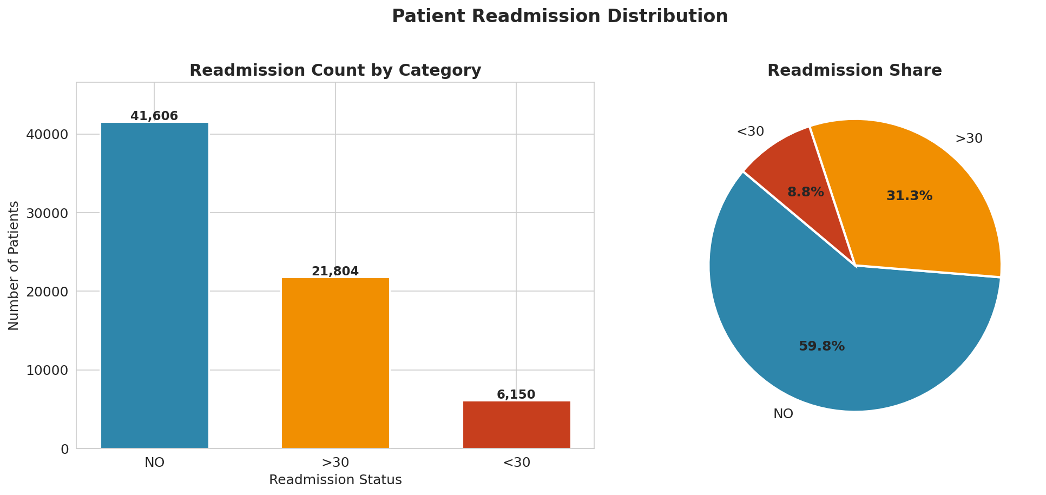
The majority of patients (59.8%) were not readmitted. Only 8.84% were readmitted within 30 days — these are the high-risk cases the model aims to identify. The class imbalance is an important consideration for modeling.

4.2 Readmission Rate by Age
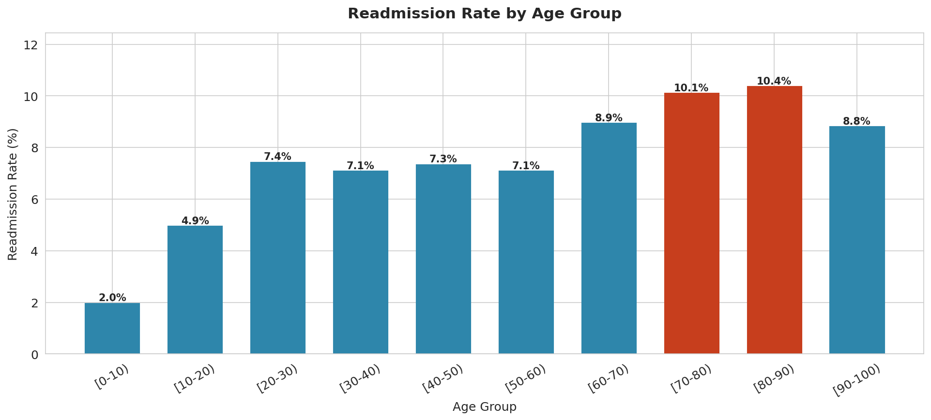
The bar chart confirms the SQL finding: readmission risk rises steeply from age 60 onwards. The 80-90 age group has the highest rate at 10.36%.

4.3 Time in Hospital vs Readmission
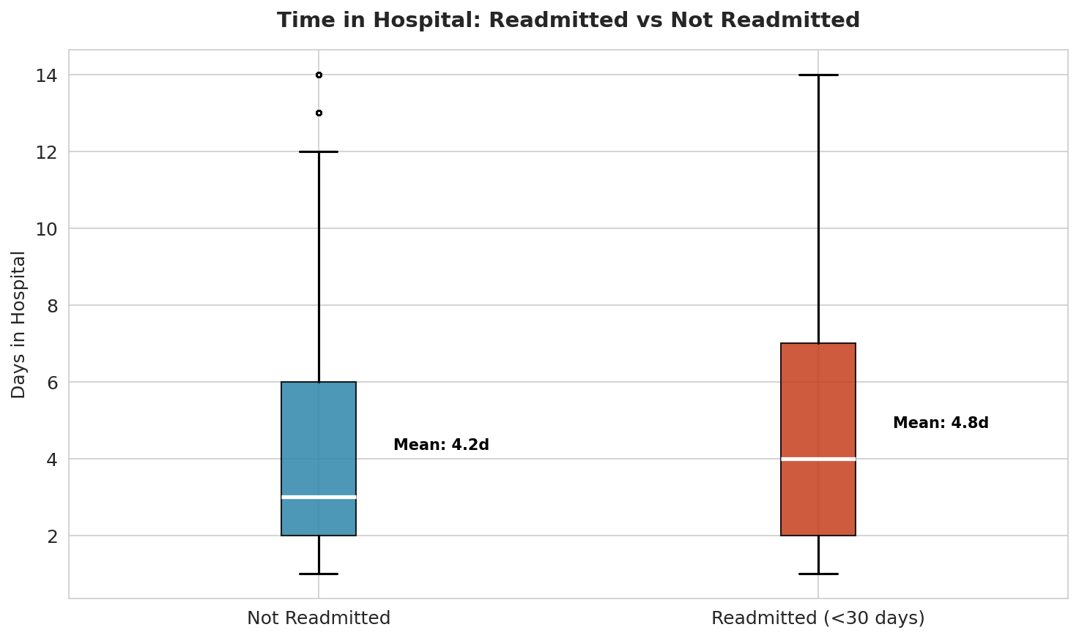
Patients readmitted within 30 days had a slightly higher average stay (4.80 days) compared to non-readmitted patients (4.24 days). However, the overlap in distributions suggests time alone is not a strong predictor.

4.4 Correlation Heatmap
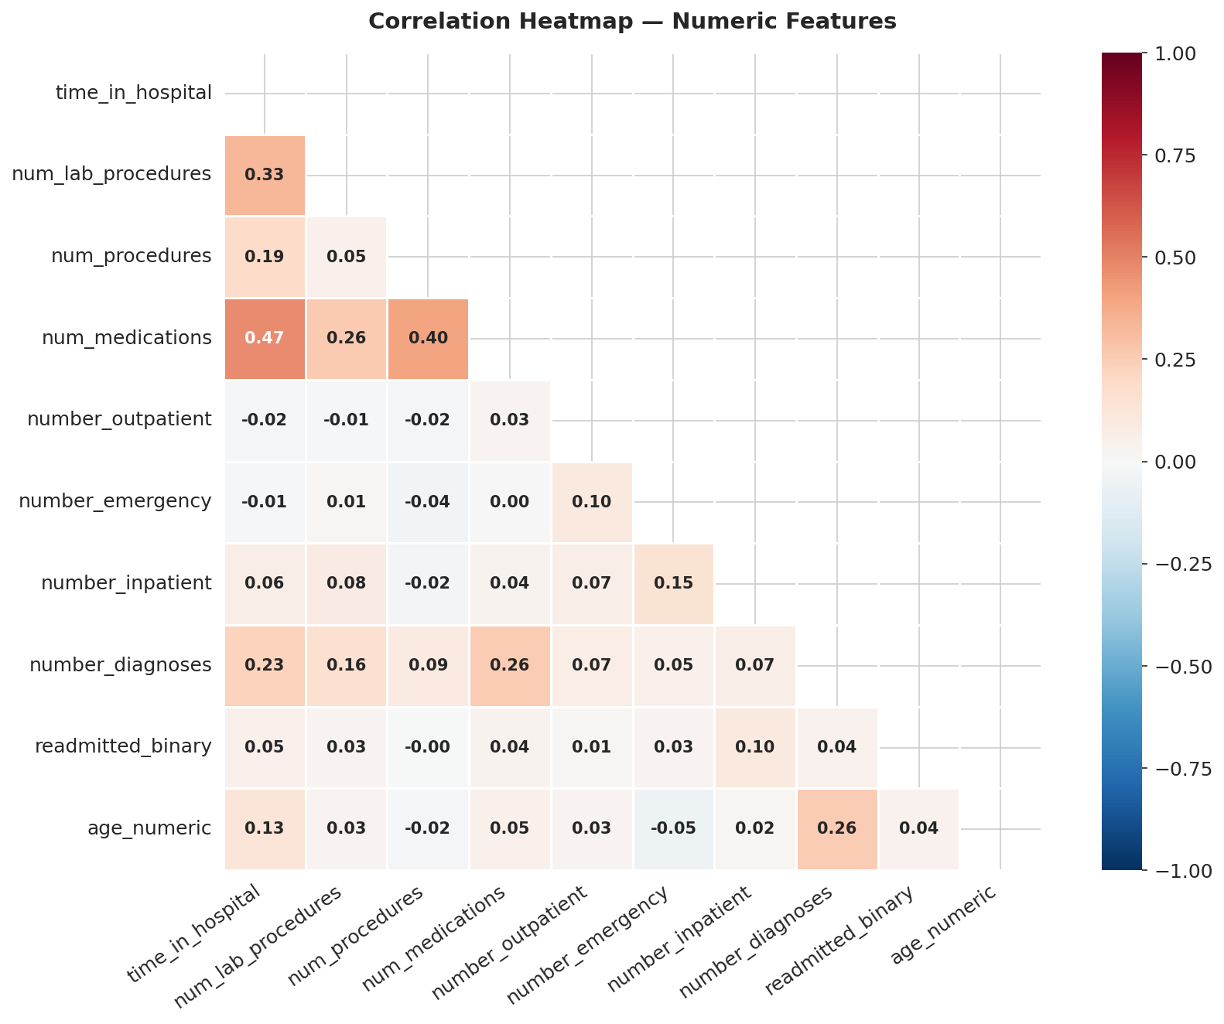
The heatmap reveals that number_inpatient, number_emergency, and number_diagnoses show the strongest positive correlations with readmission. Number of lab procedures and medications are moderately correlated with each other but weakly with readmission.

4.5 Readmission by Insulin Usage
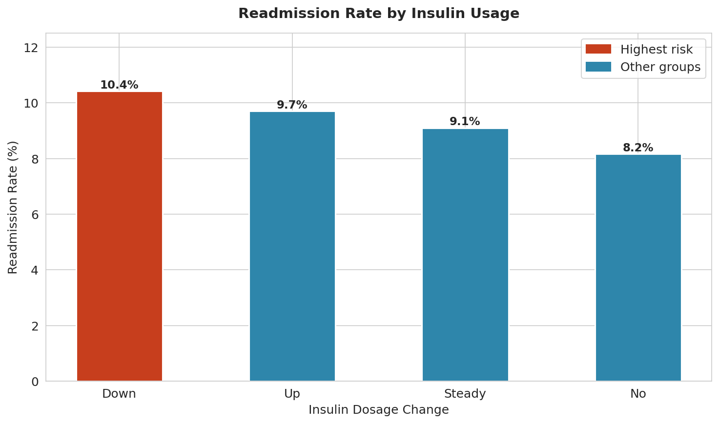
Patients with decreased insulin doses (Down) had the highest readmission rate. This is consistent with clinical evidence that poorly controlled blood sugar leads to complications and repeat hospitalizations.

4.6 Medications Distribution
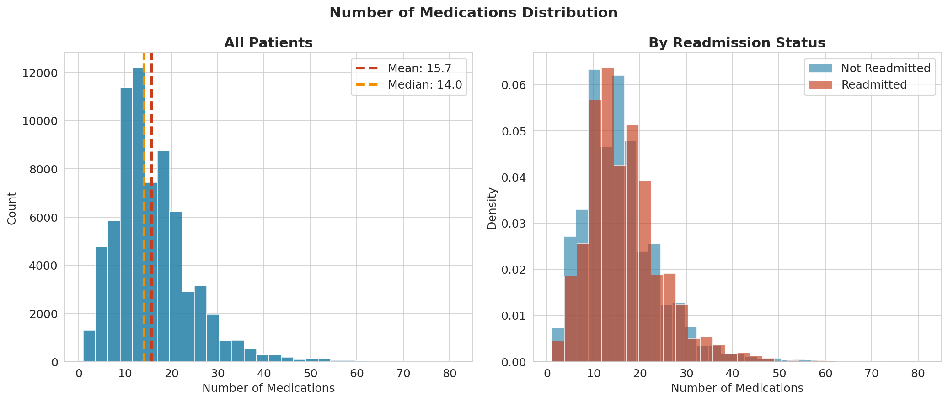
The distribution of medications is slightly right-skewed with a mean around 15. Readmitted patients tend to have a marginally higher medication count, suggesting greater clinical complexity.

5. Predictive Model Results

5.1 Model Comparison
Two machine learning models were trained to predict whether a patient would be readmitted within 30 days. Due to class imbalance (9:1 ratio), class_weight="balanced" was applied.

Model | Accuracy | ROC-AUC | Recall (Readmitted)
Logistic Regression | 61.21% | 0.602 | 53%
Random Forest | 90.66% | 0.554 | ~0%

Important note: Accuracy alone is misleading with imbalanced classes. Random Forest achieves 90.66% accuracy simply by predicting "not readmitted" for nearly everyone. Logistic Regression performs better on ROC-AUC (0.602), meaning it better distinguishes between high-risk and low-risk patients.

5.2 Confusion Matrix
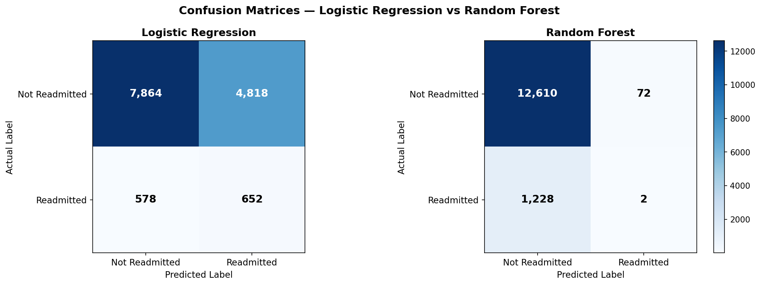

5.3 Feature Importance
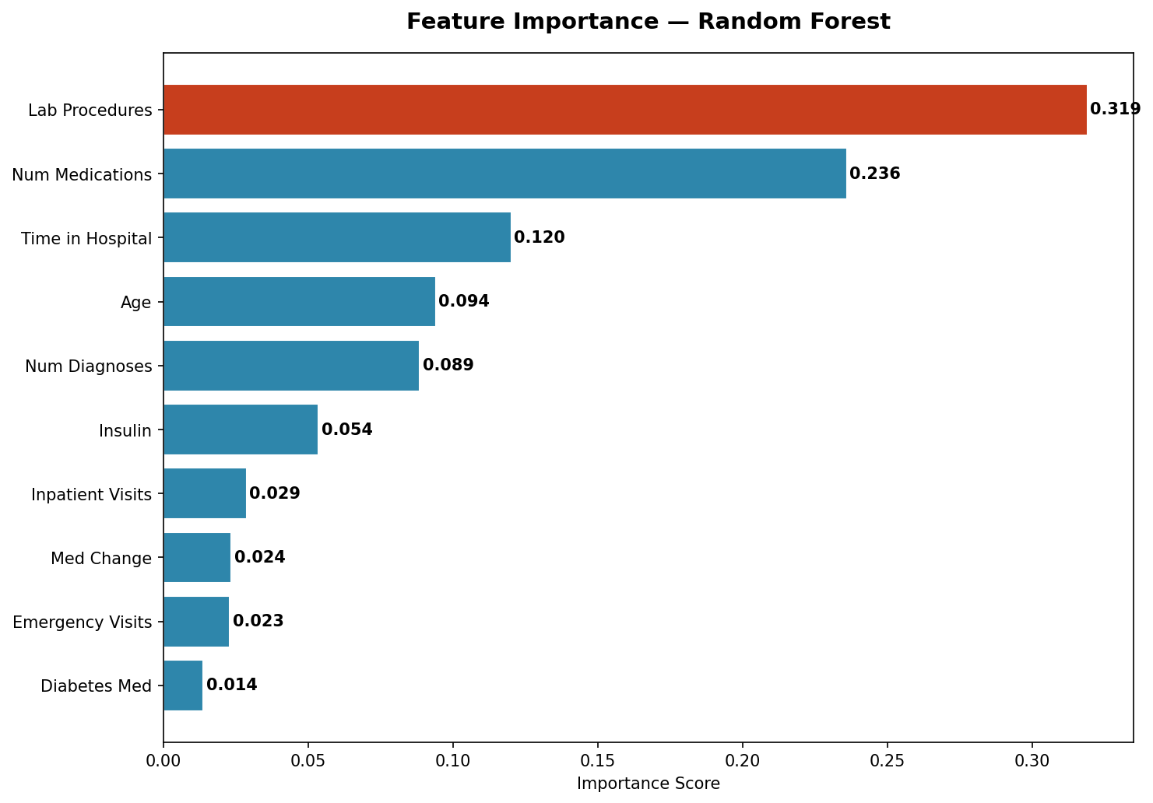

Rank | Feature | Importance Score
1 | Number of Lab Procedures | 0.319
2 | Number of Medications | 0.236
3 | Time in Hospital | 0.120
4 | Age | 0.094
5 | Number of Diagnoses | 0.089

Lab procedures and medications dominate feature importance, confirming that clinical complexity is the strongest predictor of readmission risk.

6. Business Recommendations

For Hospital Management
- Target patients aged 70+ for enhanced discharge planning and follow-up programs — they represent the highest-risk group.
- Monitor patients with insulin dosage changes closely. A "Down" change is associated with the highest readmission rate (10.42%) and may signal deteriorating glucose control.
- High medication count (>20 drugs) is a strong readmission risk signal. Consider pharmacist-led medication reconciliation for these patients before discharge.
- Patients with 7+ diagnoses should receive structured post-discharge care coordination to address multi-morbidity.
- Implement a readmission risk score at discharge using the features identified in the model (lab procedures, medications, age, diagnoses) to prioritize outpatient follow-up.

For Data Science Team
- The class imbalance (91:9) significantly limits model performance. Future work should explore SMOTE or other oversampling techniques.
- A1Cresult and max_glu_serum were dropped due to >40% missing values — collecting these consistently would improve model quality substantially.
- Gradient Boosting models (XGBoost, LightGBM) should be tested as next steps for improved recall on the minority class.
- Time-series analysis of patient re-encounters could reveal additional patterns not captured in single-encounter data.

7. Conclusion
This analysis demonstrates that hospital readmission within 30 days is driven primarily by patient complexity: older age, more diagnoses, more medications, and unstable insulin management all increase risk. While the predictive model shows moderate performance due to class imbalance, the SQL and EDA findings provide actionable, business-ready insights.

The most valuable takeaway for hospital administrators is that a small set of clinical indicators — available at time of discharge — can flag high-risk patients for targeted intervention, potentially reducing costly readmissions and improving patient outcomes.

End of Report — Hospital Readmission Analysis | BIT Mesra Data Analytics Project

