project1

abhinav palaparthy

28 September 2017

## Step 1

## Code for reading in the dataset and/or processing the data

activity<-read.csv("activity.csv")

The variable names and the structure of the file are given by

names(activity)

## [1] "steps" "date" "interval"

str(activity)

## 'data.frame': 17568 obs. of 3 variables:  
## $ steps : int NA NA NA NA NA NA NA NA NA NA ...  
## $ date : Factor w/ 61 levels "2012-10-01","2012-10-02",..: 1 1 1 1 1 1 1 1 1 1 ...  
## $ interval: int 0 5 10 15 20 25 30 35 40 45 ...

head(activity[which(!is.na(activity$steps)), ]) # data set with NA rows removed

## steps date interval  
## 289 0 2012-10-02 0  
## 290 0 2012-10-02 5  
## 291 0 2012-10-02 10  
## 292 0 2012-10-02 15  
## 293 0 2012-10-02 20  
## 294 0 2012-10-02 25

The format of the file is ready for analysis. No further processing is required.

## 2. Mean of "total number of step taken per day" over all days

Group the number of steps by date and intervals. Find the total number of steps per day over all days. Note that some of the days such as 2012-10-01 have no steps data. Remove such rows for this part.

library(reshape2)  
activity_melt <- melt(activity[which(!is.na(activity$steps)), ], id.vars = c("date", "interval"))  
head(activity_melt)

## date interval variable value  
## 1 2012-10-02 0 steps 0  
## 2 2012-10-02 5 steps 0  
## 3 2012-10-02 10 steps 0  
## 4 2012-10-02 15 steps 0  
## 5 2012-10-02 20 steps 0  
## 6 2012-10-02 25 steps 0

steps_sum <- dcast(activity_melt, date ~ variable, sum)  
head(steps_sum)

## date steps  
## 1 2012-10-02 126  
## 2 2012-10-03 11352  
## 3 2012-10-04 12116  
## 4 2012-10-05 13294  
## 5 2012-10-06 15420  
## 6 2012-10-07 11015

Then we can find the mean of 'total number of steps per day'.

summary(steps_sum$steps)

## Min. 1st Qu. Median Mean 3rd Qu. Max.   
## 41 8841 10765 10766 13294 21194

Histogram of the total number of steps taken each day.

hist(steps_sum$steps, main = "Histogram of total steps taken per day",  
 xlab = "Total steps per day", ylab = "Number of days",   
 breaks = 15, col = "black")  
abline(v = mean(steps_sum$steps), lty = 1, lwd = 1.5, col = "red")  
abline(v = median(steps_sum$steps), lty = 2, lwd = 1.5, col = "green")  
legend(x = "topright", c("Mean", "Median"), col = c("red", "black"), lty = c(1, 2), lwd = c(2, 2))

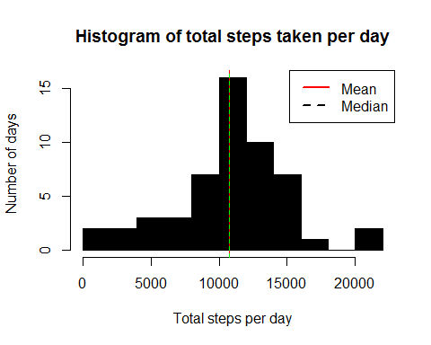

Here's a plot showing the trend in total number of steps taken per day over two months.

library(ggplot2)  
library(lubridate)

##   
## Attaching package: 'lubridate'

## The following object is masked from 'package:base':  
##   
## date

steps_sum$date <- as.Date(steps_sum$date)  
ggplot(steps_sum, aes(date, steps)) + geom_line() +   
 scale_x_date(date_labels = "%b %d") +   
 ylab("Total number of steps")

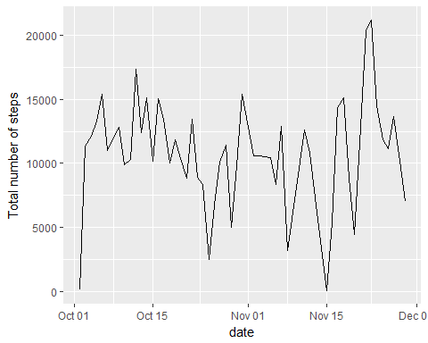

## 3. Average daily activity pattern

In this section, we make a time series plot (i.e. type = "l") of the 5-minute interval (x-axis) and the average number of steps taken averaged across all days.

stepsmeaninterval <- dcast(activity_melt, interval ~ variable, mean, na.rm = TRUE)  
head(stepsmeaninterval)

## interval steps  
## 1 0 1.7169811  
## 2 5 0.3396226  
## 3 10 0.1320755  
## 4 15 0.1509434  
## 5 20 0.0754717  
## 6 25 2.0943396

plot(stepsmeaninterval$interval, stepsmeaninterval$steps, ty = "l",   
 xlab = "time interval", ylab = "Average steps", main = "Average   
 steps taken over all days vs \n time interval")

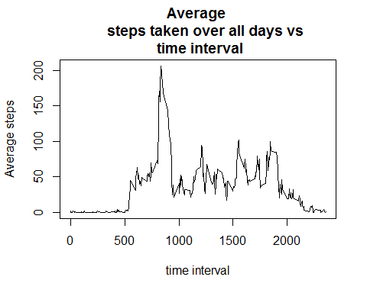

The time interval during which the maximum number of steps is taken is

maxsteps_interval <- stepsmeaninterval$interval[which.max(stepsmeaninterval$steps)]  
maxsteps_interval

## [1] 835

## 4. Imputing missing values

First of all, let us get a sense for the missing values. Are there days with all time intervals reporting NA step values?

We can replace the missing data for a day by the time average over all other days.

## Impute missing values  
activity2 <- split(activity, activity$interval)  
activity2 <- lapply(activity2, function(x) {  
 x$steps[which(is.na(x$steps))] <- mean(x$steps, na.rm = TRUE)  
 return(x)  
})  
activity2 <- do.call("rbind", activity2)  
row.names(activity2) <- NULL  
  
activity2 <- split(activity2, activity2$date)  
df <- lapply(activity2, function(x) {  
 x$steps[which(is.na(x$steps))] <- mean(x$steps, na.rm = TRUE)  
 return(x)  
})  
activity2 <- do.call("rbind", activity2)  
row.names(activity2) <- NULL  
head(activity2)

## steps date interval  
## 1 1.7169811 2012-10-01 0  
## 2 0.3396226 2012-10-01 5  
## 3 0.1320755 2012-10-01 10  
## 4 0.1509434 2012-10-01 15  
## 5 0.0754717 2012-10-01 20  
## 6 2.0943396 2012-10-01 25

Assuming that the time intervals form a disjoint partitioning of 24 hrs, i.e. 1 day is found to be erroneous. The time interval for each day corresponds to approximately 40 hours, which refutes the intervals being disjoint.

library(reshape2)  
activity_melt2 <- melt(activity2, id.vars = c("date", "interval"))  
steps_sum <- dcast(activity_melt2, date ~ variable, sum, na.rm = TRUE)  
head(steps_sum)

## date steps  
## 1 2012-10-01 10766.19  
## 2 2012-10-02 126.00  
## 3 2012-10-03 11352.00  
## 4 2012-10-04 12116.00  
## 5 2012-10-05 13294.00  
## 6 2012-10-06 15420.00

Histogram of the total number of steps taken each day with the imputed missing values.

hist(steps_sum$steps, main = "Histogram of total steps taken per day",   
 xlab = "Total steps per day", ylab = "Number of days",   
 breaks = 15, col = "green")  
abline(v = mean(steps_sum$steps), lty = 1, lwd = 2, col = "red")  
abline(v = median(steps_sum$steps), lty = 2, lwd = 2, col = "black")  
legend(x = "topright", c("Mean", "Median"), col = c("red", "black"), lty = c(2, 1), lwd = c(2, 2))

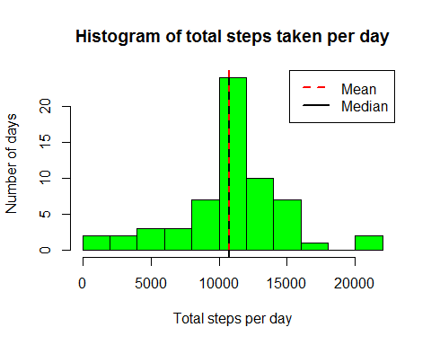

Number of rows with NA values

sum(is.na(activity$steps))

## [1] 2304

sum(is.na(activity$steps))*100/nrow(activity) # Percentage of rows with missing values

## [1] 13.11475

## 5. Differences in activity patterns: Weekdays vs Weekends

Create a new column describing if the date is a weekday or weekend.

library(lubridate)  
weekends <- which(weekdays(as.Date(activity2$date)) == "Sat" |  
 weekdays(as.Date(activity2$date)) == "Sun")  
weekdays <- which(weekdays(as.Date(activity2$date)) != "Sat" &  
 weekdays(as.Date(activity2$date)) != "Sun")  
temp <- c(rep("a", length(activity2)))  
temp[weekends] <- "weekend"  
temp[weekdays] <- "weekday"  
length(temp)

## [1] 17568

names(temp) <- "day"  
activity2 <- cbind(activity2, temp)  
names(activity2)[4] <- "day"

Steps taken over each interval averaged across weekday days and weekend days.

activity2split <- split(activity2, activity2$day)  
stepsmean_interval <- lapply(activity2split, function(x) {  
 temp <- aggregate(x$steps, list(x$interval), mean)  
 names(temp) <- c("interval", "steps")  
 return(temp)  
})  
  
## Unsplit stepsmean_interval  
stepsmean_interval <- do.call("rbind", stepsmean_interval)  
weekdays <- grep("weekday" ,row.names(stepsmean_interval))  
weekends <- grep("weekend" ,row.names(stepsmean_interval))  
temp <- c(rep("a", length(stepsmean_interval$steps)))  
temp[weekdays] <- "weekdays"  
temp[weekends] <- "weekends"  
stepsmean_interval <- cbind(stepsmean_interval, temp)  
row.names(stepsmean_interval) <- NULL  
names(stepsmean_interval)[3] <- "day"  
head(stepsmean_interval)

## interval steps day  
## 1 0 1.7169811 weekdays  
## 2 5 0.3396226 weekdays  
## 3 10 0.1320755 weekdays  
## 4 15 0.1509434 weekdays  
## 5 20 0.0754717 weekdays  
## 6 25 2.0943396 weekdays

tail(stepsmean_interval)

## interval steps day  
## 283 2330 2.6037736 weekdays  
## 284 2335 4.6981132 weekdays  
## 285 2340 3.3018868 weekdays  
## 286 2345 0.6415094 weekdays  
## 287 2350 0.2264151 weekdays  
## 288 2355 1.0754717 weekdays

library(ggplot2)  
ggplot(stepsmean_interval, aes(interval, steps)) + geom_line() + facet_grid(day ~ .)

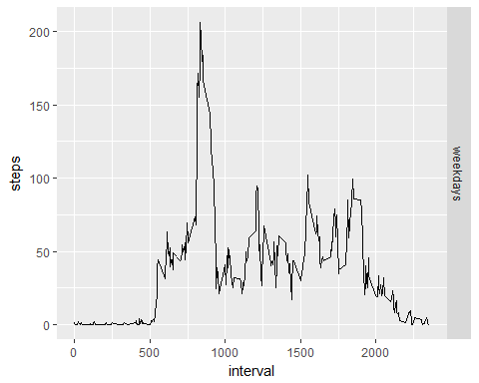

The mean number of steps taken over the weekdays and weekends.

stepsdatamelt <- melt(stepsmean_interval, id.vars = c("interval",  
 "day"))  
dcast(stepsdatamelt, day ~ variable, mean) # Average steps

## day steps  
## 1 weekdays 37.3826