# China central bank will prioritise monetary policy stability in 2021

China will prioritise stability in monetary policy in 2021, and any steps to exit stimulus measures will have a small impact on the economy, the Xinhua news agency on Friday quoted central bank governor Yi Gang as saying.

The central bank will use various policy tools to keep liquidity reasonably ample and ensure that the growth of broad money supply and total social financing basically matches nominal economic growth, Yi was quoted as saying.

China will provide more financial support to small firms, technological innovation and green development, Yi added.

"In 2021, monetary policy should prioritise stability to maintain ... sustainability," Yi said.

The central bank had said on Wednesday it would make its monetary policy flexible, targeted and appropriate in 2021, focusing on supporting small firms.

The bank has rolled out a raft of measures, including cuts in interest rates and reserve ratios since early-2020 to support the virus-hit economy.

But it has shifted to a steadier stance in recent months and kept its benchmark lending rate, the loan prime rate, unchanged since May.

Policy sources have said that the central bank will scale back support for the economy in 2021 and cool credit growth but that fears of derailing a recovery from a pandemic-induced slump and debt defaults are likely to prevent it from tightening any time soon.

Yi said any steps to exit stimulus measures will have a small impact on the economy this year because the central bank had refrained from adopting zero or negative interest rates.

While the ratio of China`s overall debt level increased last year as the pandemic dealt a blow to the economy, the debt ratio is likely to return to a basically stable track this year.

The rise in the ratio of China`s total debt to gross domestic product has started to slow since the third quarter of last year, Yi added without elaborating.

The Chinese Academy of Social Sciences, a government think tank, sees the macro leverage ratio jumping by about 30 percentage points in 2020 to over 270%.

Yi said China will continue to let the market play a decisive role in setting the yuan`s exchange rate in 2021, but it will keep the yuan basically stable.

The yuan was on course for its best week in two months, despite fresh measures rolled out by the central bank to ease capital inflows and slow the currency`s rally.

The currency has gained up nearly 1% against the greenback in the first week of the new year, building on a near 7% rise in 2020.

The central bank will push interest rate reforms to improve the transmission of its loan prime rate (LPR) to bank lending rates, and further liberalise deposit rates, Yi added.

China will also step up financial support for green development, Yi said, with measures including improving systems for green finance standards, developing green finance products and strengthening international cooperation in the sector.

Commentary

This article will be talking about china preceding stability in Monetary policy in the year 2021, in order to increase exchangeability, growth of money supply and social financing.

Monetary policy is a policy where the government/ the central bank makes use of the interest rate alongside money supply and the exchange rate to power Aggregate demand. Stabilizing monetary policy will lead to feasibility and flexible monetary policy. China also intends to support small firms in order to influence the virus-hit economy.

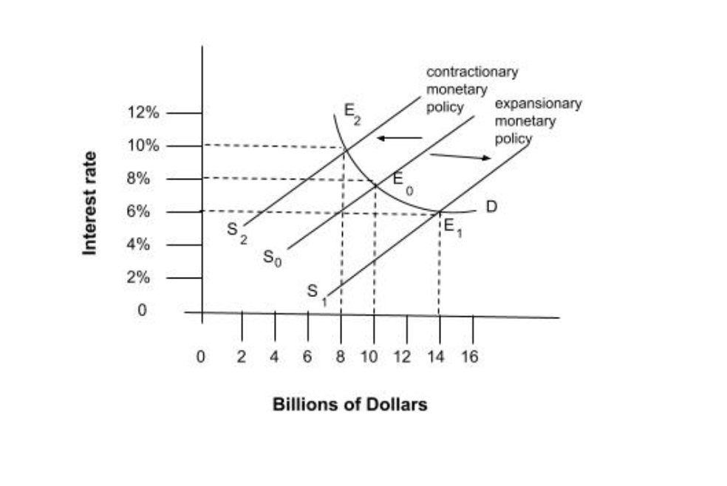**Figure 1**

The graph above explains the use of monetary policy in the economy. As we see the

The role of monetary policy includes changes in interest rates, therefore, allowing more spending and borrowing or to take place. As china is planning on loosening its monetary policy, they are going to using the expansionary side of the policy. Hence the interest rates would decrease resulting in a rightward shift in the diagram. Because of the rightward shift from E0 to E1 the quantity demanded for borrowing money would increase as the interest rates have decreased significantly.

Now since more borrowing would be allowed for china the more consumer spending power would increase resulting in a rise in the aggregate demand for good and service. As the aggregate demand will rise, businesses would start producing more and expanding. Hence this policy would also reduce the unemployment rate for china especially right after coming out of a lump it would reduce cyclic unemployment. Since now more people will get employed the more consumer spending power will increase which would increase the overall prices for good as a result of demand-pull inflation.

Hence the loosening of the monetary policy is beneficial for China as it would be then able to support small or infant firms of the country by providing them with grants or subsidies. And as china’s debt level increased last year it would be sensible to use expansionary monetary policy to encourage the growth of the total output of the country as that could reduce the government budget deficit.

The central bank has refused to take in any negative or zero interest rate which will impact the economy. Monetary policy uplifts economic activity leading to a stable global economy. Monetary policy also allows boosting exports. but monetary policy can sometimes create a risk of hyperinflation, Little levels for expansion inside an economy would not be an awful relic. They energize investments, permit specialists should hope for a higher wage, Also invigorate development whatsoever any levels for the public eye. Hosting all things expense An minimal more About whether could moderate development when necessary. Assuming that the premium rates would set as well low after that falsely low rates happen. That makes speculative air pockets the place costs expand excessively awful quickly, regularly with levels which make obstructions to entry for those Normal pernickety.

But the implementation of an expansionary monetary policy might not be guaranteed recoveree for china after the slump. As its ability to cut interest rates is not guaranteed. Secondly, it would take a lot of time to get implemented hence the recovery for china won’t be soon. Lastly implementing an expansionary monetary policy will not be that useful considering a global recession is happening hence even if the bank lowers the interest rates the export sector would suffer and the export losses would be more than what the commercial organizations could earn and plus as the consumer spending power is increasing, it would result in demand-pull inflation for china.

In conclusion, the implementation of an expansionary monetary policy for china might be suitable in the short run only as t would provide business incentives to expand, the consumers would be able to borrow more, hence the government budget deficit might decrease but in the long run an expansionary monetary policy during the time of a global recession caused due to a global pandemic, the implementation of this policy would not just result in demand-pull inflation but also would make the export sector suffer and might even depreciate the yuan in comparison to other currencies.