Economic Commentary 3

Article:- [1]

**WTO urges India to reduce tariffs**

India’s average tariff increased to 14.3% in FY21 from 13% in FY15 with the country’s policymakers frequently using trade policy measures to encourage domestic production and curb inflation, the [World Trade Organization](https://www.livemint.com/Search/Link/Keyword/Wto) (WTO) said in its latest Trade Policy Review for Asia’s third-largest economy.

“While the overall goal remains to increase exports, since policymaking in India is focused on domestic issues, trade policy is frequently used to encourage domestic production and meet domestic inflation and supply objectives. Thus, changes are made as required to import and export restrictions and the tariff to ensure stable domestic supplies of key products," the WTO secretariat said in its report, holding that frequent changes in import and export policy create uncertainty for economic factors.

“International trade receives inadequate attention both in the government and outside in India, with the inward focus being visible across most institutions both in the public and private sectors, " said a high-level advisory group of WTO in its report released in September 2019.

The report called for a reduction of the tariff for making it simple and more predictable. With regard to agriculture, it recommends that “there must not be a ‘stop and start’ policy on exports and imports of agricultural products because that prevents farmers from taking objective decisions on sowing different crops".

India’s average agricultural tariff rose from 36.4% in FY15 to 36.5% in FY21, while average non-agricultural tariff rose from 9.5% to 11.1% during the same period. The most important increase in non-agricultural goods included clothing, (from 10% to 19.6%), oilseeds, fats, oil and their products (from 26.7% to 35.1%), and sugar and confectionary (from 35.4% to 47%). In the case of non-agricultural products, the average tariff increased mainly as a result of a hike in duties levied on leather, rubber, footwear, and travel goods from 12.8% to 15.4%.

India’s tariff rates range from zero to 150% with 67.8% of all tariff lines between 0% and 10%, 22.1% higher than 10% and up to 30%, and 4% tariff lines between with rates above 30%. “The most common tariff rates continue to be 10% (31.7%) and 7.5% (24.4%). The highest rates, above 60%, apply to products such as alcoholic beverages (150%), followed by animals and their products, fruit, vegetables and plants; coffee and tea, and certain motor vehicles, with tariffs of 100%," WTO said.

Trade policy reviews are an exercise mandated in WTO agreements, in which trade related policies of members are examined at regular intervals. Key developments that may impact the global trading system are also monitored. India’s previous trade policy review was conducted in 2015.

From <<https://www.livemint.com/news/india/india-frequently-using-trade-policy-measures-to-encourage-local-production-wto-11610006956392.html>>

Commentary:-

The article is about an overall increase in Indian tariff on an average of 1.3% since FY15. Even tho the overall goal remains to increase exports, a major increase in the tariff rates leads to less spending power for customers and also affected the production of farm products. A tariff is a tax a country imposes on goods or services that are imported from another country.

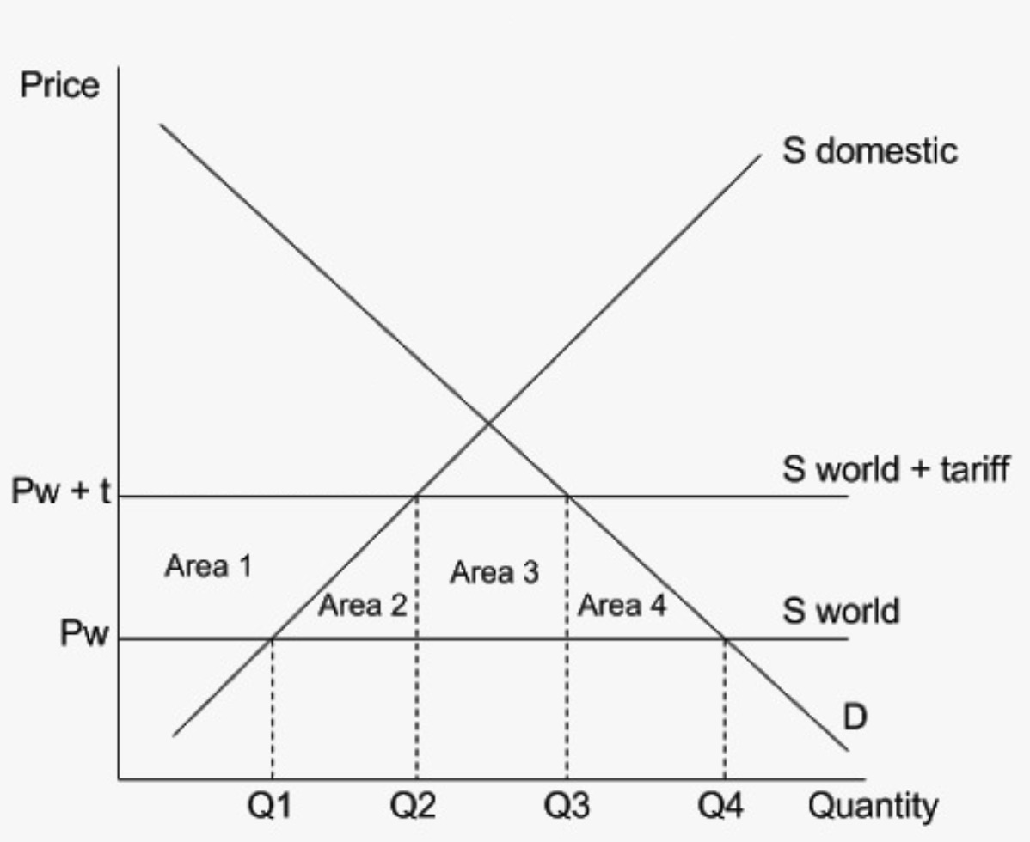

**Figure 1**

In the diagram above we can see that due to the increasing of tariff the S world curve shifted to S world+ tariff, the quantity demanded shifted from Q1 to Q2 and Q4 to Q3. decreasing the area covers by imports which before was from between Q1, Q4 and the curve to now to Q2, Q3 and the curve. Hence proving a decrease in imports for India. The price of imported goods rose from Pw to Pw+t causing increased price rates and hence a consumer surplus. Which is conveys by Area 1 on the graph. Area 2 convey the deadweight welfare of the world’s efficiency and Area 4 is the deadweight loss of the words efficiency. Area 3 represents the revenue that the Indian government generates from the tariff. All of this demonstrating that domestic production has increased.

By increasing the tariff on non-agricultural and agricultural products, the current account deficit of India would reduce. The current account deficit is a measurement of a country’s trade where the value of imports is more than the value of exports. Hence by increasing the tariff the main goal of having more exports will remain or would be more achievable as now imports would be more expensive for citizens hence they would consider switching to national substitutes. Which result is the protection of infant companies and reduces domestic unemployment, as now the aggregate demand for national good is increasing hence more employment opportunities open up causing a

decrease in cyclic and seasonal unemployment and reducing natural unemployment to an extent too. All of this also helps in decreasing the government budget deficit. Which may also curd inflation

But because of this increased tax, there might be a change of retaliation as now other countries that are frequently in negotiations with India, will now feel threatened and might result in trade wars. The increase of the tac will also result in an increased price level, which we can also see in the article. This will lead to less efficiency of the country resulting in decreasing world output. As the prices are rising, this may also lead to a consumer surplus. A consumer surplus is a difference between the price the consumers are wills to pay for a product and the price they are having to pay. Since now imports for the citizens is expensive, this might affect technological advancements in the country as maybe there might be a technology that hasn’t been developed in India and to over advice it needs to be imported, those imports would become very expensive for corporates and might lead to them not advancing technology-wise.

In conclusion, a tariff might in the short run reduce unemployment and the current account deficit and would lead to curbing of the inflation rate, hence it may be good for the country, as the main goals of India to reduce imports and increase interdependence is being attended but as seen in the article is really bad for sectors like agriculture as the WTO reports that “there must not be a ‘stop and start’” on exports for farmers as that results in them making objective decisions on sowing different crops. And in the long run, too would lead to trade wars and already this tariff has caught the attention of the international trade receives, which would further lead to loss of efficiency for the world too. Therefore the increase of this tariff might not be a recommendable and sustainable option for India.

**WORD COUNT: 650**

1. "WTO urges India to reduce tariffs - Mint." 7 Jan. 2021, <https://www.livemint.com/news/india/india-frequently-using-trade-policy-measures-to-encourage-local-production-wto-11610006956392.html>. Accessed 20 Apr. 2021.