Title of the article- **Bad news for Auto sector: Passenger vehicle sales decline by 24%, commercial by 62%**

Link to ariticle- <https://www.indiatoday.in/business/story/bad-news-for-auto-sector-passenger-vehicle-sales-decline-by-24-commercial-by-62-1608212-2019-10-11>

Section of syllabus the article relates to: *Microeconomics*

There is no relief for the auto sector in India as SIAM (Society of Indian Automobile Manufacturers) data for the month of September show that passenger vehicle sales plunged by 23.69 per cent. The commercial vehicle sales was down by 62.11 per cent in September.

This means the slump in vehicular sale has continued in the eleventh straight month at a time when the country's auto sector is facing one of the worst slowdown in decades.  
  
According to SIAM data, passenger vehicle sales dropped to 2,23,317 units in September from 2,92,660 a year ago while passenger car sales dropped by 33.4 per cent to 131,281 units compared to the same period in 2018.

Low demand in recent months has led to a massive slowdown in the auto sector of the country which is the fourth largest in the world. A massive job loss is feared in India's automotive industry, which employs more than 3.5 crore people directly and indirectly. The auto sector accounts for about hlf of total manufacturing output of Indian economy.

To tackle the crisis, several auto companies have resorted to declaring non-working days. This includes auto majors such as Maruti Suzuki, Tata Motors and Ashok Leyland. A non-working day like forced leave without pay. This is being done to reduce production of vehicles in the factories.

The SIAM data show that the total passenger vehicle production declined by over 18 per cent to 2,79,644 units in September compared to the figure of 3,41,539 units in September last year.

The production of total commercial vehicles dropped by 72.07 per cent in September against the same period last year. In terms of export, the commercial vehicle sales dropped by 45.06 per cent.

ADVERTISEMENT

On export front, there is good news, however, for passenger vehicles. The segment showed export growth of 5.64 per cent in Septmber compared to the same month last year.

The two-wheeler segment also recorded a two-digit decline in production and domestic sales in September. On year-on-year basis, the scooter sales in September declined by 16.60 per cent while motorcycle sales fell by 23.29 per cent. Their production delcined by about 16 and 19 per cent Y-O-Y respectively.

Due to rise in the pollution in India, Indian government has increased the taxes on passenger and commercial vehicle to control the sales of automobile sector which will directly help them to control pollution which is mainly emitted by automobile. Taxes have affected immensely to many automobile giant like Maruti and Hyundai

Increase in the taxes ( a sum of money demanded by a government for its support or for specific facilities or services, levied upon incomes, property, sales, etc. a burdensome charge, obligation, duty, or demand). Increase taxes in automobile will help the government reduce pollution by reducing the demand of automobile but sales have dipped excessively due to taxes that they have to shut their factories for few days.

*Figure 1 demand of car affected due to hike in price*

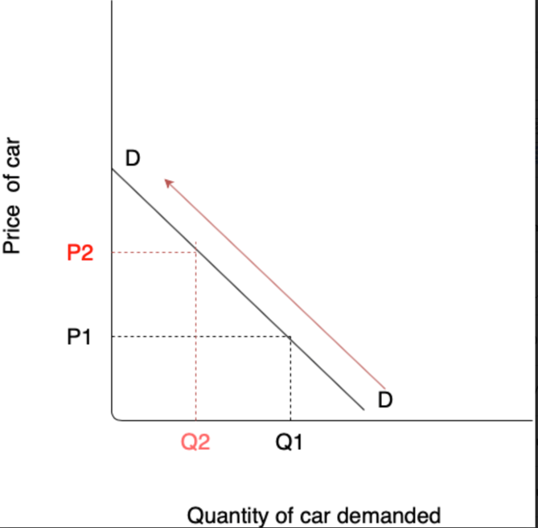

The above diagram represents how the prices of the vehicle have been increased due to imposing higher taxes on it. As in P1 (old price) Q1 (2,92,660) number of vehicle had been sold in pan India. After increasing in the rate of tax to 48% from 28% have also increased the price of vehicle to P2 in India which contracts the demand to Q2 (2,23,317). contraction have affected many automobile giants like Maruti Suzuki, Tata motors and Ashok Leyland . Due to Higher taxes they are being forced to give high discounts in order to clear up the old stock from the factory and to start producing vehicle according to new emission norms. The crisis also affected the arrival of new automobile companies in India.

*Figure 2 affected supply due to taxes*

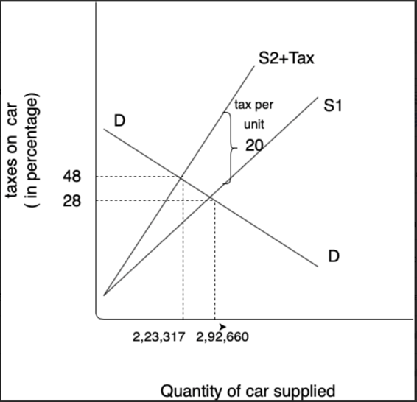

the above diagram illustrate how taxes affected supply of car in India. Hike in the taxes on car has affected supply immensely in 28% of tax 2,92,660 cars were supplied in India but when the taxes were increased to 48% the supply have been dropped to 2,23,317 due to lower demand in Indian automobile market as many middle class family is not willing to give higher price for the same vehicle. The crisis has affected the production of many automobile companies such as Maruti Suzuki, Tata Motors and Ashok Leyland. They have declared non-working day and forced leave without pay have been done to reduce production in factories which will help them to clear out the old stocks. As per SIAM ( society of Indian automobile manufacturer ) this is the huge slowdown in auto sector of fourth largest country in the world. To tackle this crisis, 3.5 crore unemployment have been done directly or indirectly in the industry which has impacted GDP of the country immensely.

*Figure 3 Impact of market based policies on automobile*

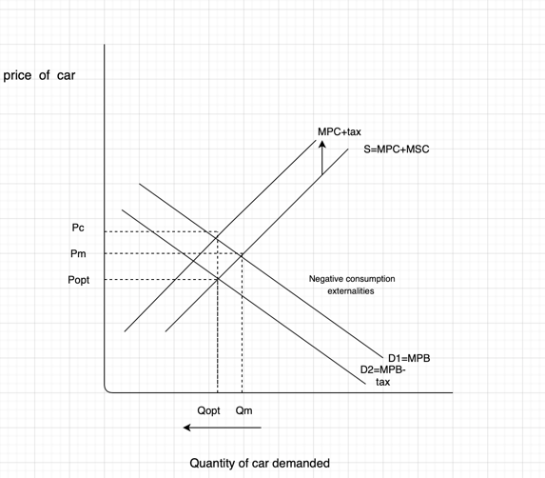

The above diagram explains the consequences of imposing higher taxes on vehicle. The supply of vehicle has been contracted Qopt and Popt and now consumer has to pay the price Pc which will reduce the demand of vehicle because of demand has negative causal relationship with price. Increase in the price due to new market based policies of the government to control increasing pollution which is emitted by vehicle. The new Market base policy(Market-based policies to correct negative consumption externalities involve the imposition of indirect excise taxes) of government will help to reduce the carbon monoxide present in the atmosphere which is emitted by Diesel and petrol engine and creates smog all-around the populated cities like Delhi and Mumbai where majority of people are dependent on automobile to do daily household work as the higher taxes will contract the demand to D2 as prices gets elevated and people will have opportunity cost to save those money. It will also reduce the diseases which cause by this harmful gas like lung cancer and asthma.

However, the policy have not worked so accurately as the government thought the new automobile companies are getting afraid to start the venture in India which has impacted the growth of the country immensely many old automobile have shut their business in India like Chevrolet due to constant decrease in the demand due to higher taxes. Massive unemployment took place as mention in the article. they should use other method to reduce pollution like building infrastructure for EVs so that and giving subsidy on them so that they can produce at less price so the consumer willing to buy instead of vehicle work on non- renewable energy.

In conclusion, government have to alter their market base policy in order to help new comers of auto brands to start their venture easily and help brands which are already exist in the market to cope up with the lower demand by giving them subsidy on vehicle with new emission laws.