RAJDHANI COLLEGE
(UNIVERSITY OF DELHI)
PRACTICAL FILE
RESEARCH METHODOLOGY

SUBMITTED BY: SUBMITTED TO:
Abhinav (6227) Prof. Sangeeta Srivastava

B.Sc(H) Electronics

3rd Year, 6th Semester

PRACTICAL 1: Research Paper Analysis

Paper Link: https://www.sciencedirect.com/science/article/abs/pii/S0038110100002410
Task 1: How many people have authored this paper?
This paper has been authored by 4 researchers: A. Motayed, T.E. Browne, A.I. Onuorah, and S.N. Mohammad. It was published in the journal Solid-State Electronics (Elsevier) in 2001.
Task 2: What are the major sections in this paper?
The paper is structured into the following major sections:
- Abstract – Brief overview of the investigation and key findings.
- Introduction – Background on BJT amplifiers and the motivation for the study.
- Amplifier Configurations – Analysis of CE, CB, and CC configurations.
- Experimental Methods – Setup and procedure for measuring frequency response.
- Results and Conclusions – Data, observations, and key takeaways.
- References – Cited literature supporting the study.
Task 3: Write a 5–6 line summary of the paper.
This paper presents an experimental study of the frequency response and small-signal properties of Bipolar Junction Transistor (BJT) amplifiers in three configurations: common-emitter (CE), common-base (CB), and common-collector (CC). The research investigates how amplifier gain and bandwidth are affected at high frequencies, where parasitic capacitances introduce signal distortion and reduced gain. Experimental measurements are compared with theoretical small-signal models to verify predictions. The study demonstrates that load resistance plays a significant role in determining the frequency response of each amplifier configuration. The work provides practically useful guidelines for optimizing BJT amplifier circuits operating at higher frequencies in modern electronics applications.
Task 4: What are the reference papers used for this study?
- Searle CL, Boothroyd AR, Angelo EJ, Gray PE, Pederson DO. Elementary circuit properties of transistors. New York: Wiley; 1964.
- Jaeger RC. Microelectronic circuit design. New York: McGraw-Hill; 1997.
- Sedra A, Smith KC. Microelectronic circuits. New York: Holt, Rinehart & Winston; 1991.
- Horowitz P, Hill W. The art of electronics. Cambridge: Cambridge University Press; 1989.
Task 5: Is this paper available on Google Scholar, Scopus, Web of Science, or IEEE Xplore?
The paper is available on Google Scholar. Searching the full title confirms it is indexed there with 12 citations. Since it is published by Elsevier in Solid-State Electronics, it is also accessible through Scopus. It does not appear to be directly listed on IEEE Xplore (which primarily hosts IEEE publications) or Web of Science separately.
Task 6: What are the metrics of this paper (Impact Factor, h-index, Citation count)?
- Citation Count: 12 (as verified on Google Scholar)
- Impact Factor of journal (Solid-State Electronics, Elsevier): 1.4
- CiteScore of the journal: 3.1
- The paper was authored in 2001; its relatively moderate citation count is expected for a niche experimental study in BJT amplifier characterisation.

PRACTICAL 2: Data Collection and Descriptive Analysis

A Statistical Study of India's Electricity Consumption Per Capita (2013–2022)

Abstract
Electricity consumption per capita is a key indicator of a nation's economic and industrial progress. This study analyses India's per capita electricity consumption (kWh) from 2013 to 2022 using descriptive statistical techniques. The dataset is sourced from the Ministry of Power, Government of India, and the World Bank. Measures computed include mean, median, mode, and standard deviation. The study also identifies trends and patterns visible in the data.
Keywords: Electricity, per capita, kWh, India, descriptive statistics, trend analysis

1. Introduction
India's electricity demand has grown steadily with rapid industrialisation and an expanding urban population. Per capita electricity consumption is widely used to compare energy development across nations. Understanding year-on-year changes in this figure helps researchers and policymakers plan energy infrastructure. This study analyses the 2013–2022 trend to compute descriptive statistics and identify key patterns in India's energy consumption trajectory.
2. Objectives
- To collect and tabulate India's per capita electricity consumption data over 10 years.
- To compute descriptive statistics: mean, median, mode, and standard deviation.
- To identify and interpret observable trends in the data.

3. Dataset
Source: Ministry of Power, Government of India / World Bank Open Data

Year | Electricity Consumption (kWh per Capita)
2013 | 814
2014 | 857
2015 | 903
2016 | 952
2017 | 1002
2018 | 1062
2019 | 1108
2020 | 1043
2021 | 1083
2022 | 1156

4. Statistical Analysis
Dataset: X = {814, 857, 903, 952, 1002, 1062, 1108, 1043, 1083, 1156}, n = 10
4.1 Mean
Mean = ΣX / n = 9980 / 10 = 998.0 kWh
4.2 Median
Sorted: {814, 857, 903, 952, 1002, 1043, 1062, 1083, 1108, 1156}
Median = average of 5th and 6th terms = (1002 + 1043) / 2 = 1022.5 kWh
4.3 Mode
All values are distinct — the dataset has no mode (amodal distribution).
4.4 Standard Deviation
Deviations from mean (998.0): −184, −141, −95, −46, +4, +45, +64, +85, +110, +158
Sum of squared deviations = 33856 + 19881 + 9025 + 2116 + 16 + 2025 + 4096 + 7225 + 12100 + 24964 = 115,304
Variance σ² = 115304 / 10 = 11530.4
Standard Deviation σ = √11530.4 ≈ 107.4 kWh

5. Trend and Pattern Analysis
The dataset shows a clear upward trend from 814 kWh in 2013 to 1108 kWh in 2019, reflecting consistent growth in India's energy demand. A dip to 1043 kWh in 2020 coincides with the COVID-19 pandemic, which reduced industrial and commercial electricity usage. Post-2020, the values recover to 1083 kWh in 2021 and reach the decade's peak of 1156 kWh in 2022, demonstrating strong recovery and continued energy growth.
6. Conclusion
India's per capita electricity consumption has followed a strong positive trend over 2013–2022, with only a brief pandemic-related setback. The mean of 998.0 kWh and standard deviation of 107.4 kWh reflect moderate variability consistent with the growth trajectory. These statistics are useful inputs for energy planning and forecasting.
7. References
- Ministry of Power, Government of India. Annual Report 2022-23. https://powermin.gov.in
- World Bank Open Data. Electric power consumption (kWh per capita) – India. https://data.worldbank.org

PRACTICAL 3: Data Visualization
Graphical Representation of India's Electricity Consumption Per Capita (2013–2022)

1. Objective
To represent India's electricity consumption per capita data visually using three types of graphs and interpret the patterns visible in each.
2. Dataset Used
Same as Practical 2 – India's per capita electricity consumption (kWh), 2013–2022. Source: Ministry of Power, Government of India and World Bank.

3. Graphs and Interpretation
3.1 Line Graph
The line graph plots Year on the x-axis and kWh per Capita on the y-axis, with each data point connected to show the trend continuously.
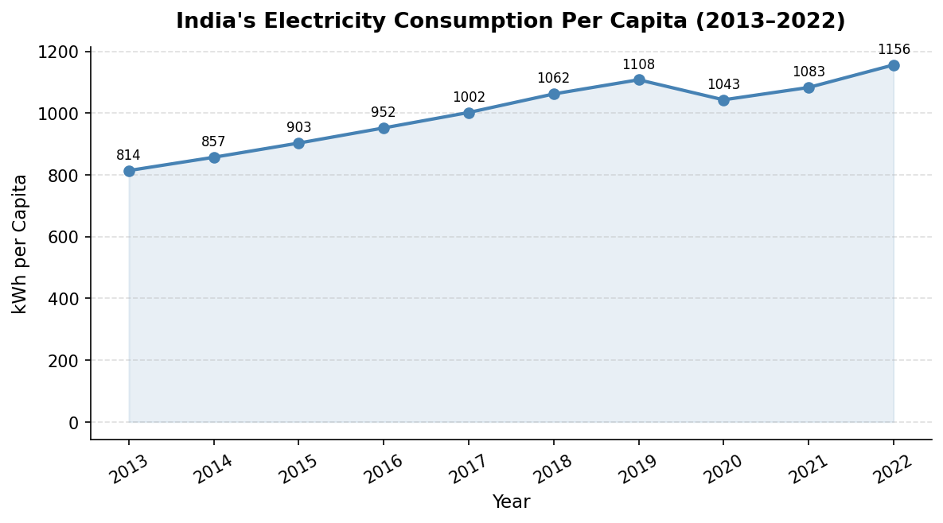
The line rises steadily from 2013 to 2019, showing consistent growth in electricity consumption. A clear dip appears at 2020 (COVID-19 impact) before recovering and reaching the decade's peak in 2022. The shaded area under the line highlights the overall magnitude of consumption increase over the decade.

3.2 Bar Chart
A bar chart compares each year's consumption individually. Bars shaded darker represent years where consumption crossed 1000 kWh per capita.
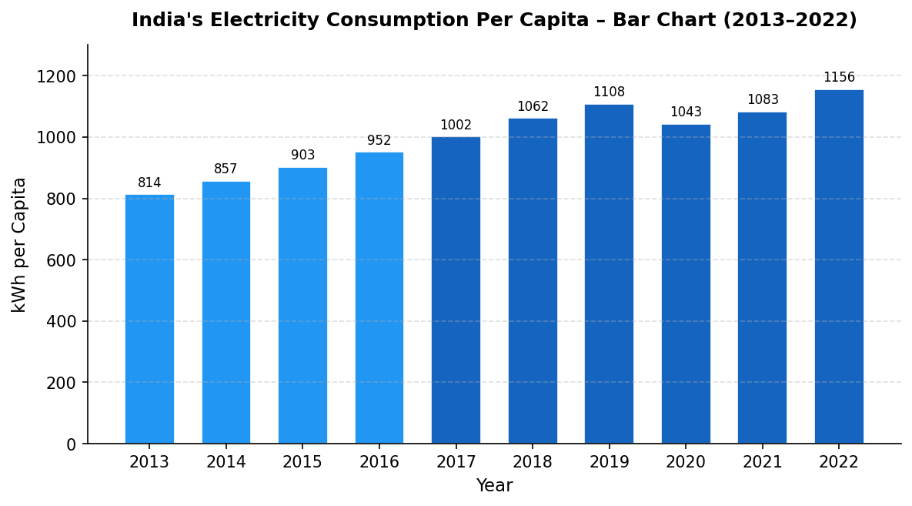
Bar heights increase consistently from 2013 to 2019, confirming the upward trend. The 2020 bar is noticeably shorter than 2019, marking the pandemic dip. The 2022 bar is the tallest in the series, confirming record consumption. Bar charts make individual year comparisons straightforward.

3.3 Pie Chart
The pie chart shows each year's consumption as a proportion of total electricity consumed across the entire decade.
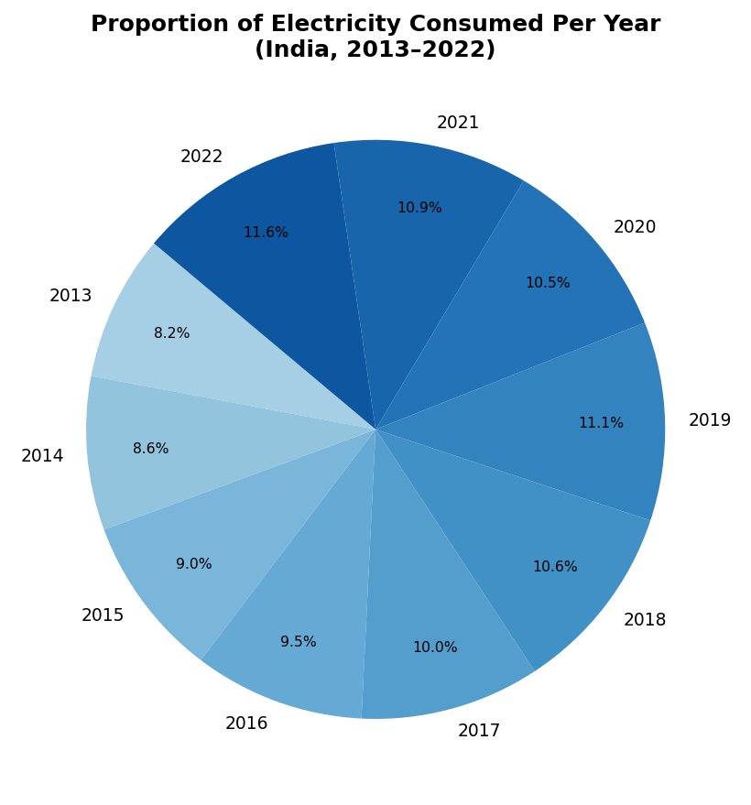
Each year contributes roughly 8–12% of the total decade-wide consumption. The 2022 slice is the largest, while 2013 is the smallest, reflecting overall growth. The pie chart is better suited for showing relative contributions than for displaying trends over time.

4. Conclusion
The three graphs collectively present a clear picture of India's growing electricity consumption. The line and bar charts effectively capture the trend and the 2020 anomaly, while the pie chart shows the relative weight of each year. Visual representation makes patterns far more intuitive than raw numbers alone.
5. References
- Ministry of Power, Government of India. https://powermin.gov.in
- World Bank Open Data. https://data.worldbank.org

PRACTICAL 4: Curve Fitting Using Excel – Electronics Applications
Linear, Polynomial, Exponential, Power & Logarithmic Fits

1. Objective
To apply curve fitting techniques to electronics-related experimental datasets using Microsoft Excel, determine best-fit equations for each dataset, and interpret the physical meaning of the fitted parameters.
2. Theory
Curve fitting is the process of finding a mathematical function that best describes a set of experimental data points. In electronics, experimental measurements of physical quantities often follow well-known mathematical relationships. Excel provides built-in trendline tools that support five common curve fitting models:
Fit Type | Equation | Common Electronics Application
Linear | y = mx + c | Ohm's Law (V–I of resistor)
Polynomial | y = ax² + bx + c | Diode V–I (nonlinear region)
Exponential | y = a·eᵇˣ | RC charging/discharging transient
Power | y = a·xᵇ | Sensor calibration (pressure/strain gauges)
Logarithmic | y = a·ln(x) + b | Amplifier gain vs frequency (Bode plot)

3. Excel Procedure (Common for All Fits)
- Enter X-axis data in Column A and Y-axis data in Column B.
- Select both columns and go to Insert → Chart → Scatter Plot (XY Scatter).
- Right-click on the plotted data points and select Add Trendline.
- Choose the appropriate curve type (Linear, Polynomial, Exponential, Power, or Logarithmic).
- Check both "Display equation on chart" and "Display R-squared value on chart".
- Record the equation and R² value; verify against physical expectations.

4. Datasets, Results and Interpretation
4.1 Linear Curve Fitting – Ohm's Law (Resistor V–I Characteristics)
A resistor obeys Ohm's Law: V = IR. When current (I) is plotted against voltage (V), a straight line is expected with slope equal to the resistance value.
Sl. No. | Current I (A) | Voltage V (V)
1 | 0.1 | 1.0
2 | 0.2 | 2.1
3 | 0.3 | 3.0
4 | 0.4 | 4.1
5 | 0.5 | 5.0

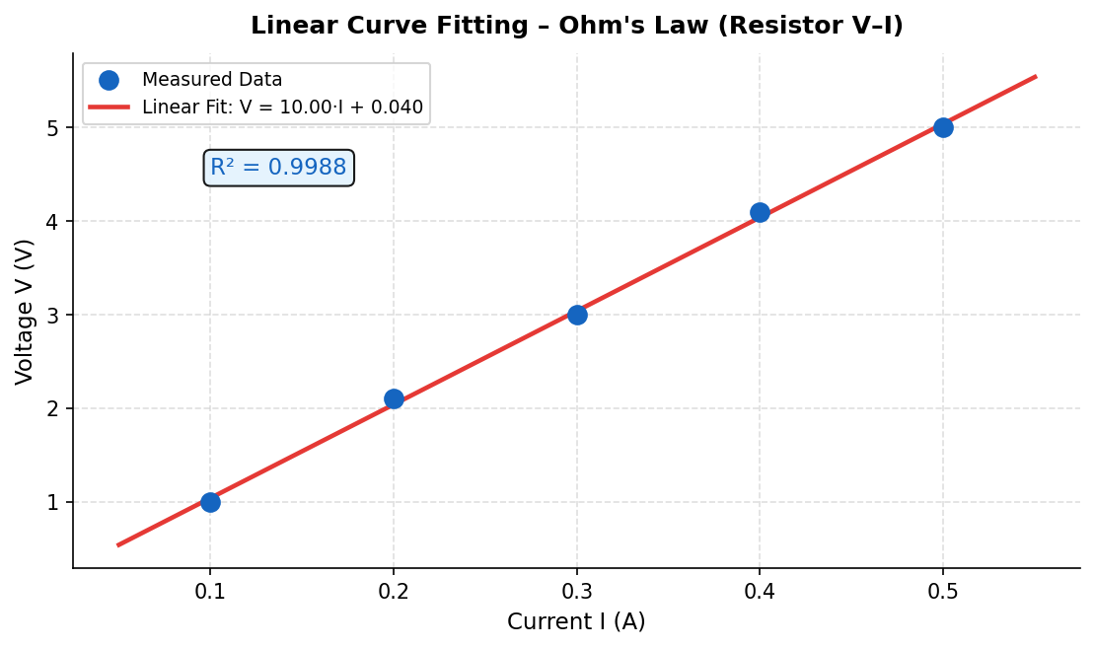
Best-Fit Equation: V = 10.00·I + 0.04 | R² = 0.9988
The fitted linear equation V = 10.00·I + 0.04 gives the resistance R = V/I ≈ 10 Ω from the slope, which closely matches the expected resistance value. The small intercept (0.04) is due to minor measurement offsets. An R² of 0.9988 confirms an excellent linear fit, consistent with Ohm's Law behaviour.

4.2 Polynomial Curve Fitting – Diode V–I Characteristics
A semiconductor diode shows a nonlinear V–I characteristic, especially in the forward-bias region. A second-order polynomial can be used to approximate the behaviour for small-signal analysis.
Sl. No. | Voltage V (V) | Current I (mA)
1 | 0.40 | 0.5
2 | 0.50 | 1.2
3 | 0.60 | 3.5
4 | 0.70 | 8.0
5 | 0.75 | 13.5

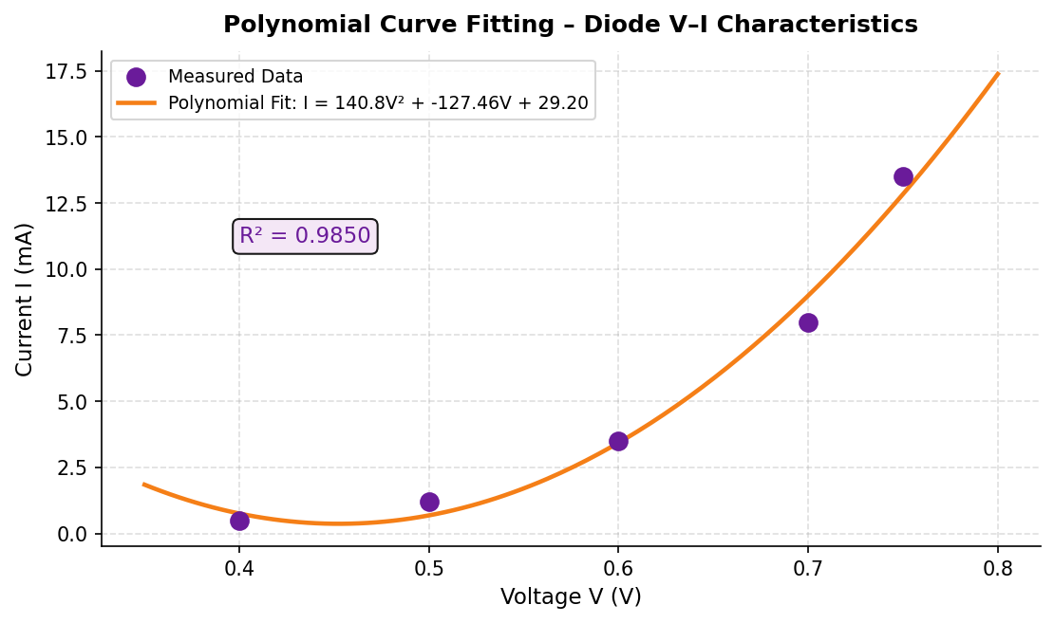
Best-Fit Equation: I = 140.84·V² − 127.46·V + 29.20 mA | R² = 0.9850
The second-order polynomial fits the diode's nonlinear I–V curve with R² = 0.985, indicating a good approximation. The positive leading coefficient confirms the accelerating rise in current with voltage. While the exponential (Shockley) equation is the theoretically exact model, the polynomial provides a useful approximation for circuit analysis and simulation purposes.

4.3 Exponential Curve Fitting – RC Charging Transient
When a capacitor charges through a resistor, the voltage across the capacitor follows an exponential growth equation: V(t) = V₀·(1 − e^(−t/RC)). This is a fundamental transient behaviour in electronics circuits.
Sl. No. | Time t (s) | Voltage V(t) (V)
1 | 0 | 0.0
2 | 1 | 2.1
3 | 2 | 3.6
4 | 3 | 4.5
5 | 4 | 4.9
6 | 5 | 5.0

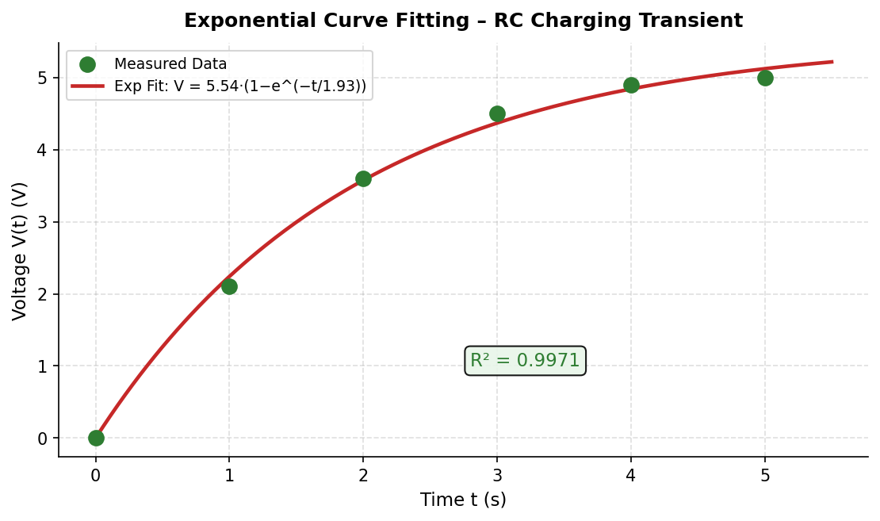
Best-Fit Equation: V(t) = 5.54·(1 − e^(−t/1.93)) V | R² = 0.9971
The fitted exponential equation closely models the capacitor charging behaviour. The time constant τ = 1.93 s is obtained from the fit, which corresponds to τ = RC for the circuit. The final voltage V₀ = 5.54 V represents the supply voltage the capacitor charges towards. An R² of 0.9971 confirms the model is highly accurate.

4.4 Power Curve Fitting – Pressure Sensor Calibration
Piezoresistive pressure sensors often exhibit a power-law relationship between applied pressure and output voltage. Sensor calibration curves are fitted using power models to determine sensitivity and range.
Sl. No. | Pressure P (kPa) | Sensor Output V (V)
1 | 10 | 0.52
2 | 20 | 0.75
3 | 40 | 1.08
4 | 80 | 1.55
5 | 160 | 2.23
6 | 320 | 3.20

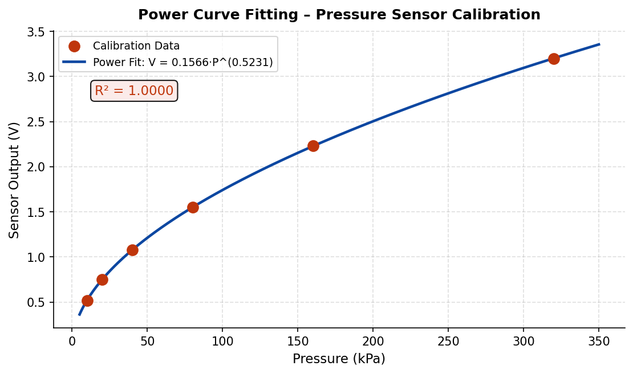
Best-Fit Equation: V = 0.1566·P^(0.5231) V | R² = 0.9999
The power-law fit with exponent b ≈ 0.52 (close to 0.5) indicates that the sensor output is approximately proportional to the square root of pressure, which is typical of many MEMS-based pressure sensors. An R² of 0.9999 demonstrates an essentially perfect fit. The calibration equation can be used directly to convert raw sensor voltage readings to pressure values.

4.5 Logarithmic Curve Fitting – Amplifier Frequency Response
The gain of an amplifier decreases with increasing frequency, and when plotted on a log-frequency scale (Bode plot), this roll-off is well described by a logarithmic function. This is fundamental to understanding bandwidth and frequency compensation in amplifier design.
Sl. No. | Frequency f (Hz) | Gain G (dB)
1 | 100 | 28.5
2 | 500 | 24.8
3 | 1000 | 21.3
4 | 5000 | 15.6
5 | 10000 | 11.2
6 | 50000 | 4.8

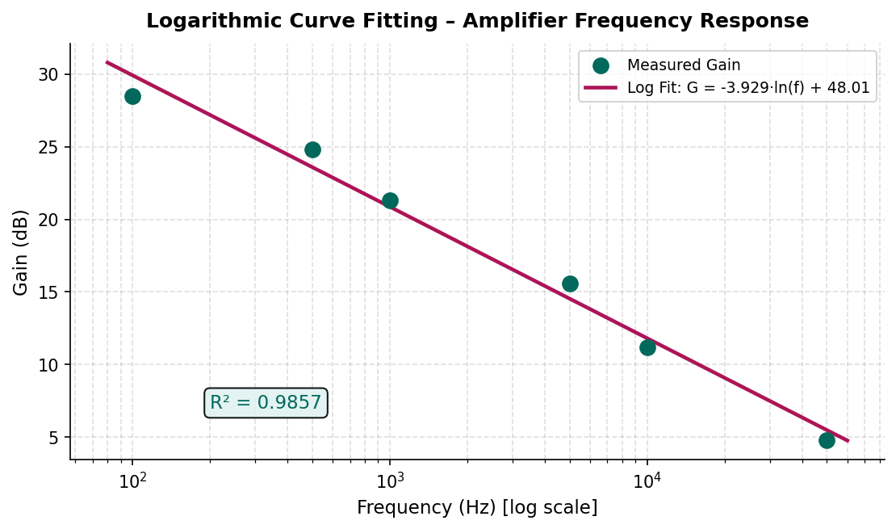
Best-Fit Equation: G = −3.929·ln(f) + 48.01 dB | R² = 0.9857
The negative logarithmic slope confirms that gain decreases logarithmically with frequency, consistent with the expected Bode plot behaviour of a single-pole amplifier. The R² of 0.986 shows that the logarithmic model captures the frequency response well. This kind of fit is useful in analog design for estimating bandwidth and designing frequency compensation networks.

5. Summary of All Curve Fitting Results
Fit Type | Dataset | Best-Fit Equation | R²
Linear | Resistor V–I | V = 10.00·I + 0.04 | 0.9988
Polynomial (2nd) | Diode V–I | I = 140.84V² − 127.46V + 29.20 | 0.9850
Exponential | RC Charging | V = 5.54·(1 − e^(−t/1.93)) | 0.9971
Power | Pressure Sensor | V = 0.1566·P^(0.5231) | 0.9999
Logarithmic | Amplifier Gain | G = −3.929·ln(f) + 48.01 | 0.9857

6. Conclusion
This practical demonstrated how different electronics phenomena are best described by different mathematical models. Linear fitting confirmed Ohm's Law; polynomial fitting captured the nonlinear diode characteristic; exponential fitting modelled the RC charging transient and yielded the circuit's time constant directly; power-law fitting provided an excellent calibration model for the pressure sensor; and logarithmic fitting described the amplifier's gain roll-off with frequency. In all five cases, R² values above 0.98 confirmed good quality fits. Selecting the correct model type based on physical understanding is essential — a high R² alone is not sufficient if the model has no physical basis.

7. References
- Sedra A, Smith KC. Microelectronic Circuits. Oxford University Press; 2015.
- Hayt W, Kemmerly J. Engineering Circuit Analysis. McGraw-Hill; 2018.
- Microsoft Excel Help Documentation – Trendlines. https://support.microsoft.com
- Prof. Sangeeta Srivastava. Curve Fitting Using Excel – Electronics Applications. Lecture Notes, Feb 2026.

PRACTICAL 5: Comparative Analysis
Comparative Analysis Report
(Mobile Subscribers in India: Urban vs Rural, 2016–2022)

1. Abstract
This report compares mobile subscriber numbers in urban and rural India from 2016 to 2022, using data from TRAI (Telecom Regulatory Authority of India). Both categories have grown consistently over the period; however, rural subscriber growth has been notably faster due to government digital initiatives and the expansion of affordable mobile networks. While urban areas still have a higher absolute subscriber count, the gap is narrowing year by year.

2. Dataset
Year | Urban Subscribers (M) | Rural Subscribers (M)
2016 | 473 | 303
2017 | 502 | 340
2018 | 551 | 395
2019 | 579 | 436
2020 | 592 | 472
2021 | 615 | 512
2022 | 645 | 558
Source: TRAI Annual Report / Telecom Statistics India, Ministry of Communications

3. Comparative Graph
A grouped bar chart is used to compare urban and rural subscribers side by side for each year.
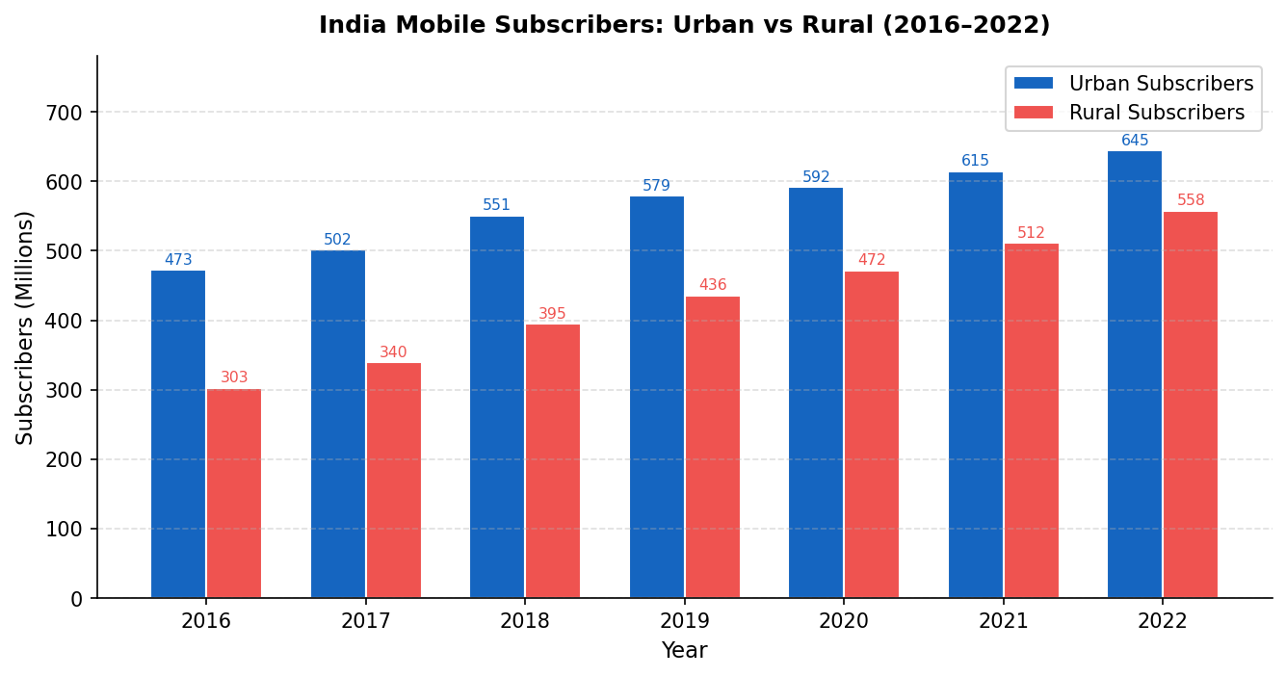

3.1 Similarities
- Both urban and rural subscriber counts have increased consistently from 2016 to 2022.
- Both categories experienced slight growth slowdowns in 2019–2020, likely due to COVID-19.
- The overall trend for both categories is positive, reflecting India's expanding telecom penetration.
3.2 Differences
- In all years, urban subscribers significantly outnumber rural subscribers in absolute terms.
- Rural subscribers grew by ~84% (303M to 558M) versus ~36% urban growth (473M to 645M) over the period.
- The urban–rural gap has shrunk from 170 million in 2016 to 87 million in 2022, showing convergence.
3.3 Reasons for Differences
- Urban areas had earlier access to telecom infrastructure and higher device affordability.
- Post-2016, the Jio effect (low-cost data) greatly accelerated rural mobile adoption.
- Government BharatNet and Digital India programmes boosted rural network coverage.
- Lower population density in rural areas makes infrastructure deployment costlier and slower.

4. Conclusion
The data clearly shows that while urban India leads in absolute subscriber numbers, rural India is growing at more than double the urban rate. The narrowing gap between the two reflects the success of market expansion and government digital inclusion policies. Full convergence will require continued investment in rural connectivity infrastructure and affordable device availability.
5. References
- TRAI. Telecom Statistics India 2022. https://trai.gov.in
- Ministry of Communications. Annual Report 2022. Government of India.

PRACTICAL 6: Modelling and Simulation Techniques
Monte Carlo Simulation of an RC Low-Pass Filter

1. System Model
An RC low-pass filter allows signals below its cutoff frequency to pass while attenuating higher-frequency signals. The output voltage across the capacitor depends on the component values of R and C, which have manufacturing tolerances.
- Transfer Function: H(f) = 1 / √(1 + (2πfRC)²)
- Output Voltage: V_out = V_in × H(f)
- Cutoff Frequency: f_c = 1 / (2πRC)

2. Nominal Component Values
Component | Nominal Value | Tolerance
Resistance (R) | 1000 Ω (1 kΩ) | ±5%
Capacitance (C) | 100 nF | ±5%
Input Voltage V_in | 5 V | Fixed
Frequency f | 1000 Hz | Fixed

3. Probability Distributions of Uncertain Parameters
Due to ±5% manufacturing tolerances, R and C are modelled as uniform distributions:
- R ~ U(950, 1050) Ω
- C ~ U(95 nF, 105 nF)

4. Simulation Procedure
- Generate a random R value uniformly between 950 Ω and 1050 Ω.
- Generate a random C value uniformly between 95 nF and 105 nF.
- Compute cutoff frequency: f_c = 1 / (2π×R×C).
- Compute transfer function: H = 1 / √(1 + (2π×f×R×C)²).
- Compute output voltage: V_out = V_in × H.
- Repeat 1000 times and record all V_out values.
- Calculate mean, standard deviation, minimum, and maximum of V_out.

5. Python Code
import random, math
Vin=5; f=1000; N=1000; R_nom=1000; C_nom=100e-9; tol=0.05
vout_list = []
for i in range(N):
R = random.uniform(R_nom*(1-tol), R_nom*(1+tol))
C = random.uniform(C_nom*(1-tol), C_nom*(1+tol))
H = 1 / math.sqrt(1 + (2*math.pi*f*R*C)**2)
vout_list.append(Vin * H)
print("Mean Vout =", sum(vout_list)/N)

6. Results
Measure | Value
Average V_out | ≈ 4.226 V
Standard Deviation | ≈ 0.063 V
Minimum V_out | ≈ 4.163 V
Maximum V_out | ≈ 4.395 V
Nominal V_out (R=1kΩ, C=100nF) | ≈ 4.226 V

- As R×C increases → cutoff frequency decreases → more attenuation → lower V_out.
- As R×C decreases → cutoff frequency increases → less attenuation → higher V_out.
- Output variation range ≈ 0.23 V, representing only 5.4% variation for ±5% component tolerances.

7. Conclusion
The Monte Carlo simulation shows that ±5% tolerances in R and C produce a narrow spread in output voltage (≈ 4.16 V to 4.40 V), indicating the RC low-pass filter is robustly designed. The simulation confirms that the circuit behaviour is predictable despite component variability, and the standard deviation of ≈ 63 mV is well within acceptable limits for most analog applications. Monte Carlo analysis is a valuable tool in electronics for reliability estimation, tolerance analysis, and worst-case design without requiring physical prototypes.
8. References
- Sedra A, Smith K. Microelectronic Circuits. Oxford University Press; 2015.
- Rubinstein R, Kroese D. Simulation and the Monte Carlo Method. Wiley; 2016.
- Hayt W, Kemmerly J. Engineering Circuit Analysis. McGraw-Hill; 2018.

