PRACTICAL 1 : CZ technique Simulation SCILAB CODE :
clc;clf;clear;
M = linspace(0, 0.9, 100);
K0 = [0.1, 0.01, 0.2, 0.6, 1.2,1.3];
colors = ['y', 'b', 'g', 'm', 'c','r'];
// Plot each curve
for i = 1:length(K0) Ki = K0(i);
Ci = Ki .* (1 - M).^(Ki - 1);
plot(M, Ci, colors(i)); end
title("CZ Technique Simulation"); xlabel("M/M0");
ylabel("Cs/C0"); xgrid();
legend(string(K0), "location", "in_upper_left"); xstring(0.01, 0.65, "K0 = 0.6");
xstring(0.35, 1.1, "K0 = 1.2");
xstring(0.05, 0.25, "K0 = 0.2");
xstring(0.05, 0.1, "K0 = 0.1");
xstring(0.05, 0.01, "K0 = 0.01");
xstring(0.40, 1.2, "K0 = 1.3");

OUTPUT:
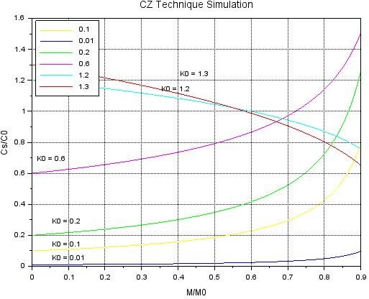

PRACTICAL 2 : Float Zone technique Simulation SCILAB CODE :
clc;clf;clear;
x_L = linspace(0,10,100); K0=[0.1,0.01,0.2,0.5,0.9,2];
colormap = jet(length(K0)); for i = 1:length(K0)
Ki = K0(i);
C_C0 = 1 - (1 - Ki) * exp(-Ki * x_L); plot(x_L, C_C0, 'color', colormap(i, :));
end
title("Float Zone technique Simulation") xlabel("x/L");
ylabel("Cs/C0"); xgrid
legend(string(K0),"location","in_upper_right"); xstring(3,0.1,"K0 = 0.01")
xstring(3,0.4,"K0 = 0.1")
xstring(3,0.65,"K0 = 0.2")
xstring(0.1,0.7,"K0 =0.5")
xstring(0.1,1,"K0 = 0.9")
xstring(1,1.2,"K0 =2")

OUTPUT:
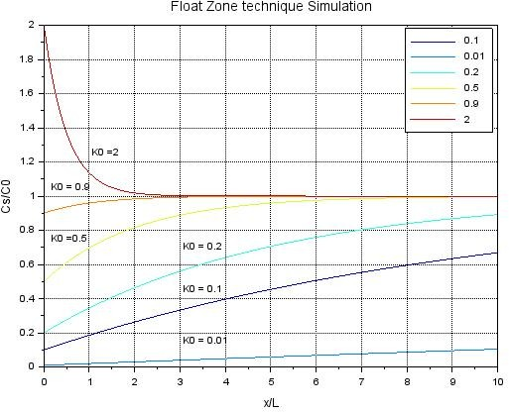

PRACTICAL 3 : Oxidation Process Simulation SCILAB CODE :
clc;clear;close;
// Time range (hours) – log scale
t = logspace(-1, 2, 200); // 0.1 hr to 100 hr
colors = ["r", "g", "b", "m"]; figure(1);clf();
// 1. DRY OXIDATION
subplot(1, 2, 1);
A_dry = [0.04, 0.09, 0.165, 0.235];
B_dry = [0.045, 0.027, 0.0117, 0.0049];
tau_dry = [0.027, 0.076, 0.37, 1.40];
labels_dry = ["1200°C","1100°C","1000°C","920°C"];
for i = 1:length(A_dry)
x = (-A_dry(i) + sqrt(A_dry(i)^2 + 4*B_dry(i)*(t + tau_dry(i)))) / 2; loglog(t, x, colors(i), "Thickness", 2);
end
xlabel("Oxidation time (hr)"); ylabel("Oxide thickness (µm)"); title("Dry Oxidation");
legend(labels_dry, "location", "upper left"); xgrid();
// 2. WET OXIDATION
subplot(1, 2, 2);
A_wet = [0.05, 0.11, 0.226, 0.50];
B_wet = [0.72, 0.51, 0.287, 0.203];
tau_wet = [0, 0, 0, 0];
labels_wet = ["1200°C","1100°C","1000°C","920°C"];
for i = 1:length(A_wet)
x = (-A_wet(i) + sqrt(A_wet(i)^2 + 4*B_wet(i)*(t + tau_wet(i)))) / 2; loglog(t, x, colors(i), "Thickness", 2);
end
xlabel("Oxidation time (hr)"); ylabel("Oxide thickness (µm)"); title("Wet Oxidation");
legend(labels_wet, "location", "upper left"); xgrid();

OUTPUT:

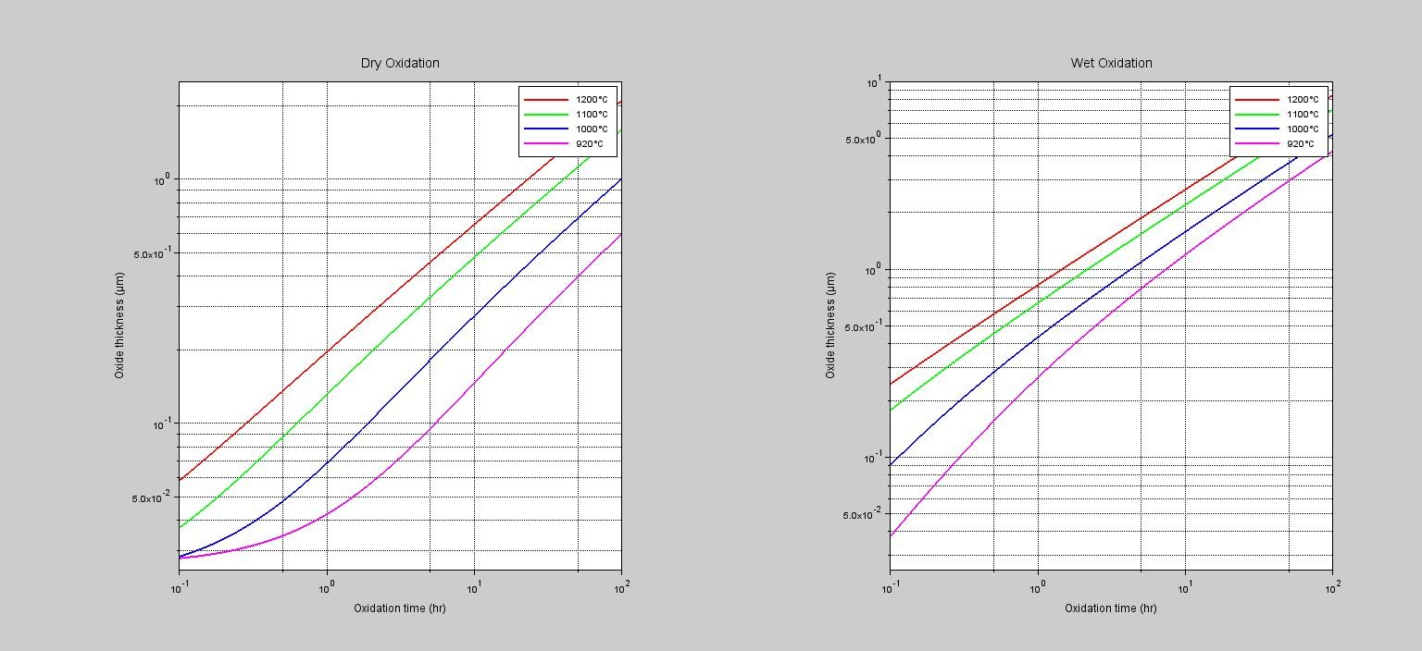

PRACTICAL 4 : Diffusion Process Simulation SCILAB CODE :
// Diffusion Profiles: erfc vs Gaussian
clc;clear;clf;
// Parameters
L_um_list = [0.1, 0.5, 1.0]; // Diffusion lengths (sqrt(Dt)) in microns
x_um = linspace(0, 4, 400); // Depth axis (0–4 µm)
x_cm = x_um * 1e-4; // Convert depth to cm
// Colors for curves
colors = [2,3,5]; // red, green, blue
// Create windowscf(1); for i = 1:length(L_um_list)
L_um = L_um_list(i); L_cm = L_um * 1e-4;
// 1. Constant Surface Concentration (erfc)
C_erfc = erfc(x_cm ./ (2 * L_cm));
// 2. Constant Total Dose (Gaussian)
C_gauss = (1.0 / (sqrt(%pi) * L_cm)) * exp(-(x_cm.^2) ./ (4 * L_cm.^2));
// ---- ERFC Linear ----subplot(2,2,1); plot(x_um, C_erfc);
e = gce();
e.children.foreground = colors(i); e.children.thickness = 2;
// ---- ERFC Semi-log ----subplot(2,2,3); plot(x_um, C_erfc);
e = gce();
e.children.foreground = colors(i); e.children.thickness = 2;
a1 = gca(); a1.log_flags = "nl";
// ---- Gaussian Linear ----subplot(2,2,2); plot(x_um, C_gauss);

e = gce();
e.children.foreground = colors(i); e.children.thickness = 2;
// ---- Gaussian Semi-log ----
subplot(2,2,4); plot(x_um, C_gauss); e = gce();
e.children.foreground = colors(i); e.children.thickness = 2;
a2 = gca(); a2.log_flags = "nl";
End
// ERFC Linear
subplot(2,2,1);
title("Constant Surface (erfc) - Linear"); xlabel("Depth (um)");
ylabel("C / Cs"); legend("L=0.1um","L=0.5um","L=1.0um"); xgrid();
// ERFC Semi-log
subplot(2,2,3);
title("Constant Surface (erfc) - Semi-log"); xlabel("Depth (um)");
ylabel("C / Cs (log)"); re_a1 = gca();
re_a1.data_bounds = [0,1e-4;4,1.5]; legend("L=0.1um","L=0.5um","L=1.0um"); xgrid();
// Gaussian Linear
subplot(2,2,2);
title("Constant Dose (Gaussian) - Linear"); xlabel("Depth (um)");
ylabel("C / S (cm^-1)"); legend("L=0.1um","L=0.5um","L=1.0um"); xgrid();
// Gaussian Semi-log
subplot(2,2,4);
title("Constant Dose (Gaussian) - Semi-log"); xlabel("Depth (um)");
ylabel("C / S (log)"); re_a2 = gca();
re_a2.data_bounds = [0,1e1;4,1e6]; legend("L=0.1um","L=0.5um","L=1.0um"); xgrid();

OUTPUT:

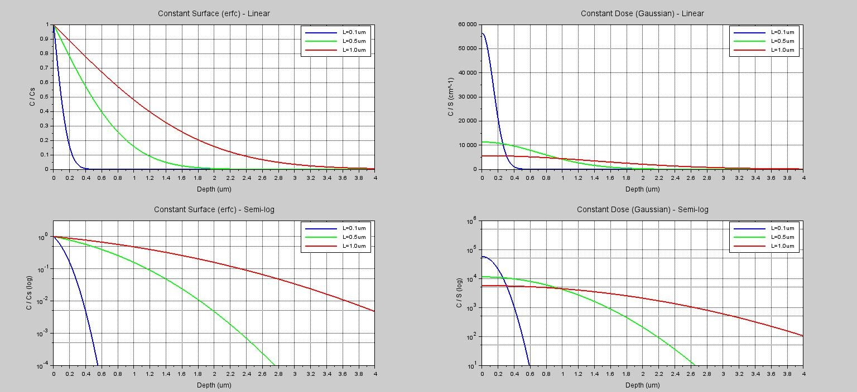

PRACTICAL 4 : Diffusion Process Simulation SCILAB CODE :
// PN Junction Depth Simulation using Eq.9
// C(x,t) = Cs * erfc( x / (2*sqrt(D*t)) )
clc;clear;clf;
Cs = 1e20;// Surface concentration (cm^-3)
NB = 1e16; // Substrate doping (cm^-3)
D = 1e-13; // Diffusion coefficient (cm^2/s)
t = 3600; // Diffusion time (s)
// 2. Depth Range
x_cm = linspace(0,2e-4,500);// 0–2 µm (cm)
x_um = x_cm * 1e4; // convert to µm
L = sqrt(D*t); //Diffusion length
C = Cs * erfc(x_cm ./ (2*L));// 4. Diffusion profile
//Find Junction Depth
[diff_min, idx] = min(abs(C - NB)); xj_cm = x_cm(idx);xj_um = xj_cm * 1e4;
//Plot diffusion profileplot(x_um, C, 'g', "LineWidth",2)
//Plot substrate doping NB
plot(x_um, NB*ones(x_um), 'r--', "LineWidth",2)
//depth line from NB cutoff
plot([xj_um xj_um], [NB 1e6], 'o--', "LineWidth",2) xlabel("Depth (µm)"); ylabel("Concentration (cm^-3)") title("PN Junction Depth Analysis")
legend("Diffusion Profile C(x,t)", "Substrate Doping NB", "Junction Depth xj")

a = gca()
;a.log_flags = "nl";// logarithmic scale xgrid()
printf("\nSurface Concentration Cs = %.2e cm^-3\n", Cs); printf("Substrate Doping NB = %.2e cm^-3\n", NB); printf("PN Junction Depth xj = %.4f µm\n", xj_um); OUTPUT:
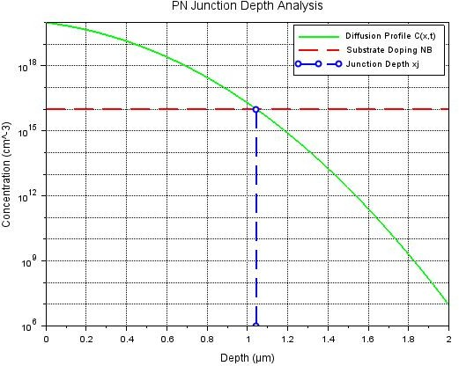
PRACTICAL 4 : At 300k, the molecular diameter of oxygen is 3.64 A˚, and the number of molecules per unit area is = 7.54 × 1014 cm−2 . Find the time required to form a monolayer of oxygen at pressures of 1 Pa, 10−4 Pa, and 10−8 Pa.

SCILAB CODE :
clc; clear;
N_s = 7.54e14; // Number of molecules per cm²
M = 32; // Molecular weight of oxygen (g/mol)
T = 300; // Temperature in Kelvin
phi = 1; // Assuming 100% sticking
constant = 2.64e20; // Given constant in formula
P = [1, 1e-4, 1e-8];// Pressures in Pascal
// Compute time for each pressure
t = (N_s ./ phi) .* sqrt(M * T) ./ (constant .* P);
disp("Time required to form a monolayer (in seconds) at different pressures:"); disp([P', t']);

OUTPUT:
