PRACTICAL 1: Write a program to generate a discrete time unit sample, unit step, ramp and sinusoidal signal. SCILAB CODE: (a) Unit step signal
clf(); clc(); clear();
L=10 n=-L:L
x=[zeros(1,L),ones(1,L+1)] // Plot the signal plot2d3(n, x, style=6); xlabel('Time');
ylabel('u[n]');
title('Discrete Unit Step Sequence');
// for bubbles plot2d(n, x, -3); // Axis settings a = gca();
a.data_bounds = [-10 0; 10 2];
a.x_location = "origin";
a.y_location = "origin";
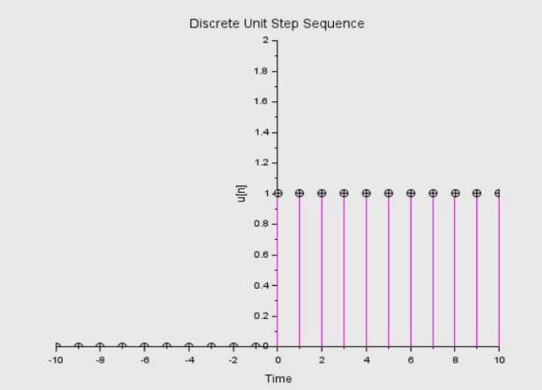
(b) Unit Impulse Sequence
clf(); clc(); clear(); n= -10:10; x= zeros(1, length(n)); x(n == 0) = 1;
plot2d3(n,x, style=5); a = gca();
a.data_bounds = [-5 0; 5 2];
a.x_location = "origin";
a.y_location = "origin"; title("Discrete-Time Unit Impulse"); xlabel("n")
ylabel("x") xgrid();
// for bubbles plot2d(n, x, -3);
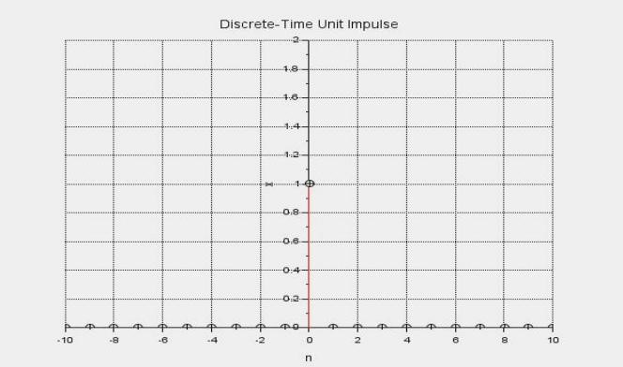
(c) Ramp Signal clf();clc();clear();
t = 0:1:15; // define the signal ramp = t .* (t >= 0);plot2d3(t, ramp, style=5); title(" Discrete Ramp Signal"); xlabel("t"); ylabel("r(t)"); a = gca(); plot2d(t, ramp, -3);
a.data_bounds = [0 0; 10 10.5];
a.background = color("grey");
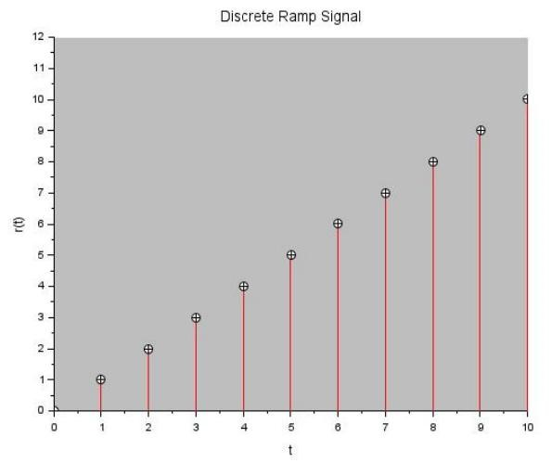
(d) sinusoidal signal clf(); clc(); clear(); t = -0:0.1:20; // Define the signals x1 = sin(t); // Ploting of sint plot2d3(t,x1, style=5);
title('sin(x)'); ylabel('Amplitude'); xlabel('Time'); plot2d(t, x1, -3);
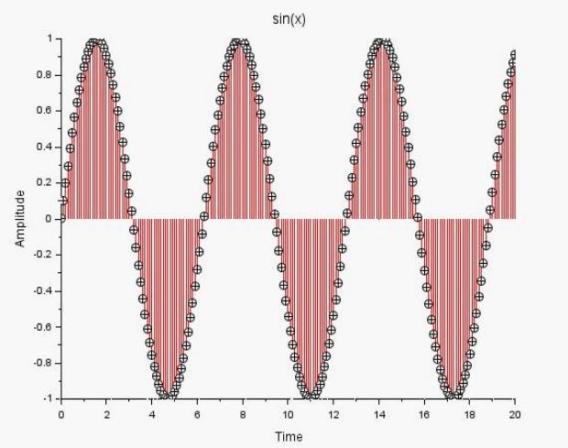
PRACTICAL 2 : write a program to find the Fourier transform of a sequence. SCILAB CODE :
clc;clear;clf;
// Define sequence n = 0:5; x = ones(1, length(n));// unit step // Plot 1:
subplot(3,1,1);
for i = 1:length(n)
plot([n(i) n(i)], [0 x(i)], 'b-');

end
plot2d(n, x, -3);title("Unit Step Sequence x[n]"); xlabel("n"); ylabel("x[n]"); xgrid();
// Frequency range w = -%pi:0.01:%pi; // DTFT
X = zeros(1, length(w));
for k = 1:length(w)
X(k) = sum(x .* exp(-%i * w(k) * n)); end
// Plot 2: Continuous DTFT subplot(3,1,2); plot(w, abs(X), 'b-'); title("Magnitude of DTFT |X(w)|"); xlabel("Frequency (rad/sample)");
ylabel("|X(w)|");xgrid(); // Plot 3: Discrete DTFT subplot(3,1,3); w_d = -%pi:%pi/10:%pi; X_d = zeros(1, length(w_d)); for k = 1:length(w_d)
X_d(k) = sum(x .* exp(-%i * w_d(k) * n)); end for i = 1:length(w_d)
plot([w_d(i) w_d(i)], [0 abs(X_d(i))], 'r-'); end
plot(w_d, abs(X_d), 'ro'); title("Discrete Magnitude |X(w)|"); xlabel("Frequency (rad/sample)");
ylabel("|X(w)|"); xgrid();
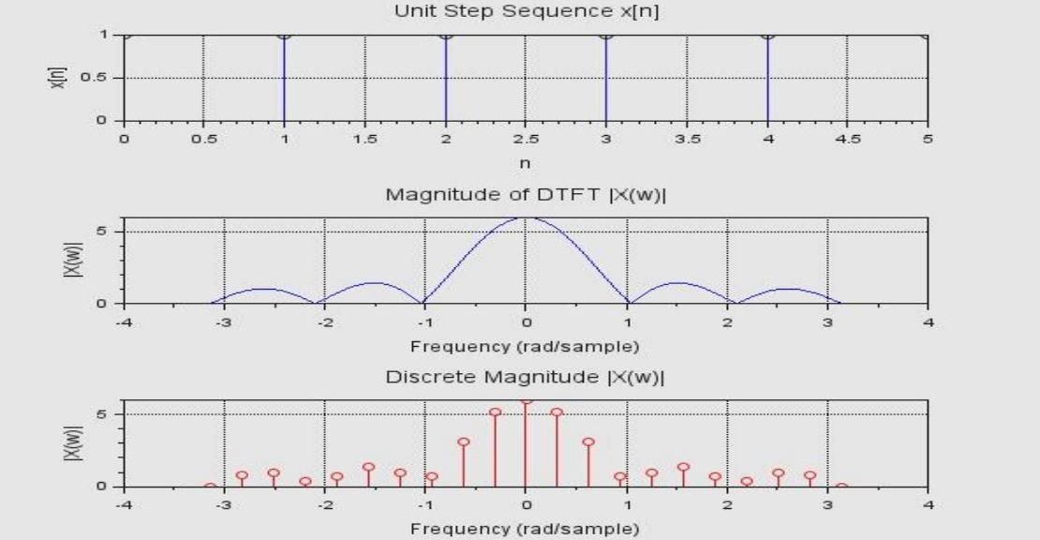
PRACTICAL 3 : Write a program to find the pole zero plot of a function. SCILAB CODE :
clc;clear;clf;
// EXAMPLE :- H(Z)= 1+0.5Z^-1 / 1-0.8Z^-1 + 0.2Z^-2. // Zeros and poles z = [0 -0.5];
p = [0.4+0.2*%i 0.4-0.2*%i];
// Plot zeros plot(real(z), imag(z), 'bo'); xgrid();
// Plot poles
plot(real(p), imag(p), 'rx'); // Plot unit circle t = 0:0.01:2*%pi;
plot(cos(t), sin(t), 'k--'); xlabel("Real Axis"); ylabel("Imaginary Axis"); title("Pole-Zero Plot"); legend("Zeros","Poles","Unit Circle");
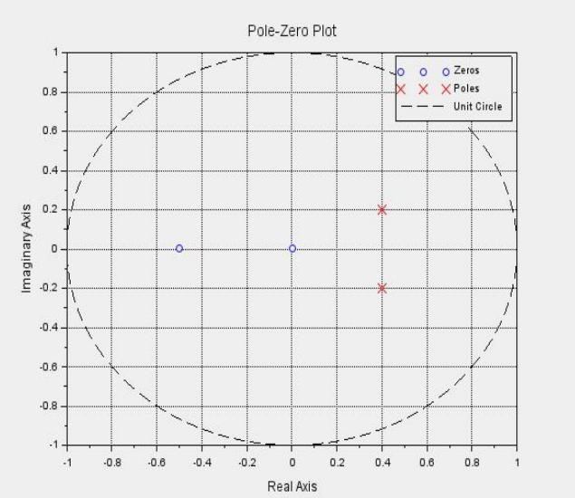
PRACTICAL 4 : Write a program to find the functions Z transform and inverse Z transform
SCILAB CODE :
clc;clear; // define n n = 1:4;
// original sequence x = (0.5).^n;
// define new variable w = z^-1 w = poly(0, 'w');
// -------- Z-TRANSFORM -------X = 0;
for k = 1:length(n)
X = X + x(k) * w^(n(k)); end
disp("Z-Transform X(w):");
disp(X);
// -------- INVERSE Z-TRANSFORM -------N = length(n); x_inv = zeros(1, N); for k = 0:N-1 x_inv(k+1) = coeff(X, k); end
disp("Inverse Z-Transform x[n]:");
disp(x_inv);
OUTPUT:
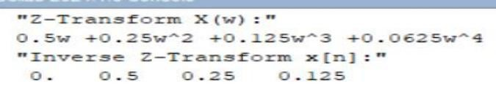
PRACTICAL 5 : Write a program to find the circular convolution of 2 sequences.
SCILAB CODE :
clc;clear;
// Input sequences x = [2 -1 3 0 1 4]; h = [1 2 -2 1 0 3];
N = length(x); y = zeros(1, N); // Circular convolution for n = 1:N
for k = 1:N
index = pmodulo(n - k, N); // always 0 to N-1 y(n) = y(n) + x(k) * h(index + 1); // shift to 1-based end

end
disp("Result y(n):");
disp(y);
OUTPUT:-
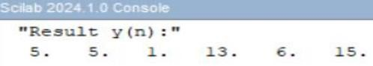
PRACTICAL 6 : Write a program to find the DFT of a sequence using direct method. SCILAB CODE :
clf(); clc(); clear();
// input sequence x = [1.5 -2.3 0.7 4.1];
// length
N = length(x);
// initialize
X = zeros(1, N); // DFT (Direct Method) for k = 0:N-1

for n = 0:N-1
X(k+1) = X(k+1) + x(n+1)*exp(-%i*2*%pi*k*n/N); end end
// Magnitude mag = abs(X); // Phase phase = atan(imag(X), real(X)); phase(abs(phase) < 1e-10) = 0;
// display disp("DFT:"); disp(X); disp("Magnitude:"); disp(mag); disp("Phase (radians):"); disp(phase);
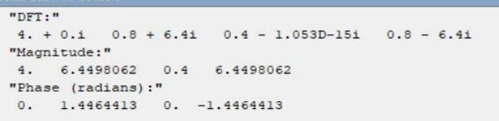
PRACTICAL 7 : Write a program to find the DFT of a Sequence using FFT. SCILAB CODE :
clc(); clear();
// input x = [1 2 3 4];
N = length(x);
// FFT
X = fft(x, -1);
// magnitude & phase mag = abs(X); phase = atan(imag(X), real(X));
phase(abs(phase) < 1e-10) = 0;
disp("DFT:"); disp(X); disp("Magnitude:"); disp(mag); disp("Phase (radians):"); disp(phase);
