NAME – ABHINAV SHARMA
ROLL NUMBER – 6227
COURSE – BSC (H) ELECTRONICS

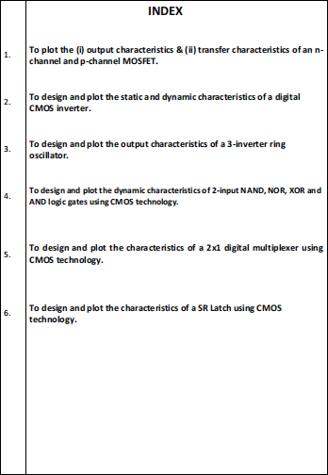

PRACTICAL – 1

AIM:- To plot the (i) output characteristics & (ii) transfer characteristics of an n-channel and p-channel MOSFET.
Platform:- LTSPICE.
Theory:- MOSFET (Metal–Oxide–Semiconductor Field-Effect Transistor) is a voltage-controlled semiconductor device widely used in digital and analog
circuits. The current in a MOSFET flows due to an inversion channel formed by the voltage applied at the gate terminal. Because the input gate terminal is insulated by an oxide layer, the MOSFET has extremely high input impedance and requires almost no gate current.
In this experiment, we study the Output Characteristics (ID–VDS) and Transfer Characteristics (ID–VGS) of both NMOS and PMOS devices.
An NMOS is a type of MOSFET in which the majority charge carriers are
electrons. Current flows between the drain and source when a positive voltage is applied at the gate terminal.
A PMOS is a MOSFET in which the majority charge carriers are holes. It turns ON when the gate voltage is negative with respect to the source.
Formulas Used:-
- Threshold voltage( VT) : Gate to source voltage at which, drain current starts
flowing.
- Transconductance (gm) : Ratio of small change in drain current (Δ ID) to the corresponding change in gate to source voltage (ΔVGS) for a constant VDS.
gm = Δ ID / ΔVGS at constant VDS.
- Output drain resistance (rd) : It is given by the relation of small change in drain to source voltage (Δ VDS) to the corresponding change in Drain Current (Δ ID) for a constant VGS.
rd = Δ VDS /Δ ID at constant VGS.
CIRCUIT DIAGRAM:-
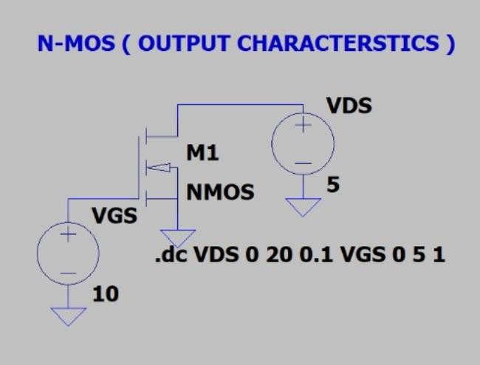

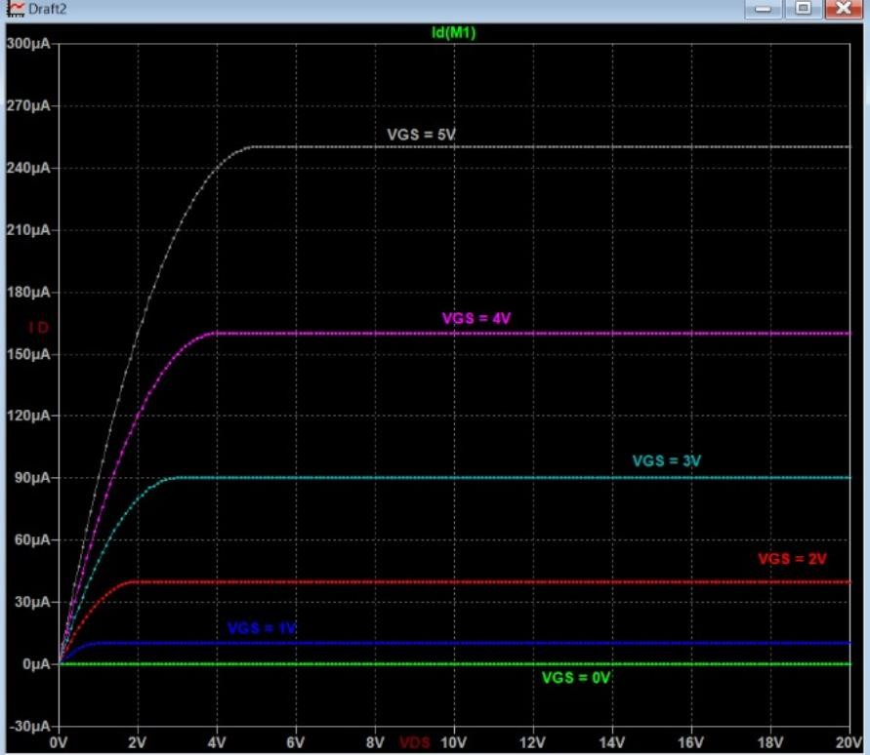
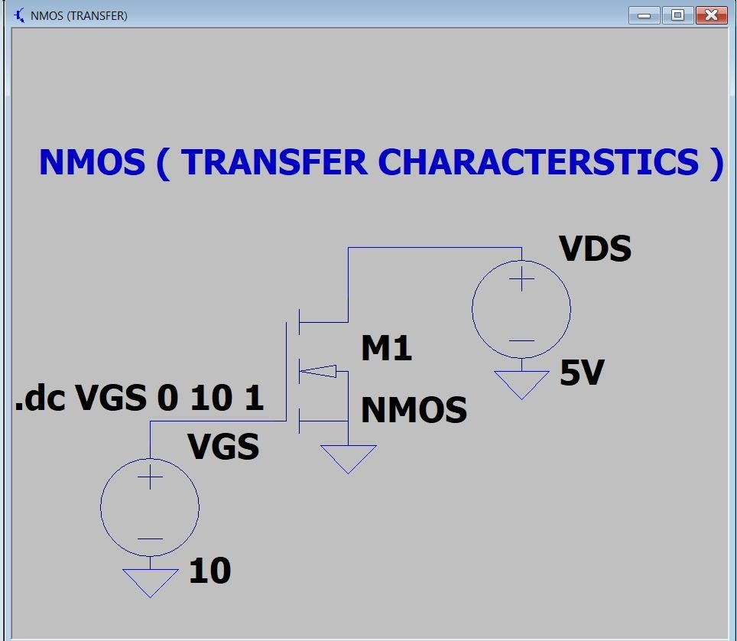

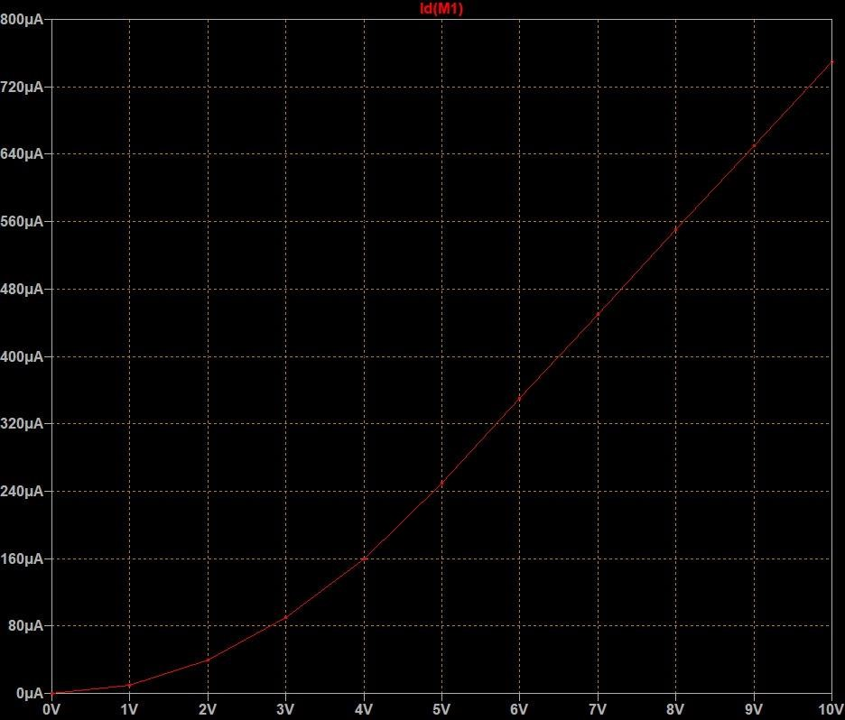

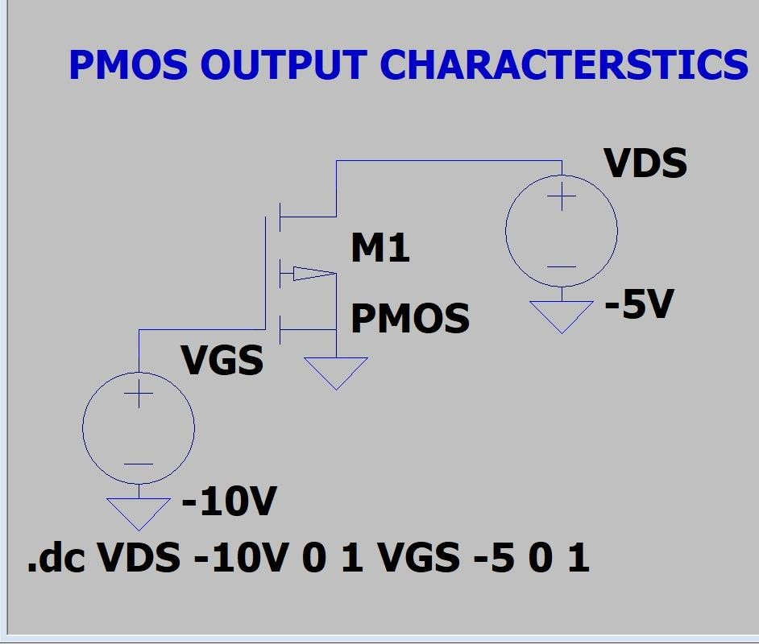

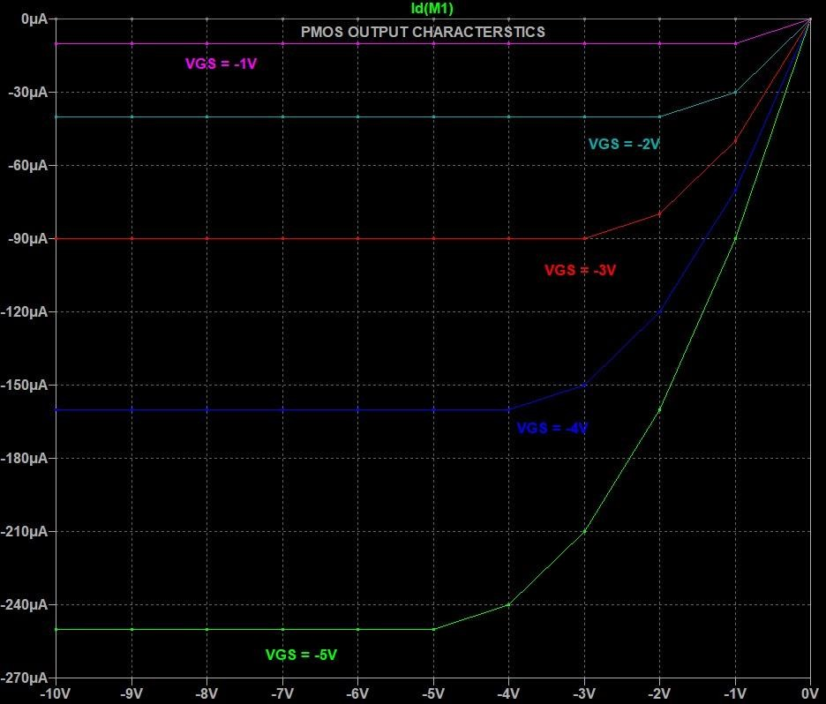
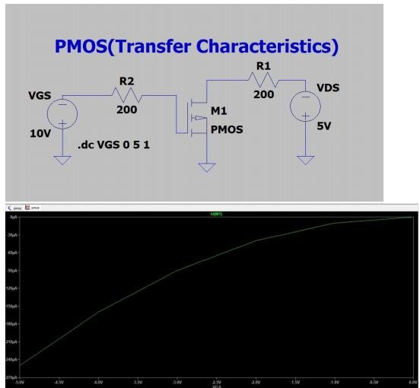

PRACTICAL -- 2

AIM:- To design and plot the static (VTC) and dynamic characteristics of a digital CMOS inverter.
Theory:- An invertor is the most basic logic gate and fundamental block of all digital circuit in VLSI degiens. It performs the NOT operation, which means it inverts the input logic.
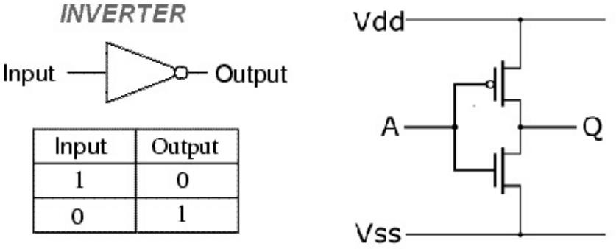
A CMOS inverter is the fundamental building block of all digital logic circuits. It consists of a PMOS transistor at the top and an NMOS transistor at the bottom, connected in a complementary manner. When one transistor is ON, the other is OFF, resulting in low power consumption, high noise margins, and excellent
switching behavior.
Inverter Static Characteristics (VTC)
The Voltage Transfer Characteristic (VTC) of a CMOS inverter is a graph of output voltage (Vout) versus input voltage (Vin) under steady-state (DC) conditions.

✔ What VTC tells us
- How the inverter behaves for every value of input.
- At what input voltage the output switches from HIGH to LOW.
- Noise margins (how much noise the circuit can tolerate).
- Quality of the inverter (good switching → steep curve).

Noise Margin is a measure of how much noise or unwanted voltage a digital circuit can tolerate without making an error.
A CMOS inverter has two logic states:
- Logic LOW (0)
- Logic HIGH (1)

Noise Margin High (NMH)
This is the maximum noise voltage the circuit can tolerate when the output is HIGH (1).

NMH = V OH -
Where: VOH = Output High Voltage, VIH = Minimum input voltage recognized as HIGH

Noise Margin Low (NML)
This is the maximum noise voltage the circuit can tolerate when the output is LOW (0).
NML = V IL -
Where: VOL = Output Low Voltage , VIL = Maximum input voltage recognized as LOW
Inverter Dynamic Characteristics:
Dynamic characteristics describe how the inverter behaves when the input changes with time (AC condition).
They show how fast the inverter can switch and are related to speed performance.
CIRCUIT DIAGRAM:-
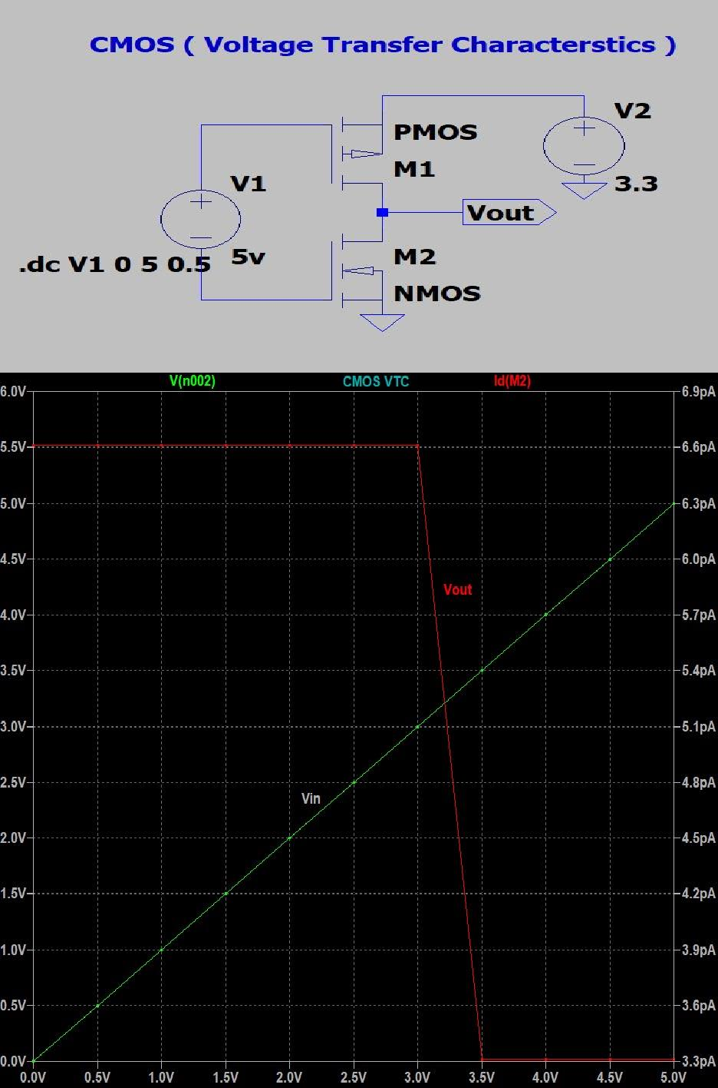

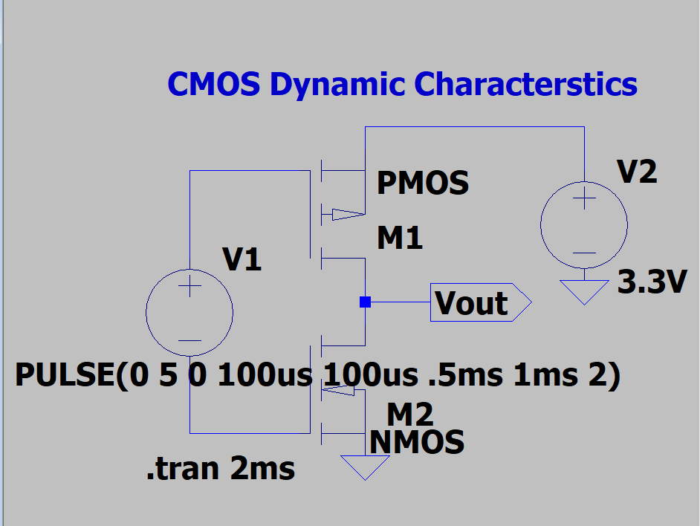
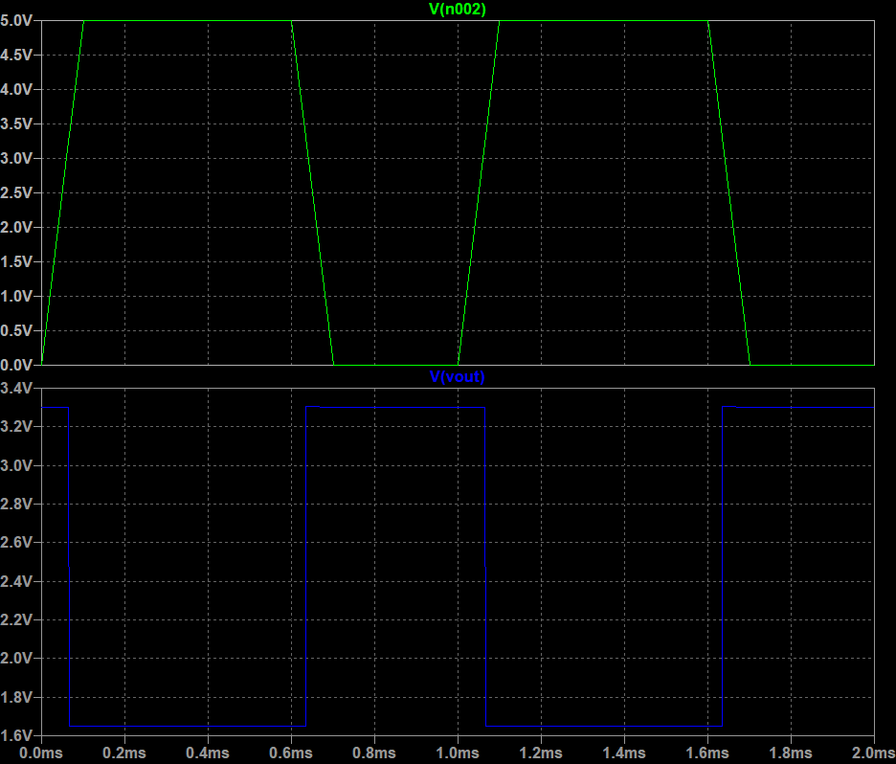

PRACTICAL :- 3

AIM:- To design and plot the output characteristics of a 3-inverter ring oscillator.
THEORY:- A ring oscillator is a simple oscillator circuit made by connecting an odd number of inverters in a loop.The output of the last inverter is fed back to the input of the first inverter, forming a closed ring.
Because the number of inverters is odd, the total inversion around the loop creates a condition where the circuit can never settle at a stable logic level. Instead, the signal keeps switching between HIGH and LOW, producing oscillations.A 3-inverter ring oscillator is the simplest form of ring oscillator.
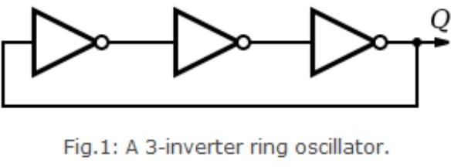

Principle of Operation
A CMOS inverter has a certain propagation delay (tp).
This is the time taken for the output to respond to a change in input. For a ring oscillator with N inverters:
- The signal must pass through all N stages,
- And return to the starting point to complete one cycle.
Thus, oscillation occurs because the feedback signal keeps getting delayed and inverted, preventing the circuit from settling in a steady state.

More inverters → more total delay → lower oscillation frequency.
- Ring oscillator frequency ∝ 1 / (number of stages × gate delay). For a 3-stage ring oscillator:
f = 1 / (6 × inverter delay) → delay can be found from the oscillator period.

CIRCUIT DIAGRAM:-

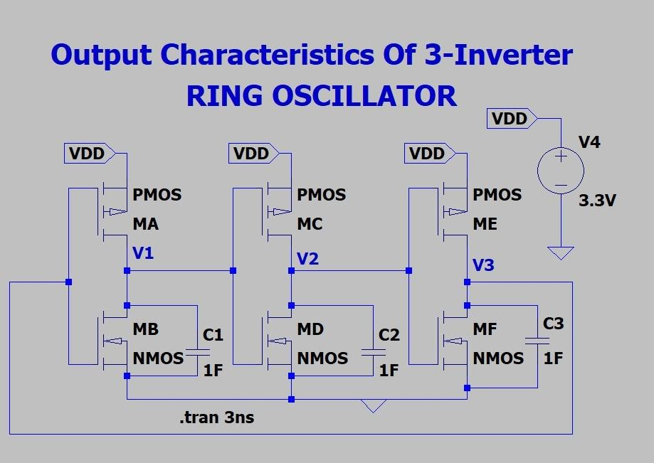
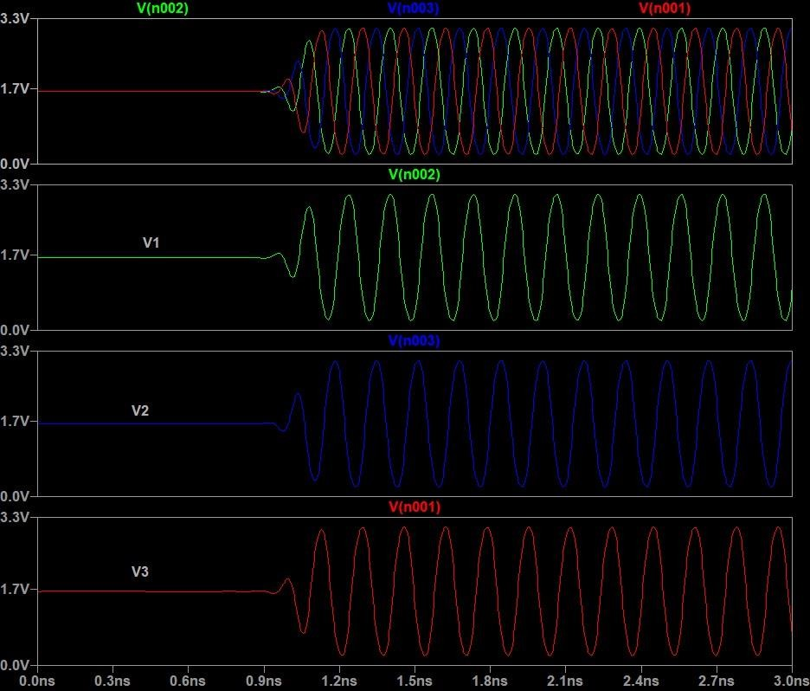

PRACTICAL -- 4

AIM:-To design and plot the dynamic characteristics of 2-input NAND, NOR, XOR and XNOR logic gates using CMOS technology.
THEORY:- Static MOS degien ( or static CMOS design) refers to a logic ckt
degien in which the output is always connected to either VDD(logic 1) or GND (logic 0).
A CMOS logic gate consists of 2 complementary Networks:
- Pull-Up Network(PUN):- made of PMOS that connects output to VDD when output = 1
- Pull-Down Network:- made of NMOS that connects output to GND when output = 0
CMOS NOR Gate (2-input):-
  - PDN: Two NMOS in parallel
  - PUN: Two PMOS in series Operation
  - Output is HIGH only when both inputs are LOW
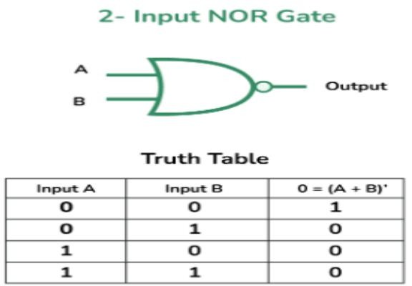

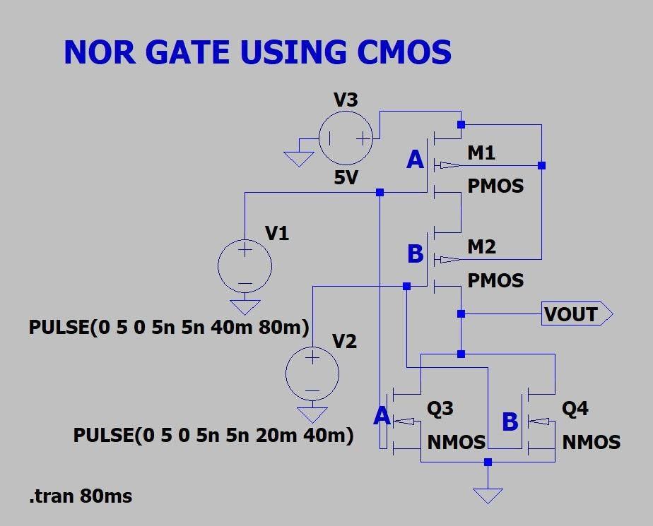
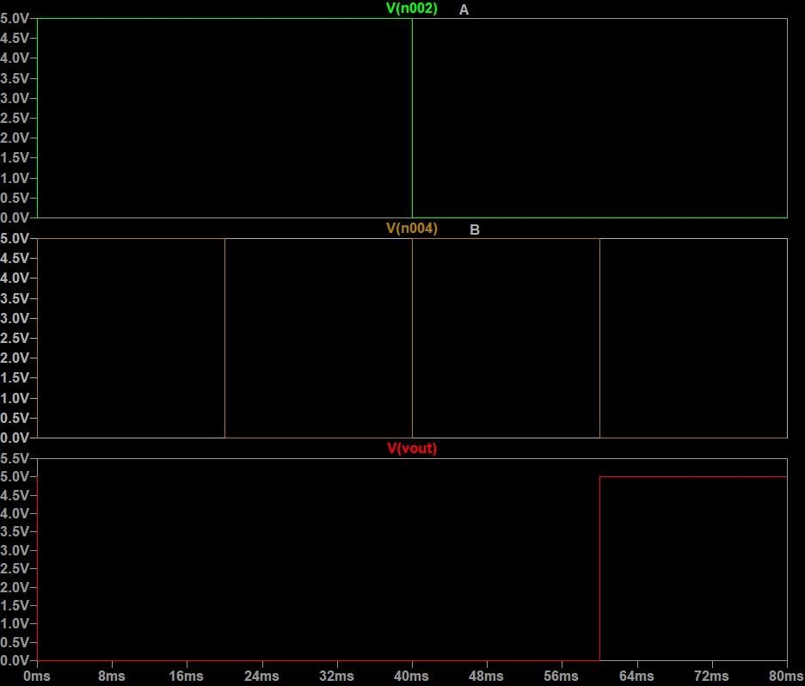

NAND Gate:-
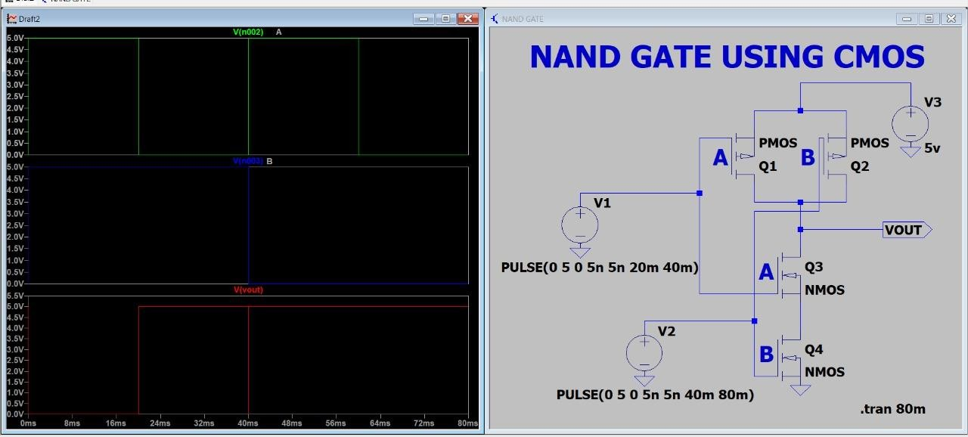
A NAND gate (short for NOT-AND) is a universal logic gate whose output is low (logic 0) only when all its inputs are high (logic 1); for any other input combination, the output is high (logic 1).

XOR GATE:-
An XOR gate (Exclusive OR gate) produces a high output (1) only when its inputs are different (an odd number of high inputs), and a low output (0) when its inputs are the same.
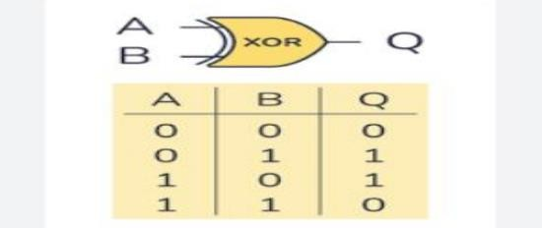

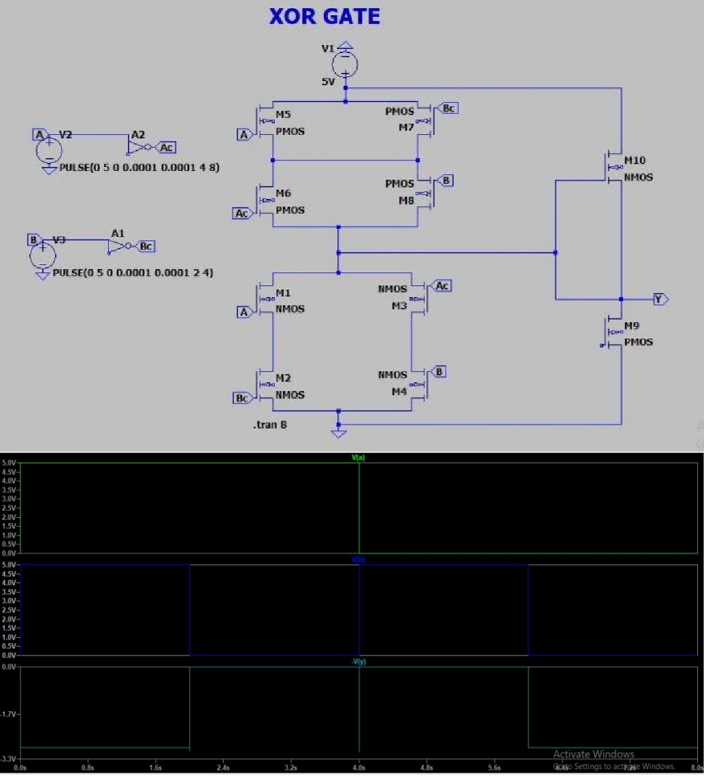

AND GATE:-
An AND gate outputs logic HIGH (1) only when all inputs are HIGH it is a basic digital logic gate that performs logical multiplication.
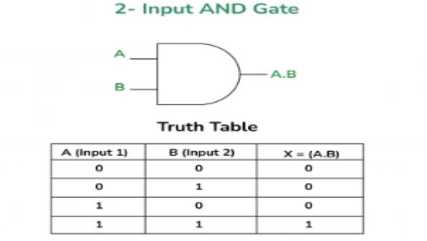

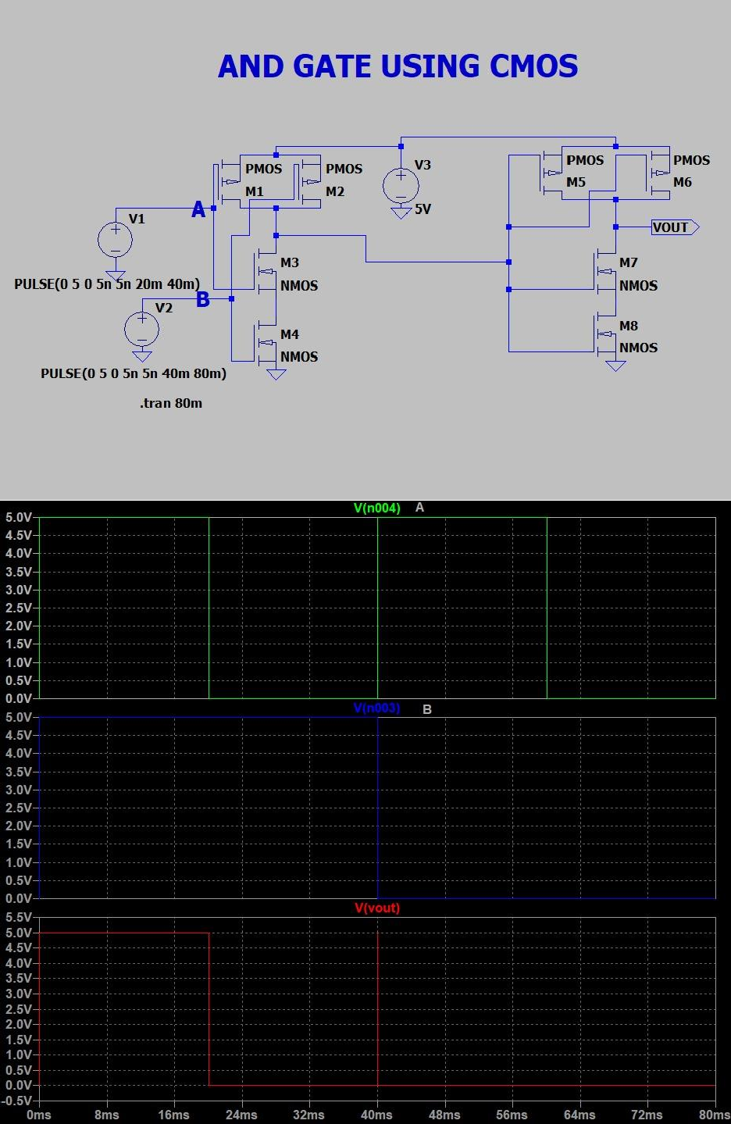

PRACTICAL -- 5

AIM:- To design and plot the characteristics of a 4x1 digital multiplexer using pass transistor logic.
THEORY:-A Multiplexer (MUX) is a digital switching device that selects one of several input signals and passes it to the output based on the value of the
select line (S).
A 2×1 multiplexer has:
- Two data inputs: D0 and D1
- One select input: S
- One output: Y
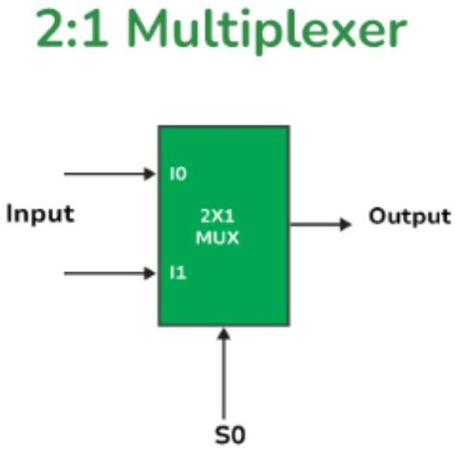

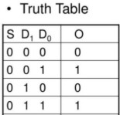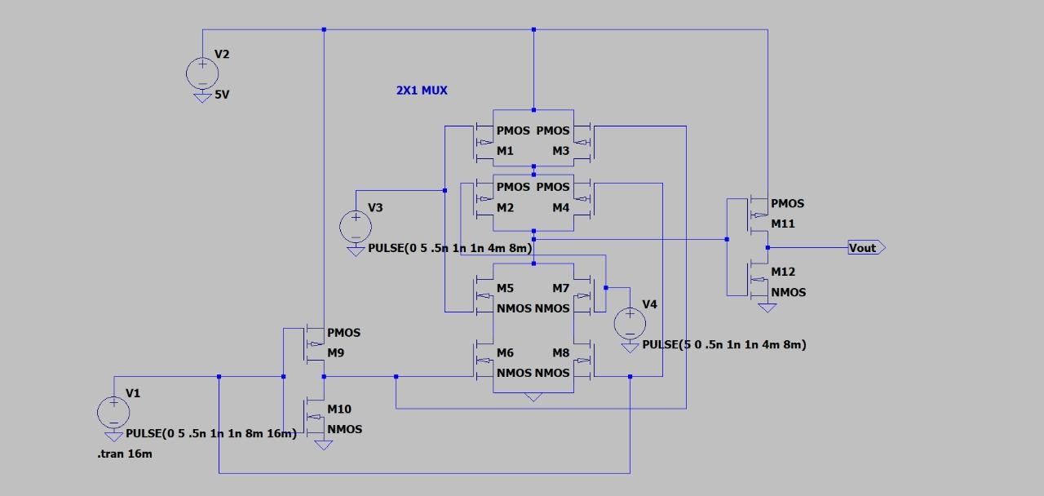

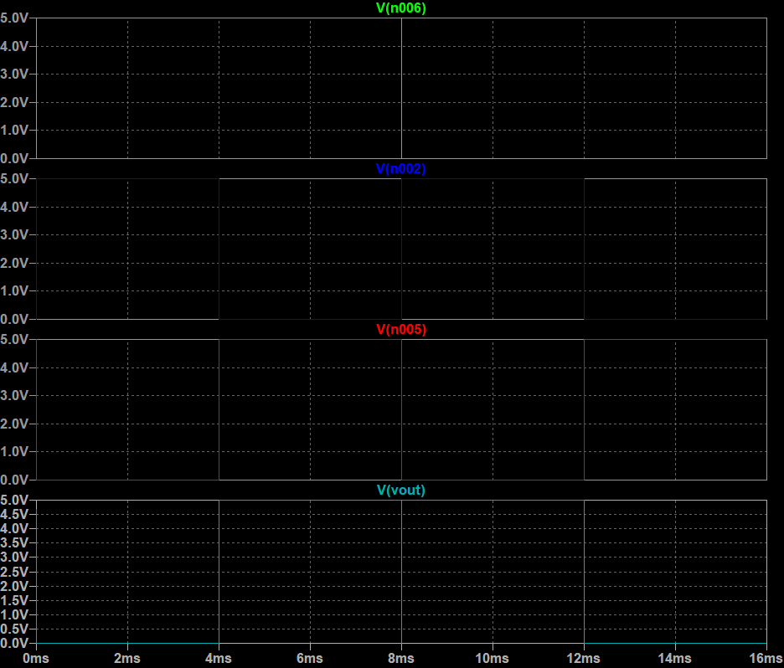

PRACTICAL -- 6

AIM:- To design and plot the characteristics of a SR Latch using CMOS technology.
THEORY:- S-R latches i.e., Set-Reset latches are the simplest form of latches and are implemented using two inputs: S (Set) and R (Reset). The S input sets the output to 1, while the R input resets the output to 0. When both S and R
inputs are at 1, the latch is said to be in an "undefined" state. They are also known as preset and clear states. The SR latch forms the basic building blocks of all other types of flip-flops. 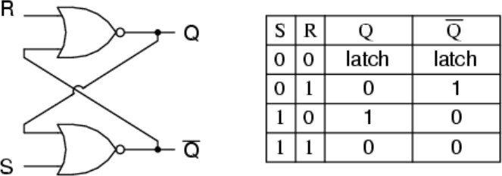

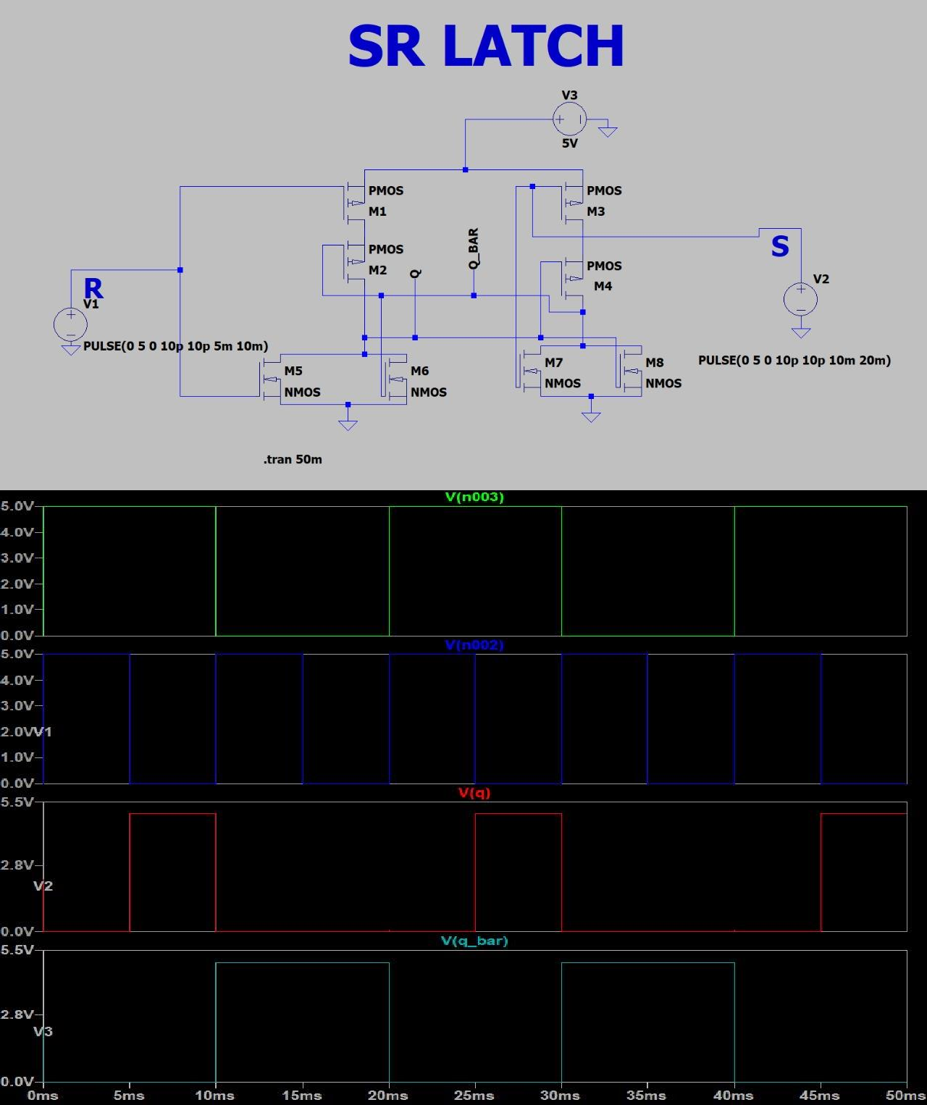
Circuit Diagram

