- Project Title & Version Control
Simulated SOC Incident Response & Analysis

Version Control
- Lab Version: Version 1.0
- Date: 06/17/2025
- Change Log: N/A

- Project Summary This project aims to provide a realistic, hands-on experience for developing Security Operations Center (SOC) incident response skills. It involves setting up a simulated enterprise network, detecting and investigating a simulated attack, and employing containment and remediation strategies alongside extensive documentation to aid future incident response readiness.

- Problem Statement / Use Case Cyber attacks are increasingly sophisticated, requiring well-trained Security Operations Center (SOC) analysts to respond effectively. This project prepares prospective analysts by offering a realistic scenario to practice their skills in a controlled, simulated environment.

- Goals and Objectives
  - Develop technical incident response skills
  - Learn to configure, manage, and respond to alerts within a Security Information and Event Management (SIEM) platform
  - Provide extensive, realistic practice in investigating and mitigating cyber attacks

- Key Features / Functions
  - Simulating a realistic enterprise attack
  - Security event detection, triaging, and investigating attacks
  - Implementing containment and remediation strategies
  - Collaborative incident response with extensive documentation
  - Simulated attacks and malware testing, including: Brute Force Authentication, Phish-Based Compromise with Malicious Payload, Privilege Escalation, Lateral Movement, Command-and-Control Communication, Malicious File / Ransomware Simulation, Data Exfiltration Attempt, Port Scanning and Network Discovery, Fileless or PowerShell Attacks, and a Malware Analysis Component

- Tech Stack and Tools
  - Security Information and Event Management (SIEM) (Splunk or Elastic SIEM)
  - Network packet capture with Wireshark
  - Linux and Windows event logging
  - SOAR (Security orchestration and automated response scripting) Software

- Architecture / Workflow Diagram Diagram depicting the simulated enterprise network, attack vectors, incident response process, and containment strategies (full image attached separately).
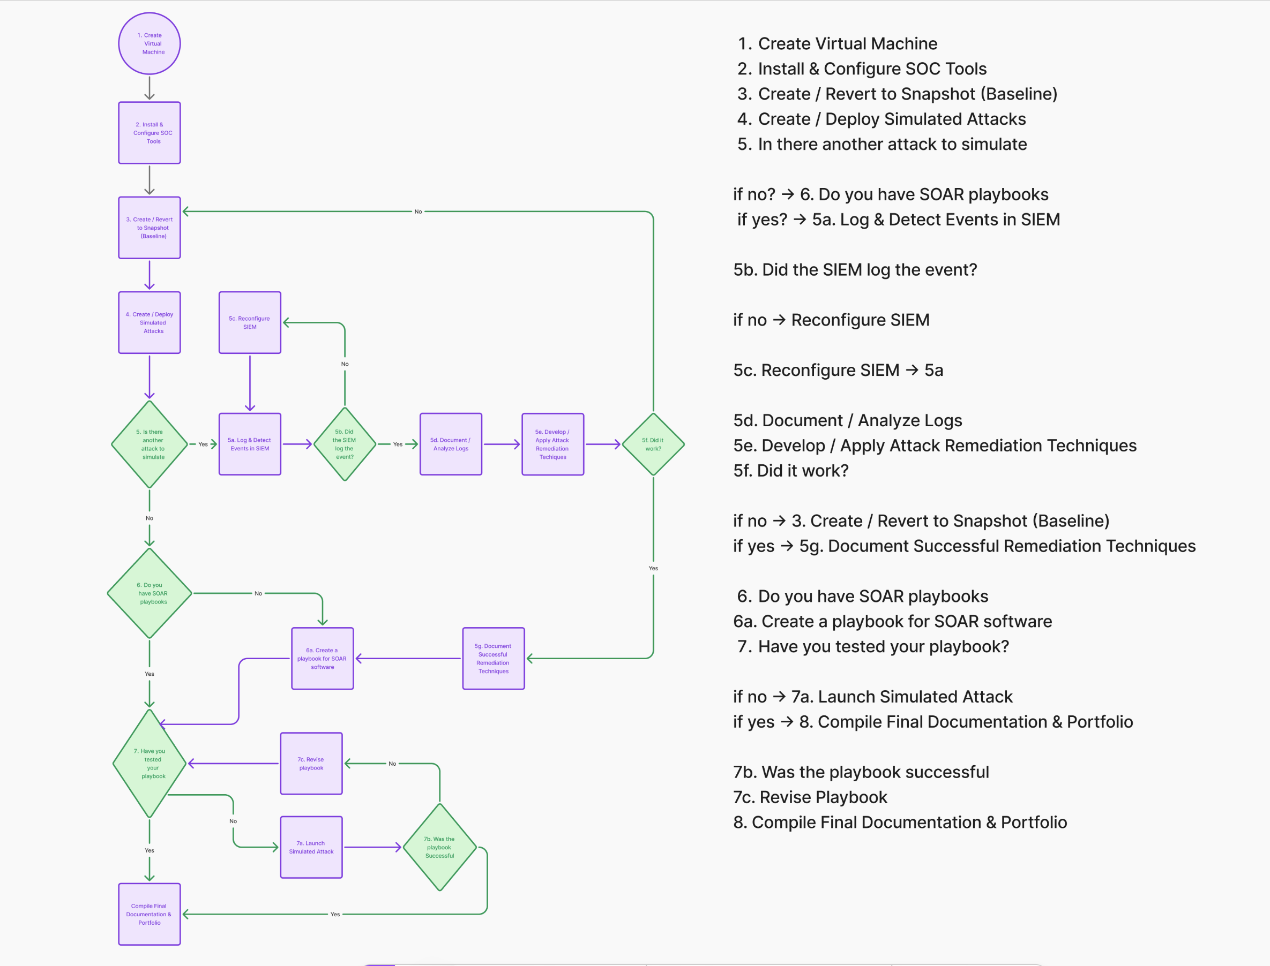

- Timeline / Weekly Milestone
  - Week 1: Lab Setup

  - Jul 7-8: Create virtual network lab (Linux, Windows, DMZ, firewall)
  - Jul 7-8: Install and configure SIEM (Splunk or Elastic)
  - Jul 9th: Install Wireshark on network monitoring node
  - Jul 7-10: Enable audit logging on Windows or Linux
  - Jul 10: Validate lab functionality with test logins

  - Week 2: Research and Implement Attack Vectors

  - Jul 14th: Launch brute force attack (e.g., Hydra)
  - Jul 14th: Simulate phishing payload delivery (email or dropper)
  - Jul 14th: Emulate privilege escalation (e.g., mimikatz)
  - Jul 15th: Conduct lateral movement (e.g., PsExec)
  - Jul 15th: Create ransomware/malicious file activity
  - Jul 16th: Conduct network scanning (nmap)Jul 16th:
  - Jul 16th: Trigger fileless attack (PowerShell scripts)
  - Jul 17th: Confirm all attacks are logged in SIEM
  - Jul 17th: Develop Remediation Scripts and Playbook for each attack

  - Week 3: Investigate attacks and respond

  - Jul 21st: Identify IOCs in SIEM (hashes, IPs, file names)
  - Jul 21st: Triaging suspicious alerts
  - Jul 22nd: Investigate incident chain (kill chain mapping)
  - Jul 22nd: Perform containment (block IPs, isolate host)
  - Jul 23rd: Improve remediation scripts (restore, clean)
  - Jul 24th: Annotate SIEM logs with incident notes

  - Week 4: Perform forensics and produce incident report

  - Jul 28th: Analyze endpoint logs (PowerShell, Sysmon)
  - Jul 28th-29th: Reconstruct attacker timeline (TTPs)
  - Jul 30th: Perform basic malware analysis (strings, behavior)
  - Jul 30th: Write detailed incident report
  - Jul 31st: Conduct project debrief & lessons learned

  - Week 5-9: Research and Implementation of Cloud Based Chat Bot for AWS Certificate Training

  - Week 10-12: Red vs Blue Capture The Flag Scenario

- Risks and Risk Mitigation
  - Network configuration complexity: Implement fallback routines and snapshots
  - Security tool configuration inaccuracies: Use community standards and extensive testing
  - Limit attack scenarios: Develop multiple attack paths and vulnerabilities

- Evaluation Criteria
- Successful containment and eradication of simulated attack
- Detailed and clear incident report
- Ability to identify attack indicators and actor motives

- Future Considerations
- Expand to more realistic attack scenarios
- Implement automated incident response routines
- Integrate additional vulnerability scanning and forensics tools

