PROBLEM STATEMENT

Problem:- Creating a visual map of the campus-wide network using scripts and tools such as traceroute.

Problem Definition:- You have to create a network map showing how the routers are connected to each other and how subnets are connected to these routers in a campus-wide area network. Also you have to generaise your procedure so that you can do for any other campus-wide area network.
Generalisation can be done using python GUI or a simple python generated command line interface.

Approach:-
Most important is to understand how a Campus-wide Area Network works.
- First using traceroute find the first router where your requests are directed.
- Look into the forwarding table of the router and analyse it (Draw a mental picture).
- You now have the idea to which routers is your first router connected.
- Analyse the routers which are connected to the first in a similar way.
- Find the subnets.
- Draw a network map.
- Can you generalise this procedure for any CAN?

Goal:-
- To produce a network map of IIT Goa.
- To understand the basics of a computer network.

Work Till First Week:-
- Using traceroute comman found the Ipv4 address of the router to which all requests are directed and the firewall or gateway of IIT Goa.
- Using route -n command found out the forwarding table used in our computer to direct the data packets.

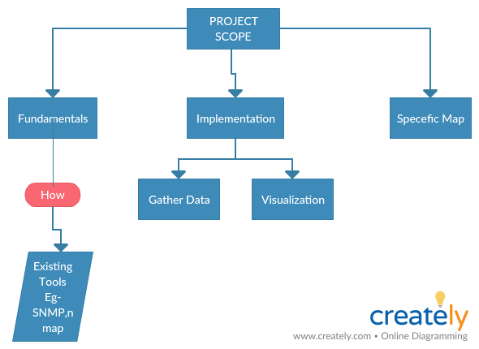

End Product:- A network map where all the devices connected to the network are shown in a small are with the links and routers.

List of Attributes:-
- Links
- Routers
- Gateways
- Hosts
- Other devices like printers etc.

Network mapping is the study of the physical connectivity of networks e.g. the Internet. Network mapping discovers the devices on the network and their connectivity.

Week 2

- Studied about SNMP protocol.
Overview- an Internet Standard protocol for collecting and organizing information about managed devices on IP networks and for modifying that information to change device behavior. It is an Application layer protocol.

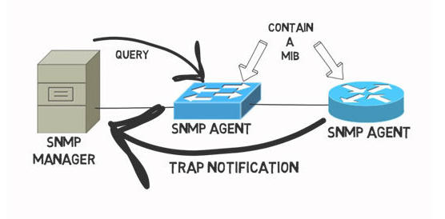
Trouble – Unable to configure SNMP host on the laptop.
- Studied about nmap and zenmap
Overview-
Nmap is a free and open-source network scanner created by Gordon Lyon. Nmap is used to discover hosts and services on a computer network by sending packets and analyzing the responses. Nmap provides a number of features for probing computer networks, including host discovery and service and operating system detection.
Zenmap is the official cross-platform GUI for the Nmap Security Scanner.
- Important Commands used in nmap-
nmap -sV -T4 -O -F --version-light 10.196.0.0/22 #(Quick Scan plus in Zenmap)
**10.196.0.0/22 is the network of IIT Goa.
nmap -T4 -F 10.196.0.0/22 #(Quick Scan in Zenmap)
nmap -sn --traceroute www.google.com #(Quick traceroute in Zenmap)
- Results obtained on Zenmap-
The following diagran show the topology of IIT Goa’s Network:-
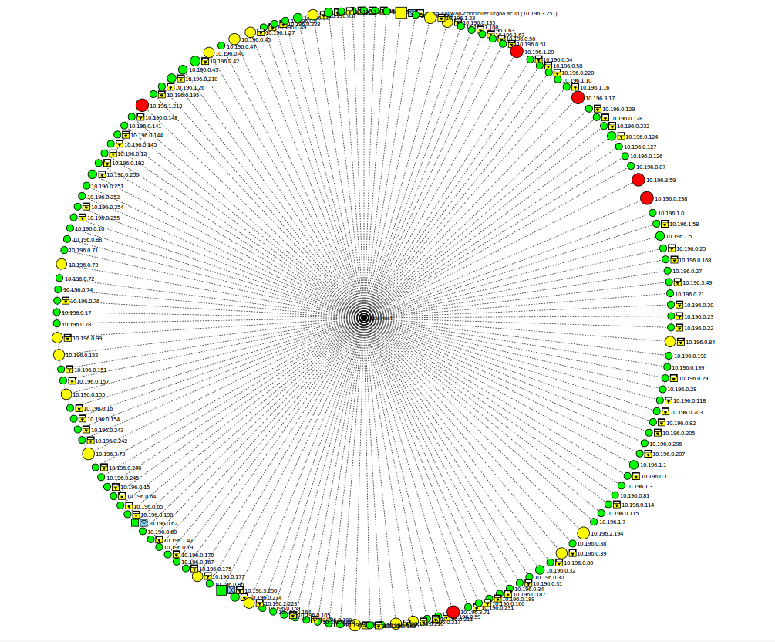
The output of the nmap commands is in xml format and can be formatted and stored in an excel format using the python script whose link is https://github.com/mrschyte/nmap-converter .
Using nmap commands we obtained the following information about IIT Goa’s network-
- Total number of hosts.
- Number of hosts up and number of hosts down.
- To some extent , the Operating System runnng on hosts.
- Opened ports on the hosts and the protocol they use.
- Type of Services.

