Data-Driven Analysis and Machine-Learning Prediction of
Chemical Short-Range Order in Metallic Alloys
UGP Phase-II - Comprehensive Progress and Technical Review Report
Purpose of this report: Transparent supervisor review of the completed database construction, scientific validation, exploratory analysis, grouped machine-learning results, feature interpretation, limitations, and next decisions. This is not the final undergraduate thesis.
Prepared by
Abhinav Choudhary
Department of Metallurgical Engineering
IIT (BHU), Varanasi
Under the guidance of
Prof. Vikas Jindal
23 August 2026

Table of Contents
Table of Contents 2
Executive Summary 3
1. Project Background and Objective 4
2. Overall Workflow 4
3. Data Sources and Data Inventory 4
4. Primary 84k Dataset 5
5. Definition of the SRO Target 6
6. Database Standardization and Quality Control 6
7. Extensive Feature Engineering 8
8. Dataset Characteristics and Exploratory Data Analysis 9
9. Correlation and Association Analysis 12
10. Feature Redundancy Analysis 16
11. Machine-Learning Methodology 17
12. Model Comparison 18
13. Generalization Results 22
14. Unified Versus Phase-Specific Models 22
15. Feature-Set Ablation 24
16. Compact High-Performance Model 25
17. Feature Importance and Physical Feature Groups 27
18. Space-Group and Configuration Sensitivity 30
19. FCC versus BCC SRO Behaviour 30
20. Robustness Analysis 32
21. Error and Extrapolation Analysis 32
22. HCP Investigation 36
23. Final Feature Recommendations 37
23.1 Minimal Common Database Feature Set 37
23.2 Compact High-Performance ML Feature Set 37
24. Major Results Summary 37
25. Limitations 37
26. Current Conclusions 38
27. Recommended Next Steps for Supervisor Discussion 38
Appendix A - Detailed Data Source Inventory 39
Appendix B - Complete Feature Categories 39
Appendix C - Extended Correlation Rankings 40
Appendix D - Full Model Comparison 44
Appendix E - Additional FCC/BCC Figures 45
Appendix F - Final Feature Lists 45
Appendix G - Reproducibility Information 46
Appendix H - Literature Support Still Required 47

The table of contents is a live Word field and is refreshed during PDF export.

Executive Summary
This report presents the completed SRO machine-learning project for supervisor review before thesis preparation. The project moved from a broad inventory of theoretical and software sources to one scientifically validated, leakage-controlled FCC/BCC modeling database. The main objective was not merely to maximize prediction accuracy, but to determine what the available SRO label means, which descriptors carry reproducible information, how validation independence changes performance, and where configuration-specific signals limit transferability.
The validated database contains 83,797 observations: 40,425 FCC and 43,372 BCC. No HCP label passed the required Warren-Cowley reference/topology validation. The primary target, target_mean_abs_sro_shell1, is the mean absolute first-neighbour Warren-Cowley coefficient across unique unlike-element pairs in each configuration. It measures aggregate ordering magnitude and is not a signed pair-specific alpha.
Repository evidence: thesis_outputs/tables/phase3/phase_counts.csv; reports/sro_definition_84k.md.
A 348-predictor library was assembled from composition, elemental references, supplied thermodynamic quantities, and leakage-safe initial/pre-relaxation structure descriptors. Final DFT outcomes and relaxed descriptors were excluded. The principal evaluation held out complete alloy systems, with grouped cross-validation inside the training partition.
Repository evidence: thesis_outputs/tables/phase4/feature_group_mapping.csv; results/tables/phase5/split_audit.csv; reports/ml_data_validation.md.
HistGradientBoosting with 198 BALANCED predictors was the best validated configuration. Alloy-system-held-out R-squared/MAE/RMSE were 0.8997/0.0535/0.0764 unified, 0.9058/0.0348/0.0534 FCC, and 0.9154/0.0563/0.0808 BCC. Five repeated alloy allocations gave a unified mean R-squared of 0.8946 with standard deviation 0.0187.
Repository evidence: thesis_outputs/tables/best_model_metrics.csv; thesis_outputs/tables/model_robustness_summary.csv.
Training-only compact refinement selected 10 predictors. The compact unified model obtained outer R-squared 0.8917, only 0.0081 below BALANCED. However, most compact predictors are initial-structure or configuration-sensitive descriptors. The compact predictor set is therefore distinct from the minimal common database metadata recommended for future cross-source records.
Repository evidence: results/tables/phase6/compact_feature_count_validation.csv; results/tables/phase6/compact_outer_test_metrics.csv; reports/final_minimal_feature_recommendation.md.
Table 1. Executive summary of validated results
Item | Validated result | Interpretation / scope
Validated observations | 83,797 | FCC 40,425; BCC 43,372; HCP 0
Primary target | target_mean_abs_sro_shell1 | Aggregate absolute first-shell WC SRO
Candidate / BALANCED / compact | 348 / 198 / 10 | All leakage-controlled
Unified best | R2 0.8997 | MAE 0.0535; RMSE 0.0764
FCC best | R2 0.9058 | MAE 0.0348; RMSE 0.0534
BCC best | R2 0.9154 | MAE 0.0563; RMSE 0.0808
Five-split unified robustness | 0.8946 +/- 0.0187 | Mean +/- SD R2
Compact model | 10 features; R2 0.8917 | Untouched alloy-held-out test
HCP status | 0 validated | 255 provisional CrCoNi frames excluded
Repository evidence: phase3/4/5/6 compact tables; detailed sources in deliverables/report_evidence_map.md.
Central scientific caution: Strong performance depends heavily on initial structure and symmetry information. These descriptors are predictive within the 84k theoretical workflow, but may encode cell/configuration-generation signatures and must not be interpreted as causal material laws or assumed to transfer unchanged across sources.

1. Project Background and Objective
Chemical short-range order describes departures from random chemical occupancy over local neighbour shells. In this project it is represented with Warren-Cowley coefficients. SRO is relevant because it provides a compact statistical description of local chemical arrangement, but detailed claims about mechanisms or property effects require verified literature support and are not inferred here from correlation alone.
Repository evidence: reports/sro_definition_84k.md; thesis_outputs/literature_support_needed.md.
The work began as a broad source and literature-oriented compilation. Inventory showed that sources differed strongly in representation, phase, temperature, pair/shell convention, structure availability, and independence. The project therefore shifted toward constructing one validated theoretical FCC/BCC database from the 84k HEA source, while retaining other sources as contextual or future validation candidates.
Repository evidence: reports/data_inventory.md; reports/project_plan.md; logs/pipeline_log.md.
The final objectives were to validate the label convention, engineer an extensive but leakage-controlled feature library, characterize the database, compare associations and redundancy, build grouped-validation models, distinguish unified and phase-specific behavior, refine a compact predictor set, and define minimal common metadata for future sources.
Repository evidence: README.md; THESIS_HANDOFF.md.

2. Overall Workflow
The completed workflow is summarized in Figure 1. Each arrow denotes a documented transformation or decision gate. Provisional HCP material exits at validation rather than entering modeling.
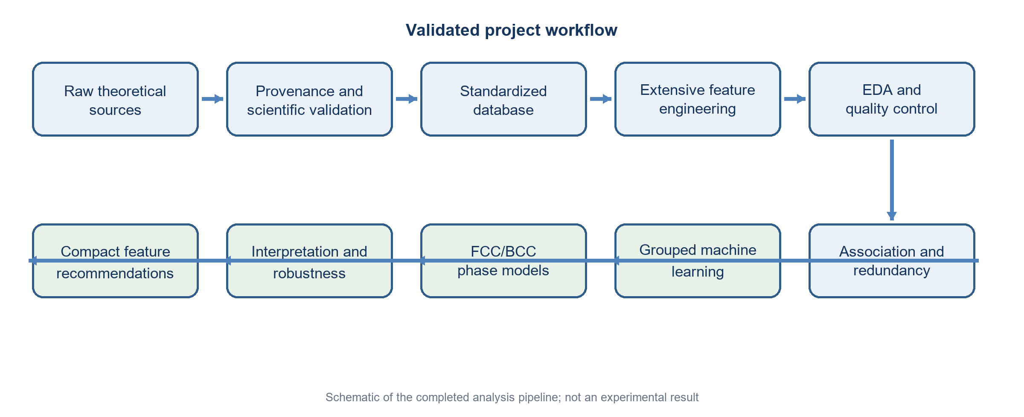
Figure 1. End-to-end workflow used in the project. This is a report schematic, not an experimental result.
Repository evidence: Created for this report from the documented Phase 1-6 pipeline in logs/pipeline_log.md.
The workflow separates source validation from feature generation, EDA from model selection, and in-source predictive compactness from cross-source database design. Reproduction commands are provided in Appendix G.

3. Data Sources and Data Inventory
Seven local source families were identified. The raw inventory contains 46,123 files totaling 10.1245 GB (9.429 GiB). These counts include many repeated simulation outputs, potential files, plots, and scripts; they must not be treated as the number of independent scientific datasets or observations.
Repository evidence: reports/data_inventory_metrics.json; reports/data_inventory.md.
Table 2. Data-source inventory and incorporation status
Source | Class/method | Phase | Usable records | Major fields | DOI/repository | Final analysis
84k HEA DFT | DFT | FCC/BCC | 83,797 validated | Structures, aggregate SRO, descriptors | 10.5281/zenodo.10854500; GitHub | Yes
Rao-Curtin | Analytical/MC | FCC/BCC | Not normalized | Pair probabilities, reduced sweeps | 10.24435/materialscloud:qa-ba | No
MLP-cSRO CrCoNi | MLIP/DFT-MC | FCC/HCP/liquid | 255 provisional HCP | CFGs, potentials, derived arrays | 10.1038/s41524-025-01722-2 | Audit only
cSRO_lattice | MLIP MC/MD | Likely FCC | Not normalized | Thermal trajectories, WC arrays | Local snapshot | No
CrCoNi ColabFit | DFT | Unresolved | 1,257 structures; no SRO | Structures, energy, force, stress | 10.60732/76208b62 | No
CMS-EAM | EAM/MC | FCC/BCC/HCP | Incomplete local outputs | Workflow, structures, property summaries | 10.1016/j.commatsci.2024.113587 | No
HEA computational toolkit | Software | FCC/BCC/HCP capable | 0 data rows | SRO/SQS calculation utilities | 10.1016/j.commatsci.2024.113196 | Reference only
Repository evidence: SOURCES.md; sources.yaml; reports/data_inventory_metrics.json; reports/hcp_data_status.md.
Table 3. Raw inventory by source family
Inventory family | Files | Size (GB)
cms_eam | 32 | 0.007
crconi_colabfit | 2 | 0.012
csro_lattice | 3,192 | 0.712
dataset_84k_hea | 6 | 1.281
hea_computational_toolkit | 100 | 0.023
mlp_csro | 1,290 | 0.170
rao_curtin | 41,501 | 7.919
Repository evidence: reports/data_inventory_metrics.json.
Only the 84k source supplied a complete, one-to-one initial-structure feature table and validated SRO summary table at the required scale. Other sources were excluded because of unresolved conventions, missing SRO labels, correlated trajectory structure, abstract species, incomplete outputs, or missing HCP reference data. These exclusions are scientific decisions, not data-cleaning failures.
Repository evidence: SOURCES.md; reports/hcp_data_status.md; reports/data_inventory.md.

4. Primary 84k Dataset
The main source originally contains 84,024 structures spanning 253 source chemical systems. Exactly 227 records lack an initial structure/lattice label; the SRO and initial-feature tables therefore share 83,797 keys. The validated subset contains 40,425 FCC and 43,372 BCC configurations.
Repository evidence: reports/data_inventory_metrics.json; SOURCES.md; reports/data_quality_report.md.
The source offers separate initial and relaxed structure representations. Relaxed/final energy, volume, space group, force, pressure, magnetization, and related outcomes can encode post-relaxation information that would not be available at prediction time. The default ML view therefore uses initial/pre-relaxation descriptors and explicitly excludes final outcomes.
Repository evidence: reports/ingestion_84k.md; reports/ml_data_validation.md; data_dictionary.md.
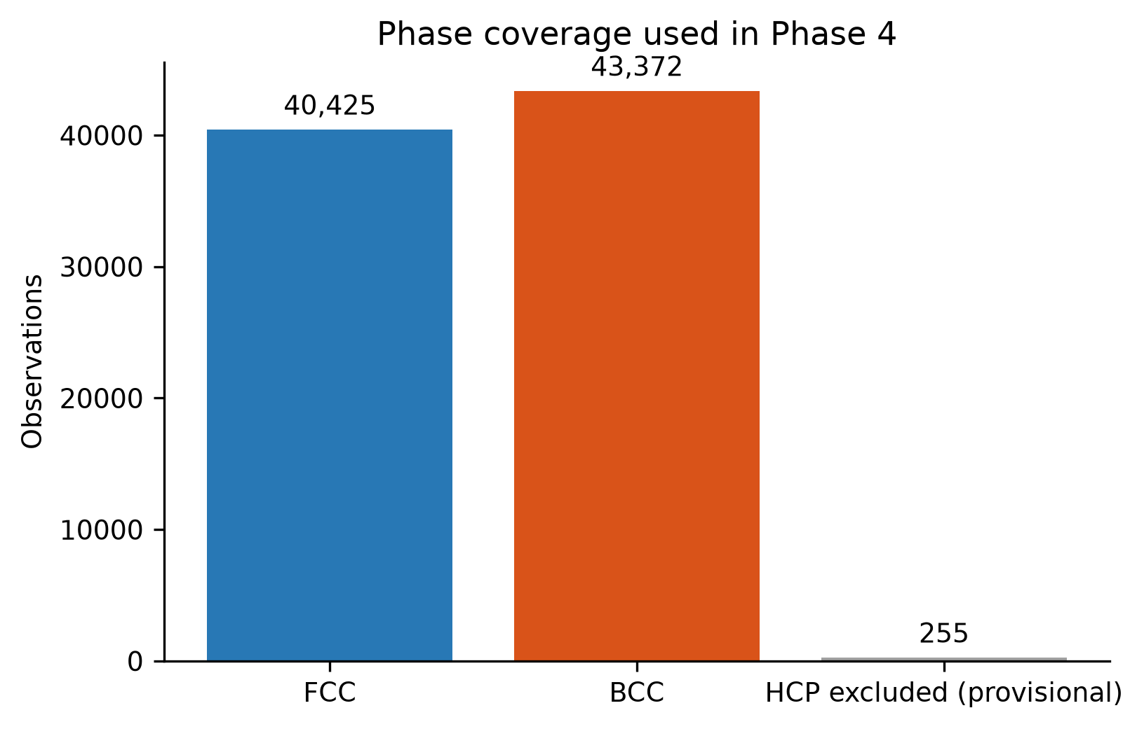
Figure 2. Validated FCC/BCC coverage and explicit exclusion of provisional HCP configurations.
Repository evidence: thesis_outputs/tables/phase4/phase_counts.csv; reports/hcp_data_status.md.
Table 4. Validated phase counts
Phase | Observations
FCC | 40,425
BCC | 43,372
HCP | 0
Repository evidence: thesis_outputs/tables/phase3/phase_counts.csv.

5. Definition of the SRO Target
For central species i, neighbour species j, and shell n, the validated convention is:
alpha_ij^(n) = 1 - P(j | i, n) / c_j
Here P(j | i, n) is the conditional probability of finding j around i in shell n and c_j is the global fraction of j. Zero denotes random mixing under the convention; sign carries ordering/avoidance information for an individual pair. The source stores summary statistics rather than the underlying pair identities and values.
Repository evidence: reports/sro_definition_84k.md.
Primary ML target: target_mean_abs_sro_shell1 is the arithmetic mean of |alpha_ij^(1)| over unique unlike-element pairs in a configuration. It measures aggregate first-neighbour ordering magnitude. It is not a signed pair-specific Warren-Cowley coefficient.
Absolute aggregation was used because it is the source-specific scalar summary that can be independently reproduced from the supplied binary and ternary structures and is defined for every validated row. Its main limitation is loss of chemical-pair identity and sign: different microscopic ordering patterns can map to the same target magnitude.
Repository evidence: reports/sro_definition_84k.md; tests/test_hea84k_ingestion.py; reports/study_limitations.md.

6. Database Standardization and Quality Control
Standardization includes canonical composition fractions, alloy-system labels, phase normalization, provenance fields, record/configuration identifiers, shell-long SRO normalization, unique-key checks, exact one-to-one joins, and explicit feature origins. The processed database is stored locally as structures, SRO-long, features, and ML Parquet tables.
Repository evidence: reports/normalized_database_schema.md; data_dictionary.md; reports/data_quality_report.md.
Table 5. Database quality-control summary
Check | Validated result | Status
Validated structure/target join | 83,797 / 83,797 | Pass
FCC / BCC / validated HCP | 40,425 / 43,372 / 0 | Pass
Candidate predictor missingness | 0% | Pass
Duplicate validated configuration IDs | 0 | Pass
Final/relaxed leakage fields in default predictors | 0 | Pass
Provisional HCP rows in ML database | 0 | Pass
Repository evidence: reports/data_quality_report.md; reports/phase3_metrics.json; tests/test_phase3_outputs.py; tests/test_phase5.py.
Figure 8 reports complete feature availability and Figure 9 confirms zero missing feature cells in the validated matrix. Structurally unavailable temperature is not fabricated or treated as a complete predictor.
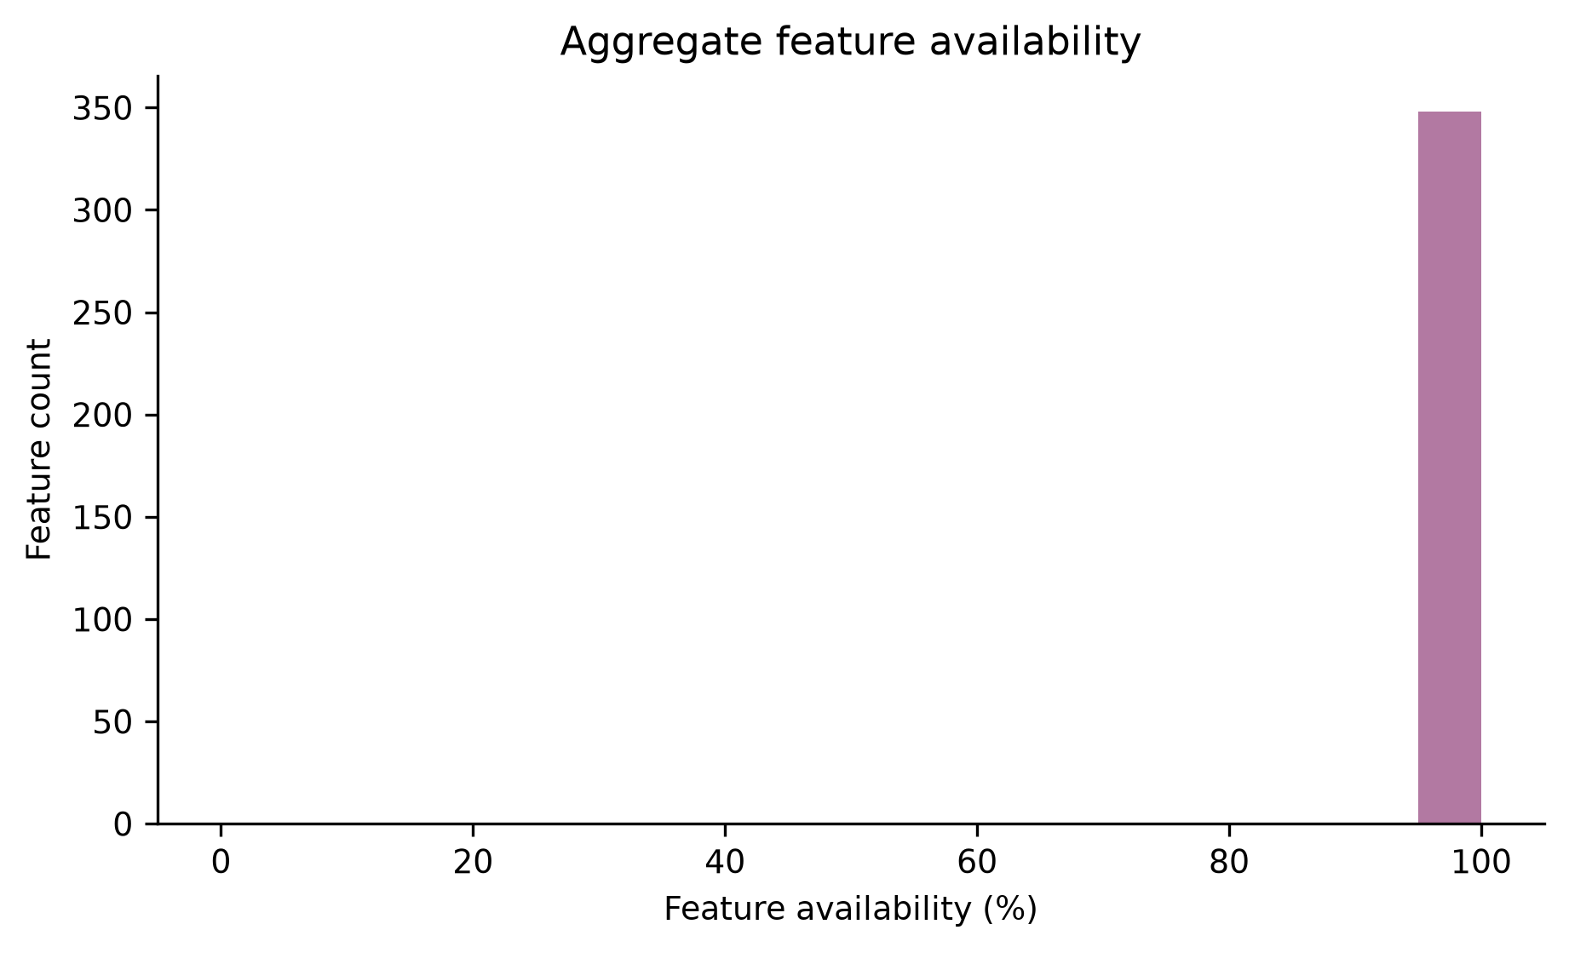
Figure 3. Feature availability in the validated FCC/BCC database.
Repository evidence: thesis_outputs/tables/phase4/feature_quality.csv.
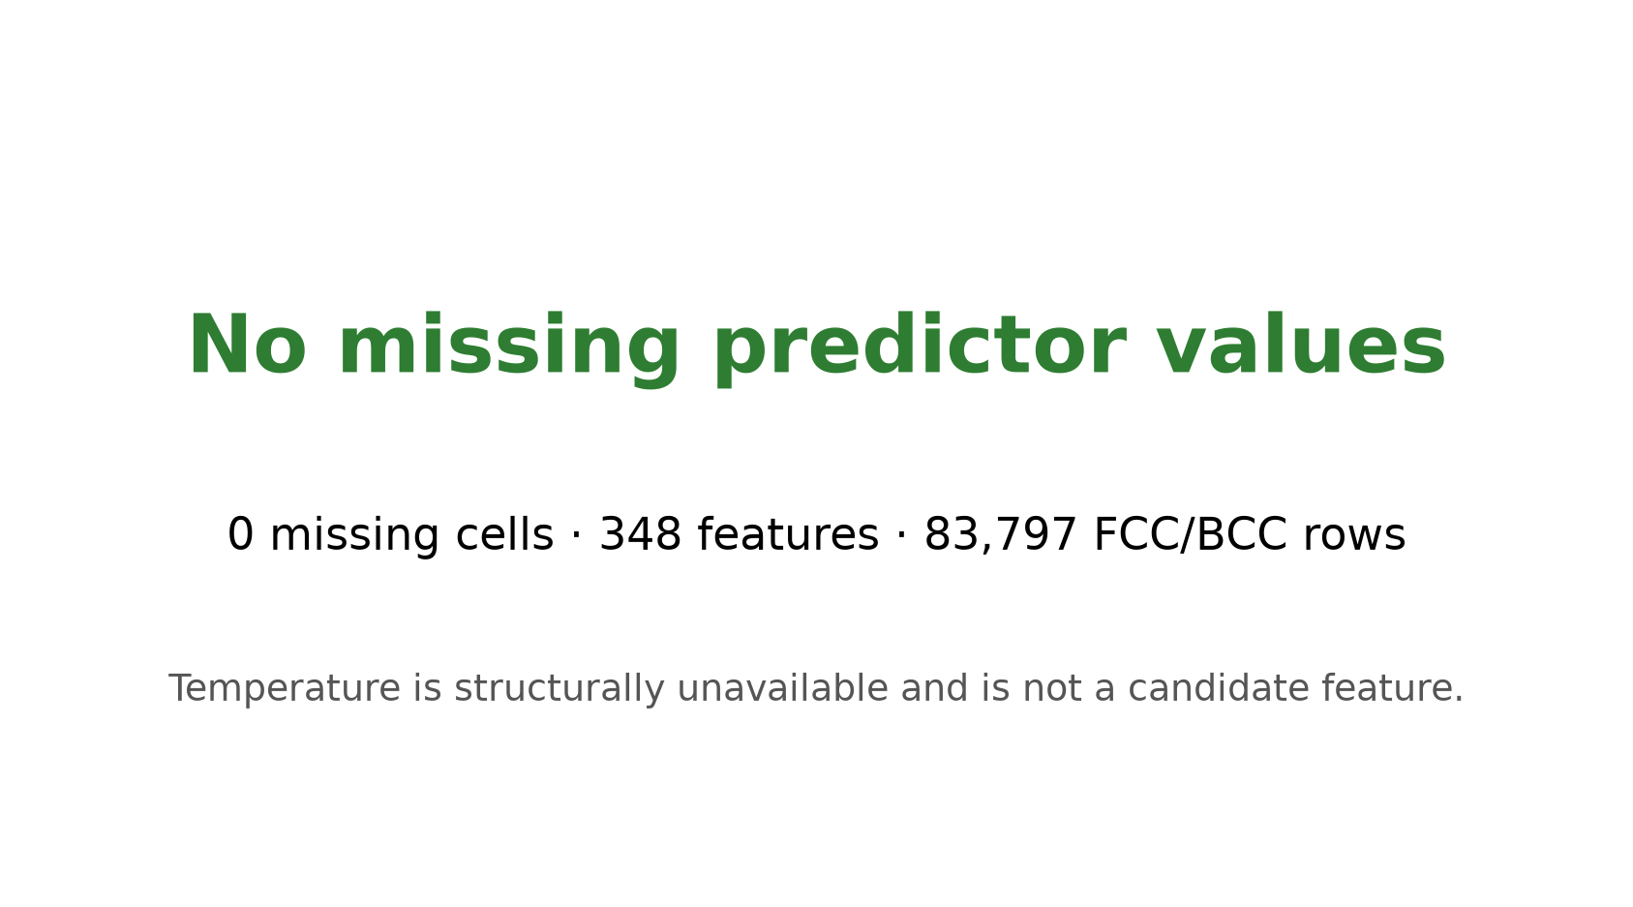
Figure 4. Missing-data audit for the candidate feature matrix.
Repository evidence: thesis_outputs/tables/phase3/feature_missingness.csv.
Leakage control does not imply that every initial descriptor is universally transferable. Initial space group, packing, neighbour geometry, and local fingerprints can still encode how source configurations were constructed. That separate concern is tested in Sections 15, 17, and 18.

7. Extensive Feature Engineering
The final candidate library contains 348 numerical predictors. It combines source-supplied initial descriptors with composition fractions, component count, ideal configurational entropy, atomic number/mass/radius statistics, size mismatch, electronegativity and pair differences, VEC/electronic statistics, melting-point statistics, and initial structural/symmetry descriptors.
Repository evidence: thesis_outputs/tables/phase4/feature_group_mapping.csv; reports/feature_groups.md; data_dictionary.md.
Table 6. Complete feature-category counts
Feature category | Predictors
valence / VEC | 118
composition pair fractions | 36
periodic-table position | 33
atomic size | 27
electronegativity / ionic | 17
atomic mass | 15
melting point | 15
atomic number | 15
initial structural geometry | 15
initial symmetry | 12
elemental electronic proxy | 11
elemental magnetic proxy | 11
composition fractions | 8
composition norms | 6
composition complexity | 3
configurational entropy | 3
phase metadata | 2
composition feasibility flag | 1
Repository evidence: thesis_outputs/tables/phase4/feature_group_counts.csv.
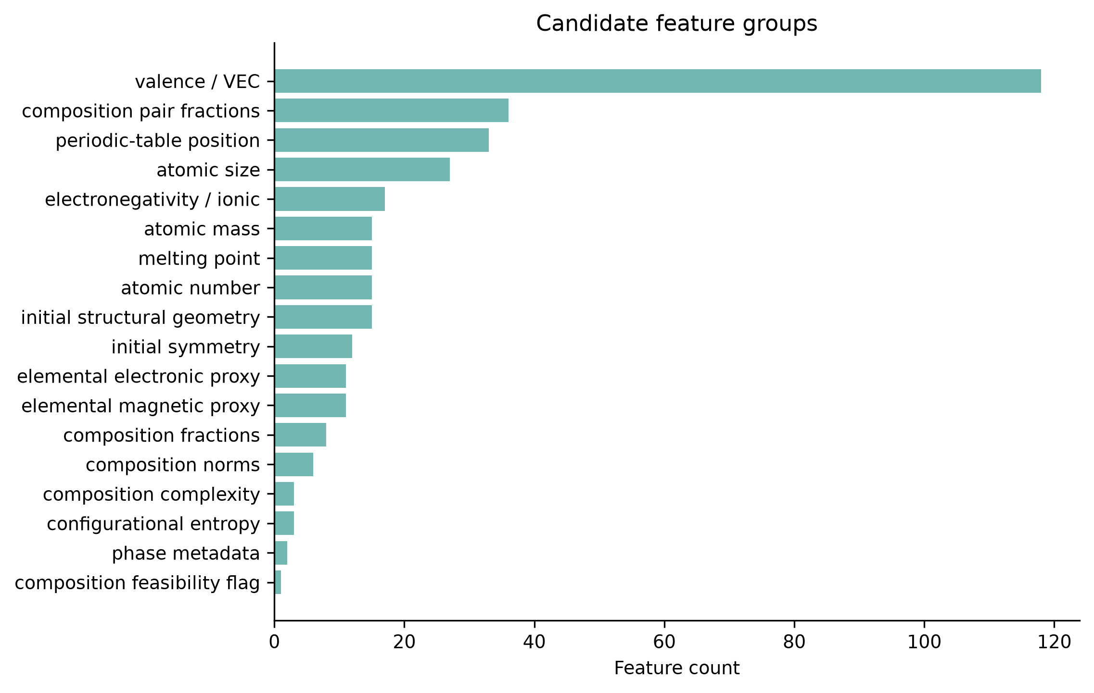
Figure 5. Distribution of candidate predictors across the Phase 4 scientific feature taxonomy.
Repository evidence: thesis_outputs/tables/phase4/feature_group_counts.csv.
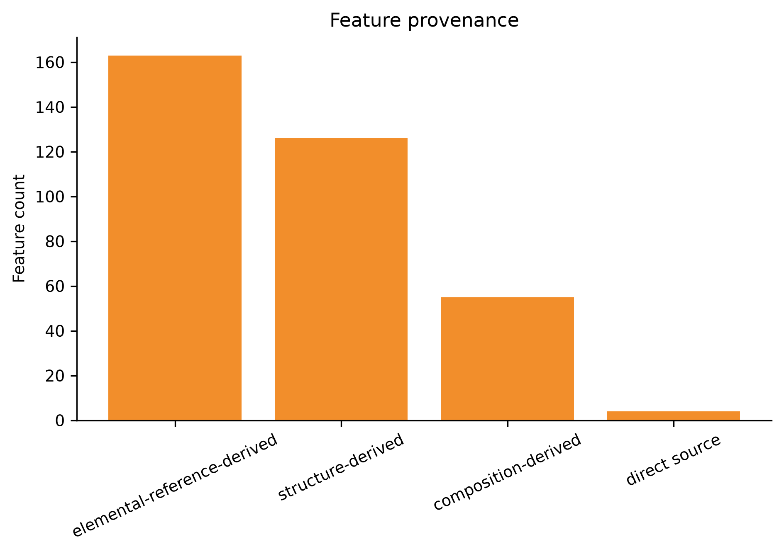
Figure 6. Feature counts by provenance class.
Repository evidence: thesis_outputs/tables/phase4/origin_counts.csv.
Provenance distinguishes direct-source, composition-derived, elemental-reference-derived, structure-derived, and externally enriched features. Transferability classification separately identifies universally derivable fields, structure-derivable descriptors, source/method-specific fields, and potential configuration encoders. This separation is essential when moving from one homogeneous theoretical source to a future multi-source database.
Repository evidence: results/tables/phase6/feature_transferability_mapping.csv; reports/feature_transferability.md.

8. Dataset Characteristics and Exploratory Data Analysis
The validated cohort spans 246 normalized alloy systems, 9,633 normalized compositions, and 11,354 formula labels. Many rows share chemistry, so row count is not an independence count and grouped validation is required.
Repository evidence: thesis_outputs/results_summary.md; thesis_outputs/tables/phase4/composition_coverage_by_phase_system.csv.
Figures 3-5 summarize alloy-system, element, and component-count coverage.
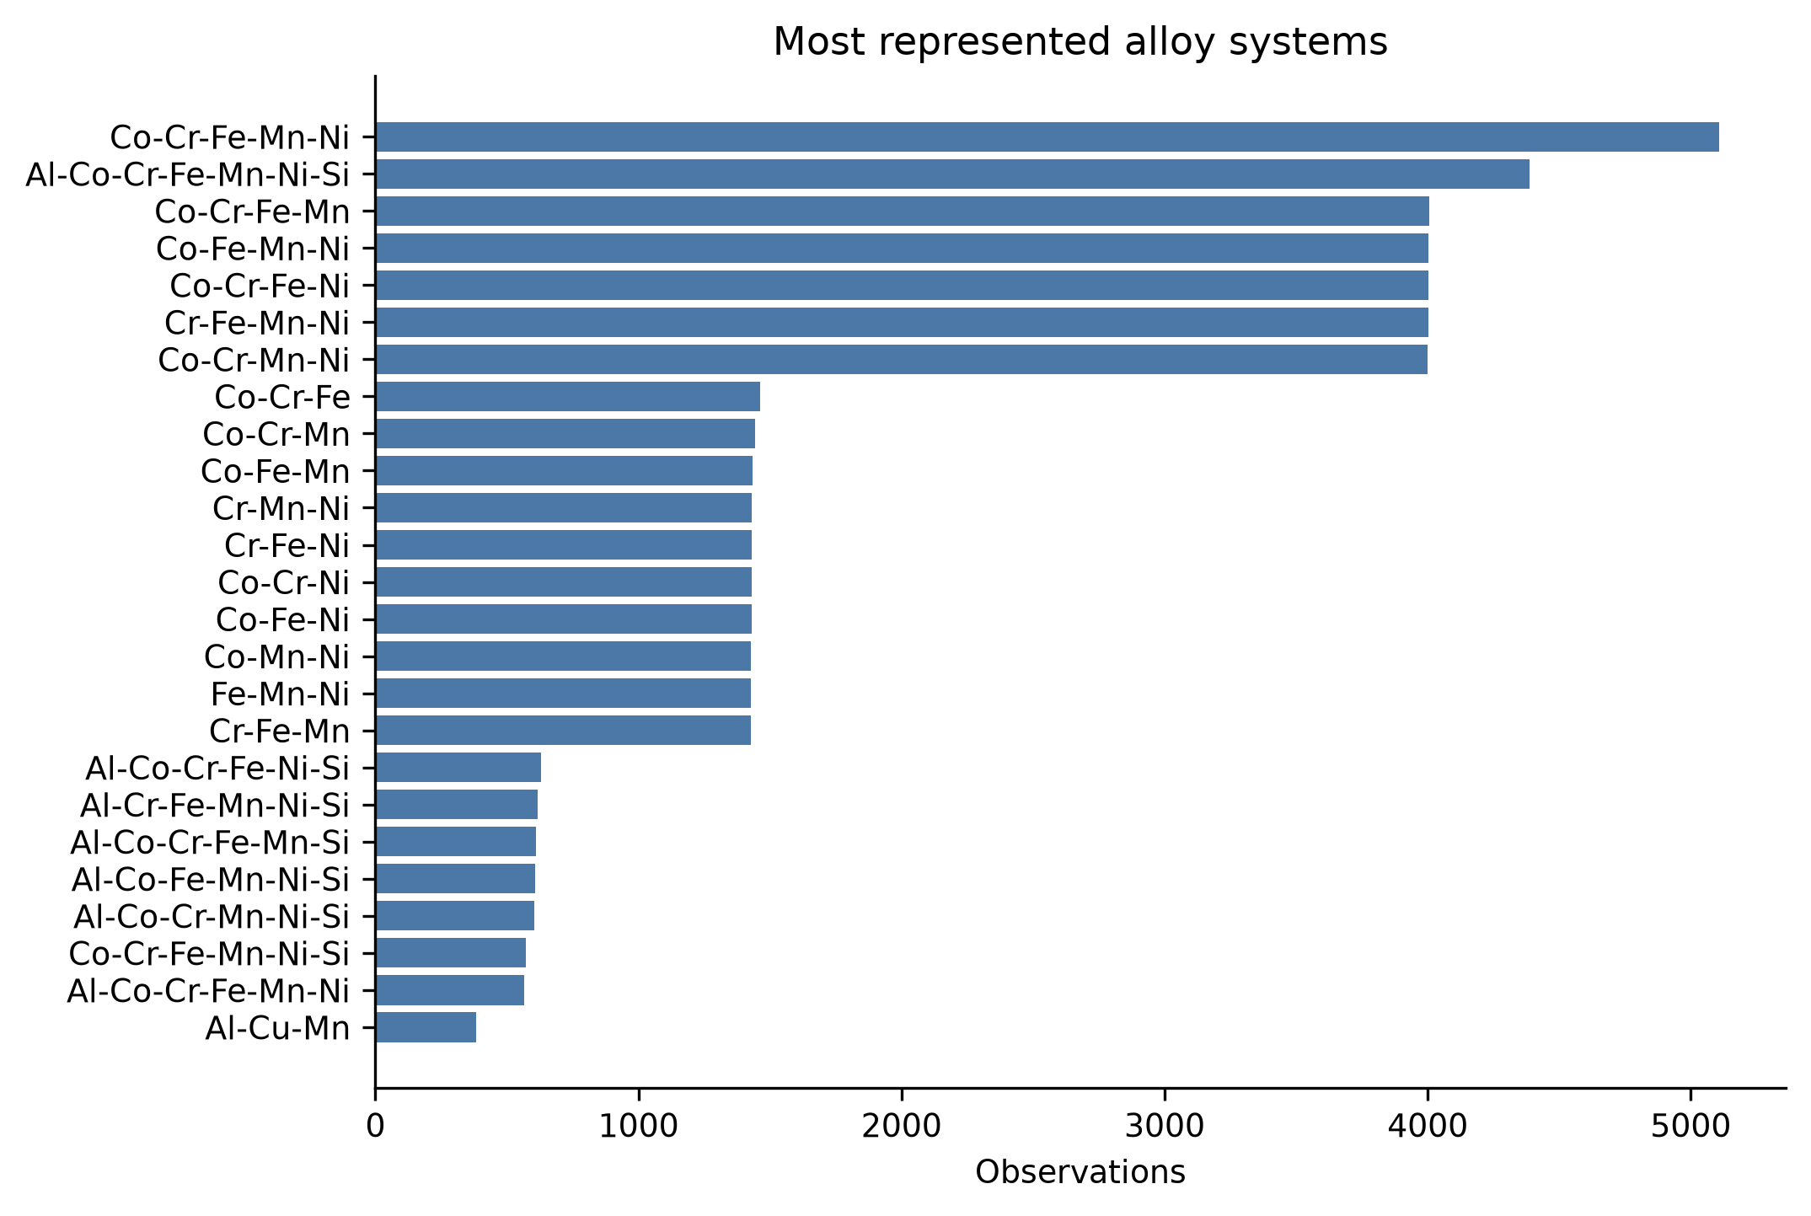
Figure 7. Most represented chemical systems in the validated FCC/BCC cohort. Counts are configurations, not independent experiments.
Repository evidence: thesis_outputs/tables/phase4/alloy_system_counts.csv.
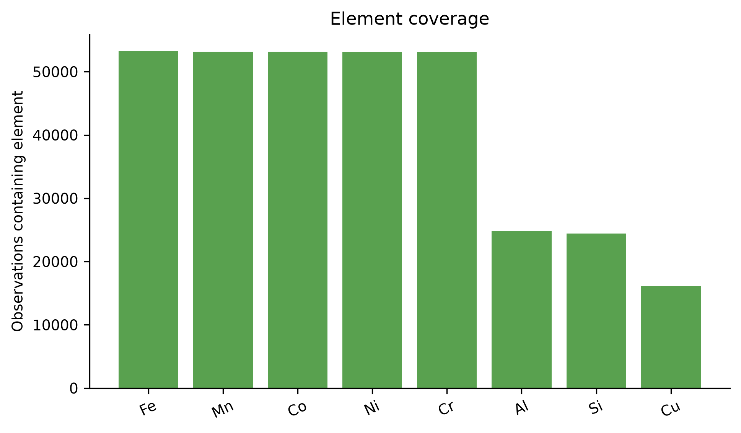
Figure 8. Element coverage across validated configurations.
Repository evidence: thesis_outputs/tables/phase4/element_counts.csv.
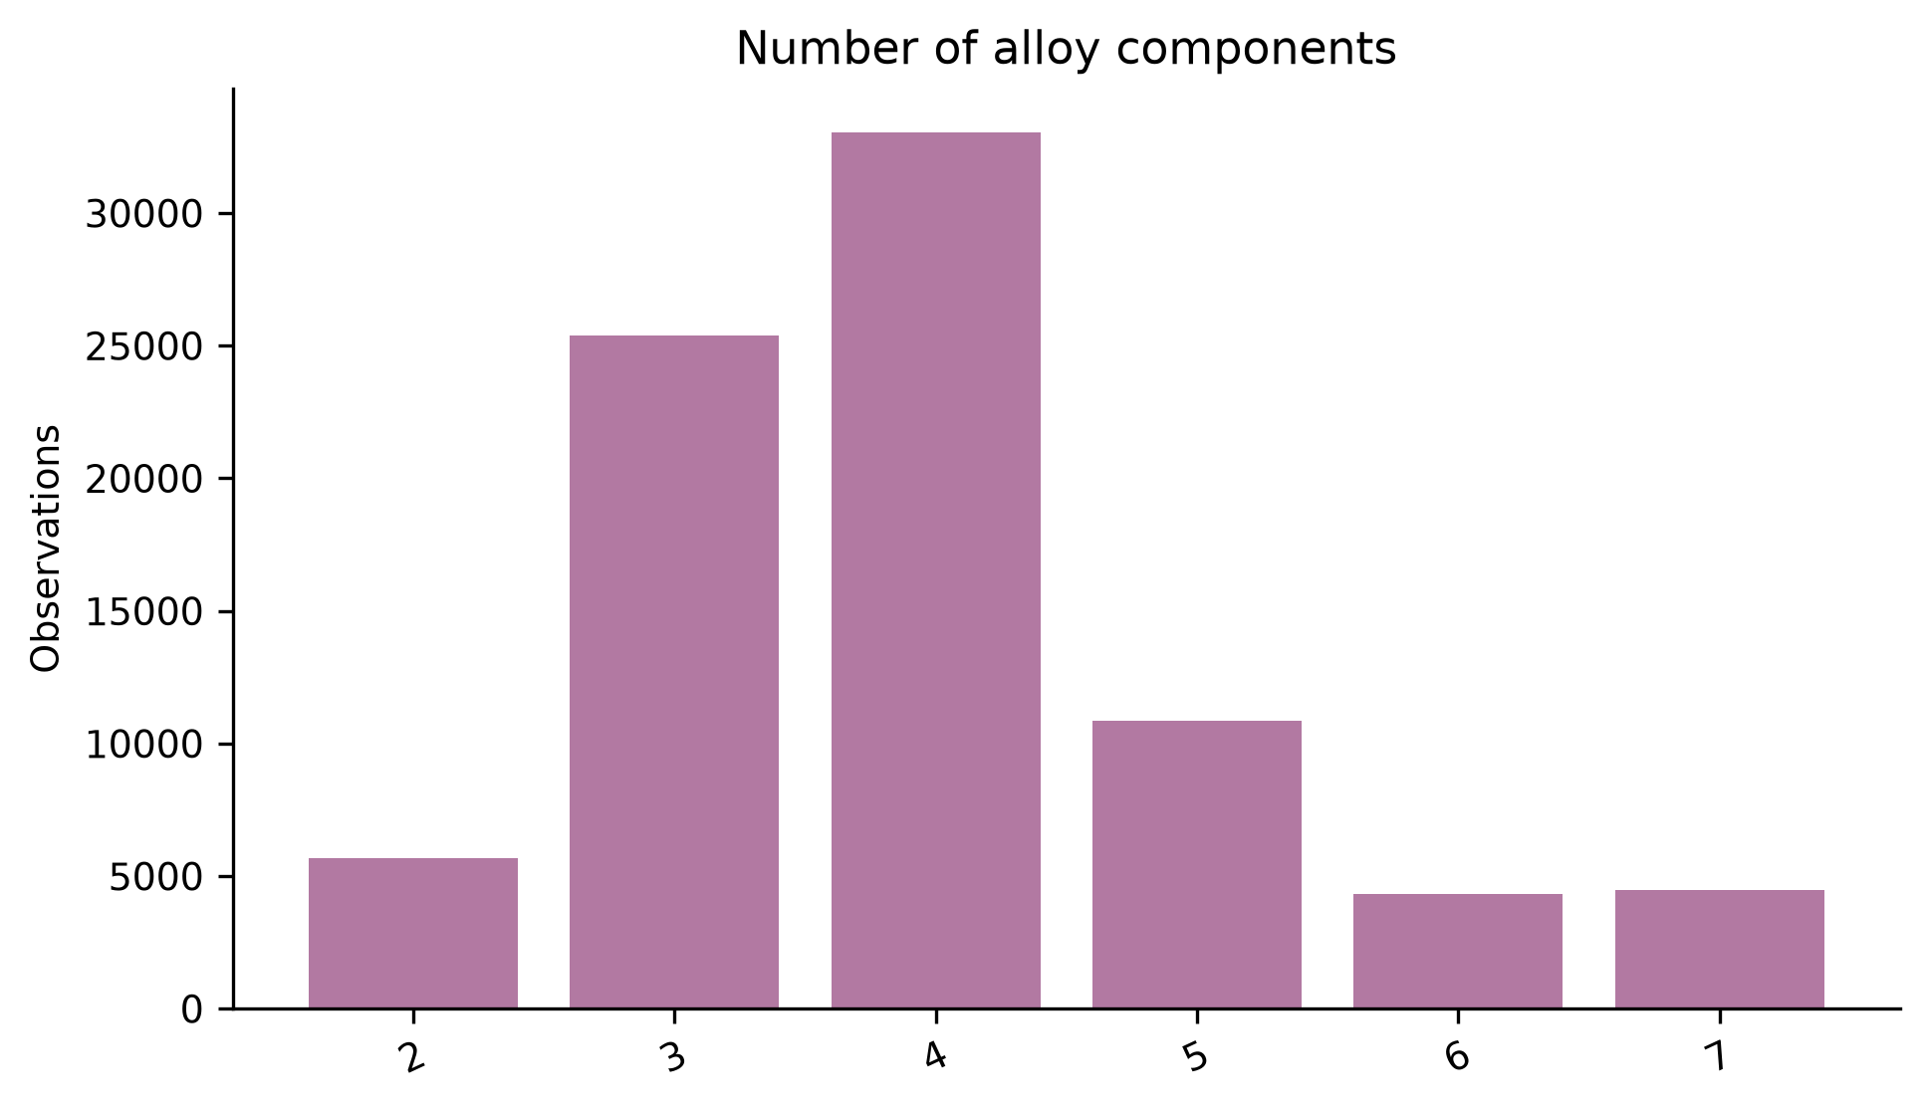
Figure 9. Distribution of the number of constituent elements per validated configuration.
Repository evidence: thesis_outputs/tables/phase4/component_counts.csv.
Table 7. Primary-target statistics by cohort
Cohort | n | Mean | Median | SD | Skew | Tukey outliers
ALL | 83,797 | 0.3345 | 0.2708 | 0.2681 | 1.106 | 1,036
FCC | 40,425 | 0.2640 | 0.2222 | 0.1999 | 0.923 | 882
BCC | 43,372 | 0.4002 | 0.3333 | 0.3045 | 0.849 | 347
Repository evidence: thesis_outputs/tables/phase4/target_statistics.csv.
The overall target mean is 0.3345, median 0.2708, and skewness 1.106. Tukey outliers were retained because they are bounded, plausible SRO configurations rather than automatically invalid records.
Repository evidence: thesis_outputs/tables/phase4/target_statistics.csv; reports/eda_analysis.md.
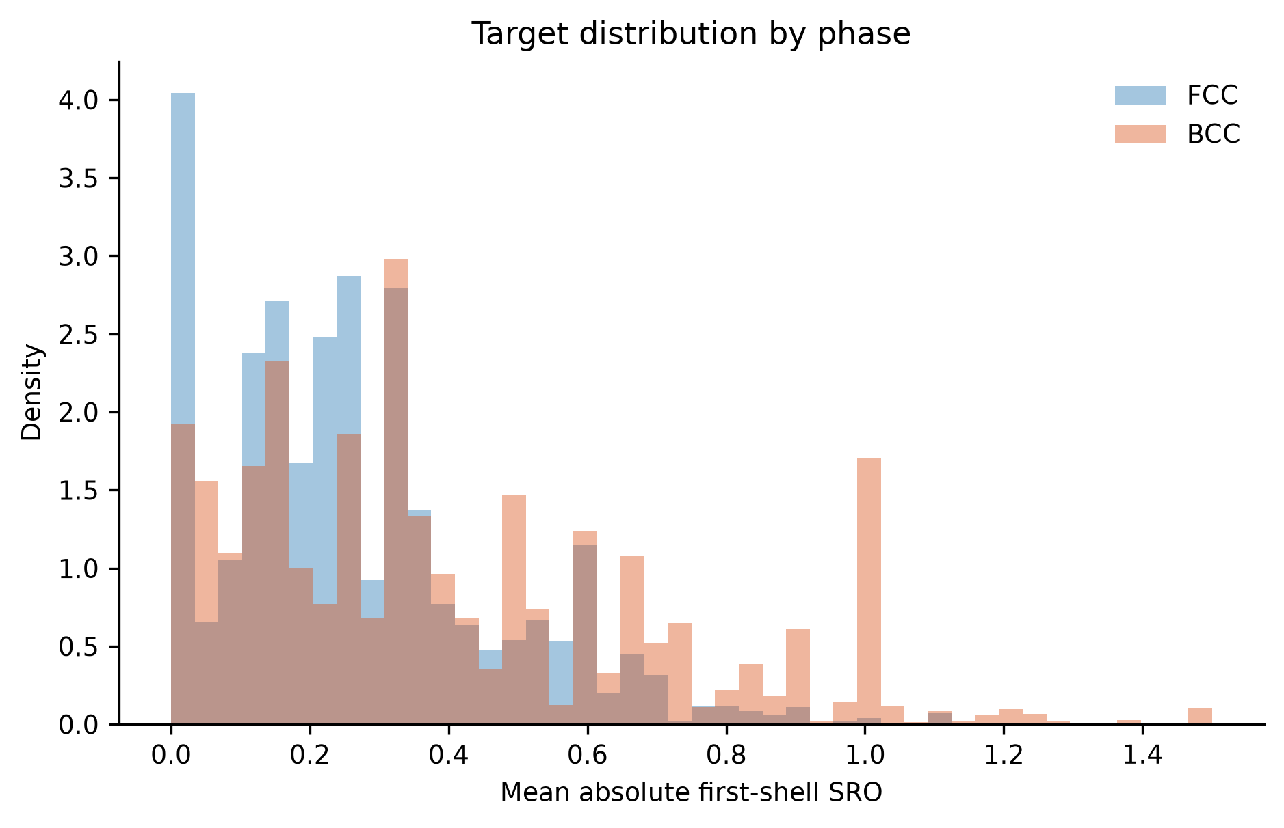
Figure 10. Distribution of aggregate first-neighbour SRO magnitude for FCC and BCC configurations.
Repository evidence: thesis_outputs/tables/phase4/target_statistics.csv.

9. Correlation and Association Analysis
Pearson correlation measures linear association; Spearman correlation measures monotonic rank association; mutual information screens for broader statistical dependence. None of these establishes causation. Mutual-information values are ranking statistics that depend on sampling and estimator settings.
Repository evidence: reports/eda_analysis.md; reports/study_limitations.md.
Table 8. Top aggregate Pearson associations
Feature | Pearson r
space_group_number_ini | 0.4753
NIONS | -0.3289
configurational_entropy_kb_per_atom | 0.3011
configurational_entropy_j_mol_k | 0.3011
2-norm | -0.2967
3-norm | -0.2880
nelements | 0.2771
composition_number_of_elements | 0.2771
0-norm | 0.2771
5-norm | -0.2746
Repository evidence: results/tables/phase4/feature_target_associations.csv.
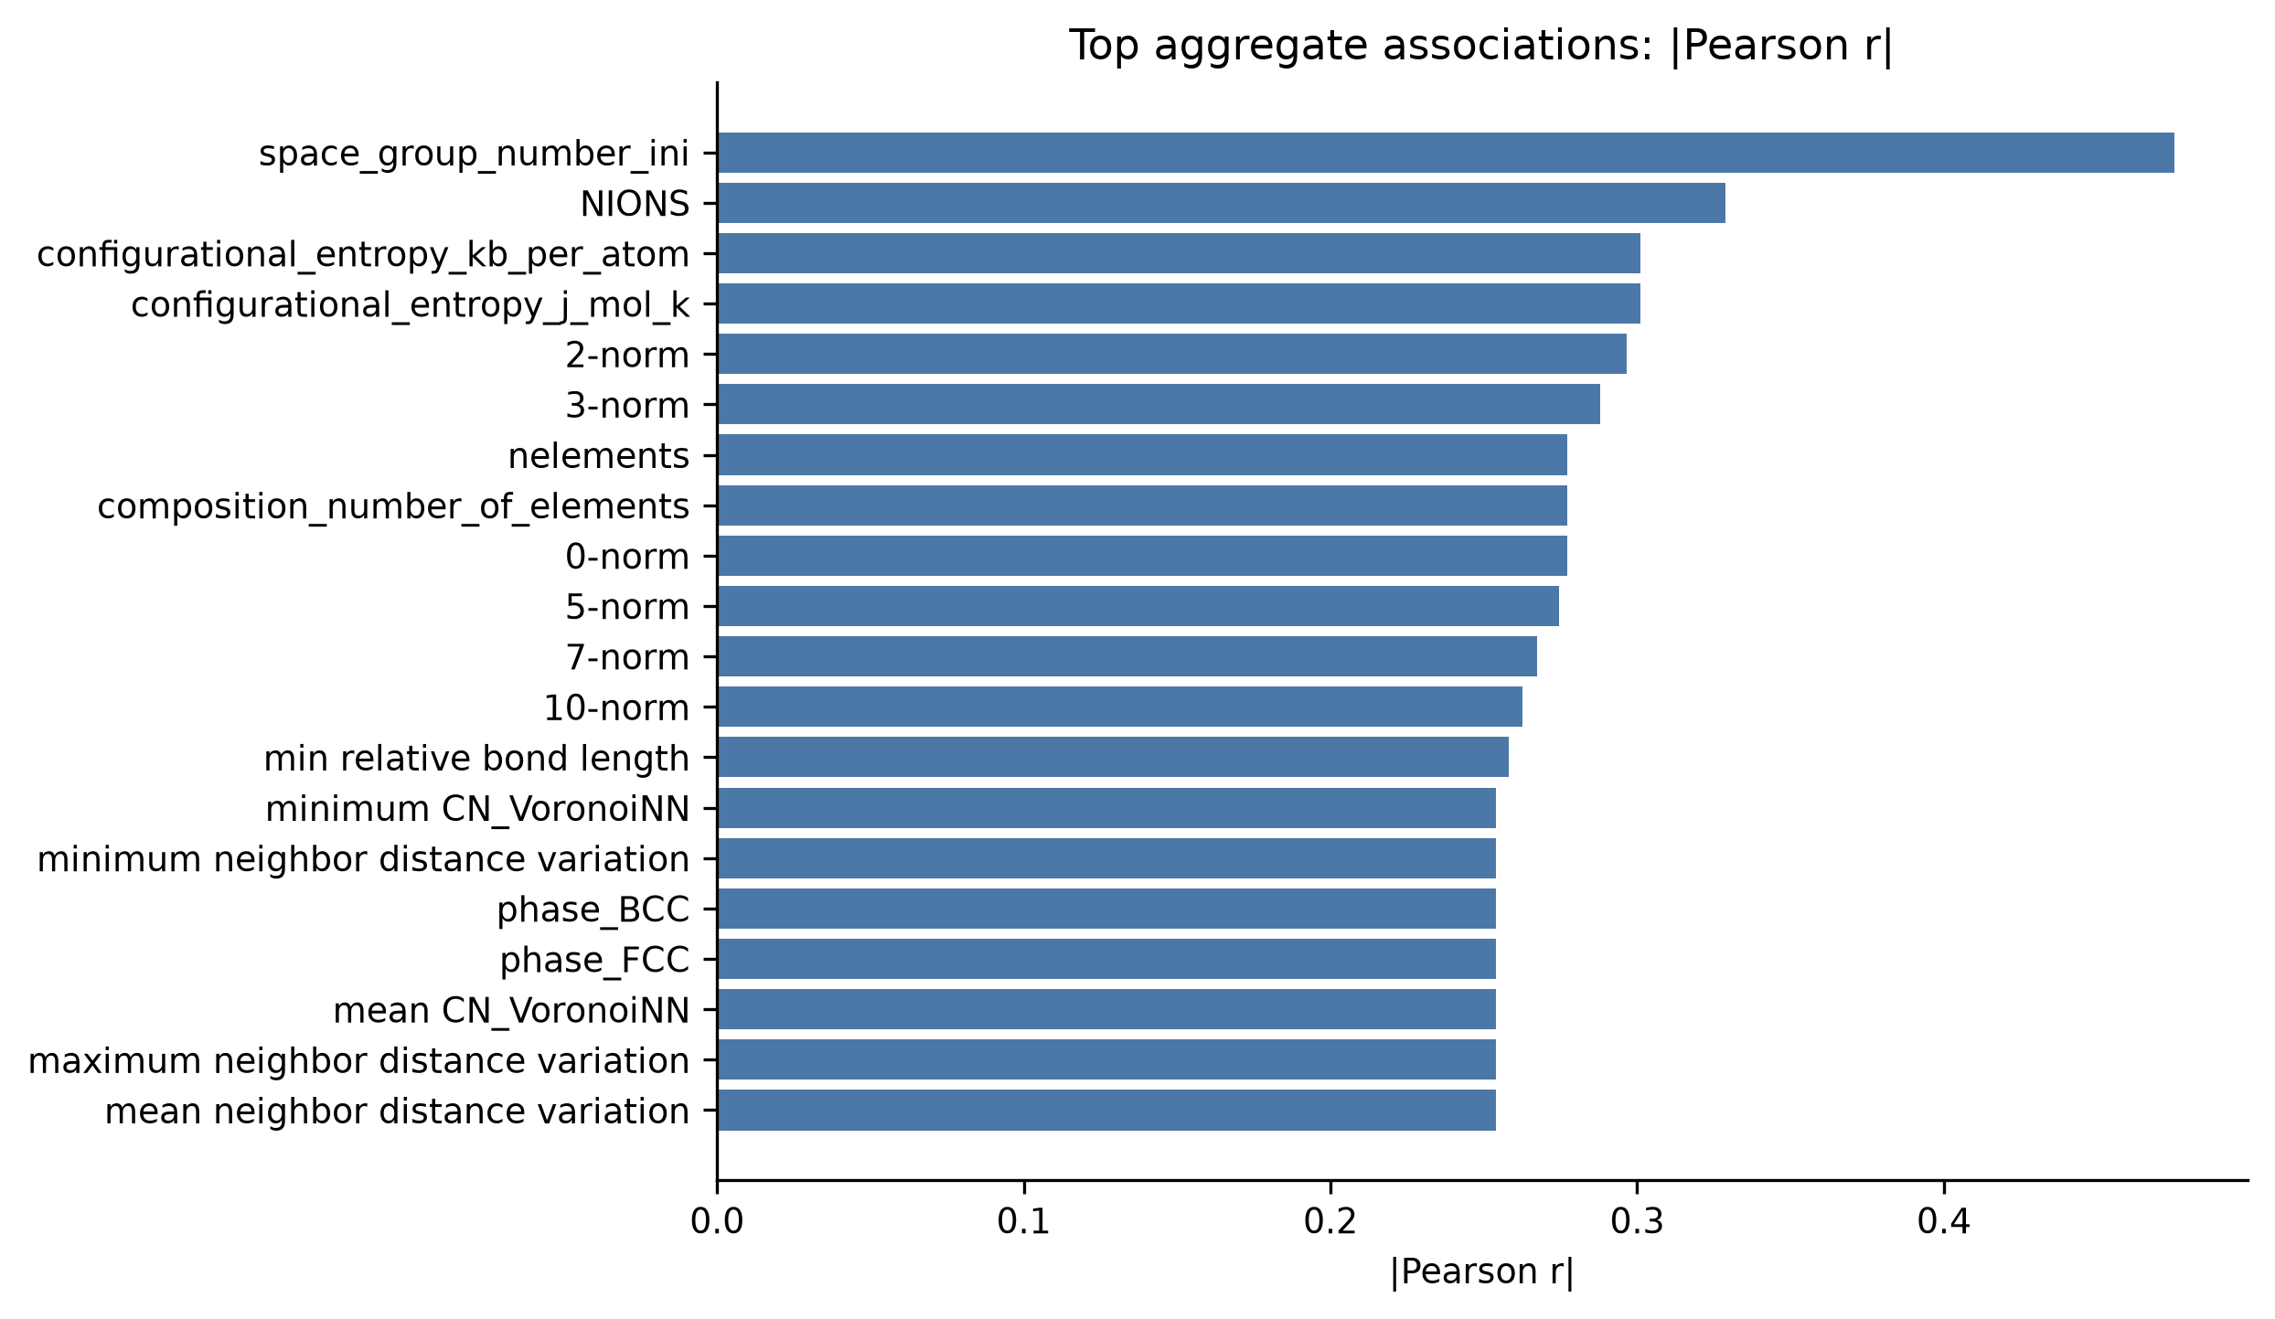
Figure 11. Largest aggregate absolute Pearson correlations with the primary target.
Repository evidence: results/tables/phase4/feature_target_associations.csv.
Table 9. Top aggregate Spearman associations
Feature | Spearman rho
space_group_number_ini | 0.5931
NIONS | -0.3260
2-norm | -0.2791
configurational_entropy_j_mol_k | 0.2714
configurational_entropy_kb_per_atom | 0.2714
5-norm | -0.2709
3-norm | -0.2706
7-norm | -0.2693
10-norm | -0.2687
avg_dev local difference in NsValence | 0.2494
Repository evidence: results/tables/phase4/feature_target_associations.csv.
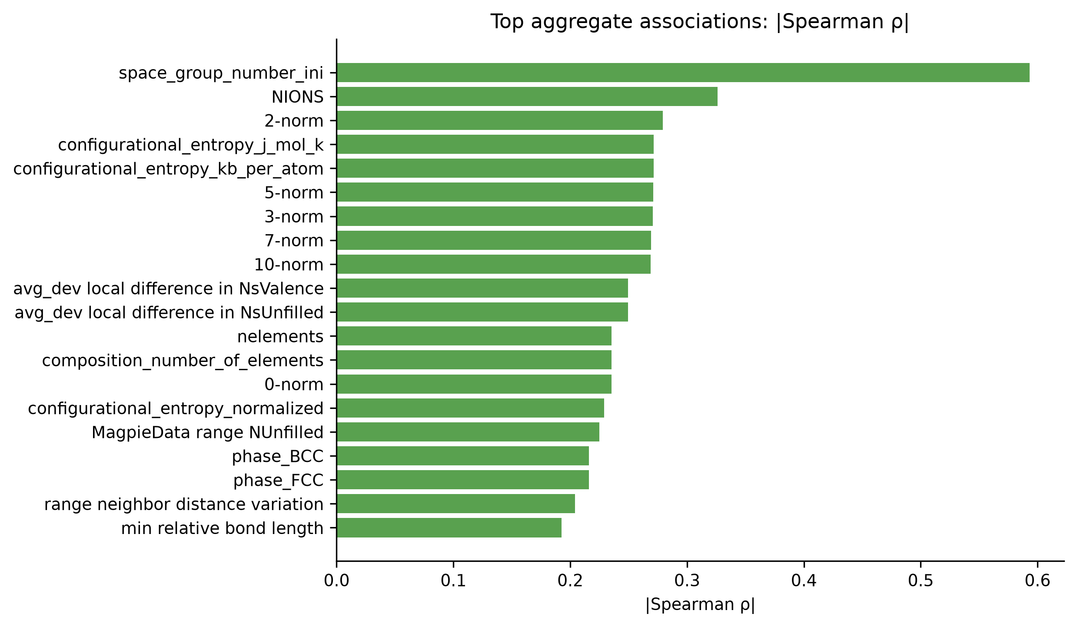
Figure 12. Largest aggregate absolute Spearman rank correlations with the primary target.
Repository evidence: results/tables/phase4/feature_target_associations.csv.
Table 10. Top aggregate mutual-information rankings
Feature | Mutual information
5-norm | 1.7996
configurational_entropy_j_mol_k | 1.7979
10-norm | 1.7939
7-norm | 1.7925
configurational_entropy_kb_per_atom | 1.7858
3-norm | 1.7762
configurational_entropy_normalized | 1.7323
2-norm | 1.6654
mean absolute deviation in relative cell size | 1.4562
avg_dev neighbor distance variation | 1.4452
Repository evidence: results/tables/phase4/feature_target_associations.csv.
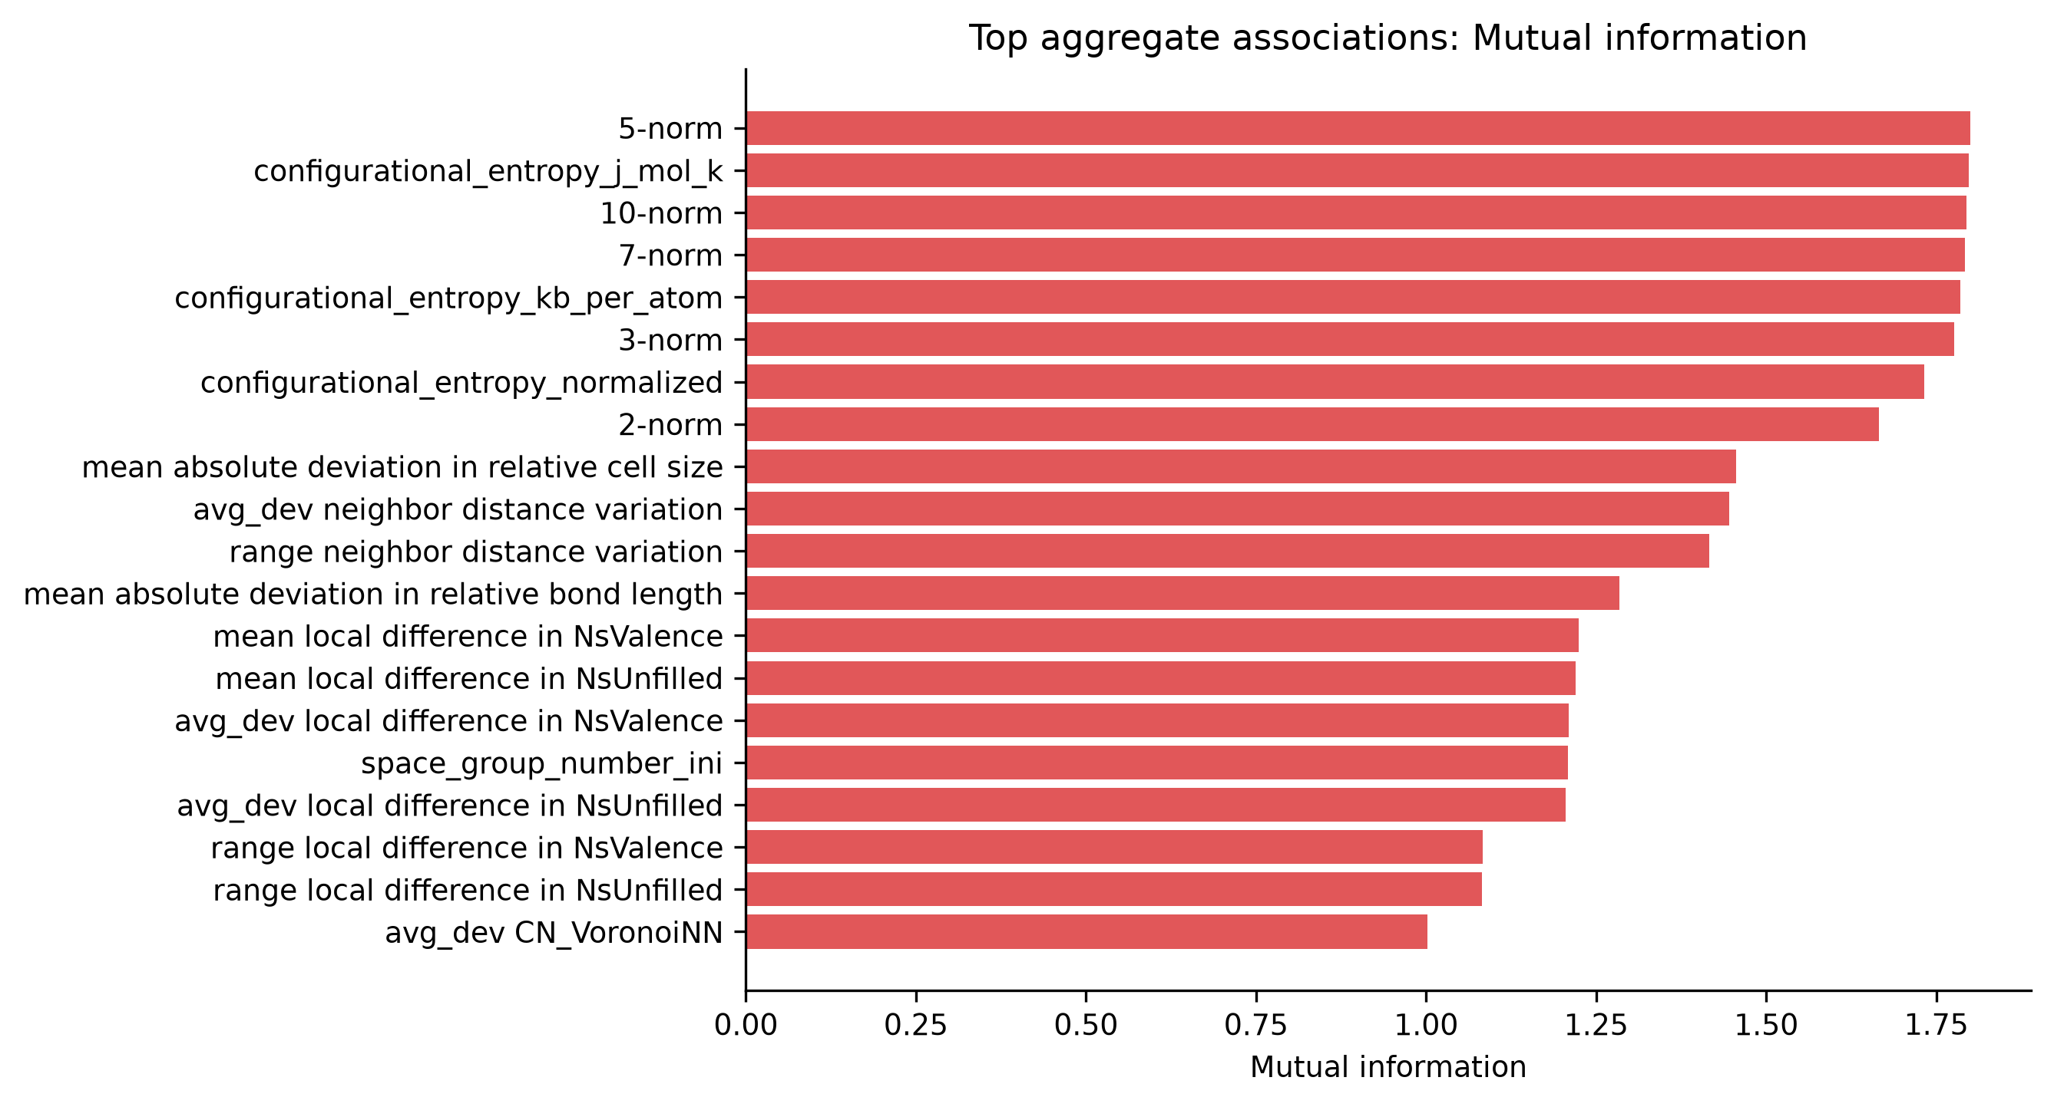
Figure 13. Leading aggregate mutual-information screening statistics.
Repository evidence: results/tables/phase4/feature_target_associations.csv.
Initial space-group number gives the strongest reported aggregate Pearson (0.4753) and Spearman (0.5931) association. The 5-norm gives the largest aggregate mutual-information statistic (1.7996). Initial symmetry is treated as a configuration/regime signal requiring sensitivity analysis, not as a causal law.
Repository evidence: results/tables/phase4/feature_target_associations.csv; reports/eda_analysis.md.
Phase-specific nonlinear screens and the cross-phase association comparison are shown in Figures 15-17.
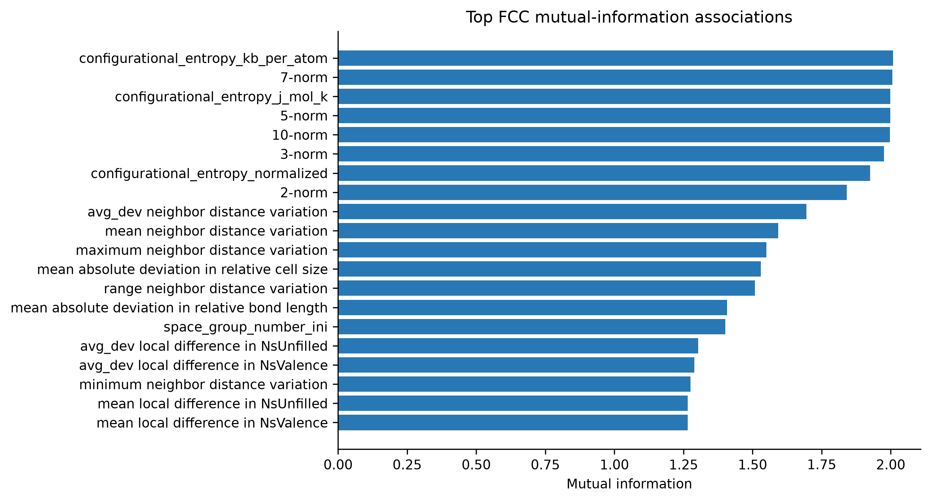
Figure 14. Leading FCC-only mutual-information screening statistics.
Repository evidence: results/tables/phase4/feature_target_associations.csv.
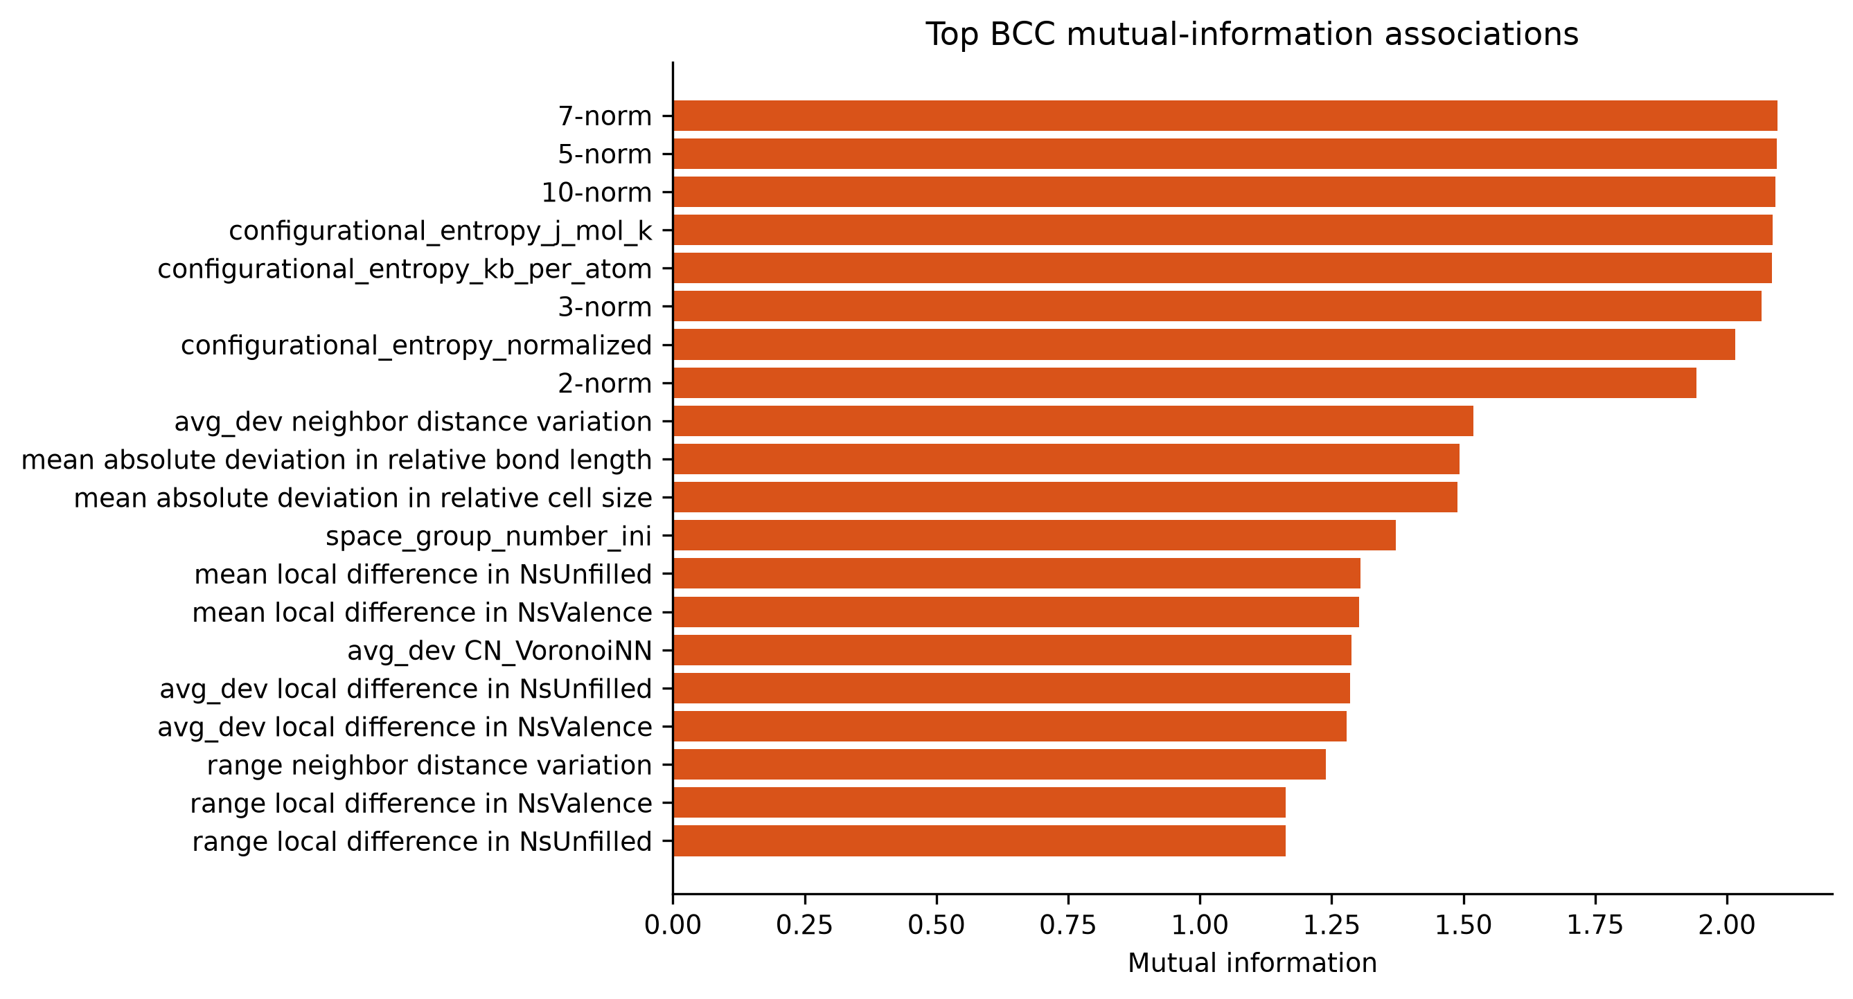
Figure 15. Leading BCC-only mutual-information screening statistics.
Repository evidence: results/tables/phase4/feature_target_associations.csv.
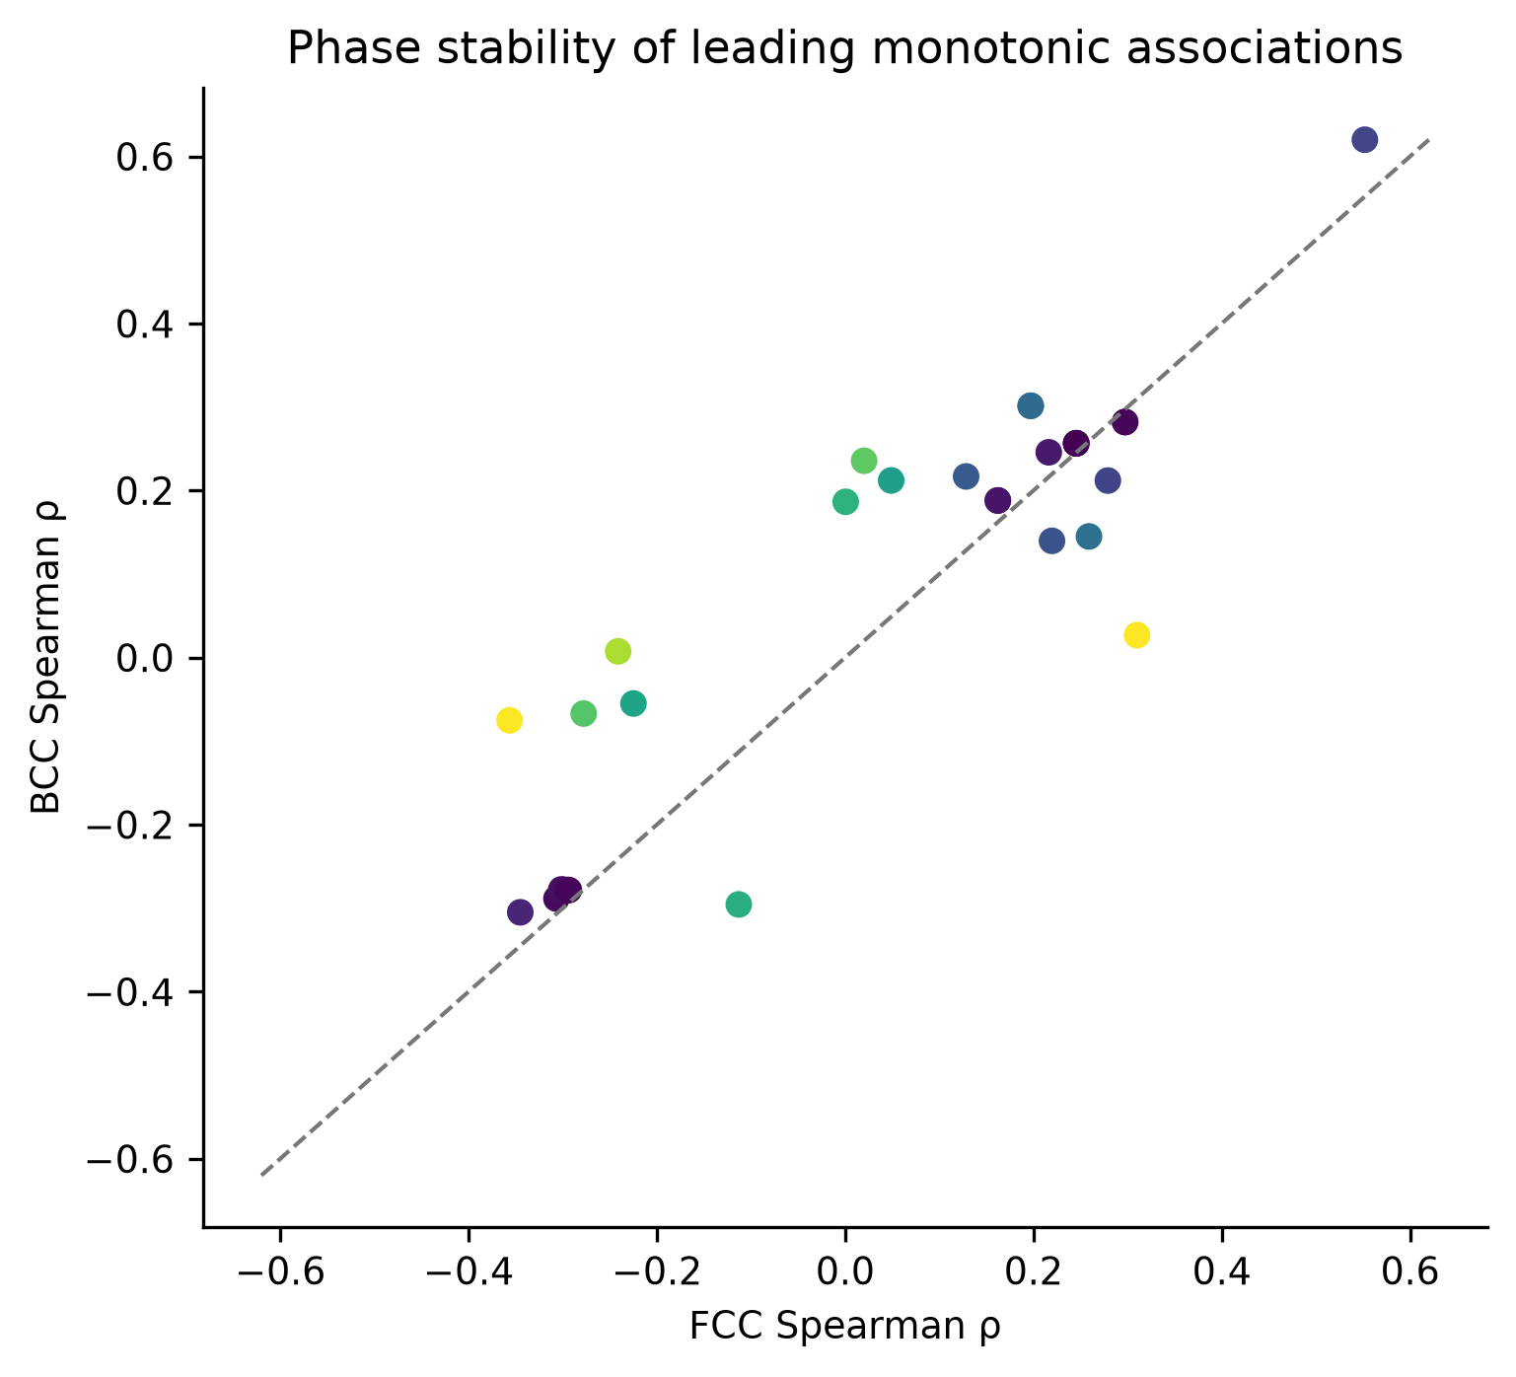
Figure 16. Comparison of leading FCC and BCC Spearman associations.
Repository evidence: thesis_outputs/tables/phase4/phase_association_comparison.csv.
Figure 18 displays binned, descriptive nonlinear trends for a small set of interpretable composition/elemental descriptors. These panels are hypothesis-generating and require literature support before any microscopic interpretation.
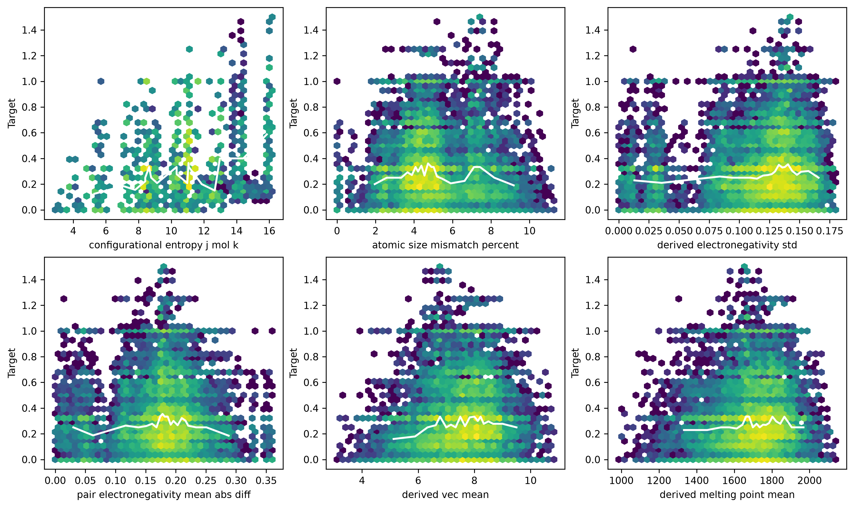
Figure 17. Descriptive nonlinear trends for selected interpretable composition and elemental descriptors.
Repository evidence: data/processed/ml_dataset.parquet; src/analysis/phase4.py.

10. Feature Redundancy Analysis
The feature library contains 24 constants, 29 near-zero-variance predictors, nine exact duplicate-column groups, and 426 pairs with absolute aggregate Pearson correlation at least 0.95. Redundancy arises from composition constraints, alternate summary statistics, and physically related elemental descriptors.
Repository evidence: results/tables/phase4/feature_quality.csv; results/tables/phase4/highly_correlated_feature_pairs.csv; thesis_outputs/thesis_analysis_notes.md.
Table 11. Phase 4 preliminary feature sets
Feature set | Predictors | Purpose
FULL_CLEAN | 324 | Leakage-clean, nonconstant library
BALANCED_PRELIMINARY | 198 | Redundancy-controlled Phase 5 set
MINIMAL_PRELIMINARY | 19 | Portable preliminary hypothesis; poor predictive retention
Repository evidence: thesis_outputs/tables/phase4/preliminary_feature_sets.csv; reports/feature_redundancy.md.
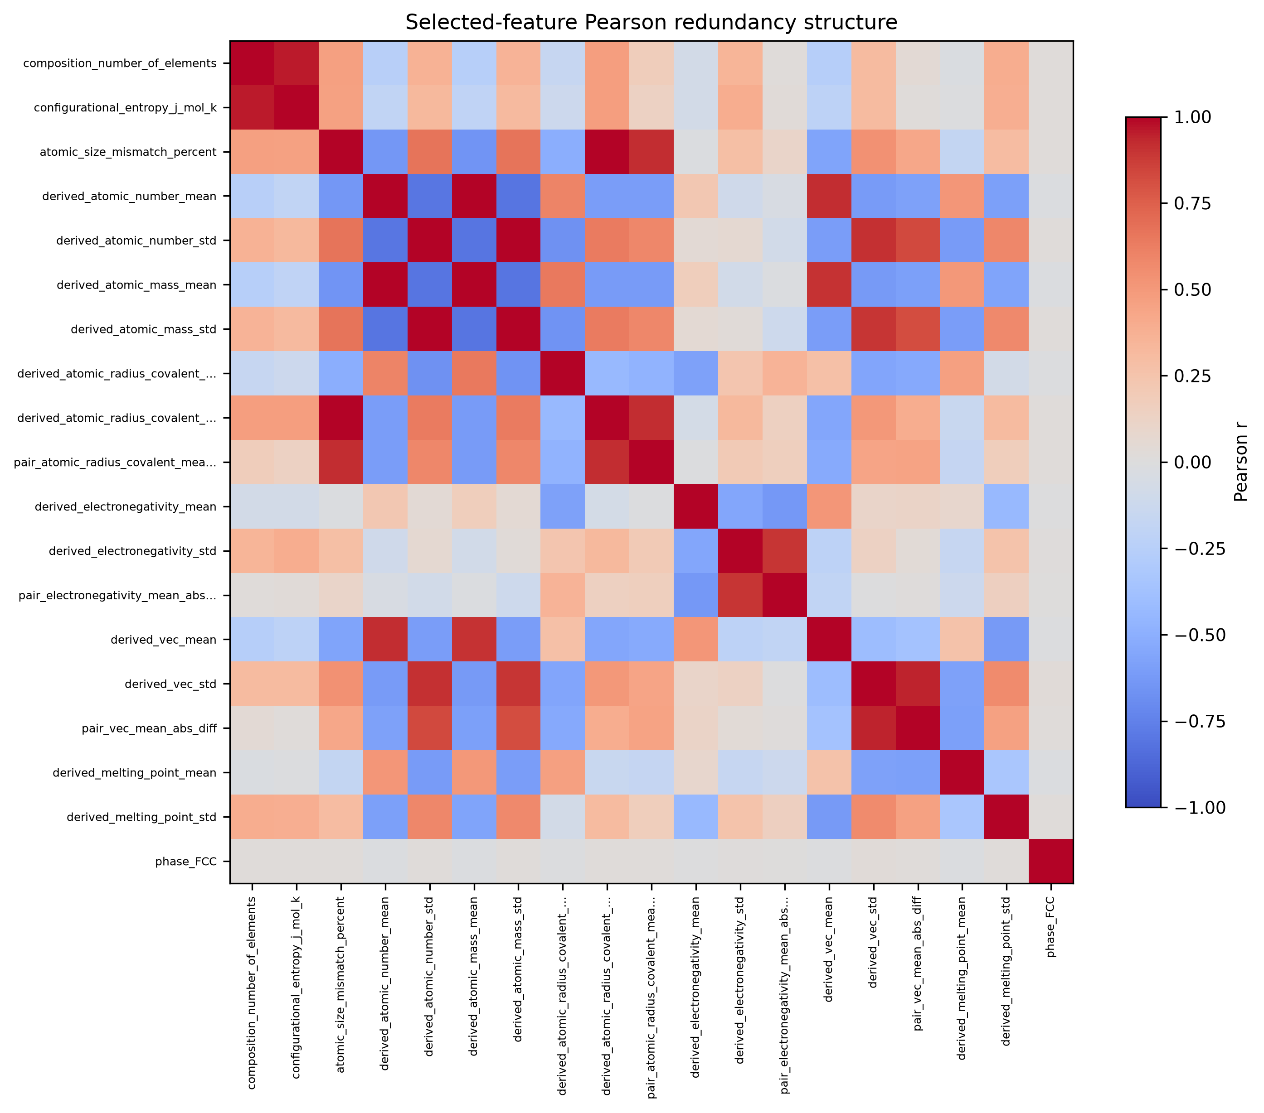
Figure 18. Pearson redundancy map for the preliminary portable descriptor set.
Repository evidence: results/tables/phase4/feature_feature_pearson_matrix.csv; src/analysis/phase4.py.
Redundancy reduction was performed to limit unstable importance allocation, reduce computational cost, and create interpretable comparison sets. The sets were hypotheses for grouped model comparison rather than claims that removed features were physically unimportant.

11. Machine-Learning Methodology
The supervised task predicts target_mean_abs_sro_shell1 for pooled FCC+BCC data and separately for FCC and BCC. Models were implemented as sklearn pipelines so constant filtering and, where needed, scaling were fitted only on training data.
Repository evidence: src/ml/phase5.py; tests/test_phase5.py.
Tested model families were median dummy, ordinary linear regression, Ridge, ElasticNet, Random Forest, Extra Trees, Gradient Boosting, HistGradientBoosting, and a bounded SVR baseline. Hyperparameters and complete comparison rows are preserved in the Phase 5 model tables.
Repository evidence: src/ml/phase5.py; thesis_outputs/tables/model_comparison_all.csv.
Table 12. Validation split audit
Strategy | Seed | Train rows | Test rows | Grouping | Train groups | Test groups | Overlap
random_configuration | 42 | 67037 | 16760 | none | 67037 | 16760 | not_applicable
composition_grouped | 42 | 68318 | 15479 | composition_fractions_json | 7706 | 1927 | 0
alloy_system_grouped | 42 | 71117 | 12680 | chemical_system | 196 | 50 | 0
Repository evidence: results/tables/phase5/split_audit.csv.
Random/configuration splitting allows highly related chemistry to appear on both sides and is retained only as an optimistic baseline. Composition holdout tests unseen stoichiometries. Alloy-system holdout prevents an elemental combination from appearing in both train and test and is the principal scientific generalization result. Model/feature configuration selection uses grouped inner cross-validation inside the outer training partition.
Repository evidence: reports/ml_split_strategy.md; src/ml/phase5.py.

12. Model Comparison
Model selection used inner alloy-system-grouped cross-validation; outer results are reported for scientific evaluation rather than used to choose the winner. HistGradientBoosting with BALANCED predictors was selected for unified, FCC, and BCC cohorts.
Repository evidence: thesis_outputs/tables/best_model_metrics.csv; reports/model_overfitting_analysis.md.
Table 13. Unified model comparison (top grouped-CV configurations)
Model | Feature set | p | CV R2 | Test R2 | MAE | RMSE
HistGradientBoosting | BALANCED_PRELIMINARY | 198 | 0.8803 | 0.8997 | 0.0535 | 0.0764
HistGradientBoosting | FULL_CLEAN | 324 | 0.8783 | 0.8973 | 0.0539 | 0.0774
HistGradientBoosting | COMPOSITION_PLUS_INITIAL_STRUCTURE | 320 | 0.8783 | 0.8970 | 0.0543 | 0.0775
RandomForest | BALANCED_PRELIMINARY | 198 | 0.8712 | 0.9151 | 0.0422 | 0.0703
RandomForest | FULL_CLEAN | 324 | 0.8695 | 0.9128 | 0.0409 | 0.0713
ExtraTrees | BALANCED_PRELIMINARY | 198 | 0.8695 | 0.9115 | 0.0450 | 0.0718
RandomForest | COMPOSITION_PLUS_INITIAL_STRUCTURE | 320 | 0.8665 | 0.9127 | 0.0419 | 0.0713
Ridge | BALANCED_PRELIMINARY | 198 | 0.6633 | 0.5802 | 0.1183 | 0.1564
LinearRegression | BALANCED_PRELIMINARY | 198 | 0.6629 | 0.5810 | 0.1183 | 0.1562
ElasticNet | BALANCED_PRELIMINARY | 198 | 0.6199 | 0.5428 | 0.1230 | 0.1632
GradientBoosting | BALANCED_PRELIMINARY | 198 | 0.5072 | 0.5099 | 0.1294 | 0.1690
HistGradientBoosting | COMPOSITION_PLUS_PHASE | 205 | 0.1764 | 0.3339 | 0.1399 | 0.1970
Repository evidence: thesis_outputs/tables/model_comparison_all.csv.
Table 14. FCC model comparison (top grouped-CV configurations)
Model | Feature set | p | CV R2 | Test R2 | MAE | RMSE
HistGradientBoosting | BALANCED_PRELIMINARY | 198 | 0.8936 | 0.9058 | 0.0348 | 0.0534
HistGradientBoosting | FULL_CLEAN | 324 | 0.8935 | 0.9067 | 0.0346 | 0.0531
HistGradientBoosting | COMPOSITION_PLUS_INITIAL_STRUCTURE | 320 | 0.8901 | 0.9062 | 0.0348 | 0.0533
RandomForest | FULL_CLEAN | 324 | 0.8788 | 0.8918 | 0.0319 | 0.0572
RandomForest | COMPOSITION_PLUS_INITIAL_STRUCTURE | 320 | 0.8768 | 0.8896 | 0.0330 | 0.0578
RandomForest | BALANCED_PRELIMINARY | 198 | 0.8752 | 0.8938 | 0.0336 | 0.0567
ExtraTrees | BALANCED_PRELIMINARY | 198 | 0.8523 | 0.8922 | 0.0350 | 0.0571
LinearRegression | BALANCED_PRELIMINARY | 198 | 0.6806 | 0.5981 | 0.0836 | 0.1103
Ridge | BALANCED_PRELIMINARY | 198 | 0.6798 | 0.6015 | 0.0833 | 0.1098
ElasticNet | BALANCED_PRELIMINARY | 198 | 0.6398 | 0.5910 | 0.0858 | 0.1112
GradientBoosting | BALANCED_PRELIMINARY | 198 | 0.5014 | 0.5137 | 0.0956 | 0.1213
HistGradientBoosting | COMPOSITION_ONLY | 204 | 0.1386 | 0.3595 | 0.1026 | 0.1392
Repository evidence: thesis_outputs/tables/model_comparison_fcc.csv.
Table 15. BCC model comparison (top grouped-CV configurations)
Model | Feature set | p | CV R2 | Test R2 | MAE | RMSE
HistGradientBoosting | BALANCED_PRELIMINARY | 198 | 0.8830 | 0.9154 | 0.0563 | 0.0808
RandomForest | FULL_CLEAN | 324 | 0.8760 | 0.9203 | 0.0447 | 0.0784
HistGradientBoosting | FULL_CLEAN | 324 | 0.8746 | 0.9128 | 0.0572 | 0.0820
RandomForest | COMPOSITION_PLUS_INITIAL_STRUCTURE | 320 | 0.8737 | 0.9150 | 0.0476 | 0.0809
HistGradientBoosting | COMPOSITION_PLUS_INITIAL_STRUCTURE | 320 | 0.8654 | 0.9116 | 0.0582 | 0.0825
RandomForest | BALANCED_PRELIMINARY | 198 | 0.8630 | 0.9156 | 0.0494 | 0.0806
ExtraTrees | BALANCED_PRELIMINARY | 198 | 0.8549 | 0.9028 | 0.0577 | 0.0866
Ridge | BALANCED_PRELIMINARY | 198 | 0.6665 | 0.6043 | 0.1358 | 0.1746
LinearRegression | BALANCED_PRELIMINARY | 198 | 0.6659 | 0.6064 | 0.1354 | 0.1742
ElasticNet | BALANCED_PRELIMINARY | 198 | 0.6226 | 0.5569 | 0.1423 | 0.1848
GradientBoosting | BALANCED_PRELIMINARY | 198 | 0.4880 | 0.5112 | 0.1579 | 0.1941
HistGradientBoosting | MINIMAL_PRELIMINARY | 19 | 0.0277 | 0.2532 | 0.1768 | 0.2399
Repository evidence: thesis_outputs/tables/model_comparison_bcc.csv.
Figures 20-24 show unified R-squared/MAE/RMSE comparisons and phase-specific R-squared comparisons. These visualizations retain the wider model screen while the tables above condense the leading configurations.
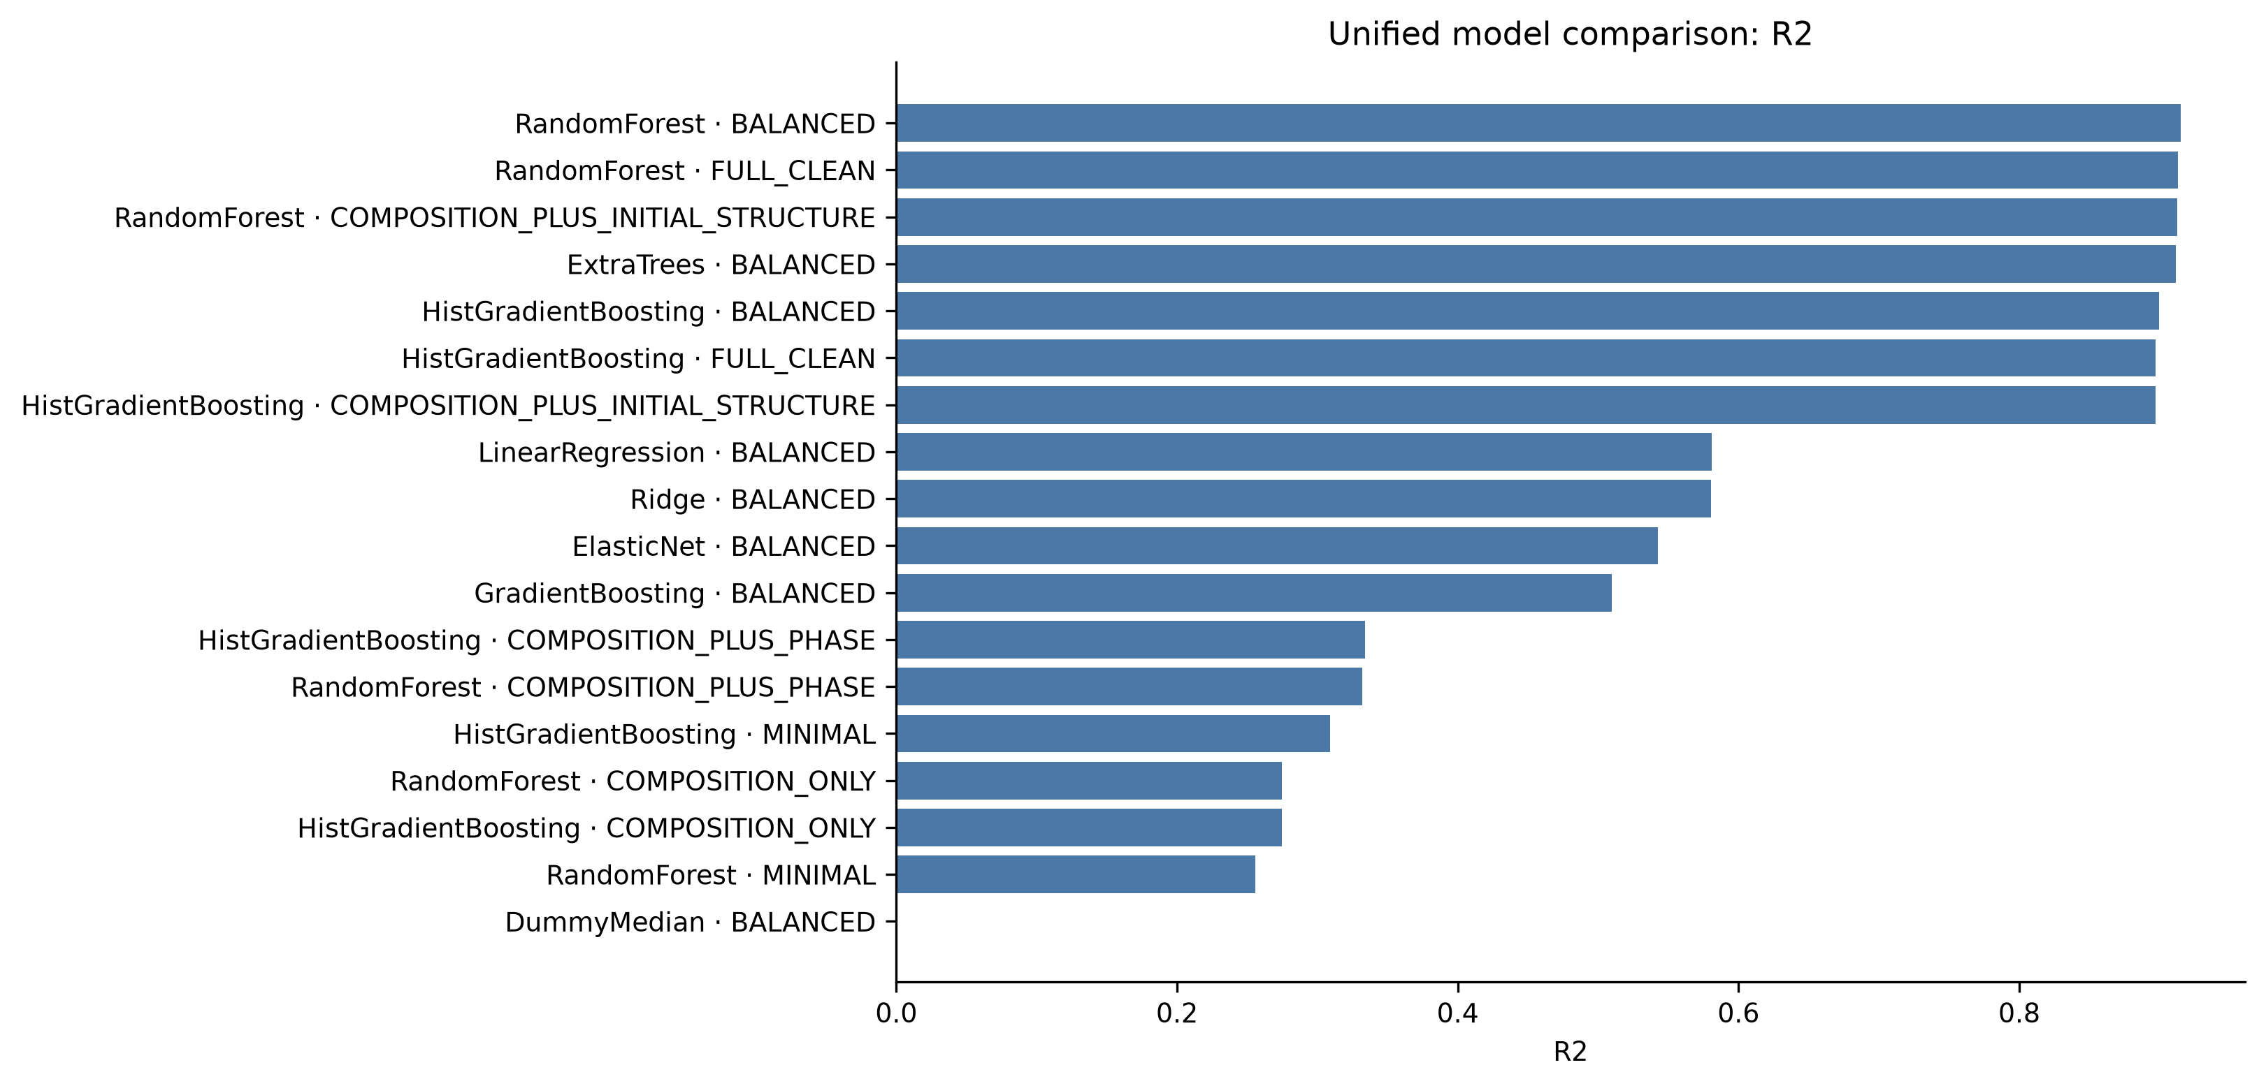
Figure 19. Unified alloy-held-out R-squared across screened model and feature-set configurations.
Repository evidence: thesis_outputs/tables/model_comparison_all.csv.
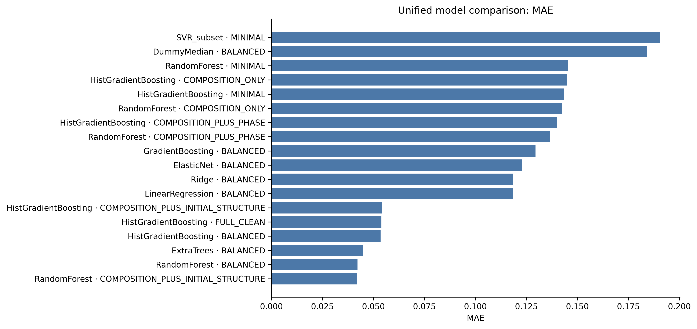
Figure 20. Unified alloy-held-out mean absolute error across screened configurations.
Repository evidence: thesis_outputs/tables/model_comparison_all.csv.
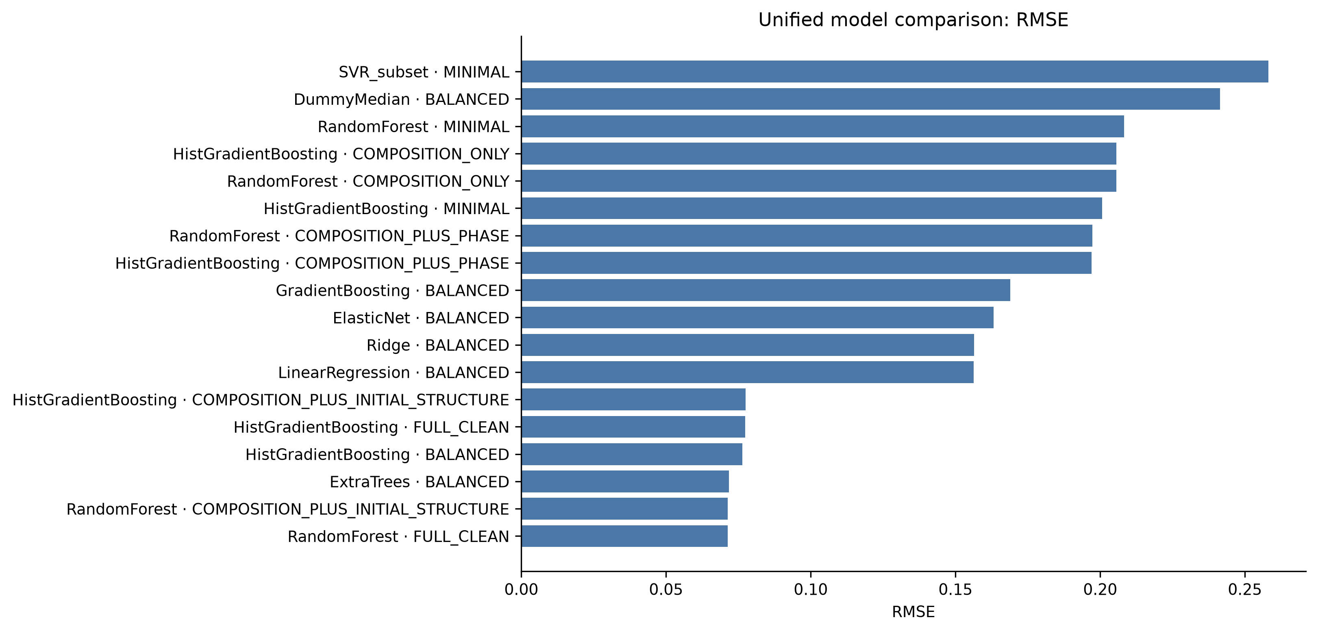
Figure 21. Unified alloy-held-out root mean squared error across screened configurations.
Repository evidence: thesis_outputs/tables/model_comparison_all.csv.
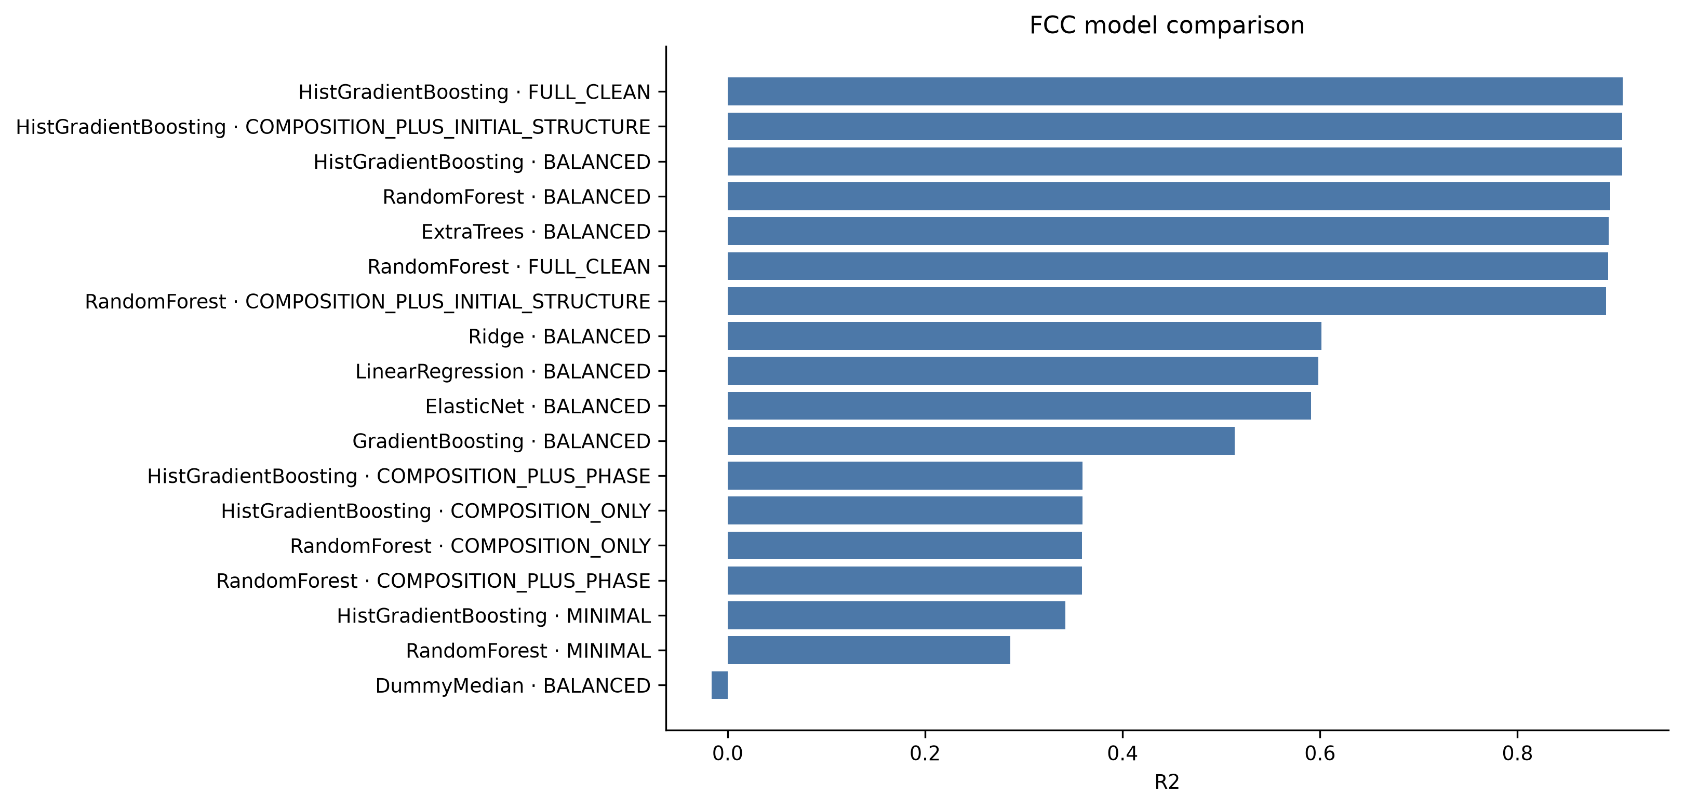
Figure 22. FCC-only alloy-held-out model comparison.
Repository evidence: thesis_outputs/tables/model_comparison_fcc.csv.
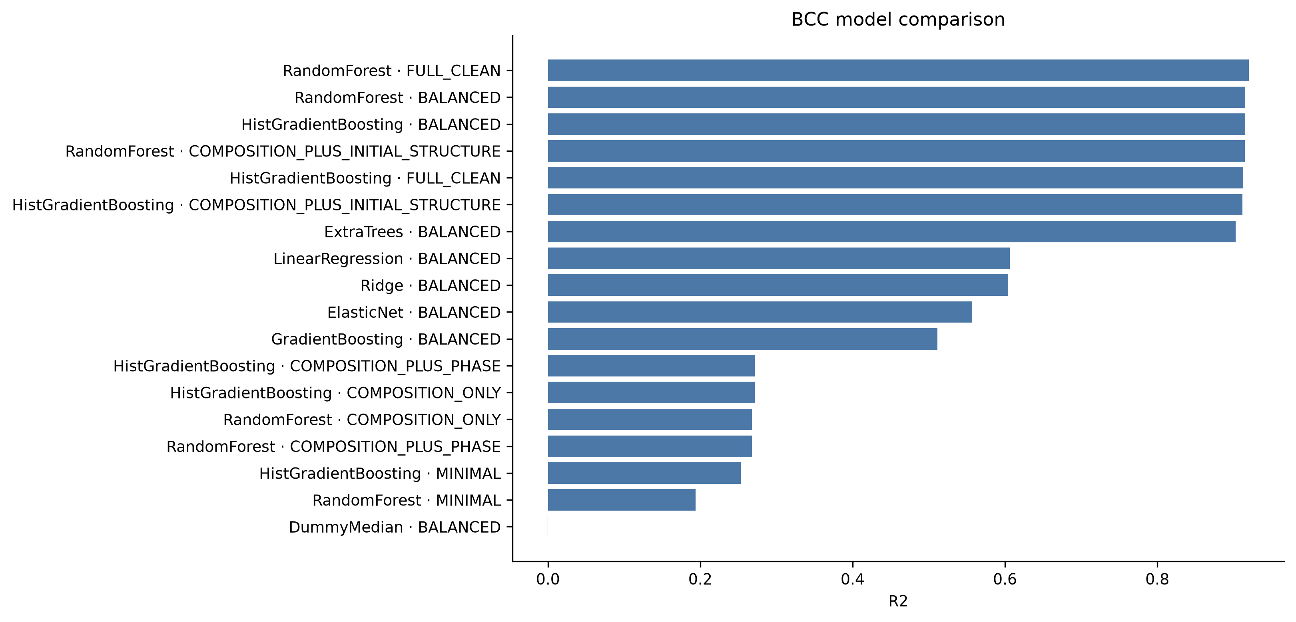
Figure 23. BCC-only alloy-held-out model comparison.
Repository evidence: thesis_outputs/tables/model_comparison_bcc.csv.
Table 16. Final best-model metrics
Cohort | Model | Features | p | R2 | MAE | RMSE
ALL | HistGradientBoosting | BALANCED_PRELIMINARY | 198 | 0.8997 | 0.0535 | 0.0764
BCC | HistGradientBoosting | BALANCED_PRELIMINARY | 198 | 0.9154 | 0.0563 | 0.0808
FCC | HistGradientBoosting | BALANCED_PRELIMINARY | 198 | 0.9058 | 0.0348 | 0.0534
Repository evidence: thesis_outputs/tables/best_model_metrics.csv.
The final alloy-held-out metrics are unified 0.8997/0.0535/0.0764, FCC 0.9058/0.0348/0.0534, and BCC 0.9154/0.0563/0.0808 for R-squared/MAE/RMSE, respectively.
Repository evidence: thesis_outputs/tables/best_model_metrics.csv.
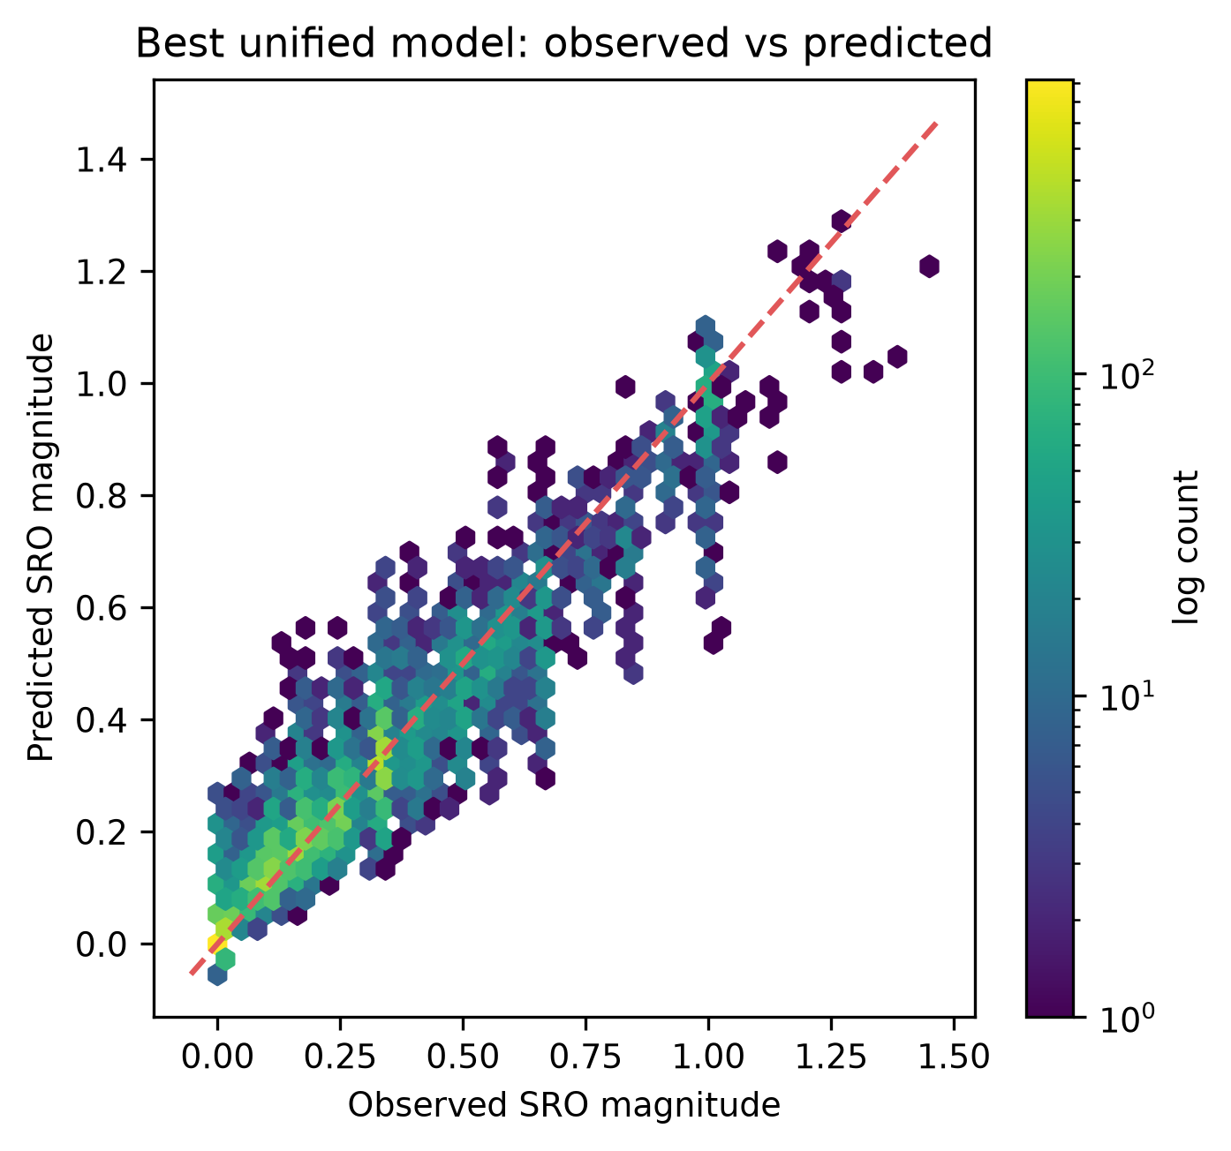
Figure 24. Unified observed versus predicted SRO magnitude on held-out alloy systems.
Repository evidence: results/tables/phase5/best_predictions_all.csv.

13. Generalization Results
Table 17. Unified split/generalization comparison
Split | Train | Test | R2 | MAE | RMSE
random_configuration | 67,037 | 16,760 | 0.9266 | 0.0508 | 0.0731
composition_grouped | 68,318 | 15,479 | 0.9161 | 0.0534 | 0.0760
alloy_system_grouped | 71,117 | 12,680 | 0.8997 | 0.0535 | 0.0764
Repository evidence: thesis_outputs/tables/grouped_validation_results.csv.
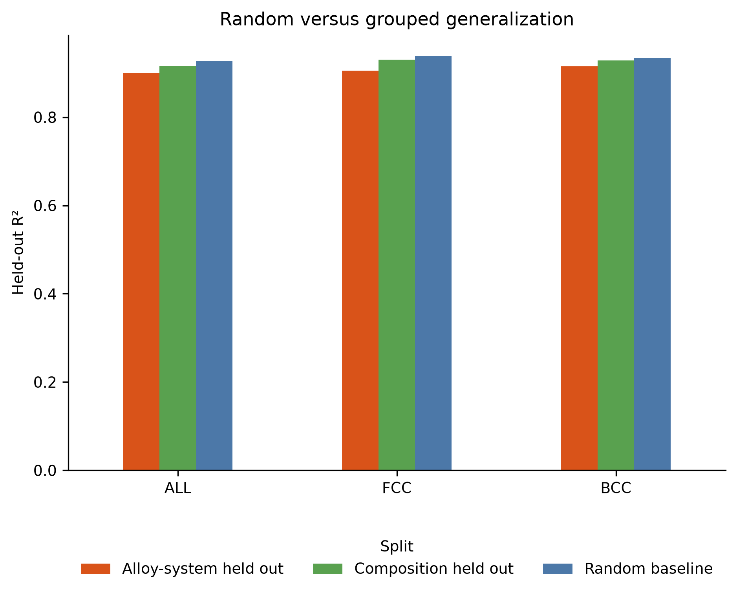
Figure 25. Random/configuration, composition-held-out, and alloy-system-held-out evaluation of the frozen best pipeline.
Repository evidence: thesis_outputs/tables/grouped_validation_results.csv.
Unified R-squared decreases from 0.9266 under random/configuration splitting to 0.9161 under composition holdout and 0.8997 under alloy-system holdout. This decrease is expected as chemical independence becomes stricter; the alloy-held-out value governs conclusions.
Repository evidence: thesis_outputs/tables/grouped_validation_results.csv.

14. Unified Versus Phase-Specific Models
Table 18. Unified versus phase-specific performance on identical phase rows
Phase | Model scope | Rows | R2 | MAE | RMSE
FCC | unified | 5,905 | 0.8668 | 0.0438 | 0.0635
FCC | phase_specific | 5,905 | 0.9058 | 0.0348 | 0.0534
BCC | unified | 6,775 | 0.9038 | 0.0621 | 0.0861
BCC | phase_specific | 6,775 | 0.9154 | 0.0563 | 0.0808
Repository evidence: thesis_outputs/tables/unified_vs_phase_specific_metrics.csv.
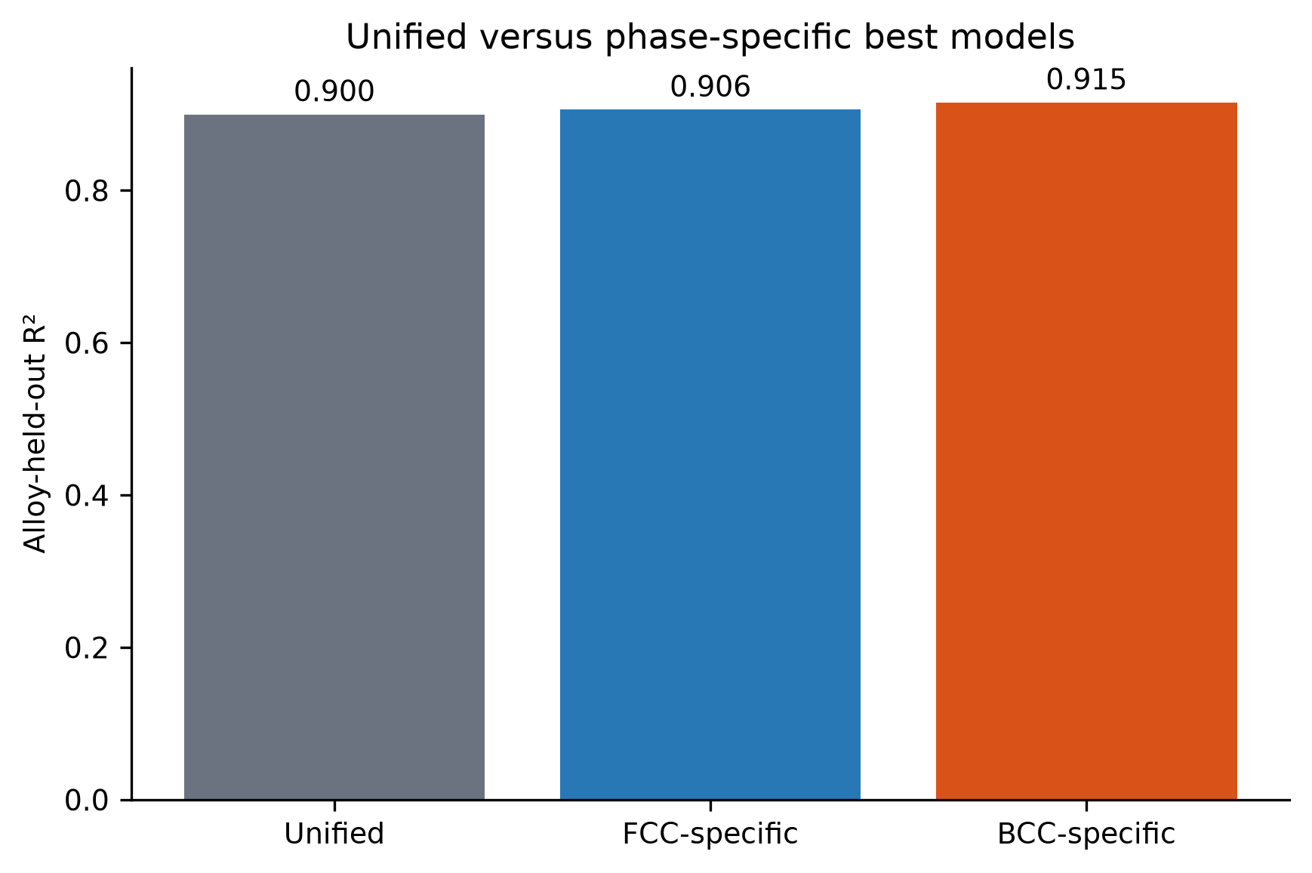
Figure 26. Unified and phase-specific performance on identical held-out phase rows.
Repository evidence: thesis_outputs/tables/unified_vs_phase_specific_metrics.csv.
For FCC, the phase-specific model improves R-squared from 0.8668 to 0.9058; for BCC it improves from 0.9038 to 0.9154. The FCC benefit is larger. Separate models are justified for phase interpretation and best in-domain accuracy, while the unified model remains the compact deployment baseline.
Repository evidence: thesis_outputs/tables/unified_vs_phase_specific_metrics.csv; reports/final_fcc_bcc_interpretation.md.
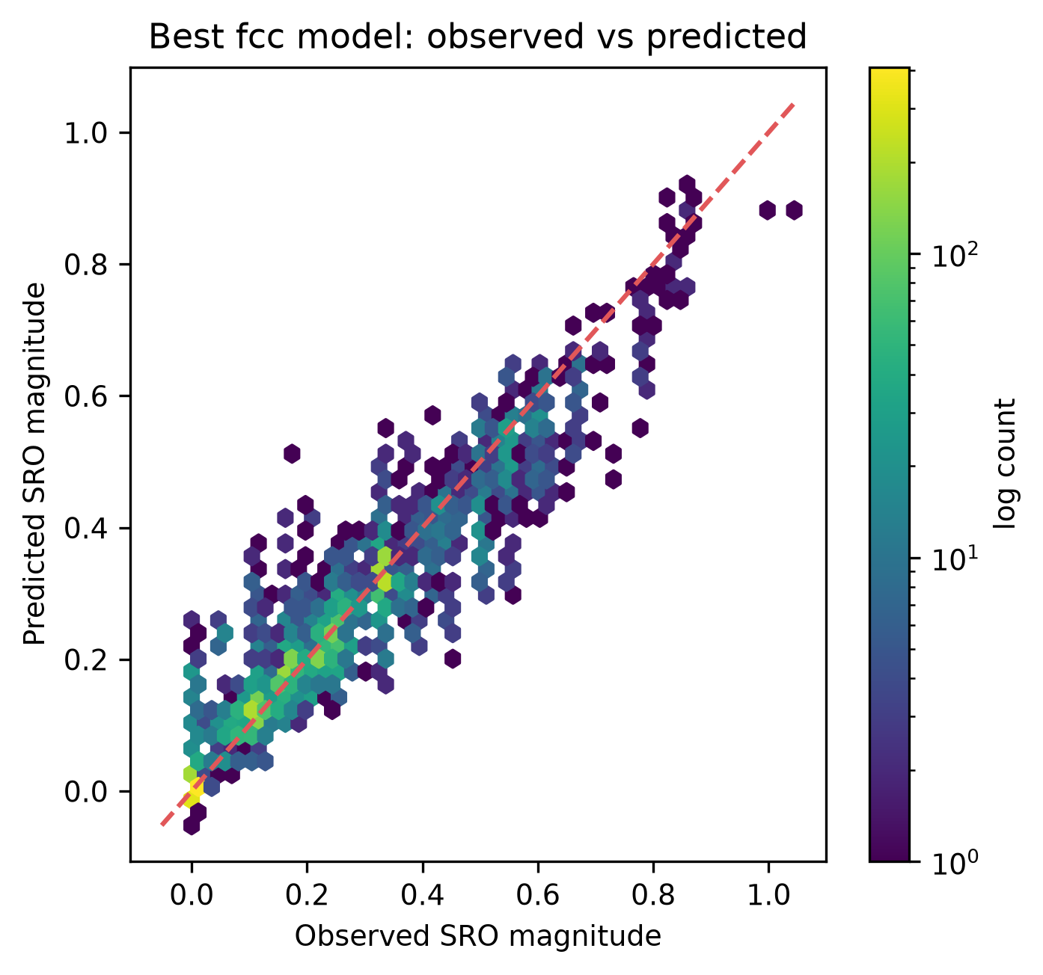
Figure 27. FCC observed versus predicted SRO magnitude on held-out alloy systems.
Repository evidence: results/tables/phase5/best_predictions_fcc.csv.
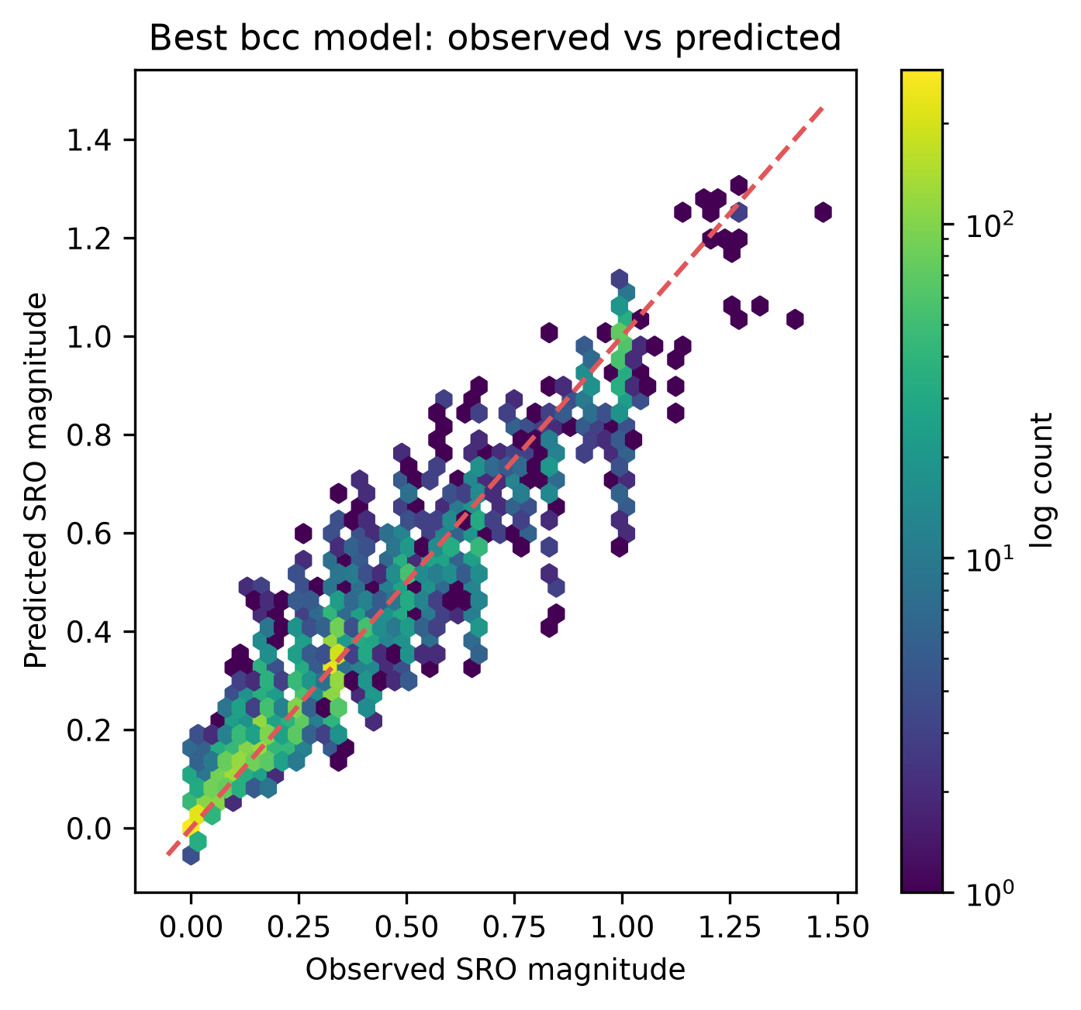
Figure 28. BCC observed versus predicted SRO magnitude on held-out alloy systems.
Repository evidence: results/tables/phase5/best_predictions_bcc.csv.

15. Feature-Set Ablation
Table 19. Unified HistGradientBoosting feature-set comparison
Feature set | p | CV R2 | Test R2 | MAE | RMSE
BALANCED_PRELIMINARY | 198 | 0.8803 | 0.8997 | 0.0535 | 0.0764
FULL_CLEAN | 324 | 0.8783 | 0.8973 | 0.0539 | 0.0774
COMPOSITION_PLUS_INITIAL_STRUCTURE | 320 | 0.8783 | 0.8970 | 0.0543 | 0.0775
COMPOSITION_PLUS_PHASE | 205 | 0.1764 | 0.3339 | 0.1399 | 0.1970
MINIMAL_PRELIMINARY | 19 | 0.1008 | 0.3089 | 0.1436 | 0.2006
COMPOSITION_ONLY | 204 | 0.0262 | 0.2745 | 0.1447 | 0.2056
Repository evidence: thesis_outputs/tables/feature_set_model_comparison.csv.
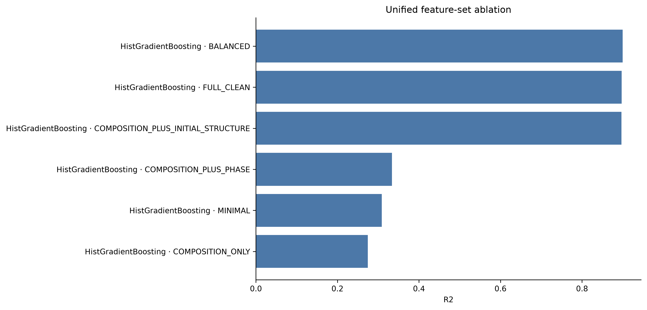
Figure 29. Unified HistGradientBoosting performance across feature-set and physical ablation definitions.
Repository evidence: thesis_outputs/tables/feature_set_model_comparison.csv.
Grouped-CV R-squared is 0.0262 for composition only, 0.1764 for composition plus phase, and 0.8783 for composition plus initial structure, compared with 0.8803 for BALANCED. The weak composition-only result means configuration-level information is essential within this source. It does not prove that the same structural descriptors transfer unchanged to an independent workflow.
Repository evidence: thesis_outputs/tables/feature_set_model_comparison.csv; reports/feature_ablation_analysis.md.

16. Compact High-Performance Model
Phase 6 tested predictor counts 10, 20, 30, 50, 75, 100, 150, and 198. Within each outer-training fold, feature ranking was rebuilt from an additional group split of the fold-training data. Subset size was selected from grouped inner validation only, without repeatedly querying the outer test.
Repository evidence: src/analysis/phase6.py; results/tables/phase6/compact_feature_count_validation.csv.
Table 20. Compact feature-count selection
p | CV R2 | SD | CV MAE | BAL R2 | Threshold | Selected
10 | 0.8636 | 0.0290 | 0.0662 | 0.8803 | 0.8503 | True
20 | 0.8731 | 0.0252 | 0.0647 | 0.8803 | 0.8503 | False
30 | 0.8776 | 0.0236 | 0.0640 | 0.8803 | 0.8503 | False
50 | 0.8780 | 0.0229 | 0.0642 | 0.8803 | 0.8503 | False
75 | 0.8750 | 0.0266 | 0.0648 | 0.8803 | 0.8503 | False
100 | 0.8787 | 0.0218 | 0.0643 | 0.8803 | 0.8503 | False
150 | 0.8780 | 0.0234 | 0.0643 | 0.8803 | 0.8503 | False
198 | 0.8803 | 0.0217 | 0.0640 | 0.8803 | 0.8503 | False
Repository evidence: results/tables/phase6/compact_feature_count_validation.csv.
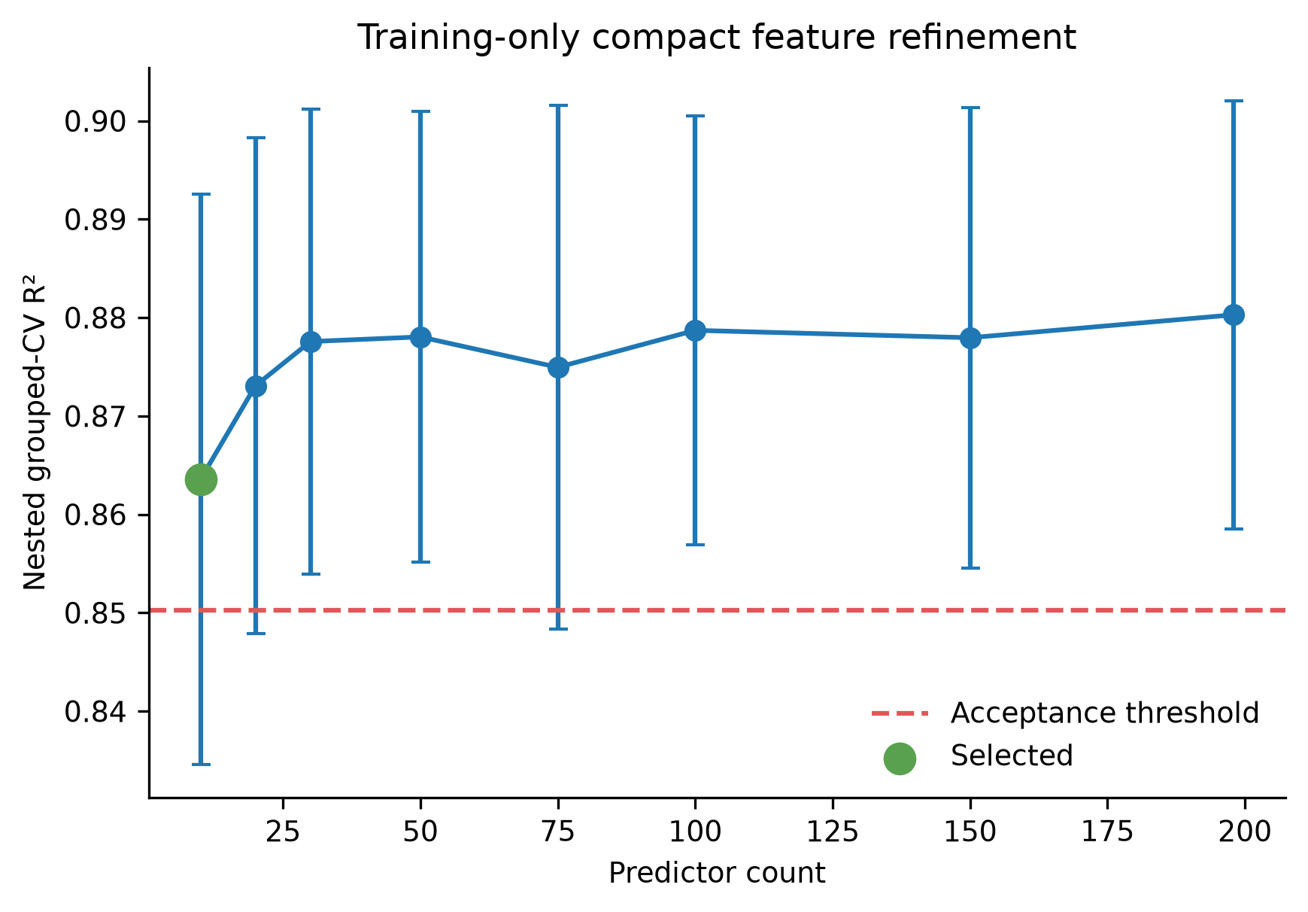
Figure 30. Training-only grouped-validation curve used to select the compact feature count.
Repository evidence: results/tables/phase6/compact_feature_count_validation.csv.
Table 21. Compact-model untouched outer metrics
Cohort | p | R2 | MAE | RMSE
ALL | 10 | 0.8917 | 0.0537 | 0.0794
FCC | 10 | 0.9038 | 0.0334 | 0.0539
BCC | 10 | 0.9061 | 0.0565 | 0.0851
Repository evidence: results/tables/phase6/compact_outer_test_metrics.csv.
Table 22. Exact compact high-performance predictors
Order | Feature
1 | space_group_number_ini
2 | configurational_entropy_j_mol_k
3 | max packing efficiency
4 | NIONS
5 | range neighbor distance variation
6 | configurational_entropy_normalized
7 | minimum local difference in NsUnfilled
8 | mean local difference in SpaceGroupNumber
9 | mean local difference in NsValence
10 | avg_dev local difference in NsValence
Repository evidence: results/feature_sets/compact_high_performance.txt.
The 10-feature unified model achieves outer R-squared 0.8917, MAE 0.0537, and RMSE 0.0794. Its absolute R-squared loss relative to BALANCED is 0.0081. Simplification is substantial, but the selected variables remain dominated by configuration-sensitive information.
Repository evidence: results/tables/phase6/compact_outer_test_metrics.csv; thesis_outputs/tables/best_model_metrics.csv; reports/final_feature_set.md.

17. Feature Importance and Physical Feature Groups
Permutation importance measures how much held-out error increases when one feature is shuffled. It is conditional on the fitted model and is affected by correlated substitutes. Physical-group ablation retrains after removing a whole descriptor family and is more interpretable, but group effects are still non-additive.
Repository evidence: reports/model_interpretation.md; reports/feature_group_interpretation.md.
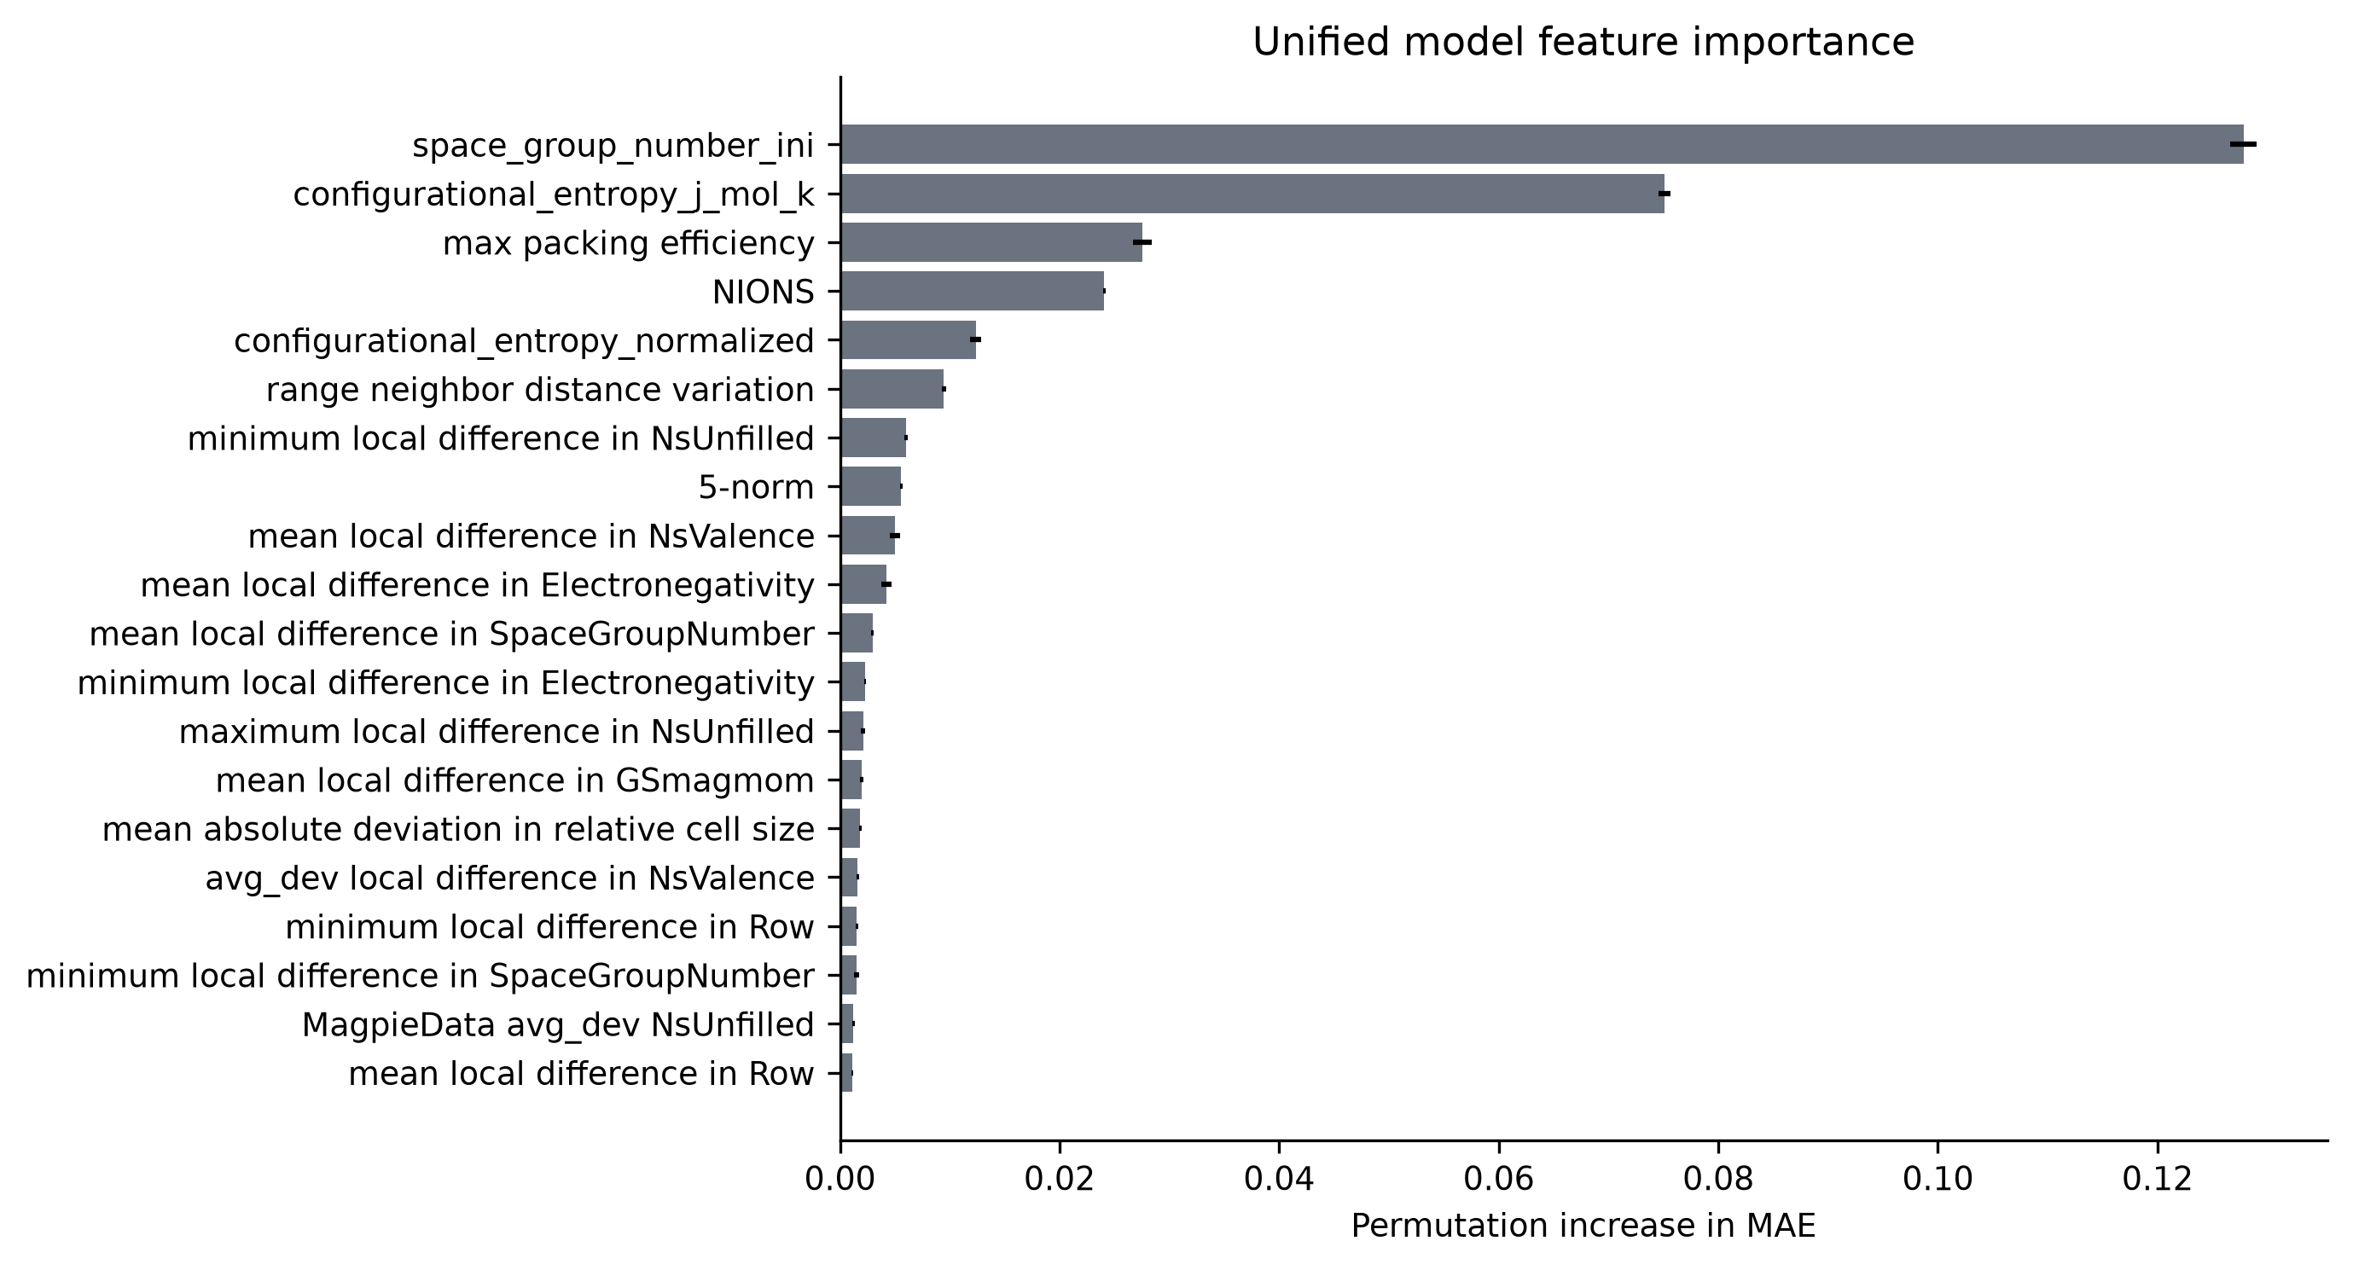
Figure 31. Unified held-out permutation importance, expressed as increase in MAE.
Repository evidence: thesis_outputs/tables/feature_importance_unified.csv.
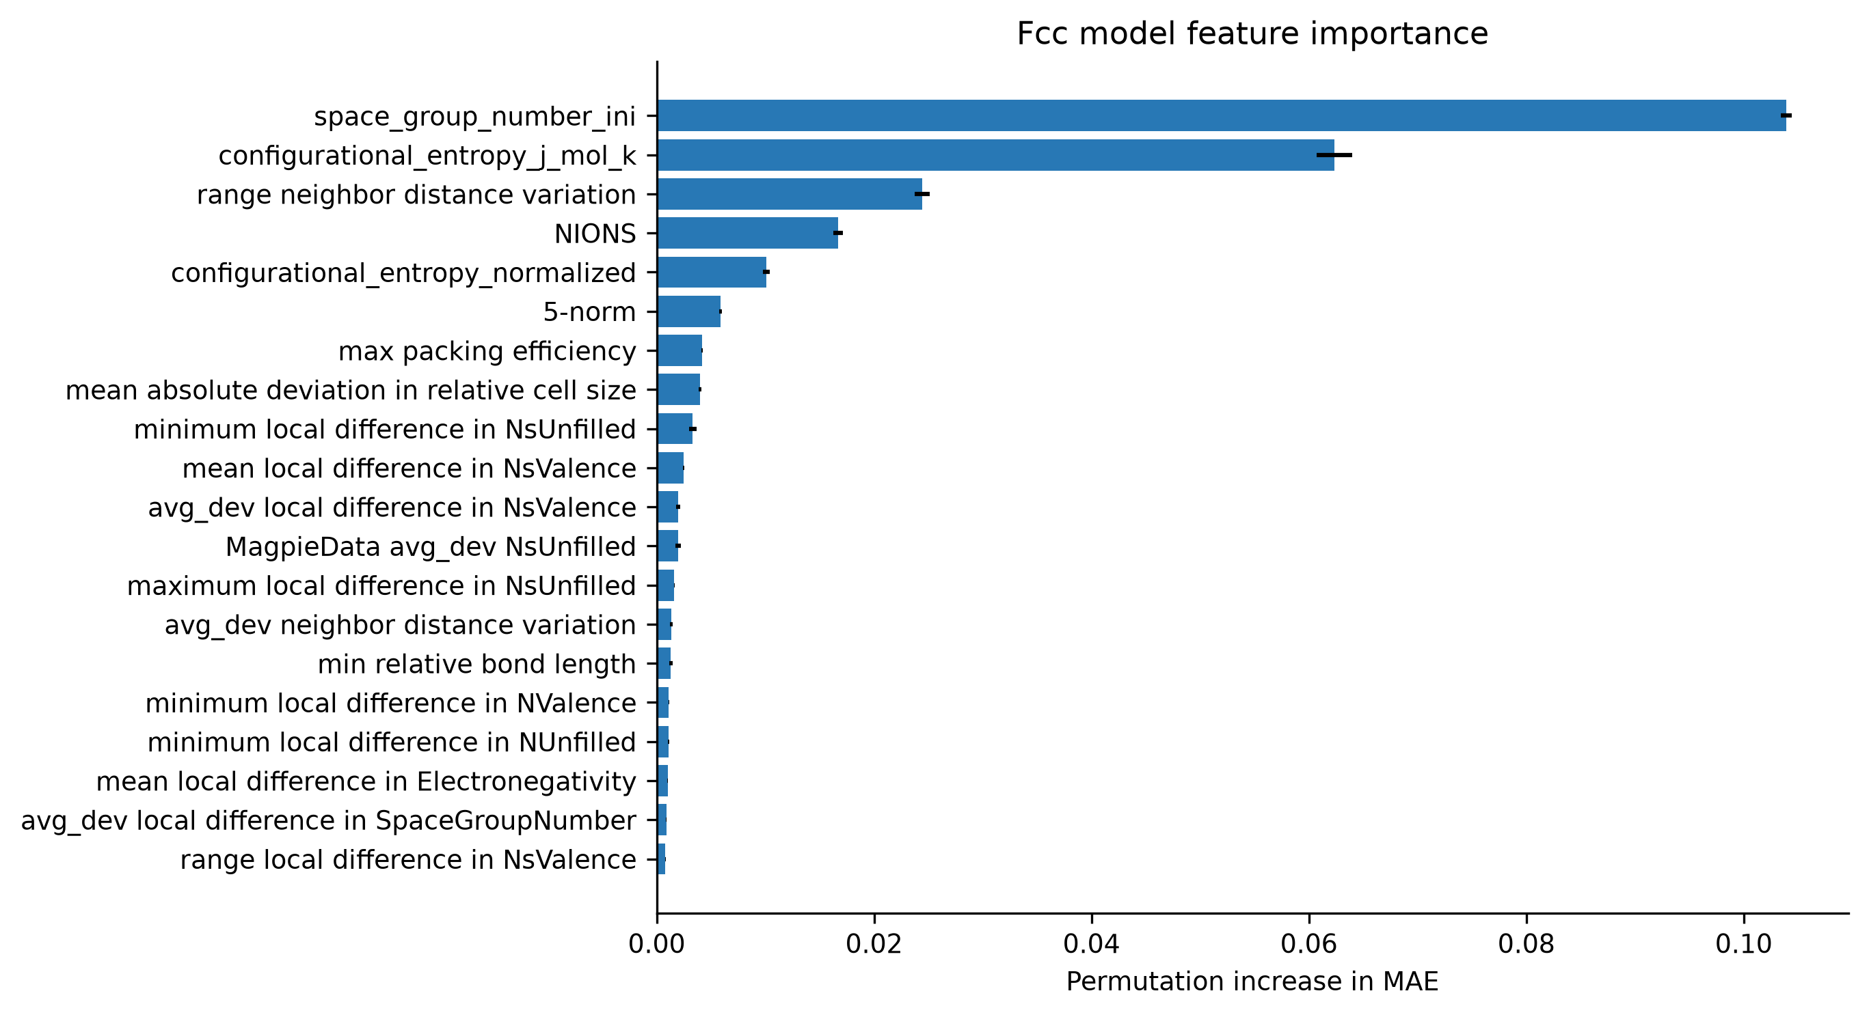
Figure 32. FCC held-out permutation importance.
Repository evidence: thesis_outputs/tables/feature_importance_fcc.csv.
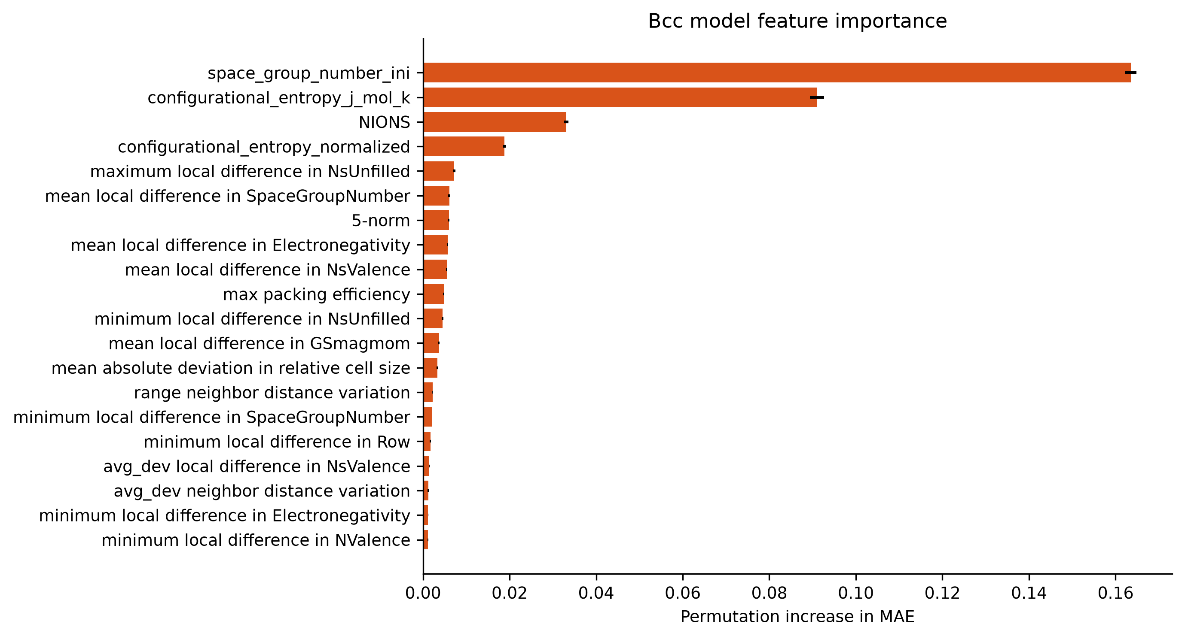
Figure 33. BCC held-out permutation importance.
Repository evidence: thesis_outputs/tables/feature_importance_bcc.csv.
Table 23. Physical feature-group ablation by cohort
Cohort | Removed group | p removed | CV R2 | Delta R2 | Delta MAE
ALL | symmetry | 11 | 0.8137 | -0.0666 | 0.0172
ALL | structural_geometry | 6 | 0.8557 | -0.0246 | 0.0086
ALL | configurational_entropy | 2 | 0.8583 | -0.0220 | 0.0074
ALL | electronic_VEC_periodic | 80 | 0.8676 | -0.0126 | 0.0032
ALL | elemental_thermophysical | 25 | 0.8759 | -0.0043 | 0.0007
ALL | electronegativity | 12 | 0.8769 | -0.0034 | 0.0007
ALL | composition | 46 | 0.8781 | -0.0022 | 0.0008
ALL | atomic_size | 16 | 0.8791 | -0.0011 | 0.0003
BCC | symmetry | 11 | 0.8256 | -0.0574 | 0.0194
BCC | electronic_VEC_periodic | 80 | 0.8676 | -0.0153 | 0.0032
BCC | configurational_entropy | 2 | 0.8679 | -0.0151 | 0.0073
BCC | composition | 46 | 0.8736 | -0.0094 | 0.0019
BCC | elemental_thermophysical | 25 | 0.8778 | -0.0051 | 0.0008
BCC | structural_geometry | 6 | 0.8788 | -0.0042 | 0.0022
BCC | electronegativity | 12 | 0.8807 | -0.0023 | 0.0002
BCC | atomic_size | 16 | 0.8838 | 0.0008 | -0.0003
FCC | symmetry | 11 | 0.8034 | -0.0901 | 0.0146
FCC | configurational_entropy | 2 | 0.8723 | -0.0213 | 0.0057
FCC | electronic_VEC_periodic | 80 | 0.8752 | -0.0184 | 0.0025
FCC | structural_geometry | 6 | 0.8832 | -0.0104 | 0.0047
FCC | composition | 46 | 0.8873 | -0.0063 | 0.0009
FCC | elemental_thermophysical | 25 | 0.8944 | 0.0008 | 0.0001
FCC | atomic_size | 16 | 0.8952 | 0.0016 | -0.0002
FCC | electronegativity | 12 | 0.8968 | 0.0032 | -0.0005
Repository evidence: thesis_outputs/tables/feature_group_ablation.csv.
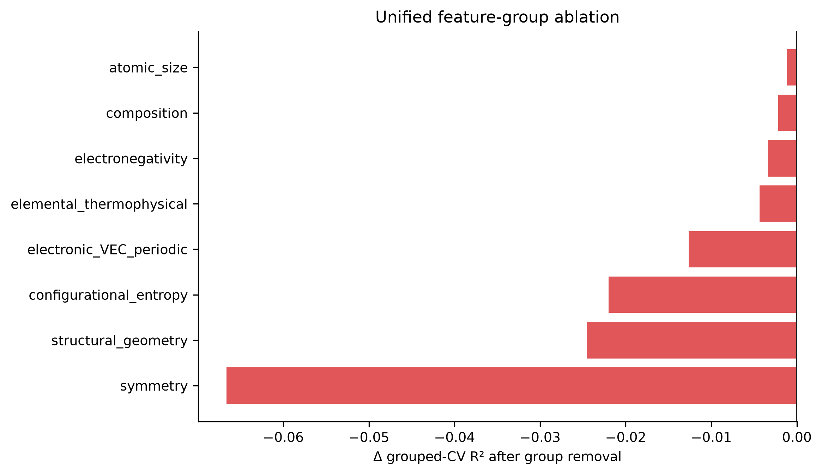
Figure 34. Change in grouped-validation R-squared after removing each physical feature group from BALANCED.
Repository evidence: thesis_outputs/tables/feature_group_ablation.csv.
In the unified model, removing symmetry gives Delta R-squared -0.0666, structural geometry -0.0246, configurational entropy -0.0220, and electronic/VEC/periodic descriptors -0.0126. These groups contribute the strongest conditional predictive information. No causal mechanism is inferred.
Repository evidence: thesis_outputs/tables/feature_group_ablation.csv.
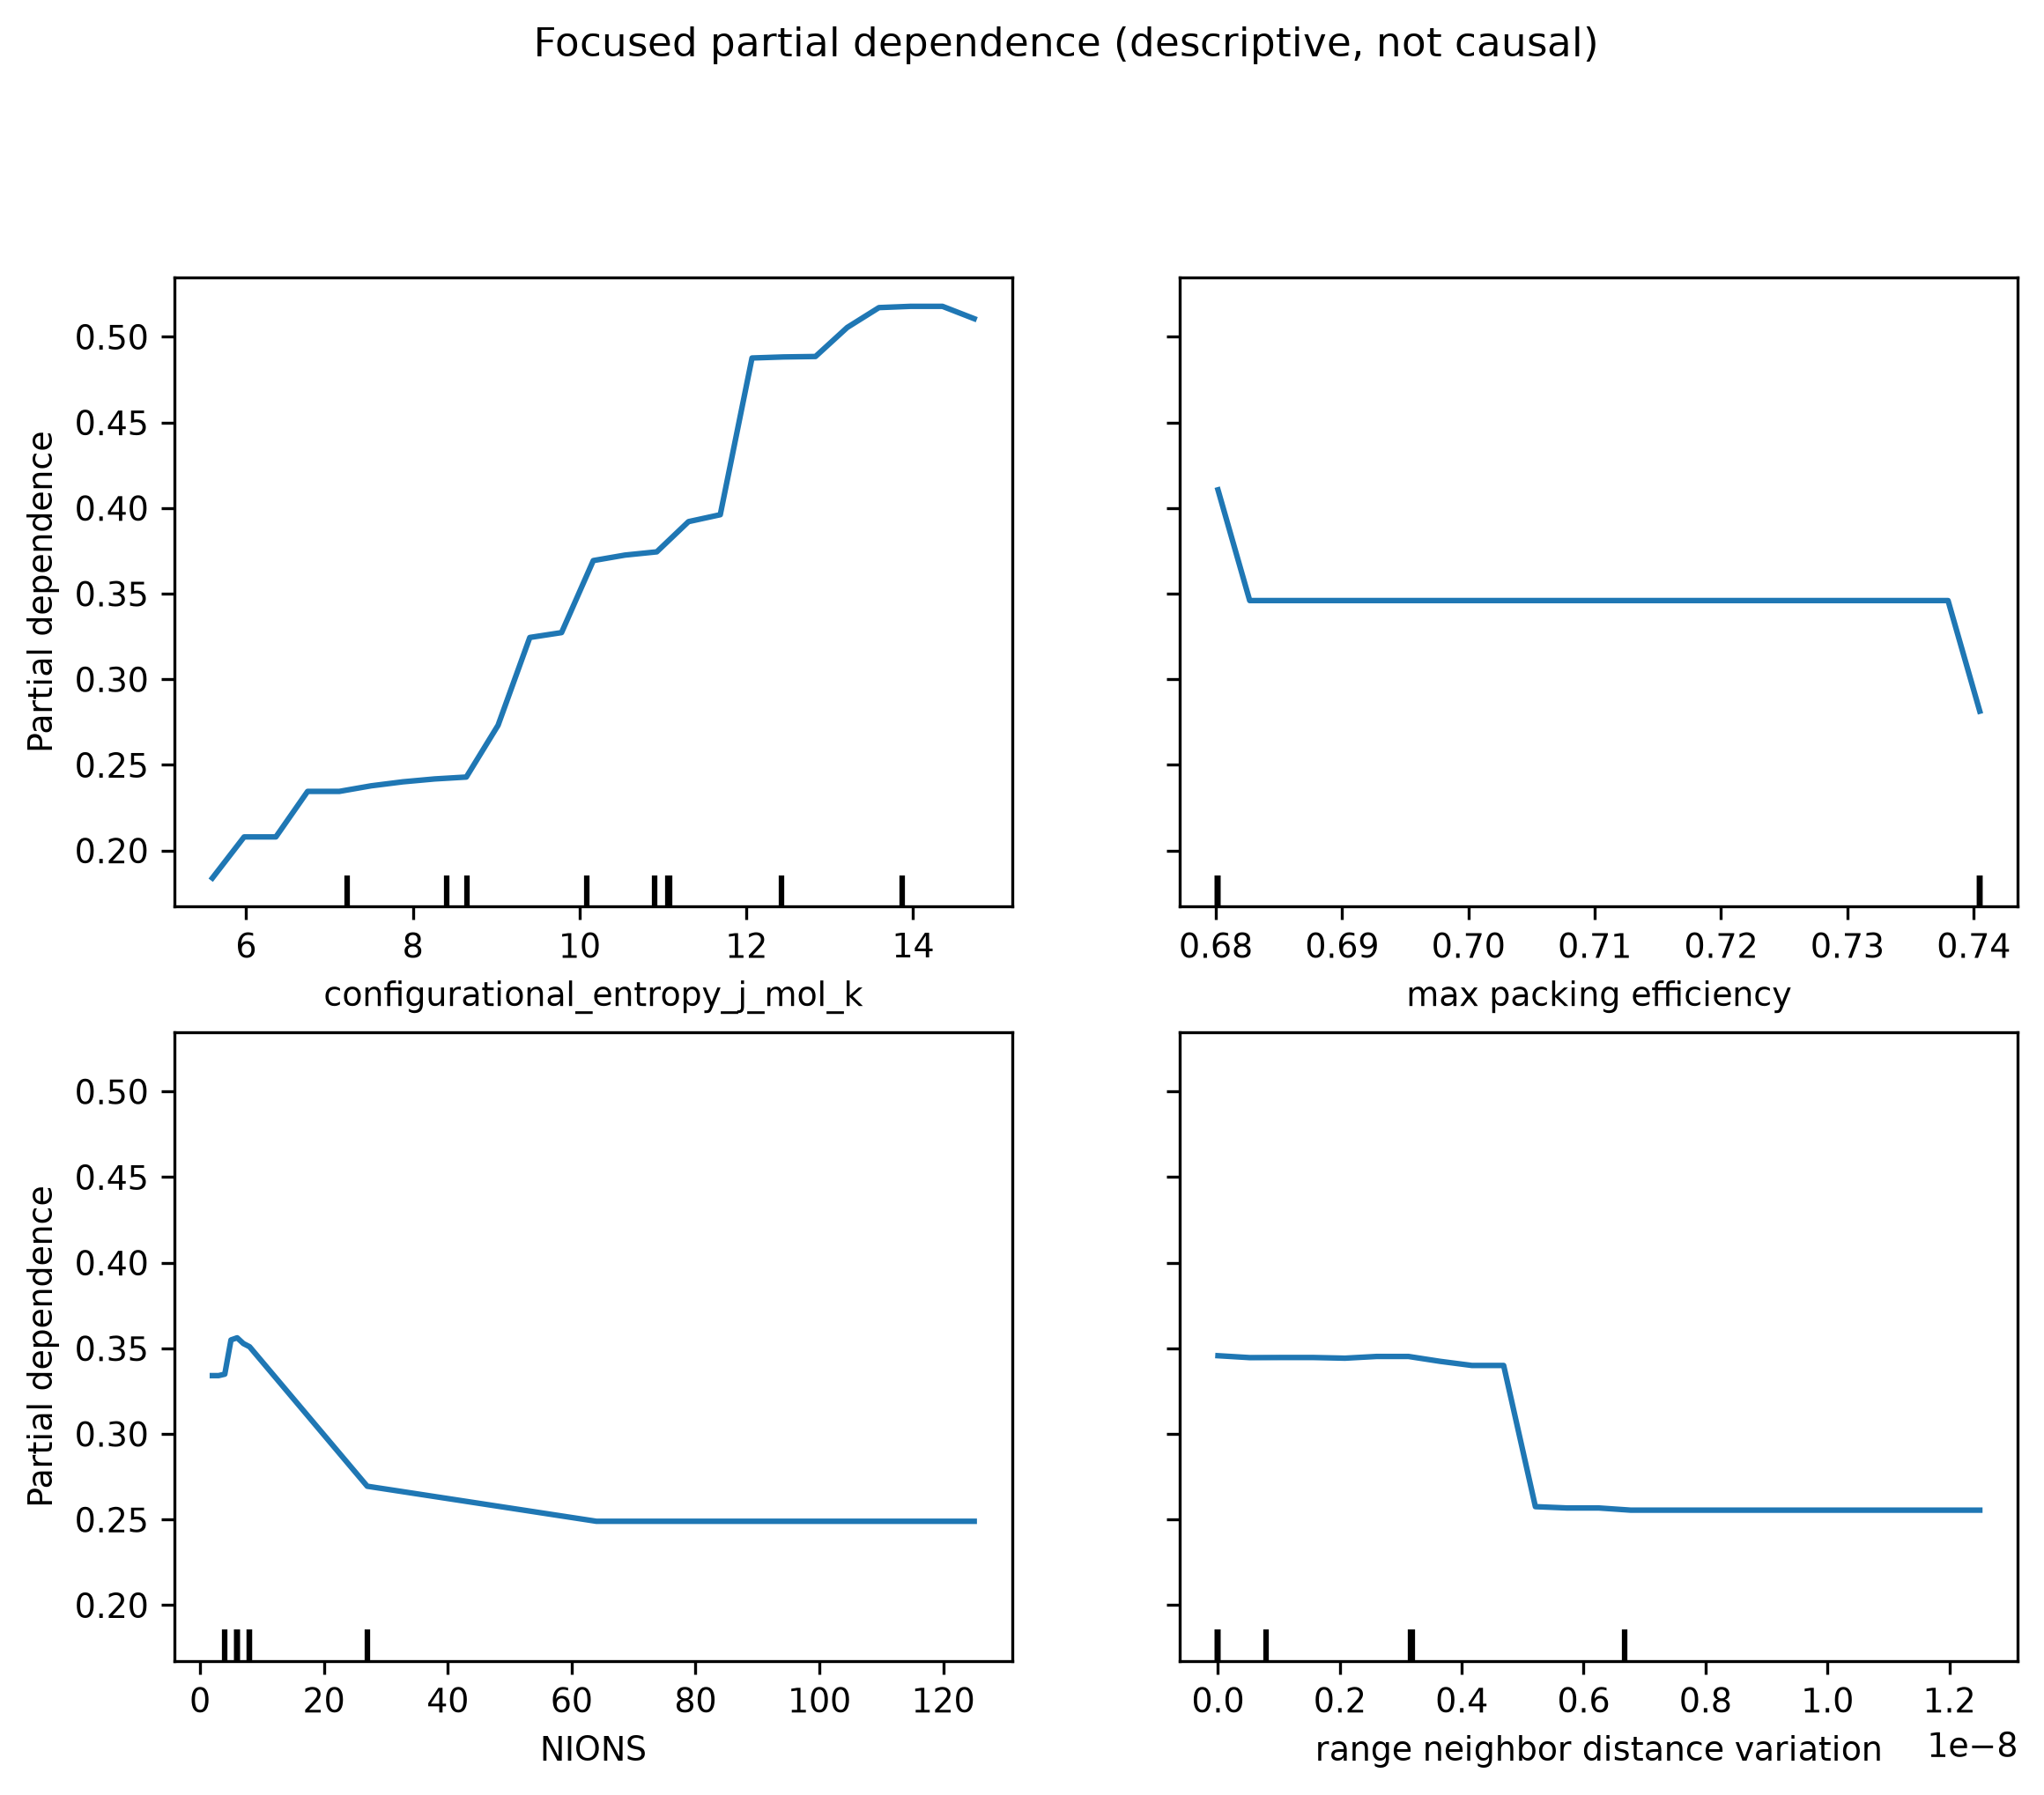
Figure 35. Focused partial-dependence summaries for selected descriptors. Curves are descriptive model associations, not causal response functions.
Repository evidence: reports/model_interpretation.md.

18. Space-Group and Configuration Sensitivity
Table 24. Configuration-descriptor sensitivity
Cohort | Removal | p | Base R2 | Test R2 | Delta R2 | Delta MAE
ALL | remove_space_group_number_ini | 1 | 0.8997 | 0.8167 | -0.0830 | 0.0185
ALL | remove_max_packing_efficiency | 1 | 0.8997 | 0.8812 | -0.0186 | 0.0051
ALL | remove_range_neighbor_distance_variation | 1 | 0.8997 | 0.8992 | -0.0006 | -0.0003
ALL | remove_structural_geometry_group | 6 | 0.8997 | 0.8656 | -0.0341 | 0.0092
ALL | remove_symmetry_group | 11 | 0.8997 | 0.8047 | -0.0950 | 0.0199
FCC | remove_space_group_number_ini | 1 | 0.9058 | 0.8307 | -0.0751 | 0.0131
FCC | remove_max_packing_efficiency | 1 | 0.9058 | 0.9040 | -0.0018 | 0.0002
FCC | remove_range_neighbor_distance_variation | 1 | 0.9058 | 0.9027 | -0.0031 | 0.0004
FCC | remove_structural_geometry_group | 6 | 0.9058 | 0.8884 | -0.0174 | 0.0044
FCC | remove_symmetry_group | 11 | 0.9058 | 0.8333 | -0.0725 | 0.0130
BCC | remove_space_group_number_ini | 1 | 0.9154 | 0.8349 | -0.0805 | 0.0238
BCC | remove_max_packing_efficiency | 1 | 0.9154 | 0.9112 | -0.0042 | 0.0017
BCC | remove_range_neighbor_distance_variation | 1 | 0.9154 | 0.9113 | -0.0041 | 0.0013
BCC | remove_structural_geometry_group | 6 | 0.9154 | 0.9075 | -0.0079 | 0.0024
BCC | remove_symmetry_group | 11 | 0.9154 | 0.8153 | -0.1000 | 0.0288
Repository evidence: results/tables/phase6/configuration_descriptor_sensitivity.csv.
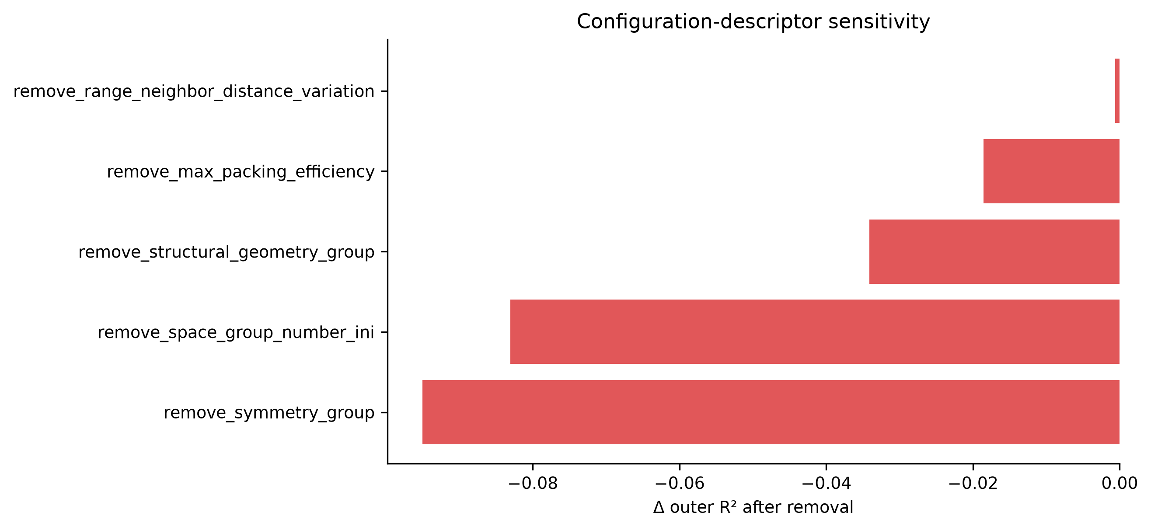
Figure 36. Unified sensitivity to removing selected configuration-sensitive descriptors or descriptor groups.
Repository evidence: results/tables/phase6/configuration_descriptor_sensitivity.csv.
Removing initial space group lowers outer R-squared by 0.0830 unified, 0.0751 FCC, and 0.0805 BCC. Removing the full symmetry group lowers R-squared by 0.0950, 0.0725, and 0.1000, respectively. The signal persists within phase, yet it may combine transferable structure information with signatures of SQS/ordered-cell construction, atom count, or preprocessing.
Repository evidence: results/tables/phase6/configuration_descriptor_sensitivity.csv; reports/configuration_descriptor_sensitivity.md.

19. FCC versus BCC SRO Behaviour
Table 25. FCC/BCC target-distribution comparison
FCC mean | BCC mean | BCC-FCC | Cohen d | KS
0.2640 | 0.4002 | 0.1362 | 0.5253 | 0.2334
Repository evidence: thesis_outputs/tables/phase4/phase_target_comparison.csv.
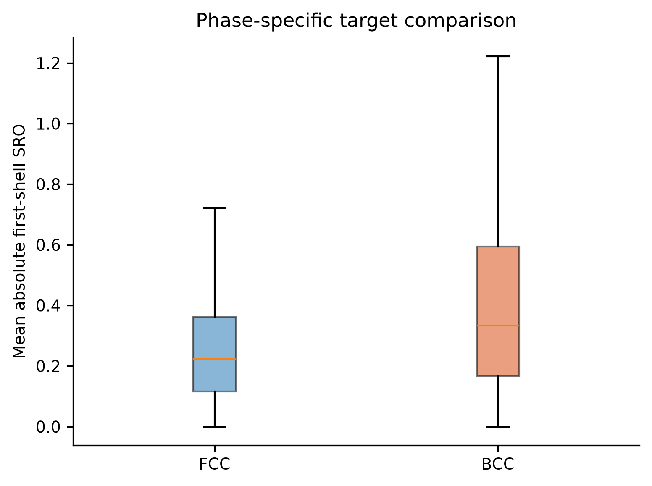
Figure 37. FCC/BCC target comparison. Visual outliers are suppressed in the box rendering but retained in numerical analysis.
Repository evidence: thesis_outputs/tables/phase4/phase_target_comparison.csv.
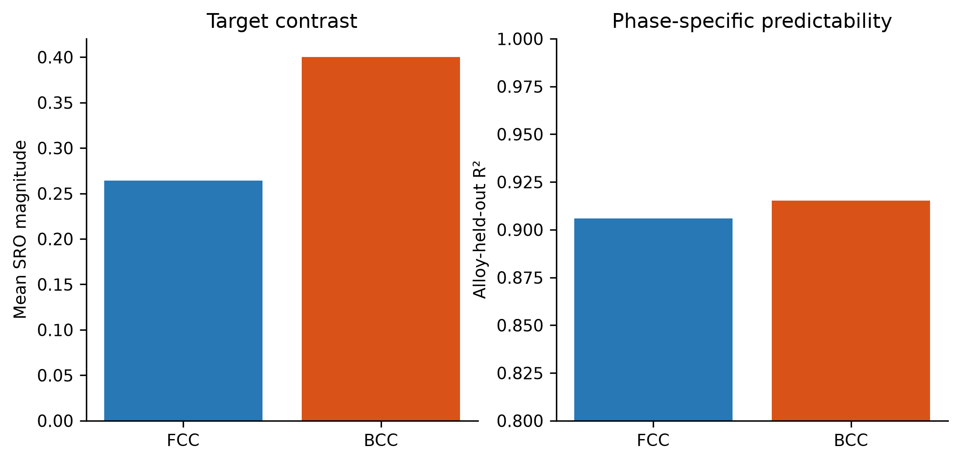
Figure 38. Comparison of phase target means and phase-specific predictive performance.
Repository evidence: thesis_outputs/tables/phase4/phase_target_comparison.csv; thesis_outputs/tables/best_model_metrics.csv.
Mean aggregate SRO magnitude is 0.2640 for FCC and 0.4002 for BCC; the BCC-FCC difference is 0.1362, Cohen's d is 0.5253, and the KS statistic is 0.2334. BCC is systematically higher in this dataset. This is a dataset association and must not be interpreted as a causal effect of crystal phase because composition and configuration distributions differ.
Repository evidence: thesis_outputs/tables/phase4/phase_target_comparison.csv; reports/final_fcc_bcc_interpretation.md.
Both phases rank initial space group, configurational entropy, atom count, normalized entropy, and local electronic differences highly. FCC gives relatively more importance to neighbour-distance/cell-size dispersion; BCC gives more importance to unfilled-state, local space-group, electronegativity, and magnetic-moment differences. Repeated-split mean R-squared is nearly identical, although BCC is less stable across which systems are held out.
Repository evidence: results/tables/phase5/feature_importance_fcc.csv; feature_importance_bcc.csv; thesis_outputs/tables/model_robustness_summary.csv.

20. Robustness Analysis
Table 26. Five-split alloy-system-held-out robustness
Cohort | Seeds | Mean R2 | SD | Min | Max | Mean MAE | Mean RMSE
ALL | 5 | 0.8946 | 0.0187 | 0.8671 | 0.9154 | 0.0569 | 0.0824
BCC | 5 | 0.9042 | 0.0287 | 0.8620 | 0.9335 | 0.0615 | 0.0892
FCC | 5 | 0.9046 | 0.0128 | 0.8907 | 0.9193 | 0.0375 | 0.0576
Repository evidence: thesis_outputs/tables/model_robustness_summary.csv.
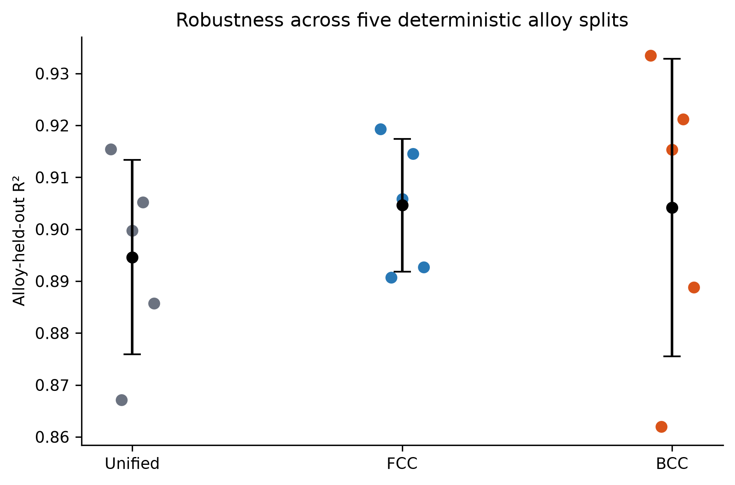
Figure 39. Alloy-held-out R-squared across five deterministic group allocations.
Repository evidence: thesis_outputs/tables/model_robustness_summary.csv.
Mean R-squared is 0.8946 unified, 0.9046 FCC, and 0.9042 BCC. Standard deviations are 0.0187, 0.0128, and 0.0287. The main conclusions are therefore not dependent on a single favorable seed, while BCC performance is more sensitive to the particular held-out systems.
Repository evidence: thesis_outputs/tables/model_robustness_summary.csv; reports/model_robustness.md.

21. Error and Extrapolation Analysis
The unified seed-42 alloy-held-out predictions contain 12,680 rows. The 95th-percentile absolute-error threshold is 0.1682, defining 634 high-error rows. Errors increase toward the highest target decile and are more frequent for BCC rows.
Repository evidence: reports/phase6_metrics.json; results/tables/phase6/error_group_summary.csv.
Table 27. Highest-MAE held-out alloy systems (unified model)
Held-out system | Rows | MAE | RMSE | Same-system train rows
Co-Mn | 342 | 0.0739 | 0.0966 | 0
Co-Mn-Ni | 1428 | 0.0709 | 0.0957 | 0
Fe-Mn-Ni | 1427 | 0.0696 | 0.0943 | 0
Al-Co-Cr-Fe-Mn-Ni | 567 | 0.0695 | 0.0965 | 0
Al-Cu-Mn | 382 | 0.0637 | 0.0852 | 0
Co-Cr-Ni | 1431 | 0.0622 | 0.0862 | 0
Al-Cu-Fe | 355 | 0.0606 | 0.0826 | 0
Al-Mn | 79 | 0.0606 | 0.0831 | 0
Fe-Si | 80 | 0.0603 | 0.0841 | 0
Cu-Fe-Mn | 298 | 0.0601 | 0.0779 | 0
Cu-Fe | 197 | 0.0582 | 0.0768 | 0
Cr-Cu-Mn-Ni | 224 | 0.0572 | 0.0803 | 0
Repository evidence: results/tables/phase5/alloy_system_error.csv.
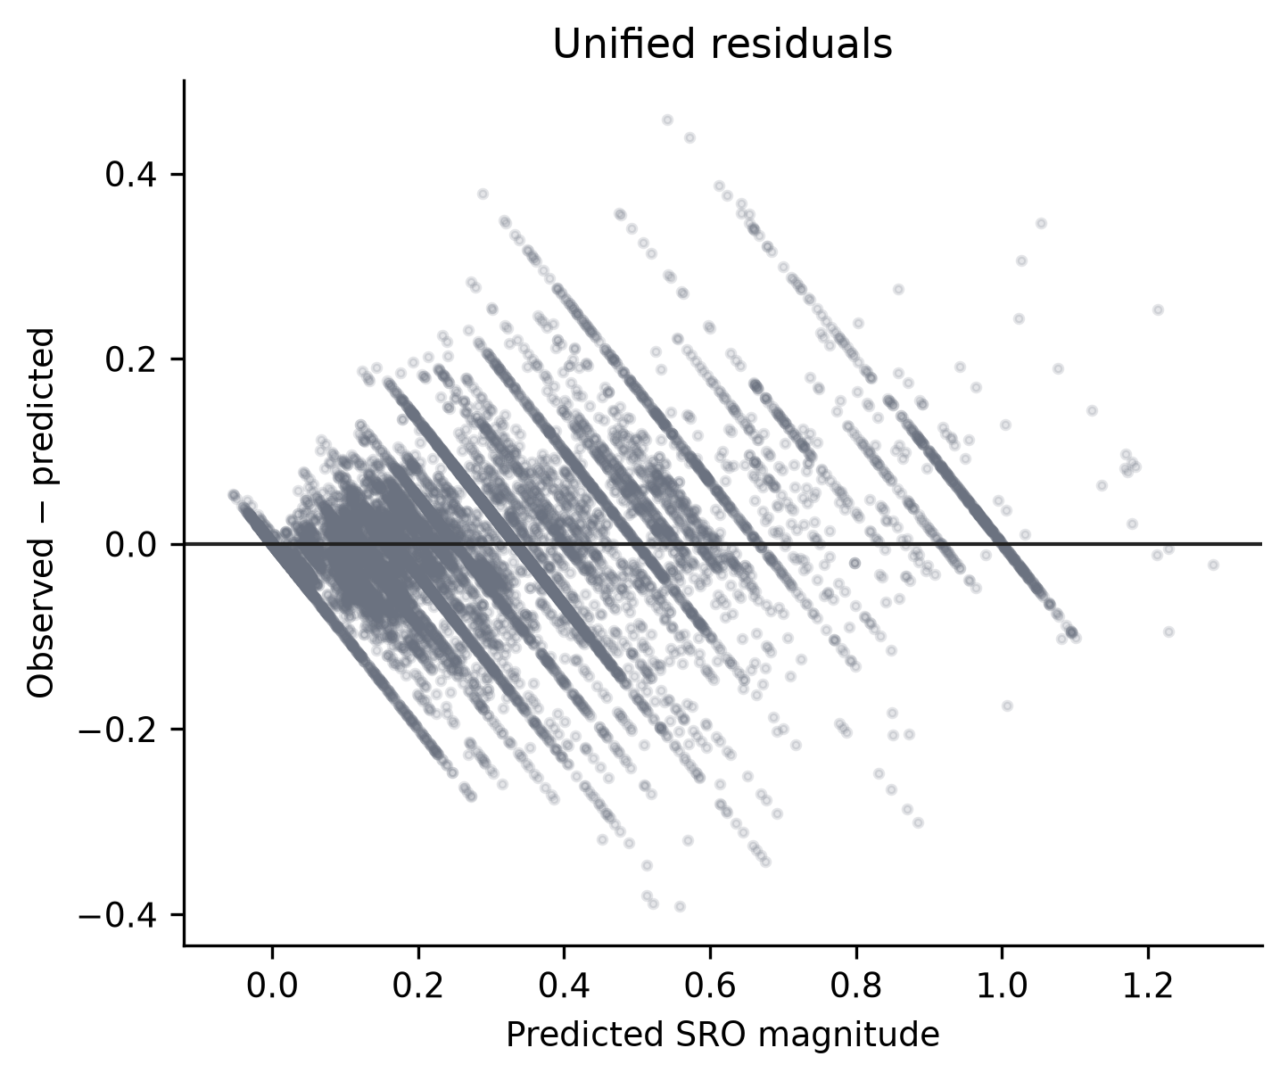
Figure 40. Unified residuals versus predictions for unseen alloy systems.
Repository evidence: results/tables/phase5/best_predictions_all.csv.
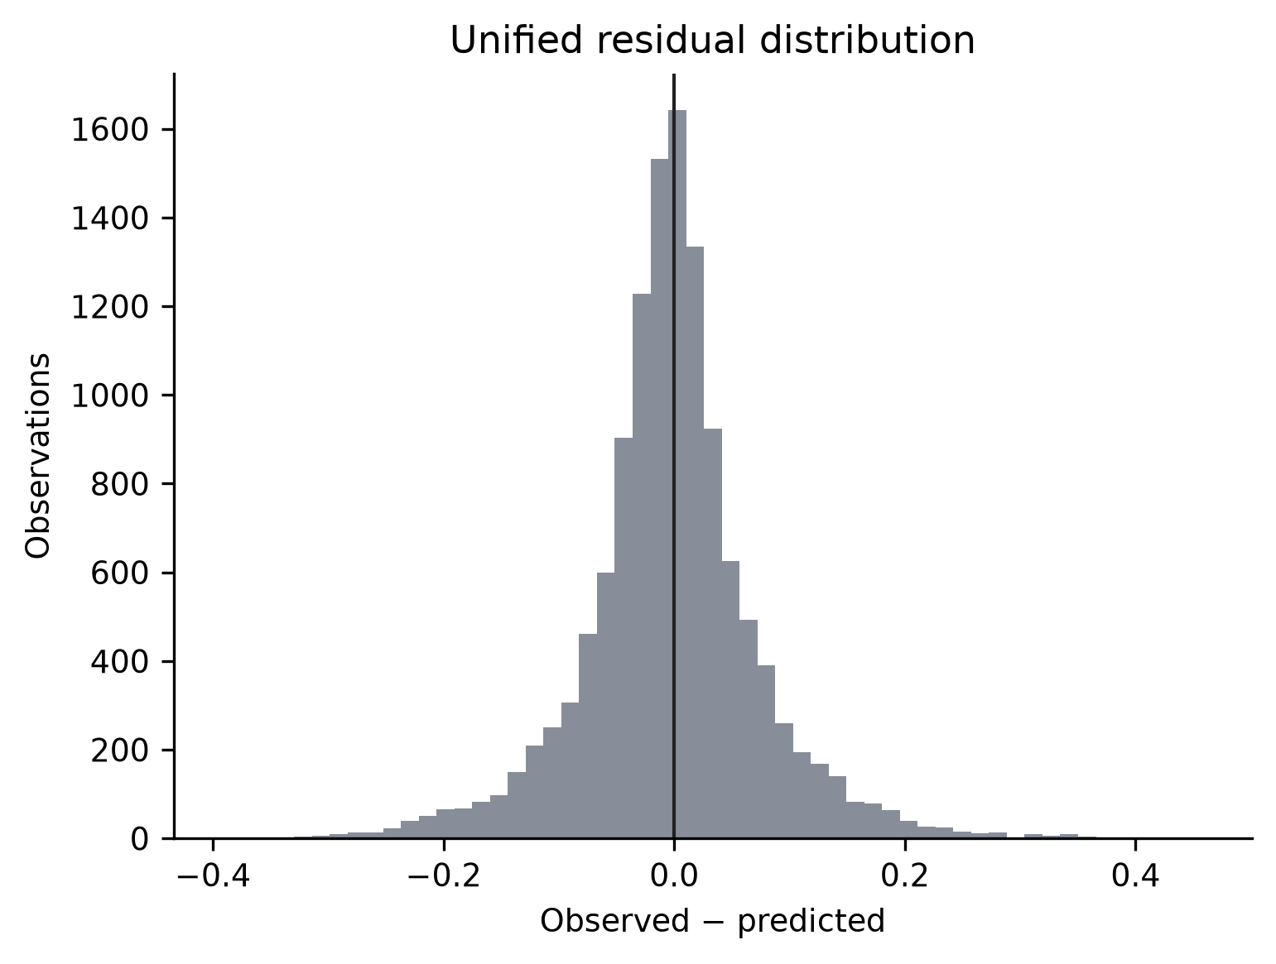
Figure 41. Distribution of unified outer-test residuals.
Repository evidence: results/tables/phase5/best_predictions_all.csv.
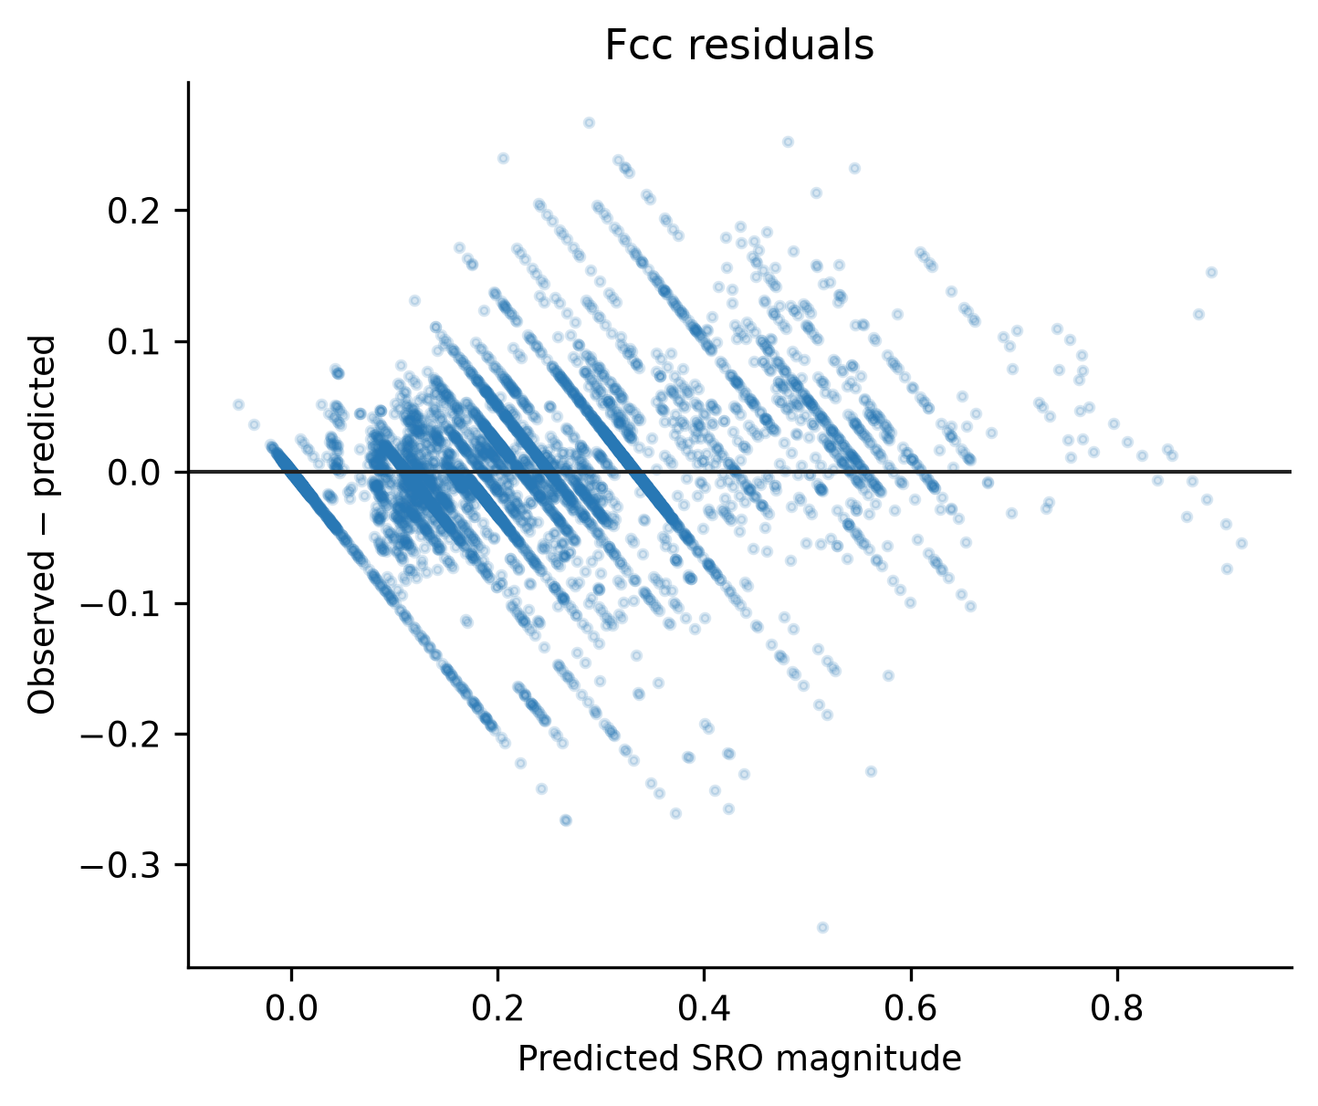
Figure 42. FCC-specific residual structure.
Repository evidence: results/tables/phase5/best_predictions_fcc.csv.
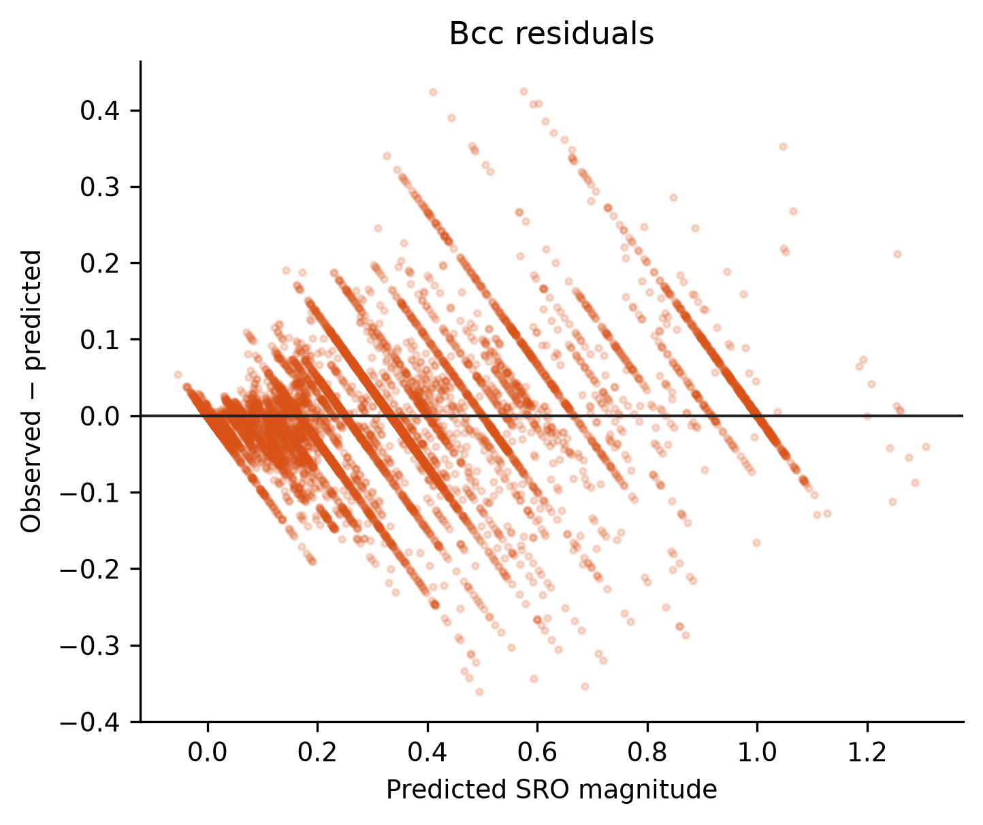
Figure 43. BCC-specific residual structure.
Repository evidence: results/tables/phase5/best_predictions_bcc.csv.
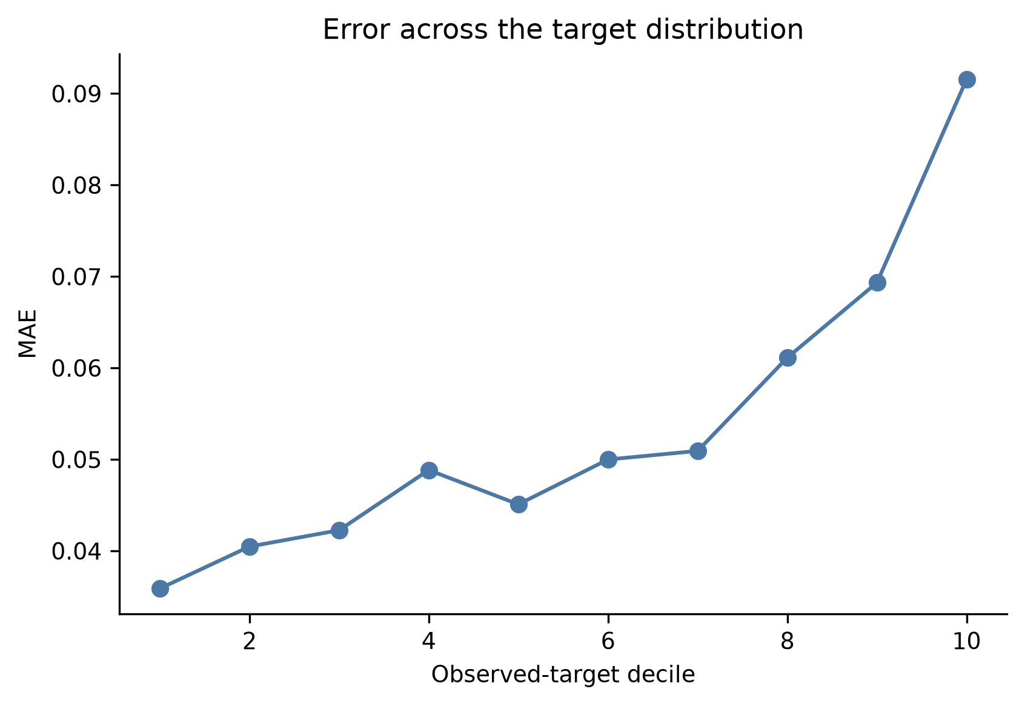
Figure 44. Mean absolute error across observed-target deciles.
Repository evidence: results/tables/phase6/error_group_summary.csv.
Table 28. Compact-feature extrapolation screen
Feature | Outside train range | Outside train p01-p99
range neighbor distance variation | 0.0000 | 0.0198
space_group_number_ini | 0.0000 | 0.0171
minimum local difference in NsUnfilled | 0.0000 | 0.0113
configurational_entropy_normalized | 0.0000 | 0.0106
NIONS | 0.0000 | 0.0101
mean local difference in NsValence | 0.0000 | 0.0094
mean local difference in SpaceGroupNumber | 0.0000 | 0.0077
avg_dev local difference in NsValence | 0.0000 | 0.0048
configurational_entropy_j_mol_k | 0.0000 | 0.0046
max packing efficiency | 0.0000 | 0.0016
Repository evidence: results/tables/phase6/feature_extrapolation_audit.csv.
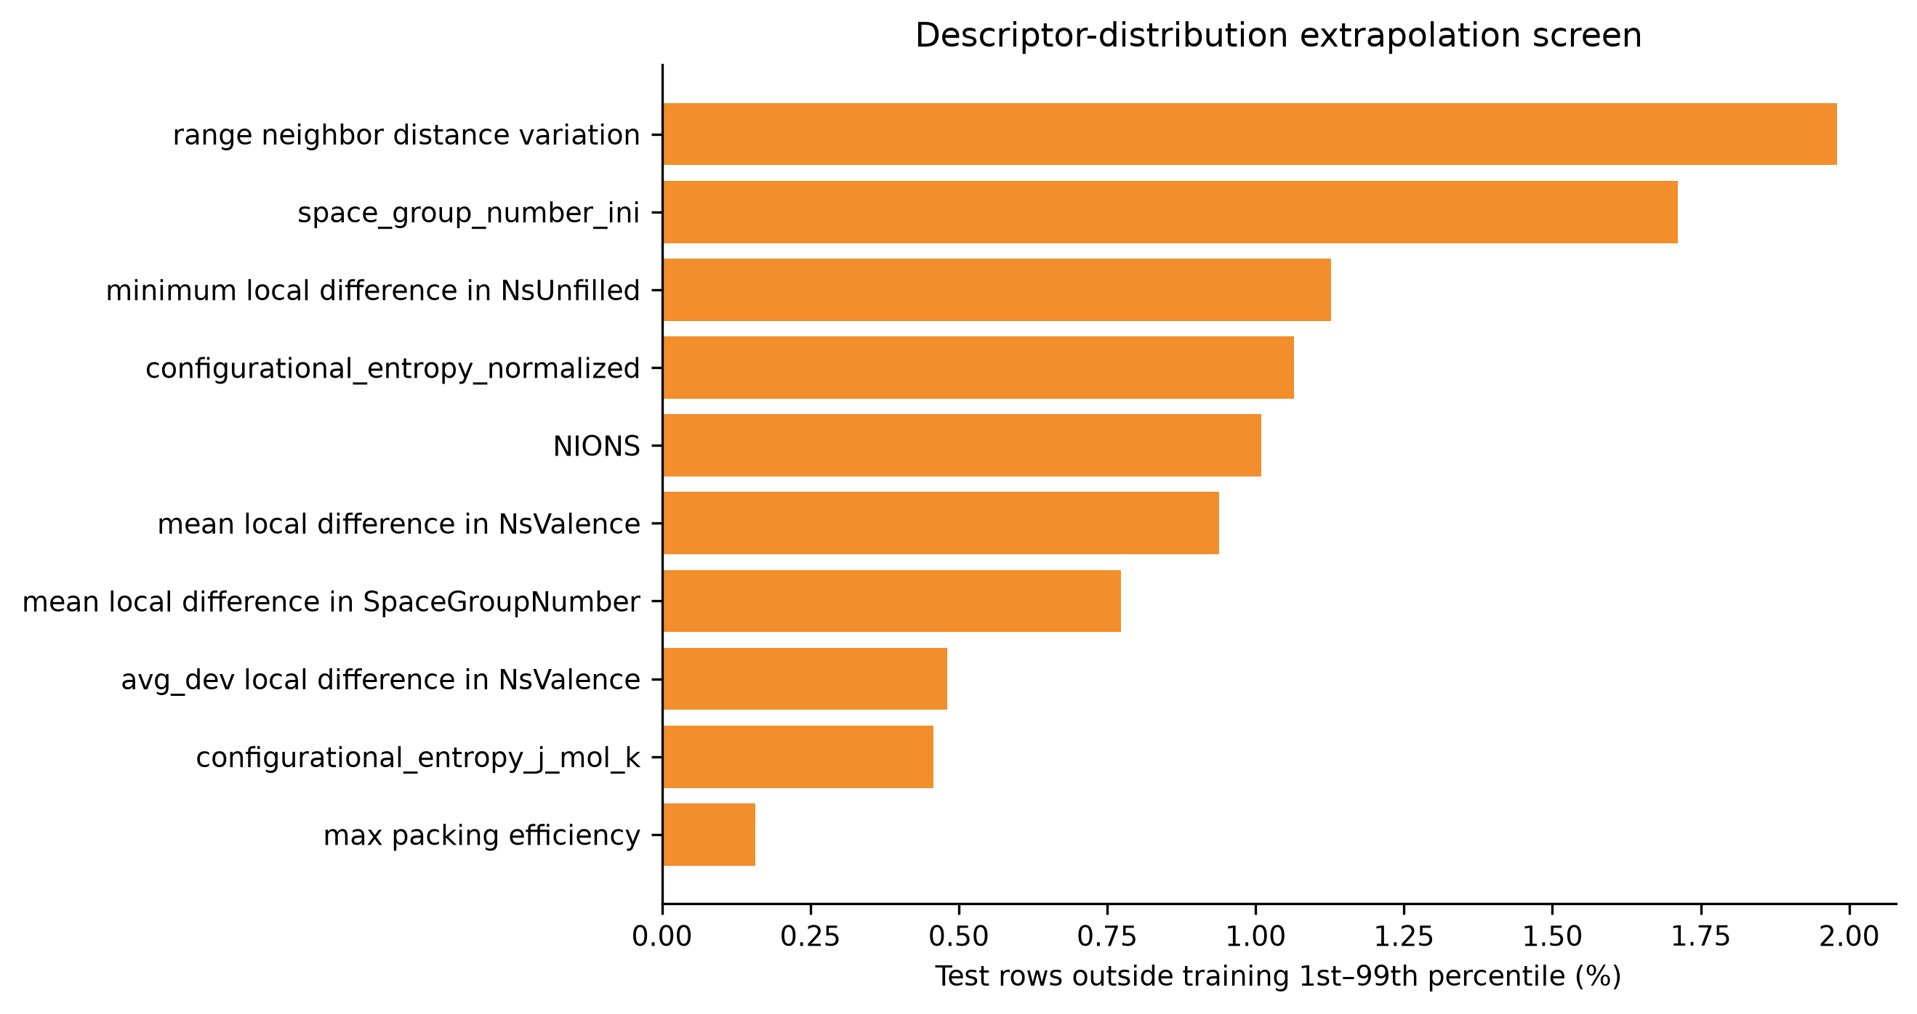
Figure 45. Fraction of held-out rows outside training 1st-99th percentile intervals for compact predictors.
Repository evidence: results/tables/phase6/feature_extrapolation_audit.csv.
No compact-feature test value lies outside the literal training minimum/maximum, but joint feature-space extrapolation remains possible. Absolute error has only weak positive association with nearest-training distance and is more strongly associated with target magnitude. The validated domain is Al-Co-Cr-Cu-Fe-Mn-Ni FCC/BCC configurations from the 84k theoretical workflow, not arbitrary metallic alloys.
Repository evidence: reports/model_error_analysis.md; reports/study_limitations.md.

22. HCP Investigation
Validated HCP count: Zero. No HCP model, metric, or prediction is included in the validated study.
The MLP-cSRO audit identified 255 provisional equiatomic CrCoNi HCP configurations. They are 144-atom frames associated with five reported 500 K Monte Carlo trajectories. However, the author six-component HCP Warren-Cowley LOP_*.npy reference arrays and exact ideal-HCP shell/topology mapping are absent from the checked repositories.
Repository evidence: reports/hcp_data_status.md; reports/mlp_csro_cfg_inventory.json.
Naive distance-ranked reconstruction is not accepted because 98 of 255 frames have a thirteenth-to-twelfth-neighbour distance ratio below 1.02, making the first-shell boundary ambiguous under displacement. These values remain provisional and local.
Repository evidence: reports/hcp_data_status.md; reports/phase3_metrics.json.
Table 29. HCP candidate status and next validation requirement
Candidate | Local material | Temperature | Blocking gap | Next action
MLP-cSRO CrCoNi | 255 provisional HCP CFGs | 500 K study context | Missing author WC arrays and topology validation | Obtain compact LOP arrays/code
CMS-EAM HfTiZr | Workflow only; 0 usable rows | 300 K documented | Generated structures/WC table absent | Obtain complete HfTiZr bundle
Repository evidence: reports/hcp_data_status.md.
The preferred immediate next step is to obtain the compact author HCP WC reference arrays/topology code to validate the existing CrCoNi frames. For chemical independence, the next new source should be a completed HfTiZr HCP configuration/WC/temperature bundle.
Repository evidence: reports/hcp_data_status.md.

23. Final Feature Recommendations

23.1 Minimal Common Database Feature Set
This is a database-design recommendation for every future SRO record, independent of whether a high-performing model can use every field.
Table 30. Minimal common database fields
Category | Recommended fields
Identity/provenance | record ID, source type, citation/URL/version, source record ID, method
Chemistry | alloy system, canonical composition, per-element fractions, component count
State | phase and validation method; temperature/pressure only if genuinely reported
SRO label | metric/convention, value, sign or magnitude status, pair, shell, topology, aggregation, uncertainty
Dependence | configuration family, trajectory/run/replica/group identifiers
Structure | atom count, structure availability, pre/post-relaxation status
Universal descriptors | configurational entropy and versioned elemental-reference statistics
Repository evidence: reports/final_minimal_feature_recommendation.md.

23.2 Compact High-Performance ML Feature Set
This is the 10-feature configuration-sensitive predictor set listed in Table 20 and `results/feature_sets/compact_high_performance.txt`. It is recommended for simplified modeling within the current theoretical source, not as a universal cross-source schema.

24. Major Results Summary
Table 31. Comprehensive final-results summary
Topic | Validated result | Primary repository source
Final database | 83,797 rows | phase_counts.csv
Phase coverage | 40,425 FCC; 43,372 BCC; 0 HCP | phase_counts.csv
Feature library | 348 candidate; 198 BALANCED; 10 compact | feature_group_mapping.csv; feature lists
Best unified | HGB; R2 0.8997; MAE 0.0535; RMSE 0.0764 | best_model_metrics.csv
Best FCC | HGB; R2 0.9058; MAE 0.0348; RMSE 0.0534 | best_model_metrics.csv
Best BCC | HGB; R2 0.9154; MAE 0.0563; RMSE 0.0808 | best_model_metrics.csv
Robustness | Unified mean R2 0.8946 +/- 0.0187 | model_robustness_summary.csv
Feature ablation | Composition R2 0.0262; +initial structure 0.8783 | feature_set_model_comparison.csv
Compact model | 10 features; unified outer R2 0.8917 | compact_outer_test_metrics.csv
Phase target contrast | FCC 0.2640; BCC 0.4002; d 0.5253 | phase_target_comparison.csv
Principal limitation | One theoretical source; aggregate target; 0 validated HCP | study_limitations.md
Repository evidence: Exact paths are listed in deliverables/report_evidence_map.md.

25. Limitations
- The primary target aggregates absolute unlike-pair coefficients and removes sign and pair identity.
- All validated labels come from one theoretical 84k workflow; source-held-out transfer has not been tested.
- Validated HCP observations remain zero.
- Initial symmetry and local structural fingerprints may encode configuration-generation signatures.
- The validated chemistry is limited to Al-Co-Cr-Cu-Fe-Mn-Ni FCC/BCC configurations.
- Rows share chemistry and generation procedures; alloy-system grouping reduces but cannot remove workflow-level dependence.
- The 84k labels lack a genuine observation temperature, so temperature-dependent SRO cannot be learned.
- Correlation, permutation importance, group ablation, and partial dependence do not establish causation.
- BALANCED was informed by Phase 4 whole-dataset EDA, so the modeling study is exploratory rather than a pristine prospective confirmation.
- Generalization outside represented alloy systems and joint feature distributions remains uncertain.
Repository evidence: reports/study_limitations.md; reports/model_interpretation.md; reports/ml_split_strategy.md.

26. Current Conclusions
- A large, provenance-preserving theoretical FCC/BCC SRO database was successfully constructed and validated.
- Aggregate first-neighbour SRO magnitude is predicted strongly under complete alloy-system holdout within the represented source domain.
- Phase-specific models improve identical-row prediction, particularly for FCC, but the improvement is modest relative to the unified model.
- Composition alone is insufficient for configuration-level prediction; initial structural information provides most of the predictive gain.
- A 10-feature compact model retains nearly all BALANCED outer performance.
- Symmetry, structural geometry, configurational entropy, and electronic/VEC/periodic groups carry the strongest conditional predictive information.
- Configuration-sensitive predictors require explicit transferability caution and must not be assigned causal control.
- HCP SRO remains unresolved and is the clearest data-extension priority.
Repository evidence: reports/final_feature_set.md; reports/model_robustness.md; reports/final_fcc_bcc_interpretation.md; reports/hcp_data_status.md.

27. Recommended Next Steps for Supervisor Discussion
The following decisions are intentionally left for supervisor review before the final thesis is prepared:
- Whether aggregate first-shell SRO magnitude is an appropriate main prediction target.
- Whether signed pair-resolved Warren-Cowley SRO should become the next target.
- Whether configuration-sensitive initial structural descriptors should remain in the final thesis model.
- Whether the thesis should emphasize more transferable composition/thermodynamic descriptors despite lower predictive performance.
- Whether additional theoretical databases should be integrated before thesis submission.
- The priority and practical route for obtaining validated HCP reference data.
- Whether future experimental data should be merged into one model or analyzed separately by source type.
- Which analyses and figures should be expanded, condensed, or moved to appendices in the final thesis.

Appendix A - Detailed Data Source Inventory
The authoritative human- and machine-readable registries are `SOURCES.md` and `sources.yaml`. Table 2 summarizes incorporation status; this appendix records the main exclusion logic.
Table 32. Detailed source decision log
Source | Status | Scientific reason
84k HEA | Accepted | Complete initial descriptors and aggregate SRO labels; exact convention reproduced
Rao-Curtin | Not integrated | Abstract species, presentation-oriented workbooks, unresolved normalized row semantics
MLP-cSRO | HCP provisional | Missing author HCP WC references and topology validation
cSRO_lattice | Not integrated | Trajectory dependence and unresolved phase/pair/shell normalization
ColabFit CrCoNi | Not integrated | Potential-training configurations without explicit SRO labels
CMS-EAM | Not integrated | Workflow present but consolidated generated SRO structures/table absent
HEA toolkit | Reference only | Software resource; SRO implementation requires validation before use
Repository evidence: SOURCES.md; reports/data_inventory.md; reports/hcp_data_status.md.

Appendix B - Complete Feature Categories
Table 33. Feature categories and counts
Feature group | Predictors
valence / VEC | 118
composition pair fractions | 36
periodic-table position | 33
atomic size | 27
electronegativity / ionic | 17
atomic mass | 15
melting point | 15
atomic number | 15
initial structural geometry | 15
initial symmetry | 12
elemental electronic proxy | 11
elemental magnetic proxy | 11
composition fractions | 8
composition norms | 6
composition complexity | 3
configurational entropy | 3
phase metadata | 2
composition feasibility flag | 1
Repository evidence: thesis_outputs/tables/phase4/feature_group_counts.csv.
Table 34. Transferability-class counts
Transferability class | Predictors
A_UNIVERSALLY_DERIVABLE | 214
B_STRUCTURE_DERIVABLE | 113
C_SOURCE_METHOD_SPECIFIC | 1
D_POTENTIAL_CONFIGURATION_ENCODING | 20
Repository evidence: results/tables/phase6/feature_transferability_mapping.csv.

Appendix C - Extended Correlation Rankings
Table 35. Top ALL Pearson rankings
Feature | Pearson
space_group_number_ini | 0.4753
NIONS | -0.3289
configurational_entropy_kb_per_atom | 0.3011
configurational_entropy_j_mol_k | 0.3011
2-norm | -0.2967
3-norm | -0.2880
nelements | 0.2771
composition_number_of_elements | 0.2771
0-norm | 0.2771
5-norm | -0.2746
7-norm | -0.2675
10-norm | -0.2625
min relative bond length | 0.2580
minimum CN_VoronoiNN | -0.2539
minimum neighbor distance variation | 0.2539
Repository evidence: results/tables/phase4/feature_target_associations.csv.
Table 36. Top ALL Spearman rankings
Feature | Spearman
space_group_number_ini | 0.5931
NIONS | -0.3260
2-norm | -0.2791
configurational_entropy_j_mol_k | 0.2714
configurational_entropy_kb_per_atom | 0.2714
5-norm | -0.2709
3-norm | -0.2706
7-norm | -0.2693
10-norm | -0.2687
avg_dev local difference in NsValence | 0.2494
avg_dev local difference in NsUnfilled | 0.2494
nelements | 0.2355
composition_number_of_elements | 0.2355
0-norm | 0.2355
configurational_entropy_normalized | 0.2290
Repository evidence: results/tables/phase4/feature_target_associations.csv.
Table 37. Top ALL Mutual information rankings
Feature | Mutual information
5-norm | 1.7996
configurational_entropy_j_mol_k | 1.7979
10-norm | 1.7939
7-norm | 1.7925
configurational_entropy_kb_per_atom | 1.7858
3-norm | 1.7762
configurational_entropy_normalized | 1.7323
2-norm | 1.6654
mean absolute deviation in relative cell size | 1.4562
avg_dev neighbor distance variation | 1.4452
range neighbor distance variation | 1.4166
mean absolute deviation in relative bond length | 1.2847
mean local difference in NsValence | 1.2240
mean local difference in NsUnfilled | 1.2194
avg_dev local difference in NsValence | 1.2101
Repository evidence: results/tables/phase4/feature_target_associations.csv.
Table 38. Top FCC Pearson rankings
Feature | Pearson
space_group_number_ini | 0.4812
NIONS | -0.3483
configurational_entropy_kb_per_atom | 0.3446
configurational_entropy_j_mol_k | 0.3446
2-norm | -0.3418
3-norm | -0.3340
min relative bond length | 0.3254
5-norm | -0.3196
0-norm | 0.3180
composition_number_of_elements | 0.3180
nelements | 0.3180
7-norm | -0.3111
10-norm | -0.3049
range neighbor distance variation | -0.2641
configurational_entropy_normalized | 0.2588
Repository evidence: results/tables/phase4/feature_target_associations.csv.
Table 39. Top FCC Spearman rankings
Feature | Spearman
space_group_number_ini | 0.5520
range CN_VoronoiNN | -0.3564
NIONS | -0.3450
minimum CN_VoronoiNN | 0.3101
2-norm | -0.3066
5-norm | -0.3014
3-norm | -0.2989
configurational_entropy_kb_per_atom | 0.2974
configurational_entropy_j_mol_k | 0.2974
7-norm | -0.2952
10-norm | -0.2934
configurational_entropy_normalized | 0.2791
range neighbor distance variation | -0.2777
min relative bond length | 0.2590
0-norm | 0.2454
Repository evidence: results/tables/phase4/feature_target_associations.csv.
Table 40. Top FCC Mutual information rankings
Feature | Mutual information
configurational_entropy_kb_per_atom | 2.0079
7-norm | 2.0062
configurational_entropy_j_mol_k | 1.9986
5-norm | 1.9981
10-norm | 1.9975
3-norm | 1.9761
configurational_entropy_normalized | 1.9257
2-norm | 1.8410
avg_dev neighbor distance variation | 1.6953
mean neighbor distance variation | 1.5924
maximum neighbor distance variation | 1.5494
mean absolute deviation in relative cell size | 1.5293
range neighbor distance variation | 1.5087
mean absolute deviation in relative bond length | 1.4081
space_group_number_ini | 1.4008
Repository evidence: results/tables/phase4/feature_target_associations.csv.
Table 41. Top BCC Pearson rankings
Feature | Pearson
space_group_number_ini | 0.4877
NIONS | -0.3424
configurational_entropy_j_mol_k | 0.3105
configurational_entropy_kb_per_atom | 0.3105
2-norm | -0.3053
3-norm | -0.2955
mean neighbor distance variation | -0.2913
composition_number_of_elements | 0.2844
0-norm | 0.2844
nelements | 0.2844
5-norm | -0.2816
7-norm | -0.2747
10-norm | -0.2701
avg_dev local difference in NsUnfilled | 0.2577
avg_dev local difference in NsValence | 0.2577
Repository evidence: results/tables/phase4/feature_target_associations.csv.
Table 42. Top BCC Spearman rankings
Feature | Spearman
space_group_number_ini | 0.6200
NIONS | -0.3050
avg_dev local difference in NsUnfilled | 0.3015
avg_dev local difference in NsValence | 0.3015
mean neighbor distance variation | -0.2955
2-norm | -0.2886
configurational_entropy_j_mol_k | 0.2820
configurational_entropy_kb_per_atom | 0.2820
10-norm | -0.2783
7-norm | -0.2783
3-norm | -0.2780
5-norm | -0.2776
composition_number_of_elements | 0.2565
0-norm | 0.2565
nelements | 0.2565
Repository evidence: results/tables/phase4/feature_target_associations.csv.
Table 43. Top BCC Mutual information rankings
Feature | Mutual information
7-norm | 2.0955
5-norm | 2.0942
10-norm | 2.0915
configurational_entropy_j_mol_k | 2.0874
configurational_entropy_kb_per_atom | 2.0856
3-norm | 2.0655
configurational_entropy_normalized | 2.0153
2-norm | 1.9421
avg_dev neighbor distance variation | 1.5190
mean absolute deviation in relative bond length | 1.4931
mean absolute deviation in relative cell size | 1.4891
space_group_number_ini | 1.3714
mean local difference in NsUnfilled | 1.3054
mean local difference in NsValence | 1.3027
avg_dev CN_VoronoiNN | 1.2875
Repository evidence: results/tables/phase4/feature_target_associations.csv.

Appendix D - Full Model Comparison
Table 44. Complete Unified screened-model comparison
Model | Feature set | p | CV R2 | Test R2 | MAE | RMSE
HistGradientBoosting | BALANCED_PRELIMINARY | 198 | 0.8803 | 0.8997 | 0.0535 | 0.0764
HistGradientBoosting | FULL_CLEAN | 324 | 0.8783 | 0.8973 | 0.0539 | 0.0774
HistGradientBoosting | COMPOSITION_PLUS_INITIAL_STRUCTURE | 320 | 0.8783 | 0.8970 | 0.0543 | 0.0775
RandomForest | BALANCED_PRELIMINARY | 198 | 0.8712 | 0.9151 | 0.0422 | 0.0703
RandomForest | FULL_CLEAN | 324 | 0.8695 | 0.9128 | 0.0409 | 0.0713
ExtraTrees | BALANCED_PRELIMINARY | 198 | 0.8695 | 0.9115 | 0.0450 | 0.0718
RandomForest | COMPOSITION_PLUS_INITIAL_STRUCTURE | 320 | 0.8665 | 0.9127 | 0.0419 | 0.0713
Ridge | BALANCED_PRELIMINARY | 198 | 0.6633 | 0.5802 | 0.1183 | 0.1564
LinearRegression | BALANCED_PRELIMINARY | 198 | 0.6629 | 0.5810 | 0.1183 | 0.1562
ElasticNet | BALANCED_PRELIMINARY | 198 | 0.6199 | 0.5428 | 0.1230 | 0.1632
GradientBoosting | BALANCED_PRELIMINARY | 198 | 0.5072 | 0.5099 | 0.1294 | 0.1690
HistGradientBoosting | COMPOSITION_PLUS_PHASE | 205 | 0.1764 | 0.3339 | 0.1399 | 0.1970
HistGradientBoosting | MINIMAL_PRELIMINARY | 19 | 0.1008 | 0.3089 | 0.1436 | 0.2006
HistGradientBoosting | COMPOSITION_ONLY | 204 | 0.0262 | 0.2745 | 0.1447 | 0.2056
RandomForest | MINIMAL_PRELIMINARY | 19 | 0.0166 | 0.2555 | 0.1454 | 0.2082
RandomForest | COMPOSITION_PLUS_PHASE | 205 | -0.0030 | 0.3319 | 0.1367 | 0.1973
DummyMedian | BALANCED_PRELIMINARY | 198 | -0.0571 | -0.0000 | 0.1842 | 0.2414
RandomForest | COMPOSITION_ONLY | 204 | -0.0677 | 0.2748 | 0.1426 | 0.2055
SVR_subset | MINIMAL_PRELIMINARY | 19 | -0.1427 | -0.1439 | 0.1907 | 0.2581
Repository evidence: thesis_outputs/tables/model_comparison_all.csv.
Table 45. Complete FCC screened-model comparison
Model | Feature set | p | CV R2 | Test R2 | MAE | RMSE
HistGradientBoosting | BALANCED_PRELIMINARY | 198 | 0.8936 | 0.9058 | 0.0348 | 0.0534
HistGradientBoosting | FULL_CLEAN | 324 | 0.8935 | 0.9067 | 0.0346 | 0.0531
HistGradientBoosting | COMPOSITION_PLUS_INITIAL_STRUCTURE | 320 | 0.8901 | 0.9062 | 0.0348 | 0.0533
RandomForest | FULL_CLEAN | 324 | 0.8788 | 0.8918 | 0.0319 | 0.0572
RandomForest | COMPOSITION_PLUS_INITIAL_STRUCTURE | 320 | 0.8768 | 0.8896 | 0.0330 | 0.0578
RandomForest | BALANCED_PRELIMINARY | 198 | 0.8752 | 0.8938 | 0.0336 | 0.0567
ExtraTrees | BALANCED_PRELIMINARY | 198 | 0.8523 | 0.8922 | 0.0350 | 0.0571
LinearRegression | BALANCED_PRELIMINARY | 198 | 0.6806 | 0.5981 | 0.0836 | 0.1103
Ridge | BALANCED_PRELIMINARY | 198 | 0.6798 | 0.6015 | 0.0833 | 0.1098
ElasticNet | BALANCED_PRELIMINARY | 198 | 0.6398 | 0.5910 | 0.0858 | 0.1112
GradientBoosting | BALANCED_PRELIMINARY | 198 | 0.5014 | 0.5137 | 0.0956 | 0.1213
HistGradientBoosting | COMPOSITION_ONLY | 204 | 0.1386 | 0.3595 | 0.1026 | 0.1392
HistGradientBoosting | COMPOSITION_PLUS_PHASE | 205 | 0.1386 | 0.3595 | 0.1026 | 0.1392
HistGradientBoosting | MINIMAL_PRELIMINARY | 19 | 0.0737 | 0.3420 | 0.1051 | 0.1411
RandomForest | COMPOSITION_PLUS_PHASE | 205 | 0.0398 | 0.3589 | 0.0994 | 0.1393
RandomForest | COMPOSITION_ONLY | 204 | 0.0398 | 0.3589 | 0.0994 | 0.1393
RandomForest | MINIMAL_PRELIMINARY | 19 | -0.0384 | 0.2861 | 0.1071 | 0.1469
DummyMedian | BALANCED_PRELIMINARY | 198 | -0.0433 | -0.0162 | 0.1418 | 0.1753
SVR_subset | MINIMAL_PRELIMINARY | 19 | -0.1909 | -0.2262 | 0.1473 | 0.1926
Repository evidence: thesis_outputs/tables/model_comparison_fcc.csv.
Table 46. Complete BCC screened-model comparison
Model | Feature set | p | CV R2 | Test R2 | MAE | RMSE
HistGradientBoosting | BALANCED_PRELIMINARY | 198 | 0.8830 | 0.9154 | 0.0563 | 0.0808
RandomForest | FULL_CLEAN | 324 | 0.8760 | 0.9203 | 0.0447 | 0.0784
HistGradientBoosting | FULL_CLEAN | 324 | 0.8746 | 0.9128 | 0.0572 | 0.0820
RandomForest | COMPOSITION_PLUS_INITIAL_STRUCTURE | 320 | 0.8737 | 0.9150 | 0.0476 | 0.0809
HistGradientBoosting | COMPOSITION_PLUS_INITIAL_STRUCTURE | 320 | 0.8654 | 0.9116 | 0.0582 | 0.0825
RandomForest | BALANCED_PRELIMINARY | 198 | 0.8630 | 0.9156 | 0.0494 | 0.0806
ExtraTrees | BALANCED_PRELIMINARY | 198 | 0.8549 | 0.9028 | 0.0577 | 0.0866
Ridge | BALANCED_PRELIMINARY | 198 | 0.6665 | 0.6043 | 0.1358 | 0.1746
LinearRegression | BALANCED_PRELIMINARY | 198 | 0.6659 | 0.6064 | 0.1354 | 0.1742
ElasticNet | BALANCED_PRELIMINARY | 198 | 0.6226 | 0.5569 | 0.1423 | 0.1848
GradientBoosting | BALANCED_PRELIMINARY | 198 | 0.4880 | 0.5112 | 0.1579 | 0.1941
HistGradientBoosting | MINIMAL_PRELIMINARY | 19 | 0.0277 | 0.2532 | 0.1768 | 0.2399
HistGradientBoosting | COMPOSITION_ONLY | 204 | 0.0093 | 0.2717 | 0.1744 | 0.2369
HistGradientBoosting | COMPOSITION_PLUS_PHASE | 205 | 0.0093 | 0.2717 | 0.1744 | 0.2369
RandomForest | MINIMAL_PRELIMINARY | 19 | -0.0605 | 0.1936 | 0.1771 | 0.2493
DummyMedian | BALANCED_PRELIMINARY | 198 | -0.0697 | -0.0003 | 0.2139 | 0.2777
RandomForest | COMPOSITION_ONLY | 204 | -0.1362 | 0.2679 | 0.1682 | 0.2375
RandomForest | COMPOSITION_PLUS_PHASE | 205 | -0.1362 | 0.2679 | 0.1682 | 0.2375
SVR_subset | MINIMAL_PRELIMINARY | 19 | -0.2181 | -0.1779 | 0.2218 | 0.3013
Repository evidence: thesis_outputs/tables/model_comparison_bcc.csv.

Appendix E - Additional FCC/BCC Figures
All phase-specific importance, predicted-versus-actual, residual, and association figures have been included in the main scientific flow. No extra debugging or duplicate figures are added here. The complete included inventory is `deliverables/report_figure_inventory.csv`.

Appendix F - Final Feature Lists
Table 47. MINIMAL_COMMON predictor list
Order | Feature
1 | composition_number_of_elements
2 | configurational_entropy_j_mol_k
3 | atomic_size_mismatch_percent
4 | derived_atomic_number_mean
5 | derived_atomic_number_std
6 | derived_atomic_mass_mean
7 | derived_atomic_mass_std
8 | derived_atomic_radius_covalent_mean
9 | derived_atomic_radius_covalent_std
10 | pair_atomic_radius_covalent_mean_abs_diff
11 | derived_electronegativity_mean
12 | derived_electronegativity_std
13 | pair_electronegativity_mean_abs_diff
14 | derived_vec_mean
15 | derived_vec_std
16 | pair_vec_mean_abs_diff
17 | derived_melting_point_mean
18 | derived_melting_point_std
Repository evidence: results/feature_sets/minimal_common.txt.
Table 48. COMPACT_HIGH_PERFORMANCE predictor list
Order | Feature
1 | space_group_number_ini
2 | configurational_entropy_j_mol_k
3 | max packing efficiency
4 | NIONS
5 | range neighbor distance variation
6 | configurational_entropy_normalized
7 | minimum local difference in NsUnfilled
8 | mean local difference in SpaceGroupNumber
9 | mean local difference in NsValence
10 | avg_dev local difference in NsValence
Repository evidence: results/feature_sets/compact_high_performance.txt.
The complete 324-feature FULL and 198-feature BALANCED ordered lists are maintained as `results/feature_sets/full.txt` and `results/feature_sets/balanced.txt`. They are not reproduced as hundreds of main-report rows because the category/mapping tables provide the scientifically useful overview.

Appendix G - Reproducibility Information
Run the following commands from the repository root after installing `requirements.txt`. Raw and processed data remain local according to `.gitignore`.
python -m unittest discover -s tests -v
python run_pipeline.py ingest-84k --dry-run
python run_pipeline.py build-phase3
python run_pipeline.py analyze-phase4
python run_pipeline.py train-phase5
python run_pipeline.py interpret-phase6
python src/reporting/build_supervisor_report.py
powershell -ExecutionPolicy Bypass -File src/reporting/export_report_pdf.ps1
python src/reporting/audit_supervisor_report.py
Random seeds, split definitions, relative paths, leakage assertions, HCP exclusion, metric recomputation, and 300-dpi figure checks are covered by the repository tests and audit reports.
Repository evidence: README.md; reports/reproducibility_audit.md; tests/.

Appendix H - Literature Support Still Required
Table 49. Literature-support map for supervisor review
Observed theme | Claim requiring verified literature
Warren-Cowley interpretation | Sign convention, shell dependence, limitations of magnitude aggregation
Configurational entropy | Relation to composition complexity and ordering tendency
Atomic-size mismatch | Elastic/size contributions to ordering after controlling correlated descriptors
Electronic/VEC differences | Relation of valence/electronegativity differences to pair ordering
Structural topology | Local descriptors for SRO and risk of SQS/configuration signatures
FCC versus BCC | Comparable controlled studies that separate phase from chemistry
Grouped validation | Best practices for composition/source-aware materials-ML evaluation
HCP topology | Robust shell mapping under displacement and reference CrCoNi/HfTiZr data
Repository evidence: thesis_outputs/literature_support_needed.md.
No unverified reference is inserted by this report. The detailed search-keyword map is maintained in `thesis_outputs/literature_support_needed.md`.

