C++ Mini Project

Section – A

Semester – 3

Topic Name : Simple Bank Management System

Team Members:

Aarav Raj - PES2UG22CS007

Abhinav P - PES2UG22CS018

Abhishek R Rathod - PES2UG22CS020

Alluri Tausiq - PES2UG22CS053

Synopsis :

The C++ bank system code is a console-based application that allows users to create, manage, and display basic bank accounts. It offers functionalities such as account creation, deposit, withdrawal, balance inquiry, and account display through a simple menu. The program employs object-oriented principles with classes for accounts and the banking system, utilizing a vector to store multiple accounts. The code prioritizes user-friendly interactions, error handling, and simplicity in managing account operations.

Account ADT :

Attributes: .

* accountNumber : The unique identifier for the account.
* accountHolderName : The name of the account holder.
* balance : The current balance in the account.

Methods:

* deposit(double amount) : Adds the specified amount to the account balance.
* withdraw(double amount) : Subtracts the specified amount from the account balance if sufficient funds are available.
* getBalance() : Retrieves the current balance of the account.
* getAccountNumber() : Retrieves the account number.
* getAccountHolderName() : Retrieves the account holder’s name.
* displayAccount() : Displays detailed information about the account.

Bank ADT

Attributes :

* accounts : a collection of individual bank accounts.

Methods :

* createAccount(string number, string name, double

initialBalance): Creates a new account and adds it to the collection.

* findAccount(string accountNumber) : Searches for an account with the given account number.

Code :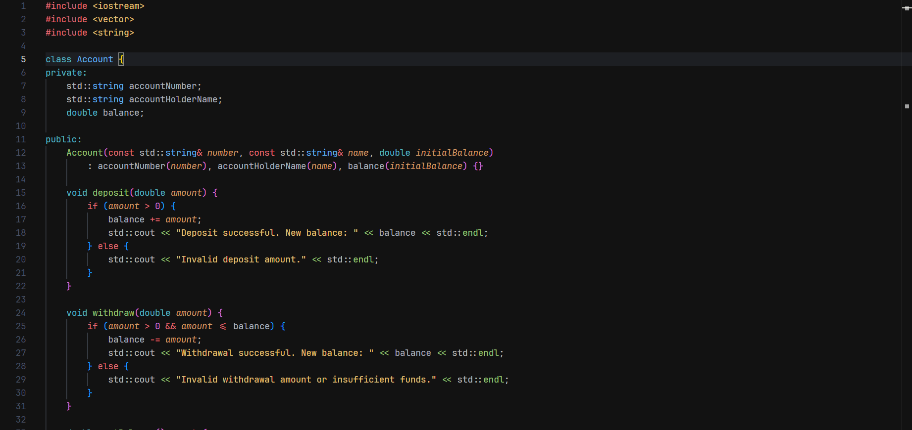

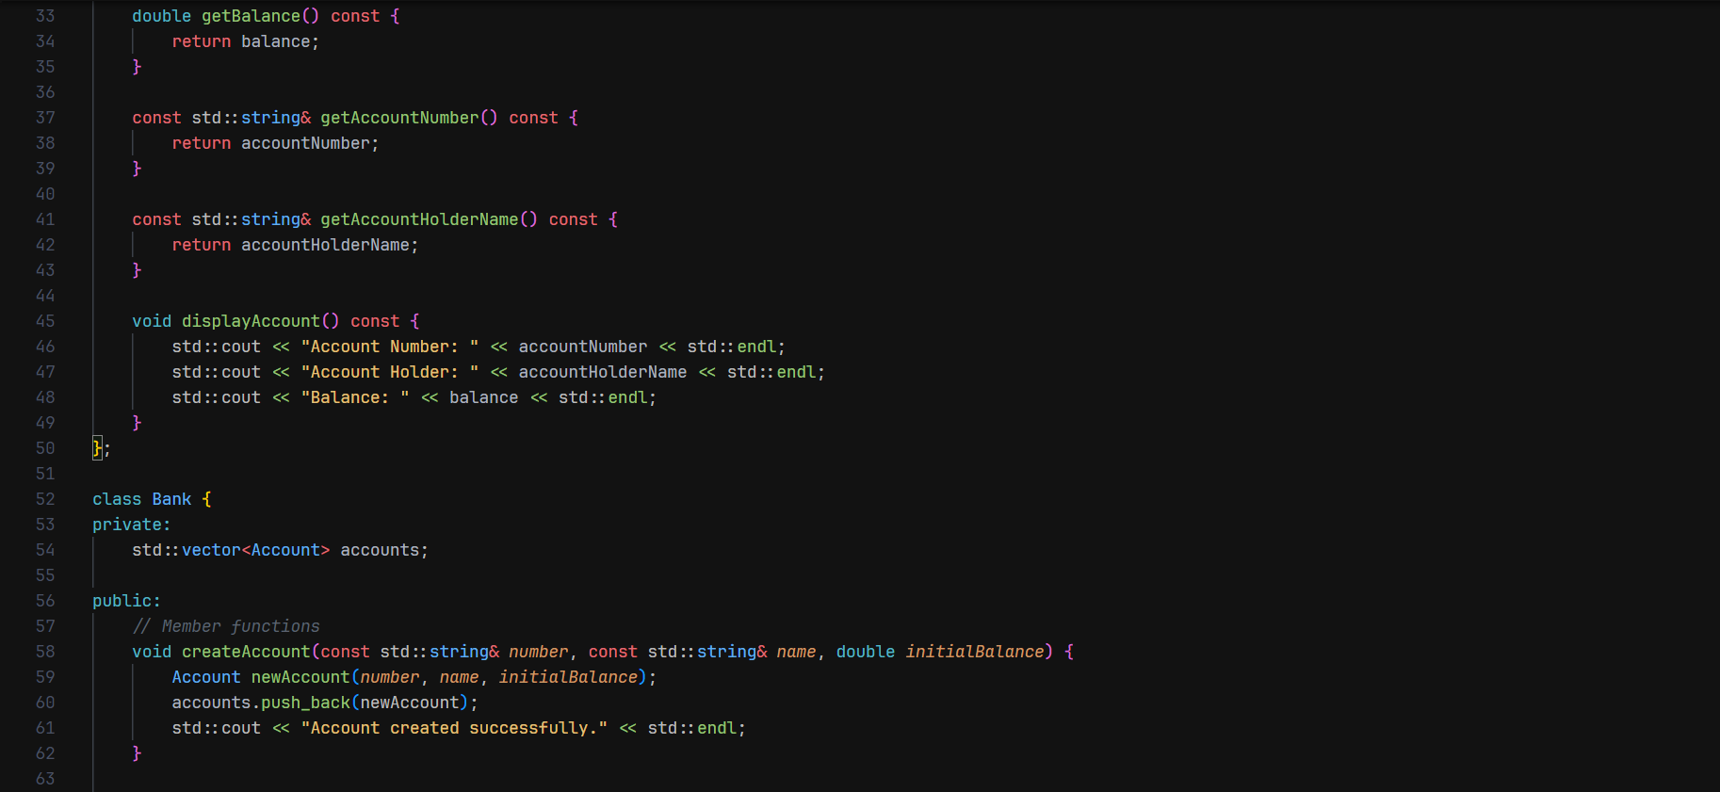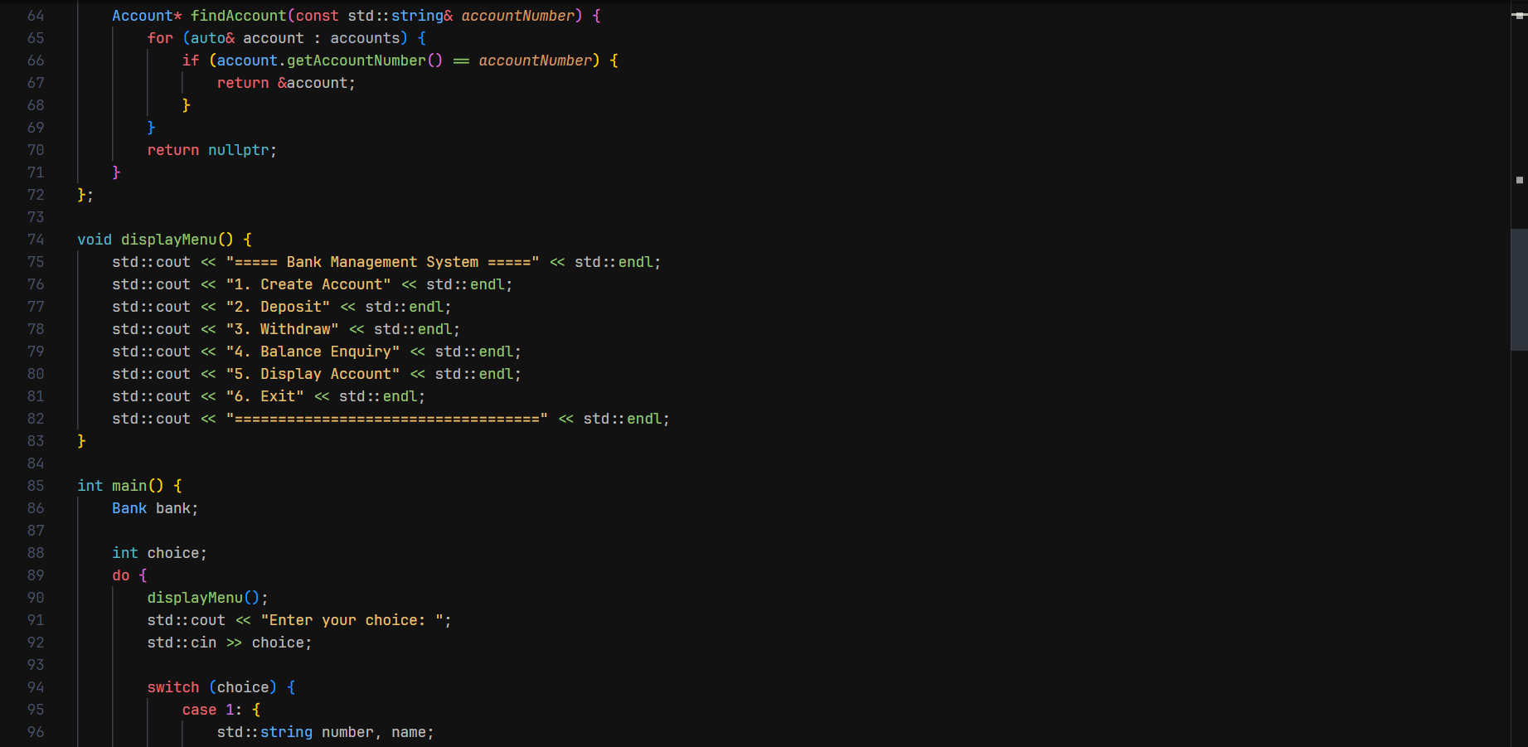

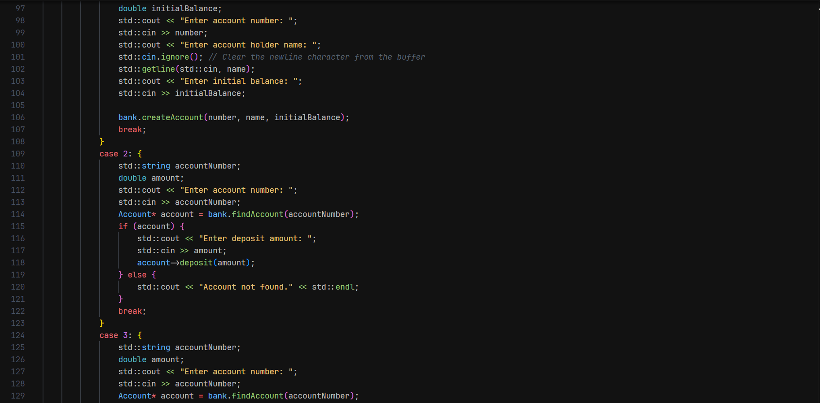

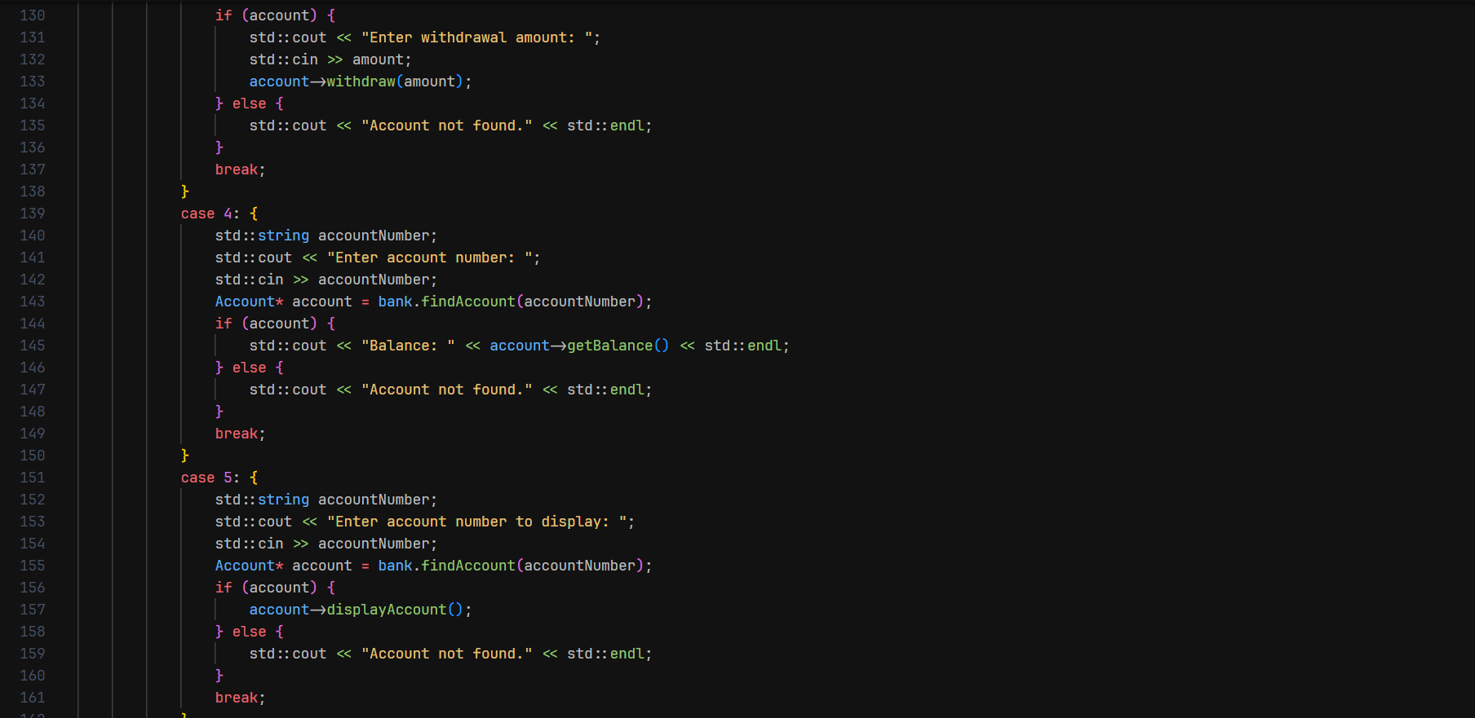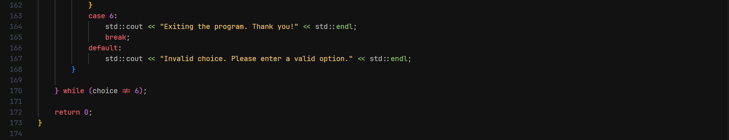

Output:

