1)Why is the splitting of energy level take place when N atoms in a crystal are taken to actual position?
2)Difference between metal, semiconductor and insulator using energy band diagram. How will the conductivity of metal, semiconductor, insulator vary with rise in temperature?
3)Draw a energy band diagram of intrinsic semiconductor at T= 0K and T>0K
4) Explain the pure semiconductor with energy band diagram and how will you relate ne, nh and ni?
5)What is doping? Why do you want to dope the pure semiconductor? What is the necessary condition for doping to take place?
6)When a pure semiconductor is doped with Phosphorus , name the type of extrinsic semiconductor. Explain with energy band diagram How in neutrality maintained in this extrinsic semiconductor?
7)Name the type of extrinsic semiconductor in which Acceptor energy level is formed. Explain the formation of intrinsic semiconductor with energy band diagram
8)Explain the formation of p-n junction diode and the formation of depletion layer and formation of potential barrier
9)How will the thickness of the depletion layer be increased? Give two reasons
10) How will the thickness of the depletion layer be decreased? Give two reasons
11) Draw potential barrier diagram for Vo for intrinsic and forward bias voltage for higher and lower voltage
12) Draw potential barrier diagram for Vo for intrinsic and reverse bias voltage
13)Explain the characteristics of junction diode and plot suitable graph
14)What is minority carrier injection? Why is reverse bias current very small?
15)Explain the function of rectifier where i) Two diodes are used b) One diode is used? Draw input and output wave form for each case
16) Identify the type of biasing given to diode in each cases
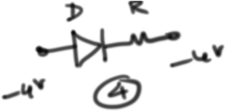
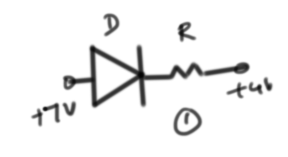
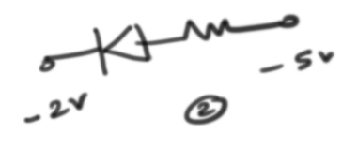
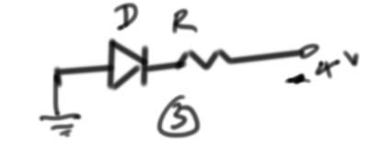

17) Can we take one slab of p-type semiconductor and physically join it to another n-type semiconductor to get p-n junction?
18) If the current in the circuit is 5mA, find V
