**The Nature Conservancy Fisheries Monitoring**

Subtitle as needed

Abhinav C  
Abhinav M  
Atit S  
Sudipto B  
Samir J

Department of Computer Science

NC State University

line 3: City, Country

line 4: e-mail: name@xyz.com

Authors Name/s per 2nd Affiliation *(Author)*

line 1 (of *Affiliation*): dept. name of organization

line 2: name of organization, acronyms acceptable

line 3: City, Country

line 4: e-mail: name@xyz.com

***Abstract*—**Every project report should have the following key elements: (1) Abstract, (2) Introduction, (3) Problem statement, (4) Objectives/Goals, (5) Literature Review (State of the Art), (6) Implementation details, (7) Evaluation, (8) Results/Analysis, (9) Conclusions and Future directions.*(Abstract)*

***Keywords-component; formatting; style; styling; insert (key words)***

# Introduction *(Heading 1)*

Start with general background. Towards the end (or separate subsection) provide problem statement.

# Related work and your contributions

This section should summarize the state of the art (various paper you read – papers that are relevant to your work), and gaps if any for solving the problem you defined in sections 1.1. Then in section 2.1 state your contributions.

# Methodology

This section provides algorithm and implementation details.

# Experiments and Results

This section defines experimental setup; datasets used; preprocessing done; analysis of the results; comparison with competing methods; and show why your method worked (or didn’t work).

# Conclusions and future directions

Summarize your experience (list all key elements). Based on experience gained, state what can be done in future.

##### Acknowledgment

Be nice to all people who helped you to reach this point.

##### References

List and number all bibliographical references in 9-point Times, single-spaced, at the end of your paper. When referenced in the text, enclose the citation number in square brackets, for example [1]. Where appropriate, include the name(s) of editors of referenced books. The template will number citations consecutively within brackets [1]. The sentence punctuation follows the bracket [2]. Refer simply to the reference number, as in [3]—do not use “Ref. [3]” or “reference [3]” except at the beginning of a sentence: “Reference [3] was the first . . .”

1. G. Eason, B. Noble, and I. N. Sneddon, “On certain integrals of Lipschitz-Hankel type involving products of Bessel functions,” Phil. Trans. Roy. Soc. London, vol. A247, pp. 529–551, April 1955. *(references)*
2. J. Clerk Maxwell, A Treatise on Electricity and Magnetism, 3rd ed., vol. 2. Oxford: Clarendon, 1892, pp.68–73.
3. I. S. Jacobs and C. P. Bean, “Fine particles, thin films and exchange anisotropy,” in Magnetism, vol. III, G. T. Rado and H. Suhl, Eds. New York: Academic, 1963, pp. 271–350.
4. K. Elissa, “Title of paper if known,” unpublished.
5. R. Nicole, “Title of paper with only first word capitalized,” J. Name Stand. Abbrev., in press.
6. Y. Yorozu, M. Hirano, K. Oka, and Y. Tagawa, “Electron spectroscopy studies on magneto-optical media and plastic substrate interface,” IEEE Transl. J. Magn. Japan, vol. 2, pp. 740–741, August 1987 [Digests 9th Annual Conf. Magnetics Japan, p. 301, 1982].
7. M. Young, The Technical Writer’s Handbook. Mill Valley, CA: University Science, 1989.
8. Electronic Publication: Digital Object Identifiers (DOIs):

Article in a journal:

1. D. Kornack and P. Rakic, “Cell Proliferation without Neurogenesis in Adult Primate Neocortex,” Science, vol. 294, Dec. 2001, pp. 2127-2130, doi:10.1126/science.1065467.

Article in a conference proceedings:

1. H. Goto, Y. Hasegawa, and M. Tanaka, “Efficient Scheduling Focusing on the Duality of MPL Representatives,” Proc. IEEE Symp. Computational Intelligence in Scheduling (SCIS 07), IEEE Press, Dec. 2007, pp. 57-64, doi:10.1109/SCIS.2007.357670.

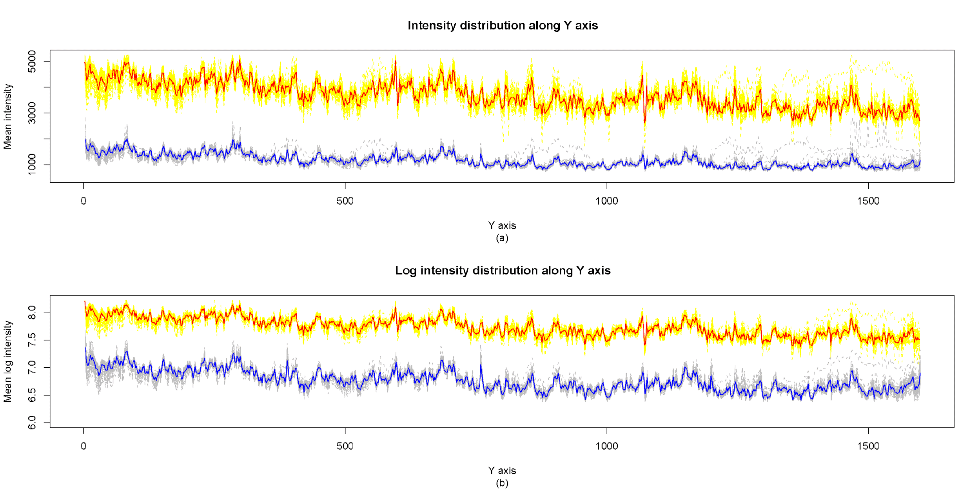 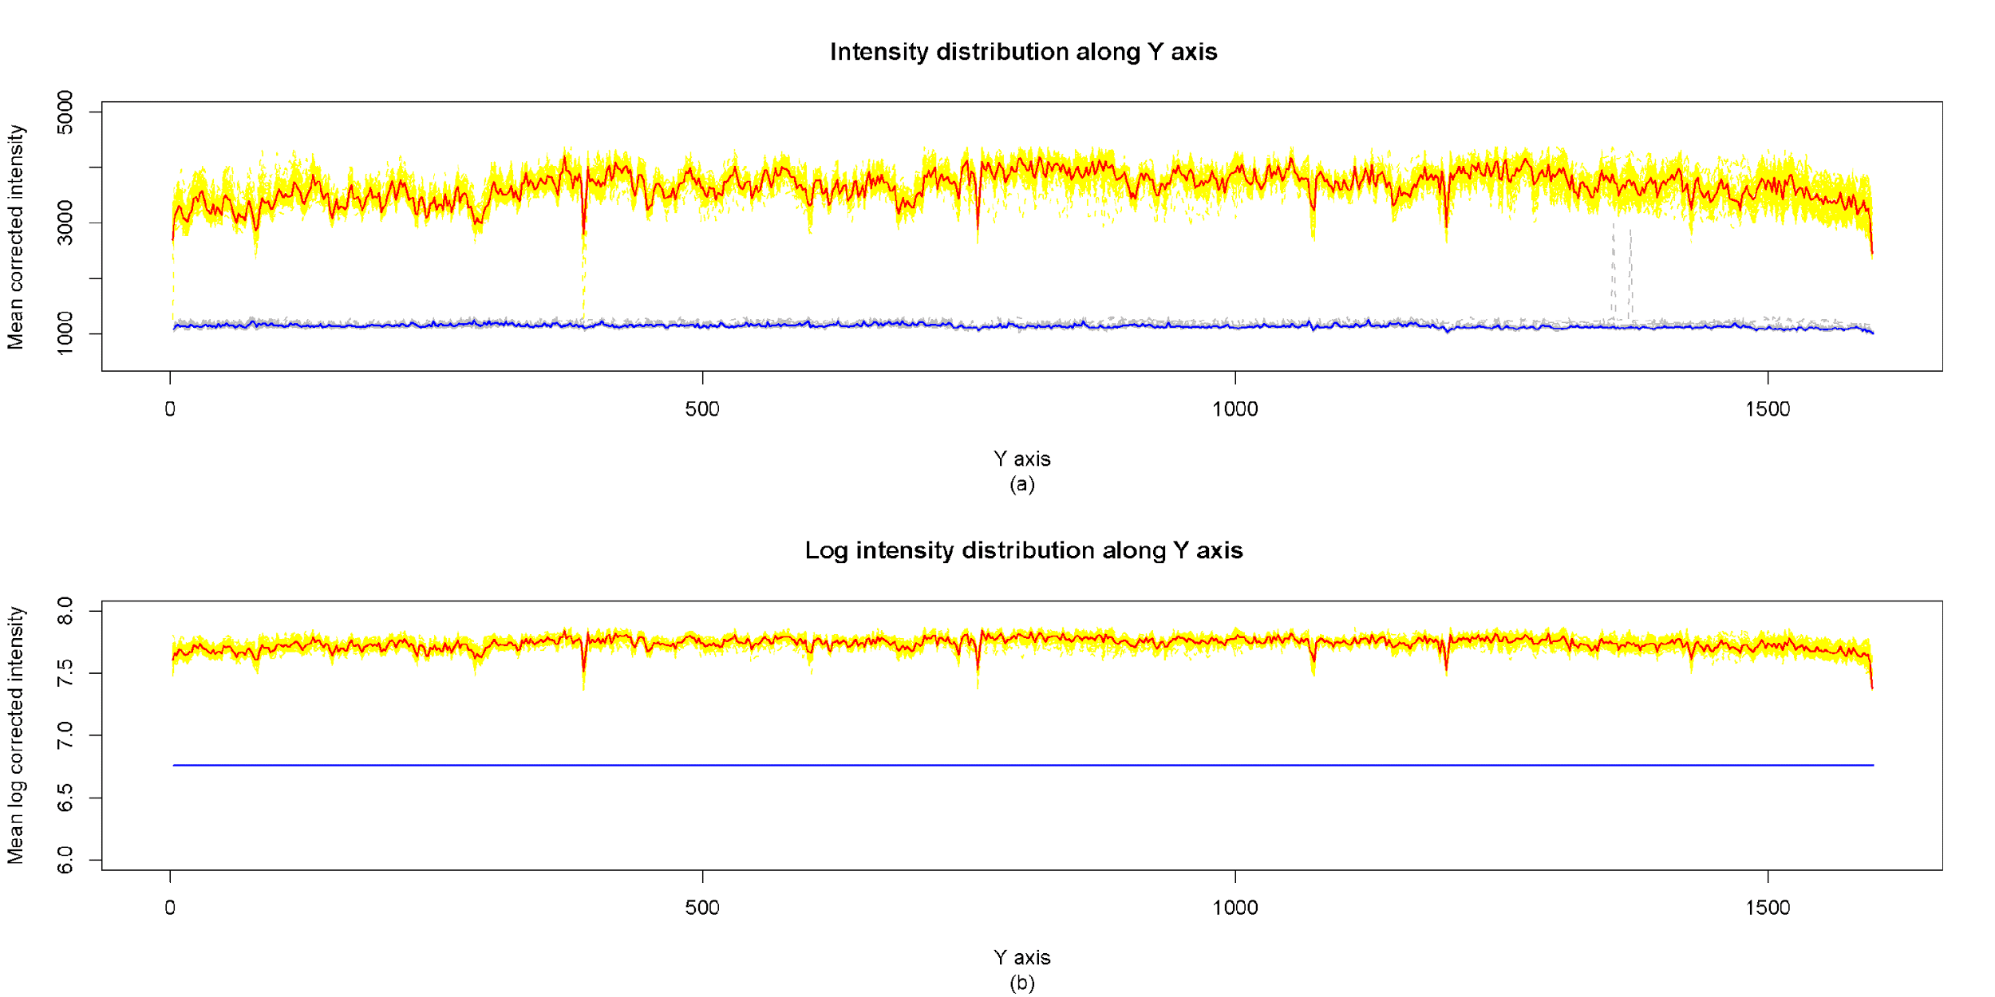

1. Example of a TWO-COLUMN figure caption: (a) this is the format for referencing parts of a figure.