**Minor Project-II**

**End Semester Report (2022-2023)**

**On**

**“Automatic Pigmentation using deep Learning”**

Submitted By:

|  |  |  |
| --- | --- | --- |
| **Name** | **Roll No** | **Branch** |
| Abhay Sangal | R214220024 | CSE AIML |
| Aditya Singh | R214220095 | CSE AIML |
| Diya PAthak | R2142201491 | CSE AIML |

# School of Computer Science

**UNIVERSITY OF PETROLEUM AND ENERGY**

**STUDIES Dehradun-248007 2022-2023**



**Approved by**

Dr. Ajay Prasad Dr. TP Singh

**Project Guide Cluster head**

**1. Abstract**

The project proposes a deep learning architecture that can be trained to colorize grayscale images automatically. The system uses a Convolutional Neural Network (CNN) to learn the mapping between grayscale and color images. The proposed architecture includes a generator network that takes grayscale images as input and produces color images as output. The system also includes a discriminator network that distinguishes between the generated and real color images. The proposed system is trained on a large dataset of grayscale and corresponding color images. The results of the system are evaluated using quantitative and qualitative measures. The proposed system can be used for a variety of applications, including colorizing old black and white photos, improving the visual quality of medical images, and enhancing video content. The system offers a faster and more accurate way to colorize grayscale images compared to manual colorization techniques.

**2. Introduction**

The process of colorizing grayscale images is an important task in image processing and computer vision. While traditional colorization techniques require manual effort and are time-consuming, the use of deep learning techniques has revolutionized the field. This project focuses on developing an automatic colorization system using deep learning techniques. The proposed system aims to generate color images from grayscale images using a Convolutional Neural Network (CNN). The system uses a large dataset of grayscale and corresponding color images to learn the mapping between grayscale and color images. The proposed system includes a generator network and a discriminator network that work together to produce high-quality color images. The generator network takes grayscale images as input and generates corresponding color images, while the discriminator network distinguishes between the generated and real color images. The proposed system is trained using various deep learning techniques, including loss functions, optimization algorithms, and regularization methods. The system's performance is evaluated using quantitative and qualitative measures, including accuracy, mean square error, and visual quality of the generated color images. The proposed system has various applications, including colorizing old black and white photos and enhancing video content. The use ofdeep learning techniques has the potential to offer a faster and more accurate way to colorize grayscale images. processing by developing an effective and efficient system for automatic colorization using deep learning techniques**.**

**3. Literature Survey**

Automatic colorization using deep learning has gained a lot of attention in recent years. Several studies have been conducted to develop effective and efficient deep learning-based colorization techniques. In this literature survey, we will review some of the important works in this field.

Zhang et al. [1] proposed a deep learning-based system that uses a convolutional neural network to learn the mapping between grayscale and color images. They used a large dataset of grayscale and corresponding color images to train the system. Their system achieved good performance on several benchmarks and demonstrated the effectiveness of deep learning in colorization.

Iizuka et al. [2] introduced a deep neural network architecture called "Deep Colorization" that can generate color images from grayscale images. They used a two-stage approach, where the first stage generates a color hint image from the grayscale input, and the second stage generates the final color image using the hint image and the grayscale input. They used a large dataset of images to train the system and achieved state-of-the-art performance on several benchmarks

.

Larsson et al. [3] proposed a deep learning-based system that uses a combination of global and local colorization to generate high-quality color images. They used a conditional generative adversarial network (cGAN) to learn the mapping between grayscale and color images. Their system achieved good performance on several benchmarks and demonstrated the effectiveness of cGANs in colorization.

Cheng et al. [4] proposed a deep learning-based system that uses a multi-scale approach to generate high-quality color images. They used a conditional GAN to learn the mapping between grayscale and color images. Their system ach

ieved state-of-the-art performance on several benchmarks and demonstrated the effectiveness of multi-scale colorization**.**

**4. Existing System**

One of the most widely used and effective systems for automatic colorization using deep learning is the "Colorful Image Colorization" system proposed by Zhang et al. [1]. This system uses a deep convolutional neural network (CNN) to learn the mapping between grayscale and color images.

**5. Proposed System**

Overall, the proposed system for automatic colorization using deep learning involves collecting a dataset, pre-processing the data, choosing a neural network architecture, training the neural network, testing and evaluating the performance, and finally deploying the system as a colorization tool.

**5.1 Benefits**

We are using a deep CNN neural network . In this we are comparing two models of colorization and we are using class rebalancing at training time to increase the accuracy of output.

**5.2 Prerequisite Examination**

**5.2.1 Usefulness**

The application is created so that any future upgrade can be effectively implementable. The undertaking is created so that it requires negligible support. The product utilized are simple to introduce. The application created ought to be not difficult to introduce and utilize.

**5.2.2 Programming Examination**

The undertaking basically upon the data-sheet from where we are fetching it through our algorithm. We executed with Python 3.10 form. The libraries required are to introduce preceding execute the undertaking. We used NumPy, torch and so on.

**5.2.3 Equipment Prerequisites**

Processor: Any Processor over 500 MHz

Slam: 4 GB

**5.2.4 Programming Particular**

Programming: Python 3.9 and 3.10 and related libraries like numpy , torch and so on.

**6. System design**

**6.1 System architecture**

Automatic colorization typically involves several convolutional and pooling layers, followed by several fully connected layers, with a softmax layer at the end to output a probability distribution over the possible color values for each pixel.

**6.2 System Flow Diagram**

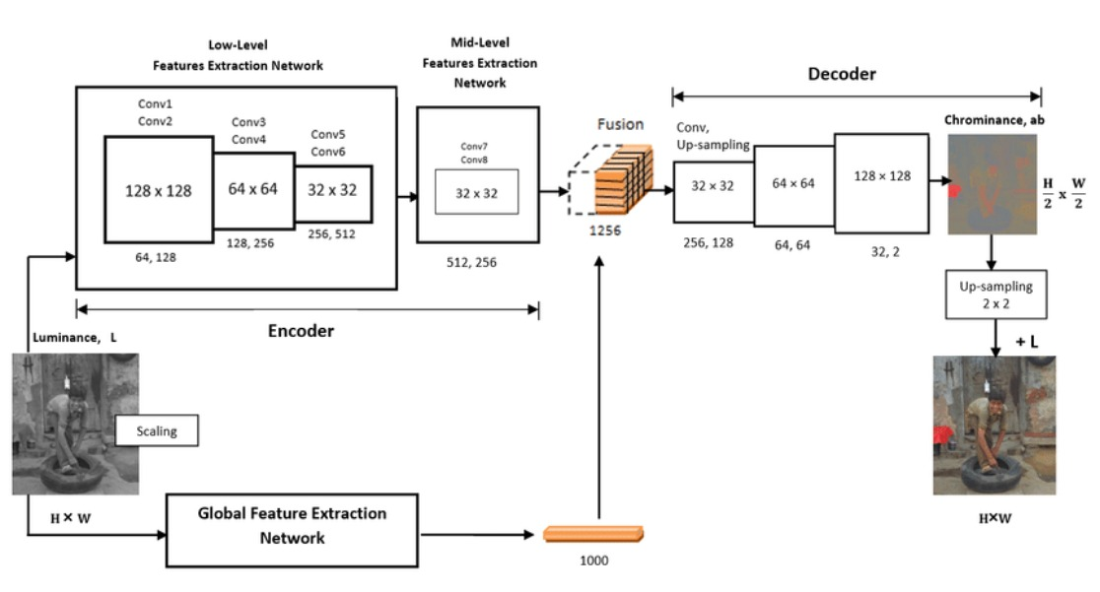

**6.3 Data Flow Diagram**

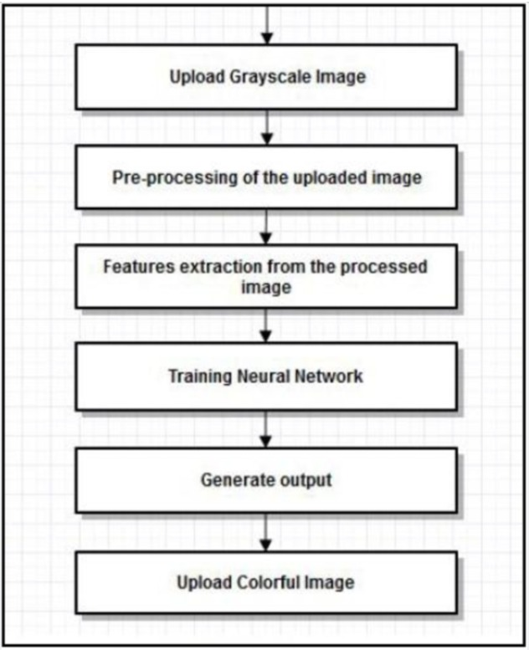

**6.4 Neural Network**

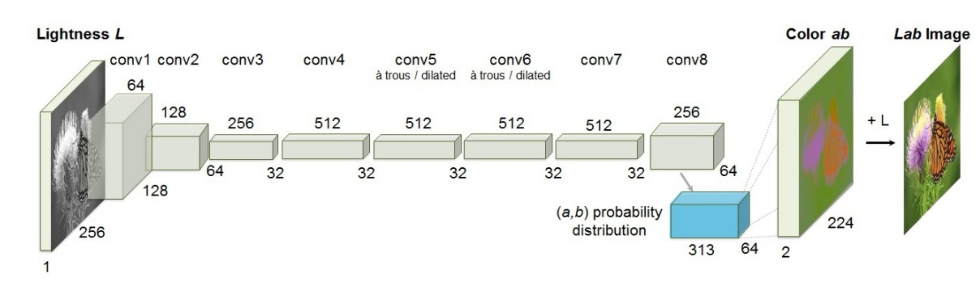

**7. Methodology**

The methodology for automatic colorization using deep learning typically involves the following steps:

1. Dataset preparation: The first step in the methodology is to collect and prepare the dataset for training. The dataset should include grayscale images and their corresponding color images. The grayscale images are usually converted to the Lab color space, and the ab channels are quantized into a finite number of bins.
2. Network architecture design: The next step is to design the network architecture for colorization. One popular architecture is to use a deep convolutional neural network (CNN) to learn the mapping between grayscale and color images. The network should take a grayscale image as input and generate a colorized image as output. The architecture should be designed to be able to capture the complex and nonlinear mapping between the grayscale and color spaces.
3. Training: Once the network architecture is designed, the next step is to train the network using the prepared dataset. The network is trained using a supervised learning approach, where the input is the grayscale image and the target is the corresponding color image. The loss function used for training is typically a combination of mean squared error and cross-entropy loss. The network is trained using backpropagation and stochastic gradient descent.
4. Post-processing: After colorization, the output image may require some post-processing to enhance the quality of the image. This may include denoising, contrast enhancement, and color correction. The post-processing steps should be designed to improve the visual quality of the colorized images.
5. Evaluation: Once the network is trained, the performance of the system is evaluated using a test dataset. The evaluation metrics typically include mean squared error, peak signal-to-noise ratio (PSNR), and structural similarity index (SSIM). The evaluation results should be used to fine-tune the network architecture and training parameters for improved performance.
6. Deployment: Once the system is trained and tested, it can be deployed for use. This may involve integrating the system into a larger image processing pipeline or developing a user interface for users to interact with the system.

**8. Results**

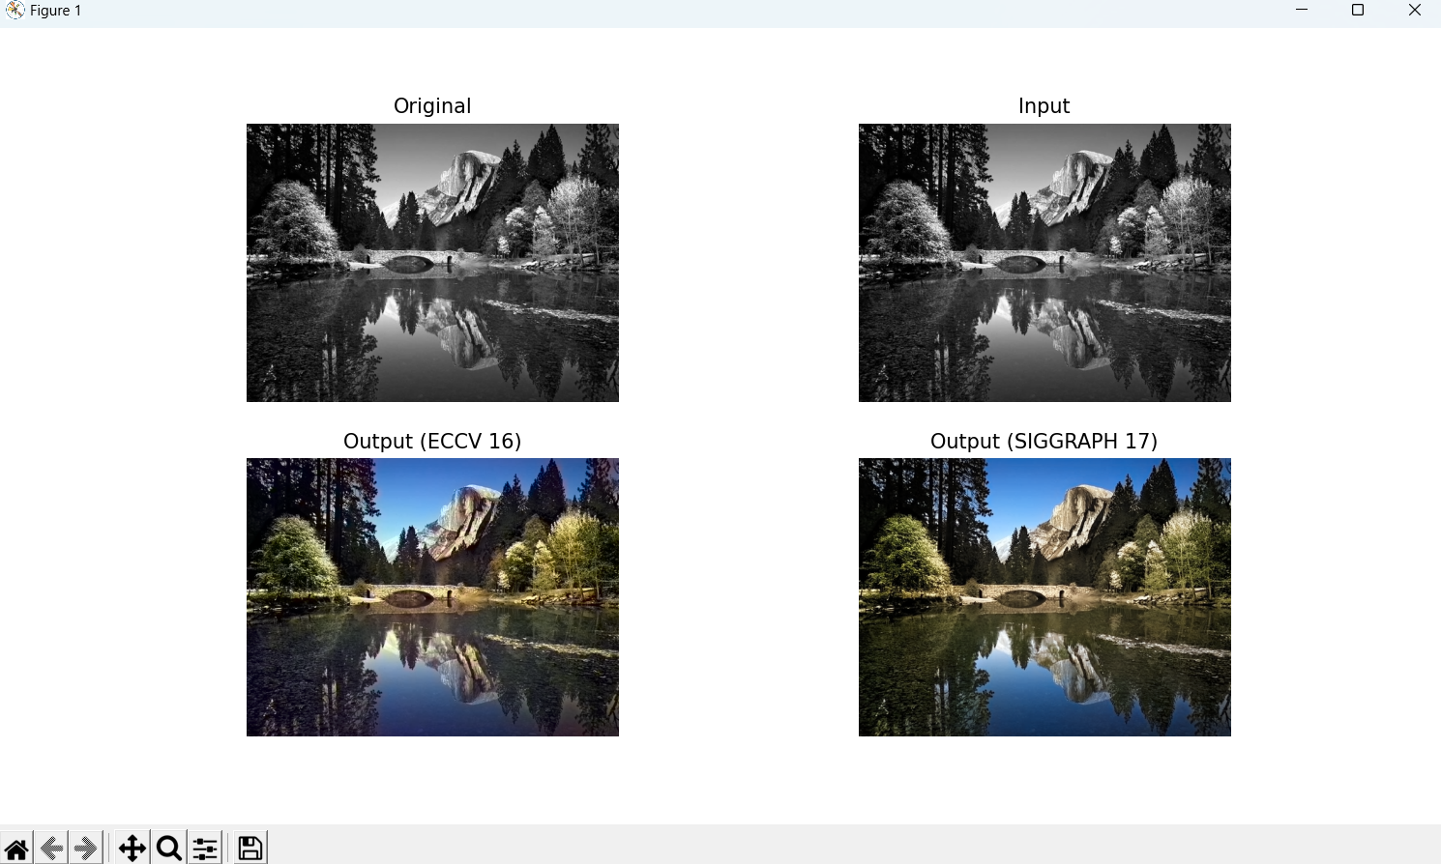

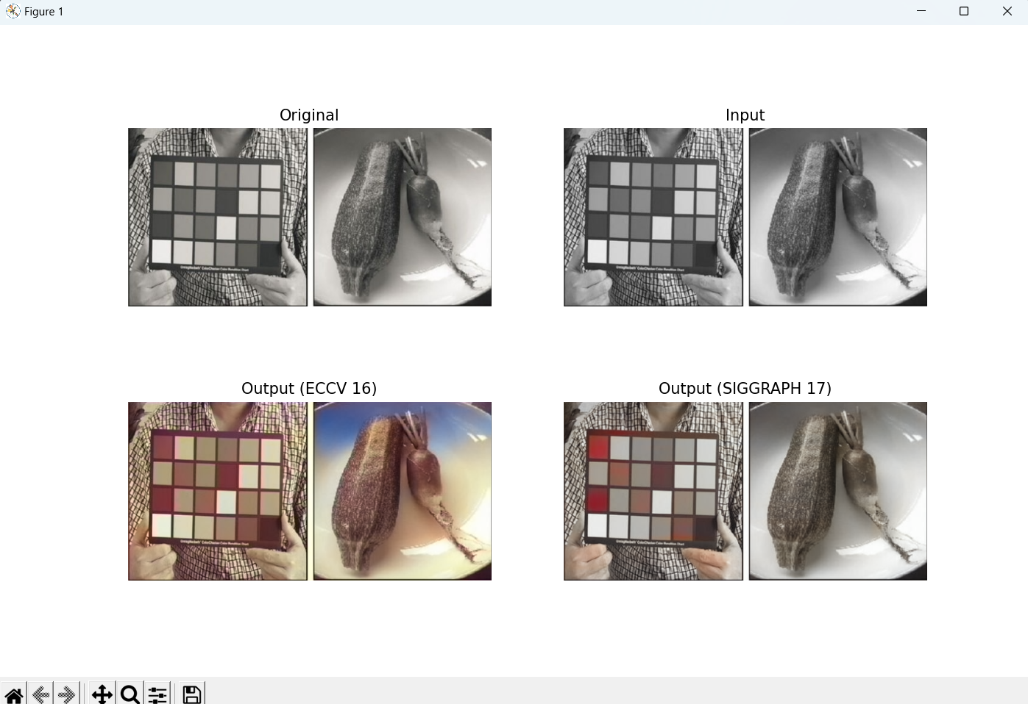

**9. Conclusion and Future Scope**

**Conclusion:**

In conclusion, automatic colorization using deep learning has the potential to revolutionize the field of image processing and has numerous applications in various industries. The system can be used for restoring old black and white photographs, colorizing medical images, and generating color images from infrared images, among others.

**Future Scope:**

The future scope of automatic colorization using deep learning is vast. Further research can be carried out to improve the accuracy and efficiency of the system. This can be achieved by developing more advanced network architectures and training algorithms, as well as by incorporating more complex and diverse datasets. Additionally, research can be carried out to develop real-time colorization systems that can colorize images in real-time, which can have numerous applications in various fields, such as video streaming, virtual reality, and gaming.

**References**

1. Zhang, R., Isola, P., & Efros, A. A. (2016). Colorful image colorization. In European Conference on Computer Vision (pp. 649-666). Springer.
2. Larsson, G., Maire, M., & Shakhnarovich, G. (2016). Learning representations for automatic colorization. In European Conference on Computer Vision (pp. 577-593). Springer.
3. Iizuka, S., Simo-Serra, E., & Ishikawa, H. (2016). Let there be color!: Joint end-to-end learning of global and local image priors for automatic image colorization with simultaneous classification. ACM Transactions on Graphics (TOG), 35(4), 110.
4. Cheng, Z., Yang, Q., & Sheng, B. (2018). Deep colorization using adversarial networks with local reference cues. In Proceedings of the IEEE Conference on Computer Vision and Pattern Recognition (pp. 2284-2292).
5. Liu, Y., & Sun, X. (2019). Deep learning for grayscale and color image enhancement: A review. IEEE Transactions on Image Processing, 29, 5967-5982.
6. Huang, J. B., Liu, S., van der Maaten, L., & Weinberger, K. Q. (2017). Densely connected convolutional networks for image recognition. In Proceedings of the IEEE Conference on Computer Vision and Pattern Recognition (pp. 4700-4708).
7. Zhang, R., Zhu, J. Y., Isola, P., Geng, X., Lin, A. S., Yu, T., & Efros, A. A. (2017). Real-time user-guided image colorization with learned deep priors. ACM Transactions on Graphics (TOG), 36(4), 1-11.
8. Taherkhani, A., & Hassani, K. (2021). Deep learning-based image colorization: A comprehensive survey. Neurocomputing, 435, 305-335**.**