**REPORT for Problem 3-Suspension system**

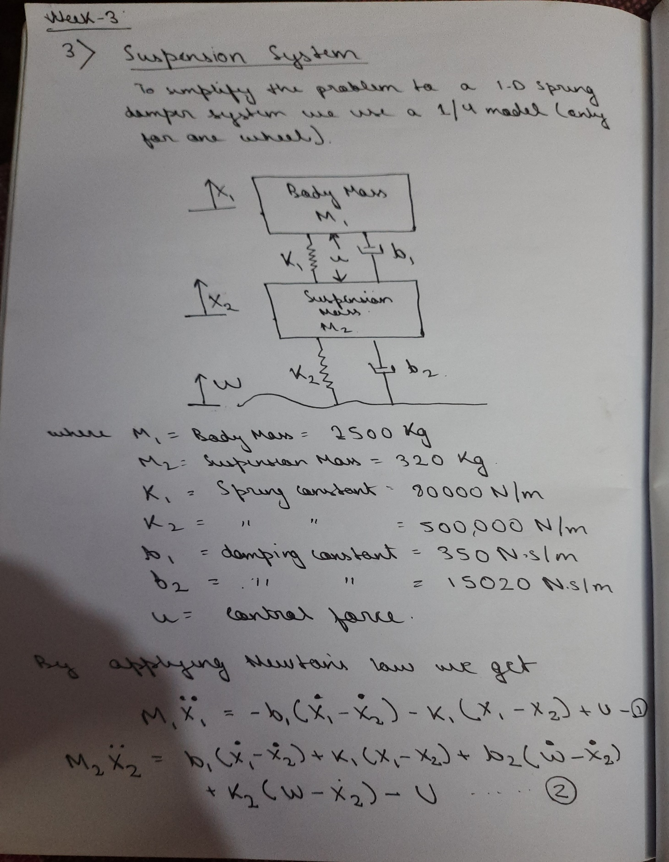

 When the vehicle is experiencing any road disturbance (i.e. pot holes, cracks, and uneven pavement) ,the vehicle body should not have large oscillations, and the oscillations should dissipate quickly.  We want to design a feedback controller so that the output has an overshoot less than 5% and a settling time shorter than 5 seconds. For example, when the vehicle runs onto a 10 cm high step, the vehicle body will oscillate within a range of +/- 5 mm and return to a smooth ride within 5 seconds.

First the plant model-

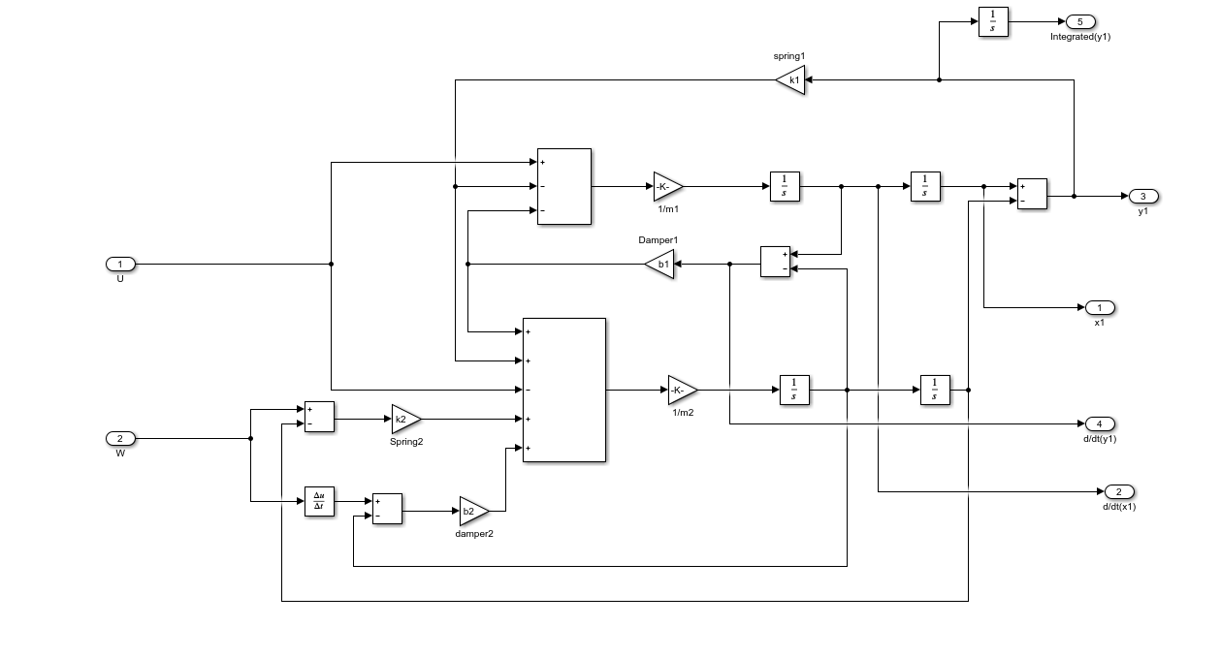

Now the plant with full state feedback control-

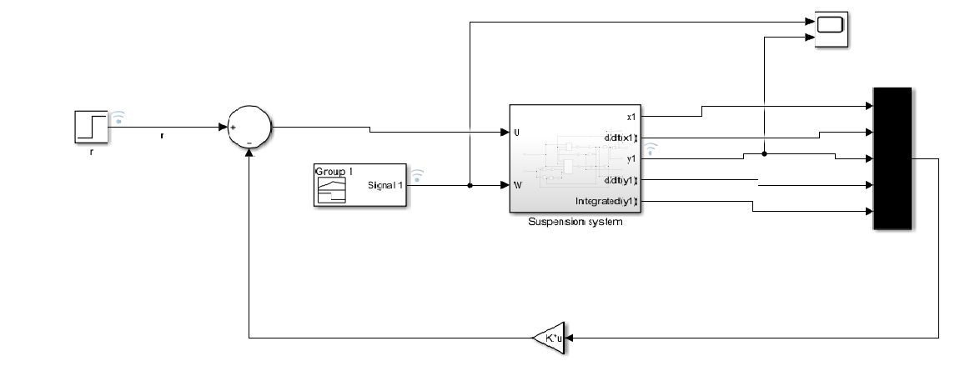

The controller used the following feedback gain matrix:

K = [ 0 2.3E6 5E8 0 8E6 ] ,this is found through trial and error

**On simulating we find that the settling time is around 2 secs for the system which is less than our design requirements, shown in the figures attached with the project.**

The Matlab Simulink Skills used in this Project are : Callbacks , Data Inspector, Solver selection Strategy and Signal builder.

Callbacks:- Callback Function used in this Project is for setting the values of the parameters or variables. The Post Load Fcn is used so that the variables are effective after loading of the project.

Data Inspector:- The signals are logged whose output has to be observed. After every run with different conditions the data inspector shows the output for the selected signals. The signals that are logged are: r(commanding vehicle to stay stable),W(step input for flat road and one pothole),Signal builder(Test signal for road conditions),y1(output)

Solver selection strategy:- Solver selected for this project is the ode45 Dormand Prince Method because the ODE in the project is time and state dependent.

Signal Builder to generate test signals:-The use of Signal Builder is for the input instead of W block so that we can give various test signals for different types of road conditions