Design:

main functions:

Basic idea:

There is a tribe lock which prevents multiple tribe people from accessing pot.
Pot lock, such that atmost 1 person can access the pot.

Pot lock is mtx, tribe lock is tribemtx.

When a tribe person tries to access pot and finds it accessible, he checks if food there or not, if there he eats and leaves.

If not there, he notifies the cook, while unlocking the pot mutex, the cook will be either sleeping or waiting for the pot lock.

Either case the code goes to the former case above.
After this the cook unlocks the mutex and cooks food while keeping the mutex locked.
The tribe person who notified checks if cook id done, if he finds he is done, he eats and leaves while unlcoking the pot mutex and the tribe mutex.

The sleeping is simulated through a while loop, this assumption is made that while loop iterations are very very fast, in each iteration of the while loop, the cook sleeps for 1 microsecond, this is iportant to get the notification from a tribe person.
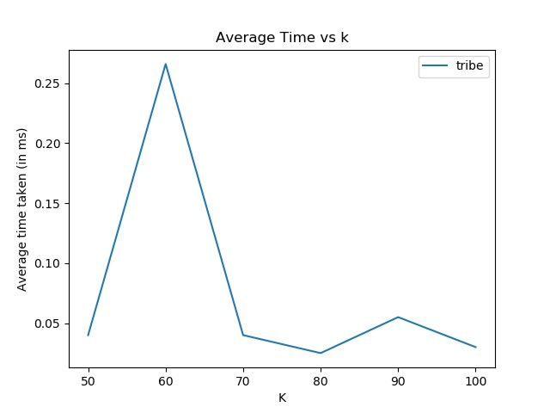
As can be seen from the graph, the average waiting time for each tribe person is almost constant on increasing number of tribe people.This is expected, as eating and sleeping is a continual process, does not depend on nymber of people, doing it, since as soon as tribe guy takes his food he leaves.

All other params are kept constant as given in the exam paper.

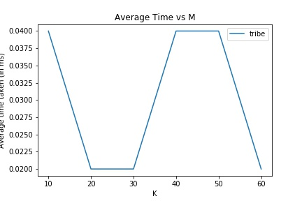

As the number of food resources increase, the time should saturate to a very low value, as cook does not spend time cooking and putting, this is found in the above graph too, the variation is due to random sleeping times.

