TELE33324 ASSIGNMENT 4

Student Name/Student ID: Abhinav Girdhar

/20

This assignment is based on chapter 9 of the textbook, and involves configuring switches with VLANs, and enabling inter-VLAN communication on a router.

\*Note – The highlighted part are the solutions to the actions asked to perform.

Submission Details

1. Assignment is due in the assignment dropbox by the end of class in week 11.

2. Submit the following documents as part of your submission:

* This document – complete with requested screenshots
* the FIVE configuration files (FOUR SWITCHES PLUS THE ROUTER). In Packet Tracer click on the device, click on “config” and click “export” beside the running-config file CLEARLY LABEL EACH CONFIGURATION FILE TO INDICATE THE SWITCH OR ROUTER

3. You will be configuring the following network:

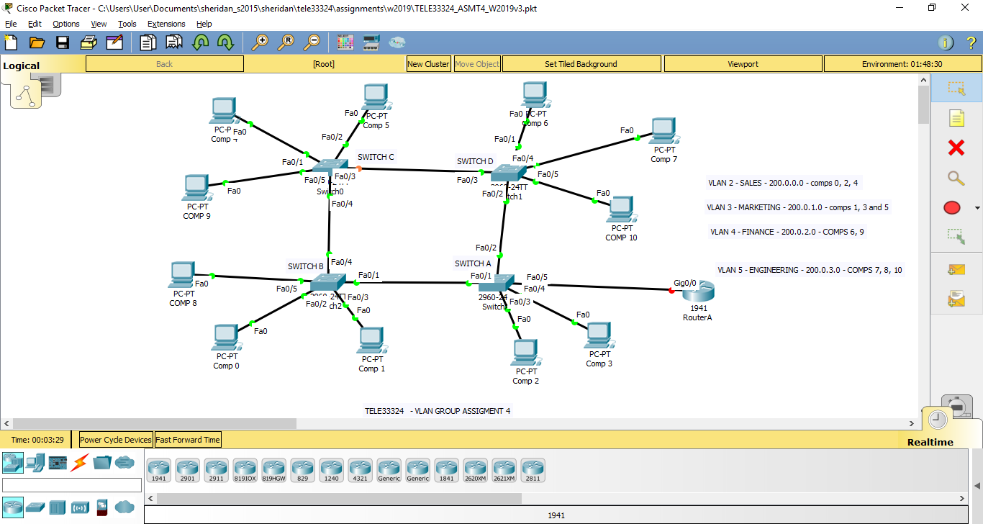

- Figure 1 -

4. Please note that the FOUR switches are 2960 (each with 16 FastEthernet ports) and the Router can be any model with a Fast Ethernet or higher interface. Use the PC-PT for the 11 computers. PLEASE NOTE THAT YOUR INTERFACE NUMBERS DON’T HAVE TO MATCH MINE.

5. Assign ip addresses and default gateways to each of the ELEVEN PCs. Use the text tool to indicate what ip address you are assigning to each of the eleven PCs.

*My Topology*

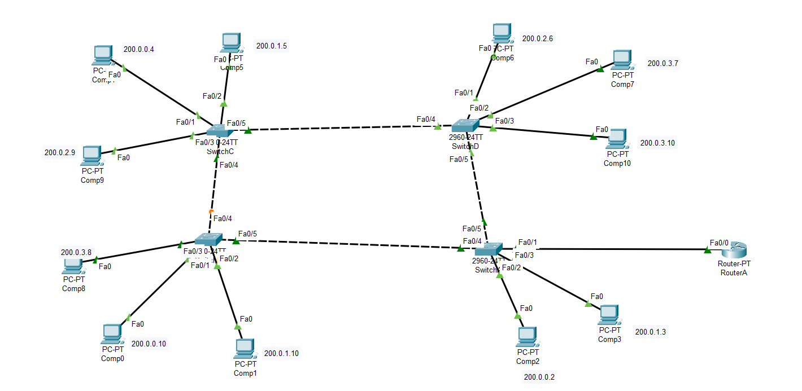

The marks for points 6 – 10 will be ascertained from the config files for the FOUR switches and the Router. BE SURE TO LABEL EACH CONFIG FILE

6. Create the four VLANs on switch A, with the names given in figure 1. Set the domain name to TELE33324v3. This will be your VTP server.

\*\*\*\*\* Insert a screenshot of “show vlan brief” and “show vtp status” \*\*\*\*\* [2]

Switch A

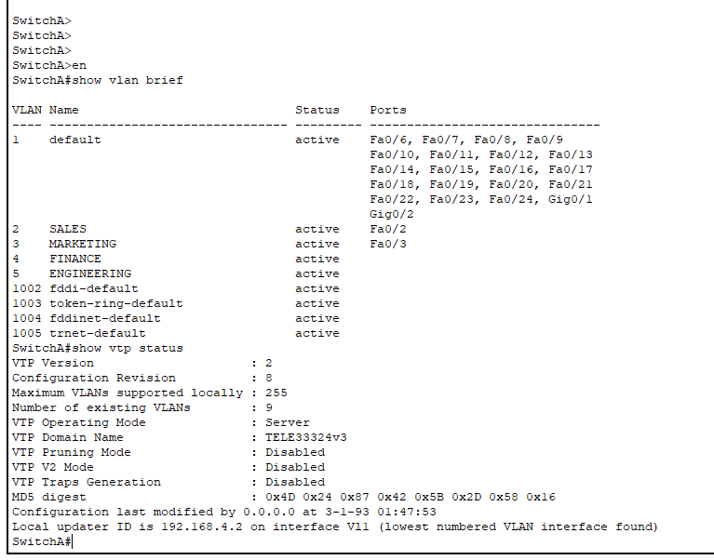

7. Set the ports on switch A to either ACCESS or TRUNK, as appropriate [2]

8. Set switches B, C and D to VTP clients, AFTER setting the domain name to

TELE33324v3.

\*\*\*\*\* For each switch, B, C and D, insert a screenshot of “show vlan brief” and “show vtp status” \*\*\*\*\* [2]

Switch B

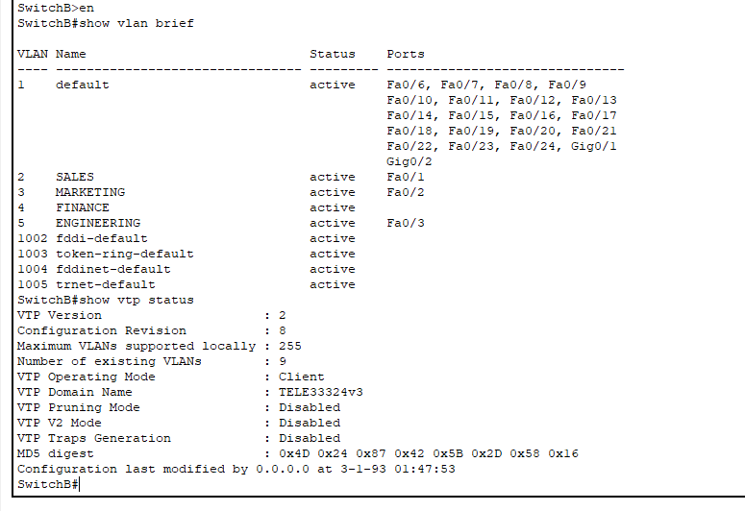

Switch C

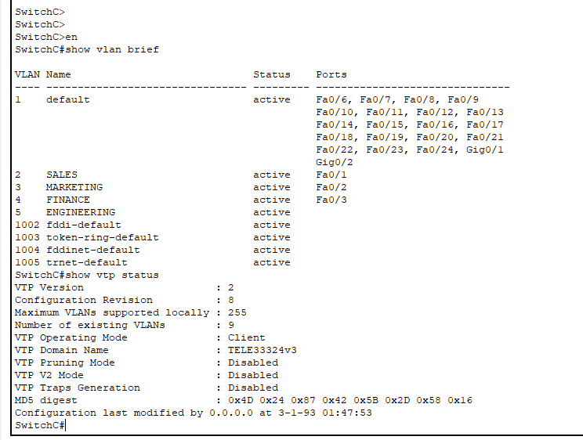

Switch D

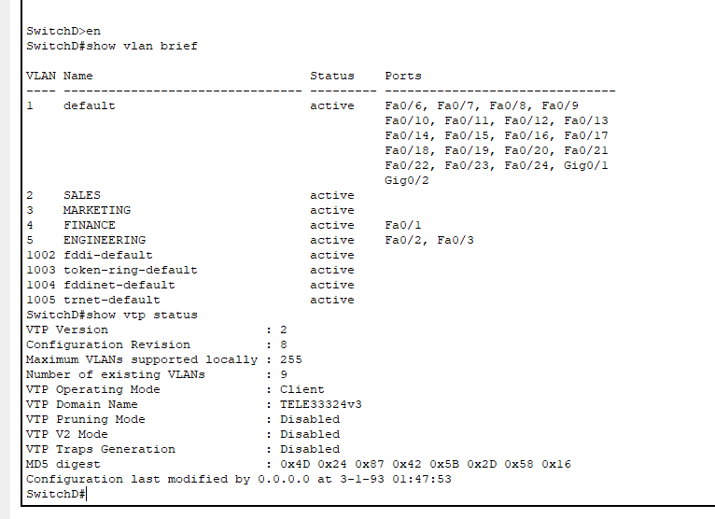

9. Set the ports on switches B, C, and D to either ACCESS or TRUNK as appropriate [4]

10. Assign addresses from network 192.168.4.0 to the Vlan1 interface for each switch, and specify the default gateway as follows:

Int vlan 1

ip address 192.168.4.x 255.255.255.0

no shut

exit

ip default-gateway 192.168.4.1

11. Enable inter-vlan communication between VLANs 4 and 5 by creating appropriate

Subinterfaces on Router A on the connection to Switch A. Also, assign ip address 192.168.4.1 to the main interface leaving router A going to switch A. [3]

11. Do screenshots of the following and LABEL THEM:

IF SCREENSHOTS ARE NOT CLEAR, COPY AND PASTE TO WORD.

*On Comp 6, show successful pings to computers 7, 8, 9 and 10* [2]

Packet Tracer PC Command Line 1.0

C:\>ping 200.0.3.7

Pinging 200.0.3.7 with 32 bytes of data:

Reply from 200.0.3.7: bytes=32 time<1ms TTL=127

Reply from 200.0.3.7: bytes=32 time=11ms TTL=127

Reply from 200.0.3.7: bytes=32 time=1ms TTL=127

Reply from 200.0.3.7: bytes=32 time=10ms TTL=127

Ping statistics for 200.0.3.7:

Packets: Sent = 4, Received = 4, Lost = 0 (0% loss),

Approximate round trip times in milli-seconds:

Minimum = 0ms, Maximum = 11ms, Average = 5ms

C:\>ping 200.0.3.8

Pinging 200.0.3.8 with 32 bytes of data:

Request timed out.

Reply from 200.0.3.8: bytes=32 time=13ms TTL=127

Reply from 200.0.3.8: bytes=32 time=10ms TTL=127

Reply from 200.0.3.8: bytes=32 time=11ms TTL=127

Ping statistics for 200.0.3.8:

Packets: Sent = 4, Received = 3, Lost = 1 (25% loss),

Approximate round trip times in milli-seconds:

Minimum = 10ms, Maximum = 13ms, Average = 11ms

C:\>ping 200.0.2.9

Pinging 200.0.2.9 with 32 bytes of data:

Reply from 200.0.2.9: bytes=32 time<1ms TTL=128

Reply from 200.0.2.9: bytes=32 time=11ms TTL=128

Reply from 200.0.2.9: bytes=32 time=2ms TTL=128

Reply from 200.0.2.9: bytes=32 time=4ms TTL=128

Ping statistics for 200.0.2.9:

Packets: Sent = 4, Received = 4, Lost = 0 (0% loss),

Approximate round trip times in milli-seconds:

Minimum = 0ms, Maximum = 11ms, Average = 4ms

C:\>ping 200.0.3.10

Pinging 200.0.3.10 with 32 bytes of data:

Request timed out.

Reply from 200.0.3.10: bytes=32 time=1ms TTL=127

Reply from 200.0.3.10: bytes=32 time=11ms TTL=127

Reply from 200.0.3.10: bytes=32 time<1ms TTL=127

Ping statistics for 200.0.3.10:

Packets: Sent = 4, Received = 3, Lost = 1 (25% loss),

Approximate round trip times in milli-seconds:

Minimum = 0ms, Maximum = 11ms, Average = 4ms

C:\>

*On Comp 7, show successful pings to computers 6, 8, 9 and 10* [2]

C:\>ping 200.0.2.6

Pinging 200.0.2.6 with 32 bytes of data:

Request timed out.

Reply from 200.0.2.6: bytes=32 time=10ms TTL=127

Reply from 200.0.2.6: bytes=32 time=11ms TTL=127

Reply from 200.0.2.6: bytes=32 time=11ms TTL=127

Ping statistics for 200.0.2.6:

Packets: Sent = 4, Received = 3, Lost = 1 (25% loss),

Approximate round trip times in milli-seconds:

Minimum = 10ms, Maximum = 11ms, Average = 10ms

C:\>ping 200.0.3.8

Pinging 200.0.3.8 with 32 bytes of data:

Reply from 200.0.3.8: bytes=32 time<1ms TTL=128

Reply from 200.0.3.8: bytes=32 time=1ms TTL=128

Reply from 200.0.3.8: bytes=32 time=1ms TTL=128

Reply from 200.0.3.8: bytes=32 time<1ms TTL=128

Ping statistics for 200.0.3.8:

Packets: Sent = 4, Received = 4, Lost = 0 (0% loss),

Approximate round trip times in milli-seconds:

Minimum = 0ms, Maximum = 1ms, Average = 0ms

C:\>ping 200.0.2.9

Pinging 200.0.2.9 with 32 bytes of data:

Request timed out.

Reply from 200.0.2.9: bytes=32 time=12ms TTL=127

Reply from 200.0.2.9: bytes=32 time=10ms TTL=127

Reply from 200.0.2.9: bytes=32 time=12ms TTL=127

Ping statistics for 200.0.2.9:

Packets: Sent = 4, Received = 3, Lost = 1 (25% loss),

Approximate round trip times in milli-seconds:

Minimum = 10ms, Maximum = 12ms, Average = 11ms

C:\>ping 200.0.3.10

Pinging 200.0.3.10 with 32 bytes of data:

Reply from 200.0.3.10: bytes=32 time<1ms TTL=128

Reply from 200.0.3.10: bytes=32 time<1ms TTL=128

Reply from 200.0.3.10: bytes=32 time<1ms TTL=128

Reply from 200.0.3.10: bytes=32 time<1ms TTL=128

Ping statistics for 200.0.3.10:

Packets: Sent = 4, Received = 4, Lost = 0 (0% loss),

Approximate round trip times in milli-seconds:

Minimum = 0ms, Maximum = 0ms, Average = 0ms