Q1. Write a program to print simple & compound interest

in python using user input?

# Aditya Ranjan 03-03-2014

p = int(input("Enter principal : "))

r = int(input("Enter rate : "))

t = int(input("Enter time : "))

simple = (p*r*t)/100

print("Simple Interest : ",simple)

compound = p*(1 + r/100)**t

print("Compound Interest : ",compound)

***output:***

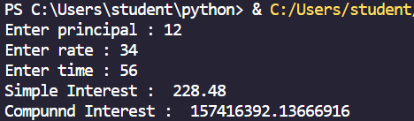

Q2.Write a program to calculate length of a string to split and join a string , to demonstrate ways to access the string in python?

# Aditya Ranjan 03-03-2014

s = "Aditya pythonation"

length = len(s)

print(f"Length of the string: {length}")

split_s = s.split()

print(f"Split string: {split_s}")

join_s = ' '.join(split_s)

print(f"Joined string: {join_s}")

print(f"First character: {s[0]}")

print(f"Last character: {s[-1]}")

***Output :***

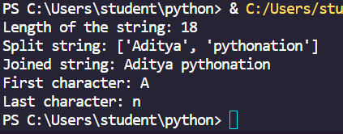

Q 3. Write a python program to perform on dictionary a) creating and inserting b) updating dictionary c) deleting from dictionary d) looping in dictionary and sorting in dictionary?

# Aditya Ranjan 10-03-2024

# Create an empty dictionary

my_dict = {}

# Insert key-value pairs

my_dict["apple"] = 5

my_dict["banana"] = 3

my_dict["cherry"] = 8

print("Original dictionary:")

print(my_dict)

# Update a value

my_dict["banana"] = 6

# Print the updated dictionary

print("\nUpdated dictionary:")

print(my_dict)

# Delete a key-value pair

del my_dict["cherry"]

# Print the dictionary after deletion

print("\nDictionary after deletion:")

print(my_dict)

# Loop through the dictionary

print("\nLooping through the dictionary:")

for key, value in my_dict.items():

print(f"{key}: {value}")

# Sort the dictionary by keys

sorted_dict = dict(sorted(my_dict.items()))

print("\nSorted dictionary by keys:")

print(sorted_dict)

***Output :***

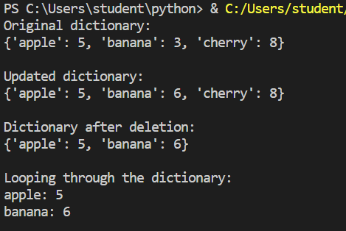

Q4. Write a function to find max & min no. from a sequence of numbers?

# Aditya Ranjan 10-03-2024

def find_min_max(numbers):

return min(numbers), max(numbers)

sequence = [10, 5, 20, 15, 8]

min_value, max_value = find_min_max(sequence)

print(f"Minimum value: {min_value}")

print(f"Maximum value: {max_value}")

***Output :***

Q5. Write a program to define a module to find fibonacci numbers and import the module to another program?

# Aditya Ranjan 10-03-2024

***Output :***