Java OOPS Assignment

Abhinav Jain

Abhinavjainn412@gmail.com

9412005184

Problem 1: Imagine a publishing company which does marketing for book and audio cassette versions. Create a Class Publication that stores the title(a String) and price(type float) of publications. From this class derive two classes: Book which adds a page count(type Int) and Tape which adds a playing time in mins(Float). Write a program that instantiates the book and tape class, allow user to enter data and display the data members. if an exception is caught, replace all the data member values with zero Value.

**import** java.util.*;

**public** **class** OopQues1 {

Scanner sc = **new** Scanner(System.***in***);

**public** **static** **void** main(String[] args) {

**try** {

Book b = **new** Book();

System.***out***.println("BookClass");

b.input();

b.display();

}

**catch**(Exception e){

System.***out***.println("Title- 0");

System.***out***.println("Price- 0");

System.***out***.println("PageCount- 0 ");

}

**try**{

System.***out***.println("TapClass");

Tap t = **new** Tap();

t.input();

t.display();

}

**catch**(Exception e){

System.***out***.println("Title- 0");

System.***out***.println("Price- 0");

System.***out***.println("Playtime- 0 ");

}

}

}

**class** Publication {

String title;

**float** price;

Publication() {

}

}

**class** Book **extends** Publication {

**int** pageCount;

**public** **void** input() {

Scanner sc = **new** Scanner(System.***in***);

System.***out***.println("Enter the title- ");

title = sc.nextLine();

System.***out***.println("Enter the price- ");

price = sc.nextFloat();

System.***out***.println("Enter the page count- ");

pageCount = sc.nextInt();

}

**public** **void** display () {

System.***out***.println("The title is- " + title);

System.***out***.println("The price is- " + price);

System.***out***.println("The page count is- " + pageCount);

}

}

**class** Tap **extends** Publication {

**int** playTime;

**public** **void** input() {

Scanner sc = **new** Scanner(System.***in***);

System.***out***.println("Enter the title- ");

title = sc.nextLine();

System.***out***.println("Enter the price- ");

price = sc.nextFloat();

System.***out***.println("Enter the play time- ");

playTime = sc.nextInt();

}

**public** **void** display() {

System.***out***.println("Title is- " + title);

System.***out***.println("Price is- " + price);

System.***out***.println("Play time- " + playTime);

}

}

**Output-**

**Normal-**

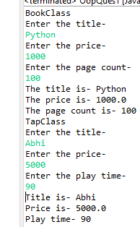

**Exception-**

Problem 2: Design and implement the Library System.

**Library.java**

**package** com.incture.LibrarySystem;

**public** **class** Library {

String title;

String authorName;

**double** bookPrice;

**public** Library() {

**super**();

}

**public** String getTitle() {

**return** title;

}

**public** **void** setTitle(String title) {

**this**.title = title;

}

**public** String getAuthor() {

**return** authorName;

}

**public** **void** setAuthor(String author) {

**this**.authorName = author;

}

**public** **double** getBookPrice() {

**return** bookPrice;

}

**public** **void** setBookPrice(**double** bookPrice) {

**this**.bookPrice = bookPrice;

}

**public** Library(String title, String author, **double** bookPrice) {

**super**();

**this**.title = title;

**this**.authorName = author;

**this**.bookPrice = bookPrice;

}

}

**LibraryService.java**

**package** com.incture.LibrarySystem;

**public** **interface** LibraryService {

**boolean** addBook(String title, String author, **double** price);

**void** showBookDetails(String title) **throws** BookNotFound;

**boolean** removeBook(String title) **throws** BookNotFound;

**boolean** issueBook(String title) **throws** BookNotFound;

**boolean** isBookAvailable(String title) **throws** BookNotFound;

}

**LibraryServicesImplementation.java**

**package** com.incture.LibrarySystem;

**import** java.util.ArrayList;

**public** **class** LibraryServicesImplementation **implements** LibraryService {

ArrayList<Library> Books = **new** ArrayList<Library>();

**public** **boolean** addBook(String title, String author, **double** price) {

Books.add(**new** Library(title, author, price));

System.***out***.println("Book added successfully");

**return** **true**;

}

**public** **void** showBookDetails(String title) **throws** BookNotFound {

**for** (Library b : Books) {

**if** (b.title.equals(title)) {

System.***out***.println("Book details are as follow:");

System.***out***.println("Author Name : " + b.authorName);

System.***out***.println("Book Title: " + b.title);

System.***out***.println("Book price is: " + b.bookPrice);

**return**;

}

}

**throw** **new** BookNotFound("No such book found in Library");

}

**public** **boolean** removeBook(String title) **throws** BookNotFound {

**for** (Library b : Books) {

**if** (b.title.equals(title)) {

Books.remove(b);

System.***out***.println("Book is removed from Library...!");

**return** **true**;

}

}

**throw** **new** BookNotFound("No such book found in Library");

}

**public** **boolean** issueBook(String title) **throws** BookNotFound {

**for** (Library b : Books) {

**if** (b.title.equals(title)) {

System.***out***.println("Book price is : " + b.bookPrice);

Books.remove(b);

System.***out***.println("Book is sued to you kindly return it within time...!");

**return** **true**;

}

}

**throw** **new** BookNotFound("No such book found in Library");

}

**public** **boolean** isBookAvailable(String title) **throws** BookNotFound {

**for** (Library b : Books) {

**if** (b.title.equals(title)) {

System.***out***.println("Book is Available");

**return** **true**;

}

}

**throw** **new** BookNotFound("No such book found in Library");

}

}

**BookNotFound.java**

**package** com.incture.LibrarySystem;

**public** **class** BookNotFound **extends** Exception {

**public** BookNotFound(String str)

{

**super**(str);

}

}

**LibraryLogin.java**

**package** com.incture.LibrarySystem;

**import** java.util.Scanner;

**public** **class** LibraryLogin {

**public** **static** **void** main(String[] args) **throws** BookNotFound {

LibraryService library = **new** LibraryServicesImplementation();

Scanner sc = **new** Scanner(System.***in***);

String title;

String authorName;

**double** bookPrice;

**while** (**true**) {

System.***out***.println(

"Enter \n 1: To add Book \n 2: showBookDetails \n 3: RemoveBook \n 4: IssueBook \n 5: check book available");

**int** choice = sc.nextInt();

**try** {

**switch** (choice) {

**case** 1:

System.***out***.println("Enter Book title");

title = sc.next();

System.***out***.println("Enter Book Author");

authorName = sc.next();

System.***out***.println("Enter Book price");

bookPrice = sc.nextDouble();

library.addBook(title, authorName, bookPrice);

**break**;

**case** 2:

System.***out***.println("Enter Book title");

title = sc.next();

library.showBookDetails(title);

**break**;

**case** 3:

System.***out***.println("Enter Book title");

title = sc.next();

library.removeBook(title);

**break**;

**case** 4:

System.***out***.println("Enter Book title");

title = sc.next();

library.issueBook(title);

**break**;

**case** 5:

System.***out***.println("Enter Book title");

title = sc.next();

library.isBookAvailable(title);

**break**;

**default**:

System.***out***.println("Invalid choice");

System.*exit*(1);

}

} **catch** (Exception e) {

System.***out***.println(e + " ");

}

}

}

}

**Output-**

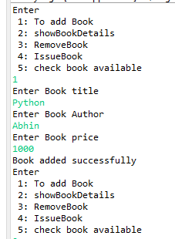

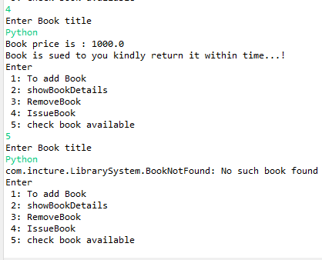

Assignment By-

Abhinav Jain

9412005184

abhinavjainn412@gmail.com