**String Handling**

Q1 .Write a program that computes your initials from your full name and displays them.

**import** java.util.*;

**public** **class** W2Ques1 {

**private** **static** String initials_Print(String str) {

**if** (str.length() == 0)

**return** "";

String sq="";

sq=sq+Character.*toUpperCase*(str.charAt(0));

**for** (**int** i = 1; i < str.length() - 1; i++)

**if** (str.charAt(i) == ' ' && str.charAt(i+1)!=' ')

sq=sq+ Character.*toUpperCase*(str.charAt(i + 1));

**return** sq;

}

**public** **static** **void** main(String[] args)

{

Scanner sc= **new** Scanner(System.***in***);

System.***out***.print("Enter a string: ");

String str= sc.nextLine();

System.***out***.print("Initials are: "+*initials_Print*(str));

}}

OUTPUT-

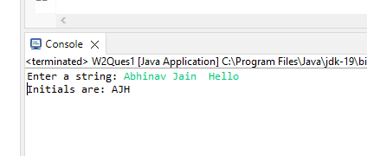

Q2. Show two ways to concatenate the following two strings together to get the string “Incture Tech"•String str1 = “Incture”•String str2 = “Tech"

**import** java.util.Scanner;

**public** **class** W2Ques2 {

**public** **static** **void** main(String args[]){

Scanner sc= **new** Scanner(System.***in***);

System.***out***.print("Enter s1: ");

String s1= sc.nextLine();

System.***out***.print("Enter s2: ");

String s2= sc.nextLine();

String s3=s1.concat(s2);

System.***out***.print("Concatenation Method1: ");

System.***out***.println(s3);

String s = s1+s2;

System.***out***.print("Concatenation Method2: ");

System.***out***.println(s.toString());

}

}

OUTPUT-

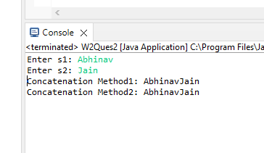

Q3. String sam = "Did Sam see bees? Sam did.";

Q:What is the value displayed by the expression sam.length()?

Q: What is the value returned by the method call sam.charAt(12)?

Q: Write an expression that refers to the letter b in the string referred to by sam.

**import** java.util.Scanner;

**public** **class** W2Ques3 {

**public** **static** **void** main(String args[]){

String sam = "Did Sam see bees? Sam did.";

System.***out***.println(sam.length());

System.***out***.println(sam.charAt(12));

System.***out***.print(sam.charAt(12));

}

}

OUTPUT-

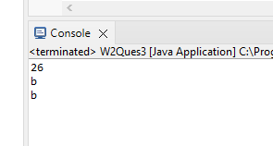

Q4. Write a small program to find if a string is palindrome.e.g. amma, 1221

**import** java.util.Scanner;

**public** **class** W2Ques4 {

**public** **static** **void** main(String args[]) {

Scanner sc= **new** Scanner(System.***in***);

System.***out***.print("Enter a string: ");

String str= sc.nextLine();

**int** zz=0;

**for** (**int** i=0;i<str.length();i++){

**if**(str.charAt(i)!=str.charAt(str.length()-i-1)) {

zz=1;

**break**;

}

}

**if** (zz==0) {

System.***out***.println(str + " is a Palindrome String.");

}

**else** {

System.***out***.println(str + " is not a Palindrome String.");

}

}

}

OUTPUT-

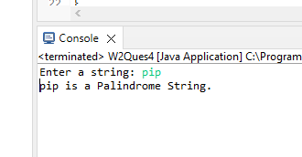

Q5. Write a program to print duplicate characters from a user input string

**import** java.util.Scanner;

**public** **class** W2Ques5 {

**public** **static** **void** main(String args[]) {

Scanner sc= **new** Scanner(System.***in***);

System.***out***.print("Enter a string: ");

String string1= sc.nextLine();

**int** count;

**char** string[] = string1.toCharArray();

System.***out***.println("Duplicate characters: ");

**for**(**int** i=0; i<string.length;i++){

count = 1;

**for**(**int** j=i+1;j<string.length;j++){

**if**(string[i]==string[j] && string[i]!=' '){

count++;

string[j]='0';

}

}

**if**(count>1&&string[i]!='0')

System.***out***.println(string[i]);

}

}

OUTPUT-

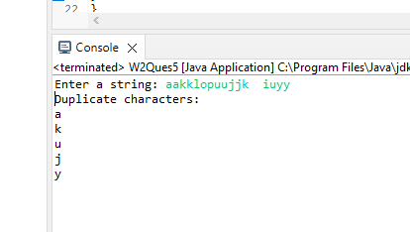

Assignment By-

Abhinav Jain

9412005184

[abhinavjainn412@gmail.com](mailto:abhinavjainn412@gmail.com)

Graphic Era University