**AN EFFICIENT MULTI-PROTOCOL GATEWAY DESIGN USING ESP32 FOR INDUSTRY 4.0 AND ELECTRIC VEHICLE**

**Lakshmiprabha Balaji\*, Akanksha Singh\*\*, Ganesh Pise\*\*, Sagar Bawane\*\***

\* Assistant Professor, Departement of Electronics and Telecommunication Engineering, DYPIEMR, Akurdi

**\*\***Student, Departement of Electronics and Telecommunication Engineering, DYPIEMR, Akurdi

|  |  |  |
| --- | --- | --- |
| **Article Info** |  | **ABSTRACT** |
| ***Article history:***  Received August 12th, 2018  Revised Oct. 30th, 2018  Accepted Nov. 10th, 2018 |  | Viewing all electronic system connected around the world in order to interchange information i.e. THE INDUSTRIAL INTERNET OF THING (IIOT) is no more dreams, but a reality. Present situation is such that the industrial equipment companies are expanding (IIOT) by creating complex systems that integrate sensors, processors and communication to create intelligent factories, smart grids and even smart cities. Also electric vehicles are making names for themselves as upcoming technology. A Gateway is a network of node that connects two networks using different protocols together. Bridge is used to join two similar types of networks; similar to that a gateway is used to join two dissimilar networks. Through this gateway we can receive the data as-well-as sort the data and store it in cloud. So our proposed work is aimed at an effective gateway using multi-protocol which can be used in industry-4.0 and electric vehicle to perform different thing. |
| ***Keyword:***  IIOT  Gateway  Technology  Industry 4.0  Cloud |
|  |
|  | | |

1. **INTRODUCTION**

Next generation factories require improvements, in order to maximize profitability, more flexibility in their layouts, more information about the process and manufactured products more intelligence in the processing of these data and an Next generation factories require improvements, in order to maximize profitability, more flexibility in their layouts, more information about the process and manufactured products more intelligence in the processing of these data and an effective integration of the human experience interaction .However, as new technology is introduced into the factory sector, some rules must be respected.

The main thing of industries is that production cannot stop. New technologies must be compatible with old systems, and interoperability between vendors should be facilitated. Furthermore, the solutions should provide a means to support real-time operation, cyber security and in some cases, safety.

Effective integration of the human experience interaction .However, as new technology is introduced into the factory sector, some rules must be respected. The main thing of industries is that production cannot stop. New technologies must be compatible with old systems, and interoperability between vendors should be facilitated. Furthermore, the solutions should provide a means to support real-time operation, cyber security and in some cases, safety. An IOT gateway provides the means to bridge the gap between devices in the field (factory floor, home, etc.); the cloud, where data is collected, stored and manipulated by enterprise applications; and the user equipment (Smartphone, tablets etc.). The IOT gateway provides a link which can be use to communicate between devices and cloud.

A Gateway is a network of node that connects two networks using different protocols together. Bridge is used to join two similar types of networks; similar to that gateway is used to join two dissimilar networks. Through this gateway we can receive the data as-well-as sort the data and store it in cloud.

The CAN module will be connected to the car which will send the status of battery, fuel, engine etc. The cloud is used to collect the data and then analyze it in a proper way which will be sent to the user. The cloud which we are going to use first is Ubidots which has simple cloud computing operations. Then we will be using AWS (Amazon Web Server) which will handle big data.

1. **LITERATURE REVIEW**

The paper“**Study** **on IOT architecture and gateway technology**”published in 2014 contains the information about IOT architecture and gateway technologies.From this research paper we learn about the gateway and how different communication protocols are connected using gateway. Figure1 shows the processing module structure. Paper also explained about upcoming technologies in the market related to gateways and also the impact of new gateways on IOT world.

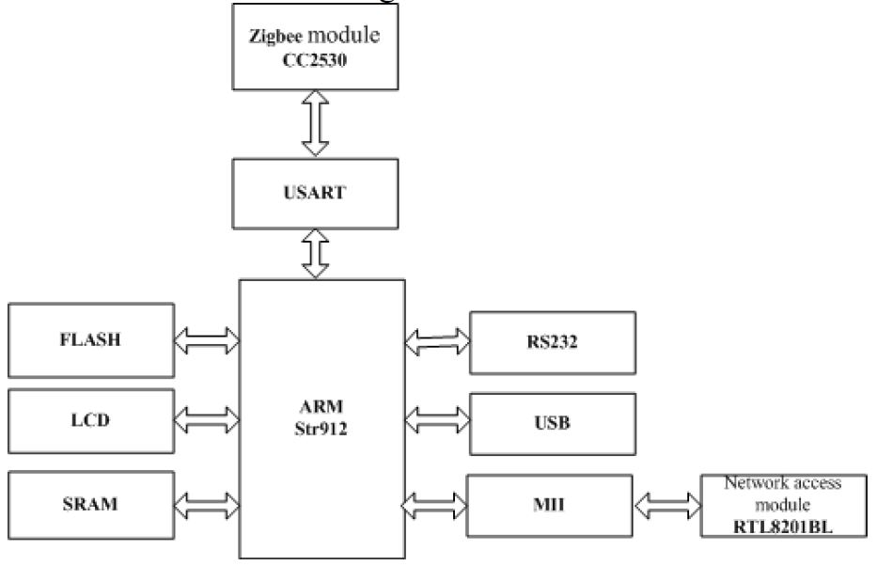

Figure1. ARM Based processing module

The paper “**Smart** **vehicles management system by using gateway, Hand-set and vmp**”published in 2007 explained about all upcoming smart vehicles and brief us about all the technologies present in vehicle which make it as smart vehicles. Paper also contains the information about CAN module and how it can be used in vehicles to vehicles communication. And paper has detailed description about the role of gateway in smart vehicles. Below Fig2. shows the block diagram of the gateway.

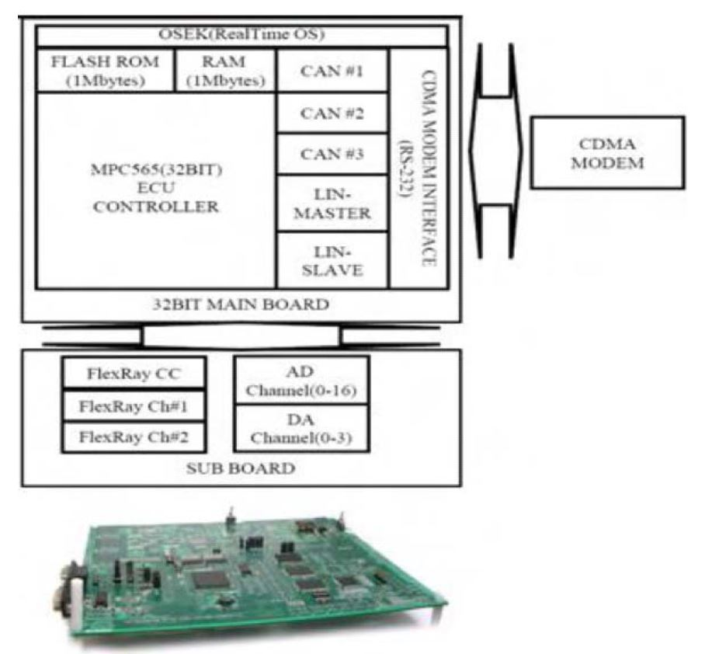

Figure 2. Block Diagram and Picture of Gateway System.

The paper “**Telematics gateway and power saving method for electric vechicle**”has thorough detailed about electric vehicle and also contain information regarding its charaterstics. It contains the information related to gateways in electric vehicles and also contain description related to batteries, its mechanism of charging and discharging, control etc. Figure below shows the diagram of the power saving application.

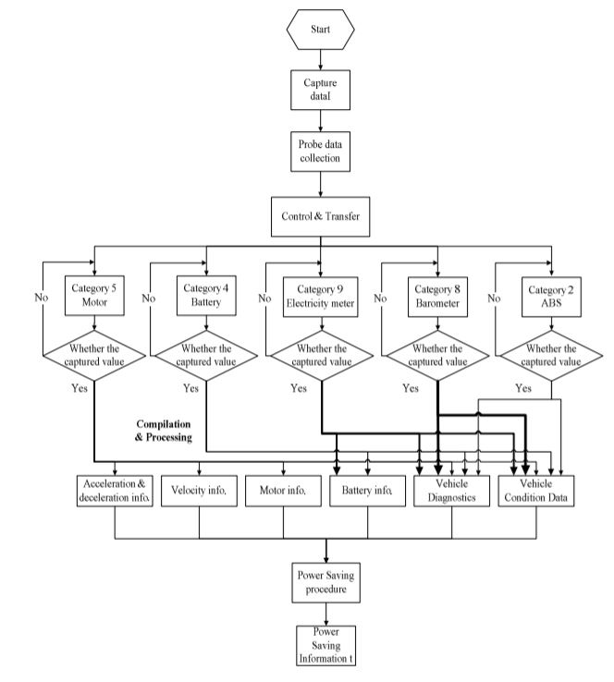

Figure 3. Flow chart of Power saving application scenario

1. **METHODOLOGY**

**A. Block Diagram**

**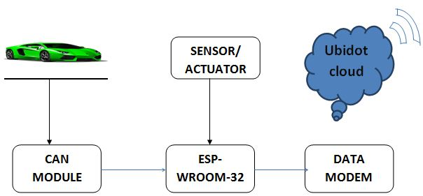**

Figure4. Block Diagram of Gateway

**B. Description**

* The CAN Module is connected to the car which receives the signals from the car about the car battery, fuel, engine, water level, oil, etc. It is constantly detected and sends to the user.
* This data is send to the user via the ESP-32 Module which is a Wi-Fi module which will send this generated data to the user as shown in Figure4.
* Data Modem is short form of modulator-demodulator. A data modem is a device that enables a computer to transmit data over. Computer information is stored in 0 and 1 form, whereas information transmitted over telephone lines is transmitted in the form of analog waves.
* As this data is too big we have to store it in the cloud. At first we will be using the cloud naming Ubidots which will be having simple functions of cloud. Then we will be using AWS (Amazon Web Server) which will then conduct various functions such as data handling and analyzing at same time.

1. **CONCLUSION**

We attempted to make a gateway using esp32 that can be used with electric vehicles and industry 4.0.Basically the gateway should work as communication device between thepoint of collecting the data and sending the data. The role of gateway in industry 4.0 is to collect the data from source giving collected data to a device which can process it and then transmitting the data to destination between the processes of collecting and receiving data there may be different protocol present depending on application. Also our aim is to use this gateway in electric vehicles where we planned to use can module for vehicles to vehiclescommunication and there may be some actuators and sensors present for different purposes. The work of gateway is to combinable collect information are pass on to cloud.

1. **ACKNOWLEDGEMENTS**

Our sincere gratitude towards the faculty members who helped us, special thanks to H.O.D Mrs.Priya Charles for the official support given and encouragement .We are thankful to our external project coordinators Mrs. Sumedha ma’am for their guidance .We also like to thank our project guide Mrs.B. Lakshmipraba ma’am for their extended support.Finally, we would like to thanks all our staff members of E&TC department who helped us directly or indirectly to complete this works successfully.

1. **REFERENCES**
2. E. Gioia, P. Passaro, and M. Petracca, “Amber: An advanced gateway solution to support heterogeneous iot technologies,” in 24th International Conference on Software, Telecommunications and Computer Networks (SoftCOM). IEEE, 2016, pp. 1–5.
3. “Modbus tcp,” <http://www.modbus.orgdocs> Modbus Messaging Implementation Guide V1 0b.pdf, 15<https://www.iotivity.org/>,.
4. “Kaa iot platform,” <https://www.kaaproject.org>,
5. J.G. Falcioni, "Mastering the Fourth Industrial Revolution,” Mehanical Engineering, Vol. 138 (3), pp. 6, March 2016.
6. M. Waidner, and M. Kasper, "Security in Industrie 4.0 - 'Towards a Semantic Administrative Shell for Industry 4.0 Components, " 2016 IEEE Tenth International Conference on Semantic Computing (ICSC), pp. 230-7, February 2016 challenges and solutions for the fourth industrial revolution, "
7. B. Vogel-Heuser, J. Weber, and J. Folmer, "Evaluating reconfiguration abilities of automated production systems in Industries 4.0 with metrics,” 2015 IEEE 20th Conference on Emerging Technologies & Factory Automation (ETFA), September 2015. 4906 2016 Design, Automation & Test in Europe Conference & Exhibition (DATE), pp. 1303-8, March 2016. [25] AR.

**BIBLIOGRAPHY OF AUTHORS**

|  |  |
| --- | --- |
| DSC_8643.JPG | **B.Lakshmipraba** received the B.E.degreee in Electronics and Instrumentation Engineering from Madras University in 2001 and M.E. degree in Applied Electronics from Anna University in 2010. Currently she is pursuing Ph.D in Electronics in Sathyabama University. She has 14 years of Teaching experience in various Engineering colleges in Chennai and Pune. Currently working as Assistant Professor in Dr. D.Y.Patil Institute of Engineering, Management and Research, Akurdi, Pune. |
|  |  |
| Passport photo.jpg | **Akanksha Singh** pursuing the B.E.degreee in Electronics and Telecommunication Engineering from Savitribai Phule Pune University in 2019 in Dr. D.Y.Patil Institute of Engineering, Management and Research, Akurdi, Pune. |
|  |  |
| scanner_20181012_155101.jpg | **Ganesh Pise** pursuing the B.E.degreee in Electronics and Telecommunication Engineering from Savitribai Phule Pune University in 2019 in Dr. D.Y.Patil Institute of Engineering, Management and Research, Akurdi, Pune. |
|  |  |
| scanner_20181012_155302.jpg | **Sagar Bawane** pursuing the B.E.degreee in Electronics and Telecommunication Engineering from Savitribai Phule Pune University in 2019 in Dr. D.Y.Patil Institute of Engineering, Management and Research, Akurdi, Pune. |