**Variable Length Intake Runner for a 125cc Single Cylinder Petrol Engine**

**Mr. Amol Mali, Hritik Ratnakar Patil, Anish Shashank Karnik, Aditya Balkrishna Mapari, Pranav Vinod Patil**

Department of Mechanical Engineering, DYPIEMR, Akurdi

[amol.mali@dypiemr.ac.in](mailto:amol.mali@dypiemr.ac.in)\*, [hritik.patil@student.dypiemr.ac.in](mailto:hritik.patil@student.dypiemr.ac.in), [anish.karnik@student.dypiemr.ac.in](mailto:anish.karnik@student.dypiemr.ac.in), [aditya.mapari@student.dypiemr.ac.in](mailto:aditya.mapari@student.dypiemr.ac.in), [pranav.patil@student.dypiemr.ac.in](mailto:pranav.patil@student.dypiemr.ac.in)

|  |  |  |
| --- | --- | --- |
| **Article Info** |  | **ABSTRACT** |
| ***Article history:***  Received July 14th, 2018  Revised Oct. 13th, 2018  Accepted Dec. 24th 2018 |  | Conventional Internal Combustion Petrol engines run on a mixture of air and fuel which are mixed and homogenized in carburetors. The air is sucked in from environment through an intake manifold which has a filter at its entry. The manufacturers who develop and sell motorcycles install a fixed length intake runner based on the data accumulated while testing. But this length of intake runner has a significant effect on the power output and efficiency of the engine. Varying this length according to the engine speed enhances many parameters. Our primary objective is to develop a system which varies the intake runner length according to engine speed. |
| ***Keyword:***  Intake Runner  Fixed Length  Variable Length  Efficiency  Power Output. |
|  |
|  | | |

1. **INTRODUCTION**

Internal Combustion engines have an intake manifold from which air is sucked from external environment. The air enters through an air filter which is placed at the entrance of the intake runner. The length of this intake runner is fixed by the motorcycle manufacturers based on the test results.

But this length of intake runner has a significant effect on the power output and efficiency of the engine. The manufacturers install an intake runner of length which is average of all the lengths required at the rpm range of the engine. This is to reduce material, weight, complexity and cost of the system.

An intake system consists of three main parts:

* Filter which is normally a special paper element, conical in shape and provides filtered air from dust and dirt particles to the engine.
* Then from Filter to Plenum Runner is the tube (pipe) which provides the air from filter to the plenum.
* And then the Plenum, it is the reservoir of air that supplies the engine with equal amount of air. The Intake Runners are the tubes that take the air from plenum to the throttle bodies.

1. **EXISTING VARIABLE LENGTH INTAKE RUNNER SYSTEM**

* Ford’s Variable Intake Manifold

Ford 2.5 Duratec V6, used separate long and short pipes, which is easily visible here. The short pipes go to the nearest cylinder bank while the long pipes go to the opposite bank. Such arrangement is space engaging. The lack of space leads to narrower pipes used, thus it is not very suitable to high-performance engines.

* Honda’s Variable Intake Manifold

Honda K20C engine, have their long and short intake paths sharing the same manifolds. At low rpm, the air runs through the long manifold; At high rpm, a valve opens to a short-cut path, thus the air joins the manifold at later stage.

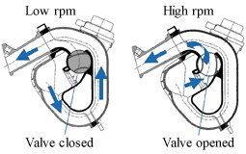

**Fig. 1** Honda VLIM

* Audi’s Variable Intake Runner

Shown here is the Audi 4.2-liter 40-valve V8 used in the late 1990s to mid-2000s. Its VLIM system is located inside the V-valley to save space. There are two flaps inside the system. With both closed, the fresh air runs through the full length of manifold. With one flap opens, the air runs through a short-cut path. With another flap opens, an even shorter path is established.

**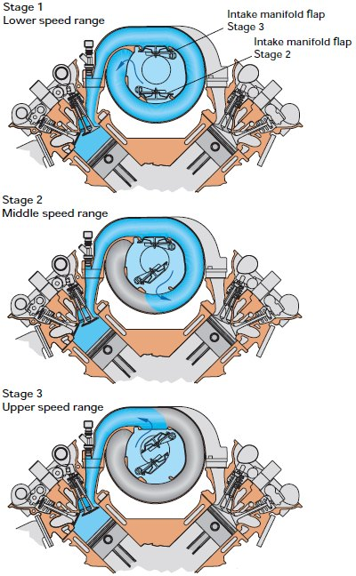**

**Fig. 2** Audi VLIM

* Ferrari LaFerrari’s Variable Intake Runner

Its V12 engine utilizes 2 sets of trumpets (the black ones in picture below)  which can move within the intake plenums, varying the effective length of intake manifolds. The trumpets are moved by hydraulic actuators located between the two plenums. In the F12tdf, the trumpets vary between long and short positions, but theoretically this design can be easily modified to vary continuously between the two positions. One shortcoming of this design is limited range of adjustment. As the movable trumpets are quite short, the difference beween long and short modes are not as big as conventional VIM systems. However, this problem could be solved by using multiple trumpet sections working in telescopic style.

**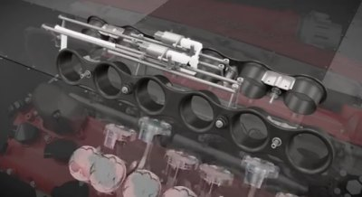**

**Fig. 3** LaFerrari VLIM

* BMW’s Variable Intake Manifold

The intake manifold of each cylinder is arranged in circular shape and half-recessed into the V-valley. The inner wall is actually a rotor, on which the air inlet is located. When the rotor swivels, the position of the air inlet moves in relation to the outer housing of manifold. This varies the effective length of the intake manifold, from a maximum 673 mm to 231 mm.

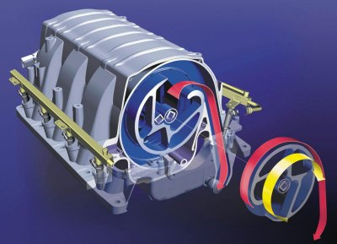

**Fig. 4** BMW’s VLIM

* Ducati’s Variable Intake Manifold

**The Desmosedici Stradale engine breathes thanks to four oval throttle bodies with equivalent diameter of 52 mm, connected to variable height intake funnels mounted for the first time on a Ducati engine. This solution makes it possible to optimise cylinder filling at all rotation speeds with important benefits in terms of power and rideability.  
Depending on the rotation speed and the torque required by the rider, the intake funnels take on a configuration that lengthens or shortens the duct, making it possible to influence the fluid dynamics of the pressure waves that run along the duct.The system is controlled by the engine control unit and is made up of two stages: a fixed funnel placed on the throttle body and a mobile one that slides, running along steel guides and moved by an electric motor. When it is lowered, it comes into contact with the short funnel resulting in a geometric elongation of the duct.**

**When it rises, the fluid dynamics sees only the fixed funnel underneath and therefore the engine configuration has only a very short duct.Each throttle body is equipped with two injectors: one below the throttle specifically for low load conditions and one above that is activated when the engine is asked to perform at a higher level. The throttle bodies of each bank are driven by a dedicated electric motor that, thanks to the Full Ride by Wire system, allows complex electronic control strategies to modulate the engine's character in relation to the riding mode chosen by the rider.**

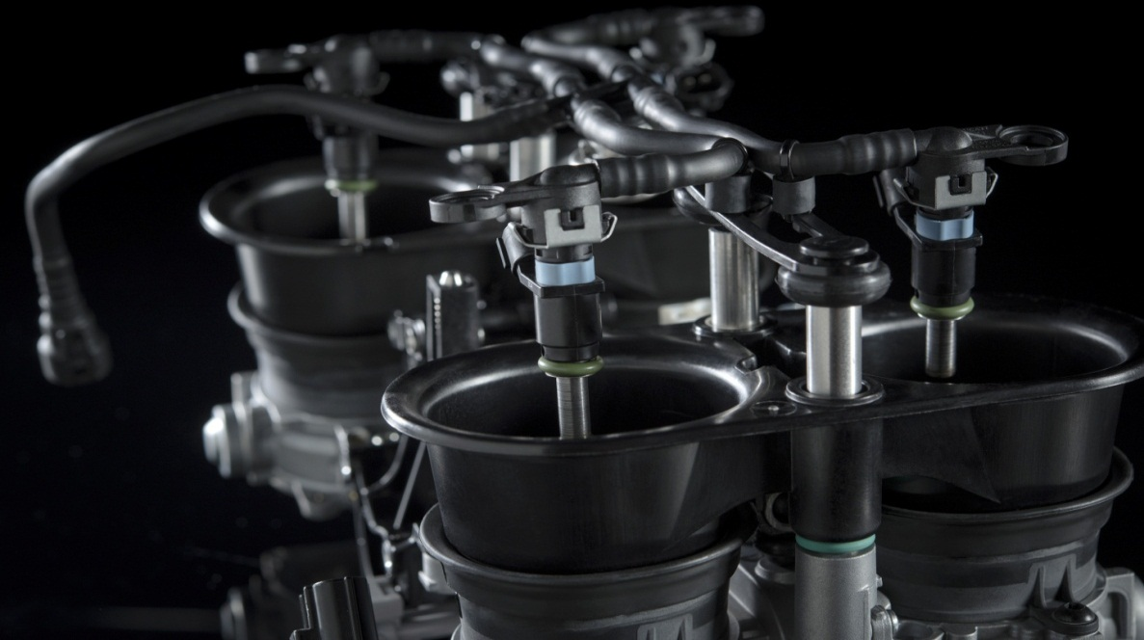

**Fig. 5 Ducati VLIM**

1. **PROPOSED VARIABLE LENGTH INTAKE RUNNER SYSTEM**

Instead of using multiple pipes of different lengths, we propose to use a pipe having variable length and diameter and extend and retract it using a telescopic system. Using the telescopic system we will save space, cost and reduce the complexity of the system. Having an intake runner of longer length at lower RPMs will increase the pressure and turbulence in the manifold which enhances the performance of the engine. On the contrary, having shorter length intake runner at higher RPMs is effective because at higher RPMs, the valve speed is very high and the engine sucks the charge at extremely high rates.

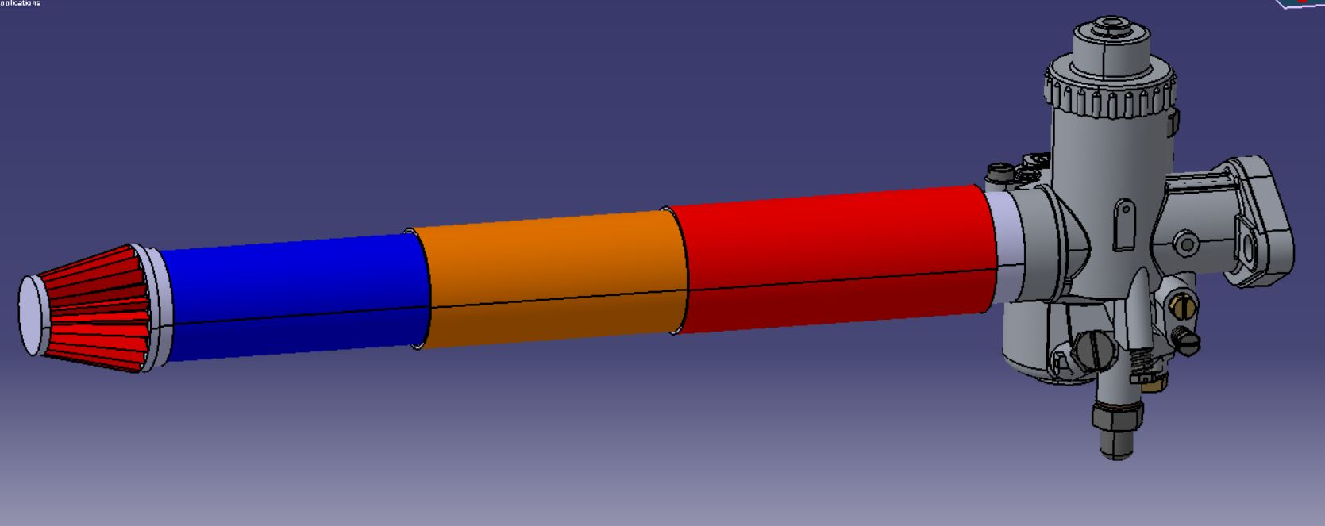

**Fig. 6** Proposed new system

1. **INTERDISCIPLINARY APPROACH**

For integrating our system with the existing intake system, we need to calibrate and tune the engine rpm with the microcontroller.

Hence, electronics will play an important role in the actuation of the mechanism.

As the rpm will vary, the microcontroller will send signals to the servomotor and it will accordingly move the sliding mechanism which operates the telescopic system.

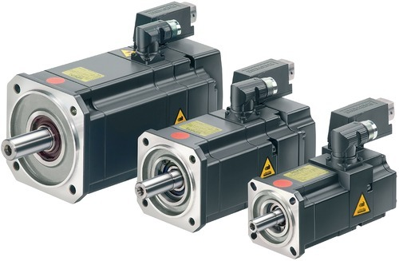

**Fig**.**7** Servo Motor

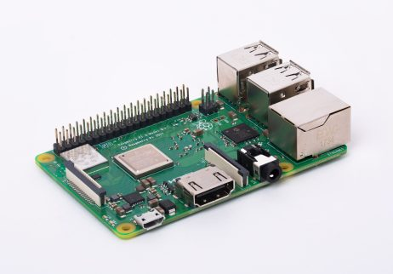

**Fig**.**8** Microcontroller

1. **ENGINE**

The Engine which we are using is a 125cc Petrol engine of Bajaj Discover 125T,

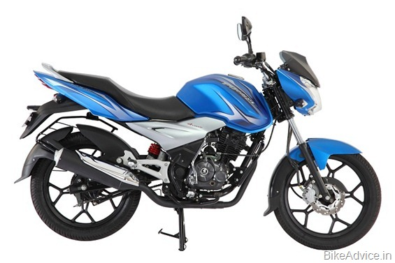

**Fig**. **9** Bajaj Discover 125T

|  |  |
| --- | --- |
| **Parameter** | **Specification** |
| Displacement | 124.6 cc |
| Type | Air cooled, 4 Stroke |
| No. of Cylinders | 1 |
| No. of valves per cylinder | 4 |
| Max. Power | 12.3 HP @ 9000 rpm |
| Max. Torque | 10.8 Nm @ 6500 rpm |
| Bore X Stroke | 57 X 49 mm |
| Fuel type | Petrol |

**Table 1** Engine Specifications of Bajaj Discover 125T

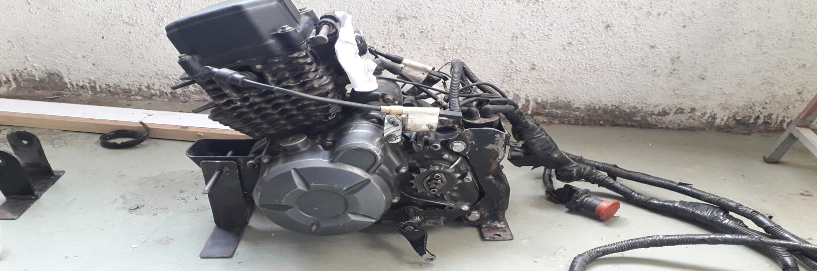

**Fig. 10** Engine of Bajaj Discover 125T

1. **RESEARCH METHOD**

After our study and research, we decided to go with David Vizard’s Theory on Intake Runner Length. The general rule is that we begin with a runner length of 17.8cm for a 10,000rpm peak torque location, from intake opening to the plenum chamber. Then we add 4.3cm to the runner length for every 1000rpm.

Calculations:

* + For 2000rpm, Runner Length = 52.2cm
  + For 3000rpm, Runner Length = 47.9cm
  + For 4000rpm, Runner Length = 43.6cm
  + For 5000rpm, Runner Length = 39.3cm

The length from the carburetor intake to the inlet valve is fixed i.e. 14cm.

Hence, after numerous iterations, we have reached a conclusion that we will use a two pipe/section telescopic arrangement. The section 1 i.e. the section attached to the carburetor is 23cm long whereas the section between the section 1 and air filter is 17cm long. By proper actuation we can achieve the previously mentioned runner lengths for the respective engine speed.

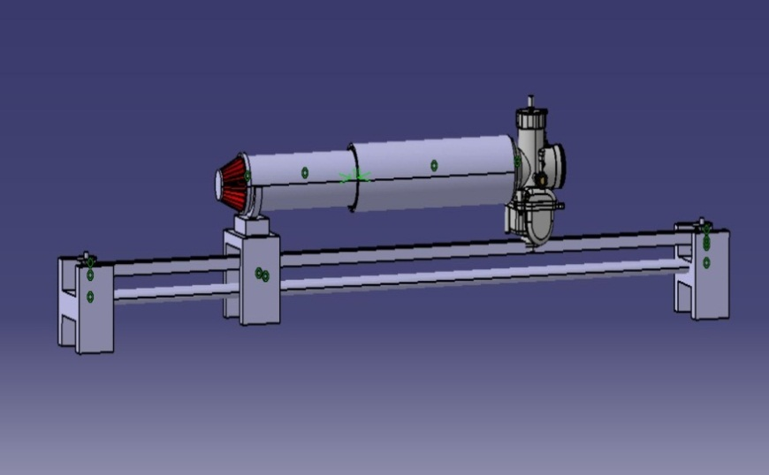

**Fig**. **11** Assembly of the system

1. **IMPORTANCE**

* Excellent alternative to the existing system as it provides power throughout the rpm range of engine.
* Explores a new field of flexible intake manifolds.
* With an interdisciplinary approach this system will ensure reliability.
* New materials can be explored for low cost and low weight intake manifolds.
* So, if the project is successful, we can file for design patent.

1. **CONCLUSION**

From the above setup,

1. Overall Efficiency of the engine may increase.
2. Power output of the system may increase.

**REFERENCES**

1. Designing and Validating a New Intake Manifold for a Formulae SAE Car (2016), International Journal of Engineering, Research and Technology (IJERT), ISSN: 2278-0181
2. Development Of A New Air Intake And Exhaust System For ASingle Seat Race Car (2011), Proceedings of the ITRN2011.
3. Analysis of Variable Intake Runner Lengths and Intake Valve Open Timings on Engine Performances (2014), Applied Mechanics and Materials, ISSN: 1662-7482, Vol. 663, pp 336-341
4. Intake plenum volume and its influence on the engine performance, cyclic variability and emissions (2005), Department of Mechanical Engineering, Faculty of Engineering, University of Atatu¨rk, Erzurum 25240, Turkey
5. Development of an engine variable geometry intake system for a Formula SAE application (2015), 69th Conference of the Italian Thermal Machines Engineering Association, ATI2014
6. Design of a new SI engine intake manifold with variable length plenum (2015), Energy Conversion and Management 51 (2010) 2239–2244
7. Intake plenum volume and its influence on the engine performance, cyclic variability and emissions, Energy Conversion and Management 48 (2007) 961–966
8. A Review Paper On Effect Of Intake Manifold Geometry On Performance Of IC Engine, IJARIIE-ISSN (O)-2395-4396 Vol-2 Issue-2 2016

1. A Review Paper on Effect of Intake Manifold Design on C.I Engine Performance and Soot Formation, International Journal of Innovative Research in Science, Engineering and Technology (IJIRSET), Vol. 6, Issue 10, October 2017
2. Study of Design Improvement of Intake Manifold of Internal Combustion Engine, International Journal of Engineering Technology, Management and Applied Sciences, March 2015, Volume 3 Special Issue, ISSN 2349-4476

**BIBLIOGRAPHY OF AUTHORS**

|  |  |
| --- | --- |
| Description: 2018_09_17 9_06 am Office Lens-01.jpeg | HRITIK RATNAKAR PATIL  [hritik.patil@student.dypiemr.ac.in](mailto:hritik.patil@student.dypiemr.ac.in)  Department of Mechanical Engineering, DYPIEMR, Akurdi, Pune |
|  |  |
| Description: AKPP_1_Anish Karnik photo-1.jpg | ANISH SHASHANK KARNIK  [anish.karnik@student.dypiemr.ac.in](mailto:anish.karnik@student.dypiemr.ac.in)  Department of Mechanical Engineering, DYPIEMR, Akurdi, Pune |
|  |  |
| Description: New Doc 2018-11-21 (1)_1-1.jpg | ADITYA BALKRISHNA MAPARI  [aditya.mapari@student.dypiemr.ac.in](mailto:aditya.mapari@student.dypiemr.ac.in)  Department of Mechanical Engineering, DYPIEMR, Akurdi, Pune |
|  |  |
| Description: New Doc 2018-11-21 11.59.05.jpg | PRANAV VINOD PATIL  [pranav.patil@student.dypiemr.ac.in](mailto:pranav.patil@student.dypiemr.ac.in)  Department of Mechanical Engineering, DYPIEMR, Akurdi, Pune |
|  |  |
| Description: RSR_2065-_AM-small.jpg | PROF. AMOL MALI  [amol.mali@dypiemr.ac.in](mailto:amol.mali@dypiemr.ac.in)  Department of Mechanical Engineering, DYPIEMR, Akurdi, Pune |