1. Go to carrerbuild folder
2. then type the command

scrapy crawl dmoz_carrer -o res1.csv

scrapy crawl dmoz_website -o res2.csv

1. If you are changing the res1.csv name or res2.csv name by your own csv then you have to replace the file name in script3.py

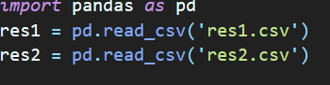

1. Run the command

python script3.py

1. Your output file will be there as named csvEXAMPLE.csv.
2. If you want to change the name of the file then change the file name here.

