1. Copy the link from craiglist website

https://losangeles.craigslist.org/d/retail-wholesale/search/ret

1. Paste it before the blue marker

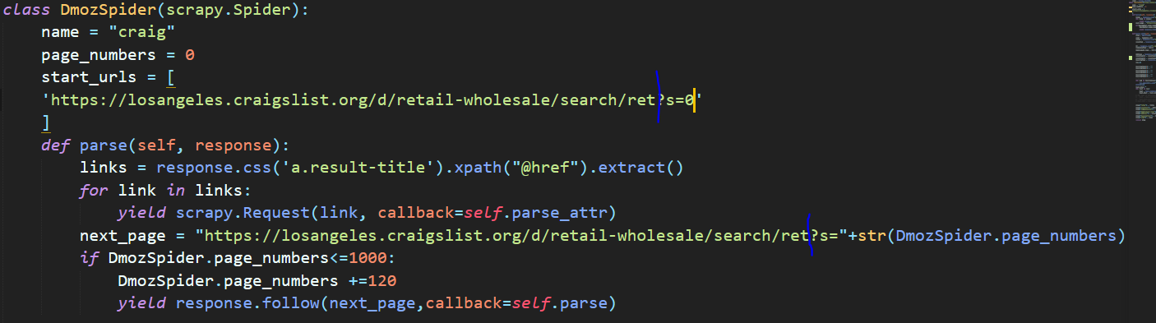

1. Run the script

scrapy crawl craig -o res1.csv