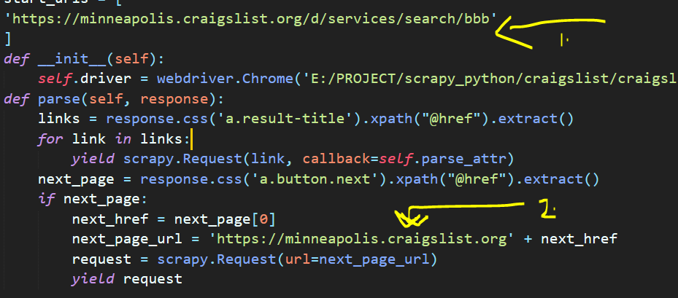

These are the links where you have to change while scraping the links.  
1. Will be the original link and 2. Is the half link