1. If you want to search anything other than the given link and scrape. Just replace these two links.

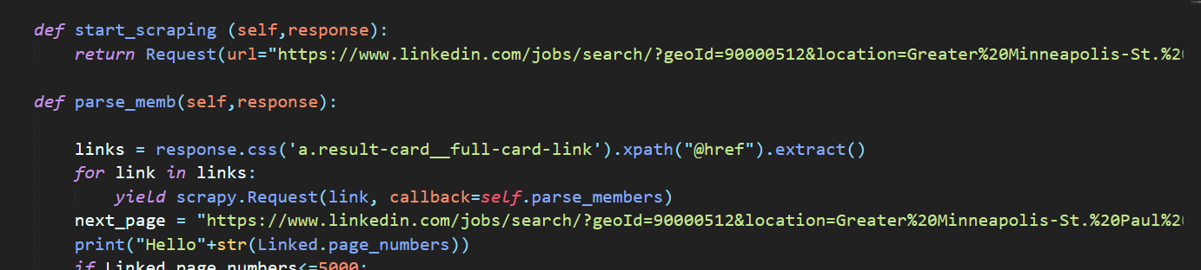

1. Go to scrapy folder named linkedin and type the following command

scrapy crawl linked -o res2.csv

Note : This code will scrape only first page after getting the confirmation that everything is correct.