Report
Of
Cloud Virtual Internship
Submitted
To
School of Computer Science and Engineering
IILM University, Greater Noida, U.P.
In partial fulfilment of the requirement of degree of
B.Tech CSE

By
Roll Number of Student: 2410031548
Name of Student: ABHINAV SAHAI KAMTHAN
Section: 3CSE19
Batch:
2024-28
CANDIDATE'S DECLARATION
I, Abhinav Sahai Kamthan, do hereby declare that the internship report titled “Cloud Virtual Internship” has been completed by me to fulfil the requirement for the award of the degree of Bachelor of Technology in Computer Science and Engineering. All the references have been quoted and I have not taken as such any material from any other source. I affirm that this report is my own work and has not been submitted to any other institute for any degree/diploma requirement, and further I shall be solely responsible for any kind of copyright violation in this regard.

Student Name: Abhinav Sahai Kamthan
Roll No.: 2410031548
Section : 3CSE19

ACKNOWLEDGEMENT
I am using this opportunity to express my gratitude to everyone who supported me throughout the AWS Cloud Virtual Internship Program. I am thankful for their aspiring guidance, invaluably constructive criticism and friendly advice during this work. I am sincerely grateful to them for sharing their truthful and illuminating views on a number of issues related to this work.
I would like to express my sincere gratitude to AICTE, the Ministry of Education, the National Internship Portal, and EduSkills for providing me the opportunity to undertake this virtual internship. I also thank AWS Academy for providing the curriculum and learning resources that made this internship possible, and the School of Computer Science and Engineering, IILM University, Greater Noida, for their continuous support and encouragement.
I express my gratitude to my parents for their blessings.

Student Name: Abhinav Sahai Kamthan
Roll No.: 2410031548
Section : 3CSE19

INTERNSHIP COMPLETION CERTIFICATE
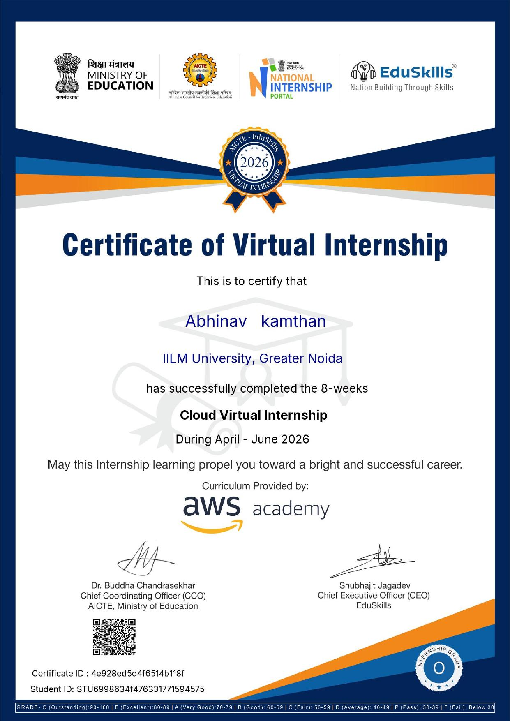

TABLE OF CONTENTS
Chapter No. | Chapter Name | Page Nos.
 | Cover Page | ---
1. | Candidate's Declaration | i
2. | Acknowledgement | ii
3. | Internship Completion Certificate | iii
4. | Project Description | 1
 | 4.1 Introduction | 1
 | 4.2 Organization Profile | 2
 | 4.3 Problem Statement | 3
 | 4.4 Project Objectives | 3
 | 4.5 Scope of the Project | 4
 | 4.6 Technologies and Tools Used | 5
 | 4.7 System Architecture | 6
 | 4.8 Methodology | 7
 | 4.9 Expected Outcomes | 8
 | 4.10 Certificate of Completion and Communication Proof | 9
5. | Bibliography/References | 10

CHAPTER 4: PROJECT DESCRIPTION
4.1 Introduction
The rapid adoption of cloud computing across industries has created a strong demand for skilled professionals who understand cloud architecture, deployment models, and service offerings. To bridge this gap between academia and industry, the All India Council for Technical Education (AICTE), in association with the Ministry of Education's National Internship Portal and EduSkills, launched the AICTE-EduSkills Virtual Internship Program. Under this initiative, I undertook an 8-week Cloud Virtual Internship, with the curriculum provided by AWS Academy, during the period April–June 2026.
The internship was designed to provide hands-on exposure to Amazon Web Services (AWS), covering the fundamentals of cloud computing, core AWS services, cloud architecture principles, and best practices for designing secure, scalable, and cost-efficient cloud solutions. As a virtual internship, all sessions, hands-on labs, and assessments were conducted online, allowing students from across the country to participate and build practical cloud computing skills relevant to current industry requirements.
4.2 Organization Profile
The internship was jointly facilitated by the following organizations:
- AICTE (All India Council for Technical Education): A statutory body under the Ministry of Education, Government of India, responsible for planning, promotion, and coordination of technical education across the country.
- National Internship Portal: A Ministry of Education initiative that connects students with internship opportunities offered by various industry and academic partners.
- EduSkills: A skilling and training organization that partners with AICTE to design and deliver industry-aligned virtual internship programs, working under the mission of “Nation Building Through Skills.”
- AWS Academy: Amazon Web Services' global education program that provides free, ready-to-teach cloud computing curriculum to higher education institutions, enabling students to build in-demand cloud skills using the AWS platform.
Together, these organizations designed and delivered a structured curriculum that combined self-paced learning modules, hands-on labs in the AWS Management Console, and periodic assessments to evaluate learning outcomes.
4.3 Problem Statement
Traditional computer science curricula often do not keep pace with the fast-evolving landscape of cloud technologies. Students graduate with strong theoretical foundations but limited practical exposure to real-world cloud platforms used by the industry. There is, therefore, a need for a structured, hands-on program that introduces students to cloud computing concepts and enables them to gain practical experience in provisioning, configuring, and managing cloud resources, so that they are better prepared for roles in cloud engineering, DevOps, and infrastructure management.
4.4 Project Objectives
- To understand the fundamental concepts of cloud computing, including deployment models (public, private, hybrid) and service models (IaaS, PaaS, SaaS).
- To gain hands-on experience with core AWS services such as EC2, S3, IAM, VPC, RDS, and Lambda.
- To learn the principles of cloud architecture, including scalability, high availability, security, and cost optimization.
- To design and deploy a sample cloud-based solution using AWS services learned during the internship.
- To develop practical skills that align with industry requirements for cloud computing roles and to earn an industry-recognized certification.
4.5 Scope of the Project
The scope of this internship was limited to the AWS Cloud Foundations and Cloud Architecting curriculum offered under the AWS Academy program. It covered the theoretical understanding of cloud computing concepts along with hands-on labs performed in a sandboxed AWS environment. The internship did not involve deployment on a production AWS account but focused on building conceptual clarity and practical familiarity with AWS services through guided labs, quizzes, and a capstone-style hands-on exercise, within the 8-week duration of the program.
4.6 Technologies and Tools Used
The following AWS services and tools were used and studied during the course of the internship:
- Amazon EC2 (Elastic Compute Cloud) – for provisioning scalable virtual servers/compute instances.
- Amazon S3 (Simple Storage Service) – for scalable object storage and static content hosting.
- AWS IAM (Identity and Access Management) – for managing users, roles, and permissions securely.
- Amazon VPC (Virtual Private Cloud) – for creating isolated, secure network environments.
- Amazon RDS (Relational Database Service) – for managed relational database deployment.
- AWS Lambda – for serverless, event-driven computing.
- Amazon CloudWatch – for monitoring resources and application performance.
- AWS Management Console and AWS CLI – for provisioning and managing cloud resources.
4.7 System Architecture
A typical AWS cloud architecture studied during the internship follows a layered approach. At the network layer, a Virtual Private Cloud (VPC) is configured with public and private subnets across multiple Availability Zones to ensure fault tolerance. The compute layer uses EC2 instances, often placed behind an Elastic Load Balancer and scaled automatically using Auto Scaling Groups to handle varying traffic loads. The storage layer uses Amazon S3 for static assets and Amazon RDS for structured, relational data storage. Security is enforced at every layer through IAM roles and policies, security groups, and network access control lists (NACLs). Monitoring and logging are handled through Amazon CloudWatch, which tracks resource utilization and triggers alerts based on defined thresholds. This layered, secure, and scalable architecture reflects the AWS Well-Architected Framework principles taught during the internship.
4.8 Methodology
The internship followed a structured, week-by-week methodology consisting of the following phases:
- Orientation and Onboarding: Introduction to the AICTE-EduSkills program, AWS Academy platform, and course structure.
- Self-Paced Learning: Completion of AWS Academy modules covering cloud concepts, core services, security, networking, databases, and architecture best practices.
- Hands-on Labs: Practical, guided labs performed on the AWS Management Console within a sandbox environment to reinforce theoretical concepts.
- Assessments and Quizzes: Periodic module-wise quizzes and assessments to test conceptual understanding.
- Capstone Exercise: A concluding hands-on activity that involved integrating multiple AWS services to design a small-scale cloud solution.
- Evaluation and Certification: Final evaluation based on cumulative performance across modules, labs, and assessments, leading to the award of the internship grade and certificate.
4.9 Expected Outcomes
- A strong conceptual understanding of cloud computing fundamentals and the AWS ecosystem.
- Practical, hands-on experience in provisioning and managing core AWS services.
- The ability to design basic, secure, and scalable cloud architectures.
- Improved employability through an industry-recognized AICTE-EduSkills-AWS Academy internship certification.
- A foundation for pursuing further AWS certifications such as AWS Certified Cloud Practitioner or AWS Certified Solutions Architect – Associate.
4.10 Certificate of Completion and Other Communication/Mail Proof
The Certificate of Virtual Internship issued by AICTE, the Ministry of Education, the National Internship Portal, and EduSkills, confirming successful completion of the 8-week Cloud Virtual Internship with curriculum provided by AWS Academy, has been attached in the earlier section of this report (Internship Completion Certificate). The certificate records an ‘Outstanding’ (Grade O) performance and bears the Certificate ID: 4e928ed5d4f6514b118f and Student ID: STU6998634f476331771594575.

CHAPTER 5: BIBLIOGRAPHY/REFERENCES
1. AWS Academy Cloud Foundations, Amazon Web Services Training and Certification, https://aws.amazon.com/training/awsacademy/
2. Amazon Web Services Documentation, https://docs.aws.amazon.com/
3. AICTE Internship Portal, https://internship.aicte-india.org/
4. EduSkills Foundation, https://eduskillsfoundation.org/
5. AWS Well-Architected Framework, Amazon Web Services, https://aws.amazon.com/architecture/well-architected/

