

G H RAISONI COLLEGE OF ENGINEERING AND
MANAGEMENT, PUNE
AN EMPOWERED AUTONOMOUS INSTITUTE, AFFILIATED TO SAVITRIBAI PHULE PUNE UNIVERSITY, PUNE
DEPARTMENT:- DATA SCIENCE (TYDS)
TAE-1
Database Management Systems (DBMS)
Title:- Fake Email Detection and Management System
Name:- Abhinav Komalwar (P 02)
PRA :-24ACDS1121063
Section:- P

Guided by:- Mr. Chinmay Mukim

Table of Contents:-

 | Student Credentials
1 | Problem Statement & System Requirements | 3
1.1 | Business Domain | 3
1.2 | Enterprise Entities | 3
1.3 | Business Constraints | 3
1.4 | Operational Transactions | 3
2 | Literature & System Reference | 4
3 | Conceptual Schema Design (ER Diagram) | 5
3.1 | Entities, Attributes & Keys | 6
3.2 | Relationships & Cardinality | 7
4 | Relational Schema & Normalization Plan | 8
4.1 | Relational Schema | 9-11
5 | Normalisation | 12-14
6 | Dataset: | 14
7 | Target RDBMS Software | 15

2

1`.Problem Statement & System Requirement

The Fake Email Detection and Management System helps store email details, identify whether an email is Genuine, Spam, or Phishing, and keep all records in one place. It makes it easier to manage email data, view detection results, and generate reports in an organized way.
1.1 Business Domain:-
- Cybersecurity and Email Management
1.2 Enterprise Entities:-
- User
- Email
- Detection Result
- Category
- Admin
- Report

1.3 Constraints:-
- Each user is assigned a unique User ID.
- Each email is identified by a unique Email ID.
- A user can receive multiple emails.
- Each email can have only one detection result.
- Every email is classified as Genuine, Spam, or Phishing.
1.4 Operational Transactions:-
- Register User
- Store Email
- Analyze Email
- Update Detection Result
- Search Email
- Generate Reports
- Delete Email Records
3
2.Literature & System Reference:-
Reference 1:-
How to Spot a Fake Email Address – 12 Red Flags (2026)
by Vishal Lamba
Link:- https://dmarcreport.com/blog/how-to-detect-fake-email-addresses-tips-to-identify-scams/
Literature - This article explains how to identify fake emails using common warning signs like fake sender addresses and suspicious links.

Reference 2:-
Phishing Emails: What They Are and How to Avoid Them
by Kaspersky
Link:- https://www.kaspersky.com/resource-center/preemptive-safety/phishing-prevention-tips
Literature - This article explains what phishing emails are, how they work, and how users can protect themselves from email scams.

Reference 3:-

Fake Email and Spam Detection
By Sushila Aghav Palwe
Link:- https://www.researchgate.net/publication/342343982_Fake_Email_and_Spam_Detection_User_Feedback_with_Naives_Bayesian_Approach
4
Literature: This paper explains how fake and spam emails can be identified using different detection techniques. The ideas from this paper helped in designing the Fake Email Detection and Management System to classify and manage email records efficiently.

3. Conceptual Schema Design (ER Diagram)

3.1 Entities and Attributes:-
1)User:-
- User_ID
- Name
- Email
- Phone
2)Email:-
- Email_ID
- User_ID
- Subject
- Content
- Received_Date

5

3)Detection_Result
- Detection_ID
- Email_ID
- Category_ID
- Confidence_Score
- Detection_Date
4)Category
- Category_ID
- Category_Name
5)Admin
- Admin_ID
- Name
- Email
6)Report
- Report_ID
- Detection_ID
- Report_Date
- Remarks

3.2 Relationships
- One User can receive many Emails.
- One Email has one Detection Result.
- One Category can classify many Detection Results.
- One Detection Result can generate many Reports.
- One Admin manages many Detection Results.

3.4 Cardinality Ratios:-
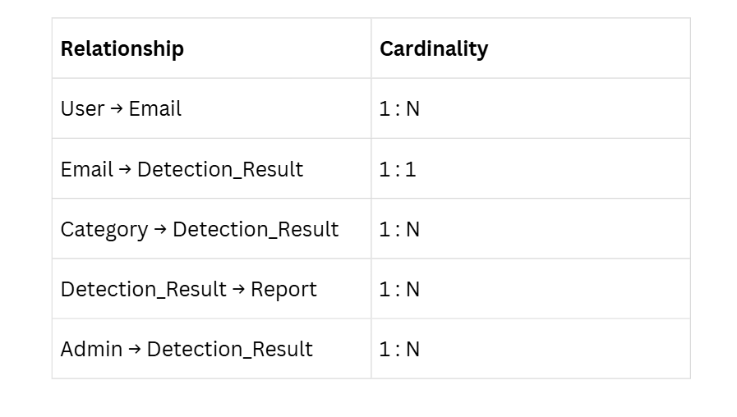

4. Relational Schema & Normalisation Plan
4.1. Relational Schema:-
The relational schema of the Fake Email Detection and Management System consists of five tables: User, Email, Email Category, Detection Report, and Admin. Each table has a Primary Key (PK) to uniquely identify its records, and Foreign Keys (FK) are used to create relationships between the tables. This structure helps organize the data, reduces duplication, and maintains consistency in the database.

Relational Tables

- User:-

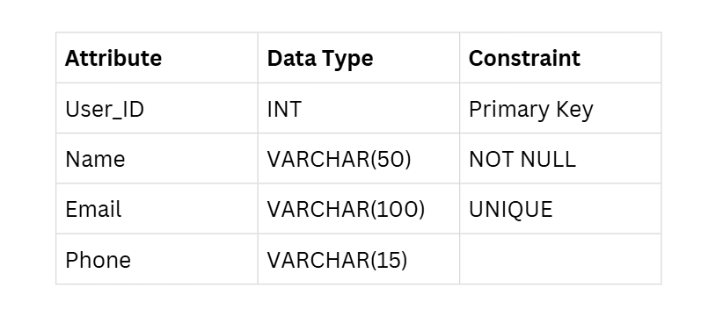

- Email
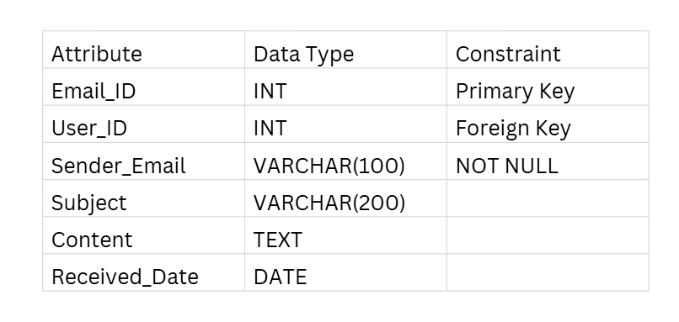
- Admin
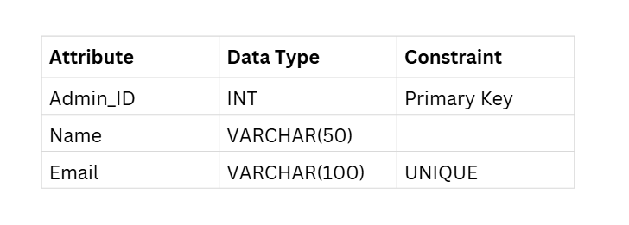
4.Report
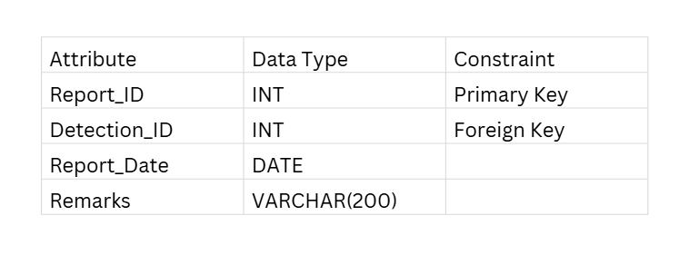
5. Normalisation:-
(UNF → 1NF → 2NF → 3NF → BCNF)
Normalization is the process of organizing data into well-structured tables to reduce duplicate data, improve consistency, and make the database easier to manage.
Problems (UNF)
- User details, email details, and detection results are stored in one table.
- User information is repeated for every email.
- Category information is repeated for every email.
- High data redundancy.
1NF (First Normal Form)
- Store only one value in each field.
- Remove repeating groups.
- Create a separate record for each email.

2NF (Second Normal Form)
- Separate data into different tables such as User, Email, Category, Detection_Result, Admin, and Report.
- Remove duplicate information.
- Reduce data redundancy.
3NF (Third Normal Form)
- Store only related information in each table.
- Connect tables using Primary Keys and Foreign Keys.
- Improve data consistency.

BCNF (Boyce-Codd Normal Form)
- Every table has a proper primary key.
- Each non-key attribute depends only on its primary key.
- The database is well organized and avoids unnecessary duplicate data.

6.Dataset:-
Raw Data:-Raw dataset
Filter data:-filtered data

6. Target RDBMS Software
Database Software: MySQL 8.0
Why MySQL?
- Easy to install and use.
- Free and open-source.
- Supports tables, SQL queries, and relationships.
- Suitable for college DBMS projects.
- Can be connected with web applications in the future.

