**GROUP 04**

**IS - 436**

**Spring 2018**

**Deliverable 04 Resubmit: 08-May-2018**

**Members:**

*Achal Malik*

*Kuran Chona*

*Mykiah Ashley*

*Abhinav Konagala*

**Table of Contents**

ERD Page 2

Text Definitions Page 3

Team Matrix Page 5

Average of Team Matrix Page 7

Alternative Matrix Page 8

Explanation of Team choice Page 10

Non Functional Architecture Design Page 11

Explanation of Architecture Design Page 13

Hardware and Software Specification Page 15

**ERD:**

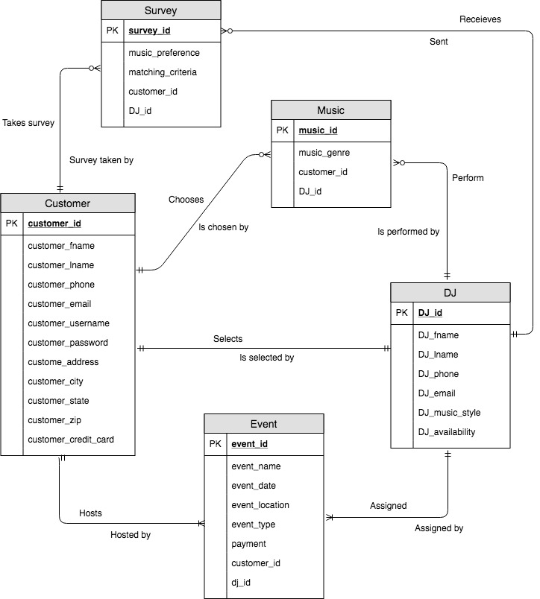

Text Definitions

Entities:

* Customer = This is a entity that interacts with our system mainly in the form of inputting data and storing data. We also store all customer related data here.
* Event = This is a entity where we store specific details for each event created. Example, time, location, and date.
* DJ = This is a separate entity where we store, update, and maintain information on our DJ’s.
* Music = This is a entity where we store the customers and DJ’s music preference choices.
* Survey = This is a entity where we store results from the survey that each customer takes before their event.

Relationships:

* One customer can host many events. However, each event has to have one and only one customer.
* One DJ can be assigned to many events. However, each event has to have one and only one DJ assigned.
* A customer can select one and only one DJ from multiple DJs which are recommended by the music quiz. Also, one and only one DJ can be selected per customer.
* A single DJ can perform zero to many music styles. However, one and only one music style must be performed per DJ.
* A customer can take zero to many surveys. However, one and only one survey is taken per customer.
* A customer can choose zero to many music genres. However, one and only one music genre is chosen per customer.
* A DJ can send zero to many requests to retrieve survey results. However, the DJ receives one and only one survey results per request made.

Team Matrix

|  |  |  |  |  |  |  |  |  |  |  |
| --- | --- | --- | --- | --- | --- | --- | --- | --- | --- | --- |
| Evaluation Criteria | Relative Importance | Alternative 1 | Score  (1-5) | Weighted Score | Alternative 2 | Score  (1-5) | Weighted Score | Alternative 3 | Score  (1-5) | Weighted Score |
| Technical Issues: |  |  |  |  |  |  |  |  |  |  |
| Criterion 1: | 15 |  | 5(KC)  4(MA)  4(AM)  4(AK) | 75  60  60  60 |  | 2  3  4  3 | 30  45  60  45 |  | 2  5  4  3 | 30  75  60  45 |
| Criterion 2 | 10 |  | 5(KC)  5(MA)  5(AM)  4(AK) | 50  50  50  40 |  | 5  5  5  5 | 50  50  50  50 |  | 5  5  5  5 | 50  50  50  50 |
| Criterion 3 | 30 |  | 5(KC)  5(MA)  4(AM)  3(AK) | 150  150  120  90 |  | 4  4  5  4 | 120  120  150  120 |  | 5  5  5  5 | 150  150  150 150 |
| Economic Issues: |  |  |  |  |  |  |  |  |  |  |
| Criterion 4 | 25 |  | 3(KC)  4(MA)  4(AM)  3(AK) | 75  100  100  75 |  | 3  5  4  5 | 75  125  100  125 |  | 1  1  1  1 | 25  25  25  25 |
| Organizational Issues: |  |  |  |  |  |  |  |  |  |  |
| Criterion 5 | 10 |  | 1(KC)  1(MA)  1(AM)  2(AK) | 10  10  10  20 |  | 5  5  5  5 | 50  50  50  50 |  | 3  4  5  2 | 30  40  50  20 |
| Criterion 6 | 10 |  | 5(KC)  4(MA)  4(AM)  4(AK) | 50  40  40  40 |  | 5  4  4  5 | 50  40  40  50 |  | 5  5  5  5 | 50  50  50  50 |
| Total | 100 |  |  | 410  410  380  325 |  |  | 375  430  450  430 |  |  | 335  390  385  340 |

Average of the Team Matrix

|  |  |  |  |  |  |  |  |  |  |  |
| --- | --- | --- | --- | --- | --- | --- | --- | --- | --- | --- |
| Evaluation Criteria | Relative Importance | Alternative 1 | Score  (1-5) | Weighted Score | Alternative 2 | Score  (1-5) | Weighted Score | Alternative 3 | Score  (1-5) | Weighted Score |
| Technical Issues: |  |  |  |  |  |  |  |  |  |  |
| Criterion 1: | 15 |  | 4 | 60 |  | 3 | 45 |  | 4 | 60 |
| Criterion 2 | 10 |  | 5 | 50 |  | 5 | 50 |  | 5 | 50 |
| Criterion 3 | 30 |  | 4 | 120 |  | 4 | 120 |  | 5 | 150 |
| Economic Issues: |  |  |  |  |  |  |  |  |  |  |
| Criterion 4 | 25 |  | 4 | 100 |  | 4 | 100 |  | 1 | 25 |
| Organizational Issues: |  |  |  |  |  |  |  |  |  |  |
| Criterion 5 | 10 |  | 1 | 10 |  | 5 | 50 |  | 4 | 40 |
| Criterion 6 | 10 |  | 4 | 40 |  | 5 | 50 |  | 5 | 50 |
| Total | 100 |  |  | 380 |  |  | 415 |  |  | 375 |

Alternative Matrix: (Key)

Alternative 1: Custom made System made from MyUmbc Survey- This will be a system that will have users on the other side that will manually respond to the user survey. It will be more personal and give more sophisticated feedback. This will also be more ticket oriented.

Alternative 2: Survey Legend- This will conduct pre-event surveys and forms to get an opinion of the attendees and tailor the event to fit for their needs and preferences. This Survey will ask all the questions that the customer does not know to provide us with all the information and the software will provide the answer in seconds. Getting the best for the business package will cost $65/month

Alternative 3: Outsourced Application made from Third party source- There will be professional management of the surveys, there will be many more employees that are involved, and will save a lot of time. Some bad things about this is that you are not in control of the project, It can be very costly, and it can be difficult at times to move survey to a different company.

Technical Issues:

Criterion 1: Integration with existing system

Criterion 2: Experience with the product

Criterion 3: Meet all end-user requirements

Economic Issues:

Criterion 4: Cost

Organizational Issues

Criterion 5: Product in the market

Criterion 6: Customizable GUI

**Alternative 1:**

***Criterion 1-*** Orders will be confirmed with customer email and sent to other systems to keep in the DB

***Criterion 2***- Only the people within the company who helped design the system will have the best knowledge of the product, otherwise everyone else will have very little to no knowledge on the system

***Criterion 3-*** Since this is a In-company based system, all of the system requirements will be met and working to the company’s standards

***Criterion 4-*** $6,000 one charge no yearly expenses for designing, implementing the system within the company

***Criterion 5-*** There is no one else in the market that has this product at all due it being implemented by the company.

***Criterion 6-*** Yes, Since this is made from within the company, maybe a user-requirement is to make it a customizable interface.

**Alternative 2:**

***Criterion 1 -*** The Orders will be saved to a number of different file formats allowing it to be easier to move to the new system.

***Criterion 2-*** Since this product is made from a big company there are numerous training videos and people within the company who know how to use the new system.

***Criterion 3-*** There are multiple versions of this Software, so this allows our company to pick the package that is closest to our system requirements to implement better work.

***Criterion 4-*** This package does have a subscription to continue using it, Although there are services that are given, like Support, warranty, and Security updates to give the best experience. So this would cost $2,200/year

***Criterion 5-*** This Product is used by so many other companies because there is so many different versions.

***Criterion 6-*** Yes, very easy to customize for the end-users and for the employees

**Alternative 3:**

***Criterion 1-*** The orders will be used from the old system, thus using the old systems file formats.

***Criterion 2-*** There will be no experience with this product because this will be outsourced from another company and also because there is no one that has ever used the system.

***Criterion 3-*** Since this system is going to be made specifically for the company all the user-requirements will be met most of the time

***Criterion 4-*** This will be the cheapest way to get the system because it will no slow down the production of their company and it will have everything that the company needs, will be $4,000 one time charge.

***Criterion 5-*** This product is not used by other companies so there is a big learning curve to this system for all the employees to learn the system.

***Criterion 6-*** yes, customizable but it is a bit difficult because the users don’t know the system that well

**Explanation of Team Choice:**

This was a very close decision in regards to a theory standpoint in which we initially thought that outsourcing this system would be the best option, but after making the matrix it shaped it in a better understanding in the system that was a good choice and a system that was the obvious bad choice. We can say very easily that the customized System that would be made from our company would be the worst idea by far. And the Second up would be outsourcing which was a which was the second best. We know now where the advantages lye with all the softwares and their disadvantages. This matrix very help shapes up the future of the company.

|  |  |  |  |  |
| --- | --- | --- | --- | --- |
| Requirements | Server-Based | Client-Based | Thin Client-Server | Thick Client-Server |
| Operational Requirements | | | | |
| The system must have backup equipment in case of hardware failure |  |  |  |  |
| The surveys and music personality quizzes should run on any browser |  |  |  |  |
| The online interface will run on IOS and Android devices |  |  |  |  |
| Performance Requirements | | | | |
| The online survey should not exceed more than 3 minutes |  |  |  |  |
| The music personality should not exceed more than 2 minutes |  |  |  |  |
| The answers to the survey must be limited to one choice per question |  |  |  |  |
| The DJ’s availability must be updated every hour and removed instantly when selected by a customer |  |  |  |  |
| The system must be able to respond to customer requests on priority based |  |  |  |  |
| Security Requirements | | | | |
| Only event managers must have authorized access to the event requests |  |  |  |  |
| Only event managers can manage and view DJ’s personal information |  |  |  |  |
| Customer payment information must be safeguarded and accessed only by managers |  |  |  |  |
| Cultural Requirements | | | | |
| The system must display information in Spanish and English |  |  |  |  |
| The system should select DJ’s according to the requested music event style |  |  |  |  |

Explanation of Architecture Matrix:

* Operational requirements:
  + The system must have back-up equipment in case of hardware failure - System integration may lead to one architecture over another, depending upon the architecture design of the system. If it is software-based, it would fall under server architecture. If it is client equipment, it would fall under thin client-based architecture.
  + The surveys and music personality quizzes should run on any browser - Both the surveys and music personality quizzes can be designed using HTML or other programming languages so the presentation logic, the application logic, and the data access logic can be independent to each other.
  + The online interface will run on IOS and Android devices - The online interface can be designed using HTML or any other programming language so the presentation logic, the application logic, and the data access logic can be independent to each other.
* Performance requirements:
  + The online survey should not exceed more than 3 minutes - Online surveys have information that require high performance and are best suited for both thin client-server and thick client-server. They are more scalable, reliable and have greater availability.
  + The music personality should not exceed more than 2 minutes - Music personality quizzes have information that require high performance and are best suited for both thin client-server and thick client-server. They are more scalable, reliable and have greater availability.
  + The answers to the survey must be limited to one choice per question - The answers to the survey fall under thin client-based architecture because it will record how fast the responses to the survey answers. It also falls under thick client-based architecture because the survey should be able run on different OS platforms.
  + The DJ’s availability must be updated every hour and removed instantly when selected by a customer - The DJ’s availability fall under both thin client-based architecture and thick client-based architecture because the availability of each DJ must be updated in real time so that customers can select the DJ’s that are available.
  + The system must be able to respond to customer requests on priority based - The availability and reliability depend on both hardware and OS so it falls under all three categories, server-based, thin client-based, and thick client-based architectures.
* Security requirements:
  + Only event managers must have authorized access to the event requests - Server-based architecture is more secure because all the information about the event details is stored in one location where mainframe operating systems are used because they are secure compared to microcomputer operating systems.
  + Only event managers can manage and view DJ’s personal information - Server-based architecture is more secure because all the information about the DJ’s personal information is stored in one location where mainframe operating systems are used because they are secure compared to microcomputer operating systems.
  + Customer payment information must be safeguarded and accessed only by managers - Payment details and transactions fall under both server-based architecture as well as thin/thick client-based architecture because the payment details and transaction information is stored on the mainframe operating systems to keep it secure. Customers make transactions through web browser or applications which fall under thin client-based architecture and thick client-based architecture.
* Cultural requirements:
  + The system must display information in Spanish and English - Multilingual requirements can be met by designing the system using HTML and other programming languages which falls under thin client-based architecture.
  + The system should select DJ’s according to the requested music event style - The system should select DJ’s based on the customers answers to the surveys and music personality quizzes.

Hardware and Software Specification

|  |  |  |  |  |
| --- | --- | --- | --- | --- |
|  | Standard Client | Standard Web Server | Standard Application Server | Standard Database Server |
| Operating System | Windows  MAC OS | Linux/Unix | Linux/Unix | Linux/Unix |
| Special Software | Google Chrome  Internet Explorer  Safari  Mozilla | Apache HTTP Server | Java, HTML | Oracle |
| Hardware | Standard Computer  Mobile phones  Tablets | 500-GB disk drive | 500-GB disk drive | 2-TB disk drive |
| Network | Basic ISP, Verizon FIOS  Infinity | 100 Mbps Ethernet | 100 Mbps Ethernet | 100 Mbps Ethernet |