DIABETES PREDICTION USING MACHINE LEARNING

Machine Learning Laboratory Project Report
By
ABHINAV KUMAR
24VE1A66H9
YEAR: III
SEMESTER: I
DEPARTMENT: CSE(AIML)
SECTION: C
A Random Forest classification model using HbA1c level, blood glucose level and BMI to predict diabetes.

1. Introduction
Diabetes prediction is a binary classification problem in which a machine learning model predicts whether a person is likely to have diabetes (1) or not have diabetes (0). This project develops a simple, focused model using three numerical health attributes: HbA1c level, blood glucose level and BMI.
The main aim is to demonstrate the complete basic machine learning workflow: dataset preparation, feature selection, model training, prediction, performance evaluation and visualization. The project is intentionally kept simple so that every stage can be clearly understood.

2. Dataset
The dataset used for this project is the Diabetes Prediction Dataset obtained from Kaggle. The original dataset contains 100,000 records and 9 attributes. The column diabetes is used as the target variable.
Attribute | Description | Role
gender | Gender of the individual | Excluded
age | Age of the individual | Excluded
hypertension | Whether hypertension is present | Excluded
heart_disease | Whether heart disease is present | Excluded
smoking_history | Smoking history | Excluded
bmi | Body Mass Index | Selected
HbA1c_level | HbA1c measurement | Selected
blood_glucose_level | Blood glucose measurement | Selected
diabetes | 0 = No Diabetes, 1 = Diabetes | Target

Source: Kaggle — Diabetes Prediction Dataset.

3. Dataset Filtering and Balancing
The original dataset was imbalanced: 91,500 records belonged to the non-diabetic class and 8,500 belonged to the diabetic class. A model trained directly on this distribution could be biased toward the majority class. Therefore, the dataset was balanced using random undersampling.
1. All 8,500 diabetic records (diabetes = 1) were retained.
2. 8,500 non-diabetic records (diabetes = 0) were randomly selected.
3. The two groups were combined and shuffled.
4. random_state = 42 was used to make the random selection reproducible.
Final dataset: 17,000 records — 8,500 non-diabetic and 8,500 diabetic.
Class | Original Records | After Filtering
No Diabetes (0) | 91,500 | 8,500
Diabetes (1) | 8,500 | 8,500
Total | 100,000 | 17,000

4. Selected Attributes and Justification
Three attributes were selected because they provide direct, numerical health measurements that are closely relevant to the prediction task and also keep the model simple.
Selected Attribute | Why it is Included
HbA1c_level | HbA1c reflects average blood glucose over a period of time and is highly informative for distinguishing diabetic and non-diabetic cases in this dataset.
blood_glucose_level | Blood glucose is directly related to the condition being predicted and is expected to provide strong predictive information.
bmi | BMI provides an additional numerical health/body-composition measure and can contribute useful information when combined with glucose-related measurements.

The three features also have the practical advantage of being numerical, so no categorical encoding is required. This keeps the preprocessing and final user-input section straightforward.

5. Excluded Attributes and Justification
The remaining attributes were deliberately excluded from this version of the model. Their exclusion is a project-design decision, not a statement that they are medically irrelevant.
Excluded Attribute | Why it is Excluded in This Project
gender | Not necessary for the chosen three-feature model. Excluding it keeps the model focused and avoids adding a categorical variable that would require encoding.
age | Age can be useful, but it is excluded because the project specifically focuses on three selected health measurements and a simple input interface.
hypertension | It is a useful medical-history variable, but it is not one of the three measurements selected for this focused model.
heart_disease | It may contain predictive information, but it is excluded to keep the input set limited to the three selected attributes.
smoking_history | This is categorical information and would require additional encoding. It is excluded to keep the preprocessing simple.

Therefore, the model intentionally answers a narrow question: how well can diabetes be classified using only HbA1c level, blood glucose level and BMI?

6. Choice of Machine Learning Algorithm
Random Forest Classifier was selected as the main algorithm because the dataset is tabular, the target is binary, and the relationship between health measurements and diabetes does not have to be purely linear.
Algorithm | Why Random Forest Was Preferred
Logistic Regression | Simple and interpretable, but assumes a mainly linear relationship between inputs and the log-odds of the target.
Decision Tree | Easy to understand, but a single tree can overfit the training data.
K-Nearest Neighbors | Simple, but prediction depends on distances between observations and is more sensitive to scaling and the local distribution of data.
SVM | Can perform well, but is more computationally involved and less straightforward to explain for this simple laboratory project.
Random Forest | Combines many decision trees, handles nonlinear relationships well, reduces the overfitting risk of a single tree, requires little preprocessing for numerical features, and provides feature importance.

Hence, Random Forest gives a good balance between simplicity, predictive performance and interpretability for this project.

7. Random Forest Parameters
Parameter | Value | Purpose
n_estimators | 300 | Builds 300 decision trees and combines their predictions.
max_depth | 12 | Limits tree depth to control model complexity and reduce overfitting.
min_samples_split | 5 | A node needs at least 5 samples before it can be split.
min_samples_leaf | 2 | Each final leaf must contain at least 2 samples.
random_state | 42 | Makes the training process reproducible.

These parameters were chosen as a simple controlled configuration rather than performing an extensive hyperparameter-search procedure.

8. Final Source Code
The following is the final source code used for the project.
import pandas as pd

from sklearn.model_selection import train_test_split
from sklearn.ensemble import RandomForestClassifier
from sklearn.metrics import accuracy_score, classification_report, confusion_matrix

import seaborn as sns
import matplotlib.pyplot as plt

df = pd.read_csv("diabetes_prediction_dataset.csv")

print("Dataset loaded successfully!")
print("Shape:", df.shape)
print(df.head())

X = df[
[
"HbA1c_level",
"blood_glucose_level",
"bmi"
]
]

# Target
y = df["diabetes"]

X_train, X_test, y_train, y_test = train_test_split(
X,
y,
test_size=0.20,
random_state=42,
stratify=y
)

print("\nTraining data:", X_train.shape)
print("Testing data:", X_test.shape)

model = RandomForestClassifier(
n_estimators=300,
max_depth=12,
min_samples_split=5,
min_samples_leaf=2,
random_state=42
)

model.fit(X_train, y_train)
print("\nModel trained successfully!")
y_pred = model.predict(X_test)
accuracy = accuracy_score(y_test, y_pred)

print("\nAccuracy:", round(accuracy, 4))
print("Accuracy percentage:", round(accuracy * 100, 2), "%")

print("\nClassification Report:")
print(classification_report(y_test, y_pred))

cm = confusion_matrix(y_test, y_pred)

plt.figure(figsize=(6, 5))

sns.heatmap(
cm,
annot=True,
fmt="d",
cmap="Blues",
xticklabels=["No Diabetes", "Diabetes"],
yticklabels=["No Diabetes", "Diabetes"]
)

importance = model.feature_importances_

features = [
"HbA1c Level",
"Blood Glucose",
"BMI"
]

plt.figure(figsize=(7, 5))

plt.bar(features, importance)

plt.xlabel("Features")
plt.ylabel("Importance")
plt.title("Feature Importance in Diabetes Prediction")

plt.show()

plt.xlabel("Predicted")
plt.ylabel("Actual")
plt.title("Diabetes Prediction - Confusion Matrix")

plt.show()

HbA1c = float(input("\nEnter HbA1c level: "))
glucose = float(input("Enter blood glucose level: "))
bmi = float(input("Enter BMI: "))

new_person = pd.DataFrame({
"HbA1c_level": [HbA1c],
"blood_glucose_level": [glucose],
"bmi": [bmi]
})

# Prediction
prediction = model.predict(new_person)

# Probability
probability = model.predict_proba(new_person)[0][1]

if prediction[0] == 1:
print("\nPrediction: DIABETES")
else:
print("\nPrediction: NO DIABETES")
print("Diabetes probability:", round(probability * 100, 2), "%")

9. How the Code Works
1. Pandas loads the balanced CSV dataset.
2. X is created using only HbA1c_level, blood_glucose_level and bmi.
3. y is created from the diabetes column.
4. train_test_split divides the data into 80% training and 20% testing data. stratify=y keeps the class proportions balanced in both sets.
5. RandomForestClassifier creates the selected Random Forest model.
6. model.fit(X_train, y_train) trains the model using the training data.
7. model.predict(X_test) generates predictions for unseen test records.
8. accuracy_score measures the percentage of correct predictions.
9. classification_report provides precision, recall and F1-score for both classes.
10. confusion_matrix shows the numbers of correct and incorrect predictions for each class.
11. model.feature_importances_ provides the relative feature-importance values.
12. For a new person, the program accepts the three measurements, predicts the class and uses predict_proba() to display the estimated probability for the diabetes class.

10. Model Evaluation
The balanced dataset contains 17,000 records. An 80:20 train-test split produces 13,600 training records and 3,400 testing records. Because both classes contain 8,500 records, the test set contains 1,700 records from each class.

10.1 Evaluation Metrics
Metric | Meaning
Accuracy | Percentage of all test cases classified correctly.
Precision | Among cases predicted as a class, the proportion that actually belongs to that class.
Recall | Among cases actually belonging to a class, the proportion correctly identified by the model.
F1-score | Harmonic mean of precision and recall; useful when both are important.
Confusion Matrix | Shows true positives, true negatives, false positives and false negatives.

For this binary classification project, accuracy gives an overall view, while precision, recall and F1-score show how well the model handles each class. The confusion matrix provides a direct count of correct and incorrect predictions.

10.2 Final Model Results
Metric | No Diabetes (0) | Diabetes (1)
Precision | 0.85 | 0.90
Recall | 0.91 | 0.84
F1-score | 0.88 | 0.87
Support | 1,700 | 1,700

Overall accuracy: 87.47%. Macro-average F1-score: approximately 0.87.

11. Outputs and Results
The following screenshots document the actual execution results of the final model.

11.1 Model Performance Output
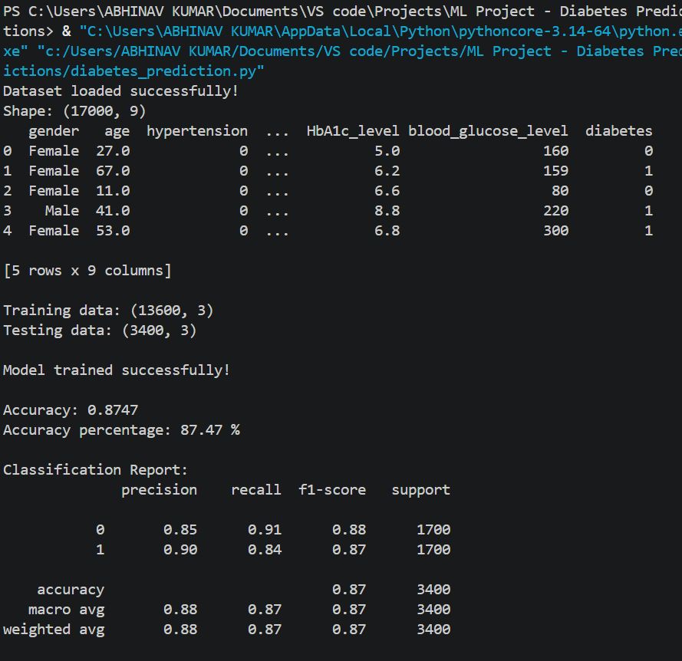
Figure 1. Console output showing dataset loading, train-test split, model training and final evaluation.

11.2 Confusion Matrix
The final confusion matrix contains 1,539 true negatives, 161 false positives, 265 false negatives and 1,435 true positives.
Actual / Predicted | No Diabetes | Diabetes
No Diabetes | 1539 | 161
Diabetes | 265 | 1435

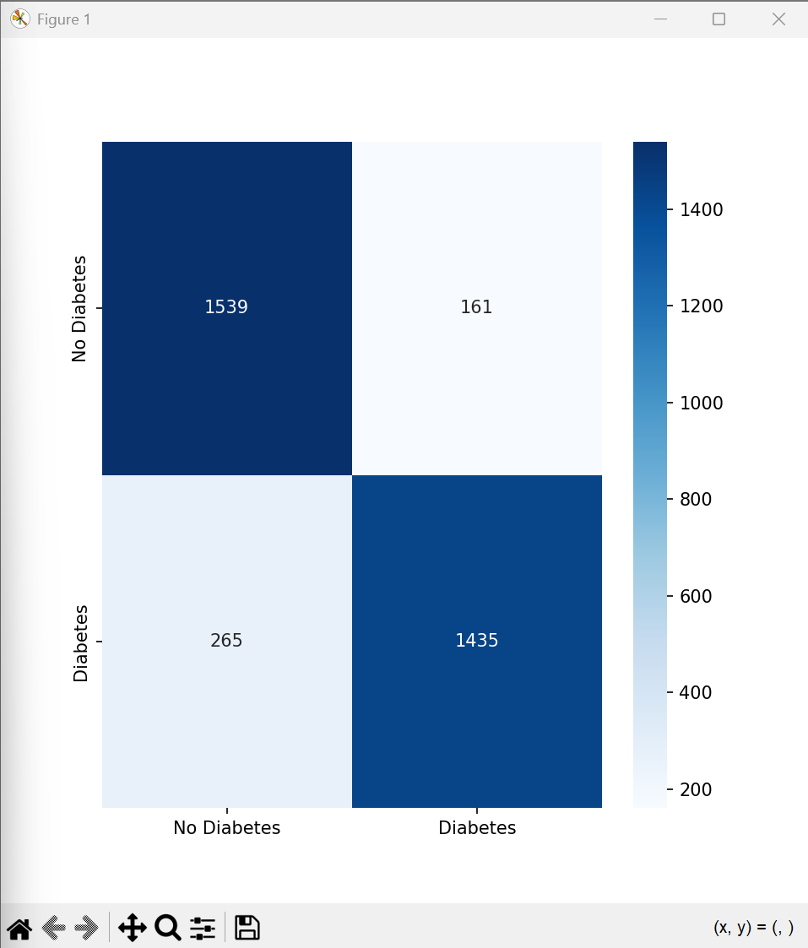
Figure 2. Confusion matrix generated by the final model.

11.3 Feature Importance
The feature-importance graph shows HbA1c as the most important feature in the trained Random Forest, followed by blood glucose and BMI.
Feature | Approx. Importance
HbA1c Level | 0.47
Blood Glucose | 0.37
BMI | 0.15

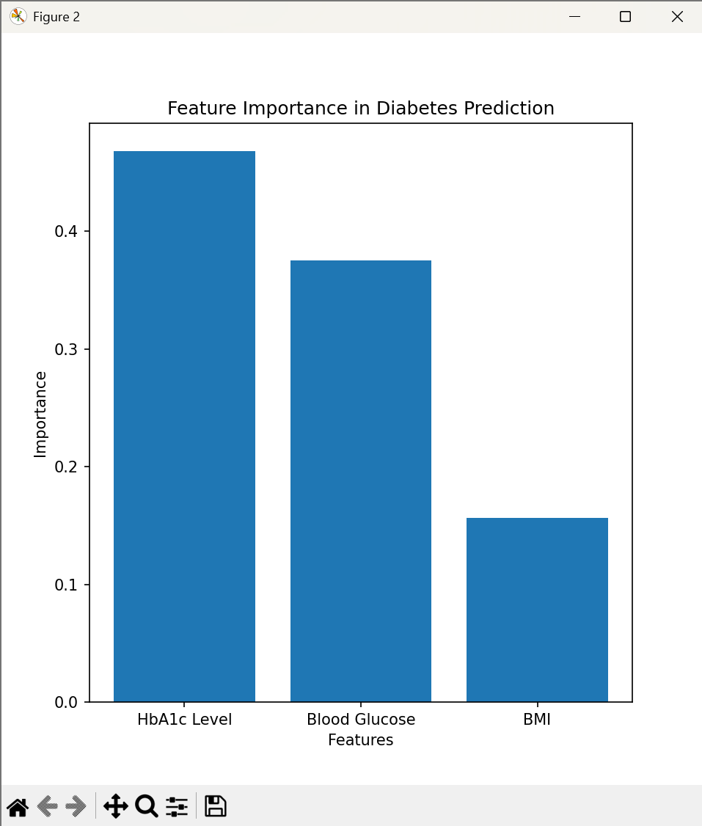
Figure 3. Feature importance graph generated by the final model.

11.4 New Prediction — Test Case 1
Input | Value
HbA1c level | 6.5
Blood glucose level | 180
BMI | 23.2
Prediction | NO DIABETES
Diabetes probability | 40.46%

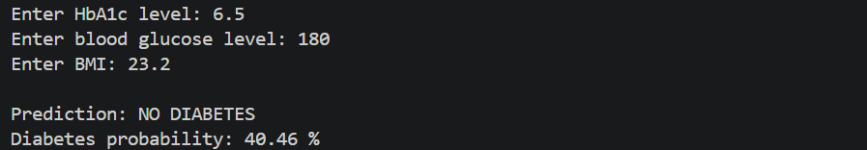
Figure 4. Console output for Test Case 1.

11.5 New Prediction — Test Case 2
Input | Value
HbA1c level | 7.0
Blood glucose level | 240
BMI | 19.5
Prediction | DIABETES
Diabetes probability | 100.0%

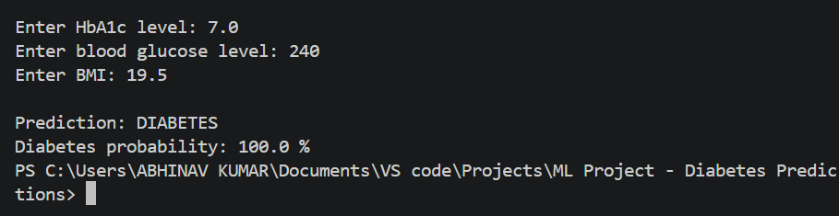
Figure 5. Console output for Test Case 2.

11.6 New Prediction — Test Case 3
Input | Value
HbA1c level | 5.2
Blood glucose level | 200
BMI | 22.34
Prediction | NO DIABETES
Diabetes probability | 0.9%

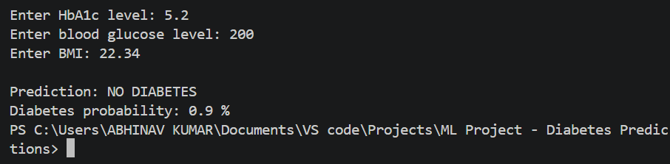
Figure 6. Console output for Test Case 3.

12. Conclusion
A simple diabetes prediction system was successfully developed using a balanced Kaggle dataset and three selected numerical attributes: HbA1c level, blood glucose level and BMI. The dataset was balanced from 100,000 records to 17,000 records using random under sampling, with equal representation of diabetic and non-diabetic cases.
A Random Forest Classifier with 300 trees and controlled tree-complexity parameters was used because it provides a practical balance of simplicity, nonlinear learning capability, robustness and feature interpretability for this tabular classification problem.
The final model achieved 87.47% accuracy on 3,400 unseen test records, with approximately 0.87 macro-average F1-score. The feature-importance analysis showed HbA1c level as the strongest of the three selected features, followed by blood glucose and BMI. The program can also accept new measurements and produce a diabetes prediction with a model probability.
This project is intended for academic and ML Laboratory purposes. The predictions and probabilities produced by the model should not be treated as a medical diagnosis.

