
BANK LOAN ANALYSIS
END TO END PORTFOLIO PROJECT
SQL , POWER BI
By - ABHINAV KUMAR
POWER BI : LINK
GITHUB : LINK
"This project demonstrates my ability to query loan data using SQL, build interactive Power BI dashboards, and translate raw lending data into actionable risk and growth strategies that improve portfolio quality and key banking KPIs."

PROJECT OVERVIEW
A bank's lending business is only as healthy as the quality of its loan book. This project builds a complete Bank Loan Report that monitors lending activity, separates Good Loans from Bad Loans, and identifies the borrower, loan and regional characteristics that drive defaults.
The analysis covers 38,576 loan applications issued between January and December 2021, with a total funded amount of $435,757,075 and a total amount received of $473,070,933.
Project objectives
- Track headline KPIs (applications, funded amount, amount received, average interest rate, average DTI) with Month-to-Date (MTD) and Month-over-Month (MoM) movement.
- Classify the portfolio into Good Loans (Fully Paid + Current) and Bad Loans (Charged Off) and measure the money lost on bad loans.
- Analyse lending by month, state, loan term, employment length, loan purpose and home ownership (Overview dashboard).
- Identify the key risk drivers (grade, term, purpose, state, income, DTI, loan size) behind charge-offs.
- Deliver three Power BI dashboards: Summary, Overview and Details, and convert findings into business recommendations.
Tools used
- SQL Server (T-SQL) for KPI calculation, aggregation and risk analysis.
- Power BI for the Summary, Overview and Details dashboards with State, Grade and Purpose filters.
- Excel / CSV as the source data (financial_loan.csv).

DATA COLUMNS
The dataset contains 38,576 rows and 24 columns. Every record is an individual loan application (application_type = INDIVIDUAL).
# | Column | Description
1 | id | Unique loan identifier
2 | address_state | US state of the borrower
3 | application_type | Type of application (all INDIVIDUAL)
4 | emp_length | Borrower's employment length (< 1 year to 10+ years)
5 | emp_title | Borrower's job title (1,438 missing values)
6 | grade | Loan risk grade, A (lowest risk) to G (highest risk)
7 | home_ownership | RENT, MORTGAGE, OWN, OTHER or NONE
8 | issue_date | Date the loan was issued (dd-mm-yyyy)
9 | last_credit_pull_date | Date of the most recent credit check
10 | last_payment_date | Date of the most recent payment
11 | loan_status | Fully Paid, Current or Charged Off
12 | next_payment_date | Date of the next scheduled payment
13 | member_id | Borrower/member identifier
14 | purpose | Stated purpose of the loan
15 | sub_grade | Detailed grade (A1 to G5)
16 | term | Loan term: 36 or 60 months
17 | verification_status | Income verification: Verified, Source Verified, Not Verified
18 | annual_income | Borrower's annual income
19 | dti | Debt-to-income ratio (stored as a decimal)
20 | installment | Monthly installment amount
21 | int_rate | Interest rate (stored as a decimal)
22 | loan_amount | Funded loan amount (principal)
23 | total_acc | Total credit accounts of the borrower
24 | total_payment | Total amount received from the borrower so far

DATA PREPARATION & KPI DEFINITIONS
- The CSV was imported into SQL Server as the table bank_loan_data. The issue_date column (dd-mm-yyyy text) was converted to a DATE type before any month-based query.
- The term column contains a leading space (' 36 months', ' 60 months'), so queries use LTRIM(RTRIM(term)) to avoid duplicate groups.
- int_rate and dti are stored as decimals (0.1527), so they are multiplied by 100 to show percentages.
- MTD = December 2021 (the latest month in the data) and PMTD = November 2021. MoM % = (MTD - PMTD) / PMTD x 100.
- Good Loan = loan_status 'Fully Paid' or 'Current'. Bad Loan = loan_status 'Charged Off'.
- Charge-off rate = Charged Off loans / Total loans. Net Return % = (Total amount received - Total funded amount) / Total funded amount.
- Average interest rate and average DTI are simple (unweighted) averages across loans, as used in the Power BI report.

SQL QUERIES

Category A: Summary KPIs (Dashboard 1)

Query 1: Total Loan Applications (Total, MTD, PMTD, MoM)
SQL Query:
WITH kpi AS (
SELECT
COUNT(id) AS Total_Applications,
COUNT(CASE WHEN MONTH(issue_date) = 12 THEN id END) AS MTD_Applications,
COUNT(CASE WHEN MONTH(issue_date) = 11 THEN id END) AS PMTD_Applications
FROM bank_loan_data
)
SELECT
Total_Applications AS Total_Applications,
MTD_Applications AS MTD_Applications,
PMTD_Applications AS PMTD_Applications,
ROUND(100.0 * (MTD_Applications - PMTD_Applications) / PMTD_Applications, 2) AS
MoM_Change_Pct
FROM kpi;
Result:
Total_​Applications | MTD_​Applications | PMTD_​Applications | MoM_​Change_​Pct
38,576 | 4,314 | 4,035 | 6.91%

Business Context:
The first KPI of the Summary dashboard: how many loan applications the bank receives and whether demand is growing month over month.
Insights:
"The bank received 38,576 loan applications in 2021. December (MTD) recorded 4,314 applications against 4,035 in November, a MoM growth of 6.91%. Demand has risen in almost every month of the year, with February the only month to dip."

Query 2: Total Funded Amount (Total, MTD, PMTD, MoM)
SQL Query:
WITH kpi AS (
SELECT
SUM(loan_amount) AS Total_Funded_Amount,
SUM(CASE WHEN MONTH(issue_date) = 12 THEN loan_amount END) AS MTD_Funded_Amount,
SUM(CASE WHEN MONTH(issue_date) = 11 THEN loan_amount END) AS PMTD_Funded_Amount
FROM bank_loan_data
)
SELECT
Total_Funded_Amount AS Total_Funded_Amount,
MTD_Funded_Amount AS MTD_Funded_Amount,
PMTD_Funded_Amount AS PMTD_Funded_Amount,
ROUND(100.0 * (MTD_Funded_Amount - PMTD_Funded_Amount) / PMTD_Funded_Amount, 2) AS
MoM_Change_Pct
FROM kpi;
Result:
Total_​Funded_​Amount | MTD_​Funded_​Amount | PMTD_​Funded_​Amount | MoM_​Change_​Pct
$435,757,075 | $53,981,425 | $47,754,825 | 13.04%

Business Context:
Funded amount is the total principal disbursed. It shows how much capital the bank has deployed and how fast the loan book is growing.
Insights:
"A total of $435,757,075 was disbursed during 2021. December funding of $53,981,425 is 13.04% higher than November's $47,754,825. Funding is growing almost twice as fast as applications (6.91%), which means the average loan size is increasing (about $12,513 in December versus $10,734 in January)."

Query 3: Total Amount Received (Total, MTD, PMTD, MoM)
SQL Query:
WITH kpi AS (
SELECT
SUM(total_payment) AS Total_Amount_Received,
SUM(CASE WHEN MONTH(issue_date) = 12 THEN total_payment END) AS
MTD_Amount_Received,
SUM(CASE WHEN MONTH(issue_date) = 11 THEN total_payment END) AS
PMTD_Amount_Received
FROM bank_loan_data
)
SELECT
Total_Amount_Received AS Total_Amount_Received,
MTD_Amount_Received AS MTD_Amount_Received,
PMTD_Amount_Received AS PMTD_Amount_Received,
ROUND(100.0 * (MTD_Amount_Received - PMTD_Amount_Received) / PMTD_Amount_Received, 2)
AS MoM_Change_Pct
FROM kpi;
Result:
Total_​Amount_​Received | MTD_​Amount_​Received | PMTD_​Amount_​Received | MoM_​Change_​Pct
$473,070,933 | $58,074,380 | $50,132,030 | 15.84%

Business Context:
Amount received tracks the cash collected from borrowers (principal plus interest). It is the key indicator of repayment and cash flow.
Insights:
"Borrowers have paid back $473,070,933 so far, which is $37,313,858 (8.56%) more than the amount funded. December collections of $58,074,380 grew 15.84% over November's $50,132,030, faster than both applications and funding."

Query 4: Average Interest Rate (Total, MTD, PMTD, MoM)
SQL Query:
WITH kpi AS (
SELECT
AVG(int_rate) * 100 AS Total_Avg_Interest_Rate,
AVG(CASE WHEN MONTH(issue_date) = 12 THEN int_rate END) * 100 AS
MTD_Avg_Interest_Rate,
AVG(CASE WHEN MONTH(issue_date) = 11 THEN int_rate END) * 100 AS
PMTD_Avg_Interest_Rate
FROM bank_loan_data
)
SELECT
ROUND(Total_Avg_Interest_Rate, 2) AS Total_Avg_Interest_Rate,
ROUND(MTD_Avg_Interest_Rate, 2) AS MTD_Avg_Interest_Rate,
ROUND(PMTD_Avg_Interest_Rate, 2) AS PMTD_Avg_Interest_Rate,
ROUND(100.0 * (MTD_Avg_Interest_Rate - PMTD_Avg_Interest_Rate) /
PMTD_Avg_Interest_Rate, 2) AS MoM_Change_Pct
FROM kpi;
Result:
Total_​Avg_​Interest_​Rate | MTD_​Avg_​Interest_​Rate | PMTD_​Avg_​Interest_​Rate | MoM_​Change_​Pct
12.05% | 12.36% | 11.94% | 3.47%

Business Context:
The average interest rate reflects the pricing of the loan book. A rising rate can mean higher-risk loans entering the portfolio or a change in pricing policy.
Insights:
"The average interest rate across the portfolio is 12.05%. December's average of 12.36% is above November's 11.94% (a relative increase of 3.47%). Query 18 shows one reason: the share of 60-month loans, which carry higher rates, climbed from 18.05% in January to 28.19% in December."

Query 5: Average DTI (Total, MTD, PMTD, MoM)
SQL Query:
WITH kpi AS (
SELECT
AVG(dti) * 100 AS Total_Avg_DTI,
AVG(CASE WHEN MONTH(issue_date) = 12 THEN dti END) * 100 AS MTD_Avg_DTI,
AVG(CASE WHEN MONTH(issue_date) = 11 THEN dti END) * 100 AS PMTD_Avg_DTI
FROM bank_loan_data
)
SELECT
ROUND(Total_Avg_DTI, 2) AS Total_Avg_DTI,
ROUND(MTD_Avg_DTI, 2) AS MTD_Avg_DTI,
ROUND(PMTD_Avg_DTI, 2) AS PMTD_Avg_DTI,
ROUND(100.0 * (MTD_Avg_DTI - PMTD_Avg_DTI) / PMTD_Avg_DTI, 2) AS MoM_Change_Pct
FROM kpi;
Result:
Total_​Avg_​DTI | MTD_​Avg_​DTI | PMTD_​Avg_​DTI | MoM_​Change_​Pct
13.33% | 13.67% | 13.30% | 2.73%

Business Context:
Debt-to-Income (DTI) measures how much of a borrower's income is already committed to debt. A higher DTI means lower repayment capacity.
Insights:
"The average borrower DTI is 13.33%. It increased slightly in December to 13.67% from 13.30% in November (a relative increase of 2.73%). The movement is small, but together with rising loan sizes it signals that new borrowers carry slightly more debt burden."

Category B: Good Loan vs Bad Loan (Dashboard 1)

Query 6: Good Loan KPIs
SQL Query:
SELECT
ROUND(100.0 * COUNT(CASE WHEN loan_status IN ('Fully Paid', 'Current') THEN id END) /
COUNT(id), 2) AS Good_Loan_Pct,
COUNT(CASE WHEN loan_status IN ('Fully Paid', 'Current') THEN id END) AS
Good_Loan_Applications,
SUM(CASE WHEN loan_status IN ('Fully Paid', 'Current') THEN loan_amount END) AS
Good_Loan_Funded_Amount,
SUM(CASE WHEN loan_status IN ('Fully Paid', 'Current') THEN total_payment END) AS
Good_Loan_Received_Amount
FROM bank_loan_data;
Result:
Good_​Loan_​Pct | Good_​Loan_​Applications | Good_​Loan_​Funded_​Amount | Good_​Loan_​Received_​Amount
86.18% | 33,243 | $370,224,850 | $435,786,170

Business Context:
To measure how much of the portfolio is performing well: loans that are either fully repaid or still being repaid on schedule.
Insights:
"86.18% of all applications (33,243 loans) are Good Loans. They received $370,224,850 in funding and have already returned $435,786,170, which is 17.71% more than the principal. The vast majority of the book is healthy."

Query 7: Bad Loan KPIs
SQL Query:
SELECT
ROUND(100.0 * COUNT(CASE WHEN loan_status = 'Charged Off' THEN id END) / COUNT(id), 2)
AS Bad_Loan_Pct,
COUNT(CASE WHEN loan_status = 'Charged Off' THEN id END) AS Bad_Loan_Applications,
SUM(CASE WHEN loan_status = 'Charged Off' THEN loan_amount END) AS
Bad_Loan_Funded_Amount,
SUM(CASE WHEN loan_status = 'Charged Off' THEN total_payment END) AS
Bad_Loan_Received_Amount,
SUM(CASE WHEN loan_status = 'Charged Off' THEN loan_amount - total_payment END) AS
Bad_Loan_Net_Loss
FROM bank_loan_data;
Result:
Bad_​Loan_​Pct | Bad_​Loan_​Applications | Bad_​Loan_​Funded_​Amount | Bad_​Loan_​Received_​Amount | Bad_​Loan_​Net_​Loss
13.82% | 5,333 | $65,532,225 | $37,284,763 | $28,247,462

Business Context:
To quantify credit losses: the share of loans that were charged off and how much money was lost on them.
Insights:
"13.82% of applications (5,333 loans) were charged off. The bank funded $65,532,225 on these loans but recovered only $37,284,763 (56.90% of principal), resulting in a net loss of $28,247,462. Bad loans are only 13.82% of the count but 15.04% of the funded amount, so charged-off loans are slightly larger than average."

Query 8: Loan Status Grid View
SQL Query:
SELECT
loan_status,
COUNT(id) AS Total_Loan_Applications,
SUM(loan_amount) AS Total_Funded_Amount,
SUM(total_payment) AS Total_Amount_Received,
ROUND(AVG(int_rate) * 100, 2) AS Avg_Interest_Rate,
ROUND(AVG(dti) * 100, 2) AS Avg_DTI,
SUM(CASE WHEN MONTH(issue_date) = 12 THEN loan_amount ELSE 0 END) AS
MTD_Funded_Amount,
SUM(CASE WHEN MONTH(issue_date) = 12 THEN total_payment ELSE 0 END) AS
MTD_Amount_Received
FROM bank_loan_data
GROUP BY loan_status
ORDER BY Total_Loan_Applications DESC;
Result:
loan_​status | Applications | Funded_​Amount | Amount_​Received | Avg_​Int_​Rate | Avg_​DTI | MTD_​Funded | MTD_​Received
Fully Paid | 32,145 | $351,358,350 | $411,586,256 | 11.64% | 13.17% | $41,302,025 | $47,815,851
Charged Off | 5,333 | $65,532,225 | $37,284,763 | 13.88% | 14.00% | $8,732,775 | $5,324,211
Current | 1,098 | $18,866,500 | $24,199,914 | 15.10% | 14.72% | $3,946,625 | $4,934,318

Business Context:
The grid view gives one table that compares every loan status on volume, money, pricing and borrower risk. It is the third visual of the Summary dashboard.
Insights:
"Fully Paid loans dominate with 32,145 applications and the lowest interest rate (11.64%). Charged Off loans carry a higher average interest rate (13.88%) and higher DTI (14.00%). Current loans have the highest rate (15.10%) and DTI (14.72%), which makes them the group to watch as they mature."

Query 9: Net Return by Loan Status
SQL Query:
SELECT
loan_status,
SUM(loan_amount) AS Total_Funded_Amount,
SUM(total_payment) AS Total_Amount_Received,
SUM(total_payment) - SUM(loan_amount) AS Net_Cash_Position,
ROUND(100.0 * (SUM(total_payment) - SUM(loan_amount)) / SUM(loan_amount), 2) AS
Net_Return_Pct
FROM bank_loan_data
GROUP BY loan_status
ORDER BY Total_Funded_Amount DESC;
Result:
loan_​status | Funded_​Amount | Amount_​Received | Net_​Cash_​Position | Net_​Return_​Pct
Fully Paid | $351,358,350 | $411,586,256 | $60,227,906 | 17.14%
Charged Off | $65,532,225 | $37,284,763 | $-28,247,462 | -43.10%
Current | $18,866,500 | $24,199,914 | $5,333,414 | 28.27%
Note: Net return is measured on cash received so far; it is not accounting profit because funding cost and operating expense are not included.
Business Context:
Counting loans is not enough. This query shows how much cash each loan group has actually returned relative to what was lent.
Insights:
"Fully Paid loans generated a net return of 17.14% ($60,227,906), and Current loans are already at 28.27%. Charged Off loans lost 43.10% of principal ($28,247,462). The profit from good loans (about $66M) comfortably covers this loss, but only because good loans dominate the book."

Category C: Overview Analysis (Dashboard 2)

Query 10: Monthly Trend by Issue Date
SQL Query:
SELECT
MONTH(issue_date) AS Month_Number,
DATENAME(MONTH, issue_date) AS Month_Name,
COUNT(id) AS Total_Loan_Applications,
SUM(loan_amount) AS Total_Funded_Amount,
SUM(total_payment) AS Total_Amount_Received
FROM bank_loan_data
GROUP BY MONTH(issue_date), DATENAME(MONTH, issue_date)
ORDER BY MONTH(issue_date);
Result:
Month_​No | Month_​Name | Applications | Funded_​Amount | Amount_​Received
1 | January | 2,332 | $25,031,650 | $27,578,836
2 | February | 2,279 | $24,647,825 | $27,717,745
3 | March | 2,627 | $28,875,700 | $32,264,400
4 | April | 2,755 | $29,800,800 | $32,495,533
5 | May | 2,911 | $31,738,350 | $33,750,523
6 | June | 3,184 | $34,161,475 | $36,164,533
7 | July | 3,366 | $35,813,900 | $38,827,220
8 | August | 3,441 | $38,149,600 | $42,682,218
9 | September | 3,536 | $40,907,725 | $43,983,948
10 | October | 3,796 | $44,893,800 | $49,399,567
11 | November | 4,035 | $47,754,825 | $50,132,030
12 | December | 4,314 | $53,981,425 | $58,074,380

Business Context:
The line chart of the Overview dashboard: it reveals seasonality and the long-term direction of lending.
Insights:
"Applications grew from 2,332 in January to 4,314 in December (+85%), and funded amount more than doubled from $25,031,650 to $53,981,425 (+116%). The biggest single-month jump was March (+15.27% applications). February was the only decline. The trend shows consistent growth with no clear seasonal dip, and the second half of the year is stronger than the first."

Query 11: Regional Analysis by State (Top 10 by Funded Amount)
SQL Query:
SELECT TOP 10
address_state AS State,
COUNT(id) AS Total_Loan_Applications,
SUM(loan_amount) AS Total_Funded_Amount,
SUM(total_payment) AS Total_Amount_Received
FROM bank_loan_data
GROUP BY address_state
ORDER BY Total_Funded_Amount DESC;
Result:
State | Applications | Funded_​Amount | Amount_​Received
CA | 6,894 | $78,484,125 | $83,901,234
NY | 3,701 | $42,077,050 | $46,108,181
TX | 2,664 | $31,236,650 | $34,392,715
FL | 2,773 | $30,046,125 | $31,601,905
NJ | 1,822 | $21,657,475 | $23,425,159
IL | 1,486 | $17,124,225 | $18,875,941
VA | 1,375 | $15,982,650 | $17,711,443
PA | 1,482 | $15,826,525 | $17,462,908
GA | 1,355 | $15,480,325 | $16,728,040
MA | 1,310 | $15,051,000 | $16,676,279
Note: Only the top 10 of 50 states are shown here; the Power BI filled map displays all states.
Business Context:
The filled map of the Overview dashboard needs a state-level view to find the regions that drive lending activity.
Insights:
"California is the largest market with 6,894 applications and $78,484,125 funded (18.01% of the total), followed by New York and Texas. The top 5 states (CA, NY, TX, FL, NJ) account for 46.70% of all funding, so the portfolio is geographically concentrated and exposed to the economy of a few states."

Query 12: Loan Term Analysis
SQL Query:
SELECT
LTRIM(RTRIM(term)) AS Term,
COUNT(id) AS Total_Loan_Applications,
SUM(loan_amount) AS Total_Funded_Amount,
SUM(total_payment) AS Total_Amount_Received
FROM bank_loan_data
GROUP BY LTRIM(RTRIM(term))
ORDER BY Term;
Result:
Term | Applications | Funded_​Amount | Amount_​Received
36 months | 28,237 | $273,041,225 | $294,709,458
60 months | 10,339 | $162,715,850 | $178,361,475

Business Context:
The donut chart of the Overview dashboard shows how lending is split between short (36 months) and long (60 months) loans.
Insights:
"36-month loans make up 73.20% of applications. 60-month loans are only 26.80% of applications but 37.34% of funding, because their average ticket is much larger ($15,738 versus $9,670). Longer loans therefore carry a disproportionate share of the money at risk."

Query 13: Employment Length Analysis
SQL Query:
SELECT
emp_length AS Employee_Length,
COUNT(id) AS Total_Loan_Applications,
SUM(loan_amount) AS Total_Funded_Amount,
SUM(total_payment) AS Total_Amount_Received
FROM bank_loan_data
GROUP BY emp_length
ORDER BY Total_Funded_Amount DESC;
Result:
Employee_​Length | Applications | Funded_​Amount | Amount_​Received
10+ years | 8,870 | $116,115,950 | $125,871,616
2 years | 4,382 | $44,967,975 | $49,206,961
< 1 year | 4,575 | $44,210,625 | $47,545,011
3 years | 4,088 | $43,937,850 | $47,551,832
4 years | 3,428 | $37,600,375 | $40,964,850
5 years | 3,273 | $36,973,625 | $40,397,571
1 year | 3,229 | $32,883,125 | $35,498,348
6 years | 2,228 | $25,612,650 | $27,908,658
7 years | 1,772 | $20,811,725 | $22,584,136
8 years | 1,476 | $17,558,950 | $19,025,777
9 years | 1,255 | $15,084,225 | $16,516,173

Business Context:
The bar chart of the Overview dashboard tests how employment history relates to loan demand and funding.
Insights:
"Borrowers with 10+ years of employment are the largest group with 8,870 applications (22.99%) and $116,115,950 funded (26.65%). Applications from borrowers with less than 1 year (4,575) and 2 years (4,382) are also high, while 8 and 9 years are the smallest groups. Query 25 shows that employment length has very little effect on default risk."

Query 14: Loan Purpose Breakdown
SQL Query:
SELECT
purpose AS Purpose,
COUNT(id) AS Total_Loan_Applications,
SUM(loan_amount) AS Total_Funded_Amount,
SUM(total_payment) AS Total_Amount_Received
FROM bank_loan_data
GROUP BY purpose
ORDER BY Total_Loan_Applications DESC;
Result:
Purpose | Applications | Funded_​Amount | Amount_​Received
Debt consolidation | 18,214 | $232,459,675 | $253,801,871
credit card | 4,998 | $58,885,175 | $65,214,084
other | 3,824 | $31,155,750 | $33,289,676
home improvement | 2,876 | $33,350,775 | $36,380,930
major purchase | 2,110 | $17,251,600 | $18,676,927
small business | 1,776 | $24,123,100 | $23,814,817
car | 1,497 | $10,223,575 | $11,324,914
wedding | 928 | $9,225,800 | $10,266,856
medical | 667 | $5,533,225 | $5,851,372
moving | 559 | $3,748,125 | $3,999,899
house | 366 | $4,824,925 | $5,185,538
vacation | 352 | $1,967,950 | $2,116,738
educational | 315 | $2,161,650 | $2,248,380
renewable_energy | 94 | $845,750 | $898,931

Business Context:
To understand why customers borrow, which is the base for designing loan products and risk policy by purpose.
Insights:
"Debt consolidation is by far the leading purpose with 18,214 applications (47.22%) and $232,459,675 funded (53.35%). Credit card refinancing (4,998), other (3,824) and home improvement (2,876) follow. More than half of the portfolio therefore depends on borrowers repaying existing debt with new debt."

Query 15: Home Ownership Analysis
SQL Query:
SELECT
home_ownership AS Home_Ownership,
COUNT(id) AS Total_Loan_Applications,
SUM(loan_amount) AS Total_Funded_Amount,
SUM(total_payment) AS Total_Amount_Received
FROM bank_loan_data
GROUP BY home_ownership
ORDER BY Total_Loan_Applications DESC;
Result:
Home_​Ownership | Applications | Funded_​Amount | Amount_​Received
RENT | 18,439 | $185,768,475 | $201,823,056
MORTGAGE | 17,198 | $219,329,150 | $238,474,438
OWN | 2,838 | $29,597,675 | $31,729,129
OTHER | 98 | $1,044,975 | $1,025,257
NONE | 3 | $16,800 | $19,053

Business Context:
The tree map of the Overview dashboard shows how lending is distributed across renters, mortgage holders and owners.
Insights:
"Renters submit the most applications (18,439, 47.80%), closely followed by mortgage holders (17,198, 44.58%). However, mortgage holders receive more money ($219,329,150 versus $185,768,475) because their average loan is larger ($12,753 versus $10,075). Outright owners are only 7.36% of applications."

Category D: Credit Risk Deep Dive

Query 16: Charge-off Rate by Loan Grade
SQL Query:
SELECT
grade,
COUNT(id) AS Total_Loans,
SUM(CASE WHEN loan_status = 'Charged Off' THEN 1 ELSE 0 END) AS Charged_Off_Loans,
ROUND(100.0 * SUM(CASE WHEN loan_status = 'Charged Off' THEN 1 ELSE 0 END) /
COUNT(id), 2) AS Charge_Off_Rate_Pct,
ROUND(AVG(int_rate) * 100, 2) AS Avg_Interest_Rate,
ROUND(100.0 * (SUM(total_payment) - SUM(loan_amount)) / SUM(loan_amount), 2) AS
Net_Return_Pct
FROM bank_loan_data
GROUP BY grade
ORDER BY grade;
Result:
Grade | Total_​Loans | Charged_​Off | Charge_​Off_​Rate | Avg_​Int_​Rate | Net_​Return_​Pct
A | 9,689 | 552 | 5.70% | 7.35% | 4.51%
B | 11,674 | 1,343 | 11.50% | 11.03% | 7.71%
C | 7,904 | 1,266 | 16.02% | 13.55% | 9.74%
D | 5,182 | 1,072 | 20.69% | 15.71% | 10.80%
E | 2,786 | 691 | 24.80% | 17.71% | 11.32%
F | 1,028 | 311 | 30.25% | 19.74% | 11.14%
G | 313 | 98 | 31.31% | 21.40% | 14.46%
Note: Net return is based on payments received to date and will change as Current loans mature.
Business Context:
Grade is the bank's own risk rating. This query checks whether the rating really separates safe borrowers from risky ones and whether pricing compensates for the risk.
Insights:
"Risk rises at every step down the grade ladder: charge-off rate is 5.70% for Grade A, 16.02% for Grade C, 24.80% for Grade E and 31.31% for Grade G, about 5.5 times the Grade A level. Interest rates increase in step (from 7.35% to 21.40%), and net return on cash received so far is positive for all grades, so pricing is compensating for risk for now. Grades D to G together hold 24.13% of loans but have charge-off rates above 20%."

Query 17: Charge-off Rate by Loan Term
SQL Query:
SELECT
LTRIM(RTRIM(term)) AS Term,
COUNT(id) AS Total_Loans,
SUM(CASE WHEN loan_status = 'Charged Off' THEN 1 ELSE 0 END) AS Charged_Off_Loans,
ROUND(100.0 * SUM(CASE WHEN loan_status = 'Charged Off' THEN 1 ELSE 0 END) /
COUNT(id), 2) AS Charge_Off_Rate_Pct,
ROUND(AVG(int_rate) * 100, 2) AS Avg_Interest_Rate,
ROUND(100.0 * (SUM(total_payment) - SUM(loan_amount)) / SUM(loan_amount), 2) AS
Net_Return_Pct
FROM bank_loan_data
GROUP BY LTRIM(RTRIM(term))
ORDER BY Term;
Result:
Term | Total_​Loans | Charged_​Off | Charge_​Off_​Rate | Avg_​Int_​Rate | Net_​Return_​Pct
36 months | 28,237 | 3,023 | 10.71% | 11.03% | 7.94%
60 months | 10,339 | 2,310 | 22.34% | 14.83% | 9.62%

Business Context:
Longer loans give borrowers more time to face income shocks. This query checks whether 60-month loans really carry more default risk.
Insights:
"60-month loans are charged off at 22.34%, more than double the 10.71% of 36-month loans. The extra interest on 60-month loans (14.83% versus 11.03%) is only about 3.8 percentage points, and the net return gap is small (9.62% versus 7.94%). Term is one of the strongest single risk signals in the data."

Query 18: Monthly Share of 60-Month Loans
SQL Query:
SELECT
MONTH(issue_date) AS Month_Number,
DATENAME(MONTH, issue_date) AS Month_Name,
COUNT(id) AS Total_Loans,
SUM(CASE WHEN LTRIM(RTRIM(term)) = '60 months' THEN 1 ELSE 0 END) AS Loans_60_Months,
ROUND(100.0 * SUM(CASE WHEN LTRIM(RTRIM(term)) = '60 months' THEN 1 ELSE 0 END) /
COUNT(id), 2) AS Share_60M_Pct
FROM bank_loan_data
GROUP BY MONTH(issue_date), DATENAME(MONTH, issue_date)
ORDER BY MONTH(issue_date);
Result:
Month_​No | Month_​Name | Total_​Loans | Loans_​60_​Months | Share_​60M_​Pct
1 | January | 2,332 | 421 | 18.05%
2 | February | 2,279 | 447 | 19.61%
3 | March | 2,627 | 589 | 22.42%
4 | April | 2,755 | 600 | 21.78%
5 | May | 2,911 | 870 | 29.89%
6 | June | 3,184 | 976 | 30.65%
7 | July | 3,366 | 932 | 27.69%
8 | August | 3,441 | 1,021 | 29.67%
9 | September | 3,536 | 1,083 | 30.63%
10 | October | 3,796 | 1,122 | 29.56%
11 | November | 4,035 | 1,062 | 26.32%
12 | December | 4,314 | 1,216 | 28.19%

Business Context:
Since 60-month loans are riskier, this query checks whether the mix of new lending is moving toward longer terms over time.
Insights:
"The share of 60-month loans rose almost every month, from 18.05% in January to 28.19% in December. This is the main reason why average loan size and average interest rate climbed during the year, and it means the bank is steadily taking on more long-tenure risk. These newer loans have not yet had time to default, so the charge-off rate of recent months may understate future losses."

Query 19: Charge-off Rate by Loan Purpose
SQL Query:
SELECT
purpose,
COUNT(id) AS Total_Loans,
SUM(CASE WHEN loan_status = 'Charged Off' THEN 1 ELSE 0 END) AS Charged_Off_Loans,
ROUND(100.0 * SUM(CASE WHEN loan_status = 'Charged Off' THEN 1 ELSE 0 END) /
COUNT(id), 2) AS Charge_Off_Rate_Pct,
ROUND(AVG(int_rate) * 100, 2) AS Avg_Interest_Rate,
ROUND(100.0 * (SUM(total_payment) - SUM(loan_amount)) / SUM(loan_amount), 2) AS
Net_Return_Pct
FROM bank_loan_data
GROUP BY purpose
ORDER BY Charge_Off_Rate_Pct DESC;
Result:
Purpose | Total_​Loans | Charged_​Off | Charge_​Off_​Rate | Avg_​Int_​Rate | Net_​Return_​Pct
small business | 1,776 | 455 | 25.62% | 13.03% | -1.28%
renewable_energy | 94 | 17 | 18.09% | 11.50% | 6.29%
educational | 315 | 50 | 15.87% | 11.65% | 4.01%
house | 366 | 57 | 15.57% | 12.38% | 7.47%
other | 3,824 | 587 | 15.35% | 11.86% | 6.85%
moving | 559 | 84 | 15.03% | 11.59% | 6.72%
medical | 667 | 100 | 14.99% | 11.57% | 5.75%
Debt consolidation | 18,214 | 2,651 | 14.55% | 12.50% | 9.18%
vacation | 352 | 50 | 14.20% | 10.88% | 7.56%
home improvement | 2,876 | 327 | 11.37% | 11.40% | 9.09%
car | 1,497 | 155 | 10.35% | 10.59% | 10.77%
credit card | 4,998 | 508 | 10.16% | 11.73% | 10.75%
major purchase | 2,110 | 206 | 9.76% | 10.87% | 8.26%
wedding | 928 | 86 | 9.27% | 11.89% | 11.28%

Business Context:
Different loan purposes have different repayment behaviour. This query finds the purposes that need stricter credit policy and the purposes that are safe to grow.
Insights:
"Small business loans are the riskiest purpose with a charge-off rate of 25.62% and the only purpose with a negative net return (-1.28%). Debt consolidation, the biggest purpose, sits at 14.55%, close to the portfolio average. The safest purposes are wedding (9.27%), major purchase (9.76%), credit card (10.16%) and car (10.35%)."

Query 20: Top 10 States by Charge-off Rate (States with 200+ Loans)
SQL Query:
SELECT TOP 10
address_state AS State,
COUNT(id) AS Total_Loans,
SUM(CASE WHEN loan_status = 'Charged Off' THEN 1 ELSE 0 END) AS Charged_Off_Loans,
ROUND(100.0 * SUM(CASE WHEN loan_status = 'Charged Off' THEN 1 ELSE 0 END) /
COUNT(id), 2) AS Charge_Off_Rate_Pct
FROM bank_loan_data
GROUP BY address_state
HAVING COUNT(id) >= 200
ORDER BY Charge_Off_Rate_Pct DESC;
Result:
State | Total_​Loans | Charged_​Off | Charge_​Off_​Rate
NV | 482 | 101 | 20.95%
FL | 2,773 | 479 | 17.27%
MO | 660 | 104 | 15.76%
OR | 436 | 68 | 15.60%
UT | 252 | 39 | 15.48%
CA | 6,894 | 1,057 | 15.33%
GA | 1,355 | 207 | 15.28%
MD | 1,027 | 155 | 15.09%
NJ | 1,822 | 273 | 14.98%
WA | 805 | 118 | 14.66%

Business Context:
A state may be big in volume but also big in losses. A minimum of 200 loans is used so that small states do not distort the ranking.
Insights:
"Nevada has the highest charge-off rate (20.95%), followed by Florida (17.27%), which also has a large volume of 2,773 loans. California is at 15.33% but, being the biggest market, has the highest absolute number of charge-offs (1,057). At the other end, among states with 200+ loans, DC (7.01%), Kansas (10.00%) and Arkansas (11.02%) have the lowest rates."

Query 21: Charge-off Rate by Annual Income Band
SQL Query:
SELECT
Income_Band,
COUNT(id) AS Total_Loans,
SUM(CASE WHEN loan_status = 'Charged Off' THEN 1 ELSE 0 END) AS Charged_Off_Loans,
ROUND(100.0 * SUM(CASE WHEN loan_status = 'Charged Off' THEN 1 ELSE 0 END) /
COUNT(id), 2) AS Charge_Off_Rate_Pct
FROM (
SELECT *,
CASE
WHEN annual_income < 40000 THEN '1. Below 40K'
WHEN annual_income < 60000 THEN '2. 40K - 60K'
WHEN annual_income < 80000 THEN '3. 60K - 80K'
WHEN annual_income < 100000 THEN '4. 80K - 100K'
ELSE '5. 100K and above'
END AS Income_Band
FROM bank_loan_data
) AS banded
GROUP BY Income_Band
ORDER BY Income_Band;
Result:
Income_​Band | Total_​Loans | Charged_​Off | Charge_​Off_​Rate
1. Below 40K | 8,415 | 1,436 | 17.06%
2. 40K - 60K | 10,698 | 1,554 | 14.53%
3. 60K - 80K | 8,547 | 1,153 | 13.49%
4. 80K - 100K | 4,771 | 553 | 11.59%
5. 100K and above | 6,145 | 637 | 10.37%

Business Context:
Repayment capacity depends on income. This query checks if lower-income borrowers default more often.
Insights:
"Charge-off rate falls steadily as income rises, from 17.06% for borrowers earning below $40K to 10.37% for those earning $100K and above, a gap of about 6.7 percentage points. Income is a clear and consistent risk indicator in this data."

Query 22: Charge-off Rate by DTI Band
SQL Query:
SELECT
DTI_Band,
COUNT(id) AS Total_Loans,
SUM(CASE WHEN loan_status = 'Charged Off' THEN 1 ELSE 0 END) AS Charged_Off_Loans,
ROUND(100.0 * SUM(CASE WHEN loan_status = 'Charged Off' THEN 1 ELSE 0 END) /
COUNT(id), 2) AS Charge_Off_Rate_Pct
FROM (
SELECT *,
CASE
WHEN dti < 0.10 THEN '1. Below 10%'
WHEN dti < 0.20 THEN '2. 10% - 20%'
ELSE '3. 20% and above'
END AS DTI_Band
FROM bank_loan_data
) AS banded
GROUP BY DTI_Band
ORDER BY DTI_Band;
Result:
DTI_​Band | Total_​Loans | Charged_​Off | Charge_​Off_​Rate
1. Below 10% | 12,775 | 1,532 | 11.99%
2. 10% - 20% | 18,510 | 2,664 | 14.39%
3. 20% and above | 7,291 | 1,137 | 15.59%

Business Context:
DTI shows how much of a borrower's income is already used to repay debt. This query tests whether a high DTI leads to more defaults.
Insights:
"Charge-off rate increases with DTI: 11.99% below 10%, 14.39% for 10% to 20% and 15.59% at 20% and above. The relationship is real but moderate (about 3.6 points between the lowest and highest band), so DTI is useful as a supporting signal rather than a standalone cut-off."

Query 23: Charge-off Rate by Loan Amount Band
SQL Query:
SELECT
Amount_Band,
COUNT(id) AS Total_Loans,
SUM(CASE WHEN loan_status = 'Charged Off' THEN 1 ELSE 0 END) AS Charged_Off_Loans,
ROUND(100.0 * SUM(CASE WHEN loan_status = 'Charged Off' THEN 1 ELSE 0 END) /
COUNT(id), 2) AS Charge_Off_Rate_Pct
FROM (
SELECT *,
CASE
WHEN loan_amount < 5000 THEN '1. Below 5K'
WHEN loan_amount < 10000 THEN '2. 5K - 10K'
WHEN loan_amount < 20000 THEN '3. 10K - 20K'
ELSE '4. 20K and above'
END AS Amount_Band
FROM bank_loan_data
) AS banded
GROUP BY Amount_Band
ORDER BY Amount_Band;
Result:
Amount_​Band | Total_​Loans | Charged_​Off | Charge_​Off_​Rate
1. Below 5K | 7,136 | 917 | 12.85%
2. 5K - 10K | 11,794 | 1,481 | 12.56%
3. 10K - 20K | 13,513 | 1,877 | 13.89%
4. 20K and above | 6,133 | 1,058 | 17.25%

Business Context:
Larger loans create bigger single losses. This query checks whether loan size also affects the probability of default.
Insights:
"Loans below $20K have similar charge-off rates (12.56% to 13.89%), but loans of $20K and above jump to 17.25%. Large loans are therefore both riskier and more costly when they fail, which makes them the right place to tighten approval limits."

Query 24: Charge-off Rate by Verification Status
SQL Query:
SELECT
verification_status,
COUNT(id) AS Total_Loans,
SUM(CASE WHEN loan_status = 'Charged Off' THEN 1 ELSE 0 END) AS Charged_Off_Loans,
ROUND(100.0 * SUM(CASE WHEN loan_status = 'Charged Off' THEN 1 ELSE 0 END) /
COUNT(id), 2) AS Charge_Off_Rate_Pct,
ROUND(AVG(int_rate) * 100, 2) AS Avg_Interest_Rate
FROM bank_loan_data
GROUP BY verification_status
ORDER BY Charge_Off_Rate_Pct DESC;
Result:
Verification_​Status | Total_​Loans | Charged_​Off | Charge_​Off_​Rate | Avg_​Int_​Rate
Verified | 12,335 | 1,936 | 15.70% | 13.09%
Source Verified | 9,777 | 1,382 | 14.14% | 12.12%
Not Verified | 16,464 | 2,015 | 12.24% | 11.23%

Business Context:
Income verification is a standard control. This query checks whether verified borrowers actually perform better.
Insights:
"Surprisingly, Verified borrowers have the highest charge-off rate (15.70%) and Not Verified borrowers the lowest (12.24%). Verified loans also carry higher interest rates (13.09% versus 11.23%), which suggests that verification is applied mostly to riskier or larger applications. The result should not be read as verification causing defaults."

Query 25: Charge-off Rate by Employment Length
SQL Query:
SELECT
emp_length,
COUNT(id) AS Total_Loans,
SUM(CASE WHEN loan_status = 'Charged Off' THEN 1 ELSE 0 END) AS Charged_Off_Loans,
ROUND(100.0 * SUM(CASE WHEN loan_status = 'Charged Off' THEN 1 ELSE 0 END) /
COUNT(id), 2) AS Charge_Off_Rate_Pct
FROM bank_loan_data
GROUP BY emp_length
ORDER BY Charge_Off_Rate_Pct DESC;
Result:
Employment_​Length | Total_​Loans | Charged_​Off | Charge_​Off_​Rate
10+ years | 8,870 | 1,322 | 14.90%
7 years | 1,772 | 262 | 14.79%
< 1 year | 4,575 | 631 | 13.79%
1 year | 3,229 | 445 | 13.78%
6 years | 2,228 | 306 | 13.73%
5 years | 3,273 | 449 | 13.72%
8 years | 1,476 | 200 | 13.55%
3 years | 4,088 | 548 | 13.41%
4 years | 3,428 | 454 | 13.24%
2 years | 4,382 | 561 | 12.80%
9 years | 1,255 | 155 | 12.35%

Business Context:
Employment stability is often treated as a positive signal. This query checks how much employment length really separates good and bad borrowers.
Insights:
"Charge-off rates for all employment groups lie in a narrow band of 12.35% to 14.90%, and the highest rates are for borrowers with 10+ years and 7 years. Employment length is a weak risk predictor in this data and should carry little weight compared with grade, term, income and loan amount."

KEY FINDINGS & BUSINESS INSIGHTS

1. Executive Summary
The portfolio is large, growing and profitable on a cash basis: 38,576 loans and $435,757,075 funded have returned $473,070,933. 86.18% of loans are Good Loans, but the 13.82% that were charged off lost $28.25M of principal. Growth in 2021 was strong, yet it was accompanied by a shift toward longer and larger loans, which increases future risk.

2. Portfolio Performance
- Applications grew 85% (2,332 to 4,314) and funding grew 116% ($25.03M to $53.98M) between January and December.
- December MoM: applications +6.91%, funded amount +13.04%, amount received +15.84%, average interest rate 12.36% (from 11.94%), average DTI 13.67% (from 13.30%).
- Average loan size increased from about $10.7K in January to about $12.5K in December.
- Fully Paid loans earned a 17.14% net return; Charged Off loans lost 43.10% of principal.

3. Risk Drivers (Charge-off Rate)
- Grade: 5.70% for Grade A rising to 31.31% for Grade G. Grade is the strongest and cleanest risk signal.
- Term: 22.34% for 60-month loans versus 10.71% for 36-month loans. The 60-month share of new loans rose from 18.05% to 28.19% during the year.
- Purpose: Small business is the riskiest (25.62%, net return -1.28%). Wedding, major purchase, credit card and car are the safest (9.27% to 10.35%).
- Income and DTI: 17.06% for income below $40K versus 10.37% for $100K+; 11.99% for DTI below 10% versus 15.59% for DTI 20%+.
- Loan size: Loans of $20K and above have a 17.25% charge-off rate against 12.56% to 13.89% for smaller loans.
- Weak signals: Employment length (12.35% to 14.90%) and verification status (which behaves in the opposite direction to expectation) add little predictive value.

4. Geographic & Segment View
- California, New York, Texas, Florida and New Jersey make up 46.70% of funding. California alone is 18.01%.
- Nevada (20.95%) and Florida (17.27%) have the highest charge-off rates among states with 200+ loans. DC (7.01%) and Kansas (10.00%) have the lowest.
- Debt consolidation is 47.22% of applications and 53.35% of funding. Renters (47.80%) and mortgage holders (44.58%) generate almost all applications.

5. Limitations
- The data covers one year (2021); seasonality and multi-year trends cannot be confirmed.
- Only 2.85% of loans are Current, and many recent loans have not had time to default. Charge-off rates for late-2021 loans may therefore be understated.
- Net return is based on cash received to date. It excludes funding cost, operating cost and recovery after charge-off, so it is not profit.
- Average interest rate and DTI are simple averages and are not weighted by loan amount.
- The findings describe patterns, not causes. They should be used to prioritise investigation and policy testing.

POWER BI DASHBOARD
Three dashboards were built in Power BI on top of the same dataset. All pages share the State, Grade and Purpose filters, so every KPI and chart can be sliced by region, risk grade and loan purpose.

Dashboard 1: Summary
- Five KPI cards: Total Applications (39K), Total Funded Amount ($436M), Total Amount Received ($473M), Average Interest Rate (12.05%) and Average DTI (13.33%).
- Good Loan vs Bad Loan panels: 86.18% good (33K applications, $370M funded, $436M received) and 13.82% bad (5K applications, $66M funded, $37M received).
- Loan Status grid: Charged Off, Current and Fully Paid compared on applications, funded amount, amount received, interest rate and DTI.
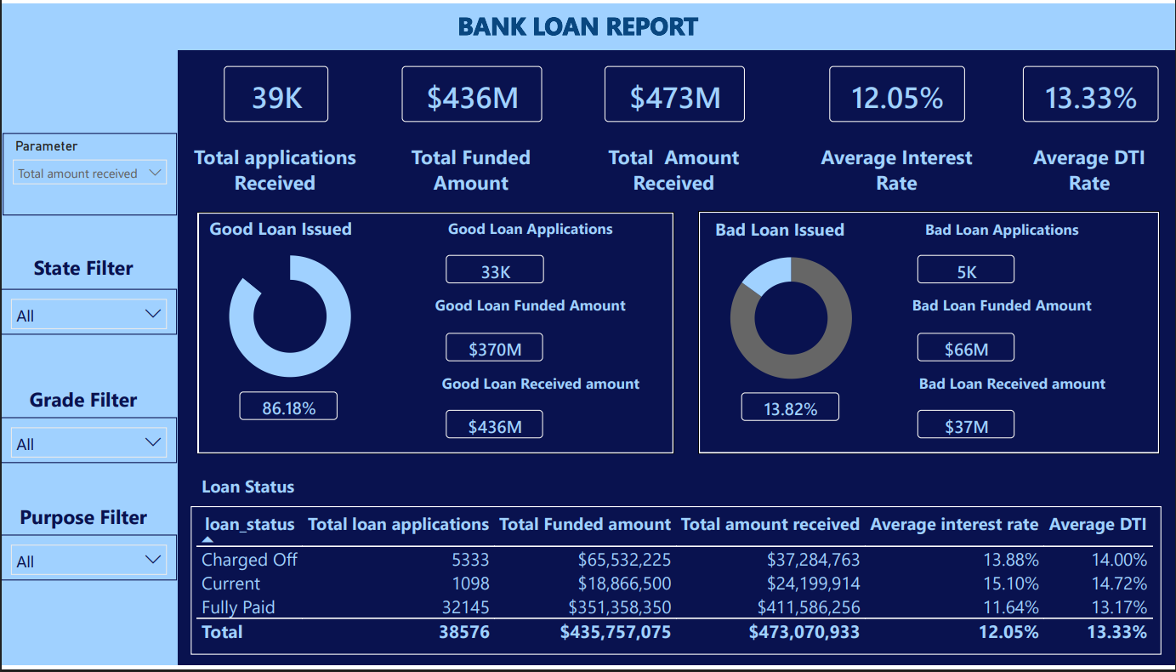

Dashboard 2: Overview
Charts planned for this page, as defined in the project problem statement:
- Monthly trend of applications, funded amount and amount received (line/area chart).
- Regional analysis by state (filled map) and loan term analysis (donut chart).
- Employment length analysis and loan purpose breakdown (bar charts).
- Home ownership analysis (tree map).
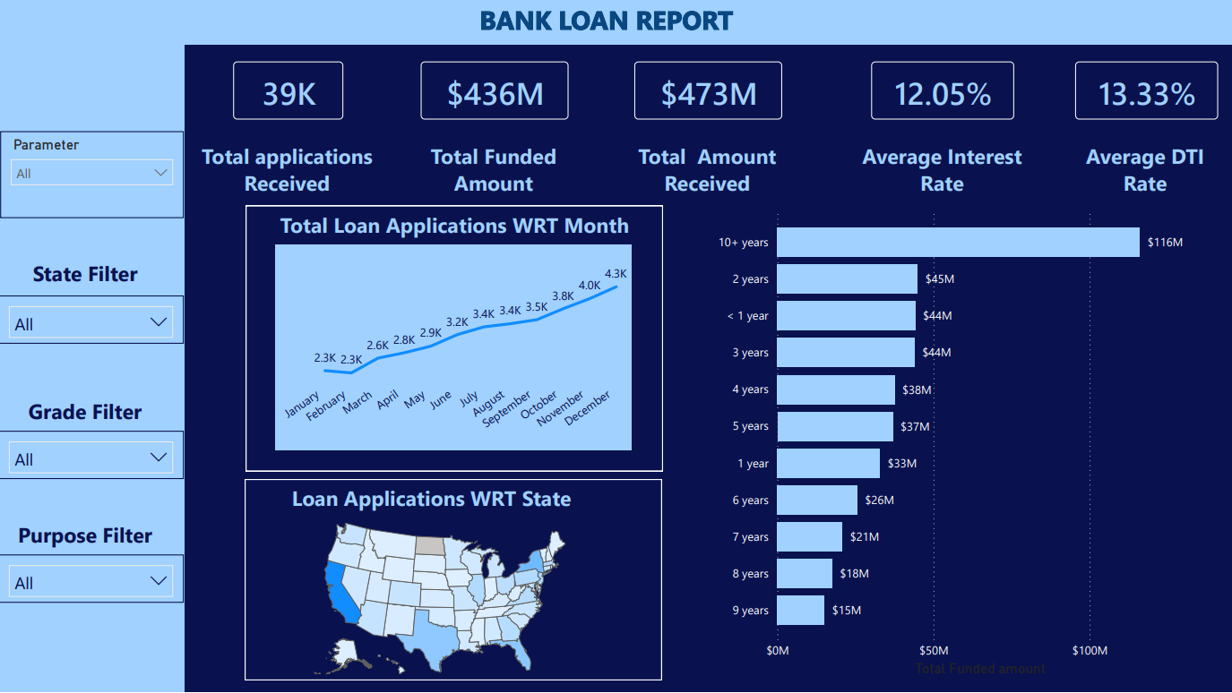

Dashboard 3: Details
- A loan-level table (id, purpose, employment length, funded amount, amount received, average interest rate, average DTI and sum of installment) with a totals row of $435,757,075 funded, $473,070,933 received, 12.05% average interest rate, 13.33% average DTI and 12,609,065.74 total installments.
- The Parameter, State, Grade and Purpose filters let users drill from the portfolio view down to individual loans.
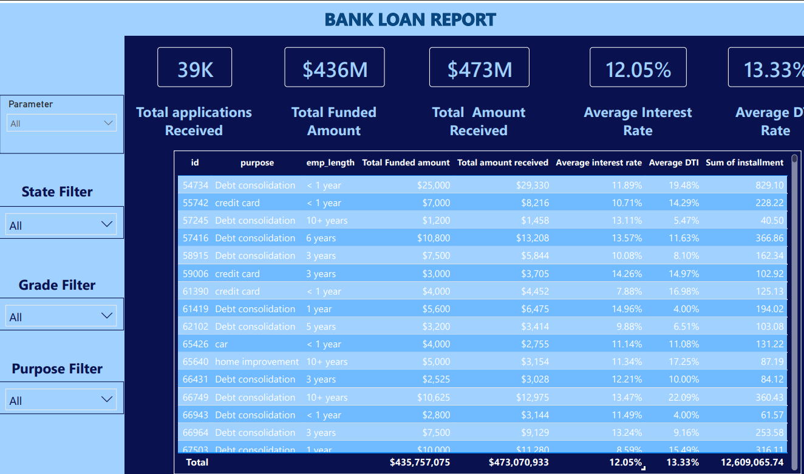

EXECUTIVE SUMMARY & ACTIONABLE RECOMMENDATIONS
Based on the SQL analysis and the Power BI dashboards of the 2021 loan portfolio, the following recommendations are proposed to reduce credit losses while continuing to grow lending:

1. Control the Growth of 60-Month and Low-Grade Loans (Top Priority)
The Issue: 60-month loans have a 22.34% charge-off rate (versus 10.71%), and their share of new loans rose from 18.05% to 28.19% in one year. Grades E to G have charge-off rates of 24.80% to 31.31%.
Recommendation: Set a cap on the share of 60-month loans in the monthly mix, restrict 60-month terms for Grades D to G or require higher income thresholds, and review risk-based pricing so that the extra interest covers the higher loss rate.

2. Tighten Underwriting for Small Business Loans
The Issue: Small business loans have a 25.62% charge-off rate and are the only purpose with a negative net return (-1.28%).
Recommendation: Require collateral or a personal guarantee, apply lower maximum amounts, and ask for additional business documents before approval.

3. Introduce Affordability Limits by Income, DTI and Loan Size
The Issue: Borrowers with income below $40K have a 17.06% charge-off rate, DTI of 20% or more has 15.59%, and loans of $20K or more have 17.25%.
Recommendation: Create tiered approval rules (for example a maximum loan-to-income ratio and stricter limits when DTI is 20% or more and the loan is above $20K), instead of relying on employment length, which is a weak predictor.

4. Manage Geographic Concentration
The Issue: Five states provide 46.70% of funding, and Nevada (20.95%) and Florida (17.27%) show elevated charge-off rates.
Recommendation: Set state-level exposure limits, apply extra scrutiny or higher pricing in Nevada and Florida, and diversify growth toward low-loss states such as DC, Kansas and Arkansas.

5. Build an Early-Warning and Recovery Process
The Issue: Charged-off loans recovered only 56.89% of the $65.53M funded, a net loss of $28.25M.
Recommendation: Use last_payment_date and next_payment_date to flag missed payments early, start collections sooner, and offer restructuring to borrowers who are still recoverable.

6. Grow the Safest Segments
The Issue: Grades A and B are 55.38% of loans with charge-off rates of 5.70% and 11.50%. Wedding, major purchase, credit card and car loans have charge-off rates between 9.27% and 10.35%.
Recommendation: Focus marketing and pre-approved offers on Grade A/B borrowers and on these low-risk purposes to improve the overall quality of the portfolio.

Future Scope
- Build a logistic-regression or gradient-boosting model to predict the probability of charge-off using grade, term, income, DTI, loan amount and purpose.
- Add vintage (cohort) analysis once more months of repayment history are available, so that the effect of the growing 60-month share can be measured.
- Add weighted averages and a profitability view (interest income versus funding cost and losses) to the dashboards.

CONCLUSION
The 2021 loan book is healthy on the surface (86.18% Good Loans and a positive overall cash return), but profit is concentrated in good loans while a 13.82% charge-off rate removes $28.25M. Risk is not random: it is concentrated in lower grades, 60-month terms, small business loans, lower-income and high-DTI borrowers, large loans and a few states. Because lending is increasingly shifting toward longer and larger loans, acting on these signals now will protect portfolio quality as the book keeps growing.
GitHub: https://github.com/abhinavkumar1268b/Bank-Loan-Analysis-2026

