

OLA SALES ANALYSIS

END TO END PORTFOLIO PROJECT

SQL , PYTHON, POWER BI

By - ABHINAV KUMAR
POWER BI : https://app.powerbi.com/links/j1qhg4id1B?ctid=0c2c5eb2-7477-4593-ac08- f1de3be027d2&pbi_source=linkShare

"This project demonstrates my ability to not just query data using SQL and build interactive Power BI dashboards, but also to translate raw data into actionable business strategies that drive revenue and improve operational KPIs."

DATA COLUMNS
1. Date
2. Time
3. Booking_ID
4. Booking_Status
5. Customer_ID
6. Vehicle_Type
7. Pickup_Location
8. Drop_Location
9. V_TAT
10. C_TAT
11. cancelled_Rides_by_Customer
12. cancelled_Rides_by_Driver
13. Incomplete_Rides
14. Incomplete_Rides_Reason
15. Booking_Value
16. Payment_Method
17. Ride_Distance
18. Driver_Ratings
19. Customer_Rating

SQL QUERIES
Category A: Overall Business Performance
Query 1: Total bookings and Booking Status Share
SQL Query:
SELECT
Booking_Status,
COUNT(*) AS bookings,
ROUND(100.0 * COUNT(*) / (SELECT COUNT(*) FROM ola), 2) AS booking_share_pct
FROM ola
GROUP BY Booking_Status
ORDER BY bookings DESC;
Result:
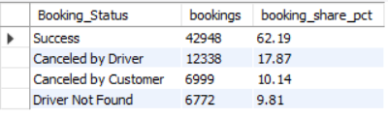
Business Context:
The purpose of this query is to understand the overall health of the platform. We need to see the exact percentage of total bookings that are successfully completed versus those that are cancelled.
Insights:
"Out of the total analyzed bookings, 62.19% (42,948) were successful. However, a significant 17.87% (12,338) were cancelled by drivers, followed by 10.14% (6,999) customer cancellations, and 9.81% (6,772) where the driver was not found. This indicates that driver-side issues (cancellations + not found) account for nearly 28% of all booking outcomes."

Query 2: Total Booking Value of Successful Bookings
SQL Query:
SELECT
COUNT(*) AS successful_bookings,
ROUND(SUM(Booking_Value), 2) AS successful_booking_value,
ROUND(AVG(Booking_Value), 2) AS avg_booking_value
FROM ola
WHERE Booking_Status = 'Success';
Result:
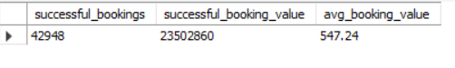
Business Context:
To calculate the total and average value of rides that actually generate revenue (successful rides). This is a primary financial KPI.
Insights:
"The platform generated a total revenue of ₹23,502,860 from 42,948 successful bookings. The average ticket size per successful ride is ₹547.24."
Query 20: Booking Outcomes vs. Booking Value Comparison
SQL Query:
SELECT
Booking_Status,
COUNT(*) AS bookings,
ROUND(SUM(Booking_Value), 2) AS total_booking_value,
ROUND(AVG(Booking_Value), 2) AS avg_booking_value
FROM ola
GROUP BY Booking_Status
ORDER BY bookings DESC;
Result:
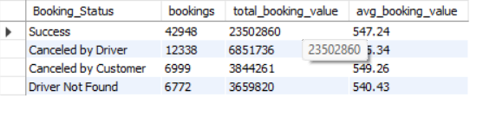
Business Context:
Simply counting cancellations is not enough; it's crucial to see if the cancelled rides had a high monetary value. This reveals the true size of the revenue loss.
Insights:
"Interestingly, the average booking value for rides cancelled by drivers (₹555.34) and customers (₹549.26) is slightly higher than the average value of successful rides (₹547.24). This suggests that higher-priced/longer rides have a marginally higher probability of getting cancelled, leading to significant revenue loss."
Category B: Cancellations & Operational Friction
Query 3: Customer and Driver Cancellations Share
SQL Query:
SELECT
Booking_Status,
COUNT(*) AS cancelled_bookings,
ROUND(100.0 * COUNT(*) / (SELECT COUNT(*) FROM ola), 2) AS share_of_all_bookings
FROM ola
WHERE Booking_Status LIKE '%Canceled%'
GROUP BY Booking_Status
ORDER BY cancelled_bookings DESC;
Result:
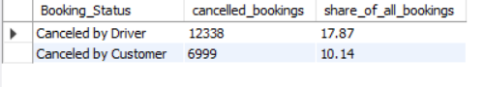
Business Context:
To quantify the total lost business. This helps determine whether customers cancel more often, or if drivers cancel more often.
Insights:
"Driver cancellations (12,338 rides / 17.87%) are almost double the number of customer cancellations (6,999 rides / 10.14%). This indicates a severe friction point on the supply side (drivers) that needs immediate management intervention."
Query 6: Cancellation Rate by Vehicle Type
SQL Query:
SELECT
Vehicle_Type,
COUNT(*) AS total_bookings,
SUM(CASE
WHEN Booking_Status LIKE '%Canceled%' THEN 1
ELSE 0
END) AS cancelled_bookings,
ROUND(
100.0 * SUM(CASE
WHEN Booking_Status LIKE '%Canceled%' THEN 1
ELSE 0
END) / COUNT(*),
2
) AS cancellation_rate_pct
FROM ola
GROUP BY Vehicle_Type
ORDER BY cancellation_rate_pct DESC;
Result:
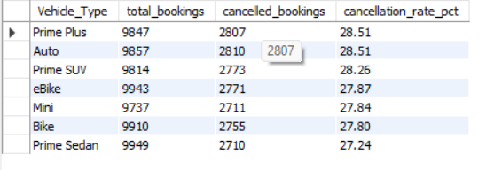
Business Context:
Are specific vehicle types (like Auto or Bike) experiencing higher cancellation rates? This is used to find operational bottlenecks.
Insights:
"The cancellation rate is alarmingly consistent across all vehicle types, hovering between 27.24% and 28.51%. 'Prime Plus' and 'Auto' have the highest cancellation rates at 28.51%, while 'Prime Sedan' has the lowest at 27.24%. This proves that cancellations are a systemic platform issue rather than an issue with a specific vehicle category."
Query 10: Top Reasons for Customer Cancellations
SQL Query:
SELECT
canceled_Rides_by_Customer AS cancellation_reason,
COUNT(*) AS bookings
FROM ola
WHERE Booking_Status LIKE '%Canceled%'
AND canceled_Rides_by_Customer IS NOT NULL
AND canceled_Rides_by_Customer <> 'NA'
GROUP BY canceled_Rides_by_Customer
ORDER BY bookings DESC;
Result:
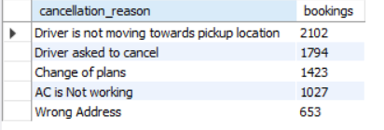
Business Context:
Why do customers cancel? Do they face long wait times, or are there app issues? This is a root cause analysis.
Insights:
"Driver behavior is the leading cause of customer cancellations. 'Driver is not moving towards pickup location' is the top reason (2,102 cases), followed by 'Driver asked to cancel' (1,794 cases). Combined, these account for more than 55% of all customer cancellations."
Query 11: Top Reasons for Driver Cancellations
SQL Query:
SELECT
Canceled_Rides_by_Driver AS cancellation_reason,
COUNT(*) AS bookings
FROM ola
WHERE Booking_Status LIKE '%Canceled%'
AND Canceled_Rides_by_Driver IS NOT NULL
AND Canceled_Rides_by_Driver <> 'NA'
GROUP BY Canceled_Rides_by_Driver
ORDER BY bookings DESC;
Result:
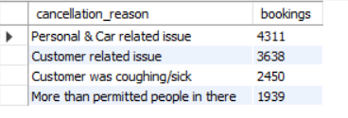
Business Context:
To understand driver-side problems. Are cars breaking down, or are there personal issues preventing them from completing rides?
Insights:
"For drivers, 'Personal & Car related issue' is the absolute top reason for cancelling rides (4,311 cases), followed by 'Customer related issue' (3,638 cases). This highlights a critical need for better driver welfare programs, vehicle maintenance support, and stricter customer verification."
Query 12: Main Reasons for Incomplete Rides
SQL Query:
SELECT
Incomplete_Rides_Reason,
COUNT(*) AS incomplete_rides
FROM ola
WHERE Incomplete_Rides = 'Yes'
AND Incomplete_Rides_Reason IS NOT NULL
AND Incomplete_Rides_Reason <> 'NA'
GROUP BY Incomplete_Rides_Reason
ORDER BY incomplete_rides DESC;
Result:
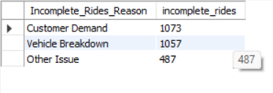
Business Context:
The ride started but was not completed. This identifies situations where both the customer and driver incur a loss.
Insights:
"Incomplete rides are almost equally split between 'Customer Demand' (1,073 cases) and 'Vehicle Breakdown' (1,057 cases). While customer changes of mind are hard to control, the high number of vehicle breakdowns indicates a pressing need for better fleet quality checks."
Category C: Revenue & Customer Behavior
Query 5: Vehicle Type with Highest Successful Booking Value
SQL Query:
SELECT
Vehicle_Type,
COUNT(*) AS successful_rides,
ROUND(SUM(Booking_Value), 2) AS total_booking_value,
ROUND(AVG(Booking_Value), 2) AS avg_booking_value
FROM ola
WHERE Booking_Status = 'Success'
GROUP BY Vehicle_Type
ORDER BY total_booking_value DESC;
Result:
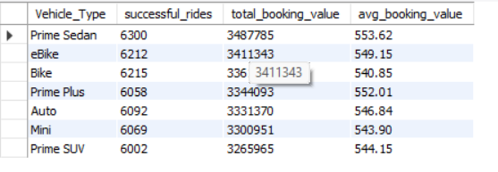
Business Context:
Which service is generating the most money for the company? (Prime Sedan, Mini, etc.)
Insights:
"Prime Sedan is the highest revenue-generating category with ₹3,487,785 from 6,300 rides, followed closely by eBike at ₹3,411,343. Surprisingly, Prime SUV generated the lowest total value (₹3,265,965) despite having a decent number of rides, indicating it might be underutilized or facing pricing issues."
Query 7: Top 5 Customers by Number of Successful Rides
SQL Query:
SELECT
Customer_ID,
COUNT(*) AS successful_bookings
FROM ola
WHERE Booking_Status = 'Success'
GROUP BY Customer_ID
ORDER BY successful_bookings DESC
LIMIT 5;
Result:
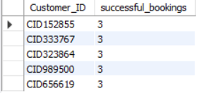
Business Context:
To identify the most frequent travelers ('Power Users') so loyalty programs can be offered to them.
Insights:
"The most active customers in this dataset (e.g., CID152855, CID333767) booked a maximum of only 3 successful rides each. This indicates a very low maximum booking frequency among the top power users in this specific dataset."

Query 8: Top 5 Customers by Total Booking Value
SQL Query:
SELECT
Customer_ID,
COUNT(*) AS successful_bookings,
ROUND(SUM(Booking_Value), 2) AS total_booking_value
FROM ola
WHERE Booking_Status = 'Success'
GROUP BY Customer_ID
ORDER BY total_booking_value DESC
LIMIT 5;
Result:
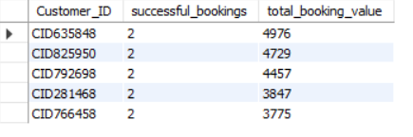
Business Context:
To find the 'VIP Customers' who spend the most money. These might be different from those who take the most rides (e.g., long-distance travelers).
Insights:
"The highest-spending customer is CID635848, generating ₹4,976 in revenue from just 2 bookings, followed by CID825950 at ₹4,729. This shows that a small set of users are taking high-value, long-distance trips."
Query 9: Customer Repeat Booking Distribution
SQL Query:
SELECT
booking_count,
COUNT(*) AS number_of_customers
FROM (
SELECT
Customer_ID,
COUNT(*) AS booking_count
FROM ola
WHERE Booking_Status = 'Success'
GROUP BY Customer_ID
) AS customer_bookings
GROUP BY booking_count
ORDER BY booking_count;
Result:
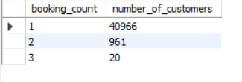
Business Context:
To check customer retention. How many people take just one ride, and how many come back repeatedly?
Insights:
"Customer retention is extremely poor. Out of roughly 42,000 unique customers, 40,966 (approx 97.6%) have booked only 1 time. Only 961 customers made a 2nd booking, and just 20 customers reached 3 bookings. The business is heavily reliant on acquiring new users rather than retaining them."
Query 13: Payment Method Distribution for Successful Bookings
SQL Query:
sql
SELECT
Payment_Method,
COUNT(*) AS successful_bookings,
ROUND(SUM(Booking_Value), 2) AS total_booking_value,
ROUND(100.0 * COUNT(*) /
(SELECT COUNT(*) FROM ola WHERE Booking_Status = 'Success'), 2
) AS booking_share_pct
FROM ola
WHERE Booking_Status = 'Success'
GROUP BY Payment_Method
ORDER BY successful_bookings DESC;
Result:
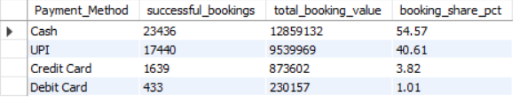
Business Context:
To understand user payment preferences. Cash, UPI, or Cards? This data helps in promoting digital payments.
Insights:
"Cash remains the most dominant payment method, accounting for 54.57% (23,436 rides) of successful bookings. However, UPI is a very close second at 40.61% (17,440 rides). This shows high digital payment adoption, but also indicates that cash handling and reconciliation remain a major operational task."
Category D: Vehicle Performance & Ratings
Query 4: Successful Rides and Average Distance by Vehicle Type
SQL Query:
SELECT
Vehicle_Type,
COUNT(*) AS successful_rides,
ROUND(AVG(Ride_Distance), 2) AS avg_ride_distance
FROM ola
WHERE Booking_Status = 'Success'
GROUP BY Vehicle_Type
ORDER BY successful_rides DESC;
Result:
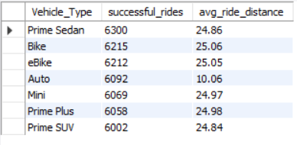
Business Context:
How much distance is each vehicle covering? Are Autos being used for short rides, and are Bikes used for something else?
Insights:
"Auto rides have a significantly lower average distance of 10.06 km compared to all other vehicle types, which average around 24.8 to 25 km. This shows that Autos are primarily used for short-distance intra-city commutes, while Bikes, eBikes, and Cabs are used for longer trips."
Query 14: Average Customer Rating by Vehicle Type
SQL Query:
SELECT
Vehicle_Type,
COUNT(Customer_Rating) AS rating_count,
ROUND(AVG(Customer_Rating), 2) AS avg_customer_rating
FROM ola
WHERE Booking_Status = 'Success'
AND Customer_Rating IS NOT NULL
AND Customer_Rating <> 'NA'
GROUP BY Vehicle_Type
ORDER BY avg_customer_rating DESC;
Result:
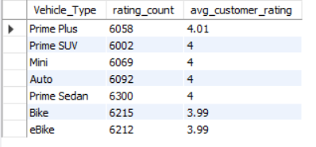
Business Context:
To benchmark customer experience. Which service do customers prefer the most?
Insights:
"Customer satisfaction is highly consistent across the board. Prime Plus leads with a rating of 4.01, while all other categories (Prime SUV, Mini, Auto, Prime Sedan) sit exactly at 4.00. Only Bike and eBike are slightly lower at 3.99. There is no major service quality gap between vehicle types."
Query 15: Prime Sedan Driver Ratings (Min, Max, Avg)
SQL Query:
SELECT
COUNT(Driver_Ratings) AS rating_count,
ROUND(MIN(Driver_Ratings), 2) AS min_driver_rating,
ROUND(MAX(Driver_Ratings), 2) AS max_driver_rating,
ROUND(AVG(Driver_Ratings), 2) AS avg_driver_rating
FROM ola
WHERE Vehicle_Type = 'Prime Sedan'
AND Booking_Status = 'Success'
AND Driver_Ratings IS NOT NULL
AND Driver_Ratings <> 'NA';
Result:
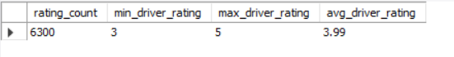
Business Context:
A deep dive into the performance of drivers in a specific flagship category (Prime Sedan).
Insights:
"For Prime Sedan, driver ratings range from a minimum of 3 to a maximum of 5. The average rating is 3.99 across 6,300 rides. The narrow rating band (3 to 5) indicates highly consistent driver performance with very few terrible experiences."
Category E: Location & Time Trends
Query 16: Top 10 Pickup Locations for Successful Bookings
SQL Query:
SELECT
Pickup_Location,
COUNT(*) AS successful_bookings,
ROUND(SUM(Booking_Value), 2) AS total_booking_value
FROM ola
WHERE Booking_Status = 'Success'
GROUP BY Pickup_Location
ORDER BY successful_bookings DESC
LIMIT 10;
Result:
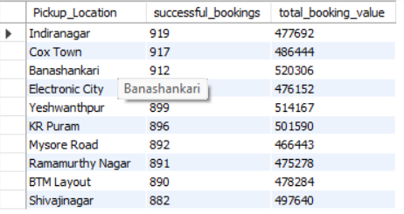
Business Context:
To identify high-demand areas (hotspots) so drivers can be directed there, and marketing can be focused on those regions.
Insights:
"Indiranagar has the highest volume of successful bookings (919), but Banashankari is the most profitable pickup location, generating the highest revenue of ₹520,306 from 912 rides. This shows that rides originating from Banashankari have a higher average ticket size."
Query 17: Top 10 Drop Locations by Successful Rides
SQL Query:
SELECT
Drop_Location,
COUNT(*) AS successful_bookings,
ROUND(AVG(Ride_Distance), 2) AS avg_ride_distance
FROM ola
WHERE Booking_Status = 'Success'
GROUP BY Drop_Location
ORDER BY successful_bookings DESC
LIMIT 10;
Result:
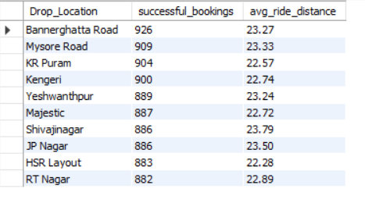
Business Context:
Where are people going the most? (e.g., Airport, IT Park, or Railway Station).
Insights:
"Bannerghatta Road is the most popular drop location with 926 successful rides and an average distance of 23.27 km. Mysore Road follows with 909 rides. These areas are major demand hubs that require high driver availability."
Query 18: Bookings by Hour of the Day (Peak Hours)
SQL Query:
SELECT
HOUR(Time) AS booking_hour,
COUNT(*) AS total_bookings,
SUM(CASE WHEN Booking_Status = 'Success' THEN 1 ELSE 0 END) AS successful_bookings
FROM ola
GROUP BY HOUR(Time)
ORDER BY total_bookings DESC;
Result:
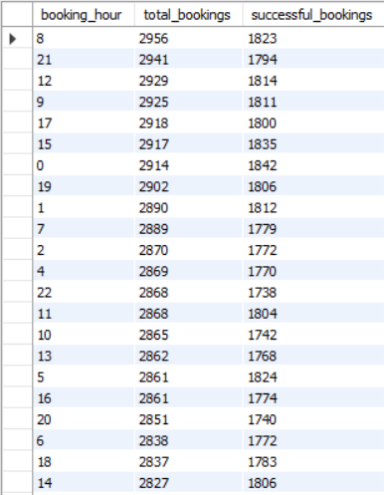
Business Context:
At what time of day are there the most rides? This is used to manage surge pricing and driver shifts.
Insights:
"The absolute peak booking hour is 8:00 AM with 2,956 total bookings, followed closely by 9:00 PM with 2,941 bookings. This aligns perfectly with standard morning and evening office commute hours. Supply (drivers) should be maximized during these two specific hours."
Query 19: Daily Successful Bookings and Revenue Trend
SQL Query:
SELECT
Date,
COUNT(*) AS successful_bookings,
ROUND(SUM(Booking_Value), 2) AS daily_booking_value
FROM ola
WHERE Booking_Status = 'Success'
GROUP BY Date
ORDER BY Date;
Result:
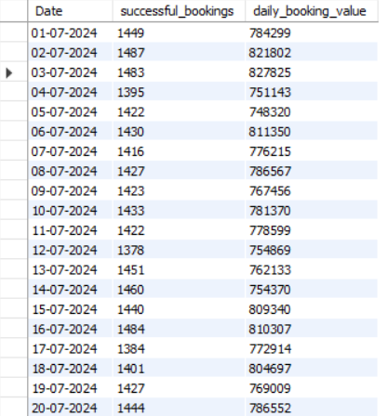
Business Context:
Time-series analysis. On which days is the business performing well, and on which days is it slow (Weekends vs. Weekdays)?
Insights:
"Daily revenue fluctuates between roughly ₹740K and ₹820K. The highest revenue was recorded on July 3rd, 2024 (₹827,825) from 1,483 rides. The highest booking volume occurred on July 16th (1,484 rides). There is no drastic drop in daily performance, indicating a stable baseline of daily operations."

PYTHON EDA & FINDINGS
Ola Ride Booking Analysis — Key Findings & Business Insights
1. Executive Summary
The Ola ride-booking analysis examined booking outcomes, operational cancellations, vehicle performance, customer behaviour, payment preferences, ratings, location-level demand, and hourly and daily booking trends. The dataset contains 69,057 booking records, of which 42,948 were successful.
The analysis highlights substantial booking friction, low repeat-booking frequency within the observed period, differences in vehicle usage patterns, and identifiable demand peaks. These findings provide opportunities to investigate booking completion, customer retention, and operational planning.
2. Overall Business Performance
- Successful bookings: 42,948 bookings, representing 62.19% of all records.
- Driver cancellations: 12,338 bookings (17.87%).
- Customer cancellations: 6,999 bookings (10.14%).
- Driver not found: 6,772 bookings (9.81%).
- Successful booking value: ₹23,502,860, with an average booking value of ₹547.24 per successful ride.
Driver cancellations and driver-not-found outcomes together account for 27.68% of all bookings. This highlights a substantial booking-completion challenge associated with driver-side outcomes.
Business implication: Improving driver availability, pickup coordination, and cancellation handling should be investigated as potential ways to improve successful booking completion.
3. Cancellation & Operational Analysis
Cancellation patterns
Driver cancellations occur almost twice as frequently as customer cancellations. Cancellation rates across vehicle categories range from 27.24% to 28.51%, with Prime Plus and Auto at the upper end and Prime Sedan at the lower end.
The relatively narrow range suggests that cancellations affect multiple vehicle categories rather than being concentrated in only one. However, this alone does not prove that the underlying cause is a single platform-wide issue.
Customer cancellation reasons
The leading recorded reasons were:
- Driver not moving towards the pickup location: 2,102 cases.
- Driver asked the customer to cancel: 1,794 cases.
These reasons point towards pickup coordination and driver-customer communication as important areas for further investigation.
Driver cancellation reasons
- Personal and car-related issues: 4,311 cases.
- Customer-related issues: 3,638 cases.
These results indicate that both driver-side operational constraints and customer interactions warrant attention. The dataset alone does not establish whether vehicle maintenance, verification, or another intervention would resolve these issues.
Incomplete rides
Incomplete rides were primarily associated with:
- Customer demand: 1,073 cases.
- Vehicle breakdown: 1,057 cases.
The similar counts indicate that both customer-related trip changes and vehicle reliability deserve investigation.
Recommended actions: Review pickup-progress monitoring, cancellation reason definitions, driver support processes, and vehicle maintenance procedures. Measure subsequent changes in cancellation and incomplete-ride rates before evaluating the effectiveness of interventions.
4. Vehicle Performance & Customer Experience
Successful ride volume and distance
Auto rides have an average distance of 10.06 km, substantially below the approximately 24.8–25 km average reported for the other vehicle categories.
This suggests that Autos serve a different trip-distance profile, with relatively shorter journeys, while other categories handle longer trips on average.
Booking value by vehicle type
- Prime Sedan: ₹3,487,785 across 6,300 successful rides.
- eBike: ₹3,411,343.
- Prime SUV: ₹3,265,965, the lowest total among the compared vehicle categories.
Prime Sedan recorded the highest total booking value, while Prime SUV recorded the lowest. This comparison should be interpreted alongside booking counts, average booking value, ride distance, and operating costs before making pricing or utilisation decisions.
Customer ratings
Average customer ratings are highly similar across vehicle categories:
- Prime Plus: 4.01.
- Most other categories: 4.00.
- Bike and eBike: 3.99.
For Prime Sedan, the average driver rating is 3.99, with observed ratings ranging from 3 to 5.
The small differences in average ratings do not indicate a substantial gap in average customer experience. However, average ratings alone cannot establish the absence of poor individual experiences; rating distributions and sample sizes should also be examined.
5. Customer Behaviour & Payment Preferences
Repeat-booking behaviour
Approximately 40,966 customers, or 97.6% of the roughly 42,000 unique customers reported, made only one successful booking during the observed period. Around 961 customers made two successful bookings, while 20 made three.
This indicates limited repeat-booking activity within the dataset's observation window.
Business implication: Customer retention is a worthwhile area for further investigation. Before concluding that long-term retention is poor, analyse a longer observation period and measure customer cohorts over time.
Highest-value customers
CID635848 recorded ₹4,976 in booking value across two successful bookings, followed by CID825950 with ₹4,729.
The highest successful booking count among the listed top customers was three.
These results show that booking frequency and total booking value provide different views of customer contribution. A customer with fewer bookings may still contribute substantial booking value.
Payment method distribution
- Cash: 23,436 successful bookings (54.57%).
- UPI: 17,440 successful bookings (40.61%).
Cash is the most frequently recorded payment method, while UPI represents a substantial share of successful bookings.
Business implication: The payment mix can inform payment-process planning. However, the dataset does not independently confirm settlement, reconciliation errors, or the operational cost of handling cash.
6. Location-Level Demand
Pickup locations
Indiranagar recorded the highest successful pickup volume, with 919 rides. Banashankari recorded the highest total booking value among the reported pickup locations, at ₹520,306 across 912 rides.
This difference illustrates why booking volume and booking value should be evaluated separately. Banashankari's higher total value does not by itself establish higher profitability.
Drop locations
Bannerghatta Road recorded 926 successful rides, with an average ride distance of 23.27 km. Mysore Road followed with 909 successful rides.
These locations represent high-volume destinations in the observed data and may be useful for further demand-planning analysis. Driver availability and supply shortages cannot be inferred from destination counts alone.
7. Hourly & Daily Booking Trends
Peak booking hours
- 8:00 AM: 2,956 total bookings.
- 9:00 PM: 2,941 total bookings.
These are the two highest reported hourly booking volumes. The morning peak is consistent with a possible commute-related pattern, while the evening peak may reflect a different mix of travel purposes. The dataset does not independently confirm the reasons for these peaks.
Business implication: Examine successful booking rates and cancellation rates by hour alongside booking volume before recommending changes to driver scheduling.
Daily booking performance
The highest reported daily booking value was ₹827,825 on July 3, 2024, from 1,483 successful rides. The highest successful ride count was 1,484 on July 16, 2024.
Daily booking value reportedly ranged from approximately ₹740,000 to ₹820,000. This suggests relatively consistent daily performance at a broad level, although exact minimums, daily fluctuations, and outlier days should be validated against the underlying data.
8. Overall Conclusion
The analysis identifies three major areas for business investigation:
- Booking completion: Driver cancellations and driver-not-found outcomes make up a substantial share of total bookings.
- Customer repeat behaviour: Most customers recorded only one successful booking during the observed period, suggesting a need to investigate repeat usage over longer time horizons.
- Operational planning: Vehicle-specific distance profiles, location-level booking volumes, and morning and evening peaks provide useful inputs for demand and operations analysis.
The results should be used as evidence for prioritising further investigation, not as proof of causation. The next step is to integrate the validated KPIs and findings into a Power BI dashboard so that stakeholders can explore booking performance by date, vehicle type, booking status, payment method, and location.

POWER BI DASHBOARD
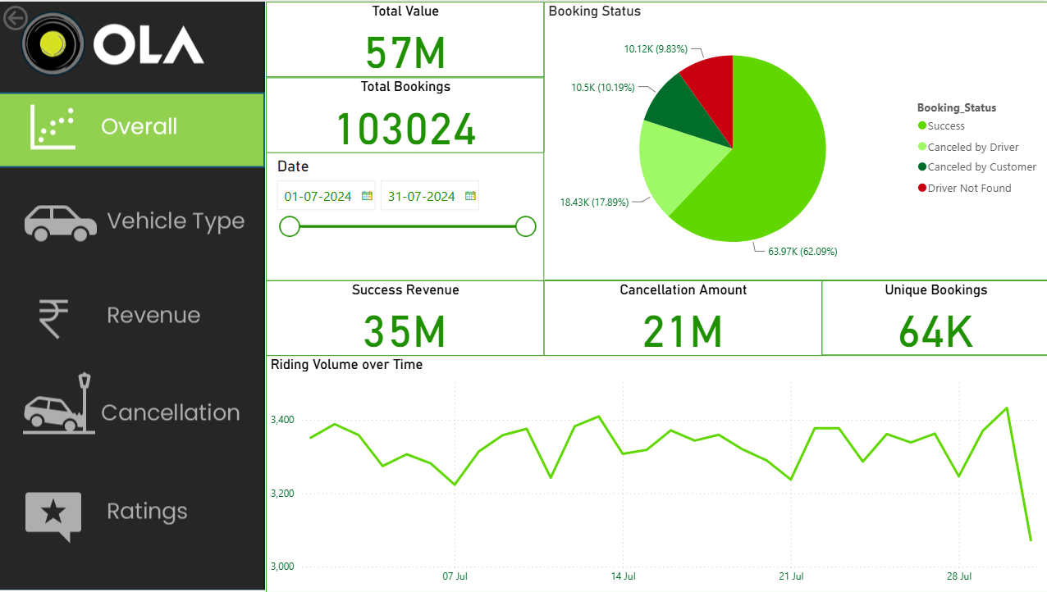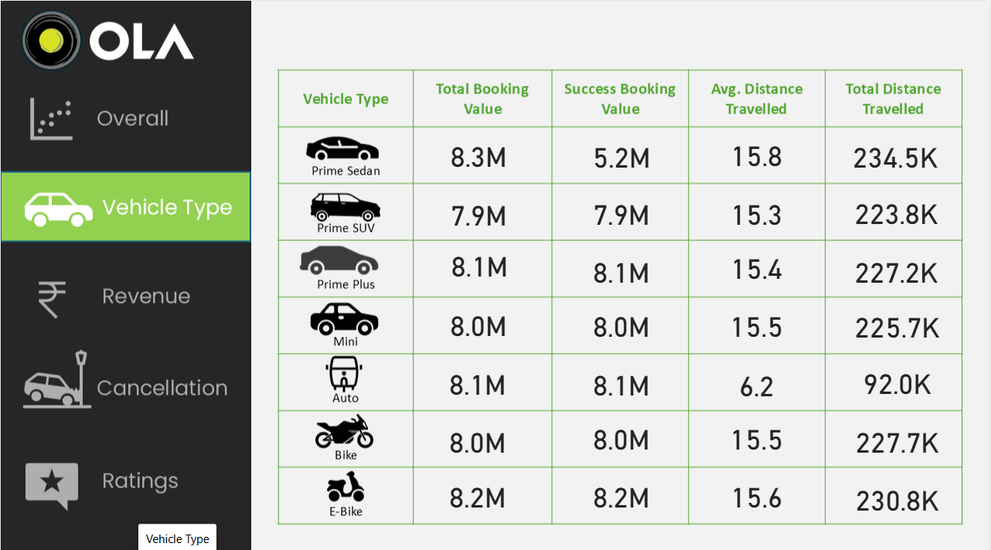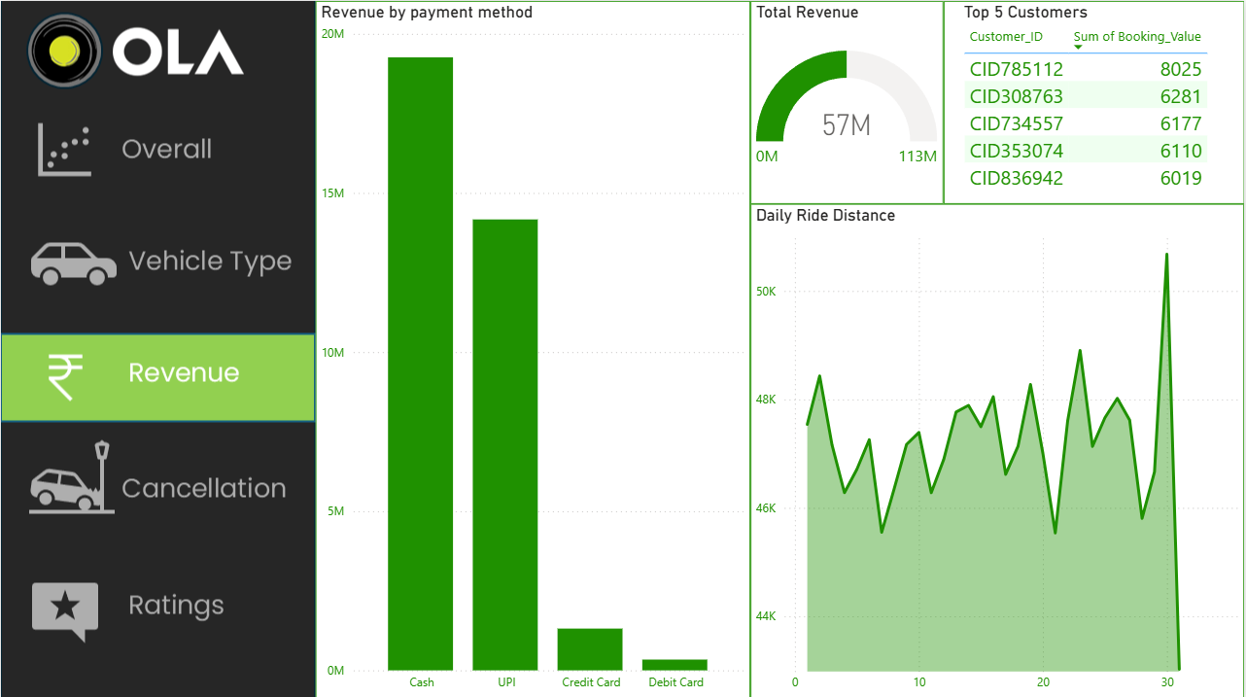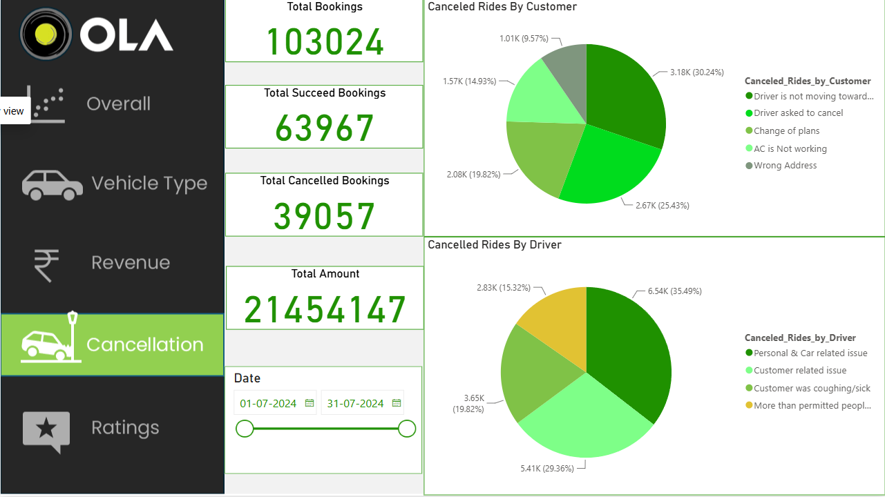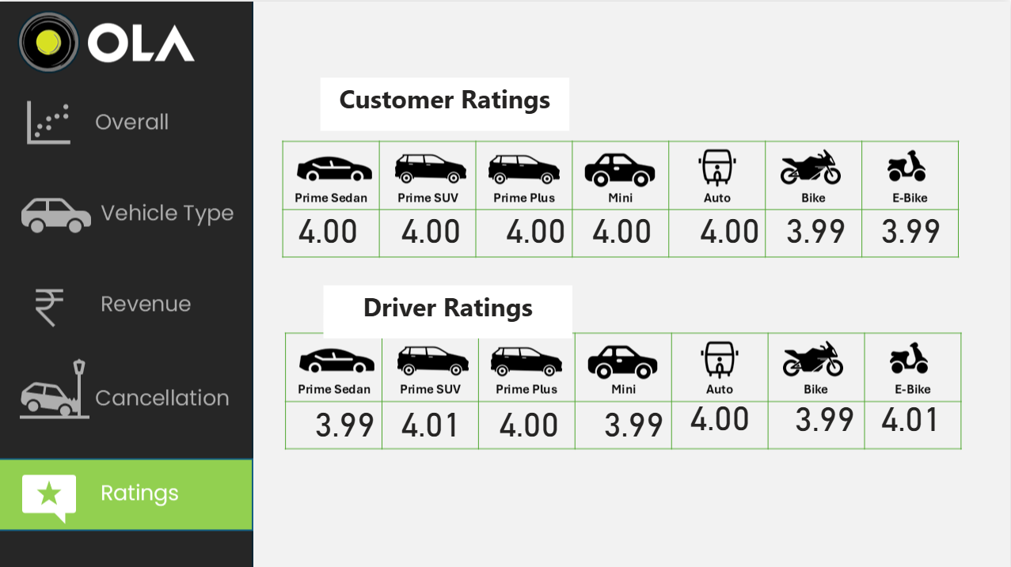
Executive Summary & Actionable Recommendations
Based on the comprehensive SQL analysis and Power BI dashboard insights of the Ola ride-booking dataset, the following strategic recommendations are proposed to improve operational efficiency, reduce revenue leakage, and enhance customer retention:
1. Curb Driver-Side Cancellations (Top Priority)
- The Issue: Driver cancellations (17.87%) are almost double customer cancellations (10.14%). The top reason is "Personal & Car related issues" (4,311 cases).
- Recommendation: Implement a robust Driver Welfare & Support Program. Provide emergency roadside assistance, subsidized vehicle maintenance, and health insurance. Furthermore, introduce a strict penalty matrix for drivers frequently cancelling rides or asking customers to cancel.
2. Improve Customer Retention & Loyalty
- The Issue: The platform is heavily reliant on one-time users, with 97.6% of customers (40,966 out of ~42,000) booking only once.
- Recommendation: Launch a targeted Customer Loyalty Program (like an Ola Pass or subscription model). Offer aggressive, personalized discount coupons for the second ride to convert one-time users into repeat customers.
3. Optimize Dispatch & Reduce Customer Friction
- The Issue: The top reason for customer cancellations is "Driver is not moving towards pickup location" (2,102 cases).
- Recommendation: Upgrade the dispatch algorithm to assign rides only to the nearest available drivers. Send proactive SMS/app notifications to customers with real-time driver ETAs to manage expectations and reduce cancellation rates.
4. Capitalize on Peak Demand Hours
- The Issue: Ride demand peaks sharply at 8:00 AM and 9:00 PM, aligning with office commute hours.
- Recommendation: Introduce dynamic surge pricing and gamified driver incentives during these specific hours. Ensuring maximum driver availability during these peaks will maximize revenue and reduce "Driver Not Found" cases (currently at 9.81%).
5. Push Digital Payments (UPI)
- The Issue: Cash is still the dominant payment method (54.57%), followed closely by UPI (40.61%).
- Recommendation: To reduce cash handling risks and operational overheads, heavily incentivize UPI usage. Offer small cashback or Ola Money credits for users who link their UPI and opt for digital payments.
6. Strategic Fleet & Geographic Allocation
- The Issue: Prime Sedan is the highest revenue generator (₹3.48M), while Auto is used strictly for short distances (avg 10 km). Banashankari is the most profitable pickup hub.
- Recommendation: Deploy a higher density of premium vehicles (Prime Sedan/SUV) in high-revenue areas like Banashankari to maximize profit per ride. Keep Auto supply concentrated in high-density, short-distance zones to meet quick-commute demands.

