**Issue Description:**

Post installation of AOS amp module, user click on **Edit in Microsoft Office** Action either in Document Browser More or Document Details page.

* User will see a blank Office application (Word or Excel application without content displayed)

**(OR)**

* User might be able to open document but will see an error popup saying **Cannot download requested content**

Root Cause: when user tried to open document Microsoft Office application tries to establish connection from client machine to server, looks out for client certificate which matches with server. This uses Crypto API calls to match certificate using certificate fingerprint. Below are the steps to resolve issue.

**Generating PKCS12 certificate using JKS certificate:**

1. Download certificate from server which is used to configure SSL in tomcat (If cert has password get it from your certificate provider).
2. Execute below command to generate PKCS12 format(.p12) which needs to be imported into client personal certificate.

**keytool -importkeystore -srckeystore {path_to_JKS_cert} -destkeystore {desired_path_for .p12} -srcstoretype JKS -deststoretype PKCS12 -deststorepass {your_password}**

* 1. Asks for root certificate password for first time. Please provide password which your certificate provides you
  2. Asks you to enter password for .p12 cert. Please provide your desired password.

**Install Cert for Inline Edit:**

1. Use above generated .p12 certificate to import in client machine.
2. Search for Run Application in your system or press “windows + r” to open run manager.
3. Enter command **certmgr.msc.** PFB the screenshot

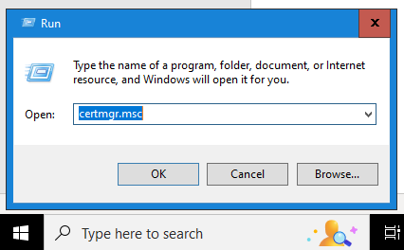

1. After running the command, PFB the screen shot

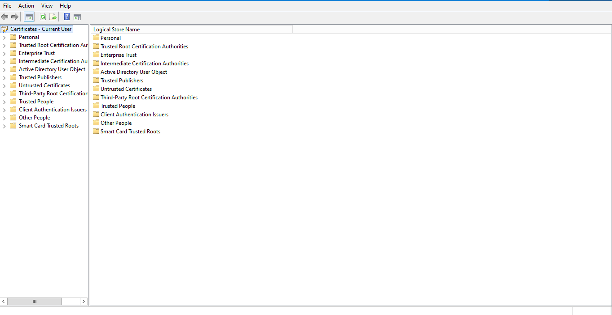

1. Click on Personal 🡪 Certificates. PFB the screenshot

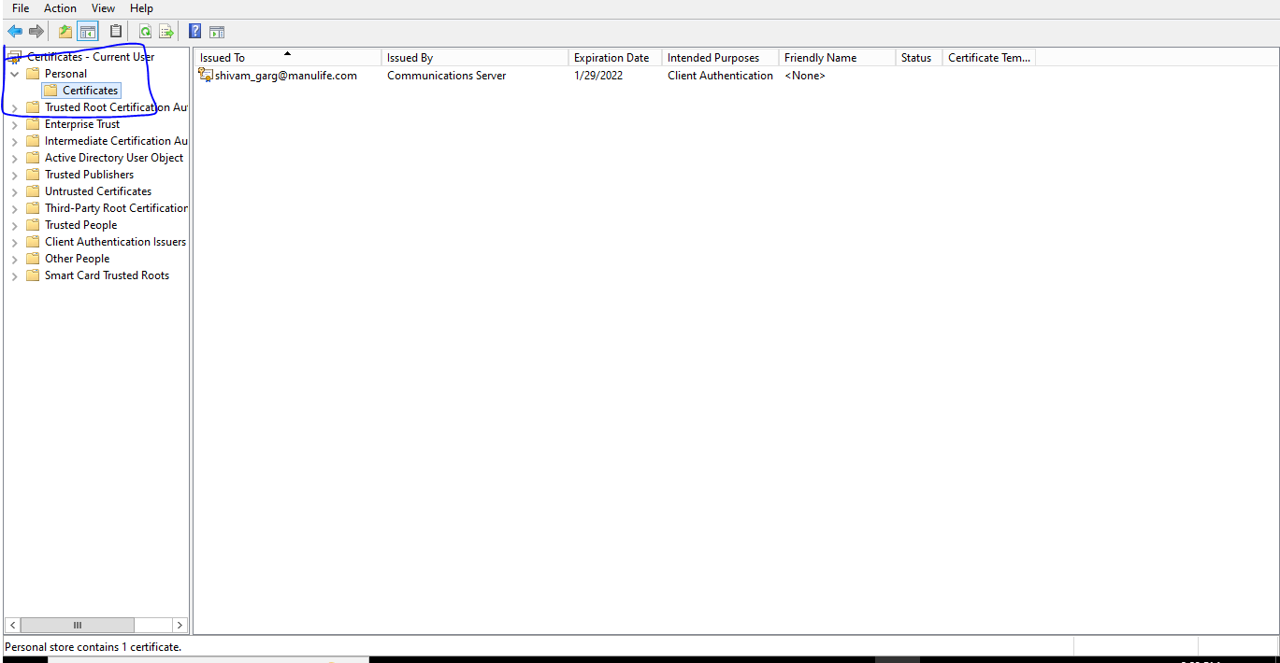

1. Right Click 🡪 All Tasks 🡪 Import

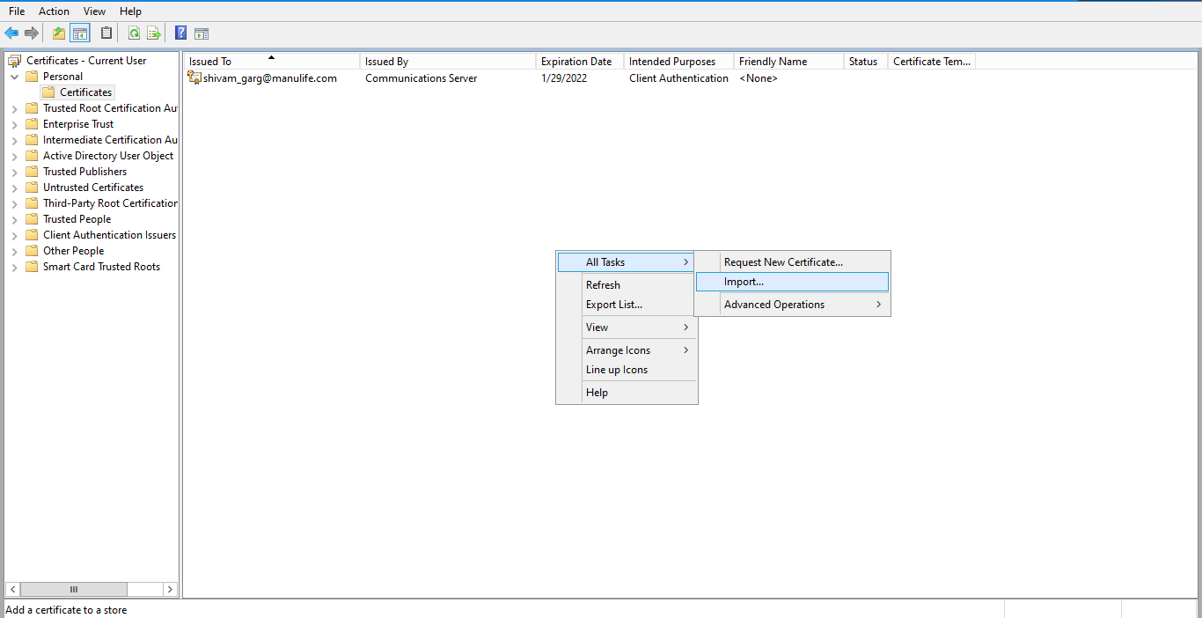

1. Select**.p12** certificate from your computer and click on next.

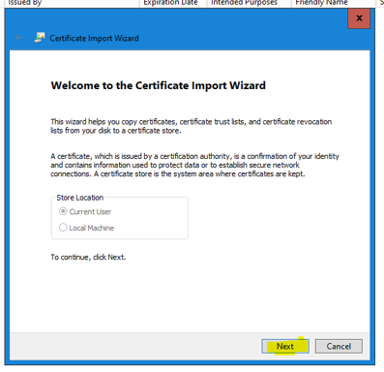

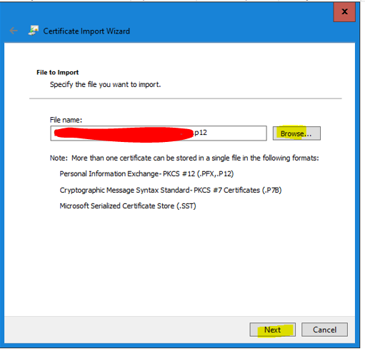

1. On password prompt enter password that is used in **Generating PKCS12 certificate using JKS certificate** point 2 sub point B and then click next.

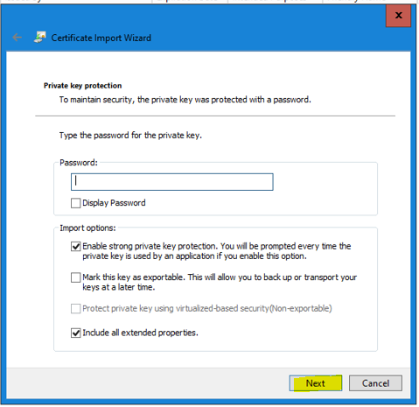

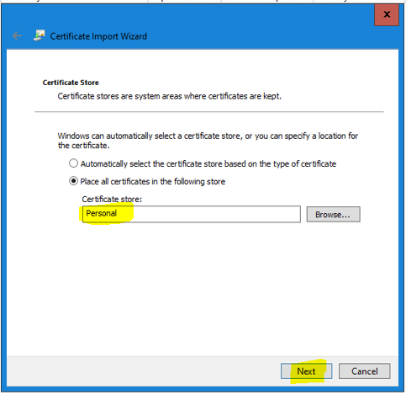

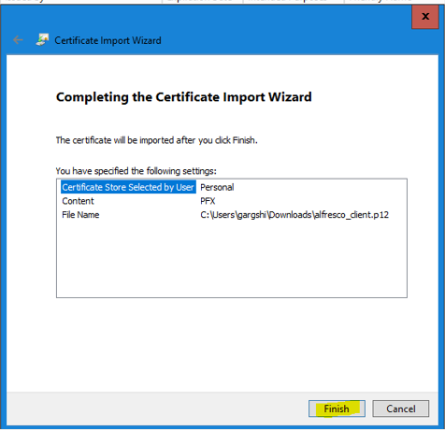

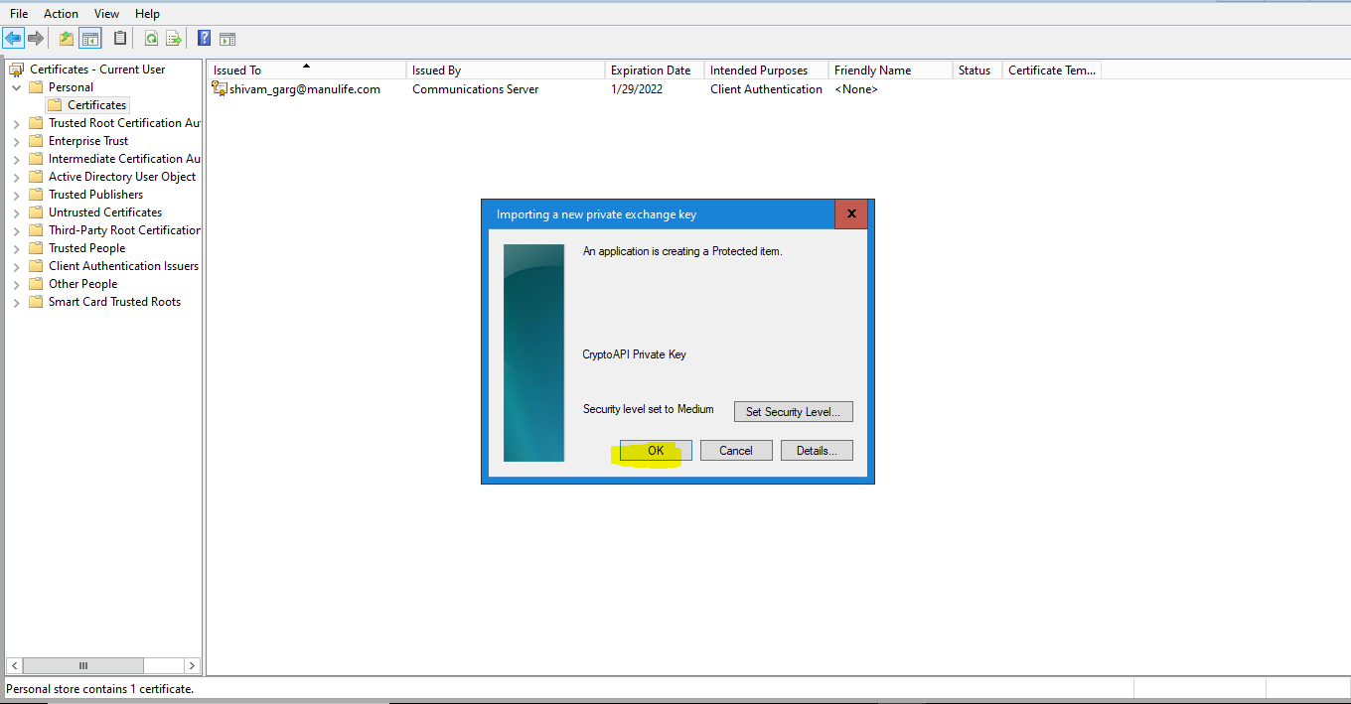

1. You should see import successful and new certificates should be visible in cert manager.
2. After installing the certificates Inline Edit will start working.