# **Constructing On-Premise Data Pipeline in Azure for AML operationalization**

Data driven decisions lie at the center of all fast growing companies. A vast majority of companies use SQL servers for data storage, aggregation, and number crunching. This data can also be used to forecast machine breakdowns, detect anomalies, manage costs, etc. While data analytics can give very precise answers to static data questions, it lacks the ability to predict trends, behaviors, or anomalies in various processes, with continuously improving high degree of accuracy. Machine learning fills this gap.

## **Scope**

This document helps you create an end-to-end (E2E) deployment ready data pipeline for consuming an Azure Machine Learning (AML) solution for data in your on-premise SQL server.

This document will describe the overall approach for operationalizing an on-premise to Azure data pipeline through the following steps:

1. An **Ingress data pipeline** that will bring in data from an on-premise SQL server to Azure Storage.
2. An **AML data pipeline** to send data from Azure Storage to AML for batch scoring and then back to Azure Storage to store the scored results.
3. An **Egress data pipeline** that will send the scores back to the on-premise SQL server from Azure Storage.
4. Lastly, a **PowerBI dashboard** to visualize scoring results in real time.

By the end of this document you will be have a fully operationalized data pipeline in Azure that is scheduled to run automatically on an hourly basis.

## **Prerequisites**

1. An active Azure Subscription.
2. Access (read/write) to an on-premise SQL server.
3. An existing pre-published AML model (we will create an operationalized ML solution using the BES endpoint of that model). TODO: Add instructions to get pick sample experiment from gallery.
4. Latest version of Azure PowerShell. To install PowerShell, follow the instructions [here](https://azure.microsoft.com/en-us/documentation/articles/powershell-install-configure/#Install).

## **Big Picture**

Building an Azure Machine Learning model requires historical data, and perhaps lots of it based on the quality of the data. This is the reason why it is important to think about building data pipelines not just for building the model but also for getting scores from the model and integrating the results with your current business processes. For our current use case we have divided this pipeline into 3 discrete parts, each serving a specific objective that can be tested separately if desired. We start by giving you an overview of the big picture below. Then we will briefly define various Azure platform services and tools we will use. Finally, we will list step by step instructions you can follow to create an E2E data pipeline.

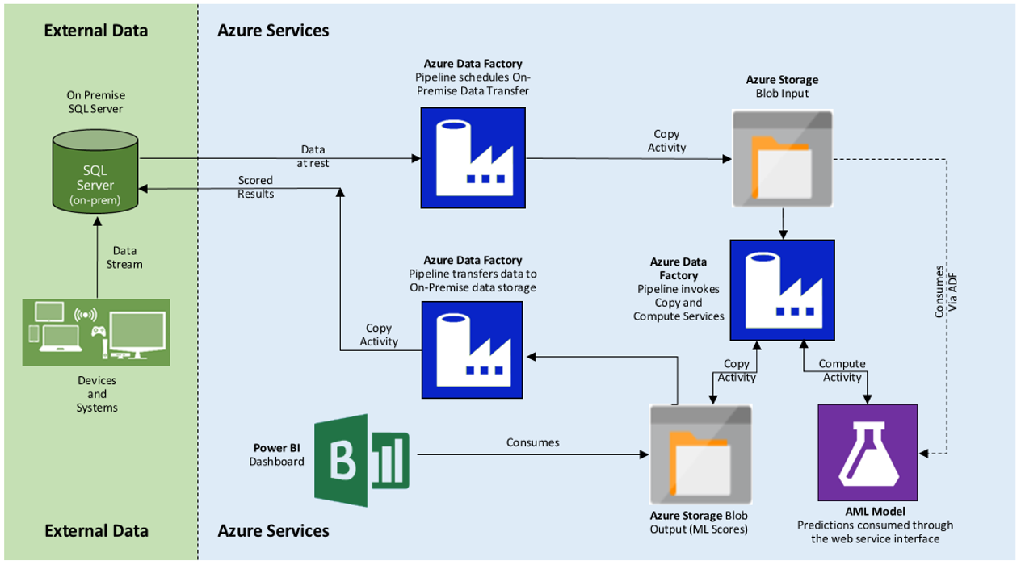

Figure 1: Overall Architecture of E2E data pipeline for On-Premise data source

In the architecture shown above, we have two key consumer and producer services – On-Premise SQL Server database and Azure Machine Learning (AML) model. The on-premise database serves both as a data source and a data sink. The AML model consumes the data hosted by the on-premise database and produces prediction data that is copied back to the on-premise database (consumer). We use Azure Data Factory (ADF) to move the data between the on-premise database and Azure as well as for calling the AML web service endpoint for scoring batches of input data. You can read more about ADF and some of the ADF terminologies we will be using [here](https://azure.microsoft.com/en-us/documentation/articles/data-factory-introduction/).

The data pipeline is divided in to three section as follows:

1. We use ADF to first copy data from an on-premise SQL Server to Azure Blob Storage (we will refer to this as the **IngressPipeline**).
2. The ADF then invokes ‘compute’ activity using AML model’s BES endpoint for prediction and copies the predicted results to an output blob location (we will refer to this as the **AMLPipeline**).
3. The scored data from the output blob location is then copied to the on-premise SQL server for integration with the rest of the business process (we will refer to this as the **EgressPipeline**).

We will also show how the scored results from section 2 can be consumed through a PowerBI dashboard that is published in Azure cloud and is available anywhere over the internet.

## **Walkthrough**

### Create an ADF and Setup Data Management Gateway

The first two steps in creating an E2E data pipeline to connect to an on-premise SQL server are to create an Azure Data Factory and install Data Management Gateway*.* Follow steps 1 & 2 of this [tutorial](http://azure.microsoft.com/en-us/documentation/articles/data-factory-use-onpremises-datasources/#step-1-create-an-azure-data-factory) to create an Azure Data Factory and install the data management gateway before returning to this document. As you follow the instructions for creating the ADF use the following values for naming

ResourceGroupName => **OnPremDataFactoryRG**

(Note the Subscription details here, make sure you run the subsequent PowerShell commands in the same subscription. Use Select-AzureSubscription -SubscriptionName "<Subscription name>” if you need to change subscription.)

DataFactoryName => **OnPremDataFactory-<your-initials> (ADF Name needs to be globally unique)**

GatewayName => **OnPremAzureDataGateway**

### Create Sample Input Data

Next, on an on-premise SQL Server create two tables, **InputSensorData** and **ScoringResults**. InputSensorData table acts as the input data source for the data pipelines and ScoringResults table will hold the output from the Azure machine learning model. Use the SQL scripts provided with this package to create tables and insert sample data.

If you have an existing dataset or table in an on-prem SQL server that you want to use for scoring, modify the "tableName” property in the **InputOnPremSQLTable** json definition to reflect the desired table name from the SQL database. The user must still create an output table called ‘ScoringResults’ described earlier to store on-premise the results of AML predictions (a.k.a., scoring).

### Create Data Pipelines

Finally, we will create 3 data pipelines (described earlier in this document) all within the context of the ADF we just created. Each data pipeline constitutes of at least one input dataset, one output dataset, and an activity that transforms the input into the output. These activities could be a simple (data) copy activity, a compute activity (such as AML scoring), or some custom defined activity (such as ETL).

Make sure you have installed [Azure PowerShell](http://azure.microsoft.com/en-us/documentation/articles/powershell-install-configure/#Install) before continuing further. You will also require scripts from ADF Ingress, AML, and Egress pipeline folder that came with this document package.

### **Ingress On-Premise Pipeline**

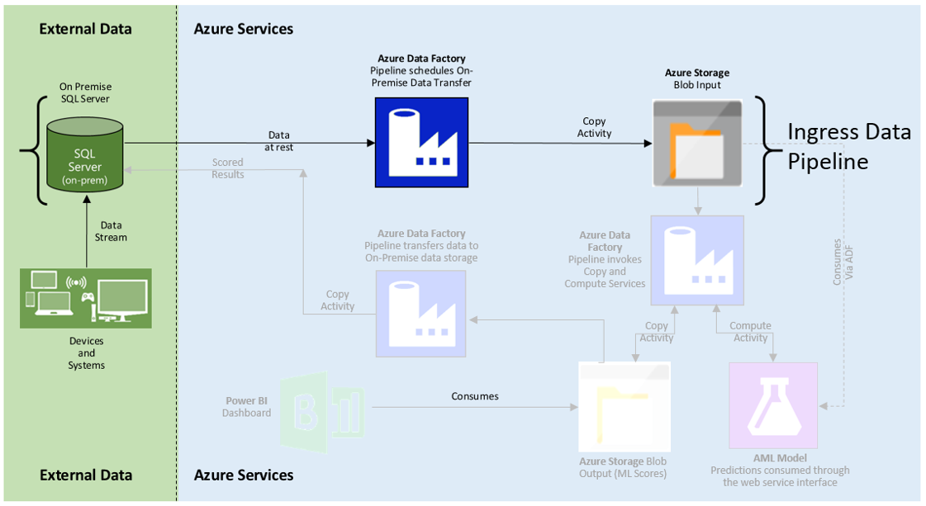

Figure 2: Ingress Pipeline

The Ingress pipeline connects your company’s on-premise SQL Server (in your data center or lab) to Azure Cloud via the data management gateway installed earlier. The ADF pipeline (shown in blue in the picture above) itself will run a “copy activity” to copy the data between SQL server database(s) and Azure Blob Storage.

1. Open Azure PowerShell and switch mode to ARM

PS C:\> Switch-AzureMode AzureResourceManager

1. Add your Azure Subscription Account:

PS C:\> Add-AzureAccount(This will open a pop up, enter your Azure subscription credentials here)

1. **Create Linked Services**: Each dataset (input or output) used in an ADF pipeline is backed by an underlying *linked service* that allows connection to the data store where the dataset resides. Each data store (storing input or output datasets for the ADF pipeline) must be uniquely defined as a new linked service. If both the input and the output datasets reside in the same data store (for example, the same blob container, or the same SQL database) then the same linked service can be used to connect to both input and output datasets.

We will define **two linked services** – one to connect to your **on-premise database** and another to an **Azure blob storage** where your data is stored.

PS C:\> New-AzureDataFactoryLinkedService –ResourceGroupName OnPremDataFactoryRG -DataFactoryName <DataFactoryName> -File <location of **OnPremSQLLinkedService** definition>

(Fill in the ConnectionString, gatewayName, username and password in the json definition file)

PS C:\> New-AzureDataFactoryLinkedService -ResourceGroupName OnPremDataFactoryRG -DataFactoryName <DataFactoryName> -File <location of **BlobLinkedService** definition>

(Put in your Azure Storage AccountName and your AccountKey in the json definition file)

1. **Create Input and Output Datasets**: Now having linked services defined, we can use them to create the *dataset* schema, partitioning and availability schedule. We will **define two datasets** – one that describes the schema and availability schedule of the table (containing input data) in your **on-premise database** and another that describes the partition, and schema and availability schedule for the **output blob store**.

PS C:\> New-AzureDataFactoryDataSet -ResourceGroupName OnPremDataFactoryRG -DataFactoryName <DataFactoryName> -File <location of **InputOnPremSQLTable** definition>

PS C:\> New-AzureDataFactoryDataSet -ResourceGroupName OnPremDataFactoryRG -DataFactoryName <DataFactoryName> -File <location of **RawInputBlobTable** definition>

1. **Create Pipeline**: Finally, create an ADF pipeline that **connects the on-premise SQL server table to the Azure blob storage** defined above and invokes ***‘copy’ activity*** to be run every hour.

PS C:\> New-AzureDataFactoryPipeline -ResourceGroupName OnPremDataFactoryRG -DataFactoryName <DataFactoryName> -File <location of **IngressPipeline** definition>

### **The AML Scoring Pipeline**

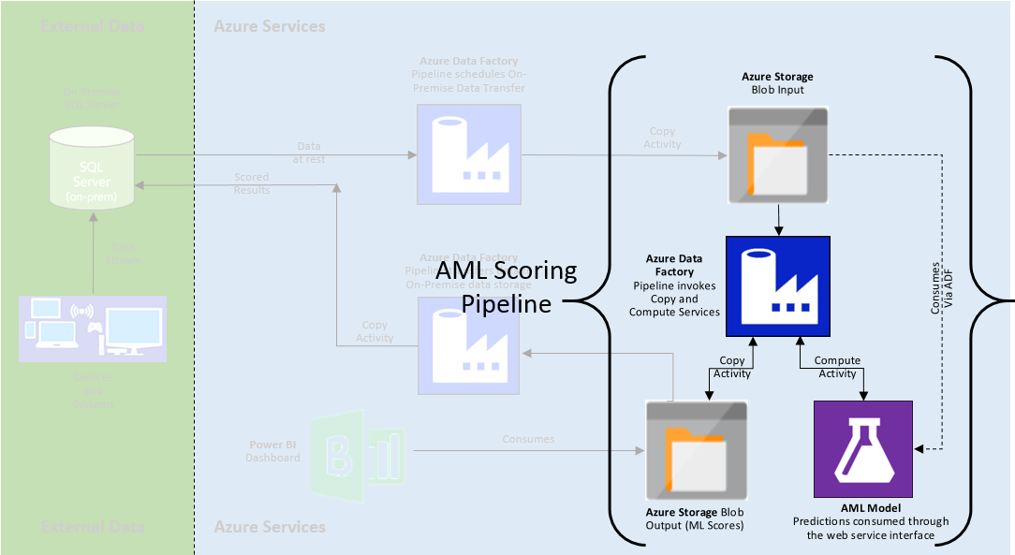

Figure 3: AML Scoring Pipeline

The AML scoring pipeline is shown in Figure 3. This pipeline connects to the AML input blob location (**RawInputBlobTable**) and to the AML output blob location (**ScoredOutputBlobTable**). Unlike the ingress pipeline, the AML scoring pipeline runs a *compute* activity that calls the AML web service batch execution endpoint, passes in the data from AML input blob location as a batch to the web service, and writes the results back to the AML output blob location.

1. **Create Linked Service** to link your AML batch execution endpoint to the ADF pipeline.

PS C:\> New-AzureDataFactoryLinkedService -ResourceGroupName OnPremDataFactoryRG -DataFactoryName <DataFactoryName> -File <location of **AMLLinkedService** definition>

1. **Create Input and Output Datasets**: We will use the **RawInputBlobTable** from the Ingress Pipeline as an input dataset and define a new blob store dataset as the output of this pipeline.

PS C:\> New-AzureDataFactoryDataSet -ResourceGroupName OnPremDataFactoryRG -DataFactoryName <DataFactoryName> -File <location of **ScoredOutputBlobTable** definition>

1. **Create Pipeline**: Finally, create an ADF pipeline that **connects input and output blob storages** and invokes **‘AMLBatchScoringActivity’** to be run every hour.

PS C:\> New-AzureDataFactoryPipeline -ResourceGroupName OnPremDataFactoryRG -DataFactoryName <DataFactoryName> -File <location of **AMLPipeline** definition>

### **The Egress Pipeline**

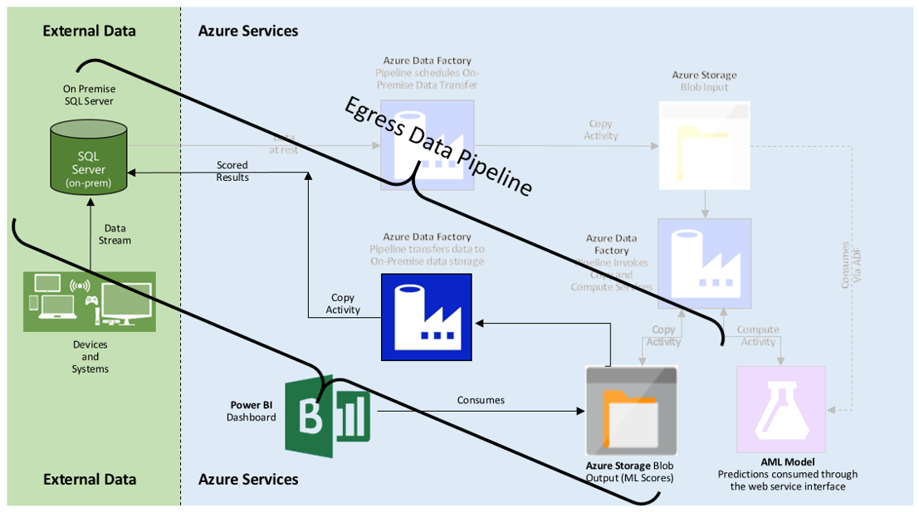

Figure 4: Egress Pipeline

The two pipelines created so far bring the data into Azure for the AML model and produce AML scores on an ongoing basis. This last pipeline will allow you to copy the scored results back to your on-premise SQL Server.

1. **Create Input and Output Datasets**: We will **use the *ScoredOutputBlobTable* from the *AML Scoring Pipeline* as an input** dataset **and define a new SQL table dataset (on-prem) as the output** of this pipeline. It is worth noting that you can choose a different SQL database to write the score results back. In that case you will need to define a new *Linked Service*, similar to the one we created in *Ingress Pipeline* connecting to the database storing the output dataset table.

PS C:\> New-AzureDataFactoryDataSet -ResourceGroupName OnPremDataFactoryRG -DataFactoryName <DataFactoryName> -File <location of **OutputOnPremSQLTable** definition>

1. **Create Pipeline**: Finally, create an ADF pipeline that **connects your on-premise SQL server table to the Azure blob storage** to copy the scores back to your on-premise server.

PS C:\> New-AzureDataFactoryPipeline -ResourceGroupName OnPremDataFactoryRG -DataFactoryName <DataFactoryName> –File <location of **EgressPipeline** definition>

### **Putting it all together - Activating the Pipeline**

In the PowerShell run the following commands to start the three pipelines for end to end ADF flow.

PS C:\> Set-AzureDataFactoryPipelineActivePeriod -ResourceGroupName OnPremDataFactoryRG-DataFactoryName <DataFactoryName> *-*StartDateTime <2015-11-03T15:00:00> –EndDateTime <2015-11-07T21:45:00> –Name **IngressPipeline**

PS C:\> Set-AzureDataFactoryPipelineActivePeriod -ResourceGroupName OnPremDataFactoryRG-DataFactoryName OnPremDataFactory-StartDateTime <2015-11-03T15:00:00> –EndDateTime <2015-11-07T21:45:00> –Name **AMLPipeline**

PS C:\> Set-AzureDataFactoryPipelineActivePeriod -ResourceGroupName OnPremDataFactoryRG-DataFactoryName OnPremDataFactoryRG-StartDateTime <2015-11-03T15:00:00> –EndDateTime <2015-11-07T21:45:00>–Name **EgressPipeline**

After you activate the pipelines you will see input data copied to Azure blob, scored by AML, and finally AML scores available in your on-premise SQL server every hour. The pipelines are activated sequentially so any failure in one of the pipelines will stop the pipelines downstream from running and producing garbled results.

### **Visualizing the Results**

The last and most important step in any solution operationalization is to visualize and integrate the results back into your business process. The egress pipeline discussed in the last step enables you to integrate the machine learning predictions back into your on-premise SQL server. Next we are going to create a dashboard in PowerBI to visualize the results from the machine learning model.

#### **Acquiring the data**

Open up a new Excel workbook and click on the *Power Query* tab. If you do not have a Power Query tab, install the plugin [here](http://www.microsoft.com/en-us/download/details.aspx?id=39379) (the plugin is already included as part of Excel 2016 – select **New Query** under the Data tab) Follow the next few steps to add Azure blob as a data model which is then uploaded to PowerBI dashboard.

* Select ‘New Query’ -> From Azure -> From Microsoft Azure Blob Storage
* Enter your blob storage account name (“starterkit”) and keys. If you do not know these, you can get these from the Azure portal [here](https://portal.azure.com/).
* If the credentials are entered correctly, you will see your blob container (“onprem”). Double-click on the container to open it in Query Editor.
* In the editor window, click on “Binary” to load the actual data and then click on ‘Close & Load To’. Make sure the workbook queries tab on the right reports the correct number of rows for data.
* In the dialog box that follows select “Only Create Connection” and click on the checkbox “Add this data to the Data Model”. This loads your data to the Excel workbook.
* Save the Excel workbook.

#### **Creating a Dashboard**

Next we logon to the PowerBI webpage, create a new dashboard, and upload Excel workbook we created in the last section containing the data from the data model.

* Visit the [Power BI webpage](https://msit.powerbi.com/) and click on the Get Data button on the bottom left corner.
* Click the Get button under File and select and navigate to the storage location where you saved the workbook you created in the last step.
* Double-click on the new dataset in the left pane; this opens up a report editor. You can select fields and visualization from the right pane. Save your report by clicking Save As under the File menu.
* When you are done click on the pin icon () to pin the visualization to your dashboard. You can create a new dashboard or use an existing one.
* You can share this dashboard with others by clicking on the share icon ().

#### **Auto Refreshing Dashboards**

In the last 2 sections we created a new dashboard and added visualizations around the AML predictions data that is produced every hour by the E2E pipeline we created earlier in this document. In this section we will add a refresh schedule to the dashboard so that as the new predictions become available from the pipeline, the dashboard visualizations are updated automatically.

* Right click on the newly added dataset in the left pane and select “*SCHEDULE REFRESH*”.
* Under Data Source Credentials, enter your blob storage account key.
* Now under “*Schedule Refresh*” click the ‘Keep your data up to date’ button to Yes. Provide a schedule (daily for this tutorial) and hit apply.
* The Visualization you pinned on your dashboard will be refreshed daily.